Ignition Control And Vehicle Theft Detection

Sneha Humne Pooja Yadav Sonali Gaidhane Shrutika Kadam
(snehah1906@gmail.com) (poojayadav.g6@gmail.com) (sonaligaidhane17@gmail.com) (shrutikakadam909@gmail.com)

Dr.U.M.Gokhale
Professor ETC Dept.
GHRIET, Nagpur

Abstract— Nowadays we all have our own vehicle, theft is happening on parking and sometimes driving insecurity places. The safety of vehicles is extremely essential. Vehicle tracking and locking system is installed in the vehicle, to track the location of vehicle and locking engine motor. The location of the vehicle is identified using Global Positioning system (GPS) and Global system mobile communication (GSM). These systems constantly watch a moving Vehicle and report the status on demand. When the theft identified, the responsible person send SMS to the microcontroller,

Keywords—Vehicle theft controlling unit, GSM, GPS, CAN, Mobile phone,

I INTRODUCTION
The purpose behind this project is “Drunk and theft detection”. Now a day, many accidents are occurring due to alcohol consumption.It is a major cause of accident all over the country.In this project alcohol detector is fitted/installed inside the vehicle. Development and deployment of GPS/GSM based vehicle tracking and alert system allows inter-city transport companies to track their vehicle in real time and provides an alert system for reporting on theft detection.
Nowadays, internet are used almost in any application and field, even small item registered with code and update in database then can buy it by online system. Numbers of vehicles are significant increase every year and many cases of vehicle theft and missing thus internet of things (IoT) is a technology can be use to overcome the issues.
Current generation smartphones provide GPS, microphones and cameras. These sensors allow smartphones to be used for various sensing tasks such as activity monitoring, personal health. The fundamental problem here is to identify vehicles theft detection. Although there are numerous object in recognition and tracking. We explain the basic idea behind the tracking algorithm developed in this research.

II. LITERATURE SURVEY

Design & Development of a GSM Based Vehicle Theft Control System.
- This paper deals with the design & development of a theft control system for an automobile, which is being used to prevent/control the theft of a vehicle. The developed system makes use of an embedded system based on GSM technology.
- The designed & developed system is installed in the vehicle. An interfacing mobile is also connected to the microcontroller, which is in turn, connected to the engine. Once, the vehicle is being stolen, the information is being used by the vehicle owner for further processing.
- The information is passed onto the central processing insurance system, where by sitting at a remote place, a particular number is dialed by them to the interfacing mobile that is with the hardware kit which is installed in the vehicle.

III. BLOCK DIAGRAM
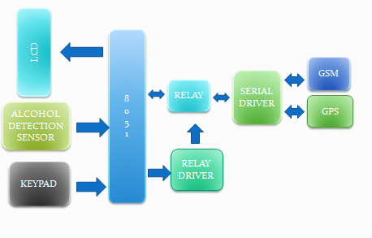
MICROCONTROLLER

A microcontroller is a compact microcomputer designed to govern the operation of embedded systems in motor vehicles, robots, office machines, complex medical devices, mobile radio transceivers, vending machines, home appliances, and various other devices. A microcontroller is a small computer (SoC) on a single integrated circuit containing a processor core, memory, and programmable input/output peripherals. Microcontrollers are used in automatically controlled products and devices, such as automobile engine control systems, implantable medical devices, remote controls, office machines, appliances, power tools, toys and other embedded systems.It has RAM of 128KB and ROM of 4KB.

ALCOHOL DETECTOR
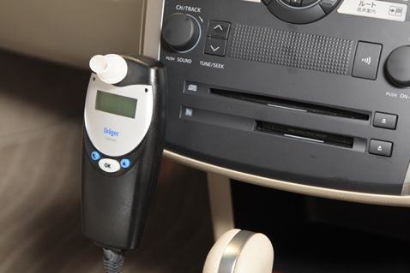
Sensitive material of MQ-3 gas sensor is SnO2, which with lower conductivity in clean air. When the target alcohol gas exist, The sensor’s conductivity is more higher along with the gas concentration rising.MQ-3 gas sensor has high sensitity to Alcohol, and has good resistance to disturb of gasoline, smoke and vapor. The sensor could be used to detect alcohol with different concentration, It is available at low cost and suitable for different application.
Character Configuration
* Good sensitivity to alcohol gas
* Long life and low cost
* Simple drive circuit

VOLTAGE REGULATOR

A voltage regulator generates a fixed output voltage of a preset magnitude that remains constant regardless of changes to its input voltage or load conditions. There are two types of voltage regulators: linear and switching. A linear regulator employs an active (BJT or MOSFET) pass device (series or shunt) controlled by a high gain differential amplifier. It compares the output voltage with a precise reference voltage and adjusts the pass device to maintain a constant output voltage. A switching regulator converts the dc input voltage to a switched voltage applied to power MOSFET or BJT switch. The filtered power switch output voltage is fed back to a circuit that controls the power switch on and off times so that the output voltage remains constant regardless of input voltage or load current changes.

GSM300

SIM300 is a Tri-band GSM/GPRS engine that works on frequencies EGSM 900 MHz, DCS 1800 MHz and PCS1900 MHz. SIM300 provides GPRS multi-slot class 10 capability and support the GPRS coding schemes CS-1, CS-2, CS-3 and CS-4. With a tiny configuration of 40mm x 33mm x 2.85 mm , SIM300 can fit almost all the space requirement in your application, such as Smart phone, PDA phone and other mobile device. SIM300 provide RF antenna interface with two alternatives: antenna connector and antenna pad. The antenna connector is MURATA MM9329-2700. And customer’s antenna can be soldered to the antenna pad.
The SIM300 is designed with power saving technique, the current consumption to as low as 2.5mA in SLEEP mode. The SIM300 is integrated with the TCP/IP protocol.Extended TCP/IP AT commands are developed for customers to use the TCP/IP protocol easily, which is very useful for those data transfer applications.

LIQUID CRYSTAL DISPLAY

LCD is a Liquified Crystal Display used as a displaying device.It is modified type of CRTdisplay.An LCD is made with either a passive or active matrix display grid. The active matrix LCD is also known as a thin film transistor(TFT) display. The passive matrix LCD contain grid of conductors with pixels located at each intersection in the grid. A current is sent across two conductors on the grid to control the light for any pixel. An active matrix has a transistor located at each pixel intersection, requiring less current to control the luminance of a pixel. For this reason, the current in an active matrix display can be switched on and off more frequently,improving the screen refresh .It will allow us to display options like entering the password.

KEYPAD

The keypad is a section found on most computer keyboards and allows an individual to easily enter numeric values and alphabets into a computer. For example, the keypad is often used for anyone who deals with numbers frequently or has to perform calculations with a software calculator. As keypads are not available with all computer keyboards, especially laptop computers, we can also use USB keypads which can be connected to any computer with USB.

MAX232
The MAX232 is a dual driver/receiver that includes a capacitive voltage generator to supply TIA/EIA-232-F voltage levels from a single 5-V supply.This will convert the TTL logic to CMOS and CMOS to TTL logic. Each receiver converts TIA/EIA-232-F inputs to 5-V TTL/CMOS levels. These receivers have a typical threshold voltage of 1.3 V, a typical hysteresis of 0.5 V, and can accept ±30-V inputs.

BLUTETOOTH MODULE
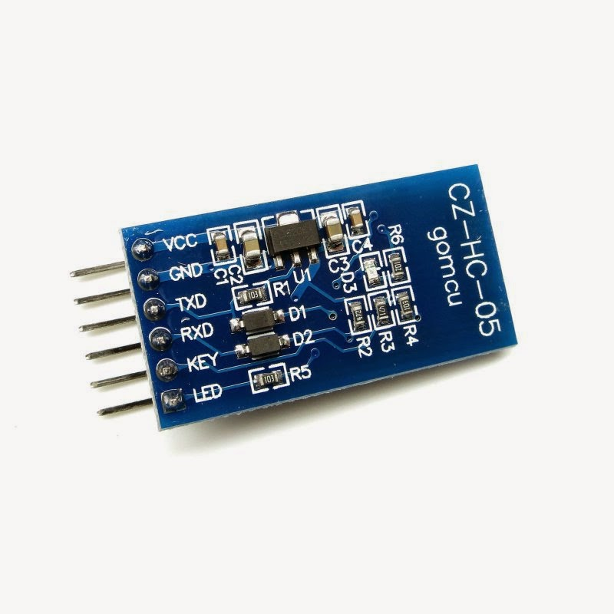
We are using Bluetooth module xc05.It Works on 2.4 GHz, It has both master and slave. Master has its authentication.it can start the communication as well as stop the communication. Slave doesn’t have authenticity. In our project mobile works as master and this module will work as slave.

IV SOFTWARE DESIGN
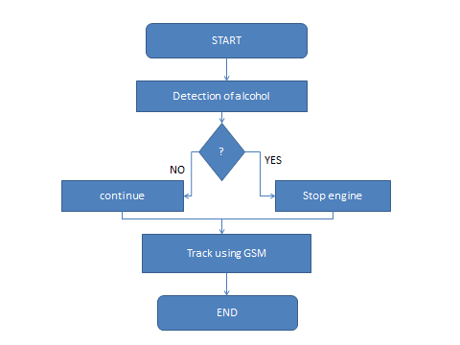

V. Advantages & Future Development

- The proposed system can be used in the various vehicles for detecting whether the driver has consumed alcohol or not.
- The system using Breathing analyzer can also be used in various companies or organization to detect alcohol consumption of employees.
- Alcohol detection system in an automobile is a must feature which every cab or bus should have.
- The proposed system provides an automatic safety system for cars and other vehicles as well.
- In future development GSM technology can be used to inform the relatives or owners of the vehicle about theft & alcohol consumption.
- GPS system can also be used to find out the real time location of the vehicle.

VI CONCLUSION

In this paper, we have proposed a novel method of vehicle tracking and locking systems used to track the theft vehicle by using GPS and GSM technology. This system puts into the sleeping mode vehicle handled by the owner or authorized persons; otherwise goes To active mode. The mode of operations changed by persons or re motely. When the theft identified, the responsible people send SMS to the micro controller, then issue the control signals to stop the engine motor. After that all the doors locked. To open the doors or to
restart the engine authorized person needs to enter the passwords. In this method, easily track the vehicle place and door locks.

REFERENCES

- Ch. Bhanu Prakash and K. Sirisha,“Design and Implementation of a Vehicle Theft Control Unit using GSM and CAN Technology”, in International Journal of Innovative Research in Electronics and Communications (IJIREC) Volume 1, Issue 4, July 2014, PP 46-53 ISSN 2349-4042 (Print) & ISSN 2349-4050 (Online)
- Champa Bhagavathi. , Gowri.B. , Kasturi. “Vehicle Theft Detection and Prevention Using GSM and GPS.”, International Journal of Innovative Research in Computer and Communication Engineering Vol. 4, Issue 5, May 2016.
- Kunal Maurya , Mandeep Singh, Neelu Jain, “Real Time Vehicle Tracking System using GSM and GPS Technology-An Anti-theft Tracking System, ”International Journa l of Electronics and Computer Science Engineering. ISSN 2277-1956/V1N3-1103-1107.
- Asaad M. J. Al-Hindawi, Ibrahee m Talib, “Experimentally Evaluation of GPS/ GSM Based System Design”, Journal of Electronic Systems Volume 2 Number 2 June 2012

