Canteen Token System with Previous Day Attendance

Ms. Varsha V.Patil1 Mr. R.V Patil2 Chaudhari Vijay D.3

1PG Scholar, M.E. (VLSI & Embedded System Design),

2Asso. Prof. E&TC Engg dept, 3Asstt.Prof. E&TC Engg.dept

1, 2,3GF’s Godavari College of Engineering, Jalgaon-4252001, Maharashtra, India

***Abstract –*** *Queue system and food wasting system in the field of canteen management is a big issue. The problem occurred in many public places like restaurants, banks, canteen etc. To solve this problem different and smart technique are going to be used by using RFID Tag for the queue system and number calling ,in bank and Food ;Company. There is ESP 8266 (Electronic stability program microcontroller) which is integrated low power 32-bit MCU. For coding PHP and HTML languages are used. For registration purpose web page generated, RTC is used for real time recording and for display scan card status LCD is used. The main theme of the system is that attendance should be taken previous day because to maintain the student record and quality of food. To overcome this problem previous day attendance is the best way system.*

***Keywords-*** *ESP 8266 module, LCD, RTC, PHP or HTML programming, RFID cards.*

1. **INTRODUCTION**

In Various educational institutes, offices etc. canteen facility is available for students and employees. Usually canteen vendors operate their regular customer on monthly basis. That maintains the eating record of persons in handwritten notebook which is usually prone to errors. The main objective of this system is to uniquely identify and to make attendance automatic which has the capability of distinguishing the different persons. This is possible by the use of new emerging technology RFID (Radio Frequency Identification). The main parts of an RFID system are RFID tag (with unique ID number) and RFID reader (for reading the RFID tag). The ESP 8266 used for storing the details has the capability of storing persons details at a time. At predefined time from the server one notification will be send either automatically or manually. Which ask for booking of meal? Working is starts from registration of the student in canteen web application or program. Once student registered his unique ID is assigned to him his account is created at on server which tracks data of his canteen token number for monthly record etc. Upcoming time say for lunch or for dinner? If reply is yes then it will book the dinner or lunch. If reply no or repeat same reply then booking will be canceled and shows invalid entry. Also it will deduct the bill of lunch or dinner after that it will conclude for number of coming entries. All this data maintained on the server and accessed by authenticate user only. We use WIFI MODULE ESP8266 which is inbuilt WIFI unit. For microcontroller programming language is the embedded c and for server handling language tool is PHP and HTML.

1. **LITERATURE SURVEY**

This paper includes literature survey and its previous outcome. This section discusses the overview of the different past research in the area of canteen management. Different methods and approaches proposed by different authors are also involved. Based on this, problem is defined and proposed system is discussed in successive sections.

* 1. **Existing system**

For the purpose of identifications the earlier researcher uses various techniques like biometric [1]. The above mentioned technique of personal identification, number of government and private sectors are in need of the system, such as border crossing, access to building, laptops and mobile phones. System needs to have tremendous growth in recognition technology. By using biometrics it is possible to recognize a person. There are traditional verification systems because they make use of fingerprint, hand shape, iris, face etc that are supposed to be unique to that person. But author found that biometric is the advanced technology which is used here but something happen with thumb then how attendance will take. After this technique in paper [2] author implemented the PON number instead of using queue system or token system. To avoid the queue or inconvenience method it is best system. Person who is having a PON to reference it is easy to manage their orders and revealed by numerical calculations. In paper [3] author suggested the system in which inconvenience in many public places like banks, canteens etc. where people follow queue system. This system is very much time consuming and boring so to overcome this problem author show a low power microcontroller based smart token system. This system is used to display from 0 to 99 two digit numbers by using this customer need not wait in the queue. He used PIC16F877A microcontroller. This system is better than queue system and low power mode which is unique that is controlled by software to go in sleep mode to save power. In paper [4] author propose a formal model for class authentication he used “Infinite alphabet password (IAP’S) instead of token system. He used alphabet password as a attendance purpose. Here used a character set of construction of the authentication token. Hence he found IAP architecture also use in many real world situation and implemented using a number and cryptographic protocols. The result of that analysis found IAP’S can offer security benefit over traditional password scheme .In paper [5] As like canteen there are ID card used for security purpose author used UTNAC (Unique Token Number Allocation) for mobile user. Now new allotment scheme will be used which can be implemented for SIM card. These numbers will be given on the basis of per person not on card that’s why the over burden on database server. By using this UTNA or new algorithm that is number allotment method the work will become easy safety for mobile user and user identification etc. In paper [6] according to next situation author invent new technique for college students. In many colleges are facing common problem like bunking the college lectures and meet in accidents hence department and college will be responsible for that also face the question to their irresponsibility. Hence to overcome this problem author maintains the record of students using RFID based taking attendance with GSM module. In paper [7] Here also used passive RFID which is based on MAC protocol i.e. STD C1G2 protocols. This protocol is very easy to implement the system but token based MAC protocol called token MAC for passive RFID. Author shows that token MAC has a higher tag rate than C1G2 and achieves good performance than TDMA based protocol. Token-MAC is a solution for passive RFID In paper [8] After studies the problem of undefined authentication he develop a new technique to generate a dynamic tokens for unknown authentication by using asymmetric design that produce most complexity to more powerful RFID readers. Instead of using complicated cryptographic Hash function he used simple hardware operations such as bitwise XOR, one- bit, left circular shift and bit flip to make their authentication easier. In paper [9] puts on the basis of smart queue system for theme park. In our side visitors carry RFID tag to record local information hence author shows that smart queue mechanism based on visitors type and entry time. This system provide a better experienced in line and short waiting time for visitors to improve management strategy, real time movement data will used for the visitors. In paper[10] RFID attendance is too much easy and good work it is automatic wireless identification system. It works with the help of active and passive cards and a reader. In this paper author tried to solve the problem of manually taking attendance by using RFID technology. The result of the system will become automatic by using RFID technology. By the basis of this survey paper [11] the whole project is to be done.

**2.2 Problem Statement**

Existing system provides the various techniques for power saving some of them used low power microcontroller which is complex architecture and higher in cost, again in Biometric there is thumb recognition which is advanced but if something happen with thumb then how attendance will taken. PON Number, UTNA, IAP’s and also many new techniques were used but there are some problems. Here we used RFID card which is wireless, easy to carry and ESP 8266 which is integrated low power, 32-bit MCU and inbuilt Wi-Fi module for detection of attendance of any person in the Canteen and new idea of managing whole data through internet by making web site which is not implemented in existing system? For microcontroller programming Language is the embedded C. And for server handling Language tool is PHP and HTML

* 1. **Proposed System**

The proposed system is built around Arduino version 1.6.9 for the ATmega328 andESP8266. Arduino is latest software which is used for programming and compiling.

For circuit design, we used Or Cad 9.2 version. For web application and for data management we used PHP and HTML. RFID card scan the ID and ;accept their registration for next day breakfast, lunch, dinner etc.

1. **METHODOLOGY**

This paper describes methodological detail of various stages of system by reminding information about tools which is used. The hardware and software design section are also described consequently.

Fig 3.1 Block diagram of Canteen Token System

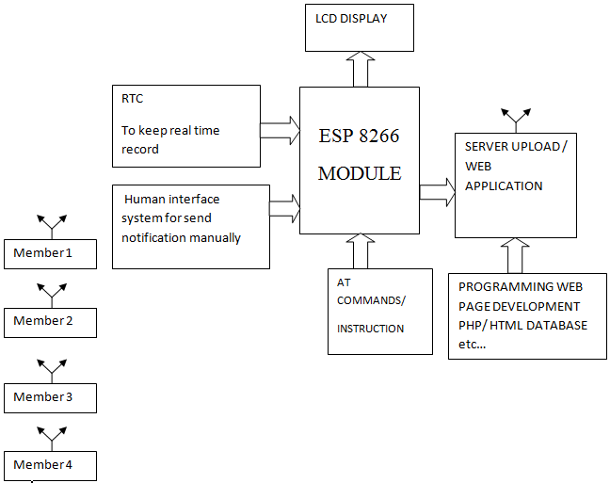

Working is start from registration of student in canteen web page. RTC is used to keep real time record which is a computer clock that track of current time. Once student register his unique ID is assigned to him with the RFID tags which are provided to him ,his account is created at on server which keeps data of his canteen token no. Then it will go through RTC At predefine time from the server one notification will be send either automatically or manually. Which ask for booking of meal at upcoming time say for lunch or for dinner? If reply is yes then it ;will book the dinner or lunch. If reply no or nothing then it will be cancelled or invalid entry. All this data maintained on the server and accessed by authenticate user only. And it will be seen by display system. We are using LCD to show scan card status. This is done by ESP 8266 module and sends notification to the cloud or main server. Which is handle by

Authorize person. For this monitoring, we make a web with the help of PHP and HTML database. This whole data will have saved on the web page due to this online

Process the authorized person can handle it from anywhere. The authorized person can only have internet with him to see or handle their own system for booking we provide a LOGIN ID and PASSWORD to monitoring it.ESP8266 WIFI module is the master module and ATmega328 is salve controller. This slave controller is used because of ESP8266 module have minimum pin count i.e. approx 16 pins so we must expand interfacing with this slave controller.

**3.2 ESP 8266 Module**



**Fig 3.2 ESP 8266 module**

Express if Systems’ Smart Connectivity Platform (ESCP) is a set of high performance high integration wireless SOCs, designed for space and power constrained mobile platform designers. It provides unsurpassed ability to embed Wi-Fi capabilities within other systems, or to function as a standalone application, with the lowest cost, and minimum space requirement. Figure 3.2 shows the ESP2866 Wi-Fi module. It offers a complete and self-contained Wi-Fi networking solution; it can be used to host the application or to offload Wi-Fi networking functions from another application processor.

**3.3 RFID Cards**

RFID is Radio Frequency Identification. Basically a RFID system contains 2 parts: A Reader, and one or more Transponders, also known as Tags. The system (RFID systems) to automatically identify and track

products and people is evolved from barcode labels.

Fig 3.2 RFID card

**ALGORITHMIC STEPS**

1. Start

2. Initialized the IR MODULE, DIPLAY, ARDUINO, ESP 8266.

3. Now initialized the web page with the help of boot program.

4. According to Registration of student, increment or decrement of the counter is done.

5. Running program for counter mode for each student registration entry is IR 1; increment counter counts its 1.

6. Running program for counter mode for each student registration cancel is IR 2; decrement counter counts its 0.

7. Now counter check whether it is “0” or not.

8. If it is not “0” then it returns to step 7.

9. If it is “0” then check status of optocoupler sensor for light ON or OFF.

10. Show this status to web page.

11. Now check the scan card status is ON or OFF.

12. If yes then make their order breakfast, lunch, dinner. Otherwise no action can be done.

13. This information is saved on web page as an excel sheet.

14. When whole steps are done then if scan card status is ON and order is given or not then, our system turns OFF it.

**4. SOFTWARE TOOLS**

**4.1 PHP 5.0**

It is web application included new features such as improved support for object- oriented programming; the PHP data objects extension defines a lightweight and consistent interface for accessing database. In 2008 PHP 5 became the stable version under development.

**4.2 HTML 5**

Database management includes detailed processing models to encourage more interoperable implementations it extends improve and rationalize the markup available for documents introduces markup and applications programming interfaces for complex web application.

1. **RESULT AND DISCUSSION**

Figure 5.1 shows the Hardware implementation “CANTEEN TOKEN SYSTEM WITH PREVIOUS DAY ATTENDENCE.” At starting my project look like this. For online status check website http://elpro.org.in/ME_project/canteen/HTML/index.html. This website is firstly copied to the Google for checking student status.

Fig 5.1 Hardware implementation

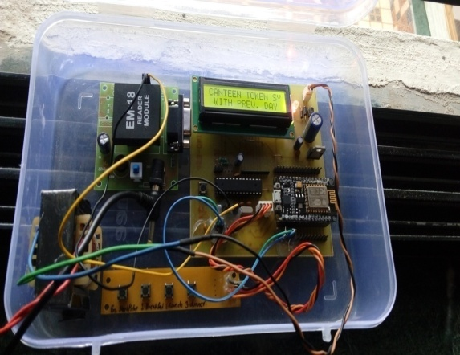

.

For online status check here is the website http://elpro.org.in/ME_project/canteen/HTML/index.html. This website is firstly copied to the Google for checking student status. Fig. 5.2 shows the software look of my project. This is the main page, from where we login to the sites. Here we need ID and PASSWORD.

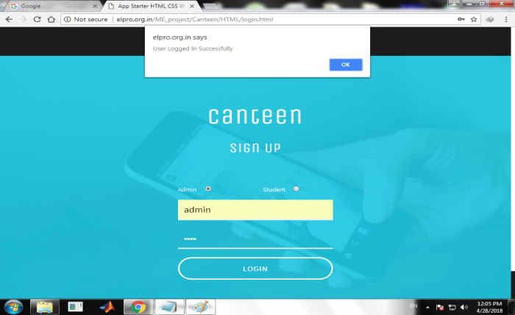

Fig 5.2 Web page generated

After login and project’s switch ON it shows the ADMIN PAGE.

5.3 Registration Form

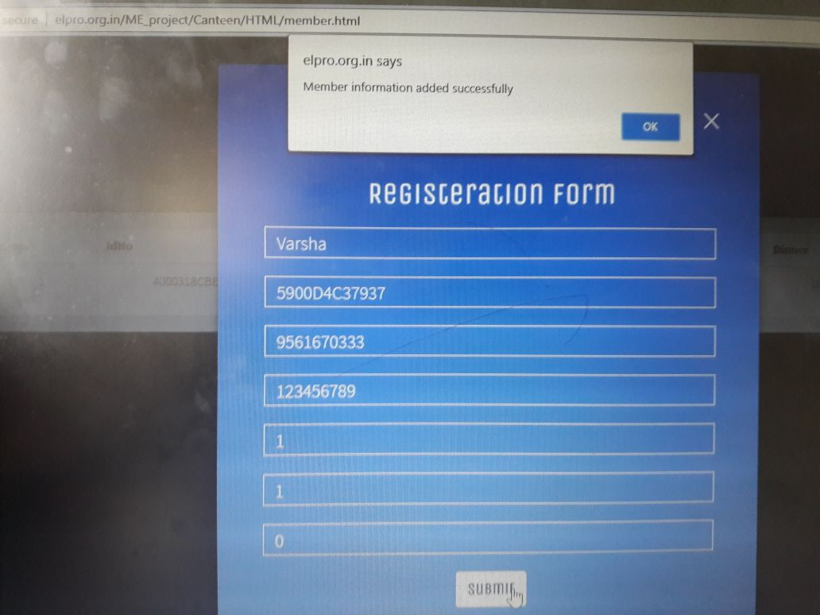

In Fig 5.3 this registration form student have to register given ID, student name, password, in this way student must update all information also select Breakfast, Lunch, Dinner and then submit the registration form. It shows user updated information successfully.

In the fig 5.4 it shows the enrollment start status after filling registration form it will send message to scan the RFID Card which is given to particular students.

Fig 5.4 Scan Card Status

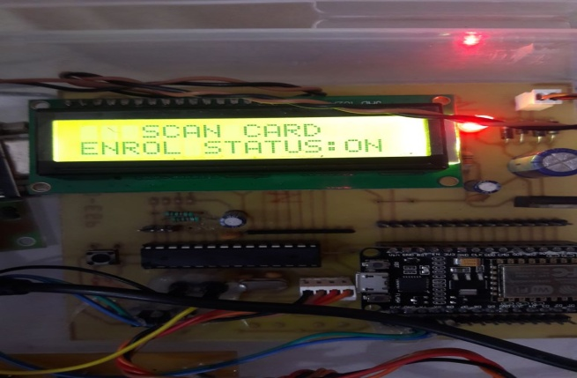

In fig 5.5 LCD displays the option [1] BREAKFAST from that option we can select the wanted food with the help of buttons which is formed by 2*2 matrix. From that image we get a clear idea about the selection process.

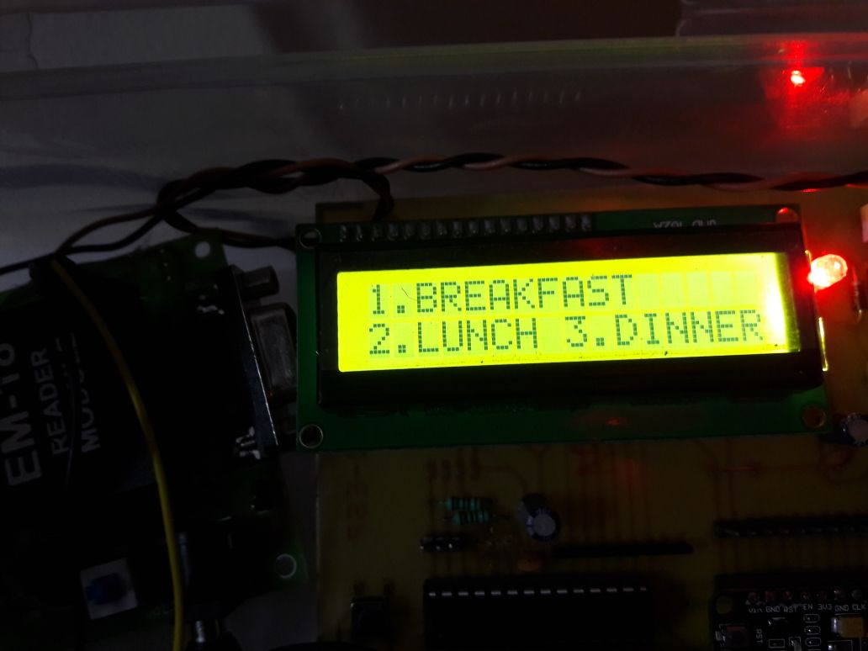

Fig 5.5 shows Breakfast, Lunch, Dinner

Fig 5.6 shows that after selecting food as a Breakfast then on the member page automatically option will be selected. This is the separate page of each member from

that member is able to keep record for his billing or food. After that if we are goes to the home page then it will show the updated list of students or member.

Fig 5.6 shows selected breakfast

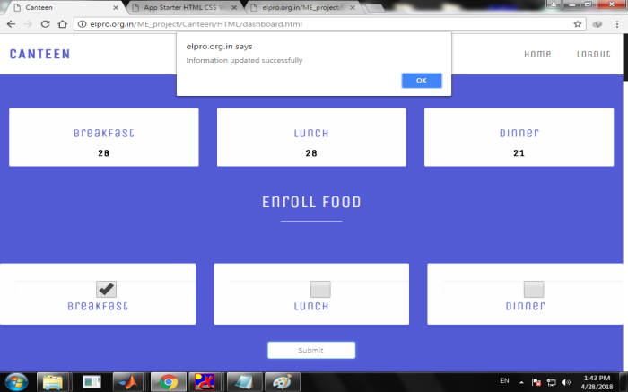

Figure 5.7 shows home page which shows the list of students updated as per server information.

Fig 5.7 List of student updated

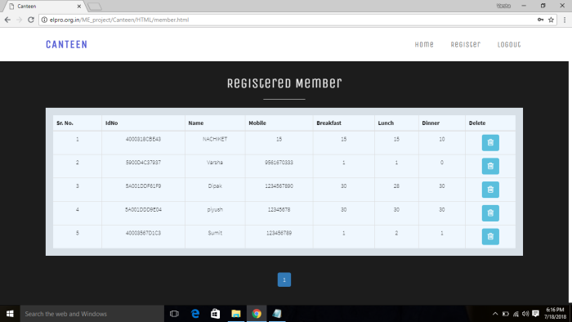

Figure 5.7 shows home page which shows the list of students updated as per server information. This is the page which can be seen by admin and users both and from that we can calculate the monthly bill or to keep record of ordered food. From that calculation process will be easy that is the advantage of the system. Also result displayed on the authorized person’s PC. This process proceeds after above steps are done

1. **CONCLUSION**

Thus we have implement the canteen token system with previous day attendance system is more effective and advantages. The main goal of the system is that we can conserve food and time .By using ESP 8266 module and RFID card for storing the persons detail at a time also taking previous day attendance is a new and different task. Hence the getting result should be best. And implementing new technology all previous problems should be overcome.

1. **FUTURE SCOPE**

We have designed this system especially for Food and Time conservation still there can be some improvements in future in field like Canteens makes as a Large Industry. Hospitals, Museum places, Cinema Hall like Metro, Ionox, etc. And most important Holly places, Museum places where people having the problem of standing in queue for 7-8 hrs. (Some famous spiritual places like Pandharpur, Tirupati, and this period will be up to one day.)

**REFERENCES**

1. Anil K. Jain “Biometrics: Proving ground for image and pattern recognition” *Fourth International conference on image and graphics (ICIG 2007),* Date of conference: 22-24 Aug 2007, Date Added to IEEE Explore: 04 September 2007, p .p 3.3.
2. Kazuhoohara; Keijji Tanaka; Yukio Horiuchichi “Performance analysis of downloading speed on token passing based PON Number” *2008 Conference on optical fiber communication / National fiber optic engineer conference,* Date of Conference: 24-28 February 2008, Date added to IEEE Explore: 23 May 2008, p .p . 1-3.
3. Rajesh KannanMegalingam; Sreenath P.S; DevidayalSoman; Jessin P.A ; Srikanths “Low Power Microcontroller Based Simple Smart Token Number Display System” *Fifth International conference on MEMS NANO, and smart system 2009,* Date of Conference: 28-30 December 2009, Date added to IEEE Explore: 21 June 2010, p. p 171-175.
4. Marcia Gibson; Marc Conrad; Carsten Maple “Infinite alphabet password: A Unified Model for a Class of Authentication system” *2010 International Conference on security and cryptography.* Date of Conference: 26-28 July 2010, Date added to IEEE Explore: 05 April 2011,p. p 1-6.
5. Puneet Sachdev; Aushotosh Kumar Dubey “Novel Number Allotment Method with UTNA (Unit Token Number Allocation) Security System For Mobile User” *2012 International Conference on Devices; Circuits and Systems,* Date of Conference: 15-16 March 2012, Date added to IEEE Explore: 23 April 2012, p. p: 594-598.
6. ChaitraliSai Krishna; Naidu Sumanth; C Raghava Prasad “RFID based student monitoring and attendance tracking system” Date of Conference : 4-6 July 2013, Date added to IEEE Explore: 30 June 2014, p. p 1-5.
7. Li Chen; IIkerDemirkol; Wendi Heinzelman“Token MAC: A Fair MAC Control for Passive RFID System” *2011 global telecommunication conference – GLOBE COM 2011,* Date of Conference: 5-9 December 2011, Date added to IEEE Explore: 19 June 2012, p. p 1-5.
8. Min Chen; Shingang Chen “An Efficient Anonymous Authentication Protocol for RFID System Using Dynamic Token” *35th International Conference on Distributed Computing System,* Date of Conference: 29 June- 02 July 2015, Date added to IEEE Explore: 23 July 2015, p. p 756-757.
9. JingGuo; Ciaxia Zhang; Xu Zhang, “Smart Queue System Based On RFID Technology For Theme Park” *2016 7th IEEE International conference on Software engineering and service science ,* Date of Conference: 26-28 August 2016, Date added to IEEE Xplore: 23 March 2017. p .p 1002-1004.
10. Hasan U. Zaman; JannatulSiffatHossain; Tasnim TamannaAnika; DeoshreeChoudhary, “ RFID Based Attendence System” *2017 8th International Conference on computing, communication and networking technology,* Date of Conference: 3-5 July 2017, Date added to IEEE Xplore: 14 December 2017, p .p: 1-5.
11. Varsha V. Patil, R.V. Patil, “Canteen Token System With Previous Day Attendance” *Proceedings of National Conference on Current Trends in Engineering, Science, Technology and Management (NACCTESTM-2017) 21 March 2017* INTERNATIONAL JOURNAL OF ADVANCED ELECTRONICS & COMMUNICATION SYSTEM approved by CSIR-NISCAIR ISSN NO:2277-7318, P.P. 122-124