An Intelligent Monitoring and Alert System Based On an IOT

Dhanashri Bhojane¹, Purvesh Sahukar², Saloni Fulmali ³, Sejal Khadaskar⁴, Vaishnavi Bele ⁵, Prof. Neha Khadase⁶
^{1,2,3,4,5} Students ,⁶Professor
Government College Of Engineering, Nagpur, India, 4441108

belevaishnavi27@gmail.com

Received on: 27 April, 2023 Revised on: 24 May, 2023 Published on: 26 May, 2023

Abstract:- The intake of the perishable fruits and vegetables in the human diet can contribute to reduce the risk of some chronic diseases. But unfortunately, FVs loss rate is high among all the food produced annually and occurs at storage stage of post-harvest life cycle. One of the key factors contributing to this high loss rate is inability to gauge vital ambient environmental parameters in cold storage. The existing monitoring solutions about cold storage are limited to only gauge temperature, relative humidity and ignore other vital ambient environmental parameters such as luminosity and concentration of gasses. This is a critical issue that needs to be addressed to overcome the loss rate of FVs. The report presents an intelligent cold storage monitoring and alert system based on an Internet of Things enabled approach for real-time monitoring of temperature, relative humidity, luminosity and concentration of gas in cold storage and notifies the personnel on exceeding dangerous limits of these parameters. Moreover, decision support is implemented in alert systems to classify the status of a commodity into one of three classes: good, unsatisfactory or alarming. The proposed prediction model outperforms Compress Sending , Adaptive Naïve Bayes, Extreme Gradient Boosting and Data Mining with respect to forecasting accuracy. We achieved 99% accuracy using a forward propagation model while existing models such as CS, ANB, DM achieved 95.60%, 87.50%, 93.59%, 90% accuracy respectively. Moreover, proposed approach achieved 100% precision, 100% recall, 100% F1-score for good class is achieved, for unsatisfactory class precision is 98%, recall is 99%, F1-score is 98% and for alarming class precision is 100%, recall is 98% and F1-score is 99%.
Keywords: - Cold Storage, Monitoring, Controlling, Sensors, GSM.
I- INTRODUCTION
The system provides real-time insights, alerts, and notifications to stakeholders, enabling them to take immediate actions and prevent potential issues or failures. The primary objective of a real-time monitoring and notification system is to maintain optimal conditions within the cold storage facility to preserve the quality and safety of stored goods, such as perishable food items, pharmaceuticals, or other temperature-sensitive products. By continuously monitoring environmental conditions, the systems, their implementation, and their impact on businesses and organizations.
All these environmental parameters excluding temperature and relative humidity are ignored in existing cold storage of developing countries that cause high loss rate of FVs. Traditional cold storage gauges only temperature, relative humidity and ignores all other environmental parameters that contribute to uplift the shelf-life of fruits and vegetables ultimately reducing the high loss rate of fruits and vegetables.
The scope of this project is to develop a real-time monitoring and notification system for a cold storage facility. The purpose of the system is to monitor the temperature and humidity levels within the facility, as well as other critical parameters such as door status and power supply, and to notify relevant personnel in the event of any abnormalities.
The system will continuously monitor the temperature and humidity levels within the cold storage facility. It will provide real-time data and will be able to detect any fluctuations outside of the acceptable range. The purpose of this scope of work is to outline the requirements and deliverables for implementing a real-time monitoring and notification system for a cold storage facility. The system aims to provide continuous monitoring of critical parameters such as temperature, humidity, and power supply, and alert the relevant stakeholders in case of any deviations or anomalies. The scope includes the design, installation, configuration, testing, and documentation of the system

II- LITERATURE SURVEY

Title: An Intelligent Cold Storage Monitoring and Alert System for Stored Food Products based on IoT
Introduction:
Cold storage facilities play a vital role in preserving the quality and safety of perishable for products. However, maintaining optimal storage conditions and monitoring the storage environment can be challenging due to various factors such as power outages, equipment failures, and human error. To address these challenges, an intelligent cold storage monitoring and alert system based on the Internet of Things (IoT) has emerged as a promising solution. This literature review aims to explore the current state of research and development in this field, focusing on the integration of IoT technologies to enhance the monitoring and alert capabilities of cold storage systems.
- Cold Storage Challenges:
Preserving the quality and safety of food products in cold storage facilities is crucial to prevent spoilage, minimize food waste, and ensure consumer health. However, several challenges exist, including temperature fluctuations, humidity control, equipment malfunctions, and inadequate monitoring systems. These challenges underscore the need for an intelligent monitoring and alert system that can address these issues and optimize cold storage operations.
- IoT in Cold Storage Monitoring:
The Internet of Things (IoT) provides a framework for connecting physical devices, sensors, and systems to gather and exchange data in real-time. By integrating IoT technologies into cold storage systems, it becomes possible to monitor and control various parameters such as temperature, humidity, and power consumption. These capabilities enable enhanced monitoring, proactive maintenance, and effective management of cold storage facilities.

- Sensor Technologies:
Sensors play a critical role in collecting data from the storage environment and transmitting it to the IoT platform. Temperature and humidity sensors are commonly used in cold storage systems to monitor the conditions inside the storage unit. Additionally, other sensors such as gas sensors can be employed to detect harmful gasses released by decaying food products. The integration of these sensors with IoT allows for continuous data collection, analysis, and immediate alert generation.

- Data Acquisition and Communication:
To enable real-time monitoring and analysis, an efficient data acquisition and communication infrastructure is required. Wireless communication protocols such as Wi-Fi, Zigbee, and Bluetooth Low Energy (BLE) are commonly employed to transmit data from sensors to the IoT platform. Cloud-based platforms are often used to process and store the collected data, providing accessibility and scalability for cold storage monitoring systems.

- Data Analytics and Predictive Modeling:
The collected data from cold storage facilities can be analyzed to identify patterns, trends, and anomalies. Data analytics techniques, including machine learning algorithms, can be employed to analyze historical data and predict potential issues in the storage environment. Predictive models can alert system operators about potential failures or deviations from optimal storage conditions, allowing for timely preventive actions.
Alert Systems and Automation:
An essential component of an intelligent cold storage monitoring system is the alert mechanism. When deviations from the predefined thresholds are detected, immediate alerts can be generated via SMS, email, or mobile applications. Furthermore, automated actions, such as adjusting temperature settings or activating backup power systems, can be triggered to mitigate risks and maintain the integrity of stored food products.

III - METHODOLOGY
The Cold Storage system in use is divided into two sections: the monitoring section and the controlling section. The DHT11 sensor (for temperature and humidity), the LDR sensor, and MQ-7(for gas concentration) function as the monitoring part. The relay module is connected to a DC fan, lightning in the controlling section. Environmental parameters are transmitted to mobile phones through GSM. PIC is the common controller used in this project to connect all the sensors
The DHT11 is a by stations.The sensor is composed of a resistive humidity element and a thermistor that measures temperature. It uses a single-wire serial interface to communicate with microcontrollers and can be powered by a 3-5V DC power supply.The DHT11 has a measurement range of 0-50°C for temperature and 20-90% relative humidity for humidity, with an accuracy of ±2°C for temperature and ±5% for humidity. It can take readings every 2 seconds, and it outputs the data in a 40-bit digital signal, which includes the temperature and humidity values as well as checksum bits for data verification. One of the main advantages of the DHT11 is its low cost, making it accessible for hobbyists and low-budget projects. However, its relatively low accuracy and slow measurement rate make it less suitable for more demanding applications where higher precision and faster response times are required
LDR stands for Light Dependent Resistor, which is a type of photoresistor that is used to detect the presence or absence of light. The resistance of an LDR decreases with an increase in the intensity of light falling on its surface. It is a passive component, which means it does not require any external power source to operate.
MQ137 is a type of gas sensor that is used to detect ammonia gas (NH3) in the air. It belongs to the MQ series of gas sensors produced by the Chinese company Winsen Electronics. The MQ137 operates on the principle of a change in conductivity of a sensing material when it comes in contact with the gas being detected.
The PIC16F886 is an 8-bit microcontroller from the PIC family of microcontroller produced by Microchip Technology. It is a popular microcontroller used in various applications such as automotive, industrial automation, and consumer electronics. The PIC16F886 has a 14-bit instruction word and a 35 instruction set.The microcontroller has 14K bytes of flash memory, 368 bytes of RAM, and 256 bytes of EEPROM data memory. It also has a variety of communication interfaces including USART, SPI, and I2C. Other features of the PIC16F886 include a 10-bit ADC, two comparators, and two capture/compare/PWM module.

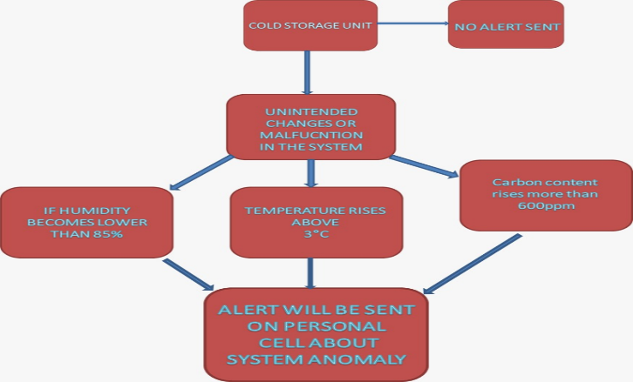
Figure 1. Diagram

IV -HARDWARE AND SOFTWARE TOOLS USED TO IMPLEMENT THE SYSTEM
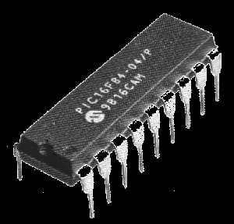  Figure 3: PIC | 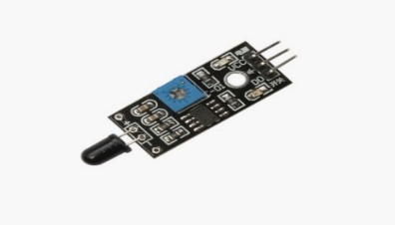  Figure 4: LDR sensor
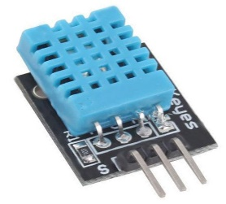  Figure 5: DHT 11 Sensor | 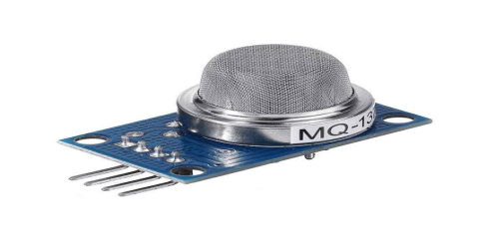  Figure 6: Soil moisture sensor
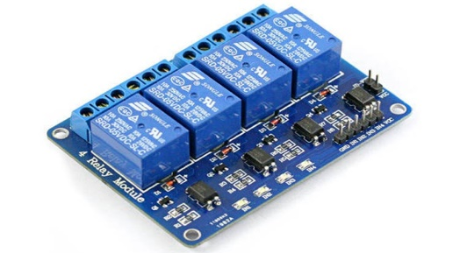  Figure 7: Relay module | 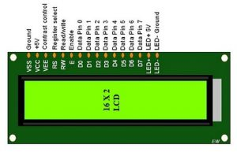  Figure 8: LCD Display (16×2)
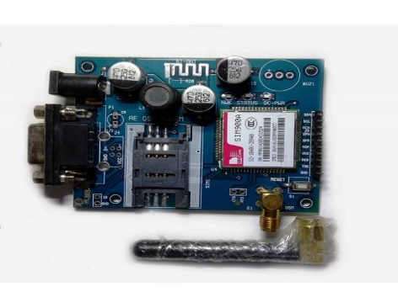
Figure 9: GSM module

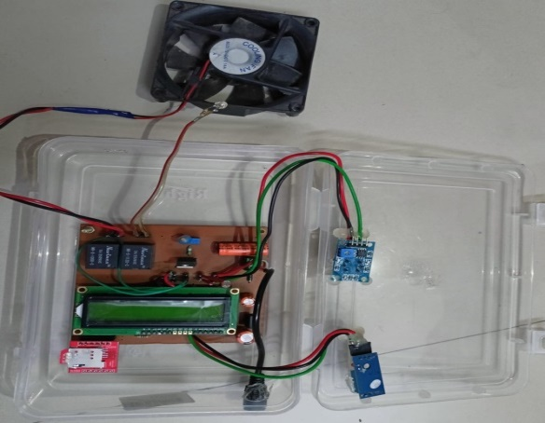
Figure 10: Prototype Design
V - RESULT

The device application allows users to access historical data collected by the monitoring system. They can analyse trends, compare different time periods, and make informed decisions based on the insights gained. This help optimize resource allocation, fine-tune control parameters, and improve overall cold storage management practices. Application present sensor data in a visually appealing and intuitive manner. Graphs, charts, and other visual representations help users quickly understand the greenhouse conditions and spot any patterns or anomalies. This aids in decision-making and troubleshooting.
The sensing and response unit receives the pre-set sensor values at the monitoring and control unit. Then these values were stored at the memory to maintain the environmental conditions of the cold storage accordingly. Four environmental conditions-maintained temperature, humidity, light and gas concentration in the cold storage. In the following, the associated response to the change of each parameter can be explored.

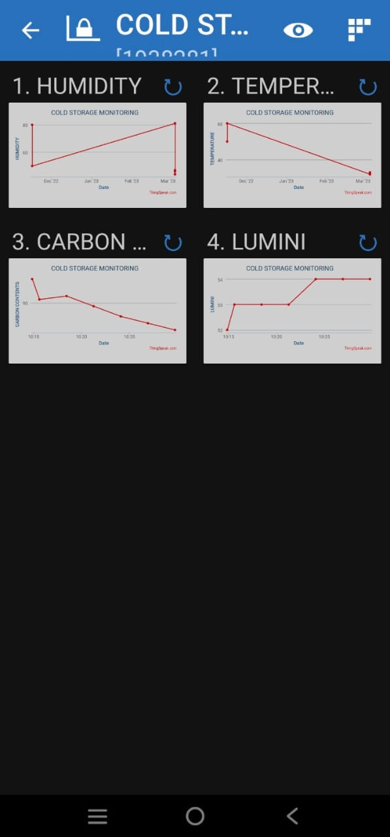

Figure 11: Temperature monitoring And Controlling

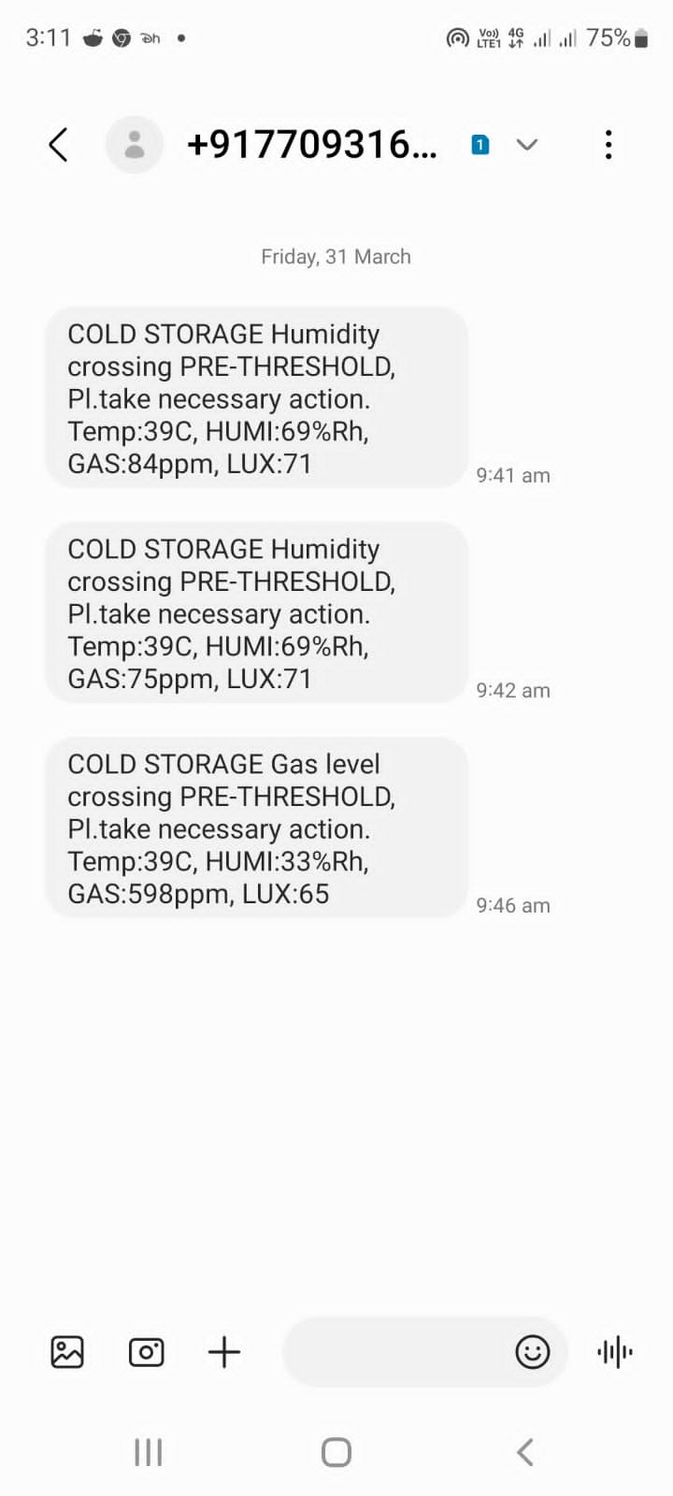
Figure 16: Massage Send Via GSM

VI - CONCLUSIONS
The model is developed in standard conditions for testing purposes. Real-time monitoring and notification systems have become essential tools for businesses and organizations in various fields. These systems provide real-time feedback and alerts, allowing businesses to identify and address issues quickly. While the implementation of these systems can be complex, the benefits they provide make them a worthwhile investment. As technology continues to advance, real-time monitoring and notification systems will become even more sophisticated, providing businesses with even greater insights and capabilities. Real-time monitoring and notification systems have many benefits, including improved efficiency, reduced downtime, and increased safety. These systems can provide businesses with real-time feedback on their operations, allowing them to identify issues and make informed decisions. The implementation of these systems can be complex, requiring the integration of various technologies and the development of customized software. However, once implemented, these systems can have a significant impact on businesses and organizations.

FUTURE SCOPE

Traditionally, existing approaches do not facilitate real time monitoring of cold storage environmental parameters excluding temperature and relative humidity. Moreover, there is no mechanism to intimate the personnel about real-time status of commodities in cold storage time by time. Henceforth, we have presented an intelligent real-time monitoring and notification system of cold storage that is based on an IoT-enabled approach and contributes to overcome the loss of perishable commodity in cold storage by automatic monitoring and notification regarding dangerous limits of environmental parameters such as temperature, relative humidity, concentration of CO2 and light intensity. On alarming or unsatisfactory status, a notification is also sent to personnel for timely necessary action. In our presented approach, we choose single commodity cold storage but in future we will choose a multi-commodity cold storage and will consider concentration of more gasses which will contribute to reducing the loss rate of FVs. We will also address imbalance dataset issues as in our case by using resampling techniques in future.

REFERENCES
- eyashree.K1 and C. G. , "monitor and control of
- environment for greenhouse using sensor
- networks," international Journal of Advanced
- Research in Electronics and Communication
- Engineering(IJARECE), vol. 5, p. 5, march 2016
- 2016.
- eyashree.K1 and C. G. , "monitor and control of
- environment for greenhouse using sensor
- networks," international Journal of Advanced
- Research in Electronics and Communication
- Engineering(IJARECE), vol. 5, p. 5, march 2016
- 2016. .
- R. Badia-Melis, L. Ruiz-Garcia, J. Garcia-Hierro, and J. Villalba, ‘‘Refrigerated fruit storage monitoring combining two different wireless sensing technologies: RFID and WSN,’’ Sensors, vol. 15, no. 3, pp. 4781–4795, Feb. 2015.

- J. Wang and H. Yue, ‘‘Food safety pre-warning system based on data mining for a sustainable food supply chain,’’ Food Control, vol. 73, pp. 223–229, Mar. 2017.

- J. Gustavsson, C. Cederberg, U. Sonesson, R. Van Otterdijk, and A. Meybeck, ‘‘Global food losses and food waste,’’ FAO, Rome, Italy, Tech. Rep., 2011. [Online]. Available: http://www.fao.org/3/mb060e/ mb060e.pdf

- WHO. Promoting Fruit and Vegetable Consumption Around the World. [Online]. Available: https://www.who.int/dietphysicalactivity/fruit/en/ index2.html

- Save Food Global Initiative on Food Loss and Waste Reduction, Food Agriculture. Org. United Nations, Rome, Italy, 2015, vol. 25, p. 2018. [Online]. Available: http://www.fao.org/3/ai4068e.pdf

- S. Noichinda, K. Bodhipadma, C. Mahamontri, T. Narongruk, and S. Ketsa, ‘‘Light during storage prevents loss of ascorbic acid, and increases glucose and fructose levels in Chinese kale (Brassica oleracea var. Alboglabra),’’ Postharvest Biol. Technol., vol. 44, no. 3, pp. 312–315, Jun. 2007.

- A. Rong, R. Akkerman, and M. Grunow, ‘‘An optimization approach for managing fresh food quality throughout the supply chain,’’ Int. J. Prod. Econ., vol. 131, no. 1, pp. 421–429, May 2011.

- E. Gogou, G. Katsaros, E. Derens, G. Alvarez, and P. S. Taoukis, ‘‘Cold chain database development and application as a tool for the cold chain management and food quality evaluation,’’ Int. J. Refrigeration, vol. 52, pp. 109–121, Apr. 2015.

- H. Q. Nguyen, B. Q. Ta, N. Hoivik, E. Halvorsen, and K. E. Aasmundtveit, ‘‘Carbon nanotube based gas sensor for expiration detection of perishable food,’’ in Proc. 13th IEEE Int. Conf. Nanotechnol. (IEEE-NANO), Aug. 2013

- M. Cantwell and T. Suslow, ‘‘Potato: Recommendations for maintaining postharvest quality,’’ Postharvest Center, Davis, CA, USA, Tech

