**Password Based Circuit Breaker Using PLC and SCADA**

**Prof.Rahul Adle1,Yash Shende 2, Nitikesh Bondare3, Mrunal Nyaykhor4,Shweta Gupta 5,Suman Sarkar 6,Megha Dongre7**

2,3,4,5,6,7*Students, Dept. of Electrical Engineering,*

*1Assistant Professor ,Dept. of Electrical Engineering*

*Priyadarshini College of Engineering, Nagpur, India, 440016*

***Abstract****- Password based circuit breaker control system is a system that access only specified password to control the circuit breaker. Here, there is also a provision of changing the password. The system is fully controlled by the PLC and SCADA system. A matrix keypad is interfaced with the PLC to enter a password and operate relays. The complete circuit is built with onboard power supply. The power supply consists of a SMPS. That converts 230 V AC into 24 V DC and supplies it to PLC. Programming device is used to program the PLC and set the password.*

***Keywords*- *Circuit breaker, Password, PLC, SCADA, Safety, Security.***

1. **INTRODUCTION**

Power System fault is defined as undesirable condition that occurs in the power system. The system is designed to control a circuit breaker by using a password for the safety of electric line man. Critical electrical accidents to line men are on the rise during electric line repair due to lack of communication and co-ordination between the maintenance worker and control room. This proposed system provides a solution that ensures safety of maintenance staff or line man. The line man has control of turning ON and OFF circuit breaker using a password. A matrix keypad is interfaced to the PLC to enter the password. The entered password is compared with the password stored in PLC Controller. System has control room for addition of new features also, as one PLC and SCADA can be used to collect data of various other

parameters related to the circuit breaker and transmission line.

For example digital counter for recording on/off of a circuit breaker which can be used to determine routine maintenance and life expectancy of circuit breaker. Time required for switching operation can be monitored to ensure the tripping mechanism is working properly.

* The main objective of this system is to develop a prototype of secured circuit breaker system to protect the linemen who are predisposed to fatal electrical accidents.
* Switching ON and OFF a circuit breaker by using a password.
* To design SCADA control and animation of the project.



**Figure (1):-** BlockDiagram of Password based Circuit breaker using PLC & SCADA.

1. **COMPONENTS**
2. **PLC:**

Programmable Logic Controller is an industrial computer control system that continuously monitors the state of input devices and makes decisions based upon a custom program to control the state of output devices. A PLC controller with 16 I/O ports and it works on 24V DC supply other requirement are as follows:

**Required Cables**

• HG9Z-XCM1A (Connects PC and HG2F/3F/4F)

• HG9Z-2C135A (Connects PLC and HG2F/3F/4F),

• 1761-CBL-PM02 (Connects PC and PLC)

**Required Software**

• Install Wind O/I-NV2 (programming software for HG2F/3F/4F).

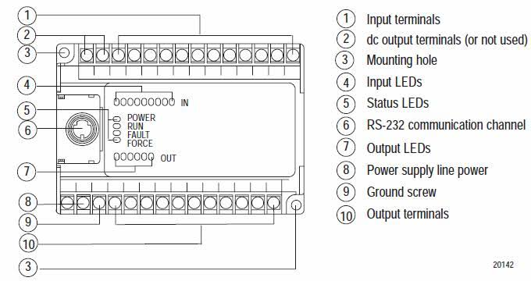

**Figure (2):-** Pin Diagram of PLC Controller.

**Function of each Pin:-**

1. Input terminals
2. DC output terminals(not used0
3. Mounting hole
4. Input LED’s
5. Status LED’s
6. RS-232 Communication Channel
7. Output LED’s
8. Power Supply line power
9. Ground screw
10. Output terminals
11. **Working:** The components that make PLC work can be divided into three core areas.

* The power supply and rack
* The central processing unit (CPU)
* The input/output section (I/O module)

The CPU is the brain of PLC. It consists of a microprocessor, memory chip and other integrated circuits to control logic, monitoring and communications. The CPU has different operating modes. In programming mode it accepts the downloaded logic from a computer. The CPU is then placed in run mode so that it can execute the program and operate the process. Since it is a dedicated controller it will only process this one program over and over again. One cycle through the program is called scan time and involves reading the inputs from the other modules, executing the logic based on these inputs and then updated the outputs accordingly. The scan time happens very quickly in range of milliseconds. The memory in the CPU stores the program while also holding the status of the I/O and providing a means to store values.

1. **Operating Cycle of PLC:-**

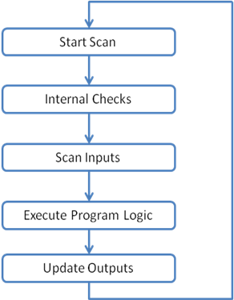

**Figure (3):-** Operating Cycle of PLC.

1. **I/O System:**

The I/O system provides the physical connection between the equipment and the PLC. Opening the doors on an I/O card reveals a terminal strip where the devices connect. Inputs can consist of digital or analog devices. A digital input card handles discrete devices which give a signal that is either on or off such as push buttons, limit switch, sensors or select switches. Output devices can also be of digital or analog types. Typical output signals can ranges from 0-10 V DC or 4-20 mA.

1. **SMPS:**

A switched-mode is an electronic circuit that converts power using switching devices that are turned on and off at high frequencies, and storage component such as inductors or capacitors to supply power when the switching device is in its non conducting state. In this system 230V AC to 24V, 1.5A DC SMPS is used. The power rating is 35W. It is used to regulate the DC output voltage from unregulated AC or DC input voltage.

1. **Working:**

The AC to DC converter SMPS has an AC input. It is converted into DC by rectification process using a rectifier and filter. This unregulated DC voltage is fed to the filter circuit. This is because around voltage peaks, the rectifier draws short current pulses having significantly high frequency energy which results in reduced power factor. A combination of the rectifier and filter is used for converting AC into DC and switching is done by using power MOSFET amplifier with which very high gain can be achieved. MOSFET transistor is low on resistance and can withstand high currents. Switching frequency is above 20 kHz.

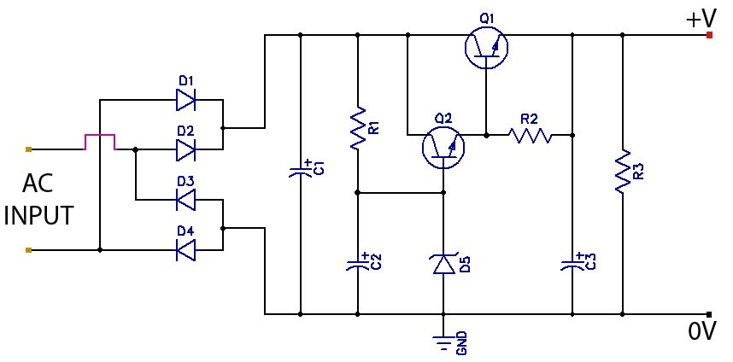

**Figure (4):-** Circuit Diagram 35W SMPS (230V AC- 24V, 1.5A DC)

1. **RELAY:**

Relay is an electromechanical switch composed of an electromagnet, an armature, a spring and a set of electrical contacts. The electromagnetic switch is operated by a small current that energize the coil and contacts are opened or closed. The relay resembles the circuit breaker. In practical relay will provide signal to the circuit breaker.

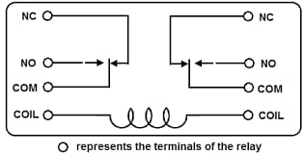

**Figure (5):-** Pin Diagram of 8 pin, DPDT relay.

1. **Functions of pins:**

**Coil:** This is the coil terminal. These are the terminals where you are applying voltage to in order to give power to the coils (which then will close the switch). Polarity does not matter. One side gets positive voltage and the other side gets negative voltage. It doesn’t matter which order. Polarity only matters if a diode is used.

**NO:** This is Normally Open switch. This is the terminal where you connect the device that you want the relay to power, when the relay is powered, meaning when the COIL receives sufficient voltage. The device connected to NO will be off when the relay has no power and will turn on when the relay receives power.

**NC:** This is the normally closed switch. This the terminal where you connect the device that you want powered when the relay receives no power. The device connected to NC will be on when the relay has no power and will turn off when the relay receives power.

**COM:** This is the common of the relay. If the relay is powered and the switch is closed, COM and NO have continuity. If the relay isn’t powered and the switch is open, COM and NC have continuity. This is the terminal of the relay where you connect the first part of your circuit.

1. **Working:**

The relay is rated for 24 V hence it requires 24 V to power ON. It may work with slightly lesser voltage than 24 V. Even after interchanging the position of positive and negative terminal it turn ON when power is supplied. The COM terminals of the relay get connected to the first part of the circuit. The NC terminals of the relay get power even when the relay is not powered. The NO terminals of the relay get power only when the relay is powered. When relay receives 24 V the relay snaps from open to close.

1. **SCADA:**

A SCADA system is a common industrial process automation system which is used to collect data from instruments and sensors located at remote sites and to transmit data at a central site for either monitoring or and programs are stored in the main memory. The controlling purpose. The collected data from sensors and instruments is usually viewed on one or more SCADA host computers that are located at the central site. Based on the information received from the remote stations, automated or operator driven supervisory commands can be pushed to remote. Station control devices, which are often referred to as field devices. The I/O SCADA programming is used to change the supervisory software. In the basic SCADA system, all the data more advanced version of SCADA has additional secondary memories in the form of magnetic disc units.

SCADA is a common process automation system which is used to gather data from sensors and instruments located to remote sites and to transmit data at a central site for either controller monitoring process. A collection of standard and/or custom software .Sometimes called Human Machine Interface (HMI) software or Man Machine Interface (MMI) software systems used to provide the SCADA central host and operator terminal application support the communications system, and monitor and control remotely located field data interface devices to SCADA system. Network connection acts as Communication Bridge for the elements in the SCADA architecture. Manual data input and sensor data inputs are interfaced with programming device. Feedback from sensors is essential for monitoring parameters of the system. Internet Protocols (IP) are used for communication between the master station and communication equipment. The facts that many networked SCADA systems are accessible from internet; the systems are potentially vulnerable to remote cyber-attacks. Due to usage of standard protocols security can be improved. However Local Area Network (LAN) connection is used in the proposed system.



**Figure (6):-** SCADA Architecture Block Diagram.

1. **Push Button:**

Push Button Switches are used to form a keypad. Push Button switch is a push button has its default state normally opened (NO). It means that the switch will make electrical contact when it is pressed down. The switch is not latching type of switch meaning it does not hold its position to close after pressing down. Single Pole Single Throw (SPST) switch is a basic ON/OFF switch that makes or breaks the connection between two terminals. The power supply to a circuit is switched by SPST switch. When the switch is open or OFF there is no current flow in the circuit. These red colored switches are rated for 4A, 24 V AC having electrical life of 50,000 cycles.

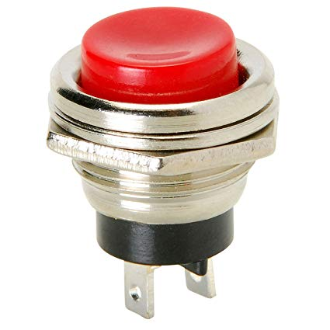

**Figure (7):-** Push Button Switch SPST.

1. **BUZZER:**

A buzzer or beeper is an audio signaling device, which may be mechanical, electromagnetic or photoelectric (piezo for short). Typical uses of buzzers and beepers include alarm devices, timers and confirmation of user input such as a mouse click or key stroke. This piezoelectric buzzer is 23mm in diameter and has 30mm spaced mount holes. Supplied with a 100mm lead it is designed for 3-20 V, it produces 85 dB sounds up to 30 cm. Works up to frequency of 3.3 KHz. The current requirement is less than 1.5 mA. Normal operating temperature range is from - $20°$ C to + $60°$ C. Piezoelectric buzzers or piezoelectric buzzers as they are sometimes called were invented by Japanese manufacturers. A piezoelectric element may be driven by an oscillating electronic circuit or other audio signal source, driven with piezoelectric audio amplifier. Sounds commonly used to indicate that a button has been pressed are a click or a beep. A piezoelectric buzzer also depends on acoustic cavity resonance or Helmholtz resonance to produce an audible beep.

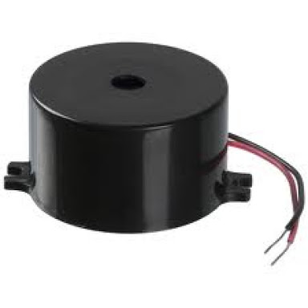

**Figure (8):-** Piezoelectric Buzzer 3-20 V <15mA, 3.3 KHz, 85 dB.

1. **WORKING**

The working of this system is very simple; for PLC based control the operator has to enter correct password in the keypad connected to PLC. It will provide a signal to the relay, hence circuit breaker is tripped. For indication of above process indicator lamp is used in system. Lamp is off. The circuit breaker is tripped it will not close unless another password is entered in the keypad. For remote control SCADA based operation is available. A user ID and password is required to login in the system and then operate the circuit breaker. SCADA based control is not possible when PLC tripped the circuit breaker because it means the line is under maintenance and only one having the password for PLC based control can close the circuit breaker. The SCADA based control is used when there is no maintenance work on the line. The password is provided to the lineman who is scheduled for maintenance. The user ID and password for logging into SCADA system is for higher authorities. The password can be changed periodically to add extra safety.

In the project a three phase line is operated using one password for turning ON and OFF the circuit breakers of all the three phases. Three relays resemble the three circuit breakers for each phase. Three indicator lamps are used for indicating the output. The password must be entered in correct sequence otherwise the PLC will trigger on the alarm. If alarm is triggered the operator has to reset system and enter password again in the correct sequence as stored in PLC database.

**Ladder Logic:** Ladder logic is a programming language that creates and represents a program through ladder diagrams that are based on circuit diagrams. It is mainly used in developing programs or software for PLC’s. The complete ladder program looks like a ladder but it is an electrical circuit. The left and right rails indicate the positive and ground of a power supply. The rungs represent the wiring between the different components which in the case of PLC are all in the virtual world of the CPU. Screenshots of program shown below are the ladder logic for the proposed system.

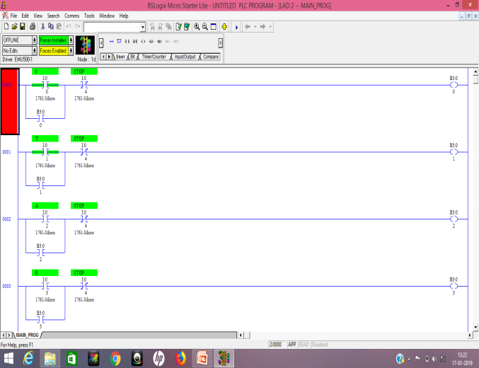

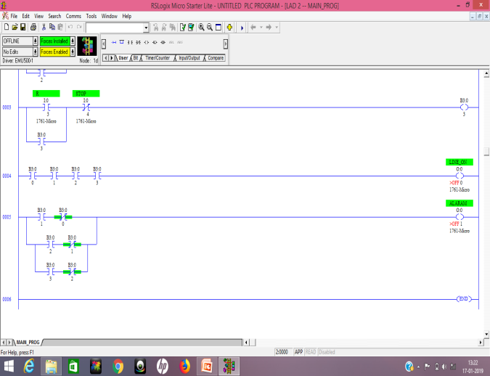

**Figure (9):-** Screenshots of Ladder program.

**Algorithm:**

Step 1: Start.

Step 2: Initialize the system.

Step 3: Read the input or password from keypad.

Step 4: If password is correct then Breaker is ON/OFF.

Step 5: If the password is wrong then go to step no.3.

Step 6: Stop.

**Flow Chart:**

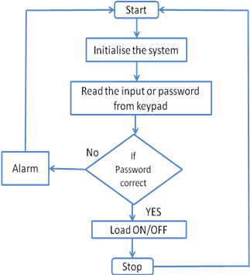

**Figure (10):-** Flow Chart.

1. **Applications**
2. Used in electrical substations and switchyards near power plants where high voltage circuit breakers are situated to ensure line man safety.
3. Keep track of Circuit breaker on/off after commissioning for routine maintenance of breaker to ensure long life.
4. It can be used as Password based electrical machine control or load control and monitoring system.
5. **Advantages:**
6. Prevent electrical accidents to line man.
7. Monitoring and real time supervisory control over circuit breaker is possible.
8. No requirement of analog counter to record on/off of circuit breaker after commissioning.
9. System is simple and easy to design and implement as it requires commonly available components.
10. Provides scope for further advancement.
11. **Future Scope:**

PLC and SCADA used in this proposed system provides scope for future advancement hence the system is not limited to circuit breaker control but monitoring and acquiring data of various parameters related to circuit breaker and the line is possible. Sensors can be added in PLC input to record tripping and closing time of circuit breaker for each operation. The collected data can be used to analyze the operating time of circuit breaker tripping mechanism within specified range, and estimate maintenance time. Various line parameters can be monitored by adding sensory devices in the system to collect useful data for research and study.

**CONCLUSIONS**

Password based circuit breaker control to ensure electric line man’s Safety the PLC & SCADA. This proposed system provides automation and real time supervisory control over circuit breaker system.

**REFERENCES**

1. *J.Veena, G.Srivani, Afreen, M. Sunil Kumar, J.Santosh, KB V.S.R Subhramanyam, “Electric Lineman Protection Using User Changeable Password Based Circuit Breaker.” International Journal of Current Engineering & Scientific Research(IJCESR), Vol.2, no.5,pp.1384-1386,Jan-Feb 2015.*
2. *Mr. Tarun Naruka, Vivek Kumar Sharma, Vikram Shingh, Sumit Vishnu Sharma, “Password Based Circuit Breaker.” Imperial Journal of Interdisciplinary Research(IJIR), Vol.3, no.4,pp.2454-1362,March-April 2017.*
3. *Raj Lakshmi, Ankit Pandey, “SCADA Based Online Circuit Breaker Monitering System.” Journal of Electrical & Electronics Engineering, Volume-5, Issue-3, March-April, 2013.*
4. *Narendra Khandelwal, Tanuj Manglani, Ganpat Singh,Amit Kumar, Dilip Khatri, “Automated load distribution with password protected circuit breakers” International Journal of Recent Research and Review, vol.8, no.1,pp.16-17, March 2015.*
5. *M. Kezunovic, Z. Ren, G. Latisko, D. R. Sevcik, J. Lucey, W. Cook, E. Koch, “Automated Monitoring and Analysis of Circuit Breaker Operation,” IEEE Transactions on Power Delivery, Vol.20, no. 3, pp.1910-1918, July 2005*
6. *Brent L. Carper, Principal Engineer, “The X, Y and Z of Circuit Breaker Control”, 34th Annual Hands-On Relay School, Vol.13, no.10, pp. 7806-7810, March 2017.*
7. *Gautam yash pal, “Password based circuit breaker with GSM module”. International journal of advance research, ideas and innovations in technology, Vol.3, no.3, pp.2454-1329, April 2017.*
8. *Pramod M. Murari, Mahabal V. Kinnerkar, Prashant S. Koppa, et. Al., “Electric Line Man Safety with Password Based Circuit Breaker and Intimation of HT Wire Sag using GSM”. IJSDR, Vol.2, no.7, pp.2455-2631, July 2017.*
9. *Jay Kumar et al., “Password Based Circuit Breaker”. International Journal of Recent Research Aspects, Vol. 3, no. 1, pp. 80-85, March 2016.*

[10] *Mane Kirti , Attar Arifa , Dandile Aishwarya, Et al.,“Password Based Circuit Breaker”. International Journal for Research in Applied Science & Engineering Technology (IJRASET), Vol.6, no.4, pp.2321-9658, April 2018*