Survey Paper on Online Android Attendance Application

Mekshyam Z. Lanjewar, Sham B. Mehar, Puja K. Chavhan
CSE Department, WCEM, Nagpur, India
Prof. Roshni Ali
Assistant Professor, CSE Department, WCEM, Nagpur, India

Abstract – Previously it was very hectic and tedious job to enter & maintain attendance of student manually. After the entry of application software it somewhat became efficient to manage attendance on computer system. Now a day with the use of android phone every work can be optimized and modified. Our aim is to optimize the work of faculty member through our application. So we are developing online attendance management application. This is installed in android mobile phone and we provide user id and password for the security purpose. Online attendance management app provides many benefits to colleges and organizations.

Keywords- Android studio,Smart phones, Firebase Database.
1. INTRODUCTION
“Online Attendance Management Application” is developed for each day student attendance in schools, colleges and institutes for maintaining the attendance of the student. If facilitates to access the attendance information of a particular student in a particular class. Here the staffs, who are handling the subjects, will be responsible to mark the attendance of the students. Only Faculty has to maintain proper record for the attendance.
Each staff will be given with a separate username and password based on the subject they handle. An accurate report based on the student attendance is generated here. This application will also help in evaluating attendance eligibility criteria of a student. All data is exhaustively reviewed and validated on the server before actual record modification occurs. All data is stored securely on SQL servers managed by the college Administrator. This system provides a simple interface for the maintenance of student information.
The manual attendance record system is not efficient and requires more time to arrange record and to calculate the average out attendance of each student. Hence there is a requirement of a system that will solve the problem of student record arrangement and student average attendance calculation.
The proposed application should store the absent and present student’s attendance details in electronic format so that management of attendance becomes easy.
This application is developed for daily student attendance in institutes. It can also be useful in an organization or company at a certain limit not the whole application.
In the following sections, we will proceed by havingoverview on Online Attendance Management Application and their classifying areas inSection 2. Section 3 explain the modules details, Section 4 explains the Concepts of system architecture and workflow, Section 5 gives the characteristics of proposed system . Section 6 mentions the application of proposed system, Section 7 gives the advantages of proposed system and finally we sum up with conclusionin Section 8.
2. LITERATURE REVIEW

In[7] The purpose of developing attendancemanagement system is to computerized the tradition way oftaking attendance. Another purpose for developing thissoftware is to generate the report automatically at the end ofthe session or in the between of the session.
In[2] The design and implementation of the system is to provide service in institute and colleges. The system is to provide comprehensive student information system and user interface is to replace the current paper records. College Staff uploads attendance, results and college notifications through a secure, online interface using android devices. All data is thoroughly reviewed and validated on the server before actual record alteration occurs. The system plans for student user interface, allowing students to access tips and tricks as provided by their seniors. All data is stored securely on SQL servers managed by the college Administrator .
In[4] The rapid progress inmobile technology has created a new area which is knownas mobile learning. Mobile learning is the next generationof e-learning that leads attractive way ofknowledgedelivery especially used in teaching and learning process. With development of this Android application the student preferred to use mobile devices as technology supportededucational tool. This system is designed because notesdictation in the class is difficult considering semester duration, student might miss the exam and importantnotice displayed due to unawareness, chances of falsemarking of attendance is more due to more paper workdone manual attendance entry, evaluation and reportgeneration is tedious and time consuming job.
In[5] In this paper basic problem of student attendance management is defined which is traditionally taken manually by faculty. One alternative to make student attendance system automatic is provided by Computer Vision. In this paper we review the various computerized system which is being developed by using different techniques. Based on this review a new approach for student attendance recording and management is proposed to be used for various colleges or academic institutes.
In[1] Thismobile application will require connecting to the internet through Wi-Fi(Wireless Fidelity) technology or through GPRS(General Packet Radio Service).Lecturers will first have to sign up for this and then they can take attendance any time they wish by first logging in with the help of a smartphone to the server. After attendance has been taken lecturer will send it over to sever via GPRS.The lecturers can also enroll new students, delete information about a particular student, modify some information etc.
3. MODULE DETAILS
- Login form:
This Form is made for security purpose. So Authenticated User only Access in to this application. There aretwo Type of persons can enter in the projectAdministrator and User.
- Add information form:
This form we provide for student registration only and givesoption to fillname of the student and password.
- Staff Module:
This module is designed for staff,which use mobile phone to take attendance, upload attendance result. The entered admin details are encrypted and sent to server for verification. Only after successful authentication the operations are performed.
- AttendanceModule:
Thepurposeof Attendance Entry Module is to enter the attendance using android cell phone. In this module Lecturer takes the attendance using the android cell phone. Lecturers select the branch, semester and year. After this session he enters in to attendance page. Here staff makes a mark on the absentees. Lecturer are only allowed to take attendance during their lecture time.
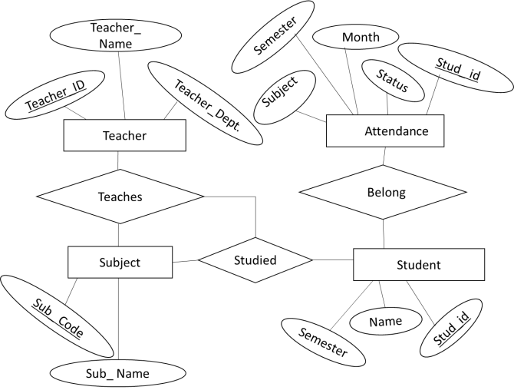
Fig1. E-R diagram for Online Attendance Management Application
4. SYSTEM ARCHITECHTURE AND WORKFLOW
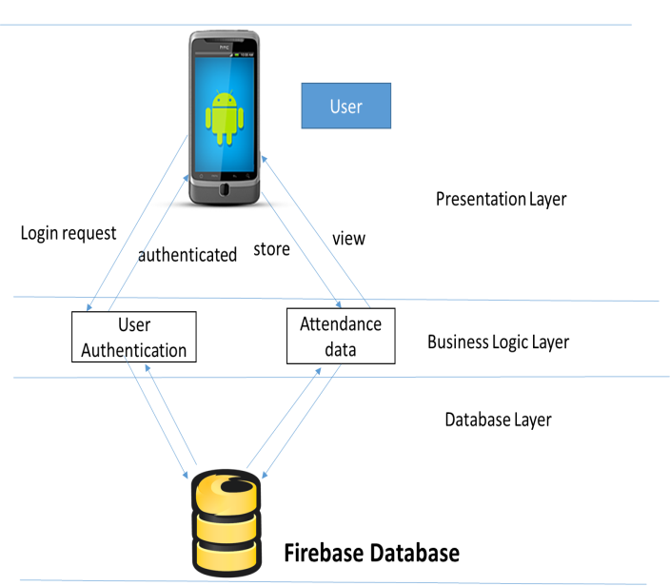
Fig2. System architecture of Online Attendance Management Application

i. Admin Registration
The first step in this application is to get theteaching faculty to register.The respective person will then provide his or her phone’s e-mail id and password for registration. An OTP would be then sent via e-mail address on the phone by the admin.
ii. Admin Login
After registering the admin is allowed to log in. He or she can now view admin homepage where there are options to take attendance, upload results.
iii. Take Attendance
Here, system will validate admin to check whether admin is applicable to take attendance for any subject which he/she selected from the application after validation is success.If admin is legitimate to take attendance and applyingthe operation at correct lecture time, now he can take attendance.
iv. Upload Result
Admin can upload student’s attendance through application. The same authentication will be performed by system as Take attendance module.

v. Upload Final
Attendance sheet A report is generated which has the student’s name, roll no., his or her attendance. This module categorized student according to their attendance.
5. CHARACTERISTIC OF THEPROPOSED SYSTEM
- User Friendly: - The online attendance application is user friendly because the retrieval and storing of data is fast and data is maintained efficiently. Moreover the graphical user interface is provided in the proposed application, which provides user to deal with the system very easily.
- Reports are easily generated: - Reports can be easily generated in the proposed application so user can generate the report as per the requirement (monthly) as well as in the middle of the session. User can give the notice to the students so he/she become regular.
- Reduce paper work:-All the data is fetch into the computer immediately and reports can be generated through computers.Moreover work becomes very easy because there is no need to keep data on papers.

6. APPLICATION:
- It used in schools and colleges
- It used in organizations.

7. ADVANTAGES:
- It is relatively fast approach to enter attendance.
- It is highly reliable.
- It has appropriate result .
- Best user Interface can be experienced.

8. CONCLUSION

The“OnlineAttendance ManagementApp” gives reduced paper work and saves time to generate accurate results from student’s attendance.Itprovide security by using individual login id and password. This application is very useful for schools and colleges.
REFERENCES
[1]Freya. J. Vora, Pooja. L. Yadav, Rhea. P. Rai, Nikita. M. Yadav , Android Based Mobile Attendance System ”,International Journal of Advanced Research inComputerScience and Software EngineeringVolume 6, Issue 2, February 2016.
[2] Vishwakarma R Ganesh [1],“Android College Management System”,International Journal of Advanced ResearchInComputer Engineering & Technology (IJARCET) Volume 5, Issue 4, April 2016.
- Shermin Sultana1, Asma Enayet1 and IshratJahan Mouri1, “A Smart, Location Based Time and Attendance Tracking Systemusing Android Application”, International Journal of Computer Science, Engineering and Information Technology (IJCSEIT), Vol. 5,No.1, February 2015
[4]Rakhi Joshi1, V. V. Shete2, S. B. Somani3, “Android Based Smart Learning and AttendanceManagement System”, International Journal of Advanced Research in Computer and Communication Engineering Vol. 4, Issue 6, June 2015
[5] Unnati A. Patel, Dr.SwaminarayanPriyaR.“Development of a Student Attendance Management System Using RFID and Face Recognition: A Review”, International Journal of Advance Research inComputer Science and Management Studies,Volume 2, Issue 8, August 2014.
[6] “A Proposed Android Based Mobile Application to Monitor Works at Remote Sites”, byS. Sivasubramanian1, S. Sivasankaran2,S. ThiruNirai Senthil3,IJSR International Journal of Science and Research ISSN (Online): 2319-7064 Volume 3 Issue 2, February 2014.
[7] Saurabh Kumar Jain,Uma Joshi, BhupeshKumar Sharma, “Attendance ManagementSystem”International School of Informaticsand Management Jaipur.
[8] Kumbhar, A. A., Wanjara, K. S., Trivedi, D. H., Khairatkar, A. U., & Sharma, D. (2014). “AutomatedAttendance Monitoring System using Android Platform.”, IJCET, Vol. 4, No. 2, pp1096-1099.
[9]S.R.Bharamagoudar, Geeta R.B., S.G.Totad “Web BasedStudent Information Management System”, International Journal of Advanced Research in Computer and Communication Engineering - June 2013, ISSN : 2319-5940.
[10] Kadry, S., &Smaili, M. (2013). ”Wireless attendance management system based on iris recognition”,Scientific Research and essays, 5(12), 1428-1435.
[11] “Mobile Phone Based Attendance System”, by Shraddha S.Chawhan1, Mangesh P. Girhale2, Gunjan Mankar3, IOSRJournal of Computer Engineering (IOSR-JCE) e-ISSN:2278-0661, p- ISSN: 2278-8727Volume 10, Issue 3 (Mar. -Apr. 2013), PP 48-50 www.iosrjournals.org.
[12] Shoewu, O. and O.A. Idowu (2012), “Development of Attendance Management System usingBiometrics”, Pacific Journal of Science and Technology, 13(1):300-307.
[13]M. K. P. Basheer and C. V. Raghu, “Fingerprint attendance system for classroom needs,” in Proc. India Conference (INDICON), 2012 Annual IEEE, pp. 433-438, 7-9 Dec. 2012.
[14] Mrs.DhanashreeAmit Gupta TeerthankerMahaveerUniversity, “Student AttendanceManagement”, Internationaljournalofscientific & engineering research volume 2, issue 11, November 2011 ISSN 2229-5518 IJSER © 2011 http://www .ijser.org
[15] “Component-Based Software Engineering” byIan Gorton,, George T. Heineman, IvicaCrnković, Heinz W. Schmidt, Judith A. Stafford, Clemens Szyperski, Kurt Wallnau9th International Symposium, CBSE 2006, Västerås, Sweden, June 29 - July 1, 2006. Proceedings Volume 40632006ISBN: 978-3-540-35628-8
[16] “Portable Lab: Implementation of Mobile remote laboratoryfor Android platform”, an IEEE paper by Macro AndreGuerra, Claudia Mariline Francisco, RuiNeves Madeira,Portugal.
[17] “Remote Access of Building Management System onWindows Mobile Devices”- an IEEE paperbyOndrejKrejcar, Dept. of measurement and control,VSB Technical Institute of Ostrava, Czech Republic.

