Hybrid Solar And Wind Power Generation For Street Lighting.
Rushabh Durge, Yugal Shende, Akash Das, Deeksha Gedam, Kajal Pillewan

Students, Dept. of Electrical Engineering,
Priyadarshini College of Engineering, Nagpur, India, 440016

Abstract- Renewable energy systems are likely to become widespread in the future due to adverse environmental impacts and escalation in energy costs linked with the exercise of established energy sources. Solar and wind energy resources are alternative to each other which will have the actual potential to satisfy the load dilemma to some degree.Study of the components required in the hybrid power generation. Hybrid power system provide reduction in complexity, maintain lowest unit cost, energy fluctuations due to DPSP (deficiency of power supply probability), with the help of proper design, advanced fast response, good optimization and control feasibility. This paper provides review of hybrid solar and wind power system. The technical feasibility of PV wind hybrid system in given range of load demand was evaluated and economical evaluation of standalone PV, standalone wind and PV wind hybrid system have been developed using the model.

Keywords - Hybrid, Renewable, Less complexity, Economical, Efficient

INTRODUCTION:
The global search and the rise in the cost of conventional fossil fuel is making supply-demand of electricity product almost impossible especially in some remote areas. Generators which are often used as an alternative to conventional power supply systems are known to be run only during certain hours of the day, and the cost of fuelling them is increasingly becoming difficult if they are to be used for commercial purposes.
There is a growing awareness that renewable energy such as photovoltaic system and Wind power have an important role to play in order to save the situation.
The hunger of electricity developed by various areas across the world has been simulated by using renewable way thereby great variety of grid power supply. About 30,000 wind turbines and 1, 00,000 off-grid solar PV panels are installed all over the world. The technical feasibility of PV wind hybrid system in given range of load demand was evaluated and economical evaluation of standalone PV, standalone wind and PV wind hybrid system have been developed using the model. It offers generation of power in rural areas. Hybrid model with proper assembly is keen interest for recent years.
Solar Power
The process of converting sun energy into electricity which can be done by following two ways
1) By using photovoltaic (PV)
2) By using concentrated solar power i.e. focusing at intensity of sun thereby using lenses, mirrors and tracking systems.
Solar power systems mainly consist of solar panel made up of PV cells (semiconductors) which emits electrons on absorption of heat and converts solar energy to electrical energy, batteries which store the power generated. The movement of electron produces the electric current.

Wind Power
Wind power is the use of air flow through wind turbines to mechanically power generators for electricity where speed and direction of wind is important factor. Wind power gives variable power which is very consistent from year to year but which has significant variation over shorter time scales. It is therefore used in conjunction with other electric power sources to give a reliable supply. Wind farms consists of individual turbines connected to electric power transmission network which produces plentiful, renewable, widely distributed, clean, inexpensive.

Hybrid Energy System
Hybrid energy system is made up of combination of two or more energy resources such as sources at a time like wind, solar, biomass, etc. Wind and solar hybrid combination is concerned to be best module because it is abundant and environmental friendly. Also the stand alone system of this combination has disadvantages that wind cannot floe continuously and solar radiation is present approx. 8to10hours a day. Thus this combination is hybridized with energy storing batteries. Wind speeds are low in the summer when the sun shines brightest and longest. The wind is strong in the winter when less sunlight is available. Beacause the peak operating time for wind and solar system occur atdifferent times of the day and year, hybrid system are more likely to produce power when you need it.
They also offer power supply solutions for remote areas, not accessible by the grid supply. Today, around 30,000 wind turbines and more than 1, 00,000off-grid Solar PV systems are installed all over the world. Hybrid systems can address limitations in terms of –
1. Fuel Flexibility
2. Efficiency
3. Reliability
4. Emissions
5. Economical

HARDWARE IMPLEMENTATION:
- COMPONENTS AND RATINGS:
The various components used in development of hybrid solar and wind power generation system one listed in table.
Sr. No. | Name of Components | Specifications
1. | Solar Panel | - Wattage (W) : 10  - Voltage at Max Power, Vmp (V) : 16.4  - Current at Max Power, Imp (A) : 0.610 A  - Open Circuit Voltage, Voc (V) : 21.0 V  - Short Circuit Current, Isc (A) : 0.700 A
2. | Dynamo | - 1000 rpm (maximum rotations)  - Maximum voltage noted :19.7 V  - Current noted : 1.3 A
3. | Microcontroller | - ATmega16 is an 8-bit high performance microcontroller from the Atmel's Mega AVR family. Atmega16 is a 40 pin microcontroller based on enhanced RISC (Reduced Instruction Set Computing) architecture with 131 powerful instructions
4. | Battery | - Nominal voltage : 12 V  - Rated Cap : 1.3 AH /20 HR  - Cycle use : 14.4-15.0V  - Stand by use : 13.5-13.8 V  - Initial current : less than 0.39 V
5. | Relay | - We have  used a SPDT (single pole double throne) relay in this project.  - Trips the circuit when battery is charged or under charged.
6. | Capacitors | - Both ceramic and electrolytic capacitors are used, for the filteration of input.
7. | Voltage sensor | - Senses voltage from battery.  - And sends signal to the microprocessor of over charing.
8. | LED display | - 16*2 mm display which shows the reading of voltage on screen.
9. | Diode | - To avoid reverse current from battery to solar panel or dynamo.
10. | LED strip (126 LEDs) | - Shows output.  - 12 V output voltage.
- HARDWARE ARRANGEMENT:
Schematic arrangement of the components used for hyrid system is as shown in figure.1.
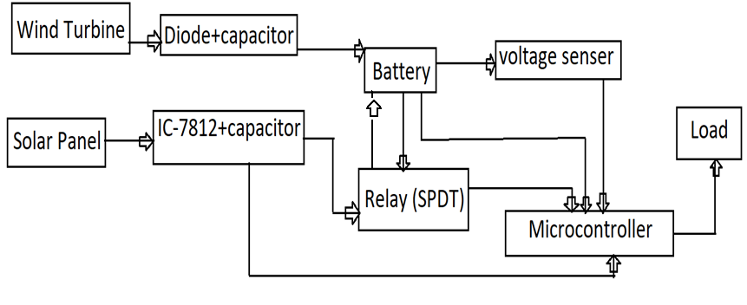
Fig.1. Schematic Diagram

WORKING:

Fig. shows circuit diagram for Hybrid solar and wind power generation. The proposed system derives power from sunlight through photo-voltaic cells. Hence, the system cannot depend on availability of supply.
We are getting solar energy and wind energy in the form of electric pulses .The supply will then pass through a protection device to avoid the reverse current.Then that current /voltage will charge the battery directly.
The voltage sensor will sense the over current and signals the microcontroller the incoming voltage. The SPDT relay which is connected to the solar panel will trip the circuit when ever over curret occurs.
Then the battery isconnected to the microcontroller using a input jack and following it a on/off switch is connected which will turn on or off the assembly.
The voltage then goes through capacitors nd resistors which will filter the AC pulses in it.
The ground of whole assembly is a common ground.The LED strip which is connected as a load will glow and give a output of 12 or approximate of 12 V.

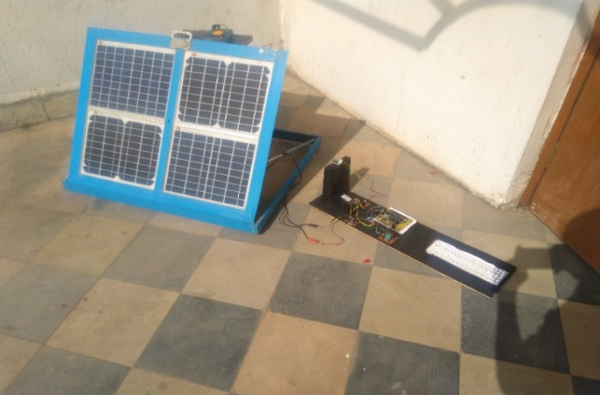

Fig 2. Picture representation
ADVANTAGES
1) Design for easy to operate, servicing and maintenance where required.
2) Most Eco-friendly & clean source of power.
3) No pollution and no recurring fuel costs, highly reliable and consistent power supply.
4) Long life span for SPV modules & Modular design.
5) Very few moving parts negligible maintenance required.
6) Increases public safety and aids in providing a safe working environment in areas where mains power is risky.
7) Low Height required.

DISADVANTAGES
1) The effect of large scale wind farms on the climate is unknown.
2) At night, we can’t use solar energy.

CONCLUSION

This project is very beneficial and economical as both solar and wind energies are used. This project can be installed on highways as there will be a continuous availability of wind as the vehicles will pass from both sides of road and the turbine will rotate. And in India there is a ample amount of solar energy available which can be used for this purpose.

REFRENCES:

- I.A.Adejumobi, S.G.Oyagbinrin, F.G.Akinboro & M.B.Olajid, “ Hybrid wind and solar power: an essential for information communication technology infrastructure & people in rural communities”, Electrical & electronics engineering, university of agriculture, Abeokuta,Nigeria, Vol 9, issue1, oct 2011

- Pijush Kanti Bhattacharjee, “Solar-rains-wind-lightning energy source power generation system”, International Journal of Computer and Electrical Engineering, Vol. 2, No. 2, April 2010

- Zhang Hua-wei, Li Nan, “study on the solar and wind hybrid control system”, International Conference on Control Engineering and Communication Technology, vol 1, 2012

- Karim Mousa, Hamzah AlZuAli Diaba, “Design of a Hybrid Solar-Wind Power Plant Using Optimization”, Research gate analysis, vol 4, may 2010

- Bharat Raj Singh,Bal Krishna Dubey, “Solar wind hybrid power generation”, International Research Journal of Engineering and Technology (IRJET), Vol 5, issue 1, Jan 2018

