Automation in Food Industry using Bluetooth Control Robotic System

Yogesh M.Motey Sudha Rani Sharddha Darne
(Electronics & Tele.Dept.) (Electronics Dept.) (Electronics Dept.)
GHRIET, Nagpur GHRIET, Nagpur GHRIET, Nagpur
Apoorva Deshmukh Priti Meshram
(Electronics Dept.) (Electronics Dept.)
GHRIET, Nagpur GHRIET, Nagpur

Abstract—The aim is to developed a pick and drop robot in the small scale food industry, it is designed to avoid the pressure on the human work in order to meet the diverse and challenging needs for the food industry .The digital and control system technology have a tremendous impact on robots which leads to automation in industries. Exploit the use of software and hardware tools, for designing the complex system it should have strong integration but it is not need as compare to earlier. Therefore, the main strategy of this paper is to implement the microcontroller based on the relied higher performance robotic system for small scale food industry. In our work at the transmitter end commands are sent to the receiver to control the movement of the robots whether to move forward or backward, left or right. Bluetooth device is connected to the microcontroller to drive DC motors via motor driver for important operations. The robot is having ability to picking the unbaked biscuits tray and placed them to furnace, then picks the baked tray from the furnace efficiently. Favorable gripper is used for picking and dropping the tray.

Keywords — Robotics, microcontroller, Bluetooth device, drivers, automation.

INTRODUCTION:-

Robots are indispensible in the food industries and defined as a programmable self-controlling for electronics, mechanical and electrical units. More importantly, a machine functions as a living agent.as robots evolved their will becoming the more versatile character, emulating the human work and switch jobs task quickly. Robots are specially made to get desire output unlike human; they never get tired of doing their work. They can work under any environment like physical which is so dangerous to work and in airless conditions and the important thing is that they never get tired of repetitions and never distracted from the task. As the human work for several hours got sick and exhausted easily but the robots powerful and reliable for any kind of temperature it may be. Another useful of this research project is leads to low cost as it ones implemented it can repeatedly work without extra cost. The robot is nothing but a completely independent and intelligent machine. In this robot mobilized power supply is used. Here, we have design a robot using microcontroller .The main purpose of micro controller based robot is to propose a design which introduces the idea of automation in small scale food industries mainly for the biscuit industry.

A robot can include following components;
a) Effectors - arms, legs, hands, feet etc.
b)Sensors - sense the parts and can detect objects and converts the object`s information into symbols that computer system can understand.
c) Computer – the main part which is a brain which controls the instructions to control the robotic system.
d) Equipment -this includes tools and mechanical fixtures.
e) Characteristics- that makes robot different from regular machinery are that robots usually function by themselves, and are sensitive to their environment conditions, adaptation to variations in the environment or errors and often have the ability to try different methods to accomplish a task [2].the robotic which is worked in this project are flexible and the manufacturing is also easy. They can operate in structural environments and perform single highly repetitive tasks under preprogrammed control [14].The robot is having ability to picking the unbaked biscuits tray and placed them to furnace, then picks the baked tray from the furnace .for picking and dropped it on the table .some reasons for installing the robotic system are as follows:

1) Increased flexibility

2) Save Manual work and Reduce wastage

3) Can do repetitive task

4) Work in hostile environment

5) Improved the quality and efficiency.

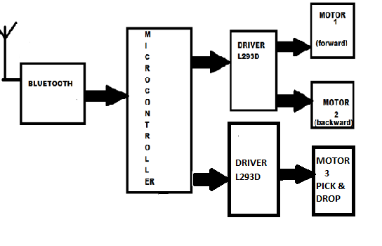

RESEARCH OBJECTIVES:-

The important objectives study was:
A. increases the manufacturing capacity in the small scale food industry
B. increases the labor integrity in the productivity of food
C. Eliminate the human based operations, reduces the cost and time of the product.

A Microcontroller:
A micro controller is an integrated circuit on a single chip or soc. The entire computer system lies within the confines of the integrated circuit chip is called single chip computer. similar to standard personal compurer micro controller also have the encapsulated sliver of silicon has[10]. Initial function of the micro controller is to store and run a program. The micro controller contains a CPU , ROM, RAM , I/O lines, serial and parallel ports, timers and may also consists of other built in peripherals as A/D (analog to digital) and D/A (digital to analog) converters.
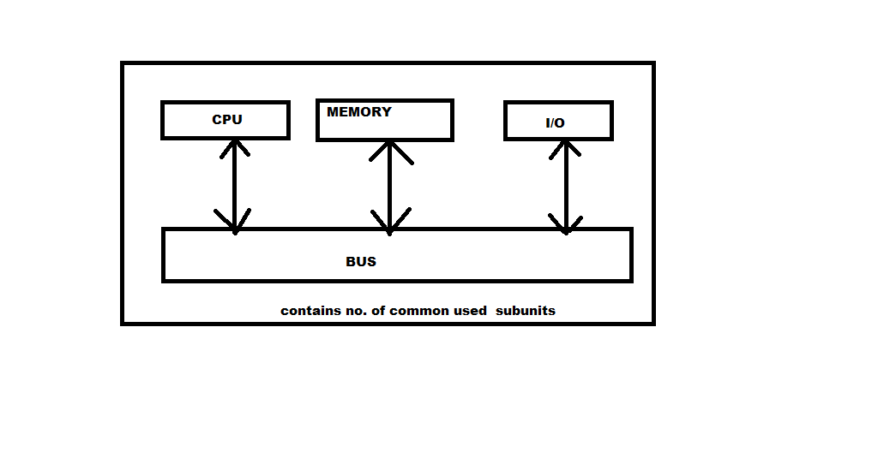
Figure 3.0: Main Components of Microcontroller [9]
Most of the microcontrollers combine other devices such as;
A Timer module:- certain time periods are allow to perform the task from micro controller [7].
A serial I/O port:- To allow data to flow between the micro controller and other devices such as another micro controller or PC[7].
An ADC: - To allow the micro controller to accept analogue input data for processing purpose[7].
B. DC Motor: To run on DC electric power, direct current motor is designed. The Pure DC designs are Michael Faraday's homo-polar motor, and the ball bearing motor, which is a novelty [15].The types of DC motor commonly used are;
1. Brushed DC motors
2. Brushless DC motors

1) Brushed DC motors: The initial function of DC motor design is to generate an oscillating current in a wound rotor with a split ring commutator, and either a wound or permanent magnet stator. A rotor is a coil wound around a rotor which is then connected to any type of battery that is it is powered[15].Due to the need for brushes to press against the commutator, the classic commutator DC motor has many limitations. Thus friction is created. Brushes have increasing difficulty in maintaining contact as the speed goes on increasing. Brushes may bounce off the irregularities in the commutator surface, creating sparks. Thus the speed of the machine is limited to maximum. The output of the motor is limited by current density per unit area of the brushes. The electrical noises are thus caused due to imperfect electric contact. Eventually brushes wear out and thus they require replacement, and then the commutator itself is subject to wear and maintenance [15].

2) Brushless DC motors: The brushless design eliminates some of the problems of the brushed DC motor. Here, an external electronic switch synchronized to the rotor's position is used instead of the mechanical "rotating switch" or commutator / brush gear assembly [13]. The efficiency of brushless motors are typically 85-90%, whereas the efficiency of DC motors with brush gear are typically 75-80% [13]. Brushless DC motor lays the realm midway between ordinary DC motors and stepper motors. Brushless DC motor and stepper motors have very similar built in fashion, which often uses one or more Hall Effect sensors to sense the position of the rotor, three phases of driving coils, a permanent magnet external rotor, and the associated drive electronics. Initially by the drive electronics, the coils are activated; one phase after the other, from the Hall Effect sensors, drives electronics is cued by the signals [13]. In effect, having its own Variable frequency drive electronics it act as three phase synchronous motors containing. A specialized class of brushless DC motor controller does not utilize Hall Effect sensors instead they utilize EMF feedback through the main phase connections for determining the position and velocity [13]. These motors extensively find application in electric radio controlled vehicles. These brushless DC motors when configured with the magnets on the outside, they are referred to by mode lists as out runner motors [13].

IV. PRINCIPLE OF OPERATION
The principal of operation in any electric motor is based on simple Electromagnetism. A magnetic field is generated by the current-carrying conductor; thus due to external electric field, it will experience a force proportional to the strength of the external magnetic field and the current in the conductor. As the law states that opposite polarities attract, while like polarities repel [9].Rotational motion is generated, the internal configuration of DC motor is designed to harness the magnetic interaction between a current-carrying conductor and an external magnetic field [9].

1) Stepper Motor: A stepper motor is a brushless. It is synchronous electric motor that divides a full rotation into a large number of steps [11]. Without any feedback mechanism, the motor’s position can be controlled precisely. Stepper motors have similar mechanism to switched reluctance motors, generally which are closed-loop commutated and are very large stepping motors with a reduced pole count [11].

2) Fundamental Operation: Stepper motors and DC motors operate differently. DC motors rotate when voltage is applied to their terminals [8]. On the other hand, Stepper motors effectively have multiple “toothed” electromagnets arranged around a central gear shaped piece of iron [8]. The Microcontroller which acts as external control circuit are used to energized the electromagnets. To order to turn the motor shaft, firstly one electromagnet is powered, and as the electromagnets are powered the gear’s teeth magnetically attracted to the electromagnet’s teeth [8]. The gear’s teeth are thus aligned to the first electromagnet, and they are slightly offset from the next electromagnet [8]. Thus the gear rotates slightly to align with the next one when the next electromagnet is turned on and the first is turned off and then the process is repeated. The slight rotations is called a “step” [8] the motor is turned to precise angle.
3) Stepper motor characteristics: Stepper motors are constant power devices which can be illustrated by (Power = Angular Velocity X Torque) [8]. The torque curve may be extended by increasing the driving voltage and by using current limiting drivers [8]. As the discrete step tends to snap the rotor from one position to another, Steppers exhibit more vibration than other types of motor. As the speed increases this vibration can become very bad and torque lose can takes place in the motor [8]. This effect can be minimized by operating through the problem speed range, physically damped system, or using a micro-stepping driver. The mode of operation depends on the no of phases motors have. The number of phases are high exhibit smoother operation than those with fewer phases [8].

There are two types of stepper motors are mainly present;
a) Permanent Magnet and
b) Hybrid Stepper motor.

a) Permanent Magnet Stepper: it has a cylindrical permanent magnet rotor. The stator usually has two windings [6].To allow for a uni-polar driver circuit the windings could be center tapped, where the polarity of the magnetic field is changed by switching the voltage from one side to the another side of the winding [6]. By using bi-polar drive of alternating polarity to power windings without the center tap. A pure permanent magnet stepper usually has a bigger step angle. Rotation of the shaft disgrace the motor to exhibits detent torque [7]. If the detent angle is large, say 7.5o to 90o, it is likely to a permanent magnet stepper than the hybrid stepper [6].

b) Hybrid Stepper: it is the combination of both the variable reluctance stepper and the permanent magnet stepper. The main function of this hybrid stepper is to produce a smaller step angle [4]. The rotor is a cylindrical permanent magnet which is magnetized along the axis withradial soft iron teeth (Figure: 4.0). With the corresponding teeth the stator coils are wound on alternating poles [4]. Between the pole pairs it typically distributes two winding phases. This winding would center tapped for uni-polar drive and the center tap bifilar winding can be acquired, wires wound normally as parallel but it is wired in series[4]. When the phase drive current is reversed ,The north-south poles of a phase swap polarity [4]. Bipolar drive is required for un-tapped windings.
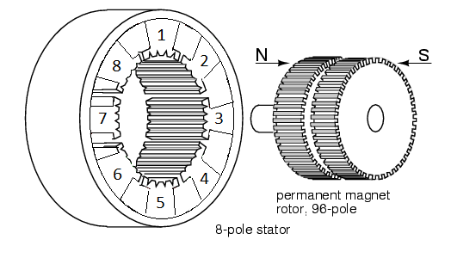
Figure 4.0: A hybrid Stepper Motor [4]

V. MODEL AND DESIGN
A. Layout of the Robot:
Three basic subsystems as;
1. Moveable base
2. Rotational manipulator
3. Magnetic gripper unit.
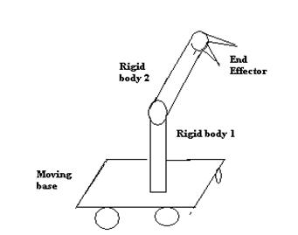
Figure 5.0: Layout of the Robot

1. Movable Base: The robot base is movable and is a three wheel vehicle, two backward movable wheels and one front fixed wheel. The two backward wheels are derived by DC motor through mechanical gears and they are controlled by controller through H-bridge drive circuit [3]. H-bridge drive circuit allows the motion of the two wheels in the forward and backward direction. The front wheel is fixed in order to support the base [3].

2. Rotational Manipulator: The rotational robotic arm consists of a stepper motor. By giving logic through controller, the stepper motor moves in step angles to 3600 [5]. A stepper motor drive circuit is used to drive the motor. Manipulators arms are used here. The manipulator is one joint and has one degree of freedom [5].

3. Magnetic Gripper Unit: Based on electromagnetic effect,We have design a special type of gripper. On each side of the gripper consists of two-inductor coil, which operates on 12 V DC signals [5]. On application of 12V DC signal from the battery, the coil in the gripper is energized and an electromagnetic field is induced around the coil [12]. There are metallic biscuit trays placed at various locations. Around the gripper an electromagnetic field is induced which picks up the metallic biscuit tray from the desired location and places it on the target place, with flexibility, when the 12V DC signal is removed [13]. Thus the metallic biscuit trays can be successfully and flexibly can be picked up and dropped at the location we have targeted to.
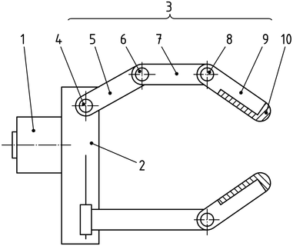

Figure 5.3: Magnetic Gripper [5]

B. Special Application:
A pick and drop robot is the one which is used to pick up an abject and place it in the desired location. Pick and drop robot has application in various areas. The gripper can be suitable in areas where we have to pick and place metal object or toll in many industries [12].

C. Operating the Robot:
The robot is operated with the help of Bluetooth. Firstly, the manipulator arm moves 900 and this manipulator pick the biscuit tray through the magnetic gripper from the table. After that the robot operates to go forward to the furnace and then places the biscuit tray into the furnace. It waits for sometimes still the biscuits baked and again picks the biscuit tray from the furnace and places it on the table. The robot also moves in the backward direction if required.
CIRCUIT DIAGRAM:-

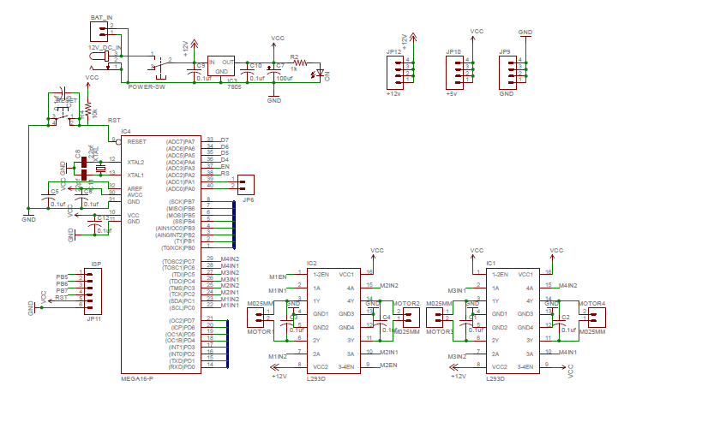

In the project the pick and place robot is controlled by a Bluetooth device of the mobile phone attached to the robot. The important components of this robot are a Bluetooth device, automation, microcontroller and motor driver. In circuit diagram atmega16 microcontroller pin 9 is connected to push button for reset. Pins10, 30 is connected to vcc +5v and pins no: 11, 31 is connected to GND. The atmega16 is an 8-bit microcontroller, has 64 kB Flash microcontroller with an 1kB RAM. It provides the features which are as follows: 64 kB of on-chip Flash program memory with ISP (In-System Programming).The system consists of two motors for providing motion to the whole robot and one motor to provide the arm motion. The end effector or the gripper needs to be controlled to apply proper pressure on the object to handle it effectively, to gives it soft grip. proper command ensured by controlling the arm motors. The output from the arm motors is connected to a resistor. Output from the micro controller is given to the motors through motor driver IC L293D. In this project there are 3 motors to control pick and place robot. Two motors are used to move robot forward and backward directions. These two motors are connected to Microcontroller pin 14 to pin 17. One motor is used to move object. The microcontroller drives the motors in Clock direction.The H-bridge is use to drive the DC-motor forward and backward direction. From the battery to the H-bridge circuit the +12V DC power is applied and controlled through the controller by applying logics.

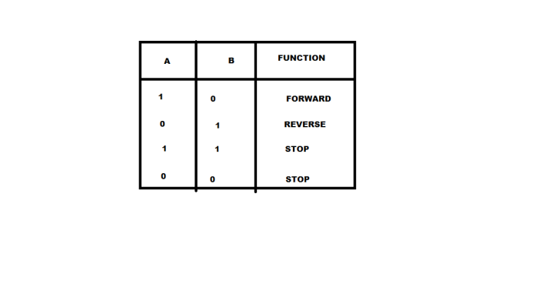

When logic 1 0 , is given to terminal A and B, the Motor moves in forward direction and when logic 0 1 is given, then it moved in reverse direction respectively. The motor will be in idle when logic 0, 0 or 1, 1 is given. To drive circuit the stepper motor is use. The stepper motor has 6 wire in which two are used for VCC and GND[3] .The remaining 4 wire is used to provide logic from the controller. From the drive circuit by giving logics to move motor in step angles through controller is shown table below:-

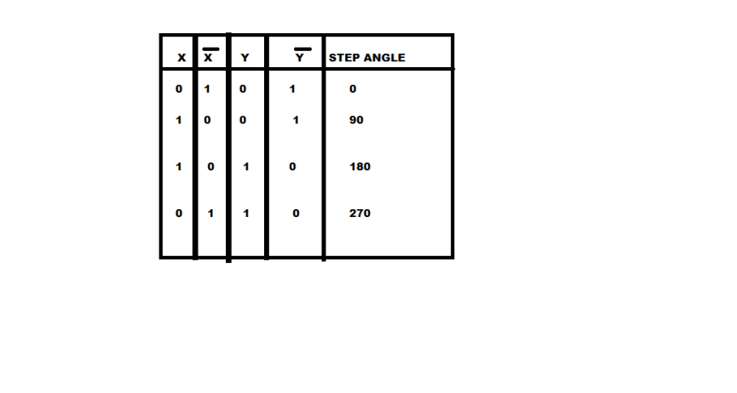

table 6.3: Stepper motor drive circuit Boolean logic

• Inputs: Even if the supply is low, these ICs are unusual because their gate inputs have a capability to withstand up to +15V.

• Outputs: 74LS gate inputs directly because These ICs are unusual they are capable of driving .To do this they must have a +5V supply .The gate output is enough to drive four 74LS inputs. NC = No Connection (apin is not used).
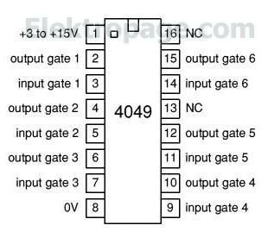

FUTURE SCOPE

The project is designed in such a way that it is a simple and reliable can be used by local industries. However with little modification, it can be used more efficiently and effectively, some of the modifications suggested are
- In order to avoid obstacles in the path, one can use vision system with artificial intelligence.
- The baking of biscuit can be checked with the help of vision system.
- The payload of the robot can be increased by making use of more powerful magnetic gripper.
- The magnetic gripper can be modified for different operation in other industries.

REFERENCES:-

- Jacquier E, Polson NG, Rossi PE (1993) Priors “models for multivariate stochastic volatility.” Graduate School of Business, University of Chicago.
- L. Righetti, A. Ijspeert, “ Design methodologies for central pattern generators” and in Proceedings of Robotics, MIT Press, 2006.
- J. Pisokas Experiments in “sub symbolic action planning with mobile robots”,from Adaptive Agents and Multi-Agent Systems II, Springer, 2005, pp. 80–87.
- YFranklin Hanshar and Beatrice Ombuki-Berman, “Dynamic vehicle routing using genetic algorithms”. Applied Intelligence, 27(1):52–91, 2007.
- Thomas L. Dean and al “Planning and control”. From Morgan Kaufmann Publishers Inc., 1991.
- Yaochu Jin and J Branke “Evolutionary optimization in uncertain environments-a survey”. Evolutionary Computation, IEEE Transactions on, 9(3):303–317, 2005
- Stuart Russell and Peter Norvig “Artificial Intelligence”: A Modern Approach (Second Edition, 2003.
- Lu SQ, Ito T, Voges K (2008) “An analysis of long memory in the SSE’s component index”. 9th International Business Information Management Association Conference. Information Management in Modern Organizations: Trends and Challenges. Morocco, pp 910–960.
- R.M. Haralick, L.G. Shapiro, “Computer and Robot Vision”, vol. I, Addison Wesley,1992.
- V.N. Vapnik, “Statistical Learning Theory”, Wiley-Interscience, 1998.
- R.R. Murphy, “Introduction of AI Robotics”, the MIT Press at USA, 2000.
- Y. Nagai,and K. Rohlfing, “Can motionese tell infants and robots what to imitate”, in: Proceedings of the 4th International Symposium on Imitation in Animals and Artifacts, AISB, 2007, pp. 274–302.
- G. Pezzulo, G. Baldassarre, M. Butz, C. Castelfranchi, J. Hoffmann, from actions to goals and goals to actions, “theoretical analysis and models of the ide motor principle and tote”, in: Anticipatory Behavior in Adaptive Learning Systems, Springer Verlag, 2007.
- Wörgötter, A. Agostini, N. Krüger, N. Shylo, B. Porr, “ relying on the predictability of object- action complexes,“ Robotics and Autonomous Systems 57 (2009) 410– 419.
- L. Montesano, and al “Learning object affordances”: from sensory-motor maps to imitation, IEEE Transaction son Robotics, 2008).

