Implementation of Model Radar Target Direction and Distance Identifier Using Zigbee Communication

YogeshMotey, Avanti Tijare, AishwaryaNinave, AmbiliRavindran, NehaWahane

ETC Deaprtment,GHRIET,Nagpur

Abstract-The project is based on implementation of modal radartarget direction and distance identifier using on zigbee communication module. The prime objective of our project is signal detection for both stationary as well as moving target. It is an acronym for radio detection and ranging to determine range, altitude, direction and speed of both moving and fixed object. In this project the radar is fitted with DC geared motor and its operation is controlled by AT89S52 microcontroller which is interfered with radar target identifier system has an array of IR pair for stationary object and ultrasonic pair for moving target. These sensors keeping track with target in all direction and If the target is found to be moved in any direction and then it transmit control signal to microcontroller which will communicate with zigbee module which are being used for wireless communication between transmitter and receiver. The status of an target is displayed on LCD for user identification and buzzer will indicate target detection for alert. The outcome result will be précised, accurate and cost effective with all parameters of target.

Keyword: Radio waves, AT89S52 Microcontroller, IR sensors, RADAR, Ultrasonic sensor, ZigBee.

- INTRODUCTION

The main objective of this project is identifying the radar target direction with remote station alert system. Radar signal containing modulates an optical, infrared signal with selected signal target simulations. The target system is provided with selectively direct modulated IR radiation onto selected areas of an RF i.e. radio frequency array. The IR radiation is converted to a radio frequency signal in the RF array and is transmitted to the radar test system. This project has two sections : Transmitter section and Receiver section the target will be detected and range will be calculated . All these values can be displayed on the LCD on the Rx side by using zigbees.

The wireless technology is becoming one of the most prominent areas of research. This paper focuses on the most widely used transreceiverstandard in wireless sensor network, zigbee technology. This paper presents zigbee wireless standards, zigbee device types, the protocol stack architecture and its applications [zigbee: A low power wireless technology for industrial applications.]
The rest paper is organized as: basic principle of radar in section[2], working process is explained in section [3],conclusion in section [4],advantages in section [5],applications in section[6],and references in section[7].

2. BASIC PRINCIPLE OF RADAR:

A radar system has a transmitter that emits radio waves called radar signal in predetermined directions.When these come into contact with an object, they are usually reflected or scattered in many directions.Radar signals are reflected especially well by materials of considerable electrical conductivity bymost metals. The radar signals that are reflected back towards the transmitterare the desirable ones that make radar works. If the object is moving either towards or away from transmitter,there is a slightly equivalent change in the frequency of the radio signals, caused by the Doppler Effect.
A microcontroller is a compact microcomputer designed to govern the operation of embedded systems in motor vehicles, robots, office machines, complex medical devices, mobile radio transceivers, vending machines, home appliances, and various other devices.
Radar target identifier is selected with areas of the RF array function to add target angular simulations and target space
position and scintillations to the other simulations contained in the radar signal. The IR radiation is converted to a radar frequency signal in the RF array and is transmitted to the radar test system.

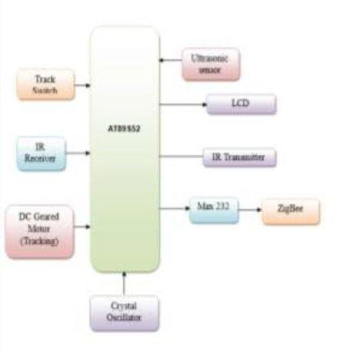

fig 1. transmitter

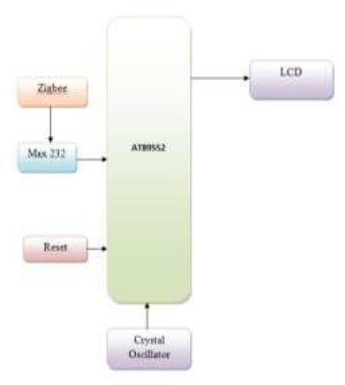

fig 2.receiver

.
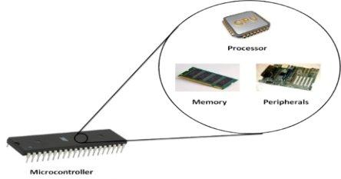

Fig 3. Microcontroller

A typical microcontroller includes a processor,
memory, and peripherals.A microcontroller is a small
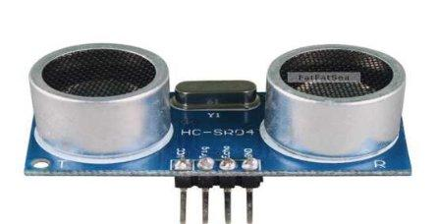
computer (SoC) on a single integrated circuit containing a processor core, memory, and programmable input/output peripherals .Microcontrollers are used in automatically controlled products and devices, such as automobile engine control systems, implantable medical devices, remote controls, office machines, appliances, power tools, toys and other embedded systems.

Fig 4.ultrasonic sensor

Ultrasonic ranging module HC - SR04 provides 2cm - 400cm non-contact measurement function, the ranging accuracy can reach to 3mm. The modules includes ultrasonic transmitters, receiver and control circuit. The basic principle of work:
- Using IO trigger for at least 10us high level signal,
- The Module automatically sends eight 40 kHz and detect whether there is a pulse signal back.
- IF the signal back, through high level , time of high output IO duration is the time from sending ultrasonic to returning. Test distance = (high level time×velocity of sound (340M/S) / 2,
Wire connecting direct as following:

5V Supply Trigger Pulse Input Echo Pulse Output 0V Ground

.RADAR EQUATION:
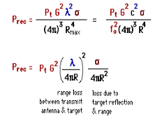

Equation 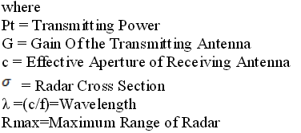

Our Project is based on the principle of DOPPLEREFFECT. Doppler Effect states that when the radarwaves aresent towards a moving target or object, they are reflectedback and received by the radar. If the frequency of the reflected wave is increased, the target is moving towards the radar. If the frequency of thereflected wave is decreased, the target is moving away from the radar.In our project we are showing the detection of signal by using IR pair sensor. The principle behind infraredsensors is the transmission and reception of infrared light. An element known as a light emitting diode (LED)transmits active infrared light, which is reflected and received by an optical receiver known as a photo diode(PD).

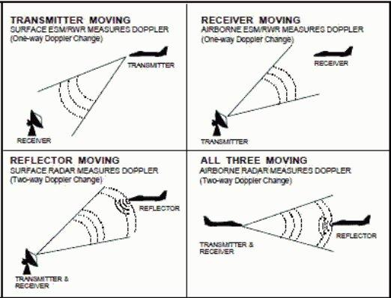

Fig 5.Doppler Creation

As long as there is no movement or object in the path of the light beam, the light pattern is static andthe sensor remains in stand-by mode. When a person or object crosses the beam, the reflection of the light isdistorted.This is registered by the PD,
Which gives off an impulse.Ultrasonic sensor is also being used for the detection of the moving targets and calculating thedistance of the target from the antenna system. The chirp is sent from the ultrasonic sensor and when thissignal strikes the target an echo is received at the sensor.

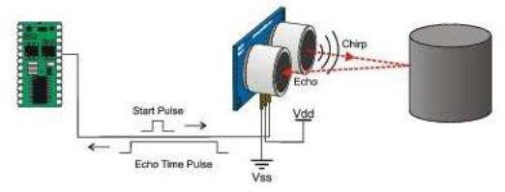

Fig 6.ultrasonic sensor

WORKING PROCESS:

Here, 230 volts AC supply is given to step down transformer which produces the output as 12 volts ACwhich is passed through the bridge rectifier. Rectifier output is pulsating DC that passes through thecapacitive filter which blocks AC components and thus its output is DC that contains very less ripples, whichis further given to 721 voltage
Regulator. The output of VR is constant DC.
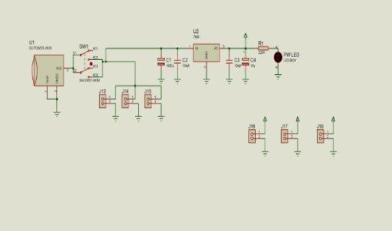
The working process of the project is described below:

- The power supply is provided to the AT89S52 microcontroller which passes the power to all the components to it.

- When the user presses the track switch for the first time, the DC motor starts rotating which is controllingthe RADAR antenna which is placed at an altitude to track various frequenciesemitted by different radiostations. The rotation of RADAR antenna is based on the signal tracked by a pair of infrared sensor basedcommand signal generated through it. Once the signal is matched RADAR rotation will stop in thatparticular direction.

- Again if the user press the TRACK switches automatically RADAR rotation will track for another radiofrequency signal and turns ON the buzzer.

- If track switch is pressed again another command based code is generated from IR remoteautomaticallyit turns ON audio buzzer indication system. In this way we can track the signal .

Meanwhile whenever the moving target comes in the region of ultrasonic sensor it can be detected and therange of the target can also be recorded.Every time the target is detected, the master ZigBee sends the data to all the connected slave ZigBee. TheSlaveZigbeegive the received data to the microcontroller which in turn sends the data toLCD for thedisplay purpose.

ADVANTAGES:
1) Very flexible - can be used in a number of ways

- Stationary mode

- Moving mode

- Two Directional mode

2)Beam spread can incorporate many targets.
3)Can often select fastesttarget , or best reflection.
4)Still very reliable

5) High penetration capability.
6)Long range

APPLICATIONS:

  - Mapping radar scans a large region for remote sensing and geography applications.

  - Wearable radar which is used to help the visually impaired.

  - Air traffic control uses radar to reflect echoes off of aircraft.

  - Weather radar uses radar to reflect echoes off of clouds.

  - Some weather radars use the Doppler Effect to measure wind speeds.

  - Missile Tracking System.

  - Marine radars are used to measure the bearing and distance of ships to prevent collision with other ships.

  - It can be used for: to locate air, ground and sea tar gets. This evolved in the civilian field into applications for aircraft, ships and roads.

  - Marine radars are used to measure the bearing and distance of ships to prevent collision with other ships, to navigate and to fix their position.

  - Doppler Effect in radars helps in identification of weather of any regions.

  - RADAR is found on ships and boats for Collision avoidance. RADARS may be used in law enforcement and highway safety.

  - RADAR may also be used for remote sensing.

Expected Result:

Radar target system is provided with selectively direct the modulated IR radiation. Radar target identifier is selected with areas to add target angular simulations and target space position and scintillations to the othersimulations contained in the radar signal. This project presents Radar modal target Direction identifier withremote station alert system is been designed and implemented with AT89S52 controller in embedded systemdomain. Experimental work has been carried out carefully. The result shows that higher efficiency is indeedachieved using the embedded system according to Requirementofthe user.

REFERENCES

- ‘Penley , bill’ , “ development of radar model with

Remote voice and text alert system using zigbeecommunication”,published an introductional 2002
- ‘e.fishler’ , “ mimo radar : an idea whose time has comelieee radar conference ” ,2004.

- swords, Sean S.,-- technical history of the beginnings of radar,IEEE history of technology series, vol. 6,London:peter pergrinus,1986.
- "IEEE Sensors Journal". 2013
[5] Ultrasonic Sensor System,"IEEE Sensors Vol 9. No. 7, pp. 767-773, July 2009.

