War Field Wireless Spying Robot with Sharp Shooting Weapon

Yadnesha Vaidya ,Sarvesh Rothe,Renuka Kale , Ranu Pand, Vaishnavi Wankhede

Electronics and Telecommunication Department, GHRIET Nagpur

Abstract- One of the ways that our military are beginning to explore new technologies in war fields come from the autonomous spying robot. The Radio frequency (RF) based spying robot is something that is very new to the military application; United States is starting to use this type of system. These spying robots are described by Industry News as a spying robot that drives it’s solving with a computer in control. Although still in the research phase of development, autonomous spying robots are rapidly becoming more of a reality than an idea.
The project is designed to develop a robotic vehicle using Radio frequency (RF) technology for remote operation attached with wireless camera for monitoring purpose. The robot along with camera can wirelessly transmit real time video with night vision capabilities. Also the Robot vehicle is provided with the laser beam gun and Water sprinkler operation. This is kind of robot can be helpful for spying purpose in war fields. An 8051 series of microcontroller is used for the desired operation

Keyword : Radio frequency (RF) Technology, Zig -bee Module Base, 8051 Microcontroller , Embedded System , Robotics,Keil,Proload

- INTRODUCTION

Embedded systems are designed to do some specific task, rather than be a general-purpose computer for multiple tasks. Some also have real time performance

constraints that must be met, for reason such as safety and usability; others may have low or no performance requirements, allowing the system hardware to be simplified to reduce costs. Wireless communication has become an important feature for commercial products and a popular research topic within the last ten years. There are now more mobile phone subscriptions than wired-line subscriptions. Lately, one area of commercial interest has been low-cost, low power, and short-distance wireless communication used for personal wireless networks." Technology advancements are providing smaller and more cost effective devices for integrating computational processing, wireless communication, and a host of other functionalities Wireless spy camera Robot wireless spy camera robot projects main functionality is deal with tough situations where human beings cannot handle situations like bomb disposal, narrow and small places…etc. This system works using a computer controlled system trough which is done using electronic programming. Using camera attached to robot we can view location where the robot is using this video we can wireless control and know location details.
Robotics is the branch of mechanical engineering, electrical engineering and computer science that deals with the design, construction, operation and application of robotics, [1] as well as computer systems for their control, sensory feedback and information processing. The aim of developing a high-tech technology serves the purpose of achieving high speed technology, advanced capacity to control the robots and to device new methods of control theory. The realization of above standards some technical improvement along with the need of high performance robot is required to create a faster, reliable, accurate and more intelligent robot which can be devised by advanced control algorithm, robot control devices and new drivers. The design of our project encourages developing a robotic vehicle based on RF technology for the remote operation connected with the wireless camera mounted on the robot for monitoring purpose.

LITERATURE SURVEY
The Zig-Bee Alliance [ZIG05] in his paper “Zig-Bee Specifications” Reference [1]. An association of companies working together to develop standards (and products)for reliable, lowpower.[2]
Wireless networking and it is foreseen that ZigBee technology will be embedded in a wide range of products and applications across consumer, commercial, industrial.
ZigBee builds upon the IEEE 802.15.4 standard which defines the physical and MAC layers for low cost, low rate personal area networks. It defines the network layer specifications, handling star and peer-to-peer network topologies, and provides a framework for application programming in the application layer.
Paolo Baronti, Prashant Pillai, Vince Chook, Stefano Chessa, Alberto Gotta, Y.Fun Hu, Reference [2]. In his paper “Wireless Sensor Networks”. Tells about sensors and how the sensors are connected.
J. Zheng and M.J. Lee in their paper [4] “A discussion on low power, low bit rate standard” defined the potential low power as well as simulations on various aspects of the standard.This paper tells that this spying robot is consumes the low power and also take the low bit rate by using zigbee technology. This paper also explained about the Microcontrollers by using this Microcontroller this robot takes low bit rate.

- PROBLEM DEFINITION

- The main aim of this project is to design a spy robot by using zigbee technology in embedded C, it can imitate the human efforts.
- How it should be interfaced,designed and collaborated.
II. METHODOLOGY

A. Radio Frequency Module
Radio frequency (RF) is any of the electromagnetic wave frequencies that lie in the range extending from around 3 kHz to 300 GHz, which include those frequencies used for communications or radar signals. In order to receive radio signals an antenna must be used. This antenna will pick up thousands of radio signal at a time and for the same we need to use a radio tuner to tune into a particular frequency. This is done by using a resonator. Resonator amplifies oscillations within a frequency band while reducing the oscillations at other frequency outside the band. In our project we are using RF 433 MHz RF module along with HT12E (Encoder) and HT12D (Decoder). Transmission of data or commands is done using the RF module while the encoder and decoder are used for controlling the robot and other interfaces. This is a 4 bit wireless module. Use it to transmit and receive 4 bits of data through a wireless RF Link. It uses our 433 MHz RF Modules and the HT12E/D IC. The transmitter and the receiver come with an 8 bit address selector switch which can be used to assign unique addresses to each wireless link. Receivers receive data only from transmitters which have a matching 8 bit address. The module can operate within a range of 100m when the transmitter is in line of sight and around 50m when indoors. This module takes care of all the encoding and decoding required to transmit data and requires no additional computation by the micro controller. Users can directly hook up the module to a micro controller and start transmitting data wirelessly. The transmitter and the receiver can be directly connected to a microcontroller or an external circuit through the header pins. RF communication has two sections RF 433 MHz Transmitter with HT12E (Encoder) and RF 433Mhz Receiver with HT12D (Decoder). A. RF 433 MHz Transmitter with HT12E: In this section a brief introduction about RF 433 MHz Transmitter and HT12E (Encoder) is given individually following with the interface of the encoder with the transmitter. This is a Hybrid 433Mhz RF transmitter & receiver module and is ideal for short-range wireless control applications where quality is a primary concern. The receiver module requires no external RF components except for the antenna. The super-regenerative design exhibits exceptional sensitivity at a very low cost. RF Transmitter 433 MHz ASK.
Features:
Transmitter Frequency: 433.92 MHz
Range: 500ft (For perfect given conditions).
Data Rate: 8Kbps
Supply voltage: 1.5~12 Volts
Circuit Shape: Saw Type
Output Power: 14dBm
Working temperature: -20 ~ +85 Celsius
Solder temperature: 230 Celsius (10 seconds)
High sensitivity is designed.
B. L293D MOTOR DRIVER
L293D is the most commonly used driver for bidirectional motor driving applications. L293D is a 16 pin motor driver IC which is used to drive the motors. L293D is a dual H-bridge motor driver. It can be used to drive direct current on either direction.. It is used as a current amplifier since it takes low current control signal as the input and provides high current signal as output. L293D can be used to drive small as well as big motors as well. L293D motor driver is available for providing user with ease and user friendly interfacing for embedded applications. It is easily compatible with any of the systems.In fig1 we can see that, It supports external power supply pins for motors.. CONCEPT: L293D works on the concept of H Bridge. It allows the high voltage to be flown in either direction. In a single L293D motor driver there are two H-bridge circuits which helps to rotate two dc motors independently.
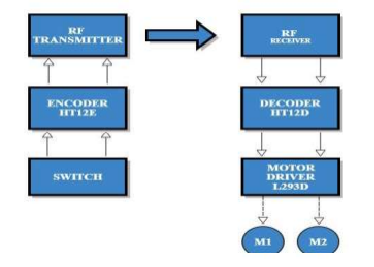
FIG-1 : L293D Motor Driver circuit Diagram

C. MODULE: ZIGBEE &CAMERA INTERFACE

RF Module XBee and XBee-PRO Modules were engineered to meet ZigBee/IEEE 802.15.4 standards and support the unique needs of low-cost, low-power wireless sensor networks.
The modules require minimal power and provide reliable delivery of critical data between devices. The modules operate within the ISM 2.4 GHz frequency band and are pin-for-pin compatible with each other.
KEY FEATURES:
¬ Indoor/Urban: up to 100’ (30 m)
¬ Outdoor line-of-sight: up to 300’ (100 m)
¬ Transmit Power: 1 mW (0 dBm)
¬ Receiver Sensitivity: -92 dBm
ZigBee is a low-cost, low-power; wireless mesh network standard targeted at the wide development of long battery life devices in wireless control and monitoring applications. Zigbee devices have low latency, which further reduces average current. ZigBee chips are typically integrated with radios and with microcontrollers that have between 60-256 KB of flash memory. ZigBee operates in the industrial, scientific and medical (ISM) radio bands: 2.4 GHz in most jurisdictions worldwide; 784 MHz in China, 868 MHz in Europe and 915 MHz in the USA and Australia. Data rates vary from 20 kbit/s (868 MHz band) to 250 kbit/s (2.4 GHz band).The ZigBee network layer natively supports both star and tree networks, and generic mesh networking. Every network must have one coordinator device, tasked with its creation, the control of its parameters and basic maintenance. Within star networks, the coordinator must be the central node. Both trees and meshes allow the use of ZigBee routers to extend communication at the network level.
The specification includes four additional key components: network layer, application layer, ZigBee device objects (ZDOs) and manufacturer-defined application objects which allow for customization and favour total integration.
III. WORKING
- TRANSMITTER SECTION
The transmitter section consists of the Radio frequency Encoder, control array switch, Battery, Radio frequency transmitter. Fig 2 shows the transmitter Section.
The Control array consist of the in all total 14 operations.
These 14 operations are mainly divided in 5 sub operations.
The five operations are:
-Wire cutter motor which consists of on and off also open close buttons.
-Gun operations motor which consist of shoot and release buttons.
-The Robot motion button such as forward, backward, left and right buttons.
-Also on and off button for water sprinkler.
-And laser gun operation.
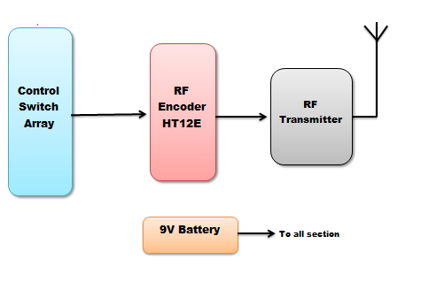
Fig-2: Transmitter Section of the Spy Robot

These all operations are forwarded to the Radio frequency encoder where in it encodes all information and are controlled by the programming done in the embedded C as per the software instruction. Through the Radio frequency transmitter the information of the controller side is sent to the Robot in the receiver section.
RECEIVER SECTION

The Receiver section consist of the Radio frequency Receiver, Radio frequency decoder, microcontroller 8051, H bridge, and 5 Driver motor IC’s.The RF modules used here are STT-433 MHz Transmitter, STR-433 MHz Receiver, HT12E RF Encoder and HT12D RF Decoder.H-bridge is a rather simple circuit, containing four switching element, with the load at the center, in an H-like configuration. H bridge circuits are used for driving motors. This type of remote Operated Spy Robot Applications can be used to keep a check on the behavior of wild animals where human beings cannot reach, in army applications to detect the bombs, in industries etc. The three switches are interfaced to the RF transmitter through RF Encoder. The encoder continuously reads the status of the switches, passes the data to the RF transmitter and the transmitter transmits the data and receives from the RF receiver.Now the Microcontroller 8051 fetches the instructions from the transmitter section with the help of keil vision software as per the programming encoded in the C programming and thus the remote operations are controlled. Every operation is aligned to function generated which was given in the functioning of the transmitter side. The fig3 shows the Receiver section.

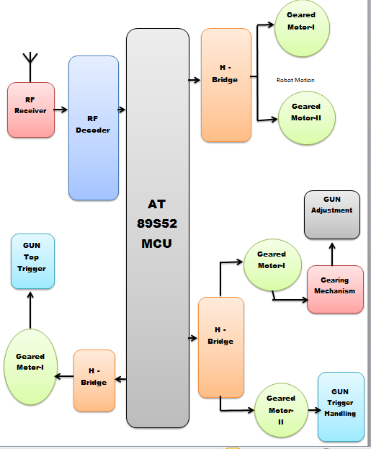
Fig-3: Receiver Section of the Spy Robot
FUTURE SCOPE

For future development we can also interface zig-bee for far distance. In this project we control this spy robot short distances 10Meters to 100Meters. Further development of this spy robot we extend the distance up to 5kilo meters by using of RF (Radio interface) frequencies. Inspired by colonies such as ants and bees, researchers are modelling the behaviour of swarms of thousands of tiny robots which together perform a useful task, such as finding something hidden, cleaning, or spying. Each robot is quite simple, but the emergent behaviour of the swarm is more complex. The whole set of robots can be considered as one single distributed system, in the same way an ant colony can be considered a super organism, exhibiting swarm intelligence. Swarms are also more resistant to failure. Whereas one large robot may fail and ruin a mission, a swarm can continue even if several robots fail .This could make them attractive for space exploration missions, where failure can be extremely costly.

CONCLUSIONS

The project “War Field Wireless Spying Robot with Live Human Detection and Explosive Having Sharp Shooting Weapon” has been successfully designed and tested. It has beendeveloped by integrating features of all the hardware components used. Robot has supported this with the Laser gun for any destruction or so use, purposes, also the Robot has added a water sprinkler in advance for the fire safety as well are for extinguishing purposes, the Robot have a gun for shooting purpose which can load and reload accordingly. Also a cutter for cutting tresses or any destruction purposes.Through all this the military people will be helped as less soldiers will die and a safe human life. This is kind of robot can be helpful for spying purpose in war fields. One of the ways that our military are beginning to explore new technologies in war fields come from the autonomous spying robot. The RF based spying robot is something that is very new to the military application which is controlled by remote.
Presence of everymodule has been reasoned out and placed carefully thus contributing to the best working ofthe unit. Secondly, using highly advanced IC’s and with the help of growing technology theproject has been successfully implemented.

REFERENCES

1.ZigBeeAllianceZig-Bee Specifications”version10 r13.December2006.
2. Paolo Baronti, Prashant Pillai, Vince Chook, Stefano Chessa,AlbertoGotta, Y.Fun Hu, “Wireless Sensor Networks: a Survey on the State of the Art and the802.15.4 and ZigBee Standards”, Computer Communication,Volume 30 Issue 7, pages 16551695,2007.
3. Ed Callaway, Paul Gorday, Lance Hester, Jose A. Gutierrez, Marco Naeve, BobHeile, Venkat Bahl, “Home Networking with IEEE 802.15.4: A Developing Standard for Low Rate Wireless Personal Area Networks”, IEEE Communications Magazine, August 2002.
4. JianliangZheng, Myung J. Lee, “Will IEEE 802.15.4 make ubiquitous networking a reality A discussion on a potential low power, low bit rate standard”, IEEE Communications Magazine, June 2004.
5. Institute of Electrical and Electronics Engineers, Inc., IEEE Std. 802.15.42003, IEEE Standard for Information Technology — telecommunications and Information Exchange between Systems Local and Metropolitan Area Networks — Specific Requirements — Part 15.4: Wireless Medium Access Control (MAC) and Physical Layer (PHY) Specifications for Low Rate Wireless Personal Area Networks (WPANs). New York: IEEE Press. 2003.

