,

A Review on GSM Based Automatic Energy Meter Technique with Instant Billing

Payal N. Ghusalikar¹, Pooja P. Bawangade²
1UG Scholar, Electrical Engineering, DES’s COET, Dhamangaon (Rly.), Maharashtra, India.
payal.ghusalikar9@gmail.com
2UG Scholar, Electrical Engineering, DES’s COET, Dhamangaon (Rly.), Maharashtra, India,
poojabawangade52@gmail.com

Abstract—

In this paper, we propose a system which measure the current consumption unit through IR sensor unit. The IR transmitter is placed in the rotating unit of the EB meter. The receiver photo diode is placed in a certain place which is used to find no of rotation. By getting the number of rotation we get the current consumption. After getting the current consumption the ARM processor will reduce the unit given for specific user. The unit here is taken as numeric value. If the unit is reduced to minimum value it will intimate the user through alarm and LCD unit. If the user wants to add more units for him, he has to send a message to EB section. From the EB section the required value will be sent to the ARM controller through GSM modem.

Keywords—
Communication, GSM modem, LCD, Energy meter.

LITERATURE SURVEY

Subhashis Maitra (Oct 2008)
In this paper, a new concept of energy meter will be discussed, where maximum demand of energy of a consumer will be indicated in the meter used by the consumer.

T El-Djazairy, B J Beggs and I F Stewart (Jun 1997)

This paper presents the results of an investigation which show that the development of the GSM network as a low cost, global carrier of digital telecommunications signals provides exciting opportunities for novel applications such as the handling of power system metering and load management telemetry.

I. INTRODUCTION

0
A wireless local area network (WLAN) links two or more devices using some wireless distribution method and usually providing a connection through an access point to the wider Internet. This gives users the mobility to move around within a local coverage area and still be connected to the network. By using Wireless Body Area Network the users links the devices through their body and nearby devices. From the recent development in low power Wireless Sensor nodes in WBAN, the applications are categorized into two as Medical and Non medical. In medical applications the vital data’s are transferred. will become very important to the electricity supply industry in the next few years. One major issue which will require to be addressed as this development takes place is the security protection of data being transferred, particularly in the radio link paths of the network.

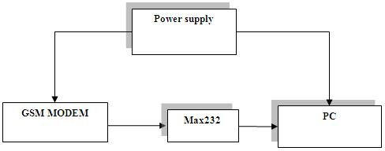

III. PROJECT ANALYSIS

Our project consist of the hardware components that contain the following units. Is power supply
display unit, Alerting unit, Driver unit, Software unit.
They are shown in figure1,2,3 that are given in the
diagram.
Figure 2. EB section block diagram

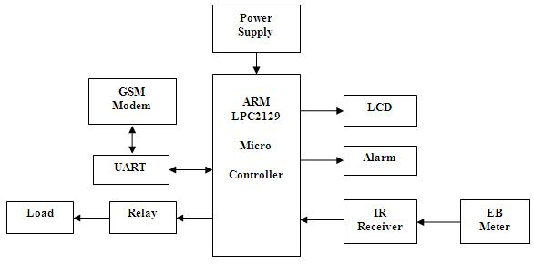

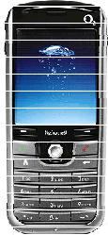

Figure 1.Home section block diagram Figure 3.Mobile section block diagram

The supply of 5V DC is given to the system which is converted from 230V AC supply. Firstly, the step down transformer will be used here for converting the 230V AC into 12V AC. The microcontroller will support only the DC supply, so the AC supply will be converted into DC using the bridge rectifier. The output of the rectifier will have ripples so we are using the 2200uf capacitor for filtering those ripples. The output from the filter is given to the 7805 voltage regulator which will convert the 12V DC into 5V DC. The output from the regulator will be filtered using the 1000uf capacitor, so the pure 5V DC is getting as the output from the power supply unit. Here we are using the PIC microcontroller which will be capable of getting the supply of 5V DC so we have to convert the 230V AC supply into 5V DC supply. Micro controller unit.

In the micro controller unit we are going to use ARM LPC2129 microcontroller which is used to sense the values from the sensors and will transfer to the monitoring section regarding the situation. In the sensing part Analog to Digital conversion is done internally in the controller. The controller will get the location detail of the node using GPS receiver. The controller also converts the data to serial communication for wireless data communication through GSM/GPRS modem. Sensor unit: The sensor unit consists of IR LED and IR Receiver. The LED is placed in the moving unit in the meter. The receiver gets the IR signal for the whole rotation of the moving unit which has the LED. Communication unit GSM Modem is a communication technology in which it is used to transmit the message from the monitoring section to the control section. Whenever there are any

abnormalities in the sensors or for certain period of time, the microcontroller is used to transmit the data to the monitor section. Display unit LCD The display unit is mainly achieved by the 16X2 LCD. A liquid crystal display (LCD) is a flat panel display, electronic visual display, or video display that uses the light modulating properties of liquid crystals (LCs). LCs does not emit light directly. The monitored data from the patient is viewed in the display . PC is connected with the MAX232 to the microcontroller the data received by the GPRS modem is given to the microcontroller. Through the microcontroller the data will be transmitted to the PC and the data will be monitored in PC in

hyper terminal. Alerting Unit Buzzer will produce the beep sound to alert the user when the

power theft occurs.

Here the relay driver is used to drive the load. Relay is an electromechanical switch which acts as an interface between the microcontroller and the load.

Software Unit
Software is used to compile the coding of the desired application for the corresponding embedded system.

KEIL uvision4

This is the embedded C compiler which is compatible for the ARM microcontroller to compile the code. Keil Software makes C compilers, macro assemblers, real-time kernels, debuggers, simulators, integrated environments, and evaluation boards for the 8051, 251, ARM, and XC16x/C16x/ST10 microcontroller families.

Global System Mobile (GSM)
GSM is a second generation cellular system standard. A GSM wireless communication module is integrated with an electronic energy meter of each entity to have remote access over the usage of electricity. A GSM channel is a very useful means of communication, as sending data as Short Messaging Service (SMS) turns out to be a very handy tool due to its good area coverage capability and cost effectiveness. GSM networks operate in four different frequency ranges. Most GSM networks operate in the 900 MHz or 1800 MHz bands. Some countries in the Americas use the 850 MHz and 1900 MHz bands because the 900 and 1800 MHz frequency bands were already allocated. The rarer 400 and 450 MHz frequency bands are assigned in some countries, where these frequencies were previously used for first generation systems.

GIVEN INPUT AND EXPECTED OUTPUT
Given Input:

230V, 5A, 50 Hz AC Supply

Expected Output:

12V, 500mA- 1A, DC Voltage

Microcontroller Unit:

Given input:

It receives the input from the IR receiver and over load

sensing unit:

Expected output:

It sends the remaining pre defined units into text message format and sends it to the GSM modem Sensor unit.

IR sensor:

Given input:

The IR sensor needs of 5V dc power supply

Expected output:

ON\OFF pulse, which changes as per the LED input is the output communication unit.

GSM Modem:

Given input:

The serial text format data from the microcontroller is the input.

Expected output:

Transmission of wireless packets to the network is the output.

Driver unit:

Motor driver

Given input:

The 5v trigger is given from microcontroller.
Expected output:

The load gets disconnected from the supply.

MAX 232:

Given Input:

The input to MAX 232 is the information in TTL Level.

Expected Output:

The output of the MAX 232 is the same information in RS232 level.

Display Unit:

LCD

Given Input:

The text from the microcontroller indicating the device status is given as input to the LCD. Expected Output:
The received text is displayed on the LCD E section.

APPLICATIONS

Industrial control, Medical systems, Access control, Point-of-sale, Communication gateway, Embedded soft modem, General purpose applications.

ACKNOWLEDGMENT

We are thankful to principle and Head of the Department of electrical ( electronic & power ) Engineering. And also thankful to dhamangaon education society’s college of engineering and technology dhamangaon rly. for providing research facility and valuable suggestions for this work.
CONCLUSION

In this paper, Various electronic meters have been study and are still being study. However the use of GSM in this particular system provides numerous advantages over methods that have been previously used. Data transmission is charged at standard SMS rates, thus the charges are not based on the duration of data transmission. The cost efficient transmission of readings ensures that power consumption values can be transmitted more frequently to a remote station. The main moto of being able to transmit readings more often are that energy utilities will be able to generate timely bills, better understand energy demand patterns, manage meter failures more efficiently and manage the fraud .

REFERENCES

- Yujun Bao and Xiaoyan Jiang, “Design of electric Energy Meter for long-distance data information transfers which based upon GPRS”, ISA 2009. International Workshop on Intelligent Systems and Applications, 2009.

- H.G.RodneyTan,C.H.Lee,V.H.Mok,“Automatic power meter reading system using GSM network”, The 8 Conference (IPEC 2007). International Power Engineering

- Vivek Kumar Sehgal,Nitesh Panda, Nipun Rai Handa, “Electronic Energy Meter with instant billing”,UKSim Fourth European Modelling Symposium on Computer Modelling and Simulation.

- Subhashis Maitra, “Embedded Energy Meter- A new concept to measure the energy consumed by a consumer and to pay the bill”, Power System Technology and IEEE Power India Conference, 2008

45

