Raspberry Pi Based Automatic Dam Monitoring and Alert System

Sneha D. Kayte¹
UG Student,
Department of ETC,
G.H. R.I.E.T,
Nagpur (India)
snehakayte94@gmail.com

Shweta Jamodkar²
UG Student,
Department of ETC,
G. H. R.I.E.T,
Nagpur (India)
shwetajamodkar1404@gmail.com

Mimansa Raut³
UG Student,
Department OF ETC,
G. H. R.I.E.T,
Nagpur (India)
mimansa1.raut@gmail.com

Abstract—The purpose of our project is to monitor the water level in dam using the advanced concept of IOT employing Raspberry pi. The Internet of Things (IOT) is a system in which real time things are interconnected to web. This system can also be used to sense the earthquake vibrations and explosive detection and as alert system.Ultrasonic sensor is placed in the dam to serve the same purpose automatically and forward the status to raspberry pi. The Raspberry pi unit checks that input and upload status on web. By this project each and every variation of water level is informed to control room through internet and nearby people can be informed in time thus saving lots of lives avoiding the unpleasant scenarios.

Keyword—Internet of things(IOT),General purpose input-output port(GPIO),
I.INTRODUCTION

In India, most of the Dams are monitored manually. The datasending is also done with traditional modes which lacks
the specific information.Dam researchers require dam parameters data for their research. Common people are also
not acquainted about dam parameters i.e.dam water level and gate status.Thus they have to face the devastating effects of sudden floods.To solve these problems we are proposing system which will monitor the water level of dam and alert the citizens using piezo-ultrasonic sensor and sirens. Basically our system is meant to reduce the human intervention in the dam monitoring and improve the service quality for the extra-ordinary conditions such as heavy rains, wind, temperature etc.

Again we are using the system for explosives(metal)detection and earthquake detection.Automatic detection of the explosives planted by terrorists at public places is most important to combat the threat to human life by these unfair means.Here we are using the metal detector to detect the most commonly used metals in the explosives.

Earthquake is occurred due to movement of the tectonic plates of the earth. Due to the movement of these plates the uppermost layer of the earth surface began to shake.these vibrations are of concern to detect the occurrence of earthquake as soon as possible.For earthquake detection is done by using the vibrational sensor .

All the recorded information will be made available on web with the help of Raspberry pi 2B module exhibiting theconcept of IOT.LCDdisplay is used to give the final output of the executed program.

The basic block diagram of our project is as shown in the figure1 given below:

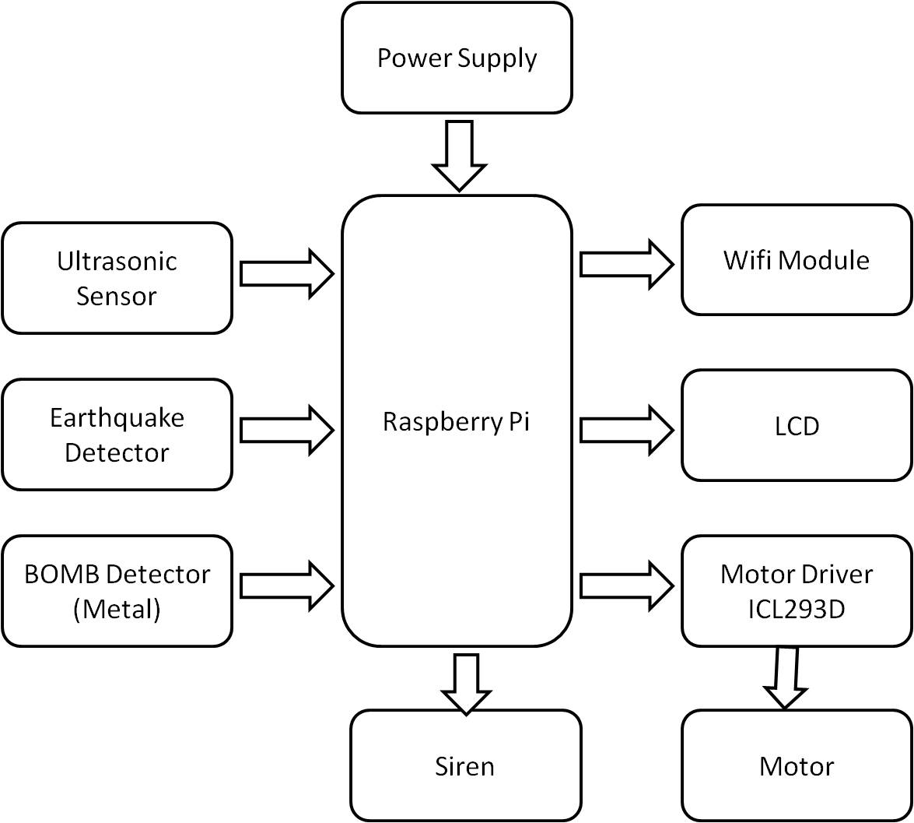

Fig. 1.1:overall block diagram of system

As shown in the figure1.1,in this project we are using raspberry pi 2B model.It has large processing power than the older version of raspberry pi.It consists of BroadcomBCM2836 ARMv7 quad core processor equipped with 4x USB ports. For video connections HDMI port is available .40 GPIO pins are available to make the connections .Micro SD card with 1 GB RAM is present to store the information .Wi-fi module is connected to the raspberry pi for sending the status through IOT .
LCD is connected to the raspberry pi which displays the message. Siren is used which plays role of alerting system.
Motor driver IC is used to run the motor. Motor is used to operate the gate of the dam.We are using piezo-ultrasonic sensor HC-SR04 IC,metal detector VK557.
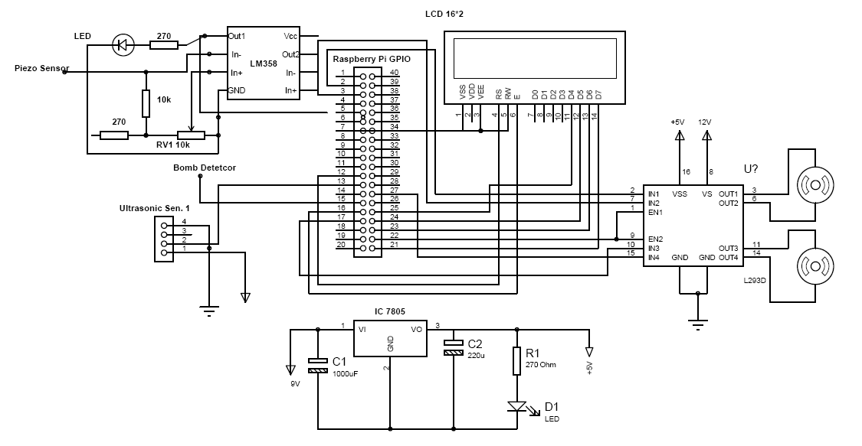

Fig. 1.2 :schematic layout of system

POWER SUPPLY:
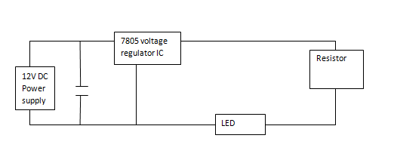Fig.1.1 Represents the power supply circuit

Here we are using Raspberry pi which require 5V power supply. The power supply consists of voltage regulator IC to regulate the supply to 12V DC adapter output.We are using 7805 IC to convert the 12V to 5V.

- DAM WATER LEVEL MONITORING SYSTEM

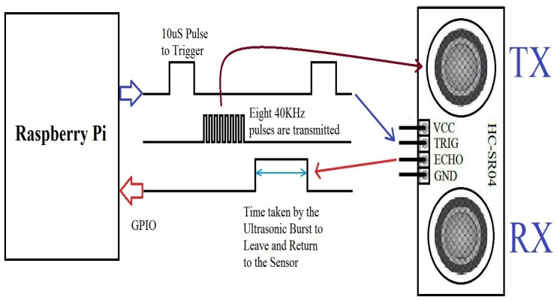

Fig.2 working of ultrasonic sensor

Ultrasonic sensor provides an efficient method of distance measurement.As shown in the figure,we are using HC-SR04 piezo-ultrasonic sensor IC to monitor the water level.It consists of four terminals namely VCC,GND,TRIG ,ECHO.VCC is given 5V dc power supply.When TRIG is initialised it generates 4Khz ultrasonic waves.When they are obstructed by the water surface,these ultrasonic waves are reflected back and captured by ECHO.Meanwhile the time required by the ultrasonic waves to be reflected back and reach to ECHO is recorded to estimate the distance and hence the water level.
If the water level exceeds the specified range in the program,the motor driver IC will invoke the motor to lift the gate of dam to maintain the water level in dam.
Python language programing for the same is as given below:
importRPi.GPIO as GPIO
import time
GPIO.setmode(GPIO.BCM)
TRIG = 23
ECHO = 24
print "Distance measurement in progress"
GPIO.setup(TRIG,GPIO.OUT)
GPIO.setup(ECHO,GPIO.IN)
while True:
GPIO.output(TRIG, False)
print "Waitng For Sensor To Settle"
time.sleep(2)
GPIO.output(TRIG, True)
time.sleep(0.00001)
GPIO.output(TRIG, False)
while GPIO.input(ECHO)==0:
pulse_start = time.time()
while GPIO.input(ECHO)==1:
pulse_end = time.time()
pulse_duration = pulse_end - pulse_start
distance = pulse_duration * 17150
distance = round(distance, 2)

if distance > 2 and distance < 400:
print "Distance:",distance - 0.5,"cm"
else:
print "Out Of Range"

The above program follows the flow chart :

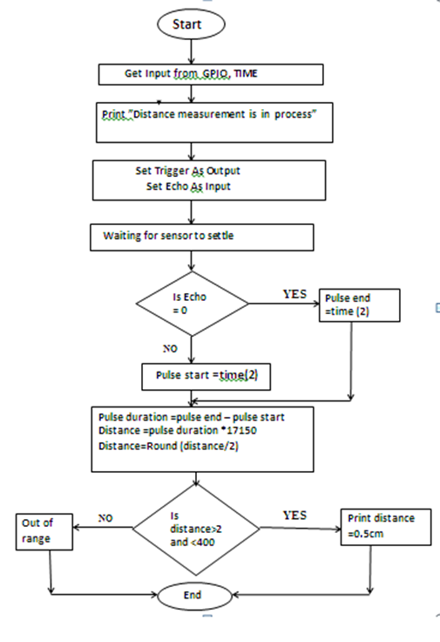
- METAL(BOMB) DETECTION

A metal detector is an electronic instrument which detects the presence of metal nearby. Metal detectors are useful for finding the metal inclusions hidden within objects or metal objects buried underground. Here,we are using metal detector VK557 for in dam area.When activated through the python program,it sends the presence of metal and send alert to web depicting concept of IOT.The alert message is displayed on the LCD screen.IOT helps to transfer data over a network without humaninterference.

- EARTHQUAKE DETECTION

For earthquake detection , we are making use of a system which is purely based on the vibration sensing. Here the system sensesthe vibrations before the actual earthquake occurs and sends the remark to the web and again the alert is displayed on LCD screen.We also have a provision of siren to alert nearby people.

Python language programing for earthquake & explosive detection using the ultrasonic sensor is as given below:

importRPi.GPIO as GPIO
import time
GPIO.setmode(GPIO.BCM)
GPIO.setwarnings(False)
GPIO.setup(4,GPIO.OUT)
GPIO.setup(2,GPIO.OUT)
while True:
GPIO.output(2,GPIO.HIGH)
GPIO.output(4,GPIO.LOW)
time.sleep(2)
GPIO.output(2,GPIO.LOW)
GPIO.output(4,GPIO.HIGH)
time.sleep(2)

- CONCLUSIONS AND FUTURE WORKS

In this paper we are detecting the water level of the dam using ultra sonic sensor.If the level of water is in between 2 to 400m,its will display the status of water level on LCD. Otherwise,it will give the message “Out of range.”.Also if it will sense the earthquake vibrations and presense of nearby explosive (metal) ,then it will give prior intimation about it.
In future we can add radar system to detect the explosive instead of using the sensors.Also we can detect toxins present in dam water.

REFFERENCES

[1] Nikhil M. Dhandre ,M. M. Jadhav, “Dam Data Collection and Monitoring System”,2013,IJSR.
[2] A.O Afolabi ,T.JAfolabi, “Implementation of Electronic Nose Technique In Explosives Detection” ,2013,IJES
[3] RavinderSingh ,K.S.Nagla “Proposed model of an earthquake detector by using UBG-04LX-F01 laser rangefinder”,2012 available at www.ijarcsse.com
[4]S.M.Khalel, Reza, Shah AhsanuzzamanMd.Tariq, S.M.Mohsin Reza “Microtroller Based Auutomated Water Level Sensing And Controlling”,2010,WCECS.
[5]Seideh J Rastin, Charles Unsworth(University of Auckland)KenGledhil(GNS),George Coghill(ECE)(EQC funded project 06/U531)”Seismology and geology”,2011

