Design and Fabrication of Solar Power Cultivator

Dhiraj R. Lanjewar¹,Rohit Y. Dighore², Sagar A. Ukey³, Nilesh C. Bendewar⁴
Rajendra B. Gaikwad⁵, Sharayu Wasu⁶

^{1,2,3,4,5}Research Scholar, ⁶ Assistant Professor, Department of Mechanical Engineering, Wainganga College of Engineering, Dongargaon, Nagpur, Maharashtra, India – 441108

dhirajlanjewar140202@gmail.com

Received on: 15 April, 2022 Revised on: 24 May, 2022, Published on: 26 May, 2022

Abstract – In Indian agriculture, the preparation of seedbed for deep tillage using additional machinery and tilling tools are increased. Power tiller or cultivator is one of the tillage machines most suitable for seedbed preparation. In a power tiller machine, the blade is a critical part, which is engaged with the soil to prepare a seedbed and mix to fertilizer. For increasing the maximum weed removal efficiency of tilling blade in new design. There is because to utilize and increase the fertility of land to increasing the crop productivity. In this machine we have added some extra part which is help to improve the maximum weed removal efficiency. The parts are adjustable wheels (for adjusting tilling depth), clearance between two blades etc. Is create a favorable environment for the sustain growth of crop. Commonly used blade shapes are L, J, and C. power tiller is useful for maintaining beds already formed. Power tiller perform both operations like pulverizing and bed maintaining at same time.

Keywords- Motor Powered tiller, house gardening, tools, blades, etc.

I – INTRODUCTION

Now a day’s Indian farmers are unhappy to spent money for seedbed preparation because of one reason raises in fuel price. To overcome this problem, we made an electric power tiller which is power by electric motor and battery. The battery is eco-friendly and rechargeable. The power tiller is mainly used in agriculture sector for preparing a seedbed on upper layer of soil. The power tiller is not only the higher soil mixing capacity compared with the other machine but also good weed cutting capacity. Power tiller leads to the water air, thermal and nutrient of the soil is improved. In a power tiller we provide an adjustable wheel for various working depths for soil bed preparation. Types of blades are available in market. Just like L, J and C shape Of blade. The power tiller in a market it is operated on IC Engine. For the running of engine, the petrol and diesel are needed it is big problem, because the engine creates a pollution in environment and it is very harmful for human beings. Because of this problem we find a solution and make an electric power tiller. This is economical and no any pollution is creating. In electric power tiller we added some more useful accessories, which are adjustable handle is used to adjust the height of handle with respect to operator and adjustable wheel is used to adjust the tilling depth of blades in soil and one more application of wheel is, when it is transport from one place to another place then the total load of machine is wheel and easily transportable. One more thing is added in it which is Solar Plate. When battery is discharge in working condition, in this case the solar plate is used for charge the battery and increase the life battery.
Cultivator Functions are:

- To inter-culture the soil.
- Remove the unwanted plants in the field.
- To increase Aeration of the soil for higher
yields.
- To Preserve moisture content by mulching the
soil.
- To sow seeds when it is provided with sowing
attachments.
- To avoid surface evaporation.
- To encourage rapid infiltration of rain water
into the soil.

II-LITERATURE SURVEY
The present research has dealt with solar rotary tiller design for the power tiller that is made for using in primary and secondary tillage[1]. Comparative study for portable weeders and power tillers in the Indian market is discussed. Various methods used for weed removal in crops are also discussed. This study revealed that most of the Indian farmers, majority of which are small scale farmers can afford only portable weeders. Project concentrate on reduction of efforts of using the manual farm equipment. The new developed soil tiller is operated on the solar power and it consist of following parts likes Solar plate, Battery 12 Volt D.C., Wiper motor, Pedestal bearings, tiller blade. In the new modified soil tiller the rotor blade is mount on shaft between the two pedestal bearings which is fixed on the frame of tiller and wiper motor is attached to the rotor blade using v-belt and wiper motor is fixed on the frame. Solar plate is fixed on the upper part of the tiller so that the sun rays will directly spread on the solar plate and solar plate output is given to the battery which supplies current to the wiper motor. The rotation of the motor is clockwise or anticlockwise depends on the connection. Now the project mainly concentrates on designing a suitable operating system. project achieves high safety, reduces human effort, increases the efficiency of the soil tiller, reduces the work load, reduces the fatigue of workers and reduces maintenance cost[2].
The study summaries the progress made in the development of lubricating pumps for internal combustion engines during the last two decades. Gear units' working points are determined by examining their circuit interplay after a description of the original fixed-diameter gear units. There appears to be a mismatch between the engine's flow needs and the pump's feature, as evidenced by the inquiry A substantial quantity of fuel is lost as a result of the flow-generating unit's overall inefficiency. Recent years have seen several initiatives to minimize power consumption by the lubricating pump. Among the pumps examined in this study are those with variable displacement, those with variable timing, and
This report details a student's design, manufacture, analysis, control, and testing operations for a motor-powered tiller for agricultural labor. We need to look at non-conventional energy sources to tackle these concerns with fossil fuels. In order to implement this concept, we created a solar-powered cultivator [3].
Agriculture is the primary source of the India population. It plays a crucial role in the economic growth of our country. In olden days plows are used to stir or tillage the soil. Nowadays tractors are used for different cultivations [5]. The tractor is an engineering vehicle specially designed for agriculture purposes. Many cultivators or farming equipment are attached to the tractor for tillage and stir the soil. Using the tractor is more expensive for small farmers. Design and manufacturing of multifunctional agricultural machines by using worm and worm wheel gearbox mainly used for inter agricultural purposes. As a worm wheel gearbox is utilized for producing less speed and more torque, hence introduced in machine further speed reduction is carried out by chain drive [6]. It is nothing but a two-wheeled tractor popularly known as power tiller. The conventional power tiller is having many drawbacks. As like fails to deliver high torque and fails to absorb shocks during agricultural operation. The project relates to developing more torque and design different attachments to it. Plough implement is firstly introduced to power tiller via this project. As per the name multifunctional, machine utilized for pump sets, material handling, pesticide spraying, etc.
III- WORKING PROCESS

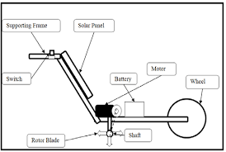
Fig.1- Schematic representation of Solar Power Cultivator

The intercultural blades tap power from the geared Direct Current powered motor with 100rpm. The rotating blades continuously remove the unwanted plants and the Rotavator is propelled forward with help of manually. Depth of imbecilitating is adjusted by means of the screw and nut mechanism with the help of the screw rod, as shown in fig.1. The working diameter of the weeding mechanism should be as small as possible to operate within the crop row. The weeding mechanism should not be required to work at a depth more than 20-30 mm because early growth stage weeds have not penetrated deeply into the soil. The average draft power availability in sustained working from male agricultural worker is consider as 60 Watts while for a woman it is consider as 48Watts. Development of equipment which allows different categories of tasks: Removal of weeds, aeration of the root zone, creating soil mulch, spray the Pesticides or liquid fertilizers on the vegetables, fruits, seeds, washing /cleaning and also part of that energy is stored in the form of battery which may be further utilized by using other attachments

IV-WORKING COMPONENT
- Battery
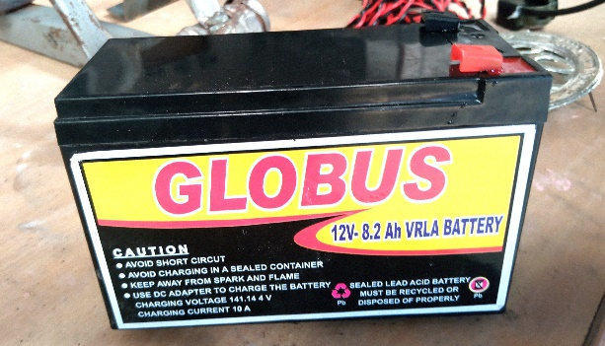
Fig 2-Battery

A twelve-volt battery has six single cells in series producing a fully charged output voltage of 12.6 volts, as shown in fig.2. A battery cell consists of two lead plates a positive plate covered with a paste of lead dioxide and a negative made of sponge lead, with an insulating material (separator) in between.
Lead acid batteries are quite common in our day-to-day life. it's the foremost oftentimes used battery in physical science. though it's lower energy density than the atomic number 3 particle batteries however since is incredibly safe to use lead acid battery with correct precautions taken.

- Solar Panel:
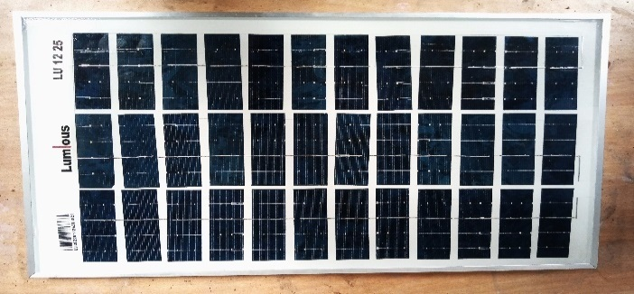
Fig 3-Solar Panel

The star cultivator is operated by solar power. The lead acid battery charged with voltage generated thanks to solar power with the assistance of an electric cell. star cells convert the solar power directly into electricity victimization electrical phenomenon result. The electrical phenomenon result involves conversion of nonparticulate radiation into electricity. The physical phenomenon and electrical phenomenon effects area unit associated with daylight , however area unit completely different in this electrons area unit ejected from a material's surface upon exposure to nonparticulate radiation of enough energy in physical phenomenon , and therefore the electrons that area unit generated area unit transferred to completely different bands of valence to conductivity at intervals the fabric therefore this results into build - up of voltage between 2 electrodes in electrical phenomenon , star cells area unit connected electrically and made as a module with a sheet of glass on prime to permit lightweight to pass and defend the semiconductor from the weather . to get the voltage of twenty-four V 2 panels of 12V every area unit connected nonparallel. because the title suggests the bicycle is operated by solar power. The lead acid battery is charged with solar power with the assistance of an electric cell.

- DC SERIES MOTOR:
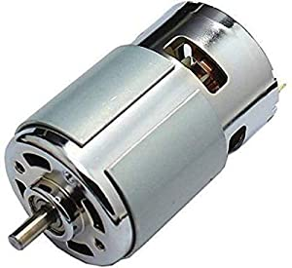
Fig 4- Dc Motor

This type of motor very large amount of running force called torque, from a stand still because of this characteristic the DC motor can be used to operate small electric appliances, portable electric tools, cranes winches & like another characteristic is that the speed varies widely between number load & full loaded. Series motor cannot be used where a relatively constant speed required under conditions of varying load. The manor disadvantage of dc series motor is related to the speed characteristic of mention in last paragraph. The speed of series motor with number of loads connected. To it increase to point, where becomes the motor will be damaged. Usually either the bearings are damaged or the winding fly out of the slots in armature. There is danger to both equipment & personal some load must always be connected to a series motor before it turns on. This precaution is primarily for large motor, small motor such as these used in electric hands drills, have enough internal frictional to load than selves

V- RESULT & CONCLUSION

Solar power cultivator is a capable to crushing Soil properly in skill agricultural Process. Mainly in small skill agricultural Process. Using Solar Power Cultivator, we remove. Unnecessary plants from flow. All types of soils we crushing properly and Make the soil soft.
Cultivator is Our project is successfully implemented for emphasizes on minimization of harmful efforts of using the manual rotavator. The new developed battery power operated. Today in the world fuel prices rises day by and the pollution may also. To control this pollution and to save the petroleum product and bio product this project is design and developed. This system requires heavy initial investment but it gives the energy output for life time with low maintenance etc. Here in our project, we conclude that by using this machine we reduce the manpower, risk, and cost. Our main intention is to help the farmers.
Renewable energy utilization is the best option to reduce the use of various non-renewable energy sources. From the various reference we come to conclusion that solar energy utilization is more advantage than other energy sources. Solar energy absorbed by solar panel and stored in the battery and then this solar energy issue to run various equipment. Hence, we decide to developed the solar powered blade harrow equipment which is beneficial for farmer in their agricultural work.

REFERENCES
- Ms. Jagtap Pooja At. All ; “Solar Seed Sowing Machine”; IJSRD - International Journal for Scientific Research & Development| Vol. 3, Issue 11, 2016 | ISSN (online): 2321-0613.
- John Chembukkavu At. All;“Solar Operated Automatic Seed Sowing Machine”;IJSRD – International Journal for Scientific Research & Development| Vol. 4, Issue 11, 2017 | ISSN (online): 2321-0613.
- Vipul Saxena; “Solar Powered Seed Sowing Machine”; International Journal of Applied Engineering Research ISSN 0973-4562 Volume 13, Number 6 (2018) pp. 259-262.
- Manjesh M N; “Solar Powered Digging and Seed Sowing Machine”; International Journal for Research in Applied Science & Engineering Technology (IJRASET) |Volume 5 Issue III, March 2017 |ISSN: 2321-9653.
- Byre Gowda At. All; “Solar Seed Sowing Machine”; International Journal of Engineering Research & Technology (IJERT)| Vol. 8 Issue 05, 2019| ISSN: 2278- 0181
- Prof. Swati D.Kale, Swati V. Khandagale, Shweta S. Gaikwad, “Agriculture Drone for Spraying fertilizer and pesticides”, “International journal of advance research in computer science andsoftware Engineering”, volume 5,Issue 12,(Dec-2015)
- S.R.Kulkarni, Harish Nayak, Mohan Futane, “Fabrication of portable foot operated Agricultural Fertilizer and pesticides spraying pump”, “International journal of Engineering Research and technology”, ISSN:2278- 0181,volume 4,Issue 07(July-2015)
- Saharawat, Y.S., Singh, B., Malik, R.K., Ladha, J.K., Gathala, M., Jat, M.L. and Kumar, V. 2010. Evaluation of alternative tillage and crop establishment methods in a ricewheat rotation in north-western IGP. Field Crops Res. 116: 260– 267.
- Kalay khan, S.C. Moses, Ashok kumar “A Survey on the Design, Fabrication and Utilization of Different Crops Planter” European Academic Research - vol.iii, July 2015.
- D.N.Sharma and S. Mukesh (2010) “Farm Machinery Design Principles and Problems” Seciond revised edition Jain brothers,New Delhi Vern Hofman, Elton Solseng, "Spray Equipment and Calibration", Agricultural and Biosystem Engineering, North
- .Dakota State University, Sept 2004. Aditya Kawadaskar, Dr. S. S. Chaudhari “Review of Methods of Seed Sowing Concept of Multi-Purpose Seed SowingMachine”, International journal of pure and applied research in engineering and technology, 2013; Volume 1(8):267-276.
- Srinivasan R.Zanwar, R.D.Kokate (June2012), Advanced Agriculture System, International Journal of Robotics and Automation (IJRA) magazine.9. R. Eaton, J. Katupitiya , S.D. Pathirana (2008), Autonomous Farming Modelling And Control Of Agricultural Machinery in a unified framework,15th international conference on mechatronics and machine vision in practice,New Zealand.
- Blackmore S. (2007). A systems view of Agricultural Robotics. Precision Agriculture conference, Wagon Academic Publishers, Netherlands.Simon Blackmore, Bill Stout, Maohua Wang, Boris Runov (2005), Robotic agriculture – The future of agriculture mechanism, Agro Technology, the royal veterinary and agriculture University.

