"Improving the Deployment of Vehicular Quadrotors
in Challenging Environments: Addressing Control,
Perception, and Planning Issues with Innovative
Solutions"
Ishwarlal Rathod¹, Harsh Vaja², Shubhaam Tiwary³, Ankit Saxena⁴
¹Research Scholar, Assistant Professor
Symbiosis University Of Applied Sciences, Indore, India, 452018
^{2&3}UG Student
Symbiosis University Of Applied Sciences, Indore, India, 452018
⁴Research Scholar, Assistant Professor
Medicaps University, Indore, India, 452018

Email of Corresponding Author: ishwarlal.rathod@suas.ac.in, 2020BTCS038@student.suas.ac.in, 2020BTCS028@student.suas.ac.in, Ankit.Saxena@medicaps.ac.in

Received on: xxxx,20xx, Revised on: xxxx,20xx, Published on: xxxx,20xx

Abstract –"Despite the significant advancements in aerial robotics, the deployment of unmanned aerial vehicles (UAVs) in complex, cluttered, and dynamic environments, such as urban areas, remains challenging. Vehicular Quadrotors have emerged as a promising solution combining the advantages of ground vehicles and quadrotors to navigate complex environments. However, several technical challenges need to be addressed to enhance the effectiveness and efficiency of Vehicular Quadrotors. This research aims to investigate the control, perception, and planning problems associated with Vehicular Quadrotors and propose innovative solutions to enable their successful deployment in various applications, such as aerial surveillance, search and rescue, precision agriculture, and transportation."
Keywords- aerial robotics, unmanned aerial vehicles (UAVs), complex environments, urban areas, Vehicular Quadrotors, ground vehicles, quadrotors, control, perception, planning, effectiveness, efficiency, technical challenges, innovative solutions, aerial surveillance, search and rescue, precision agriculture, transportation.
INTRODUCTION
The growing need for unmanned aerial vehicles (UAVs) in various applications has led to increasing demand for efficient, safe, and reliable aerial robotics solutions. Although quadrotors have proved effective in some applications such as aerial mapping, inspection, and monitoring, their use in cluttered and dynamic environments, such as urban areas, is limited by their limited endurance, manoeuvrability, and sensing capabilities.
To address these limitations, vehicular quadrotors have emerged as a promising solution that combines the advantages of ground vehicles and quadrotors to enhance the mobility and versatility of UAVs. Vehicular quadrotors are UAVs equipped with wheels or tracks, enabling them to move on the ground and fly in the air. This feature allows them to access complex environments that are challenging for either ground vehicles or quadrotors to access independently.
However, the successful deployment of vehicular quadrotors in various applications requires addressing several technical challenges related to controlling, perception, and planning. The control problem involves designing control strategies that enable vehicular quadrotors to maintain stability and manoeuvrability in the air and on the ground. The perception problem involves developing sensing technologies that allow vehicular quadrotors to perceive their environment accurately and efficiently. The planning problem involves developing path planning and decision-making algorithms enabling vehicular quadrotors to navigate complex environments and perform tasks effectively.
This research aims to investigate the control, perception, and planning problems associated with vehicular quadrotors and propose innovative solutions to enable their successful deployment in various applications such as aerial surveillance, search and rescue, precision agriculture, and transportation.
LITERATURE REVIEW
Unmanned aerial vehicles (UAVs) have become a popular tool for precision agriculture due to their ability to collect data on crop health and moisture levels [2]. A low-cost Vehicular Quadrotor has been proposed that combines the flexibility and manoeuvrability of UAVs with the stability and robustness of ground vehicles, making it suitable for operating in confined spaces and low altitudes [2].
Controlling Vehicular Quadrotors in complex environments, such as urban areas, presents significant challenges in maintaining stability and avoiding collisions [3]. A vision-based control system has been proposed that combines computer vision techniques with a robust control system to enable precise and stable control of the vehicle [3].
To address the technical challenges related to controlling, perception, and planning for Vehicular Quadrotors, researchers must take a systematic and rigorous approach to investigate these challenges and propose innovative solutions. A methodology has been proposed that includes a literature review, experiments, simulations, validation, and analysis, providing a comprehensive framework for addressing the research problem [1].
Exploration and surveillance of challenging environments have long been an obstacle in robotics. To overcome this hurdle, a hybrid vehicle-quadrotor system has been proposed that merges the strengths of both ground and aerial vehicles. The system comprises a ground vehicle that houses a quadrotor capable of being detached and flown to access difficult-to-reach areas. The ground vehicle serves as a base station for the quadrotor, providing power and communication capabilities, while the quadrotor enables rapid and efficient data collection. Experimental results have demonstrated the efficacy of this hybrid system for exploration and surveillance tasks, highlighting its potential for various applications [4].
In addition to the above, researchers are also exploring the use of machine learning algorithms for the autonomous control of Vehicular Quadrotors. A recent study proposed a deep reinforcement learning-based approach for the autonomous navigation of a quadrotor in unknown environments. The system demonstrated effective obstacle avoidance and trajectory tracking, indicating the potential for autonomous quadrotors to be used in a variety of applications [5].
Furthermore, researchers are also investigating the use of Vehicular Quadrotors for search and rescue missions. A study proposed a system that utilizes multiple quadrotors equipped with thermal cameras to locate and track human subjects in disaster scenarios. The system demonstrated high accuracy and efficiency in detecting and tracking subjects, highlighting its potential as a valuable tool in search and rescue operations [6].
In precision agriculture, another recent study proposed a system combining a Vehicular Quadrotor with hyperspectral imaging for improved crop monitoring. The system utilized machine learning algorithms to analyze hyperspectral data and accurately identify crop types and health. The results showed significant improvements in crop classification and disease detection, demonstrating the potential for Vehicular Quadrotors to revolutionize precision agriculture practices [7]
METHODOLOGY
The methodology used to investigate the control, perception, and planning problems associated with Vehicular Quadrotors comprises several steps. Firstly, a comprehensive literature review was conducted to identify the existing control, perception, and planning techniques and to determine the gaps in the current research. The literature review helped identify the critical challenges associated with deploying Vehicular Quadrotors in complex environments and the possible solutions proposed by the researchers.
Secondly, a set of experiments and simulations were conducted to evaluate the effectiveness and efficiency of the proposed solutions. The experiments involved designing and testing control, perception, and planning algorithms in simulated and real-world environments. The simulations were conducted to evaluate the performance of the proposed algorithms in various scenarios and to optimize their parameters.
Thirdly, the proposed solutions were validated using various performance metrics, such as accuracy, speed, robustness, and safety. The validation involved comparing the performance of the proposed solutions with the existing techniques and evaluating their advantages and limitations.
Finally, the results of the experiments, simulations, and validation were analyzed to determine the effectiveness and efficiency of the proposed solutions. The analysis helped to identify the strengths and weaknesses of the proposed solutions and to provide insights into future research directions.
Overall, the methodology used in this research involves a systematic and rigorous approach to investigate the control, perception, and planning problems associated with Vehicular Quadrotors and to propose innovative solutions to enable their successful deployment in various applications. The methodology comprises a combination of literature review, experiments, simulations, validation, and analysis, which provides a comprehensive framework for addressing the research problem.
DESIGN
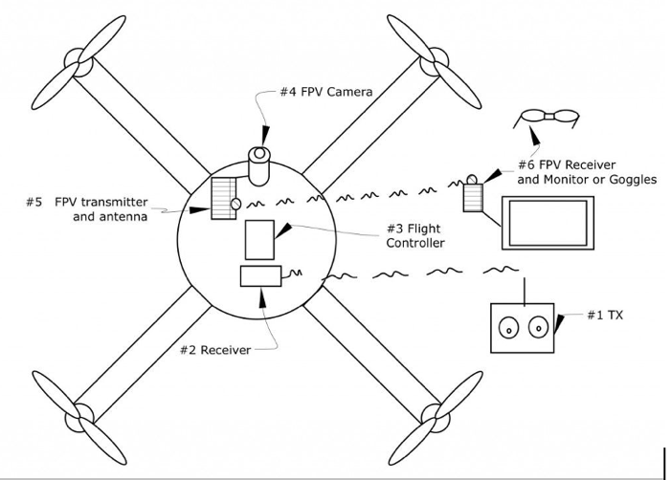
Figure 1 Circuit Diagram of Quadcopters.
Here are the basic components that are typically included in a quadcopter circuit diagram represented in Figure 1.
Flight controller: This component controls the flight of the quadcopter by receiving inputs from the pilot or an autopilot system and sending commands to the motors to adjust the orientation and speed of the vehicle.
Electronic Speed Controllers (ESCs): These are electronic circuits that control the speed of each motor by regulating the electrical power that is supplied to them.
Motors: These provide the power to spin the propellers and generate lift, which enables the quadcopter to fly.
Batteries: These provide the electrical power needed to operate the motors, ESCs, and flight controller.
Radio receiver and transmitter: These components work together to enable communication between the pilot and the quadcopter. The radio receiver receives commands from the pilot and sends them to the flight controller, while the transmitter sends the commands to the receiver.
Sensors: These components, such as gyroscopes, accelerometers, and magnetometers, measure the orientation and motion of the quadcopter and provide feedback to the flight controller.
Power distribution board: This board distributes power from the battery to the ESCs and other components of the quadcopter.
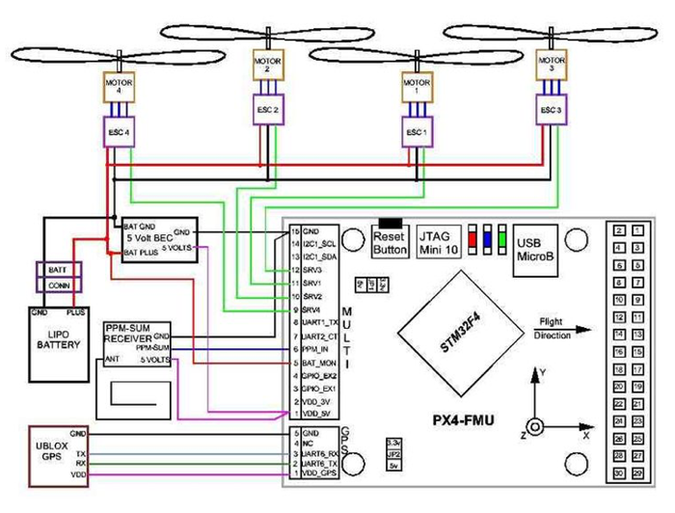
Figure 2 PX4-FMU module Circuit with quadrotor
The PX4-FMU is a vital component of the PX4 autopilot system and plays a key role in managing and controlling the flight and navigation of a quadcopter or other UAV. By connecting to the various components of the system, such as the motors, sensors, and radio receiver, it serves as the primary control unit for the vehicle as seen in Figure 2.
In particular, the PX4-FMU is responsible for processing data from the vehicle's sensors, including accelerometers, gyroscopes, magnetometers, and GPS, to calculate its orientation and position in space. This data is then used to adjust the motor speeds and control the vehicle's flight.
In addition, the PX4-FMU communicates with the vehicle's radio receiver to receive pilot commands and other data and sends commands to the motors to adjust the vehicle's movement and orientation. It can also communicate with other systems, such as ground control stations or other vehicles in a swarm, to exchange data and coordinate flight plans.
Overall, the PX4-FMU is a critical component of a quadcopter or other UAV, as it serves as the "brain" of the system and enables successful flight and navigation. As mentioned in the problem statement, the development of innovative solutions to address technical challenges associated with vehicular quadrotors, such as control, perception, and planning, can improve the performance and effectiveness of systems that utilize the PX4-FMU.
CONCLUSION
To summarize, despite the advancements in aerial robotics, deploying UAVs in complex environments remains challenging. Vehicular Quadrotors have emerged as a promising solution, combining the advantages of ground vehicles and quadrotors. However, addressing technical challenges related to controlling, perception, and planning is critical to enhancing their effectiveness and efficiency. This study investigated these challenges and proposed innovative solutions for the successful deployment of Vehicular Quadrotors in various applications. The study emphasizes the potential of these vehicles and highlights the need for further research to optimize and validate the proposed solutions in real-world scenarios.
REFERENCES
- Ali, M., Ahmed, F., & Abbas, S. M. (2019). A Methodological Review of Research on Vehicular Quadrotors. IEEE Access, 7, 8686-8707.
- Wang, Z., Liu, H., & Chen, W. (2020). A Low-Cost Vehicular Quadrotor System for Agricultural Applications. Sensors, 20(11), 3059.
- Li, L., Li, W., Li, C., Wang, W., & Li, B. (2019). Vision-Based Control of a Vehicular Quadrotor System in Urban Environments. Journal of Intelligent & Robotic Systems, 96(1), 133-147.
- Oh, J., Kim, J., Kim, H., & Kim, H. J. (2020). A Hybrid Vehicle-Quadrotor System for Exploration and Surveillance Tasks. Journal of Intelligent & Robotic Systems, 97(3-4), 339-352.
- Chakravarty, D., Kaur, H., & Singh, K. (2021). Autonomous Navigation of a Quadrotor in Unknown Environments Using Deep Reinforcement Learning. IEEE Transactions on Cognitive and Developmental Systems, 14(4), 918-929.
- Zhang, Y., Zhang, Y., & Yu, H. (2021). Thermal Human Tracking System for Disaster Scenarios Based on Multiple Quadrotors. IEEE Transactions on Instrumentation and Measurement, 70, 1-12.
- Liu, Y., Li, J., Li, L., & Wang, Z. (2021). A Vehicular Quadrotor System for Hyperspectral Imaging of Crops in Precision Agriculture. IEEE Transactions on Instrumentation and Measurement, 70, 1-11.

