Design and Analysis of U-Shaped Notch Bar for Multi-axial Loading

**Akash Nagendra Daharwal1, Dr. Bharat Chede2, Prof. S.M Choudhary3, Prof. Nitin Sawarkar4**

*1M. Tech student, 2Professor, 3,4Assistant Professor  
 Mechanical Engineering, Wainganga College of Engineering & Management, Nagpur*

*akashdaharwal@gmail.com*

***Received on****: 27March, 2022* ***Revised on****: 28 April,2022,* ***Published on****: 01May, 2022*

***Abstract –*** *The main purpose of this paper is the fatigue assessment and determination of stress concentration in U-shaped notched round bars under multi-axial loading. Despite its importance in the factors of mechanical design, very little work has been done in this field. The fatigue life prediction model relies on the assumption that both the smooth and the notched samples fail when a critical value of the total strain energy density is reached. In a first instance, consists of developing a fatigue master curve that relates the total strain energy density and the number of cycles to failure using smooth specimens subjected to strain-controlled conditions. In a second stage, the total strain energy density of the notched samples is computed from representative hysteresis loops obtained through a three-step procedure: reduction of the multiaxial stress state to an equivalent stress state using a linear-elastic finite-element model.*

***Keywords-*** *Stress concentration, FEA, Multi-axial loading.*

1. **INTRODUCTION**

Most of the engineering components contain geometrical discontinuities, such as shoulders, keyways, and grooves, generally termed notches. When a notched component is loaded then local stress and strain concentrations are generated in the notch area. The stresses often exceed the yield limit of the material in the small region around the notch root, even at relatively low nominal elastic stresses. The knowledge of stress and strain distributions on the net section is valuable for practical design and application of various engineering elements.

Stress and strain concentrations in any type of loading arise when uniformity of geometry is disrupted. Particularly, geometrical irregularities such as notches, grooves, holes, or defects are acting as local stress and strain raisers. They alter the lines of the principal stress; and bring about the stress and strain concentrations at the notch tip. Moreover, biaxial or triaxial stress state is produced at the net section even if the single loading, like axial tension, is applied to the notched bars. This single loading generates the uniaxial stress state in the un-notched part with the gross section. It should be noted that the net section is subjected simultaneously to the stress and strain concentrations and the multiaxial stress state.

A considerable amount of work has been completed with regard to the determination of elastic stress concentration factor for common discontinuities or geometrical irregularities under static loading. Results of these studies have been presented in graphical representation of analytical results, FEA results and experimental results.

Fewer studies have been done examining the SNCF of discontinuities under static loading. For static tension, it has been predicted by Neuber’s that the plastic SNCF increases and the plastic SSCF decreases from their elastic values as plastic deformation develops from the notch root.

Many experimental or analytical studies under static axial tension have confirmed this prediction. These results indicate that the SNCF is more important than the SSCF. This is because the plastic SNCF maintains a value much greater than unity while the plastic SSCF decreases towards unity. There have been many studies used to calculate the stress and strain at the notch root under static and cyclic tensile loading using Neuber’s rule, Glinka’s method, and linear rule. The predicted values have been compared with finite element and experimental ones. The results of these comparisons indicate that there is no rule which can accurately predict the magnitude of the axial strain at the notch root.

**METHOLOGY**

Analytical investigation for stress concentration factor to account for the peak in stress near a stress raiser, the stress concentration factor or theoretical stress concentration factoris defined as the ratio of the calculated peak stress to the nominal stress that would exist in the member if the distribution of stress remained uniform; that is,

$$Kt=\frac{σ_{max}}{σ_{nom}}$$

The nominal stress is found using basic strength-of-materials formulas, and the calculations can be based on the properties of the net cross section at the stress raiser. Sometimes the overall section is used in computing the nominal stress. The effect of the stress raiser is to change only the distribution of stress. Stress concentration results not only in unusually high stresses near the stress raiser but also in unusually low stresses in the remainder of the section. When more than one load acts on a notched member (e.g.2500N, 5000N, 7500N, 10000N, 12500N and 15000N) the nominal stress due to each load is the stress concentration factor corresponding to each load, and the resultant stresses are found by superposition.

The line spacing for the table content should be single only.

**PROBLEM DEFINITION**

The problem under consideration is to investigate the interference effect of U and V notch at fix parameters such as, Notch width, Notch inclination, Notch depth, Notch centre distance and Notch root shape (U-shaped, V shaped) of double circumferential notch shaft on stress-strain concentration for multi-axial loading conditions. The detail work is carried out with the help of Numerical method and the results are validated analytically (in some cases through redefining the existing mathematical models for our problem) & also experimentally. [1, 3]

Terminology used in Figure 1 as,

do= initial net-section diameter,

*D*o = initial gross diameter

ρo= initial notch radius

2Lo = the un-notched length from the notch center to the loaded end,

2lo = the notch pitch or the distance between the centers of the two notches.



Fig 1: Cylindrical bar with double-slant circumferential U notches.

Objective of the proposed work with reference to the above problem, the following objectives are set for this project:

1. Redefining the existing mathematical models to suit for our problem, and obtaining the stress & stain concentration analytically.

2. To analyze circumferential double notch shaft for its stress concentration & stress interference effect numerically.

3. Investigating the effect of same notch parameters discussed above on elastic stress concentration & interference effect through detail Numerical analysis.

4. Experimental investigation of the same to validate the FEA results.

5. To compare findings of the Numerical & experimental investigation for deriving the characteristic curves & comparative statistics of both notch parameters as an attempt to set the standard use of notch parameter selection for specific application in future.

Calculation of Stress concentration factor in elastic range

Following standard analytical steps are used to calculate Stress Concentration Factor and maximum stress at notch root in Elastic Range. Depends on the geometry of notches of notched specimen and load types the calculations and formulae are different. Refer to figures for the geometries of the specimen’s calculations notations used for calculations are as follows,

Notation,

Kt = Stress Concentration Factor in Elastic Range

σ = Applied stress in N/mm2,

P = Applied axial force in N,

M = Applied moment in Nmm,

T = Applied torque in Nmm,

σnom = Nominal normal stress in N/mm2,

σmax = Maximum normal stress at stress raiser in N/mm2,

τnom = Nominal shear stress in N/mm2,

τmax = Maximum shear stress at stress raiser in N/mm2.

U-shaped notch in semi-infinite plate

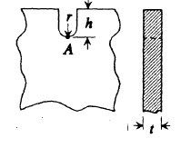

Fig: 2 U-shaped Notch in semi-infinite plate

Fig 2 shows the U-shaped notch in semi-infinite plate having notch radius r and notch depth h and thickness t. Point A is the bottom most point of notch where stress is maximum stress σmax.

U-shaped Notch in semi-infinite plate having uniaxial tension



Fig: 3 U-shaped Notch in semi-infinite plate having uniaxial tension

Figure 3 shows the U-shaped notch in semi-infinite plate having uniaxial tension which gives nominal stress σ. Stress concentration factor is calculated by,

*Kt* = 0*.*855 + 2*.*21 $\sqrt{h/r }$ for 1 ≤ *h/r* ≤ 361

Maximum stress is present at point A, and is calculated by,

σmax = σA = Ktσ

Opposite single U-shaped notches in finite-width plate



Fig: 5 shows the Opposite single U-shaped notches in finite-width plate having notch radius r and notch depth h and thickness t. The bottom most point of notch having maximum stress σmax..

U-shaped circumferential groove in circular shaft



Fig: 9 U-shaped circumferential grooves in circular shaft

From, Fig: 9 shows the shaft having circumferential U-shaped notch. Diameter of un-notched portion of shaft is indicated by D, and notched diameter is denoted by the d, also r is the root radius and h is depth of the notch.

Stress concentration factor of U-shaped circumferential groove in circular shaft under axial loading is calculated by,

Where,

|  |  |  |
| --- | --- | --- |
|  | 0*.*1 ≤ *h/r <* 2*.*0 | 2*.*0 ≤ *h/r* ≤ 50*.*0 |
|  | 0*.*89 + 2*.*208− 0*.*094*h/r* | 1*.*037 + 1*.*967 $\sqrt{h/r }$ + 0*.*002*h/r* |
| $$C_{2 }$$ | −0*.*923 − 6*.*678 $\sqrt{h/r }$ + 1*.*638*h/r* | −2*.*679 − 2*.*980 $\sqrt{h/r }$ − 0*.*053*h/r* |
| $$C_{3 }$$ | 2*.*893 + 6*.*448 $\sqrt{h/r }$ − 2*.*516*h/r* | 090 + 2*.*124 $\sqrt{h/r }$ + 0*.*165*h/r* |
| $$C_{4 }$$ | −1*.*912 − 1*.*944 $\sqrt{h/r }$ + 0*.*963*h/r* | −0*.*424 − 1*.*153 $\sqrt{h/r }$ − 0*.*106*h/r* |

For semicircular groove (h/r = 1.0)

$$K_{t}=004- 5.963 {\left(\frac{2h}{D}\right)}^{1}+ 6.836{\left(\frac{2h}{D}\right)}^{2}- 2.893{\left(\frac{2h}{D}\right)}^{3}$$

Maximum stress is calculated by,

$$σ_{max}=K_{t}×σ_{nom}$$

$where$

$$σ_{nom}=\frac{4×P}{d^{2}×π}$$

Stress concentration factor of U-shaped circumferential groove in circular shaft under bending loading is calculated by,

$$K_{t}=C_{1 }+ C_{2} {\left(\frac{2h}{D}\right)}^{1}+ C_{3} {\left(\frac{2h}{D}\right)}^{2}+ C_{4} {\left(\frac{2h}{D}\right)}^{3}$$

Where,

|  |  |  |
| --- | --- | --- |
|  | 0*.*25 ≤ *h/r <* 2*.*0 | 2*.*0 ≤ *h/r* ≤ 50*.*0 |
| $$C_{1 }$$ | 0*.*594 + 2*.*958 $\sqrt{h/r }$ − 0*.*520*h/r* | 0*.*965 + 1*.*926 $\sqrt{h/r }$ |
| $$C_{2 }$$ | 0*.*422 − 10*.*545 $\sqrt{h/r }$ + 2*.*692*h/r* | −2*.*773 − 4*.*414 $\sqrt{h/r }$ − 0*.*017*h/r* |
| $$C_{3 }$$ | 0*.*501 + 14*.*375 $\sqrt{h/r }$ − 4*.*486*h/r* | 4*.*785 + 4*.*681 $\sqrt{h/r }$ + 0*.*096*h/r* |
| $$C_{4 }$$ | −0*.*613 − 6*.*573 $\sqrt{h/r }$ + 2*.*177*h/r* | −1*.*995 − 2*.*241 $\sqrt{h/r }$ − 0*.*074*h/r* |

For semicircular groove (h/r = 1.0)

$$K_{t}=032-7.431{\left(\frac{2h}{D}\right)}^{1}+ 10.390{\left(\frac{2h}{D}\right)}^{2}- 5.009{\left(\frac{2h}{D}\right)}^{3}$$

Nominal stress calculated by, $$σ_{nom}=\frac{32×M}{{π×d}^{3}}$$

Maximum stress is calculated by,

$$σ_{max}=K_{t}×σ_{nom}$$

Stress concentration factor of U-shaped circumferential groove in circular shaft under twisting loading is calculated by,

$$K_{t}=C_{1 }+ C_{2} {\left(\frac{2h}{D}\right)}^{1}+ C_{3} {\left(\frac{2h}{D}\right)}^{2}+ C_{4} {\left(\frac{2h}{D}\right)}^{3}$$

Where,

|  |  |  |
| --- | --- | --- |
|  | 0*.*25 ≤ *h/r <* 2*.*0 | 2*.*0 ≤ *h/r* ≤ 50*.*0 |
| $$C_{1 }$$ | 0*.*966 + 1*.*056 $\sqrt{h/r }$ − 0*.*022*h/r* | 1*.*089 + 0*.*924 $\sqrt{h/r }$ + 0*.*018*h/r* |
| $$C_{2 }$$ | −0*.*192 − 4*.*037 $\sqrt{h/r }$ + 0*.*674*h/r* | 1*.*504 − 2*.*141 $\sqrt{h/r }$ − 0*.*047*h/r* |
| $$C_{3 }$$ | 0*.*808 + 5*.*321 $\sqrt{h/r }$ − 1*.*231*h/r* | 2*.*486 + 2*.*289 $\sqrt{h/r }$ + 0*.*091*h/r* |
| $$C_{4 }$$ | −0*.*567 − 2*.*364 $\sqrt{h/r }$ + 0*.*566*h/r* | −1*.*056 − 1*.*104 $\sqrt{h/r }$ − 0*.*059*h/r* |

Maximum shear stress is calculated by,

$$τ_{max}=K_{t}×τ_{nom}$$

$$where$$

$$τ_{nom}=\frac{16×T}{{π×d}^{3}}$$

**DESIGN OF EXPERIMENT FEA**

**1.** Design analysis of notched bar in ANSYS

A typical ANSYS analysis has three distinct steps:

1. Build the model.

2. Apply loads and obtain the solution.

3. Review the results.

These steps are performed using pre-processing, solution and post-processing processors of the ANSYS program. Actually, the first step in an analysis is to determine which outputs are required as the result of the analysis, since the number of the necessary inputs, analysis type and result viewing methods vary according to the required outputs. After determining the objectives of the analysis, the model is created in pre-processor. The next step, which is to apply loads, can be both performed in pre-processor or the solution processor. However, if multiple loading conditions are necessary for the required outputs and if it is also necessary to review the results of these different loading conditions together, solution processor must be selected for applying loads. The last step is to review the results of the analysis using post-processor, with numerical queries, graphs or contour plots according to the required outputs.

1.1 Determination of design outputs

The basic goals of FEA are to investigate the interference effect of both U-Shaped and V-Shaped root notch under axial loading.

1.2 Determination of design parameters

The notched bar design parameters are-

Notch root shape (U-shaped, V- shaped) of circumferential double notch shaft on elastic stress-strain concentration for multi loading conditions in axially.

1.3 Determination of loads

The different load on double circumferential notch shaft will be axial tension load for both notches to find the interference effect of stress concentration and strain concentration and also find total deformation in notch shaft or bar. Number of axial loads applied like 2500N, 5000N, 7500N, 10000N, 12500N and 15000N.

2. Specimen Geometries

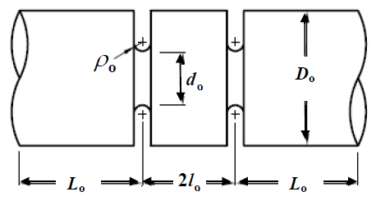

Fig: 1 Specimen Geometry

The employed cylindrical bar with double circumferential U-notches is shown in Figure 1. The net-section diameter is denoted by do (in mm), the gross diameter is denoted by Do (in mm), Do=50mm, 2Lo= the un-notched length from the notch center to the loaded end, 2lo= the notch pitch or the distance between the centers of the two notches. The specimen length is expressed as, Specimen length=2Lo+2lo.The un-notched length is held constant, while the half notch pitch lo is varied from 0.0 to 25 mm to examine the interference effect of the double circumferential U-notches. It should be noted that the notch angle γ =00 represents the cylindrical bar with a circumferential U-notch, perpendicular to the axial direction.

3. Sample analysis and Discussion of the results

The material for current sample analysis is selected as Structural Steel Fatigue Data at zero mean stress comes from 1998 ASME BPV Code, Section 8, Div 2 and Table 5-110.1

Yield tensile strength and Yield compression strength are Syt=Syc=2.5E+08Pa,

Ultimate tensile strength is, Sut =6 E+08Pa

Density of Structural Steel =7850kg/m-3

Figure 2 shows the CAD Model of U-Shaped Notched bar prepared in design modeler environment of ANSYS Workbench. For the accuracy in result, a model is meshed in symmetric shape with 450446 elements and 646900 nodes using tetrahedral element Solid 187 element. A mesh model of bar with U-notch is shown in figure 3. A bar is having two notches along its length and hence the refine meshing has been carried out at U-notch section as shown in figure 4. To find the stresses over the bar, it is fixed at one end and a load is applied at another end. The applied boundary condition on the bar is shown in figure 5.

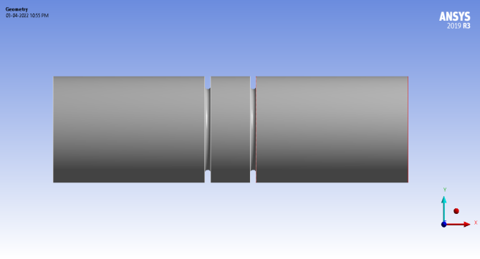

Figure 2 Specimen Geometry U- Shaped Notched bar

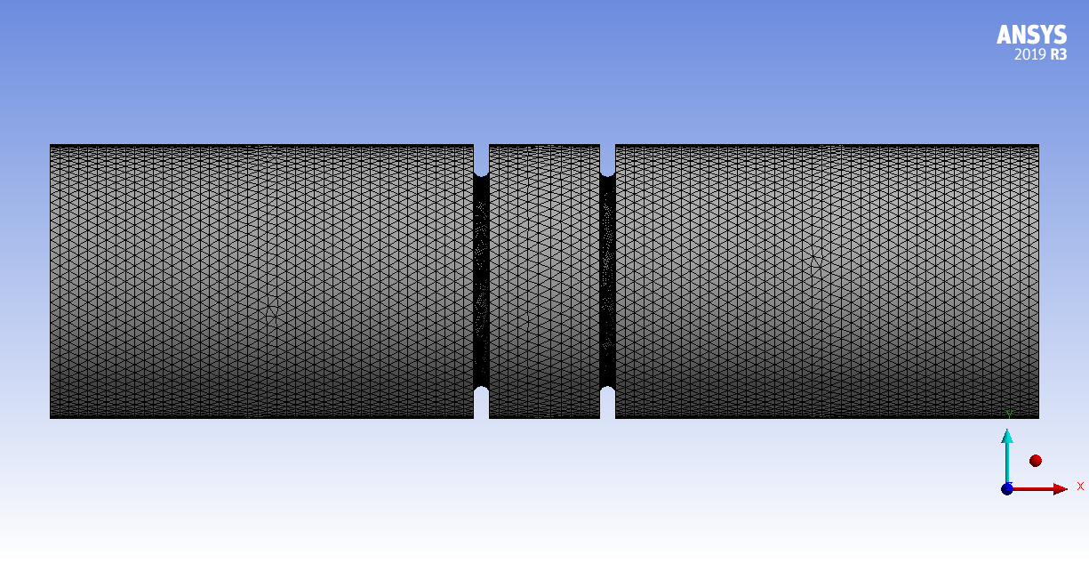

Figure 3 Meshing U-Shaped Notched bar

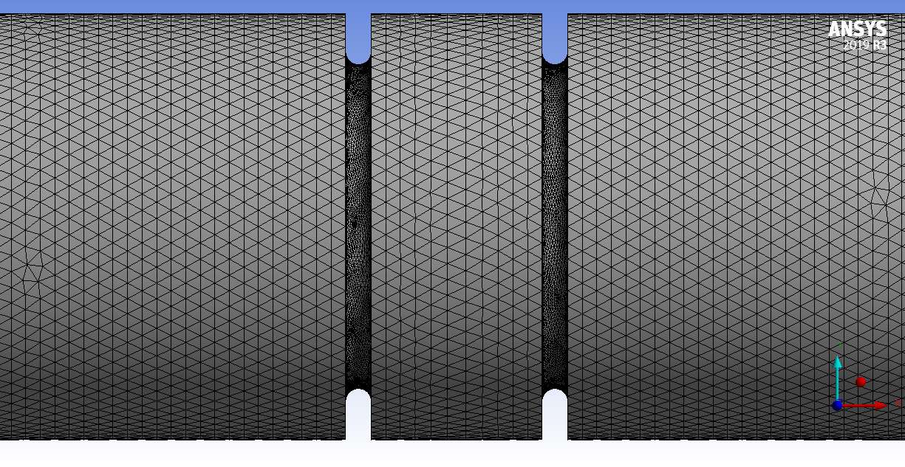

Figure 4. Refine Mesh at U-Notch

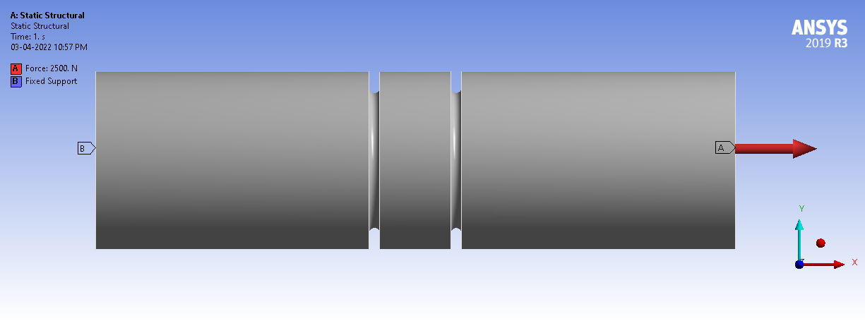

Figure 5. Boundary and loading condition

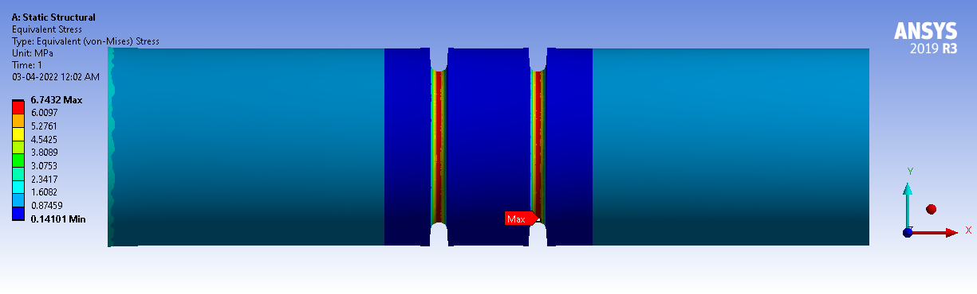

Figure 6. Equivalent (von-Mises) Stress (MPa)

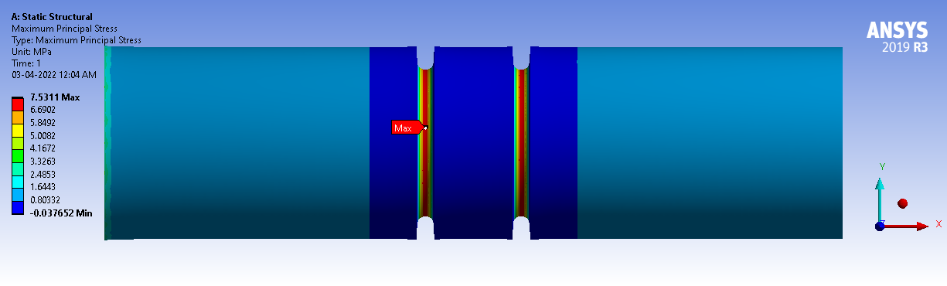

Figure 7 Maximum Principal Stress (MPa)

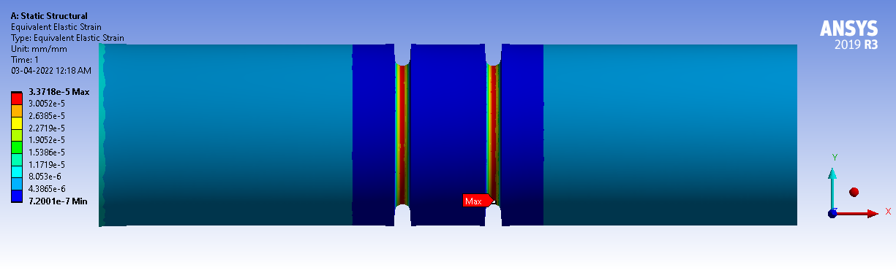

Figure 8. Equivalent (von-Mises) Elastic Strain

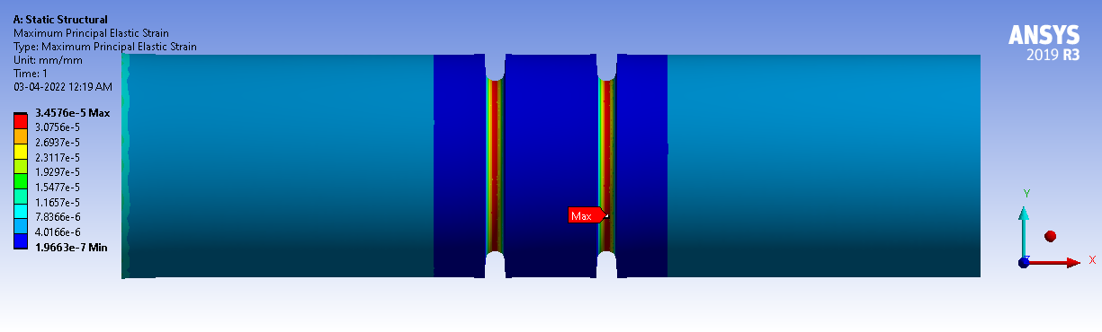

Figure 9. Maximum Principal Elastic Strain

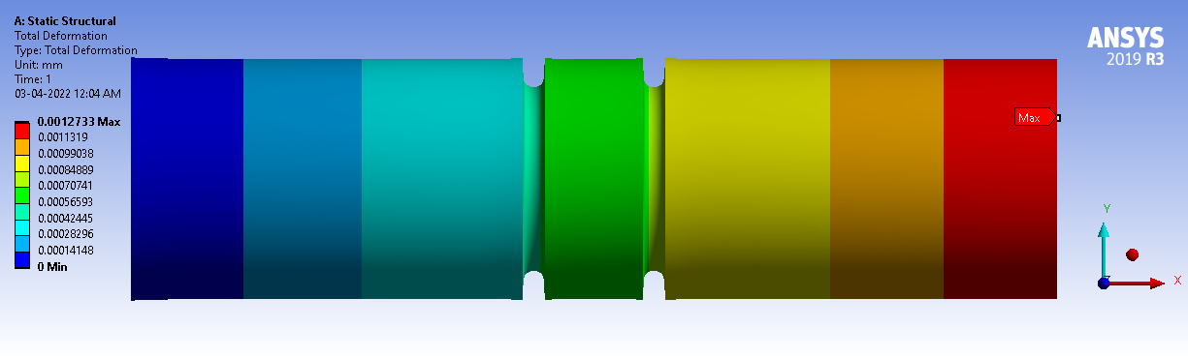

Figure 10. Total Deformation (mm)

The first step of solution is to choose the analysis type based on the loading conditions and the required outputs. FEA Results give complete idea of the interference effect of stress concentration and strain concentration. In Figure 3 shows the meshing of U-notch geometry and from Figure 6 FEA gives Equivalent (von-Mises) Stress (MPa). From Figure 7, we can understand that the Maximum Principal Stress concentration is occurred at the notch root. Also stress interference is occurred at the notched length of double circumferential inclined notched. In Figure 8 FEA gives Equivalent (von-Mises) Strain which elaborate the concept of strain concentration at notch root and strain interference at notch length. Figure 9 indicates the pattern of Maximum Principal Elastic Strain Intensity. Strain intensity is occurred at the notched length. Figure 10 shows the total deformation output from FEA which gives that deformation is occurred maximum at free end where load is applied and deformation is occurred minimum at fixed end.

**ANALYTICAL VALIDATION**

1. Calculation of U-shaped circumferential notched in circular shaft for axial load

Consider the shaft having symmetrical circumferential notch with un-notched diameter as 50mm, notch depth 6mm, notch root radius 1.5mm, hence notched diameter of shaft is 38mm which is subjected to various axial load of 2500N, 5000N, 7500N, 10000N, 12500N and 15000N.

Stress concentration factor of U-shaped circumferential groove in circular shaft under axial loading is calculated by,

Where,

|  |  |  |
| --- | --- | --- |
|  | 0*.*1 ≤ *h/r <* 2*.*0 | 2*.*0 ≤ *h/r* ≤ 50*.*0 |
|  | 0*.*89 + 2*.*208–  0*.*094*h/r* | 1*.*037 + 1*.*967 $\sqrt{h/r }$ + 0*.*002*h/r* |
| $$C_{2 }$$ | −0*.*923 − 6*.*678 $\sqrt{h/r }$ + 1*.*638*h/r* | −2*.*679 − 2*.*980 $\sqrt{h/r }$ − 0*.*053*h/r* |
| $$C_{3 }$$ | 2*.*893 + 6*.*448 $\sqrt{h/r }$ − 2*.*516*h/r* | 090 + 2*.*124 $\sqrt{h/r }$ + 0*.*165*h/r* |
| $$C_{4 }$$ | −1*.*912 − 1*.*944 $\sqrt{h/r }$ + 0*.*963*h/r* | −0*.*424 − 1*.*153 $\sqrt{h/r }$ − 0*.*106*h/r* |

$$\frac{h}{r}=\frac{6}{1.5}=4$$

Hence, should select the range 2*.*0 ≤ *h/r* ≤ 50*.*0

${ C}_{1 }=$ 1*.*037 + 1*.*967 $\sqrt{h/r }$ + 0*.*002*h/r*

$=1.037 + 1.967\sqrt{4 }+ 0.002×4$

= 4.974

$C_{2 }=-2.679 - 2.980\sqrt{h/r }- 0.053h/r$

$$=-2.679 - 2.980\sqrt{4}- 0.053×4$$

= $-$ 10.71

${ C}_{3}$ = 090 + 2*.*124 $\sqrt{h/r }$ + 0*.*165*h/r*

$$= 090 + 2.124\sqrt{4 }+ 0.165×4$$

$=8.808$

${ C}_{4}=$ −0*.*424 − 1*.*153 $\sqrt{h/r }$ − 0*.*106*h/r*

= −0*.*424 − 1*.*153 $\sqrt{4}$ − 0*.*106

=

And,

* 1. Calculate Nominal and Maximum stress in Notch shaft for axial load 2500N

Nominal stress can be calculated as,

σnom=

Maximum stress is calculated by,

σmax = Ktσnom

σmax =

σmax = 6.3256

* 1. Calculate Nominal and Maximum stress in Notch shaft for axial load 5000N

Nominal stress can be calculated as,

σnom=

Maximum stress is calculated by,

σmax = Ktσnom

σmax =

σmax = 12.6517

* + 1. Calculate Nominal and Maximum stress in Notch shaft for axial load 7500N

Nominal stress can be calculated as,

σnom=

Maximum stress is calculated by,

σmax = Ktσnom

σmax =

σmax =

* + 1. Calculate Nominal and Maximum stress in Notch shaft for axial load 10000N

Nominal stress can be calculated as,

σnom=

Maximum stress is calculated by,

σmax = Ktσnom

σmax =

σmax =

* + 1. Calculate Nominal and Maximum stress in Notch shaft for axial load 12000N

Nominal stress can be calculated as,

σnom=

Maximum stress is calculated by,

σmax = Ktσnom

σmax =

σmax =

* + 1. Calculate Nominal and Maximum stress in Notch shaft for axial load 15000N

Nominal stress can be calculated as,

σnom=

Maximum stress is calculated by,

σmax = Ktσnom

σmax =

σmax =

From above analytical investigation, we got that the maximum stress at notch root for various loads and from FEA we get the maximum principal stress is shown in previous section 5 which clearly shows the stress interference and stress concentration at notch root with magnitude. So, both analytical stress intensity and maximum principal stress by FEA at notch root much closed with analytical calculations and their details results shown in Table 1.

Table 1 Analytical and FEA results for U shape notch shaft or bar

|  |  |  |
| --- | --- | --- |
| Force | Analytical | FEA |
| (N) | Max. Stress  (Mpa) | Max. Principal Stress (Mpa) |
| 2500 | 6.3256 | 5.7402 |
| 5000 | 12.6517 | 11.480 |
| 7500 | 18.9775 | 17.221 |
| 10000 | 25.3034 | 22.961 |
| 12500 | 31.6292 | 28.701 |
| 15000 | 37.9551 | 34.441 |

Hence one can say that FEA results for the axial load are validated by analytical investigation. This validation shown graphically in Figure 6.1 is as follows,

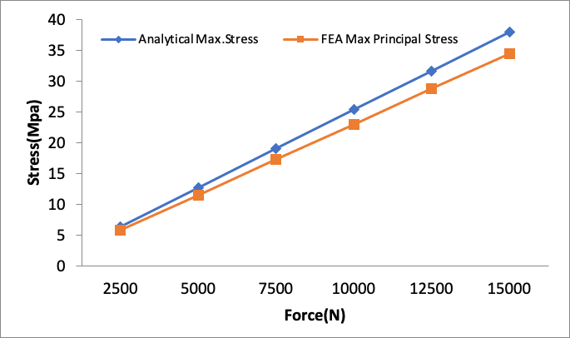

Figure 1. Analytical stress vs FEA Stress (Mpa) value for U shape notch shaft

**MODEL EVALUATION**

EFFECT ON NOTCH FOR AXIAL LOADS USING FEA

The effect of notch parameters such as various loads on U shaped and V shaped notches for axial loading is performed and investigation of stress distribution at notch surface are obtained by FEA software ANSYS.

The output of FEA is used deriving the characteristic curves & comparative statistics of various notch loads as an attempt to set the standard load and notch selection for specific application in future.

Effect on U shaped notch for various axial load

The effect on U shape notch at various loads such as 2500N, 5000N, 7500N, 10000N, 12500N and 15000N are observed for stress and strain distribution and check for stress concentration over the notch surface. The FE analysis for various loading condition are as follows,

1.1 Effect on U shaped notch at 2500N axial load

For notch depth 6mm, notched diameter 38mm and un-notched diameter 50mm, angle of notch inclination 0o, notch root radius 1.5mm and axial load 2500N, FEA steps and output are discuss as per following figures.

In order to take the advantage of geometrical symmetry, modeling geometry is done as shown in Figure 1 and Figure 2 gives the loading condition on geometry. The material of the specimen is considered as Structural Steel having Syt=Syc=2.5E+08Pa, Sut =4.6 E+08Pa, Density=7850kg/m-3.

FEA Results give complete idea of the interference effect of stress concentration and strain concentration. In Figure 3 FEA gives Equivalent Stress. From Figure 3, we can understand the concept of the stress concentration at the notch root. Also stress interference is occurred at the notched length of double circumferential inclined notched. In Figure 4 FEA gives Equivalent Strain which elaborates the concept of strain concentration at notch root and strain interference at notch length.

Stress intensity is maximum at notch root and interference of stress intensity is occurred at the notched length. Figure 5 and Figure 6 shows the Maximum Principal Stress (MPa) and Maximum Principal Strain and both indicate the interference of same clearly and Figure 7 gives the total maximum deformation (in mm).

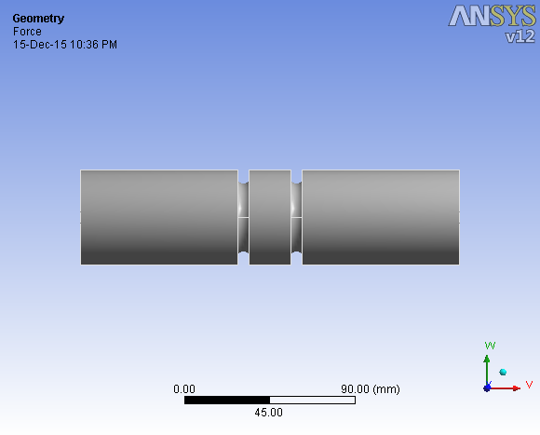

Figure 1 Model of double notched bar

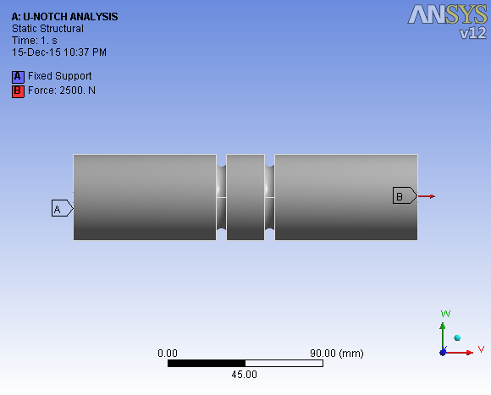

Figure 2 Load applied



Figure 3 Equivalent Stress



Figure 4 Equivalent Strain

Figure: Force (N) vs Equivalent Stress and Maximum Principal Stress (MPa)

Figure: Equivalent Stress (Mpa) along length of bar at U-notch

**CONCLUSION**

This paper describes the procedure for determination of stress concentration factors using numerical simulation as alternative to real mechanical tests. In particular, the problems with bar of circular cross section with U-groove subjected to tension and bending are investigated.

Geometrical variations for both tension and bending are obtained using MATLAB, whereas the calculation of stress concentration factors is performed via ANSYS. Final expressions for stress concentration factors are obtained using regression analysis tools in MATLAB. The obtained values for stress concentration factors over a range of geometrical variations for both tension and bending show a very good agreement with the data from literature.

Further investigation is also possible in order to extend presented investigation for the case of torsion. However, the procedure and software used in this paper could be used for other cases of stress concentration, where data are no available or to simplify and improve existing models.

**REFERENCES**

1. Kisija J., Determination of stress concentration factors for circular cross-section bar with U- groove subjected to tension and bending (in Bosnian), final year project, Masinski fakultet,

Univerzitet u Zenici, 2009

1. Kacmarcik, Beslagic, Spahic: New Mathematical Model of Stress Concentration Factor in Tension of Rectangular Bar With Opposite Edge U-notches.
2. Pilkey Walter D, Pilkey Deborah D.: Peterson's Stress Concentration Factors, Third Edition, John Wiley & Sons, Inc., 2007
3. Warren C. Young, Richard G. Budynas: Roark's Formulas for Stress and Strain, Seventh Edition,

McGraw-Hill, 2002

1. Fatigue calculator, [http://www.fatiguecalculator.com,](http://www.fatiguecalculator.com/) 2010
2. Pilkey, W. D., Peterson’s Stress Concentration Factors, Wiley, New York, 1997.
3. 6.2. Timoshenko, S. P., and Goodier, J. N., Theory of Elasticity, 3rd ed., McGraw-Hill, New York, 1970.
4. 6.3. Maleev, V. L., and Hartman, J. B., Machine Design, 3rd ed., International Textbook Co., Scranton, PA, 1954.
5. 6.4. Neuber, H., “Theory of Stress Concentration for Shear Strained Prismatic Bodies with Nonlinear Stress–Strain Law,” J. Appl. Mech., Vol. 28, Ser. E, No. 4., 1961, pp. 544–550.
6. 6.5. Fuchs, H. O., “Discussion: Nominal Stress or Local Strain Approaches to Cumulative Damage,” in Fatigue under Complex Loading, Society of Automotive Engineers, Warrendale, PA, 1977, pp. 203–207.
7. 6.6. Leyer, A., Maschinenkonstruktionslehre, Birkhauser Verlag, Basel, Switzerland: English language ¨ edition. Machine Design, Blackie & Son, London, 1974.
8. 6.7. Boresi, A. P., Schmidt, R. J., and Sidebottom, O. M., Advanced Mechanics of Materials, 5th ed., Wiley, New York, 1993.
9. 6.8. Juvinall, R. C., Stress, Strain, and Strength, McGraw-Hill, New York, 1967.
10. 6.9. Hooke, C. J., “Numerical Solution of Plane Elastostatic Problems by Point Matching,” J. Strain Anal., Vol. 3, 1968, pp. 109–115.
11. 6.10. Liebowitz, H., Vandervelt, H., and Sanford, R. J., “Stress Concentrations Due to Sharp Notches,” Exp. Mech., Vol. 7, 1967.
12. 6.11. Neuber, H., Theory of Notch Stresses, Office of Technical Services, U.S. Department of Commerce, Washington, DC, 1961.
13. 6.12. Atsumi, “Stress Concentrations in a Strip under Tension and Containing an Infinite Row of Semicircular Notches,” Q. J. Mech. Appl. Math., Vol. 11, Pt. 4, 1958.
14. 6.13. Durelli, A. J., Lake, R. L., and Phillips, E., “Stress Concentrations Produced by Multiple Semicircular Notches in Infinite Plates under Uniaxial State of Stress,” Proc. SESA, Vol. 10, No. 1, 1952.
15. 6.14. Matthews, G. J., and Hooke, C. J., “Solution of Axisymmetric Torsion Problems by Point Matching,” J. Strain Anal., Vol. 6, 1971, pp. 124–134.
16. 6.15. Howland, R. C. J., “On the Stresses in the Neighborhood of a Circular Hole in a Strip under Tension,” Philos. Trans. Roy. Soc. Lond. A, Vol. 229, 1929/1930.