Utilization of Solar Energy for Drying Paddy in Par Boiled Rice Mill by using Flat Plate Solar Air Heater

Dr.Jayant D. Supe¹ , Mr.Fanindra Faglal Katre², Mr Dhirendra Chourasia³,Mr.Ishan P.Lade⁴

¹Asso. Prof. Dept. of Civil Engg., RCET, Bhilai
^{2,4}Asst. Prof, Dept. of Civil Engg., Gurunanak Inst. Of Tech, Nagpur
³Asst. Prof, Dept. of Civil Engg., RCET, Bhilai

Abstract - The present crisis of fossil fuel shortages for producing thermal energy is creating increasing emphasis on the use of solar energy. Solar energy is freely available and is abundant in India for most of the year, it is non-polluting and inexhaustible. Here is a project for industrial use and that is “Utilization of Solar Energy for drying paddy in a par boiled rice mill.” In this project load on Steam Boiler has been reduced by using Flat Plate Solar Air Heater. The solar air heater which increases the air temperature used for paddy drying by about 35 ⁰ C more than ambient air temperature. A solar dryer uses a solar energy collector for heating the air. A flat plate solar collector can be used to dry agricultural produce efficiently and economically during sunny as well as overcast periods. It works with solar energy which has no operational cost and does not produce pollution. It will also contribute for the reduction of CO₂ emissions and hence reducing global warming.
INTRODUCTION
Existing process of paddy drying in a par boiled rice mill-
Function of Par Boiled Rice mill is to produce par boiled rice from harvested paddy .The steps of conversion from harvested paddy to par boiled rice are -:
Soaking of paddy, drying of paddy & milling of dried paddy for par boiled rice production in a milling machine.
For soaking and drying, steam is used which is generated in a fire tube boiler using paddy husk as fuel. In paddy rice mill number of equipments are installed for the production of par boiled rice such as Handa , Elevator , Drier , Heat exchanger , Blower , Boiler , Water softening unit , Water storage tank , recycled hot water storage tank , feed pump , water make up line , and accessories .

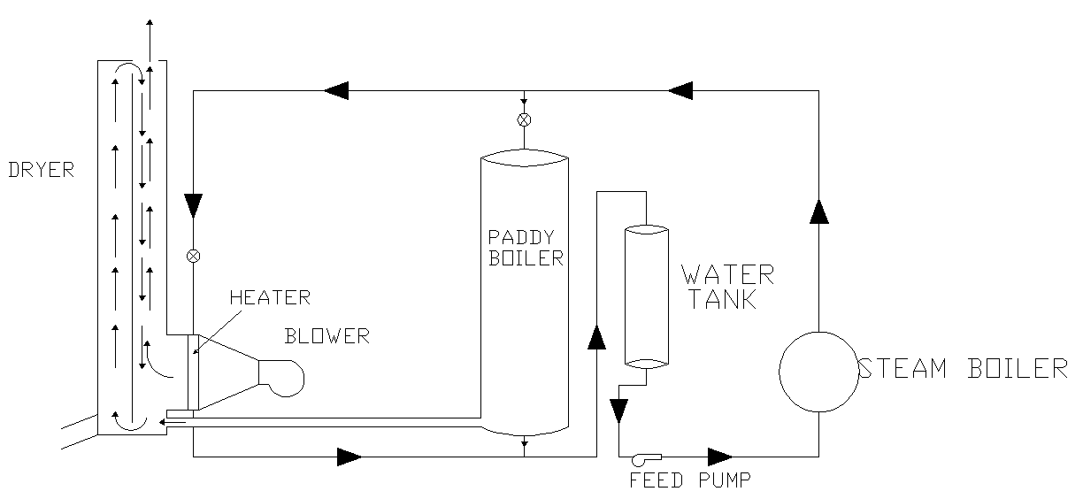
Fig-Line diagram of existing paddy drying system

Modification Proposed
For the modification in Par boiled rice mill and implementation of Flat plate solar air heater the following data has been collected ,

Latitude and Longitude of the site 21 ⁰ 13’ 0 / 81 ⁰ 25’ E
Likely turn over of the company = 2 crores,
Annual capacity = 10000 tonnes
Number of drier used for drying purpose = 2
Capacity of blower = 24000 m³/hr
Capacity of drier = 24 tonnes in 8 hrs
Temperature of hot air used in drier = 60 ⁰ C .
Total hour of drier used per year = about 1600 hour.
The horse power of blower = 7.5 HP.
Water used for steam production = Soft
Quantity of water to be heated per day = 9000 liter.
Steam type used = dry.
Pressure of steam supplied for heat exchanger = 6 Kg/cm²
Temperature of steam = between 160 to 168⁰C.
The working hours of mill = 8 hr per day.
The initial temperature inlet water = 30⁰C.
The final temperature of water required for = 80⁰C
Paddy soaking is in Handa.
Soaking time of paddy = 6 to 8 hr.
A Husk Pac steam boiler model HP-20 B of capacity 250 ⁰c temp and 10 Kg/cm² pressure, Paddy husk is used as fuel , the quantity of fuel used is 2 tonnes per day.

In existing system the ambient air is sucked by a blower and thrown to the heat exchanger , where the air is heated up to the required temp for paddy drying . The main aim of this project is, to supply air for heat exchanger through blower with higher temperature than ambient air temperature which can be achieved by installing a flat plate solar air heater (FPC) which can be connected with the suction line of the blower. By installing a flat plate solar air heater with the existing system the suction air temperature can be increased by approximately 35⁰ C. The schematic diagram below shows the modification done in existing process.
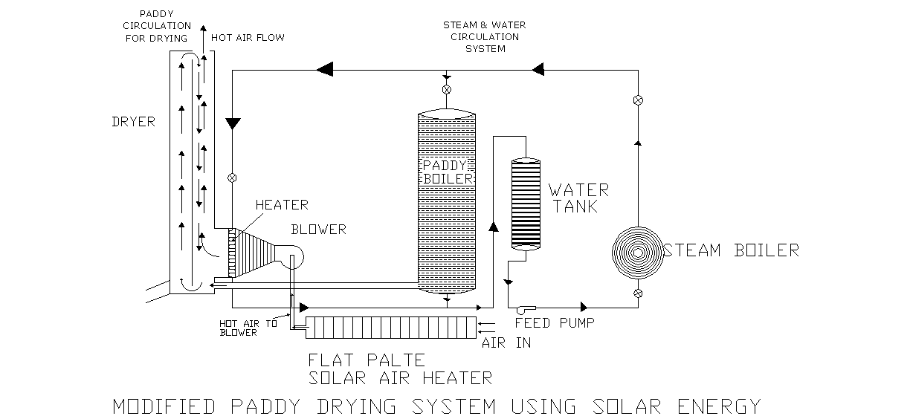
Fig-Layout Plan of Par Boiled Rice Mill after modification
After the calculation it has been found that to increase air temp. outlet 70.8 ⁰ C from ambient temp 35 ⁰ C and for air flow rate 400kg/hr , 8 sqm flat plate collector is required , so for 24000 kg/hr air flow rate the area of the flat plate required , will be 480 sqm
The flat plate solar air heater of size 480 sqm can be installed on the roof of the mill .

The installation cost and the pay back period of the solar flat plate air heater which is proposed in this project is as follows -:

C_{p} (Specific heat) of air from 0 to 60 ⁰ C is 1.005 kj/kg ⁰ K and from
70 -120⁰C 1.009 kj/kg- k , so let us consider an average C_{p} = 1.007 kj/kg-k .

Energy saving by increasing temp through FPC (Solar air heater) up to 35⁰ C of 24000 kg air will be

= m x C_{p} x del T
= 24000 x 35 x 1.007
= 845880 kj / hr
= 845880 / 4.187
= 202025.32 kcal (4.187 J = 1 cal )

Calorific value of paddy husk 3000 kcal / kg and let us consider the thermal efficiency of boiler is 40% , then saving of husk per hr will be ,
202025.32 / 3000 x 0.4 = 168 kg

So saving of paddy husk per day will be 8 x 168 = 1346.8 kg (as the working hrs of the mill is 8 hr)
Note – The saving of paddy husk 1348.8 kg for the summer when the global solar radiation is very high. For the whole year the average solar radiation will be less. So, here we consider 33% of summer season’s husk saving.
Amount saving per day @ Rs 1.20 / kg of paddy husk will be
= 1.2 x 1346.8 kg x 0.33 = Rs 533.33 per day
If working day of mill in a year is considered to be 200 days then the total annual saving will be 533.33 x 200 = Rs 1,06,666.56 /- .

The cost of flat plate solar air heater is Rs 1500 / m² area of dia coordinated research project on renewable source of energy for agriculture and agro based industries) .
So the installation cost of FPC 480 m² FPC will be 480 x 1500 = Rs 7.2 lakhs.

So capital investment is 7.2 lakhs
Govt subsidy @ 35% = 2.52 lakhs
So net amount required = 4.68 lakhs
Pay back period = net capital required / annual saving
= 468000/ 106666 = 4.38 years
( say 4 years & 5 months )
SUMMARY & CONCLUSION
It is found from the result out come calculation that the saving of paddy husk per day is about 500 kg .Though the CO₂ emission is not directly controlled by reducing the use of paddy husk as a fuel in a boiled rice mill because it is a natural carbon cycle of earth, but indirectly we can reduce the CO₂ emission by using the paddy husk as fuel in place of coal where burning is required round the clock, like thermal power plant, brick manufacturing, industrial boiler etc. So in thermal power plant, brick manufacturing, industrial boiler or this type of industry where coal is used as fuel can be replaced by paddy husk as a fuel. As the calorific value of coal is 4500 kcal / kg and the calorific value of paddy husk is about 2300 kcal / kg , so one kg of coal can be replaced by two kg of husk for power generation in power plant . By burning of one kg of coal 1.6 Kg of CO₂ is produced and as in this project 500 kg of paddy husk is saved per day which is equivalent to 250 kg of coal so CO₂ reduction per day will be 1.6 x 250 = 400 kg. By the implementation of flat plate solar air heater in Rani Sati Agro Pvt. Ltd .
As there are about 500 par boiled rice mill in Chhattisgarh so 400 x 500 = 20,0000 kg of CO₂ emission can be reduced By this way we can reduce the CO₂ emission and contribute to control the global warming.
Secondly we can reduce the operational cost of par boiled rice mill by Rs 533.33 /- per day by installing the solar system which will be a direct benefit to the owner of par rice mill. Solar equipment costs are generally high, relative to fossil fuel equipment costs, but operating costs are much lower. The variability of solar energy also limits its usefulness. However, as fossil fuel supplies dwindle and costs continue to rise, solar energy should become economically feasible for many applications.
REFERENCES
- Journal - Research , energy and development Sep. 2007 Vol.4
2 Breaking News on Food and Beverage in Asia Pacific www.AP-Foodtechnology.com , 20-02-08
3 Promoting & assisting the development of sustainable energy ttp://www.sei.ie/index.asp?locID=264&docID=-1 , 21-02-08
4 Sustainable Energy Ireland (SEI), http://www.sei.ie/index.asp?locID=264&docID=-1 , 22-02-08
5 Discover Solar Energy, a comprehensive resource http://www.discoversolarenergy.com/solar/radiation.htm , 22-02-08
6 G .D . Rai .Solar Energy Utilization , Fifth edition , Third revised -2000 , Khanna Publishers
7 Non-renewable ources,http://www.nonrenewablesources.com
8 Nuclear Energy. What is nuclear energy used for today? www.westinghousenuclear.com/Community/WhatIsNuclearEnergy.shtm
9 A Brief about Solar Energy . Economic growth with energy Alam, M.Shahid Northeastern university, Boston 25 dec 2006 http://mpra.ub.uni-muen-chen.de/1260/MPRA Paper No.1260,posted 07 . November 2007 / 01:38
10 Climate information, Geography, Cartography and Weather Maps
11 Energy Efficiency & Environmental News: Practical Uses of Solar Energy1 Florida Energy Extension Service and Mike West2 http://www.p2pays.org/ref/13/12135.pdf
12 S P SUKHATME , Solar Energy – Principle of Thermal Collection and Storage ,Second edition , Thirteenth reprint 2005
13 S.L Grassie & N.L Sheridan . “ The use of Planar Reflectors for increasing the Energy yield of Flat Plate Collector ” ,Solar Energy 19 , 663 (1977) .
14 4A flat plate solar collector system embodying a plurality of individual conventional solar collector panels . http://www.freepatentsonline.com/5365920.html . R.Hilpert “Warmeabgabe von geheizen Drahten and Rohren ” . French Gebiete Ingenieurw , 4 ,220 , (1933)
15 Single axis tracking systems , http://www.solar-tracking.com
16 M.P.THEKAEKARA and A.J.PRAMMOND, “Standard values for the solar constant and its spectral components”, Nat.Phys. Sci., 229, 6(1971)).
17 E. Frolich an R.W.Brusea, “Solar radiation & its variation in time”.) Solar Phy,74, 209 ( 1981))

