AN IOT BASED APPROCH FOR MEASURING AIR POLLUTION LEVEL
SHITAL PATIL,KAVERI DEOSARKAR,SHITAL MATE
Asst.prof. wainganga collage of engineering and management,Nagpur.
Asst.prof. wainganga collage of engineering and management,Nagpur.
m.tech,wainganga collage of engineering and management,Nagpur
shitalmate7@gmail.com

Abstract – The impact of daily emissions of gaseous and particulate pollutants of machines and industries on human health and the environment has attracted increasing concerns. This impact has significantly led to a notable increase in mortality in the highly industrialized zones. Therefore, monitoring air quality and creating public awareness are important for a safer future, which led the governments globally to invest multi-billion in policymaking and solution stratification to address the problem. This study aims to design a real time Internet of Things low-cost air quality monitoring system. The system utilizes air quality and carbon monoxide sensors for monitoring gaseous pollutants. Moreover, the system utilizes an Arduino Nano development board equipped with a WiFi module to effectively send readings to a ThingSpeak online channel platform for instantaneous and real-time display of air quality. The ThingSpeak uses HTTP protocols to send emails in raising awareness of poor air quality. The level of concentration is monitored graphically through channels with the help of ThingSpeak to aid remote communication. A threshold value is set. Thus, when pollutants have become unhealthy and harmful, the system trips off an alarm, and e-mail notifications are sent to the officials. The results have shown that the work was successfully implemented a design of a low-cost air quality monitoring system using Arduino and ThingSpeak, showing that an air quality system can be implemented using a low cost technology, Arduino and ThingSpeak.
INTRODUCTION
Maintaining adequate air quality possesses a global challenge to governments and citizens. The deteriorating air quality has essentially caused governments globally to invest in multi-billion sums in policymaking and solution stratification to address the problem. Air pollution is caused by particulate effects. In a survey conducted in 2016, the World Health matter emitted from industries, cars, machinery, waste recycling, industrial practices, and household. Some of the notable pollutants are the dust of heavy metals, carbon monoxide, ozone, carbon dioxide, nitrogen dioxide, suspended particulate matter, hydrogen fluoride oxides of sulfur, and others. These pollutants get into the atmosphere and cause severe health and environmental Organization (WHO) stated that air pollution, specifically of the ambient (outdoor) origin, is the estimated cause of 4.2 million premature deaths annually worldwide [1]. This value is a reflection of the population living in rural and urban areas. The map in Fig. 1 shows the density and intensity of air pollution globally. 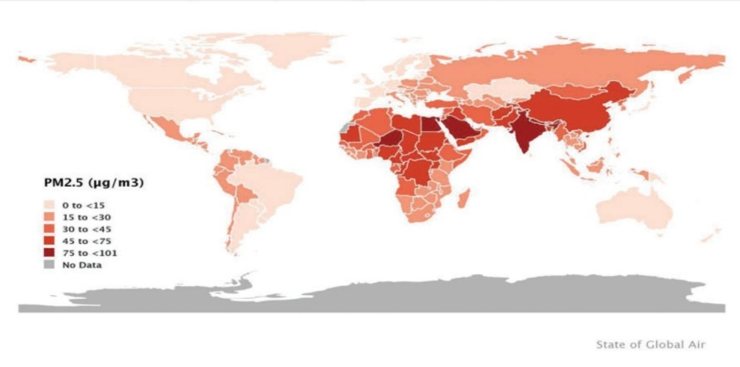 FIGURE: PM2.5 concentrations around the world
LITARATURE REVIEW
The AQI is a numerical value representation system created by the Environmental Protection Agency (EPA) to make a logical way of reporting daily air quality concerning the environment and human health. The AQI focuses on the negative impacts that people may experience on their health while breathing polluted air over a few hours or days. An increase in the AQI represents a subsequent increase in air pollution and human health threats [9]. The AQI is calculated for the six major pollutants stated under the Clean Air Act by the EPA in 1970: nitrogen oxides, particulate matter (PM 10, PM 2.5), carbon monoxide, sulfur dioxide, and ground-level ozone. Recent advances in technology have led to creating innovations and opportunities, such as the IoT, whereby embedded systems connected to the Internet can interact and be controlled through the Internet. For instance, researchers deployed IoT technology to monitor the water quality of a lake [10]. Numerous research projects on wireless sensory networks or IoT to detect and monitor the AQI has been performed [11]. These concluded projects measured various air pollutants with the use of mobile or stationary sensors. The proposed system evaluates the Waspmote platform created by Libelium, which offers various radio technologies, sensors, application programming interface (API), and open-source software development kits to improve neural networks [12]. This study evaluates the power consumption of wireless sensor networks, identified analytical functions, and then created a framework with utilization parameters. Reference [13] proposed a system using a wireless monitoring system to measure concentrations of pollutants. The proposed system was implemented on an IoT platform using sensory nodes connected to the Internet via a network gateway. The researchers used sensory nodes to ascertain the concentration of carbon dioxide and carbon monoxide in the environment. This proposed system employs mobile sensors placed on city buses to symbolize a smart air pollution system named “OpenSense” [14]. In this project, the researchers deployed trams as mobile platforms for conveying sensors. The sensors communicate to the cloud through a radio device cloud platform. Then, [15] proposed a system that monitors outdoor air parameters. The system consists of a PIC18F87K22 microcontroller interface with infrared gas and aerometry sensors. The researchers strategically placed the nodes embedded with the neural network at some locations in the town. This paper proposed the utilization of the IEEE/ISO/IEC 21451 standard to monitor air quality [4]. The system uses infrared and electrochemical sensors to measure NO2, CO, SO 2, and CO 2 concentration. The results were relayed and stored on a data server.Then, [2] implemented a system to create awareness of the effects of pollutants, gases, and toxins on air quality. The proposed system analyzes meteorological data, traffic data, and contaminants using an intelligent business engine called “APA.” The system detects the trends in air pollution and reports human activities that influence the decline in air quality.
METHOLOGY
Materials and Methods This section describes an IoT-based air quality monitoring system comprising the hardware components and the software platforms. Some of the tasks performed include design specification, design concept, and materials and method. Design Specification The air quality monitoring system comprises five units as shown in Tab. 1. The first unit is a power supply unit, which consists of a DC jack and a regulator. The second unit is the sensing unit, which consists of an air quality sensor and a carbon monoxide sensor. Then, the third unit is the control unit, which consists of the Arduino Uno atmega microcontroller. The fourth unit is the communication unit, which consists of a WiFi module used to transfer the air quality status from the control unit to the IoT platform. Finally, the fifth unit is the output unit, which consists of an LCD, a buzzer, and a ThinkSpeak IoT platform.

DESIGN
Implementation Using Fritzing
Fritzing is an open-source initiative that is used for schematic and printed circuit board (PCB) hardware simulation and design. The system circuitry framework, schematic, and PCB layout were executed using the Fritzing software. Fritzing was the preferred option because of its extensive library, which contains all the components used in the system. The simulation was conducted to ensure that the system operation was working properly before the commencement of the system development. Fig. 10 shows the breadboard pin connection view.
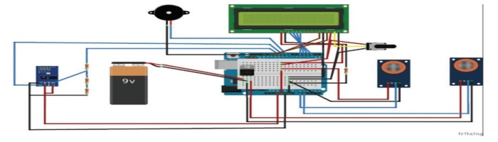
Fig 2:Pin connection of the entire system (modeled with Fritzing)
CONCLUSION
This work successfully implemented a design of a low-cost air quality monitoring system using Arduino and ThingSpeak, showing that an air quality system can be implemented using a lowcost technology, Arduino and ThingSpeak. The executed project was tested using various testing categories, namely, unit, sub-unit, system, acceptance, and program testing. The system performs credibly well in all testing parameters. With this system, a mobile app that can be easily deployed to monitor the air quality across the spectrum can be developed, thereby improving the health of the populace.

REFERENCES
[1] S. T. Odonkor and T. Mahami, “Knowledge, attitudes, and perceptions of air pollution in Accra, Ghana: A critical survey,” Journalof Environmentaland Public Health, vol. 2020, no. 9, pp. 1–8, 2020.

[2] P. Mehndiratta, A. Jain, S. Srivastava and J. E. Gupta, “Environmental pollution and nanotechnology,” Environment and Pollution, vol. 2, no. 2, pp. 49–54, 2013.

[3] Y. Huang, Q. Zhao, Q. Zhou and I. A. Jiang, “Air quality forecast monitoring and its impact on brain health based on big data and the internet of things,” IEEE Access, vol. 6, no. 5, pp. 78678–78688, 2018.

[4] K. Bianchini, R. Alvo, D. C.Tozer and M. L. Mallory, “The legacy of regional industrial activity: Is loon productivity still negatively affected by acid rain,” Biological Conservation, vol. 255, no. 3, pp. 108977–108997, 2021.

[5] D. Rickerby, M. J. S. Morrison and T. O. Aly, “Materials, nanotechnology and the environment: A European perspective,” Science and Technology of Advanced Materials, vol. 8, no. 2, pp. 19–30, 2007.

[6] D. E. Williams, G. S. Henshaw, M. Bart, G. Laing, J. Wagner et al., “Validation of low-cost ozone measurement instruments suitable for use in an air-quality monitoring network,” Measurement Science andTechnology, vol. 24, no. 6, pp. 65803–65823, 2013.

[7] A. C. Lewis, J. D. Lee, P. M. Edwards, M. D. Shaw, M. J. Evansetal., “Evaluating the performance of low cost chemical sensors for air pollution research,” FaradayDiscussions, vol. 189, no. 5, pp. 85–103, 2016.

[8] P. Arroyo, F. Meléndez, J. Suárez, J. Herrero, S. Rodríguez et al., “Electronic nose with digital gas sensors connected via bluetooth to a smartphone for air quality measurements,” Sensors, vol. 20, no. 3, pp. 786–806, 2020.

[9] B. Bishoi, A. Prakash and V. J. A. Jain, “A comparative study of air quality index based on factor analysis and US-EPA methods for an urban environment,” AerosolandAirQualityResearch, vol. 9, no. 1, pp. 1–17, 2009.

[10] M. Ansah, R. Sowah, J. Melià-Seguí, F. Katsriku, X. Vilajosana etal., “Characterising foliage influence on LoRaWAN pathloss in a tropical vegetative environment,” IETWirelessSensorSystems, vol. 10, no. 5, pp. 198–207, 2020.

[11] S. Kaivonen and E. Ngai, “Real-time air pollution monitoring with sensors on city bus,” Digital CommunicationsandNetworks, vol. 6, no. 1, pp. 23, 2020.

[12] V. Vinod, V. Mekala, S. Abinaya, A. Srinivas and S. Arun, “A customizable cartographic air pollution monitoring system,” InternationalJournalof ScientificandTechnology, vol. 9, no. 4, pp. 1675–1678, 2020.

[13] R. Dhanusha and S. Rathi, “A survey on air pollution monitoring using internet of things,” International Journal of Scientific Research in Science, Engineering and Technology, vol. 7, no. 3, pp. 350–355, 2020.

[14] P. Souza, A. Anjomshoaa, F. Duarte, R. Kahn and C. Ratti, “Air quality monitoring using mobile lowcost sensors mounted on trash-trucks: Methods development and lessons learned,” Sustainable Cities and Society, vol. 60, no. 3, pp. 102239– 102248, 2020.

[15] N. Motlagh, E. Lagerspetz, P. Nurmi, X. Li, S. Varjonen et al., “Toward massive scale air quality monitoring,” IEEE CommunicationsMagazine, vol. 58, no. 2, pp. 54–59, 2020. [16] K. Zheng, S. Zhao, Z. Yang, X. Xiong and W. Xiang, “Design and implementation of LPWA-based air quality monitoring system,” IEEE Access, vol. 4, no. 2, pp. 3238–3245, 2016
.

