Android Based Smart Healthcare Application

Anuj Rajesh Waghulde¹, Leena R. Waghulde ², Rajesh R. Waghulde³
¹UG Student, PCCOER, Pune, India, 411044
^{2,3} Assistant Professor, KCES’s COEM, Jalgaon, India, 425001

waghulderajesh10@gmail.com

Received on: 29 March,2023 Revised on: 21,April,2023 Published on:23 April,2023

Abstract –The aim of this system is to create a mental health system. In this project, try to understand the psychology of the user, find out if he is suffering and then show the steps they can take to get out of the current situation. Users answer some questions and show them activities based on their answers, and we collect information about their emotions to display on the dashboard. All over the world, mental illness is common. However, there is a global shortage of human resources to provide mental health services. Leaving people with mental illness untreated can lead to suicide attempts and death. In this study, Chabot, an integrated mobile application that uses cognitive behavioral therapy (CBT) method to support mental health in the management of emotions and feelings, thoughts and feelings is presented. It uses natural language processing to determine the user's needs by understanding language and dictionary operations only. Through this app, appropriate measures such as activities or awareness can be suggested based on thoughts.
Keywords- Keyword should be times new roman size 10 italic, bold.
INTRODUCTION
In this era of computerization, data security has become a very important area due to the large amount of data openly accessible on the web. Although security studies and testing in this area have progressed, many security attacks are still successful. In addition, knowledge has become an important part of the business world. In fact, even large organizations' data is still vulnerable and at risk of losing it. In particular, human vulnerability is addressed in a variety of ways to control people and build relationships to access their sensitive information.
Inspired by these developments, the field of information security is still very young and its analysis is more comprehensive. Man-in-the-middle attacks, phishing attacks, driver attacks, critical attacks, SQL injection protection, etc. More functional analyzes are needed to detect security attacks. Review the PCAP data generated by the metal shark during the attack and report the results to the organization for evaluation and appropriateness. The attack will be classified later. Another way would be to use artificial intelligence. Also, many strategies have been introduced to prevent phishing attacks[1].

BMI Calculator: MI corresponds to "Mass Index", which is your height and weight. With the BMI calculator app you can find out if you are anorexic, healthy, overweight or obese. BMI calculator app is exactly for that, just enter your height and weight and your BMI will be displayed with numbers and below your BMI you will be informed about your body. With the BMI calculator app you can now easily set the maximum weight you want to achieve with your diet. However, if you need help preparing food products with good ingredients, try our "Calories & Nutrition" app, which can give you accurate information about the nutritional values ​​of colored ingredients.

Disease Information: A disease or disorder is the result of a change or disorder in the structure or function of an organism or system. Illness is more of a condition in which a person defines himself based on physical or mental symptoms. Symptoms are symptoms that only the person with the disease can see and know. The main difference between symptoms and signs depends on the person observing the effects.
For example, a rash may be a sign, symptom, or both: if the patient sees a red rash, it is a symptom. The resource includes the name and address of the hospital and specialist so that the patient can contact them directly. We can list 5 diseases that are common in India. These are 1) Cancer 2) Tuberculosis AIDS 4) COVID-19 5) Diabetes.

Recommendations: Mobile health (mHealth) has been very popular in recent years. Our app's yoga page helps users exercise at home and improve their health. It is worth talking about how to provide yoga therapists with a better and improved experience to increase their willingness to continue using yoga practices. Today, with the spread of yoga culture, yoga for a healthy lifestyle is not only a method of exercise, decompression and body shaping, but is increasingly becoming its representative in every field.

Nutrition Facts: The processes by which organisms use food to sustain life Nutrition is a biochemical and physiological process that includes support, service, digestion, biosynthesis, catabolism, and excretion. The branch of science that studies the physiological processes of food is called nutrition. Meal plans are customized based on the patient's health, weight, and lifestyle, as well as weight loss and wellness goals.
Meal plans work as formulas to guide your eating habits, exercise and lifestyle to achieve optimum health and comfort. In this application you can choose from 6 to 12, 13 to 20, 21 to 31, 32 to 45 and 46'. We did 6 hours from 60 to 60.

Community Portal: The community portal will provide services to users to improve their level of knowledge on how to include exercise and health. include them in their own lives and provide clients with health and wellness. In this regard, we are working hard to create a community where patients can interact with each other.
We make chatbots where patients of the same type can interact and talk freely with each other.

LITERATURE REVIEW
The article [1] introduces patient programming based on intelligent agents. The appointment is determined by the health personnel as a priority and the following doctors can access all appointments, making it easier for patients to get consultation. It is a hierarchical system and doctors do not have direct appointment rights. The authors at [2] propose a Smartphone app to improve health in Bangladesh. This article introduces a mobile phone app-based medical device with many advantages that can change the way people respond to emergencies.
You can use this application to find quick and effective solutions instead of panic. In this study [3], various features such as Android Smartphone and tablet applications that can be accessed free of charge from Google Play Store, employee health information, tracking medical records, number of steps and working hours are discussed. The design of [4] has provided hospital users with many benefits, including staffing and reconnaissance models, guidance, and the ability to access medical information. Individuals are retained in local medical records.
METHODOLOGY
SYSTEM DESIGN
Block diagrams are often used at a higher level, less descriptive, to clarify a general idea without worrying about the use of context. As shown in Figure 1.
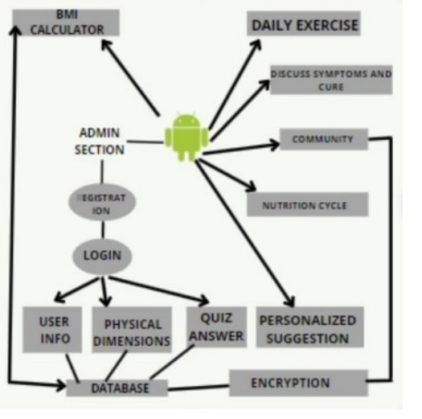
Fig. 1: System Design of Smart Health Care
"An Android-based app has been created that helps users get health advice from experts and communicate with each other through a community portal." It includes a complete health app, a BMI calculator, a nutrition chart, a fitness trainer, a disease page, and a community website. Therefore, it is necessary to create an application with five different options on the home page. It will gather reliable information from the Internet, determine what fits the user's profile and choose the basis for advice, update its selections based on experience, and learn from the best community of advice and practitioners.
WORKFLOW OF SMART HEALTH CARE
In this application we will start with instructions on how to use this application after the login page appears. If the user is not logged in, the user can register. After that, the user will be asked some questions. Based on the answers given by the user, describe the thinking state and the current thinking and present the results to the user. Users can view their mental health by graph.
According to the report, users will be advised to work to improve their health. Finally, the app provides contact information for some psychiatrists. If the user needs help from a psychologist, then he or she can seek help from a psychologist. This application is a user friendly application. The user interface of the application is easy to use and the power is easy for users to understand.
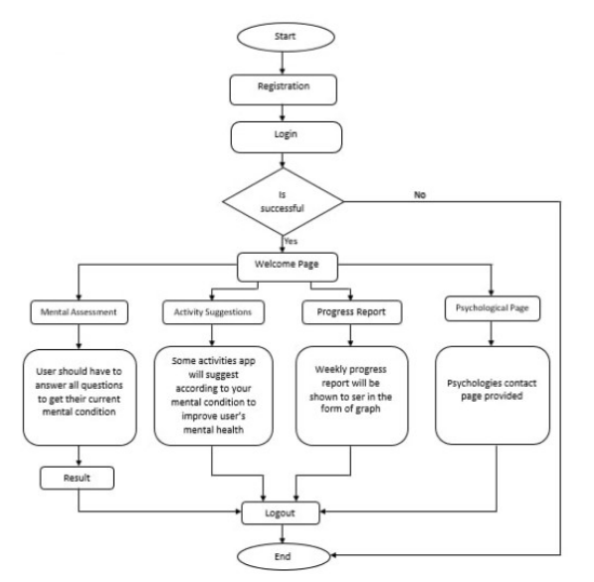
Fig.2- Flowchart of Smart Health Care
contents of the paper should be size 10 normal, line spacing 1.15, justified. The contents of the paper should be size 10 normal, line spacing 1.15, justified.
RESULT & DISCUSSION
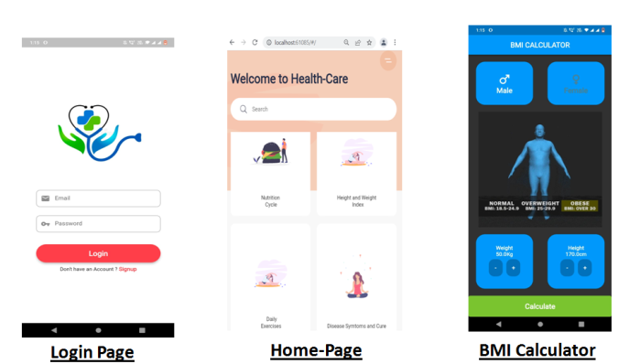
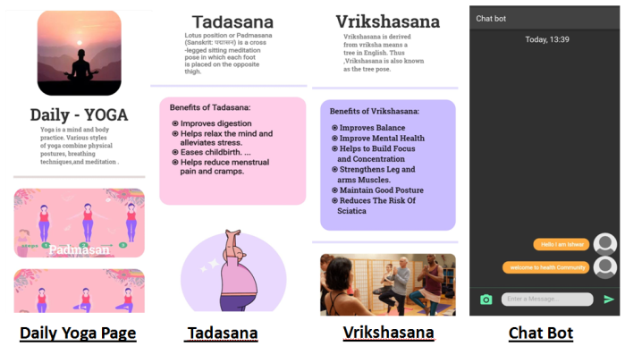
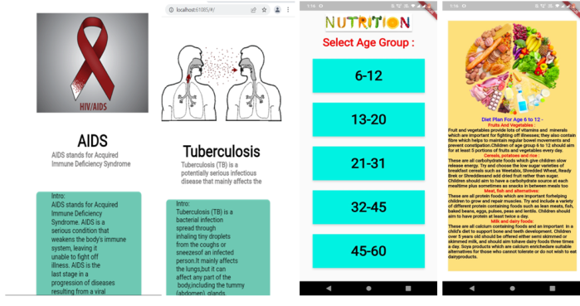
Fig.3. possible display
The application is based on the user's needs and is user-centered. The system will solve many problems in the field of medicine. It can help with health-related problems that users face in their daily lives.
CONCLUSION
It can be concluded that health advice will be given to users using our smart medical application. The user community is provided by this app to interact with experts and other users and help users stay healthy.

REFERENCES
- Thach, K.S. User’s perception on mental health applications: A qualitative analysis of user reviews. In Proceedings of the 2018 5th NAFOSTED Conference on Information and Computer Science (NICS), Ho Chi Minh City, Vietnam, 23–24 November 2018; pp. 47–52.
- Torous, J.; Nicholas, J.; Larsen, M.E.; Firth, J.; Christensen, H. Clinical Review of User Engagement with Mental Health Smartphone Apps: Evidence, Theory and Improvements. Evid. Based Ment. Health 2018, 21, 116–119.
- Wies, B.; Landers, C.; Ienca, M. Digital Mental Health for Young People: A Scoping Review of Ethical Promises and Challenges. Front. Digit. Health 2021, 3, 91.
- Zhang, X.; Lewis, S.; Firth, J.; Chen, X.; Bucci, S. Digital Mental Health in China: A Systematic Review. Psychol. Med. 2021, 51, 2552–2570.

