“Retrofitting Of R.C.C Building Considering The Future Expansion Of The Structure”
Mr Pratik D Akarte¹, Mrs G.B. Bhaskar²

¹M-Tech Student, G.H.Raisoni Academy Engineering and Technology, Nagpur, India 440016.
²Assistant Professor, G.H.Raisoni Academy Engineering and Technology, Nagpur, India 440016

Abstract: Most of the structures regularly we see are made of reinforced cement concrete. These R.C.C structures, at the end of design period of structure, may not be capable of carrying loads or there may be a reduction in compressive strength of concrete. There are considerable numbers of existing Reinforced concrete structures that do not meet current design standards because of inadequate design or need structural upgrading to meet new design requirements. So it is required to repair such a existing structures, prolong their design life and to upgrade structures for alternative use and additional loading. In this Paper how condition of the existing structure is assessed using NDT’S and it is proposed to extend the structure is done and new designing of building is done such way that it can take extra floor load that come on same column using techniques of retrofitting column by jacketing methods.
Keywords’: NDT, retrofitting of column, jacketing.
INTRODUCTION
A RCC structure is designed to have a capacity to carry combined loads (dead, live and seismic loads) at certain safety level and at certain degree of reliability. When this design is finally executed in construction process, the expected performance of the structural building should come into satisfaction. However, this ideal condition is not always realized. Almost all the structures are constructed of R.C.C and even though it is a wonderful construction material, but once set it is very difficult to increase its strength. The performance of building reduces in terms of safety level, strength or capacity due to the variety of causes or situations such as deterioration of concrete, unskilled work, alteration of building units, larger loads due to extension of structure etc. These structures behave or perform normally during their entire life span but at the end of design period of structure, the structure may not be capable to take the existing loads and obviously it will not be possible to take the extra loads on it. This pose a more difficult scenario for a structural engineer than designing and constructing a new building. Enhancement of the performance of such a deficient building can be done by increasing the strength and the strength of building can be increased by the process of retrofitting.
RCC Buildings can be made to undergo three different R’s namely Repair, Rehabilitation and Retrofitting. Repair is partial improvement of the degraded strength of a building after an earthquake. Rehabilitation is a functional improvement, wherein the aim is to achieve the original strength of a building after an earthquake. Retrofitting means structural strengthening and enhancement of performance of deficient structural elements of a building to a pre-defined performance level whether or not an earthquake has occurred. The performance of a retrofitted structure is aimed higher than that of original structure. The structural elements are strengthened according to the load carrying capacity required. Retrofitting of deficient existing building to improve the performance will be a pathway to assure the future safety of the structure.
METHODOLOGY
In recent years, RCC jacketing is commonly used to increase the seismic strength of a R.C framed structure, for rehabilitation of structures damaged by an earthquake or for strengthening of an undamaged structure made necessary by revision on structural design or for taking additional loads.
JACKETING OF COLUMN: Column failures have caused the most significant failures of reinforced concrete structures. To prevent the column failure mechanism during earthquakes, column should never be the weaker components in the whole structure. Practical methods available for strengthening existing R.C column include adding concrete jackets, steel jackets, FRP jackets, external prestressing wires, strands or belts and steel collars.
STEPS IN THE JACKETING PROCESS
1) Adding steel connectors into the existing column in order to fasten the new stirrups and vertical steel bars of the jacket at spaces not more than 50cm. These connectors are added into the column by making holes 3 – 4 mm larger than the diameter of the used steel connector and 10–15cm depth.
2) Filling the holes with appropriate epoxy material and inserting the connector into the hole.
3) The size of the jacket and the number and diameter of the steel bars used in process depend on the structural analysis of the column.
4) Installing the new vertical steel bars and stirrups according to the designed dimensions and diameters.
5) Coating the existing column with appropriate epoxy material which would guarantee the bond between old and the new concrete.
6) Pouring the concrete of the jacket before the epoxy material dries. Concrete used should be of the low shrinkage consisting of small aggregates, sand, cement and additional materials to prevent shrinkage.
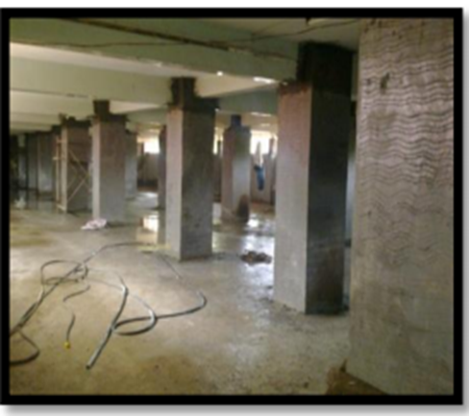
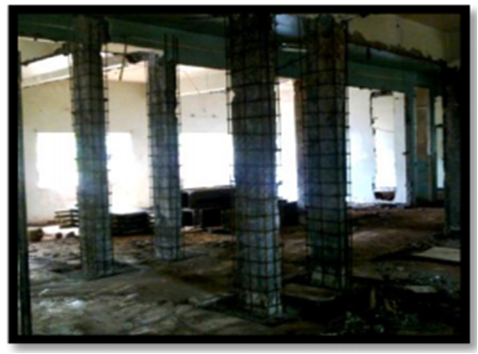
Fig1: Jacketing of column
Methods of NDT:
1. Ultrasonic pulse Velocity Method
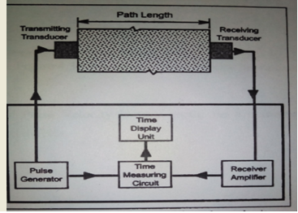
Fig 2: Schematic representation of ultrasonic pulse velocity method
To evaluate concrete condition of R.C.C structure, Ultrasonic Pulse Velocity test and rebound hammer tests have been performed on various R.C.C members.
As per the Non Destructive Tests are carried out on existing structure and it is observed that the Ultrasonic Pulse Velocity Results with direct, semi direct and indirect methods indicates the maximum readings are below 3km/sec and between 3.0 km/sec to 3.5km/sec. And (refer to IS 13311 (Part I) 1992 “Non –Destructive Testing of concrete methods of test, Ultrasonic Pulse Velocity”). It is observed that quality of concrete is medium and doubtful.
2. Rebound hammer test : As per Rebound Hammer test (refer to IS 13311 (Part II) 1992 “Non-Destructive Testing of concrete - methods of test, Rebound Hammer”) the readings of Rebound
Hammer indicates the probable compressive strength of concrete is M18 to M22
DESIGN
Modelling And Analysis
For modelling and analysis G+2 & G+5 storeys building is analyzed by using software STAAD PRO 2008, which is our actual site for this project located at NAGPUR. This site is located at low seismicity region i.e. Zone II as per IS 1893:2002(part1) and the zone factor is 0.1 (Z=0.10). For modelling and analysis various data was collected and calculated. This chapter describes about model development and method of analysis.
In this project, condition of the existing structure is assessed using NDT’S and it is proposed to extend the structure. The building was designed according to the state of the art over 40 years ago, it did not meet the present-day requirement. The project study deals with strengthening and enhancement of performance of existing structure by means of Retrofitting, so that structure can perform well when it would be subjected to additional loads over it. Building is residential community building having G+2 storey. Utility or purpose of building is for society gatherings. Number of floors proposed to extend are three. The present work deals with NDT on existing structural elements, determination of load and moment carrying capacity of structural elements before and after extension, method applied for strengthening of structure and design of the existing structural elements such as r.c.c beams and columns according to the load carrying capacity required
ANALYSIS OF (G+2) STRUCTURE-EXTENDED STRUCTURE:
Table 1: Actual load on existing column and L.C.C
Col. No.  (support  reactions) | Existing col. Details | Actual load on column (Factored) in KN  (G+2) | L.C.C of Existing column (Factored) in kN
C1 | (230 X 450)  8 – 12φ | 837.735 | 1080
C2 | (230 X 500)  8 – 16φ | 1062.049 | 1368
C3 | (230X 600)  10 – 16φ | 1223.594 | 1664
C4 | (300 X 600)  10 – 16φ | 1545.12 | 1999
Table shows the Result for axial force, for G+2 storey with load combination of 1.2(D.L+ L.L+EQ) in software and the actual load caring capacity of the column is calculated manually as per IS code by formula (P=0.4Fc*AC +.67Fy*As) with the of the dimension of the column and grade of concrete is taken. Where, we find out the Actual load coming on column is less as compared to the load caring capacity of the existing column, so there is no need of any retrofitting for the existing structure.
ANALYSIS OF (G+5) STRUCTURE-EXTENDED STRUCTURE:
Table 2 : Actual load on column after extension and L.C.C
Col. No.  (support  reactions) | Existing col. Details | Actual load on column (Factored) in Kn  (G+5) | L.C.C of Existing column (Factored) in kN
C1 | (230 X 450)  8 – 12φ | 1580.59 | 1080
C2 | (230 X 500)  8 – 16φ | 1915.727 | 1368
C3 | (230X 600)  10 – 16φ | 2276.543 | 1664
C4 | (300 X 600)  10 – 16φ | 2880.827 | 1999

Table shows the Result for axial force, for G+5 storey with load combination of 1.2(D.L+ L.L+EQ) in software and the actual load caring capacity of the column is calculated manually as per IS code by formula (P=0.4Fc*AC +.67Fy*As) with the dimension of the column and grade of concrete is taken. Where, we find out the Actual load coming on column is much more as compared to the load caring capacity of the existing column, so retrofitting for the existing structure is needed.
CONCLUSION
After evaluating concrete condition of R.C.C structure using Ultrasonic Pulse Velocity test and rebound hammer tests have been performed on various R.C.C members it is observed that the Ultrasonic Pulse Velocity Results with direct, semi direct and indirect methods indicates the maximum readings are below 3km/sec and between 3.0 km/sec to 3.5km/sec. And the readings of Rebound Hammer indicates the probable compressive strength of concrete is M18 to M22. So it is required to strengthen the structure for new G + 5 because actual load carrying capacity of column is less than required new column.
REFERENCES
- Pravin S Waghmare, “Jacketing technique for retrofitting of structures”, International journal of advanced engineering research and studies, Vol. I, Issue: 15-2011
- Bhavar Dadasaheb O, Dhake Pravinchandra D, Ogale ramesh A,“ Retrofitting of existing R.C.C building by method of jacketing”, International journal of research in modern engineering and emerging technology Vol 1, Issue:5-2013
- Dr. Gopal L. Rai, “Different strenghtening techniques for R.C columns”, R and M international pvt. Ltd.
- Mahdi shariati, Nor Hafizah ramli-sulong, Mohammad Mehdi Arabnejad k.h, Payam shafigh and Hamid sinaei, “Assessing the strength of reinforced concrete structures through ultrasonic pulse velocity and schmidt rebound hammer tests”, Scientific research and essays vol.6 (1)-2011.
- A.k. Singh, Dr. R.S. Jangid, Dr. Gopal L. Rai, “Structural Retrofitting - a case study, Municipal Corporation, Mumbai-2009
- IS Code
- IS 13311(1992), “Code of practice for Non Destructive Testing of concrete – methods of test part: 1 Ultrasonic pulse test”, Bureau of Indian standards (BIS), New Delhi.
- IS 13311(1992), “Code of practice for Non Destructive Testing of concrete – methods of test part: 2 Rebound Hammer test”, Bureau of Indian standards (BIS), New Delhi.

