**“Review** **Of** **Recent** **Advances** **In** **Engineering** **Measures** **For** **Disaster** **Prevention** **And** **Mitigation”**

**Rashmi** **Y.** **Deshmukh1 AshwinkumarA.Gawai2**

*1Student,* *Civil* *Engineering* *Government* *College* *Of* *Engineering,* *Nagpur,* *India,* *441108.*

*2Assistant Professor ,* *Civil* *Engineering* *Government* *College* *Of* *Engineering,* *Nagpur,* *India,* *441108.*

*ABSTRACT* *-* *Disasters,* *each* *natural* *and* *human-caused,* *are* *occurring* *with* *increasing* *frequency* *and* *effects* *in* *recent* *decades* *in* *several* *countries* *round* *the* *world.* *They* *have* *had* *a* *disproportionately* *serious* *toll* *on* *developing* *countries* *each* *in* *terms* *of* *loss* *of* *lives* *and* *injury* *to* *the* *property.* *The* *necessity* *to* *require* *the* *action* *to* *effectively* *manage* *disasters* *has* *been* *highlighted* *at* *several* *major* *international* *conferences* *and* *also* *the* *measures* *are* *undertaken* *in* *many* *countries* *at* *the* *international* *level.* *The* *developing* *countries* *are* *less* *able* *to* *handle* *the* *causes* *and* *impacts* *of* *disasters.* *It’s* *vital* *to* *develop* *the* *development* *industries* *of* *the* *poorer* *nations* *so* *as* *to* *equip* *them* *to* *manage* *disasters.* *This* *paper* *considers* *however* *this* *may* *be* *done.* *It* *starts* *by* *providing* *samples* *of* *recent* *disasters* *and* *their* *impacts* *on* *human* *settlements.* *It* *then* *considers* *the* *role* *construction* *will* *play* *in* *disaster* *management* *and* *mitigation.*

*In* *this* *paper* *a* *review* *of* *some* *of* *the* *recent* *advancements* *in* *the* *engineering* *measures* *to* *prevent* *disasters* *and* *mitigate* *them* *are* *described.*

*KEYWORDS:* *disasters,* *prevention,* *mitigation,* *advancements.*

**OBJECTIVES** **OF** **PAPER**

This paper considers the following:

• Some recommendations for more acceptable action.

**INTRODUCTION**

Civil Engineering works like buildings and infrastructure are the carriers of human civilization. They are, however, in addition the origins of various types of disasters. Disasters are caused primarily by applied science defects, that are usually attributed to the improper alternative of the development site, hazard assessment, vogue and construction, occupancy, and maintenance. The developing countries are less able to handle the causes and impacts of disasters. It’s vital to develop the development industries of the poorer nations so as to equip them to manage disasters. This paper considers how this may be done. It starts by providing samples of recent disasters and their impacts on human settlements. It then considers the role construction will play in disaster management and mitigation. The necessity to require the action to effectively manage disasters has been highlighted at several major international conferences and also the measures are

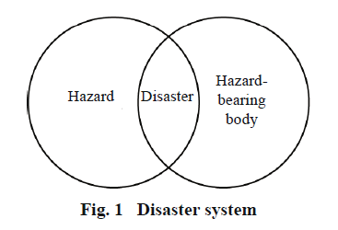underway in many countries at the international level.

**CIVIL** **ENGINEERING** **DISASTER**

isasters are classified into 2 major categories based on the natures of the connected hazards, namely, natural disasters and man-made disasters.

Natural disasters are then classified as

(1) Geological disasters, that are caused by hazards within the layer, like earthquakes, landslides, detritus flows, and volcanic eruptions;

(2) Meteorological disasters, that are caused by hazards within the atmosphere and hydrosphere, such as hurricanes, tornados, droughts, forest fires, significant rains, and floods; and

(3) Biological disasters that are caused by hazards within the region, like plagues and pests.

Man-made disasters may be classified by hazards into the following 3 categories:

(1) Disasters caused by technical mistakes, like nuclear accidents, an explosion of dangerous substances;

(2) Disasters caused by human faults, like fires in buildings, traffic accidents, and gas explosions; and

(3) Disasters caused by hostile actions, like wars, riots, and terrorist attacks.

Human beings play a special role during a disaster system. They are typically the hazard-bearing bodies, being the direct or indirect victims of disasters. However, people may also be hazards that cause disasters. In some cases, individuals are at the same time each, the hazards and hazard-bearing bodies. Civil engineering works are major examples during which humans play this twin role. In the evolution of the many disasters, civil engineering works are attacked by external unsafe actions such as earthquakes and winds, and that they could then persist to constitute deadly hazards to human life and property in the event of their failure or collapse because of low resistance capability. The terrorism on the World Trade Center in 2001 totally demonstrated this dual with buildings being the direct hazard-bearing bodies.

However, the buildings became hazards once they collapsed because of structural inadequacy, causing significant losses of human life and property (Fig. 2).

During damaging earthquakes, applied science works are at first hazard-bearing bodies. Their failure or collapse because of low unstable resistance may, however, cause them to become hazards that will cause more casualties

and loss (Fig. 3).

The loss of life and property through past earthquakes has actually been primarily attributed to the failure and the collapse of buildings. The failure of applied science works additionally sometimes disrupts the delivery of emergency services. For instance, the injury of transport and facility infrastructure may impede rescue operations, hamper the delivery of health services, and cause illness.

The failure of civil engineering works could also, lead to the harm of different utility systems such as gas supply pipes, a selected case that will cause serious fire. It is therefore clear that, in several natural and unreal disasters, applied science works aren't solely hazard bearing bodies, however their failure conjointly constitutes more hazards. Particularly in earthquake disasters, building collapse is that the most important reason behind casualties and financial loss. This mechanism is nevertheless to receive adequate emphasis on the investigation of disasters. Indeed, losses that are attributed to several alleged natural disasters, like earthquakes or winds, were truly caused by applied science factors instead of the particular natural phenomena. This can be the key to developing correct methods for disaster prevention and mitigation.

The conception of a civil engineering disaster has the following 2 implications:

First, all the losses are essentially because of the failure of civil engineering works.

Second, civil engineering strategies are the first means of preventing and mitigating such disasters.

**CAUSES** **OF** **STRUCTURAL** **DEFICIENCY**

Civil engineering works are designed, created, occupied, and maintained by people in general. Consequently, the underlying reason behind all civil engineering disasters, irrespective of whether or not they are associated with natural or man-made hazards could be a structural deficiency within the civil engineering work and this may perpetually be attributed to human factors like lack of data or mistakes. During this context, the explanations for structural deficiency in civil engineering works will be summarized as follows.

**1)** **Improper** **site** **choice**

Sites that are set on active faults, exposed to landslides or detritus flows, or at risk of a non-uniform settlement are some samples of sites that are improper for civil engineering constructions. It’s presently either technically not possible to attain adequate disaster existence in

Buildings and infrastructure on such sites or the value of

doing therefore would be unreasonably high. A practical strategy is so to avoid such improper sites.

The suitableness of a site for construction is changeable. On Dec. 20, 2015, thirty three buildings in an industrial park in Shenzhen, China were buried or broken to totally different extents by a landslide that affected a vicinity of 380000 sq.m. killing sixty nine folks. Investigations showed that the landslide wasn't from the original mountain behind the industrial park, however from mountains of constructional debris that had been dumped there starting in 2014. The deadly debris didn’t exist once the commercial park was created however was created by

human behavior.

mechanism of civil engineering disasters, and to mitigate the occurrences of the disasters in cities and rural areas.

To fully perceive the evolution mechanism of a civil engineering disaster, it's essential to quantify the effects of the hazards on civil engineering work. It is equally vital to work out however civil engineering work is broken or fails beneath the action of the hazard. However, these goals will solely be achieved by correct numerical simulation of the

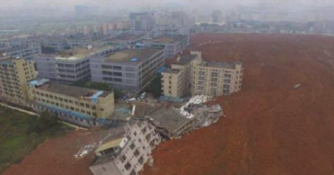failure of civil engineering work.

**RESEARCH** **ON** **CIVIL** **ENGINEERING** **DISASTERS** **AND** **THEIR** **MITIGATION**

**1)** **Goals**

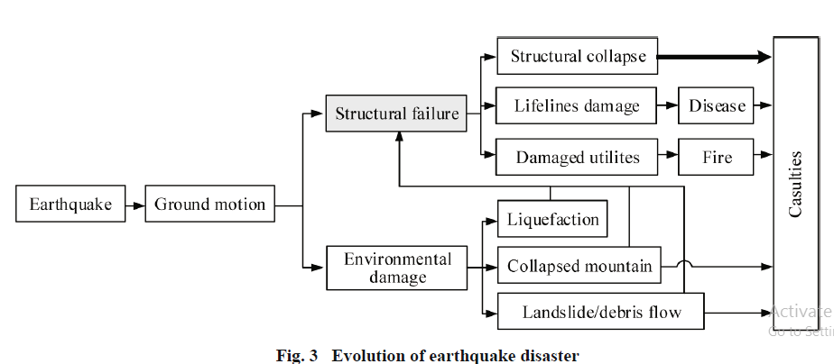A study of civil engineering disasters and their mitigation not solely involves civil engineering disciplines however additionally considerably attracts on several rising

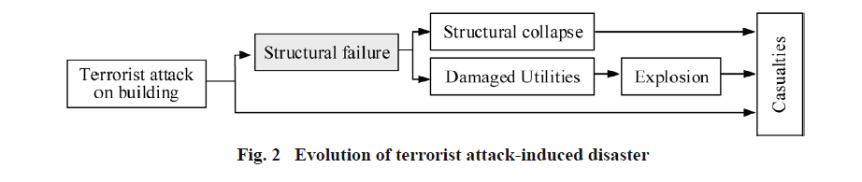

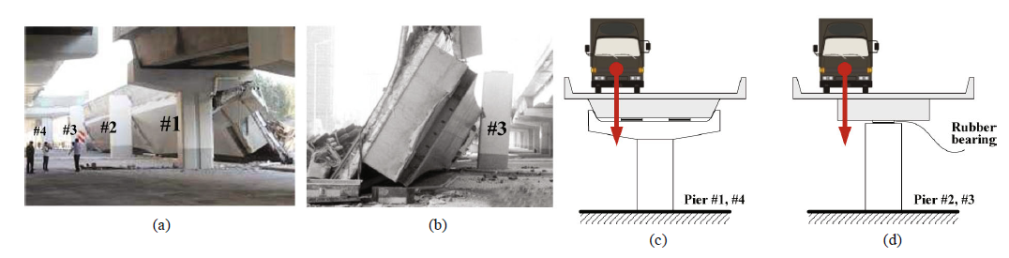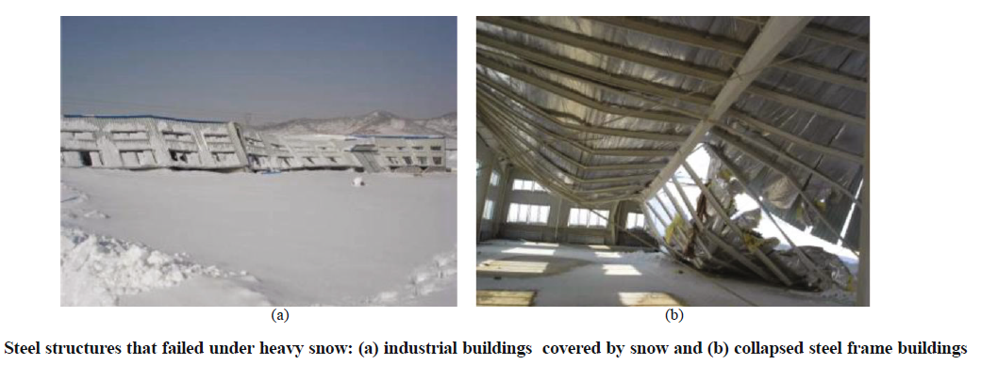

he ultimate goal of a study on civil engineering disasters and their mitigation is that the protection of human life and property. This may solely be achieved by comprehensive improvement of the resistance capability of civil engineering works to hazards. It should however be conceded that its full attainment is on the far side the flexibility development, education, rules, and native customs are all pertinent factors during this regard.

**2)** **Characteristics** **of** **risky** **actions**

Taking earthquakes as an example, hazardous action is the shaking of the ground. There has been a gradual improvement within the understanding of earthquake actions over quite the last a hundred years. At the start of the twentieth century, earthquake actions were thought of as being similar to the applying of horizontal static forces on buildings. This ordered the inspiration for the seismic style of buildings. It absolutely was later recognized that an earthquake action was captivated with the dynamic properties of the buildings. This use of response spectrum analysis, time history analysis, and nonlinear dynamic analysis has greatly extended the understanding of earthquake actions. Studies on earthquake actions have conjointly progressed quickly by exploiting the invasive information on real earthquake ground motion records. Tens of parameters for quantifying earthquake actions are planned by researchers worldwide, who have demonstrated the complexness of the matter and contributed to the improved understanding of the earthquake engineering community.

**3)** **Zonation** **of** **unsafe** **actions** **and** **risk** **analysis**

The objective of hazard zonation is that the provision of the time and spatial distributions of hazards for engineering design. Though abundant effort has been made on this line, the task is extremely difficult. In the case of earthquakes, the zonation of the ground motion parameters are the premise of unstable design and involve many scientific processes and factors associated with unstable hazard analysis, ground motion attenuation modeling, and local website effects. Massive scatterings and uncertainties still, exist in addressing these problems. Together with the continuous effort to cut back the uncertainties, additional efforts are required to know the inherent uncertainties of many unsafe actions and risks and to develop robustly civil engineering solutions to reduce the influence of such uncertainties.

**4)** **Response** **characteristics** **and** **injury** **mechanism** **of**

**Civil** **engineering** **works** **beneath** **unsafe** **actions**

There has been an improvement within the understanding of the response characteristics and injury mechanisms of civil engineering works, the behaviors of that vary from linear elastic to nonlinear. Several parameters based mostly on force, displacement, energy, or mixtures of those have been planned to quantitatively describe the failure mechanism and dynamic behavior of civil engineering works beneath unsafe actions. Within the method, many physical and numerical models are developed, with the latter having obvious benefits and showing promise for application to the simulation of the injury of civil engineering works.

**5)** **Engineering** **measures** **and** **design** **codes** **for** **enhancing** **hazard** **resistance** **capability** **of** **civil** **engineering** **works**

New technologies and design codes are the foremost necessary basis for increasing the hazard resistance capacity of civil engineering works. Differing from research, engineering practice provides consideration to safety, cost, simplicity, effectiveness, and standardization. The supply of effective solutions to civil engineering issues at an affordable cost is usually more vital than the scientific quantification of the elaborate parameters. Additionally, research findings must be enforced in civil engineering constructions for them to be of any profit to the community. To the present finish, design codes and standards are developed for the utilization of scientific and technological innovations to guard civil engineering works under unsafe actions. However, extra effort is needed within the directions of management and regulation that are beyond the scope of this paper.

**MANAGING** **DISASTERS** **THROUGH** **CONSTRUCTION**

Whereas disaster management has several dimensions, it'd seem that those relating to the built surroundings are high in priority. The post-disaster report on the Gujarat earthquake, ready by the world Bank and Asian Development Bank, identified the subsequent immediate needs: provision of temporary shelter before the onset of the monsoon season; restoration of public services like hospitals, schools, facility, power, communications, municipal and environmental infrastructure, and state administration; and, securing income-earning opportunities for vulnerable individuals within the affected areas (World Bank, 2001).

The World Bank (2001) observes that international

xpertise from different disaster-hit areas suggests that the recovery programme ought to follow principles including:

The revival of the economy; empowering people and communities; affordability, private sector participation, and equity; decentralization; and communication and transparency. Consultation with, and participation by, the affected communities should be at the center of the recovery programme, including, as far as doable, reconstruction of their own homes by people in their original location. When learning the post-war reconstruction of villages in Lebanon, El-Masri, and Kellett (2001) conjointly stressed community participation. To attain the on top of parts, all the parts of industry development ought to be pursued in developing countries. First, human resource development ought to equip construction professionals with the data and skills required to undertake acceptable styles and construction. It ought to be doable for local practitioners to stay themselves knowledgeable of developments in data overseas. Second, a programme of materials development ought to be instituted in each region to search out high-performing (disaster-resistant) materials that are suited to the native context and are of excellent quality, durability, and affordability. Third, it is necessary to place measures in situ in pursuit of the technological development of the

**RECOMMENDATIONS** Individual developing countries and regional or sub-regional partnerships of them, are creating combined efforts to attain peace, stability and socio-economic

development with a view to increasing opportunities and fostering larger wealth creation (Bartels, 2001). For instance, actions are presently being taken to place Africa on the trail to sustained growth and improved living conditions for its individuals through a partnership among African countries and also the international community under the New Economic Partnership for African Development (NEPAD).

**CONCLUSION**

Among the various kinds of disasters, civil engineering disasters are the foremost closely associated with human beings and have recognized a very important stimulant for civil engineering development. Several scientific and technological topics are relevant to the understanding and mitigation of civil engineering disasters, the conception of that emphasizes the transformation of civil engineering works from hazard-bearing bodies into hazards once they

fail. Not like disasters caused by natural hazards, which

trade to confirm that it's the potential to handle the varied projects which can be needed to provide protection against disasters, and those that the post-disaster reconstruction method can involve.

egularly cannot be foreseen or controlled, civil engineering disasters will be effectively mitigated based on a radical understanding of the associated failure mechanisms and by improvement of the resistance capacity of engineering works. The 2 goals of studies on applied science disasters are to know the evolutionary mechanisms of the failure of civil engineering works and to mitigate the disasters to guard human communities. The previous goal will solely be accomplished by accurate replica of the failure of the engineering works, whereas the latter needs comprehensive improvement of the engineering works.

**REFERENCES**

[1] *Xie* *Lili†* *and* *Qu* *Zhe†,* *“On* *civil* *engineering* *disasters* *and* *their* *mitigation”,* *Earthq* *Eng* *&* *Eng* *Vib* *(2018)* *17:* *1-10*

[2] *George* *Ofori,* *“Construction* *Industry* *Development* *For* *Disaster* *Prevention* *And* *Response”,* *National* *University* *of* *Singapore.*

[3] *Mihail* *E.,* *“Engineering* *Measures* *for* *Landslide* *Disaster* *Mitigation”,* *(Illinois* *Institute* *of* *Technology,* *USA),* *Katsuo* *Sasahara* *(Kochi* *University,* *Japan)*

[4] *Shi,* *Yang* *Hang;* *Yang,* *Li* *Dan;* *Wu,* *Chong;* *Yu,* *De* *Hai;*

*Xu,Jing* *Yu,* *“Strategies* *on* *Earthquake* *Prevention* *and*

*Disaster itigation* *in* *Rural”,* *Applied* *Mechanics* *and*

*Materials,* *vol.* *105-107,* *pp.* *1105-1109,* *09/2011*

*.*

[5] *W.* *Liu* *et* *al.,* *"The* *Mitigation* *Measures* *of* *Frequent* *Earthquake* *in* *the* *Construction* *of* *New* *Rural* *Area",* *Advanced* *Materials* *Research,* *Vols.* *594-597,* *pp.* *1629-1633,* *2012*

[6] *Noguchi.T,* *“Recent* *Trends* *Of* *Development* *Of* *Disaster* *Prevention* *Technologies”,* *Railway* *Technical* *Research* *Institute,* *Quaterly* *Reports,* *pg* *9-12.*

[7] *Jovanovic* *P* *(1986),* *“Modelling* *of* *Relationship* *Between* *Natural* *and* *Man-Made* *Hazards,”* *Proceedings* *of* *the* *International* *Symposium* *on* *Natural* *and* *ManMade* *Hazards,* *Quebec,* *Canada,* *9‒17.*

[8] *Wang* *YY* *(2010),* *“Revision* *of* *Seismic* *Design* *Codes* *Corresponding* *to* *Building* *Damages* *in* *the* *“5.12”* *Wenchuan* *Earthquake,”* *Earthquake* *Engineering* *and* *Engineering* *Vibration,* *9(2):* *147‒155.*

[9] *Ye* *LP,* *Lu* *XZ* *and* *Li* *Y* *(2010),* *“Design* *Objectives* *and* *Collapse* *Prevention* *for* *Building* *Structures* *in* *MegaEarthquake,”* *Earthquake* *Engineering* *and* *Engineering* *Vibration,* *9(2):* *189‒199.*

[10] *Hillebrandt,* *P.M.* *(2000).* *Economic* *Theory* *and* *the* *Construction* *Industry,* *Third* *Edition.* *Macmillan,* *Basingstoke.*

[11] *El-Masri,* *S.* *and* *Kellett,* *P.* *(2001).* *Post-war* *reconstruction:* *Participatory* *approaches* *to* *the* *damaged* *villages* *of* *Lebanon:* *A* *case* *study* *of* *al-Burjain.* *Habitat* *International,* *25,* *535-557*