**Performance Based Analysis of Low Rise Open Ground Storey Building**

**Mr. Abhishek T. Takalkhede1, Dr. Tushar G. Shende2, Mr. Laxmikant N. Vairagade3**

*1M-Tech Student (SE), Department of Civil Engineering, GHRAET, Nagpur, Maharashtra, India 440016*

*2Associate Professor, Department of Civil Engineering, GHRAET, Nagpur, Maharashtra, India 440016*

*3Assistant Professor, Department of Civil Engineering, GHRAET, Nagpur, Maharashtra, India 440016*

***Abstract –*** *Many Urban multistoried building in India today have open storey as an unavoidable features. This is primarily being adopted to accommodate parking or lobbies in open storey, such features are highly undesirable in building built in seismically active areas, and this has been verified in numerous experience of strong shaking during past earthquake. Though multistoried building with open (soft) ground floor is inherently vulnerable to collapse due to earthquake load, their construction is still widespread developing nation like India. Open storey at different levels of the structure for out-weighs the warning against such building from engineering community.*

*In this paper we are concentrating on finding the best place for soft stories which is use for parking space and offices in high-rise building. Soft storey is one of the main reasons for building damage during an earthquake and has been mentioned in all investigation report. Soft storey due to increase storey height is well known subject. Infill are usually not considered as a part of load bearing system. This study investigates the soft storey behavior due to increase in storey height, of infill’s at ground floor storey by means of linear static and nonlinear static analysis for midrise reinforced concrete building displacement capacity at immediate occupancy, life safety and collapse prevision, performance level and storey drift demands. Soft storey behavior due to change in infill’s amount is evaluated in view of the displacement capacities, drift demand and structural behavior.*

***Keywords-*** *Pushover analysis, open ground storey, infill wall, Seismic analysis, Compression member.*

**INTRODUCTION**

Due to increasing population since the past few years car parking space for residential apartments in populated

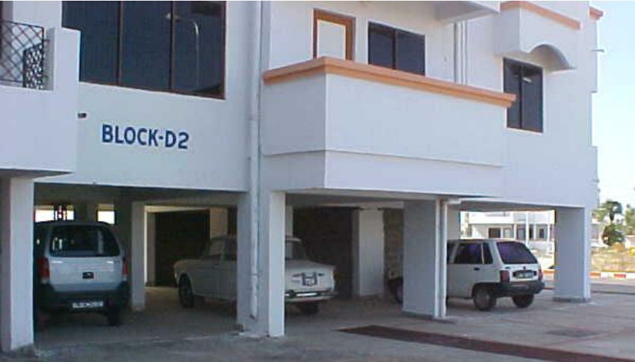cities is a matter of major concern. Hence the trend has been to utilize the ground storey of the building itself for parking. These types of buildings having no infill masonry walls in ground storey, but infilled in all upper storeys, are called Open Ground Storey (OGS) buildings. There is significant advantage of these category of buildings functionally but from a seismic performance point of view such buildings are considered to have increased vulnerability Due to the presence of infill walls in the entire upper storey except for the ground storey makes the upper storeys much stiffer than the open ground storey. Thus, the upper storeys move almost together as a single block, and most of the horizontal displacement of the building occurs in the soft ground storey itself. In other words, this type of buildings sway back and forth like inverted pendulum during earthquake shaking, and hence the columns in the ground storey columns and beams are heavily stressed. Therefore, it is required that the ground storey columns must have sufficient strength and adequate ductility. The vulnerability of this type of building is attributed to the sudden lowering of lateral stiffness and strength in ground storey, compared to upper storeys with infill walls.

Fig.1 - Open ground Storey of the building

The OGS framed building behaves differently as compared to a bare framed building (without any infill) or a fully infilled framed building under lateral load. A bare frame is much less stiff than a fully infilled frame. When this frame is fully infilled, truss action is introduced. A fully infilled frame shows less inter-storey drift, although it attracts higher base shear (due to increased stiffness). A fully infilled frame Inclusion of stiffness and strength of infill walls in the OGS building frame decreases the fundamental time period compared to a bare frame. Dya et. al, 2015, investigated the severity of OGS with increase in height of soft story building. Pushover analysis is carried out by considering vertical irregularity in the stiffness. Wibowo et. al, 2015, carried out an experimental analysis to investigate the precast soft storey building and concluded that it had considerable displacement capacity as compare to traditional construction. Jennings et. al, 2014, presented retrofitting strategy for soft storey wood frame building. It consist of energy dissipating device and shape memory alloy for recent ring capability. Rai, 2013 presented a design procedure and analytical evaluation of two strengthening techniques to improve the seismic performance of the existing non-ductile RC frames with soft-story at the ground story level. Kirac N. et al., 2011 studied the seismic behavior of weak storey. It is observed that negative effects of this irregularity can be reduced by some precautions during the construction stage.Sarkar P. et al., 2010proposed a new method of quantifying irregularity in such building frames, accounting for dynamic characteristics (mass and stiffness). The proposed `regularity index' provides a basis for assessing the degree of irregularities in a stepped building frame. Wibowo A. et al. (2010) reported a unique experimental field test study that provides insight into the push-over load deflection and collapse behavior of a soft storey building. Four field tests were undertaken to investigate the actual lateral force deflection behavior of the soft storey columns. Interestingly, the tests indicated that the soft storey columns possessed significant displacement capacity despite significant strength degradation. Athanassiadou C.J. (2008) addressed multistory reinforced concrete (R/C) frame buildings, irregular in elevation. Two ten-storey two-dimensional plane frames with two and four large setbacks in the upper floors respectively, as well as a third one, regular in elevation, have been designed to the provisions of the 2004 Euro code 8 (EC8) for the high (DCH) and medium (DCM) ductility classes, and the same peak ground acceleration (PGA) and material characteristics. The over strength of the irregular frames is found to be similar to that of the regular ones. Pushover analysis seems to underestimate the response quantities in the upper floors of the irregular frames. The conclusion from above literature review is that open ground storey is vulnerable for seismic excitation, so the present study is based on the seismic evaluation of OGS buildings and the reason why they are adopted by the designers in spite of the fact that they are more vulnerable during earthquake. To study linear analyses of the building model considering various cases and critically evaluate the linear analysis results to compare the building responses with and without considering infill.

**METHOLOGY**

To study the Seismic behavior of building structure while considering the effect of open ground storey, building frame is modeled as 3D space frame using standard two nodded frame element with two longitudinal degrees of freedom and one rotational degree of freedom at each node. At the interface of infill and frame, the infill element and the frame element are given same nodes.

The idealized form of a typical 5 bay x 2 bay 4 storey building frame with infill wall modeled as represented schematically in Fig. 1 the present study also considers bare frame to see how correctly the influence of open ground storey on Seismic behavior can be predicted.

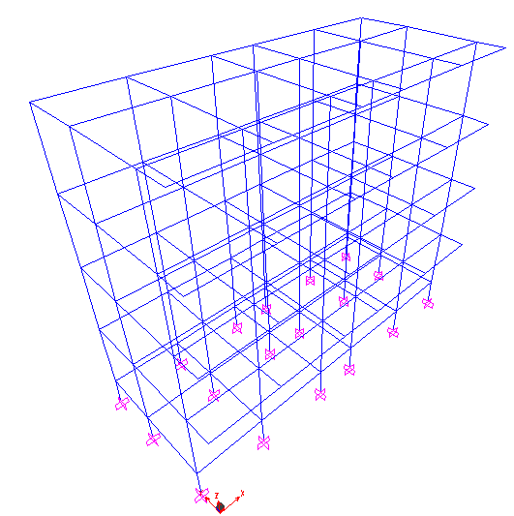A 5 bay x 2 bay building frames with 4 storeys on isolated footing have been considered. The height of each storey is taken as 3.1 m. Thickness for roof and floor is taken as 120 mm and their corresponding dead load is directly applied on the beam. The brick infill with thickness 230 mm. slab thickness is 120 mm. All the above dimensions were arrived on the basis of the design following the respective Indian code for design of reinforced concrete structure. However, these design data are believed to be practicable and hence, do not affect the generality of the conclusion. Table 1 and 2 shows the sectional properties of the beam and column and material properties.

Fig.2 - 3D view and Elevation of building considered

Table 1 - Sectional Properties

|  |  |  |  |
| --- | --- | --- | --- |
| **Columns** | **Size (mm)** | **Beams** | **Size (mm)** |
| C1 | 230 x 450 | B1 | 230 x 350 |
| C2 | 230 x 400 | B2 | 230 x 400 |
| C3 | 230 x 350 | B3 | 230 x 300 |
|  |  | B4 | 200 x 400 |

Table 2 - Properties of material

|  |  |  |
| --- | --- | --- |
| **Materials** | **Modulus of elasticity (kN/m2)** | **Poisson’s ratio** |
| Concrete M25 | 25 x 106 | 0.2 |
| Masonry | 4.5 x 106 | 0.19 |

**Results and Interpretation**

Initially the displacement of the building in X and Y direction is performed with and without infill wall. It has been observed that zone factors highly influences the performance of OGS building which can be seen with the help of graphical representation as shown in fig. 3. With the introduction of infills the stiffness increases and hence the displacement of the building in various zones decreases.

Pushover analysis is carried out for building models. First pushover analysis is done for the gravity loads (DL+LL) incrementally under load control. The lateral pushover analysis (PUSH-X) is followed after the gravity pushover, under displacement control. The building is pushed in lateral directions until the formation of collapse mechanism. The capacity curve

(base shear versus roof displacement) is obtained in X- direction and presented in Fig. These figures clearly show that global stiffness of an open ground storey building hardly changes even if the stiffness of the infill walls is ignored. If there is no considerable change in the stiffness elastic base shear demand for the building will also not change considerably if the stiffness of the infill walls is ignored. The variation of pushover curves in X-directions is in agreement with the linear analysis results presented in the previous section with regard to the variation of elastic base shear demand for buildining models. Fig. 4 shows the hinge formation of the building after pushover analysis.

Fig. 3 - Displacement comparison with and without infills

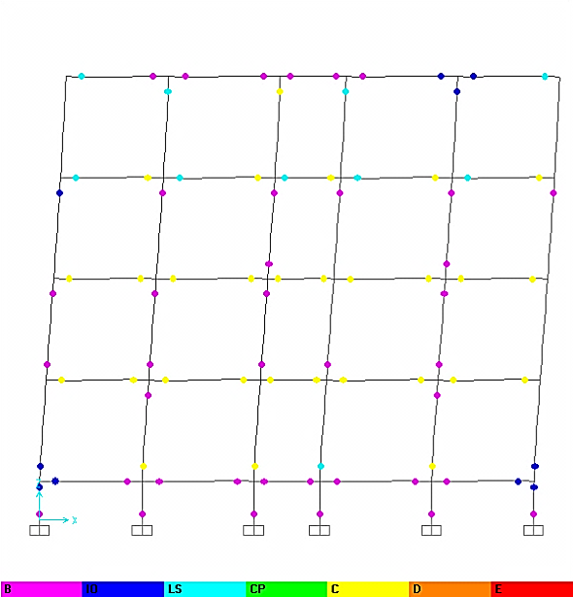

Fig. 4 - Hinge pattern of the building



Fig.5 - Pushover Curve without infills for different zones

**Pushover analysis with Infills**

In the case of an infill wall located in a lateral load resisting frame the stiffness and strength contribution of the infill are considered by modeling the infill as an equivalent compression strut. Infill parameters (effective width, elastic modulus and strength) are calculated using the method recommended by Smith [5]. The length of the strut is given by the diagonal distance *d* of the panel (Figur1c) and its thickness is given by the thickness of the infill wall. The estimation of width *w* of the strut is given below. The initial elastic modulus of the strut *Ei* is equated to *Em* the elastic modulus of masonry. As per UBC (1997), *Em* is given as 750*fm*, where *fm* is the compressive stress of masonry in Map. The effective width was found to depend on the relative stiffness of the infill to the frame, the magnitude of the diagonal load and the aspect ratio of the unfilled panel.

The relative stiffness of the infill to the frame is expressed in terms of a parameter

$$λ=\sqrt[4]{\frac{E_{i}tsin2θ}{4E_{c}I_{c}h^{'}}}$$

Here, *Ei* is initial elastic modulus of the infill material, *E* is elastic modulus of the concrete in column, is height of column between centerlines of beams, *h'* is clear height of infill wall, *Ic* is moment of inertia of each column, *l* is length of beam between centerlines of columns, *t* is thickness of infill wall, and θ *=*tan-1 (*h /l*)is the slope of the infill diagonal to the horizontal.

Fig. 6 - Equivalent diagonal strut

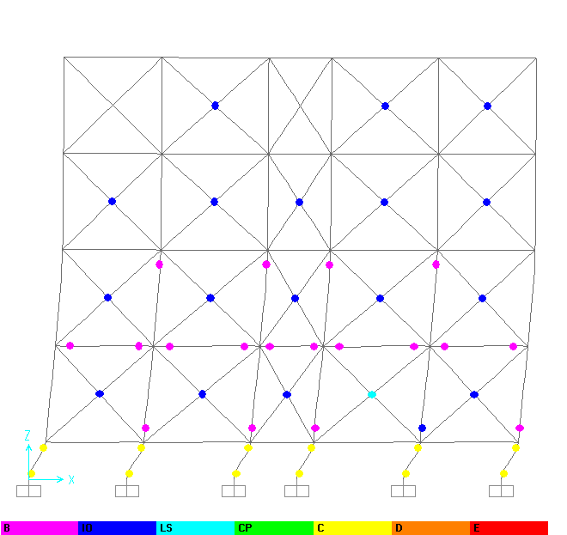

Fig. 7 - Hinge formation with brick infill at ground

**CONCLUSION**

Open ground storey is detrimental during base excitation, as stiffness at the bottom storey reduces and the hinge formation occurs directly on the bottom storey column which leads to global failure of the structure. The infill walls at the suitable location on the ground may avoid the complete collapse of the structure. The modeling of infill as a diagonal strut is best suited to simulate the stiffness of the infill walls. The responses are found to increase with the zones

**REFERENCES**

1. *Dya A. F. C. and Oretaa A. W. C. (2015). “Seismic vulnerability assessment of soft story irregular buildings using pushover analysis”, Procedia Engineering, 125, 925 – 932.*
2. *Wibowo A., Wilson J. L., Lam N. TK and E. F Gad (2015). “Collapse behaviour assessment of precast soft storey building”, Procedia Engineering, 125, 1036 – 1042.*
3. *Jennings E., Lindt J. W., Ziaei E., Mochizuki G., Pang W. and Shao X. (2014). “Retrofit of a soft-story woodframe building using SMA devices with full-scale hybrid test verification”, Engineering Structures, 80, 469–485.*
4. *Sahoo D. R. and Rai D. C. (2013). “Design and evaluation of seismic strengthening techniques for reinforced concrete frames with soft ground story”, Engineering Structures, 56, 1933–1944.*
5. *Kirac N., Dogan M. andOzbasaran H. (2011). “Failure of weak-storey during earthquakes”, Engineering Failure Analysis, 18, 572–581.*
6. *Hejazi F., Jilani S., Noorzaei J., Chieng C. Y., Jaafar M. S. and Abang Ali A. A. (2011). “Effect of Soft Story on Structural Response of High Rise Buildings”, Materials Science and Engineering, 17, 1 – 13.*
7. *Sarkar P., Prasad A. M., Menon D. (2010). “Vertical geometric irregularity in stepped building frames”, Engineering Structures, 32, 2175 – 2182.*
8. *Wibowo A., Wilson J. L., Lam N. TK and E. F Gad (2010). “Collapse modelling analysis of a precast soft storey building in Australia”, Engineering Structures 32, 1925 – 1936.*
9. *Athanassiadou C.J. (2008). “Seismic performance of R/C plane frames irregular in elevation”, Engineering Structures, 30, 1250–1261.*
10. *Lee H. S. and Ko D.W. (2007). “Seismic response characteristics of high-rise RC wall buildings having different irregularities in lower stories”, Engineering Structures, 29, 3149–3167.*
11. *Yoshimura M. (1997). “Nonlinear Analysis of a Reinforced Concrete Building with a Soft First Story Collapsed by the 1995 Hyogoken-Nanbu Earthquake”, Cement and Concrete Composites 19, 213-221.*