Accident and Alcohol Detection Using Bluetooth Enabeled Smart Helmet
Archana. P¹, Aishwarya.S ², Aikya M.H ³, Ananya K.N ⁴, Jeevan G. K⁵
¹²³⁴⁵AssistantProfessor
Dept.of Computer Science &Engineering, Adichunchanagiri Institute of Technology Chikkamagaluru, Karnataka

archana.havish@gmail.com
Received on: 11 June ,2022 Revised on: 05 August ,2022, Published on: 09 August,2022

Abstract – In this current world where technology is growing up day by day and scientific researchers are presenting new era of discoveries, the need for security is also increasing in all areas. At present, the vehicle usages basic necessity for everyone. Simultaneously, protecting the vehicle against theft is also very important. Traditional vehicle security system depends on many sensors and cost is also high. When the vehicle is stolen, no more response or alternative could be available to help the owner of the vehicle to find it back. The main goal of this project is to protect the vehicle from any unauthorized access, using fast, easy-to-use ,clear, reliable and economical face recognition technique. In this propose system using a wireless communication between bike to helmet, bike to signal section, bike to caution boards.

Keywords: Smart helmet, Convolution Neural Network, IOT, Laws and Regulation.
I – INTRODUCTION
SMART HELMET for two-wheeler riders in order to reduce the causalities. Two wheelers are most sold vehicles throughout the India. The Indian two-wheeler (2W) industry registered sales volume of 13.7 million units in 2012-13, a growth of 2.9% over the previous year FY 2011-12. Lot of people are able to fulfill their dream of buying a vehicle of their own and it’s growing ridiculously and will grow more in future. The number of two wheelers are growing, especially the craze among youngsters. The people are buying the two wheelers which are faster and powerful. In accordance with the growth of the number of two wheelers the safety factor. Out of all the most severe case is of head injury, which most of the times lead to body paralysis and sometimes death. The
main reason is due to lack of safety gear that is no Helmet. When the people are riding the two wheeler and then aren’t wearing helmet and if, by their or some other’s mistake they just met with some sort of accident, since the two wheelers have balancing on the two wheels hence after hitting the two wheeler get unbalanced and the rider fall down and at that time his head may collide with the solid surface and if helmet is not there then the head might have serious injuries . Now these injuries can be minimized by use of helmet but people in our country aren’t using helmet as their habit. So in order to minimize the injuries head injuries we came up with an idea that is SMART HELMET.
- Related Work
In this survey we are discussing various smart helmets with various approaches and methodologies. Jesudoos A et.al[1] proposed a mechanism, where sensors such as IR sensor, vibration sensor and gas sensor, mems are used. The gas sensor is used to detect the amount of liquor he had consumed by checking the breath of a person wearing the helmet. The bar control of the vehicle is handled by MEMS.
Accident is detected by vibration sensor. Load of the vehicle is recognized by load checker. The Sensors are interfaced with the PIC microcontroller. The gas sensor will detect if a user consumed alcohol and display on the LED display. If an accident occurs the vibration sensor, sense the accident and send information through GPS to the hospital .If there is any rash driving is done by the rider the MEME sensor detect the amount of the person from his bank account.
To check whether the rider is wearing the helmet or not IR sensor is used. In this system exactness and accuracy are high and ambulance is booked automatically based on ten location. K.M. Mehata et.al proposed a technique which provide safety to the workers or to identify any fall of the workers in working area. The proposed system has two components. One is the wearable device built using sensors and electronic elements. Another component is the cell phone. The communication
between the two components is provided by GSM module. These devices also monitor the health and safety of the worker is continuously. This system ensures good fall detection and alerts the register person to give medical attention. Divyasudha N et.al proposed a system consists of micro controller, position sensor, Alcohol sensor, piezoelectric sensor, RF Transmitter, IOT Modem, GPS receiver, Power supply & Solar panel to avoid the accidents and check the alcohol consumption. In this system two condition is checked that is whether the rider is wearing the helmet or not and to check whether he had consumed alcohol or not if this is not followed by the rider the bike will not start and it is indicated by beep sound. If any accident Occur it is informed to predefined number and police station using IOT modem. This system is cost efficient compare to other kind of helmets.
Manish Uniyalet.al proposed a system with two units that is helmet unit and two wheeler unit. RF receiver of the matching frequency gives the helmet position data to the two wheeler section. The microcontroller placed on the TW section will have information of the helmet position which is continuously checked. There are various other sensors such as accelerometer (tilt angle measurement), Hall-effect sensor (speed measurement), GPS module (location pointer) placed on the TW vehicle. The sensors collect the data and send the data to the microcontroller then if there is a internet connection then it is sent to the server. The speed of the vehicle can be accessed by the people at any instant by this method. In this system people can access the speed of the vehicle. Parents can see that is their child have worn helmet or not.
ShoebAhmed Shabbeer et.al [5] proposed the smart helmet method which detect and report the accidents. In this method they use microcontroller interfaced with accelerometer and GSM module. The notification and report of the accident is provided using cloud infrastructures. In this method if the level of the acceleration exceeds than the threshold or if any accident occurs the information is sent to the emergency authority server whithen

Sends the message to the assigned emergency contact through GPS module. The result of this system was able to identify accidents is of 94.82% and sends the correct coordinates 96.72% of time. P.Rojaet.al has proposed a system consisting a 6 unitsas follow, that is remover sensor, IR sensor, Air quality sensor, Arduinouno microcontroller, GPRS, GSM. This helmet provides the alert about the harmful gases in the mining areas to the workers and also proved information to the server if helmet is removed. Here this data transmission is done using IOT technology.

C.J Bheret.al has proposed a system of smart mining helmet that detects three types of hazards that is harmful gases, remove of helmet and if any collision. Here they uses many sensors such as IR sensors, gas sensors, accelerometer.
Serenity Chandran et.al has proposed a system of smart helmet named konnect. Here they use integrated network of sensors, Wi-Fi enabled processors, cloudcomputing infrastructures to detect and prevent the accidents. This system also provides the information to the provided contact by text message if the speed is increased than the threshold level.
Mohammed Khaja Areebuddin Aatifet.al proposed a technique consisting of arduinouno, Bluetooth module, push button and 9V battery. Here the smart helmet integrated with Bluetooth is connected to the cell phones and push button is used if any emergency occur.
Archana.Det.al proposed a system to reduce accidents, here the system consist of a sensor which sense the human
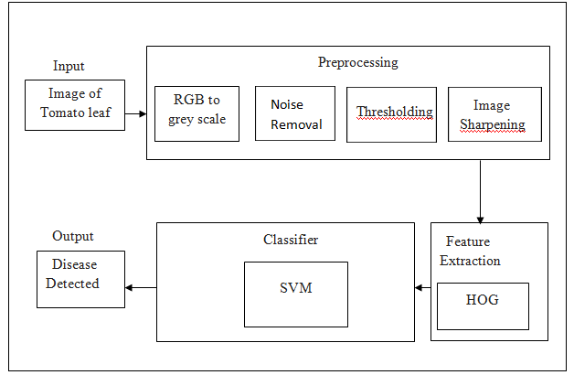
Figure 1: Architectural of the Proposed System using CNN
II- METHOD
The basic definition of image processing refers to the processing of digital images by removing noise, any kind of irregularities that may have crept into the image, either during its formation, transformation, storage, etc. For mathematical analysis, an image may be defined as a two dimensional function f(x,y), where x and y are spatial coordinates and the amplitude off at any point (x,y) is called the intensity of f at that point. In grey scale images, it is also called the greylevel. When x, y and these intensity values are all finite, discrete quantities, the image is digital image. It is very important that a digital image is composed of a finite number of element.
A .Input data
Face recognition and Helmet Detection using image processing
Preprocessing: The image is first pre-processed to enhance the visible characteristics and make classification of face easier. using the median filter to remove noise from the image, use basic global thresholding to remove the background, and then, a high pass filter to amplify the finer details in the image. Feature Extraction: Histogram Orientation Gradient is used to extract the features from the image. This produces a histogram of angles versus their frequency in the image, which is used for further classification Classification: Using CNN to classify the faces observed in the images. Moreover, we will be comparing the results of both with MQ3 sensor values. Camera is used to take images of the as input to the computer. The computer creates a database and analysis of images. A set of algorithms developed on an IDE suitable for image processing is used to perform various operations on the images. In the initial stages of database development, only photographs are used- as they give precise variance parameters, as compared to hand drawn images, which may not be appropriately suggestive. The detection and recognition system uses certain algorithms to check the variance of the image from the normal parameters and its closeness to the defined parameters of the image.

- Digital Image Processing
The term digital image processing generally refers to the processing of a two dimensional picture by a digital computer. In a broader context, it implies digital processing of any two dimensional data. A digital image is an array of real numbers represented by a finite number of bits. The principle advantage of Digital Image Processing methods is its versatility, repeatability and preservation of original data precision. The various steps involved in image processing are:
- Image Pre-processing
- Image Enhancement
- Image Segmentation
- Feature Extraction
- Image Classification
- Image Pre-Processing
In image preprocessing, image data recorded by sensors on a camera related to geometry or brightness values of the pixels may not be very precise, as a lot of noise may interfere with these bit values. These errors are corrected using appropriate mathematical models which are either definite or statistical models. Image enhancement is the modification of images by changing the pixel brightness values to improve its visual impact. Image enhancement involvesa collection of techniques to improve the visual appearance of an image- both to machines as well as humans.
Sometimes, images obtained from satellites and digital cameras lack in contrast and brightness because of the limitations of imaging sub-systems and illumination conditions while capturing the image. Images may have different types of noise. In image enhancement, the goal is to accentuate certain image features for the next analysis stages or display. These may involve contrast or edge enhancement, pseudo-coloring, noise filtering, sharpening and magnifying. Image enhancement is useful in feature extraction, image analysis and display. The enhancement process itself does not increase the inherent information in the data. It simply emphasizes certain special image characteristics. These algorithms are generally interactive and application dependent. Some of these are:
- Noise Filtering
- Contrast Stretching
- Histogram Modification
Since we have used noise filtering in our project, we would describe it briefly as a technique used to filter unnecessary information from an image. It is also used to remove various types of noises from the images. Mostly, the feature is interactive. Various filters like low pass, high pass, mean, median, etc. are available. Here, we have used the median filter to effectively filter out noise.
- Image Segmentation
Segmentation is one of the key problems in image processing. Image segmentation is the process that subdivides the image into constituent parts or objects. The level of subdivision depends on the problems being solved. This mainly divides the image into a relevant portion and an irrelevant portion. Image thresholding techniques are majorly used for segmentation.
Here, we have used the most basic method for filtering the background out- the basic global thresholding filtration method, wherein, we give a certain threshold value T, as the least pixel intensity of the relevant object. Hence, all pixels with lower values would simply be set to 0. However, this is not the only approach, as other filters have other ways of doing the same job of conveying relevance A method which is based on idea and uses a correlation to select the best threshold is described below. Sometimes, grey level histograms have only one maximum, It can be caused, for instance by inhomogeneous illumination of various regions of the image. In such cases, it is impossible to select a single thresholding of various regions of the image. In such cases, we can’t use one threshold for the entire image and local binarization is used. General methods to solve the problem of binarization must be applied not available such imagery and employ special algorithms designed to perform various types of spectral analysis.
unsupervised. In supervised classification, the identity of the related parameters also accompanies the image for ‘learning’ purpose These are commonly called the training sets because the spectral characteristics of these are known and are used to train the classification algorithm. Multivariate statistical parameters are calculated for each training set. Every pixel, both within and outside these training sets is evaluated and assigned to a class of which it has the highest likelihood of being a member.
- Feature extraction
The feature extraction techniques were developed to extract features in synthetic aperture radar images. The technique extracts high level features needed in order to perform classification of targets. Features are those items which uniquely describe a target such as size, shape, texture, composition, location, etc. Segmentation techniques are used to isolate the desired object from the scene so that measurements can be made on it subsequently. Quantitative measurements of object features allow classification and description of image.
When the preprocessing and the desired level of segmentation has been achieved, some feature extraction technique is applied to the segments to obtain features, which is followed by application of classification and post processing techniques. It is essential to focus on the recognition system. Feature selection of a feature extraction method is the single most important factor in achieving high recognition performance, covering vast possibilities of cases.

F Image classification
Image classification is the labeling of a pixel or group of pixels based on its grey value. Classification is one of the most often methods of information extraction. In classification, usually, multiple features are used for a set of pixels, i.e., many images of a particular object are needed. In remote sensing area, the procedure assumes that the imagery of a specific geographic area is collected in multiple regions of the electromagnetic spectrum and is in good registration. Most of the information extraction techniques rely on analysis of the spectral reference properties of such imagery and employ special algorithms designed to perform various types of spectral analysis.
The process of multispectral classification can be performed using either of the two methods- supervised or unsupervised. In supervised classification, the identity of the related parameters also accompanies the image for ‘learning’ purpose. These are commonly called the training sets because the spectral characteristics of these are known and are used to train the classification algorithm. Multivariate statistical parameters are calculated for each training set. Every pixel, both within and outside these training sets is evaluated and assigned to a class of which it has the highest likelihood of being a member. False positive must be tailor in a different way. In an unsupervised classification, the identities of the class types have to be specified as classes within a scene which are not generally known as priori because ground truth is lacking or surface features within the scene are not well defined. The computer is required to group pixel data into different spectral classes according to some statistically determined criteria. The comparison we have used is majorly supervises, which usually results in a high accuracy rate.

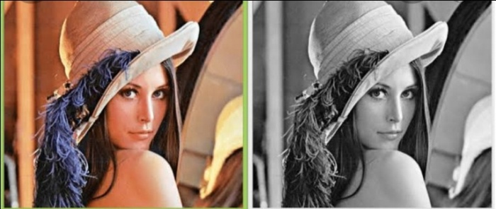

- Design of the CNN
.
The benefit of multiple convergence layers alternating before the use of one layer is that the number of neural network parameters can be reduced. The issue of the use of a number of convolution and pooling layers in front of each form is that the amount of memory required for background spreading is larger. Because the application's key bottleneck is the memory used during the training phase, one layer of each form has been selected.
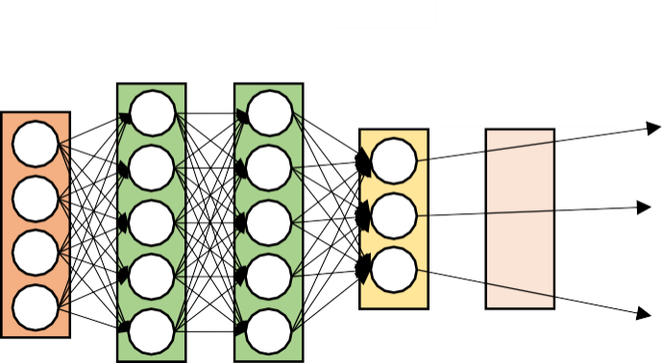
Input
layer
Hidden Layer
Output
Layer
Softmax activation
function

image to enhance the functionality of image processing. Captured images are in the RGB format. The pixel values and the dimensionality of the into Gray image. Then we carry out Noise Removal followed by Thresholding, the last step is Image Sharpening after which we obtain the preprocessed Image linked to the file set account from which the data is accessed. The obtained RGB image is converted in to gray scale image to reduce complexity.

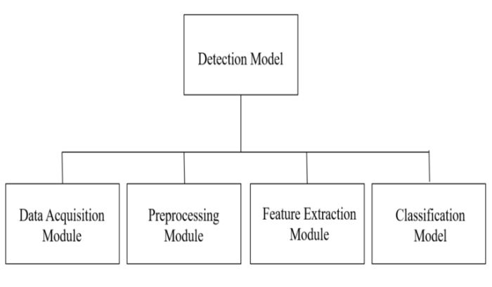

- Noise removal
Noise removal algorithm is the process of removing or reducing the noise from the image. The noise removal algorithms reduce or remove the visibility of noise by smoothing the entire image leaving areas near contrast boundaries. Noise removal is the second step in image pre-processing. Here the gray scale image which was obtained in the previous step is given as input. Here we are making use of Median Filter which is a Noise Removal Technique.
Median Filtering
The median filter is a nonlinear digital filtering technique, often used to remove noise from an image or signal. Here 0’s are appended at the edges and corners to the matrix which is the representation of the grey scale image. Then for every3*3 matrix, arrange elements in ascending order, then find median/middle element of those 9 elements , and write that
median value to that particular pixel position. The figure depicts Noise filtering using Median Filter.

D. Module specification
Module Specification is the way to improve the structure design by breaking down the system intomodulesandsolvingitasindependenttask.Bydoingsothecomplexityisreducedandthemodules can be tested independently.
The number of modules for our model is three, namely pre-processing, identification, feature extraction and detection. So each phase signify the functionalities provided by the proposed system. In the data pre-processing phase conversion of RGB to Gray conversion and that Gray scale value is converted to binary value for efficient calculation of features in next phase. The second phase is to identify the required part of the image from which we need to detect. In the binary values zero is considered as white and one is consider as black. The region with black is identified as required region to extract feature in the next phase.
For next process convolution neural network algorithm is applied. The third phase is to extract the feature from the identified region in the convolution layer of CNN. This includes the part of image which is considered as a required part of image which is used for the detection of the lesion. All the required information of the image is converted into pixel and stored in the form of image. In the final phase each feature from the previous phase is considered and send to fully connected layer. Apply artificial neural network to those features by continuous iteration in the hidden layer of CNN each feature are efficiently identified and finally get the predictive value for output by using soft max activation function. Based on that face will be detected

IV-DISCUSSION

This method is implemented in smart helmet. Thus classification of face using CNN feature extraction and Harcasade is successfully achieved.

Future Work
The work of the future classification of face based on detection should concentrate on finding other CNN composition that exceeds what was conceived in this work. This includes change of architecture, several layers of convolution and bundling, or the activation or error functions used even if their properties are selected. For the future, the search process should not focus only on changing hyper parameters using the same structure.
The position of the face that will be classified as this is usefully information is useful further research. The amount of input data could be reduced much more. The major problem when using such techniques is to refer to the position of a specific face.

V- CONCLUSION

The survey demonstrates Smart helmet for accident avoidance. The helmet should be designed in order to reduce number of accidents in two wheelers this can be done by designing the device using IOT technology. Some sensor like IR sensor, alcohol sensor, GPS modules etc can be used to design a cost effective and user friendly smart helmet. The result should be accurate and should be useful to the government and society. This smart helmet can also be changed to seat belt system in case of four wheelers and can be implemented in future.

VI- ACKNOWLEDGMENT

This paper and the research behind it would not have been possible without the exceptional support of our Head of the Department, Dr. Pushpa Ravikumar, and my supervisor Mrs. Archana. P, Assistant. Professor, Dept .Of Computer Science & Engineering, Adichunchanagiri Institute of Technology, Chikkamagaluru. Her enthusiasm, knowledge and exacting attention to detail have been an inspiration and kept my work on track. I would like to thank our beloved parents for their support, encouragement and blessings

REFERENCES
- Saha, Himadri Nath, Abhilasha Mandal, and Abhirup Sinha."Recent trends in the Internet of Things." Computing and Communication Workshop and Conference (CCWC), 2017 IEEE7th Annual. IEEE, 2017.
- Wilhelm Von Rosenberg, Theerasak Chanwimalueang, ValentinGoverdovsky, David Looney, David Sharp, Danilo P. Mandic,Smart Helmet: Wearable Multichannel ECG and EEG, IEEEJournal of Translational Engineering in Health and Medicine (Volume: 4 )
- Sreenithy Chandran ; Sneha Chandrasekar ; N Edna Elizabeth,Konnect: An Internet of Things(IoT) based smart helmet foraccident detection and notification, India Conference (INDICON),2016 IEEE Annual
- C. J. Behr; A. Kumar; G. P. Hancke , A smart helmet for air quality And hazardous event detection for the mining industry, 2016 IEEEInternational Conference on Industrial Technology (ICIT)
- Sudhir Rao Rupanagudi ; Sumukha Bharadwaj ; Varsha G. Bhat ;S. Eshwari ; S.Shreyas; B. S. Aparna ; Anirudh Venkatesan, AmritShandilya, Vikram Subrahmanya, Fathima Jabeen. A novel video processing based smart helmet for rear vehicle intimation& collision avoidance, 2015 International Conference onComputing and Network Communications (CoCoNet)
- AAjay ; G. Vishnu ; V. Kishoreswaminathan ; V. Vishwanth ;K. Srinivasan ; S. Jeevanantham, Accidental identification andnavigation system in helmet, 2017 International Conference onNextgen Electronic Technologies: Silicon to Software (ICNETS2)
- Mohd Khairul Afiq Mohd Rasli ; Nina Korlina Madzhi ; JulianaJohari, Smart helmet with sensors for accident prevention, 2013International Conference on Electrical, Electronics and System Engineering (ICEESE)
- Muthiah M ; Aswin Natesh V ; Sathiendran R K, Smart helmets for automatic control headlamps, International Conference on Smart Sensors and Systems of (IC-SSS)

