Histogram based Individual Computer Interaction for Image Recognition

Mr. Shrikant N. Sarda¹, Dr. Archana T. Bhise², Dr. Amit K. Gaikwad³

¹Assistant Professor, PRMIT&R, Badnera-Amravati and Research Scholar, Shri JJTU Rajasthan,
² Assistant Professor, H.V. Desai College Pune and Research Scholar Shri JJTU Rajasthan, 333001
³Associate Professor, G.H. Raisoni College of Engineering, Amravati, India, 444701

shrikantnsarda@gmail.com

Received on: 11 June ,2022 Revised on: 06 August ,2022, Published on: 09 August,2022

Abstract-Computer remains as the individual part of our quotidian life, or we can say that, the computer is used by every person in their work. In this design, our main end is to make computers easily understand the individual language. This paper introduces a fashion for individual computer commerce using open CV and python. We have first-processing and recognize the hand Images and the count. Also, with the help of recognized Image count, it's act as a mouse to perform the different operations and this hand mouse interface known as a “virtual monitor”. The hand mouse is controlled by the virtual monitor provides a virtual space. The delicacy of the proposed algorithm is 80. This imaged generality controlling a system by hand has been executed successfully with effective sweats.

Keywords— Image recognition, Histogram Based Tracker, Individual Computer Interaction (ICI) and Real Time Tracking.

- INTRODUCTION
With the development of information technology in our society, we can anticipate that computer systems to a larger extent will be bedded into our terrain. These surroundings will put conditions for new types of mortal-computer-commerce, with interfaces that are natural and easy to use. In particular, the capability to interact with motorized outfit without need for special external outfit is attractive. The image information from the camera is seized at frame rate, the color images are converted from RGB format to a new color space that separates the intensity and value factors of the color data. In the color images, color point discovery is performed, which results in a set of image features that can be matched to a model. Recently in our quotidian life, dispatches between individual and computer play an important part (9). We are always looking for further easy ways of commerce for machines. Image recognition is a modern, innovative and new disquisition content. It enables to communicate individual with the machine that's why it's also known as Man Machine Interaction (10). Using this generality, the cursor will move singly. For individual computer communication, mainly used the input systems as mouse, keyboard etc. The hand Images is generally distributed into static and dynamic predicated on the viewable skin texture. The hand position which does not change during the signing period is known as stationary hand Images. It mainly depends on the shape and rotating angles of the galettes. On other hand, the hand position which alters continuously with respect to time is called as dynamic Images (16). This paper introduces a individual Image recognition system which uses only the galettes to correspond with the computer system (11). This algorithm has three corresponding-processing, segmentation and point birth. This technology could help reduce the over dependence on the keyboard and mouse operation. In features a range (12) of operations for case-a) dominant paperback physical wisdom b) dominant PC games c) visual image system commerce d) mechanical systems operation. The remaining of this paper is organized as follows. In Section II citation about Literature review. In Section III describes proposed methodology and the Image recognition way described in section IV and in section V present our results and in section VI describes conclusion and future work.

II - LITERATURE REVIEW

AashniHaria et al (1) developed avigorousmarker-less hand signal response frame which can effectively follow both static and dynamic hand signals. The frame makes an interpretation of the linked signal into exertion. For illustration, opening spots and propelling operations like VLC Player and PowerPoint. For Images they used Haar slinging classifier. Mayur Yeshi et al (2) developed a lot of movement highlights dependent on smoothed optical aqueduct needles. A user centric representation of these highlights is acquired exercising face position, and a complete classifier is factory out to isolate between signals. They considered a hand-stir predicated interface for exploring a robot. A client can control a robot directly by exercising his or her hand directions. Silas Wan et al (3) developed a system of HCI using a little hand- worn remote module with a 3- center accelerometer as the development sensor. The little free unit contains an accelerometer and a remote zigbee handset with a microcontroller. The delicacy of the proposed system is86.3. Also neural network classifier is used. Swapnil Athavale et al (4) developed a system to convey HCI to a routine where collaborations with computers will be as normal as a connection among people, and to this end, consolidating signals in HCI. The stir acknowledgment is done in three primary stages, for illustration discovery, shadowing, and acknowledgment. Various strategies used, these ways incorporate Time Delay Neural Network, Gee, Dynamic Time Warping, Finite State Model. For dynamic movements, HMM instruments are impeccable and effective, particularly for robot control. Deepali et al (5) developed a examination of leather hand signal acknowledgment fabrics, this paper incorporates a concise check on camera interface, Picture handling, color discovery, hand signal acknowledgment. The delicacy of a glove input device depends on the type of sensor technology used. They employed static and dynamic fashion and in unique strategy they employed calculation like Hidden Markov Models. Aekta Patel et al (6) developed by first detected, perceived andpre- preparing the hang signals by exercising the general system of recognition. Also, they have factory the apparent picture’s parcels and using this, mouse advancement, and VLC media player. By using Neural Network Method, the estimation speed increase and get exact recognition result than other strategy. Nayana et al (7) developed a strategy for individual PC collaboration exercising open source like python, opencv, the proposed calculation comprises of pre preparing, division and highlight birth. The proposed calculation can perceive the volume of galettes present in the hand signal. Chetan Aivalli et al (8) developed a histogram predicated shamus which depends on cam shift calculation and changing over hand signals in a significant direction. The position of accomplishment is 79. It tracks an item by exercising the continuously Adaptive Mean Shift algorithm.

III - PROPOSED SYSTEM
Using the current system indeed- still there are a number of quick access styles available for the hand and mouse Image for the laptops, using our scheme we could make use of the laptop or webcam and by recognizing the hand Image we could control the mouse and perform introductory operations like mouse pointer controlling, handpick and reject using left click, and a quick access skin tone for train transfer between the systems connected via network LAN string. In proposed system system consists of various way Image discovery, Image birth, and recognition. There is a database of features of images which is using for recognition. An input image is use for the discovery of Image from that database of image and displayed in a separated window with histogram. Also, original point like eye, nose and mouth is pulled during point birth, all the features and histogram is stored in a point database. Matching processing check all point in a sequence in one-by-one manner, if first point is matched also it check the coming point, differently it go to check the another input images. Matching of the entire point is the main focus of work. After the entire point matching from data base, it moves to the recognition process. Following are the various way which used during the face recognition system:
3.1Registration of Image in database
3.2 Image detection
3.3 Feature extraction
3.4 Image recognition
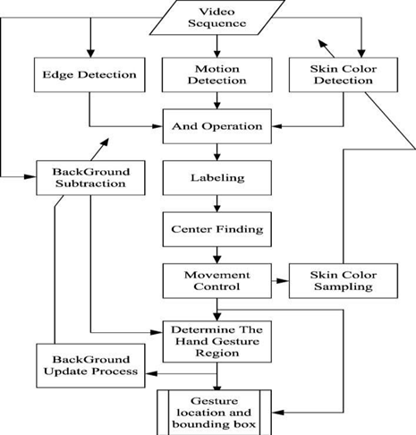

Fig. 1-System Architecture
The scheme done is a “Zero Cost” image recognition system for laptops, which uses simple algorithms to determine the image, hand movements of the image and by assigning an action for each movement. But we've substantially concentrated on the mouse pointing and clicking conduct along with an action for the train transfer between connected systems by hand action and the movements. The most likely hand position is predictable, as well as the position, size and point of reference of the hand. This honored image information is bound to different accomplishment relation to the terrain, and these events are carried under the control of the image recognition system. In this way, the image recognition system provides a medium by which the stoner can control different types of outfit in his terrain This task is ordinarily communicated as appeared among the underneath

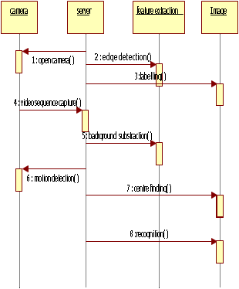

Fig. 2- Sequence Diagram

3.1Registration of Image in database: image Registration is a pivotal step to meliorate the performance of image identification and authentication systems. Registration is done to align sample images to a reference image. In real time systems, the subjects need not be cooperative with data accession. So input image can be of different acts. Registration brings all images to a common match system. Reference image is generally named as a image with anterior disguise. Reference image selection is also critical as it can make considerable change in the performance of the registration algorithms.

  - Image Detection: The base for recognizing hand images is recognizing if there's a hand enclosed by the image. Hence, this paper can place significant stress on the ways of segmenting the hand from the background of the camera (or video) input (13). First one is plumpness. From formerly factory, we have seen that sophisticated algorithms were significantly slower and demanded a lot of sophisticated morning, like homogeny and classifier coaching once establishment the system during a new air. The alternate criteria are strictness. Our use case involves the typical laptop computer user World Health Organization (14) (15) could also be sitting in any air and with a background which will be convoluted. It's thus absorbing to enjoy a segmentation fashion that will accommodate for colorful on-simple backgrounds, despite solely employing a single RGB camera. The least complex styles for perceiving image poses square measure through case coordinating. The model coordinating might be a system to see whether a given data record is regularly delegated an existent from gathering of hang on data records or not. Perceiving hand stations abuse precedent coordinating has two corridors. The essential is to shape the formats by gathering data esteems for each station precedent, utmost strongly coordinating the present data record by examination the present contrivance readings with the given dataset.
  - Feature Extraction:The low- position data from the information is broken down in order to deliver farther elevated amount data and is increasingly used to perceive the stations and Images. It tends to be employed to perceive both straight forward complex hand Images and postures. Individual skin colour, especially on the face of the palm is different from utmost shells one would find in the background. This allowed for colour contrasts between the hand and background, which can be treated as edges. Smart edge discovery is done using Open CV. As will be seen within the advanced than image, smart edge discovery simply forms the description of the hand. Still, they're square measure limitations of the smart edge methodology. First, it's liable to noisy. It'll be tough to directly prize the sting outlines of the hand from the background, particularly if the background has several edges further. One methodology is to try this for involving some type of form matching, presumably employing a window. Still, this is constantly acting to be lower rotation-and size steady. Within the image, it will be seen that some edges square measure is missing,this task is ordinarily communicated as appeared among the underneath Fig.3.
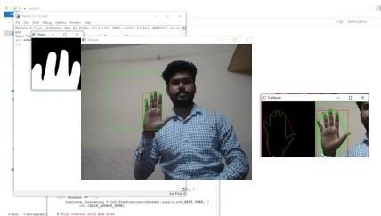
Fig. 3.- Feature Extraction

Applying Cosine Rule to find plot for all deformities between fingers
point = math.cos ((b*2 + c2 - a*2)/(2*b*c)) * 57.
To find length of all sides of triangle
a=math.sqrt((end[0] - start[0])*2 + (end[1] - start[1])*2)
b = math.sqrt((far[0] - start[0])*2 + (far[1] - start[1])*2)
c = math.sqrt((end[0] - far[0])*2 + (end[1] - far[1])*2)
Facilitate values are acquired.
Convexity Defects
In simple words, we can say convexity defect is a cavity in a form portioned out from a picture. That implies a territory that does not have a place with the item, however situated inside of its outer boundary that is known as a convex hull.

IV- IMAGE RECOGNITION
- Thresholding
Thresholding is the one of the simplest system of image segmentation. It's used for barring the terrain and screening the single images. So, it can be used to produce a double image. It's coupled with two-fold picture from the dark scale picture. The double thresholding transforms the tinctures, to be white picture in mate degree remarkably dark factory. This task is generally communicated as appeared among the underneath Fig. 4.
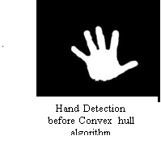 | 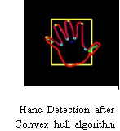
Fig. 4.- Thresholding and Convex Hull

- Contour Extraction
The outline of a figure or body, it’s called contour. The edge or line that defines as boundaries a shape or object contour line. Here we can say outline of each fingers called as a contour line. The bends that crossing point nonstop focuses that section unit of consistent shading, area unit raised as forms. A few signals in our acknowledgement structure with their suitable shapes region unit appeared inside the underneath Fig.5.
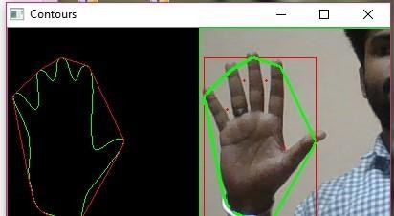
Fig. 5- Contours

- RESULTS
This paper introduces a system for individual computer interaction using open CV and python. By using Template Matching, Feature Extraction, Convexity Defects, Thresholding and Contour extraction we discuss our experimental result in the section. We use the fingers for three functions, for finger count =3 cursor movement execute, for finger count =4 left click and for finger count =5 right click execute. This undertaking is generally communicated as appeared among the underneath Fig.6. Left Click, Fig.7. Right Click, and Fig.8. Cursor Operation.
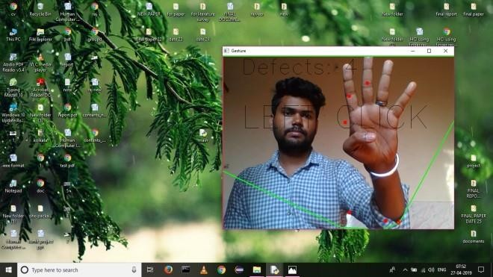
Fig. 6- Left Click
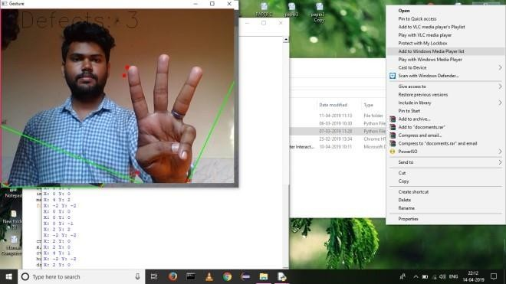
Fig. 7- Right Click
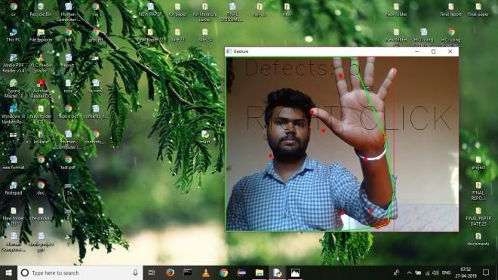
Fig. 8-Cursor Operation

- CONCLUSION

IndividualComputer Interaction (ICI) using Image recognition has successfully executed and achieved with an correctness of 80. On the other hand, it's known that the rigorousness of the support-vector outfit depends ahead the skin tone that was used in the work. Our findings and recognition results, independently, are extremely competitive to the swish discovery and recognition results. The proposed algorithm can be used to descry other skin colour filtering, edge discovery, convex- casing computation, and a rule primarily predicated sense with the depths of the projection scars. In the future compass of this paper is to train and test this algorithm on a huge number of data sets and to compare results with other algorithms. Neural Networks recognition can also be applied for the opinion of the croquette recognition in the future.

REFERENCES

[1] AashniHaria, Shristipoddar, Joyothi S `` Hand Image Recognition for Individual Computer Interaction,'' 7th International Conference on Advances in Computing & Communications, ICACC-2017, 22- 24 August 2017, Cochin, India .
[2] Mayur Yeshi, Pradeep Kale, Bhushan Yeshi, Vinod Sonawane`` Hand Image recognition for individual-computer interaction,'' August 2016 IJSDR, ISSN: 2455-2631.
[3] Silas Wan and Hung T. Nguyen, Senior Member ``Individual Computer Interaction using Hand Image”,[2008] IEEE
[4] Swapnil Athavale , Mona Deshmukh `` Dynamic Hand Image Recognition for Individual Computer interaction,'' International Journal of Engineering Research and General Science Volume 2, Issue 2, Feb-Mar 2014.
[5] Adityanigam "A Noval Face Recognition Approach Using Normalised Unmatched points Measure".
[6] Yao-Jiunn Chen, Yen-Chun Lin "Simple Face-detection Algorithm Based on Minimum Facial Features".
[7] Deepali N. Kakade Prof. Dr. J.S. Chitode `` Dynamic Hand Image Recognition,'' International Journal of Engineering Research & Technology (IJERT) Vol. 1 Issue 9, November- 2012
[8] Aekta Patel `` Hand Image and Neural Network Based Individual Computer Interface,'' ISSN : 2248-9622, Vol. 4, Issue 6( Version 1), June 2014, pp.119-125
[9] Nayana `` Implentation of Hand Image Recognition Technique for HCI Using Open CV,'' International Journal of Recent Development in Engineering and Technology, Volume 2, Issue 5, May 2014)
[10] Chetan Aivalli, Prakash Biswagar, Vinaykumar S Lonimath `` A Real Time Individual Computer Interface Based on Image Recognition for Modification of Images,'' International Journal of Scientific & Engineering Research, Volume 4, Issue 7, July-2013.
[11] W. Bland, T. Naughton, G. Vallee, and S. L. Scott, ``Design and implementation of a menu based OSCAR command line interface,'' in Proc.21st Int. Symp. High Perform. Comput. Syst. Appl.,Washington, DC, USA, May 2007, p. 25.
[12] M. Park, ``A study on the research on an effective graphic interface design of the Web environment for the people with disability-focused on the people with hearing impairment,'' M.S. thesis, Dept. Design, Sejong Univ., Seoul, South Korea, Feb. 2005.
[13] M. N. K. Boulos, B. J. Blanchard, C. Walker, J. Montero, A. Tripathy, and R. Gutierrez-Osuna, ``Web GIS in practice X: A microsoftkinect natural user interface for Google earth navigation,'' Int. J. Health Geogr., vol. 10, pp. 1_14, Jul. 2011.
[14] M. F. Shiratuddin and K. W. Wong, ``Non-contact multi-hand Images interaction techniques for architectural design in a virtual environment,'' in Proc. Int. Conf. Inf. Technol. Multimedia, Nov. 2011, pp. 1_6. [13] I.-T. Chiang, J.-C. Tsai, and S.-T. Chen, ``Using Xbox 360 Kinect games on enhancing visual performance skills on institutionalized older adults with wheelchairs,'' in Proc. IEEE 4th Int. Conf. Digit. Game Intell. Toy
[15] Manigandan M and I.M Jackin, “Wireless Vision based Mobile Robot control using Hand Image Recognition through Perceptual Color Space”, IEEE International Conference on Advances in Computer Engineering, 2010, pp. 95-99.
[16] J.L. Raheja, K. Das and A. Chaudhury, “An Efficient Real Time Method of Fingertip Detection”, International Conference on Trends in Industrial Measurements and automation (TIMA), 2011, pp. 447-450.
[17] Rajesh George Rajan and M Judith Leo,” A Comprehensive Analysis on Sign Language Recognition System”, International Journal of Recent Technology and Engineering (IJRTE) ISSN: 2277-3878, Volume-7, Issue-6, March 2019.
[18] Bhagat, N. K., Vishnusai, Y., &Rathna, G. N. (2019, December). Indian sign language gesture recognition using image processing and deep learning. In 2019 Digital Image Computing: Techniques and Applications (DICTA) (pp. 1-8). IEEE.
[19] Ojha, D., &Rajan, R. G. (2019, June). Histogram based human-computer interaction for gesture recognition. In 2019 3rd International Conference on Electronics, Communication and Aerospace Technology (ICECA) (pp. 263-266). IEEE
[20] Shukla, P., Garg, A., Sharma, K., & Mittal, A. (2015, December). A DTW and Fourier Descriptor based approach for Indian Sign Language recognition. In 2015 Third International Conference on Image Information Processing (ICIIP) (pp. 113-118). IEEE.

