Numerical Investigation of Deflection Amplification Factor in Moment Resisting Frames Using Nonlinear Pushover Analysis
Ramin Taghinezhad¹; Arash Taghinezhad²; Vahid Mahdavifar³; Vafa Soltangharaei⁴
¹ Research Assistant, Ph.D.
Department of Civil and Environmental Engineering, Florida International University
Rtagh001@fiu.edu

² Graduate Research Assistant
Department of Construction Management, Louisiana State University

³ Post-doctoral Research Associate, Ph.D.
Department of Environmental Conservation, University of Massachusetts Amherst

⁴ Graduate Research Assistant
Department of Civil and Environmental Engineering, University of South Carolina.

Abstract – The lateral deflections were obtained from an elastic analysis under seismic loads are much lower than actual deflections which building structures must withstand during strong ground motions. Recent building codes increased the elastic deflection by an amplification factor which is a parameter of overstrength factor and ductility ratio. The overstrength factor is a coefficient which applied to design forces to find the maximum base shear after forming plastic hinges, and ductility ratio is the capability of structures to withstand nonlinear deflection before the collapse. These seismic parameters can be obtained performing nonlinear pushover analysis and using capacity curve. In this research, five ordinary and special moment resisting frames with three, five, seven, nine, and twelve stories have been subjected to a nonlinear pushover analysis and their capacity curves has been derived. The calculated values for the overstrength factor and deflection modification factor were compared with the introduced values in ASCE 7-10. The results of this comparison indicate that ASCE 7-10 values are slightly conservative.
Keywords – Deflection Amplification Factor, Overstrength Factor, Ductility Ratio, Nonlinear Pushover Analysis, Ordinary Moment Resistant Frame, Special Moment Resistant Frame.
1. INTRODUCTION
The seismic design of steel structures was radically changed after the Northridge 1994 earthquake in California, United States. After this earthquake, based on the observed damages in the existing steel structures, special seismic design specifications were established in the American Institute of Steel Construction, AISC, and Uniform Building Code, UBC [1,2].
Overstrength factor, Ω₀, is an important coefficient in estimating the maximum lateral displacement for the building and bridge structures under seismic loads [3]. Considering overstrength factor, ductility ratio and deflection amplification factor in the design of new components in building and bridge structures lead to less damage under vibration loads during the service life [4-7]. Nonlinear static and incremental nonlinear dynamic analyses are common numerical methods for an estimation of seismic parameters [8]. Soltangharaei et al, estimates behavior factors for special moment resisting frames, for near and far fault ground motions using incremental dynamic analysis [9-10]. Although incremental dynamic analysis resembles more realistic seismic behavior of structures compared to pushover analysis, it is much more complex and time costly than pushover analysis, and highly sensitive to ground motion record selection. In this research, several steel moment resisting frames subjected to nonlinear pushover analysis. The effective parameters that control lateral displacement of structures under seismic loads are described using the capacity curve. Finally, the calculated values from the capacity curves were compared with the prescribed values in the ASCE 7-10.
2. SEISMIC DESIGN CONCEPTS USING CAPACITY CURVE
Current seismic design practice is based on analysis results from the elastic analysis which decreased by implementing response modification factor [11]. In this method, some of the components of the structure are designed in such a way that acts as a fuse against seismic loads, which means that these members are placed in inelastic-plastic range and energy dissipated through the plastic deformation in predefined members. These members are weak links of the system and entered in inelastic-plastic range, while the other members and their connections must remain in elastic range.
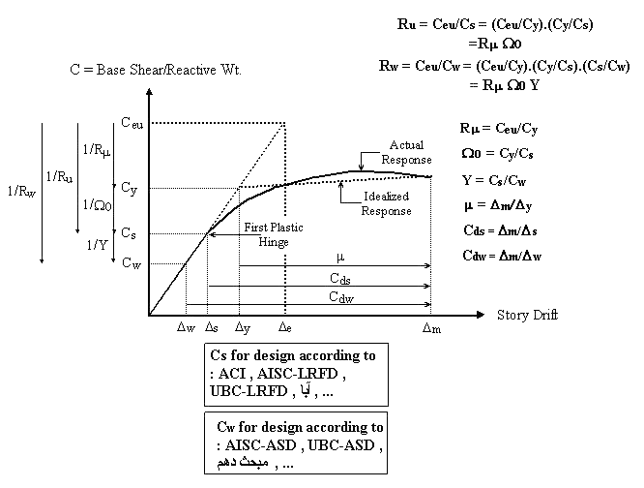
Figure 1. Capacity curve and different force levels.

Figure 1 shows the capacity curve of a structure. In this curve, the horizontal and vertical axis represents the story drift and the base shear, respectively. If it was assumed that the structure is designed to behave inelastic during seismic loads, the maximum elastic base shear, C_{eu}, would be much larger than the design force level calculated based on the codes. Due to the dissipated energy by nonlinearity in some internal elements, the design force reduced to C_{s} for LRFD method and C_{w} for ASD method. This reduction to the level of design forces takes place by applying response modification factor R_{u} for LRFD method and R_{w} for ASD method. For example, in the LRFD method, design force is obtained by dividing the maximum elastic base shear, C_{eu}, by R_{u}.
(1)

The first plastic hinge forms in the structure at the design force, C_{s}. By increasing the lateral load beyond design force, C_{s}, other members in the structure potentially enter in the nonlinear range, and the whole structure response curve would show nonlinearity behavior. The capacity curve of the structure idealized by a bilinear curve which represents the elastic-plastic behavior. The bilinear curve is represented by the dotted lines in Figure 1. This bilinear curve shows that R_{u} dependents on other coefficients as below.
(2)

(3)
(4)
Ductility reduction factor, R_{μ}, reduces seismic forces from C_{eu} to C_{y} level in the capacity curve. This capability is provided by elements of a structural system designed to dissipate energy [12]. Miranda and Bertero have proposed equations to estimate R_{μ} at a 5% damping on different soil types [13]. Also, Krawinkler and Nassar developed equations for obtaining this coefficient on a rock or stiff soil at 5% damping [14]. In this research, this coefficient is calculated using the proposed equations by New Mark and Hall [15]. These equations are as below:
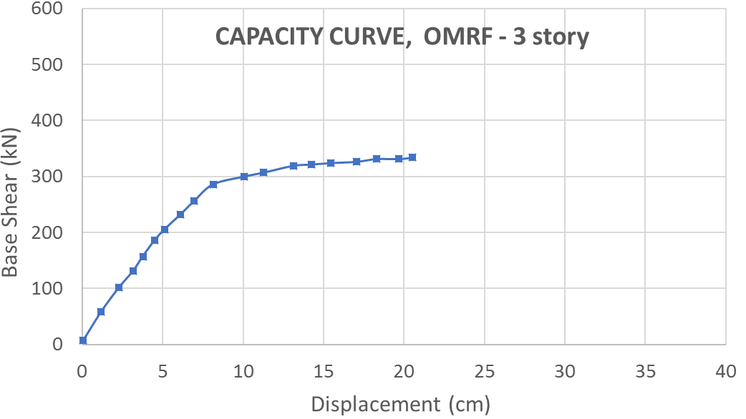 | 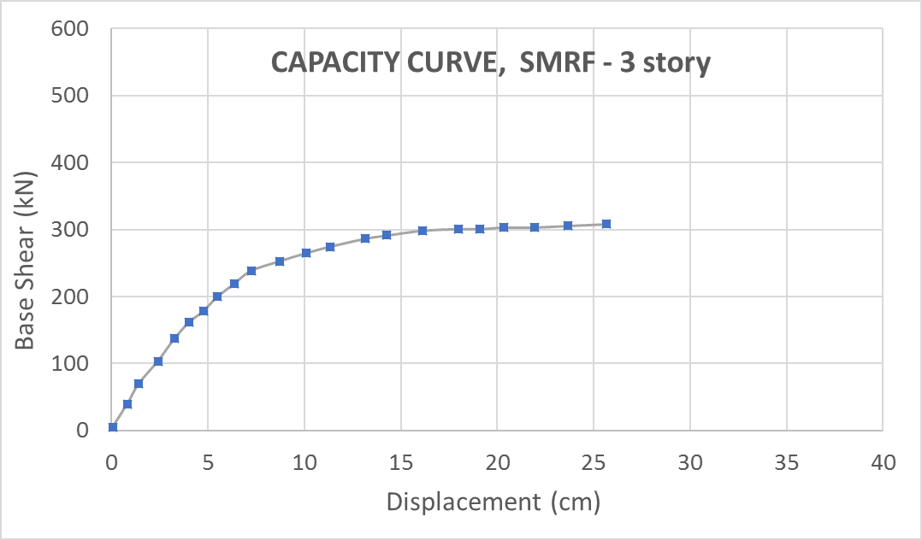
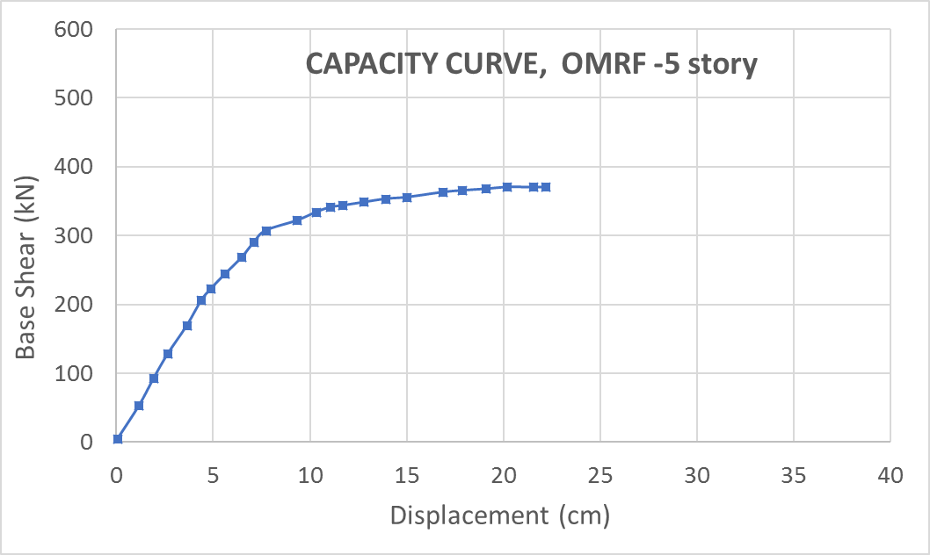 | 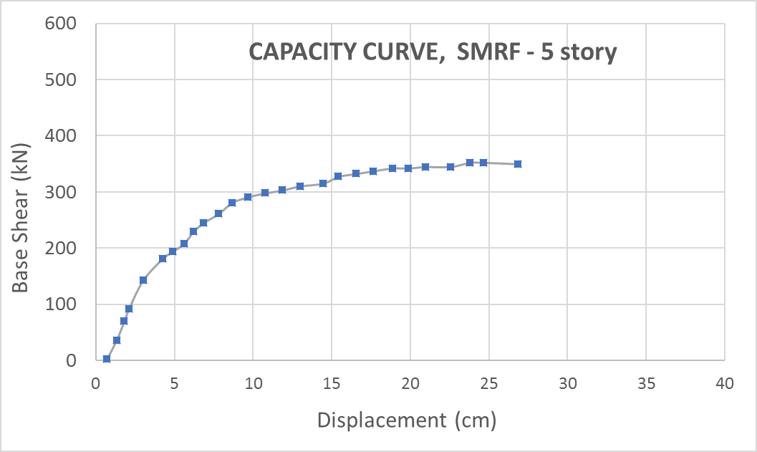
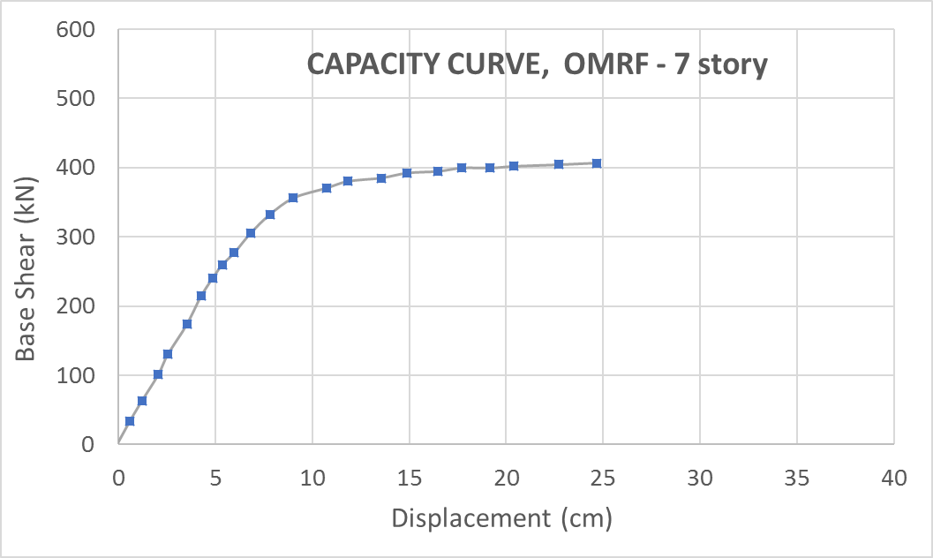 | 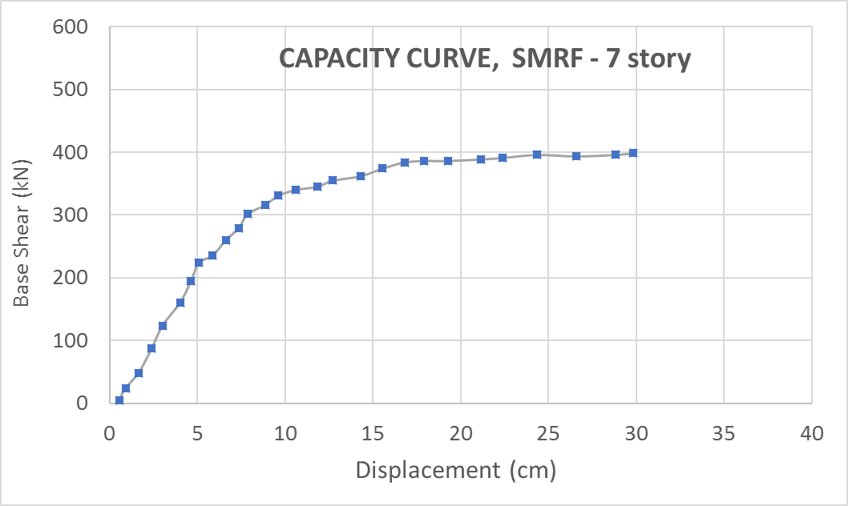
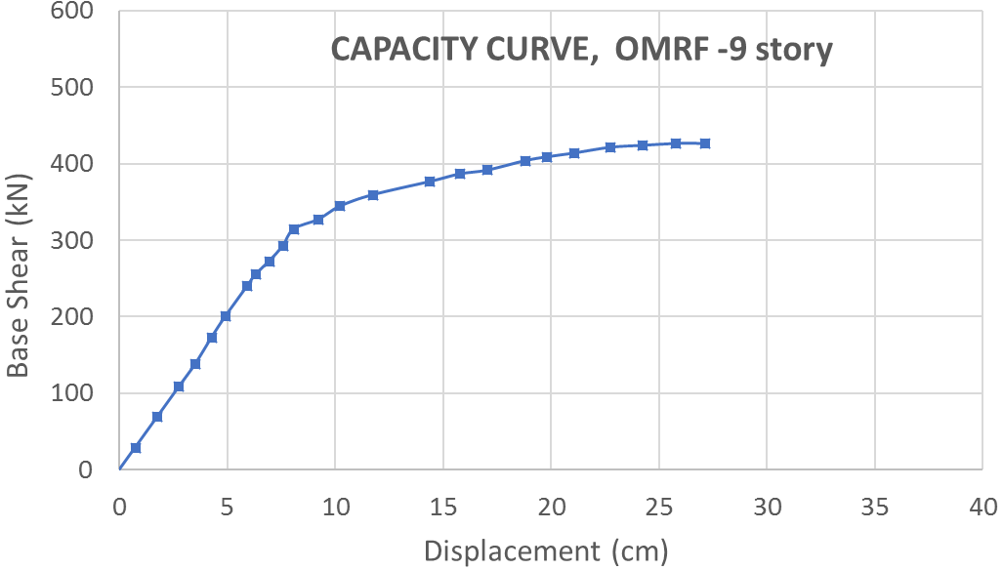 | 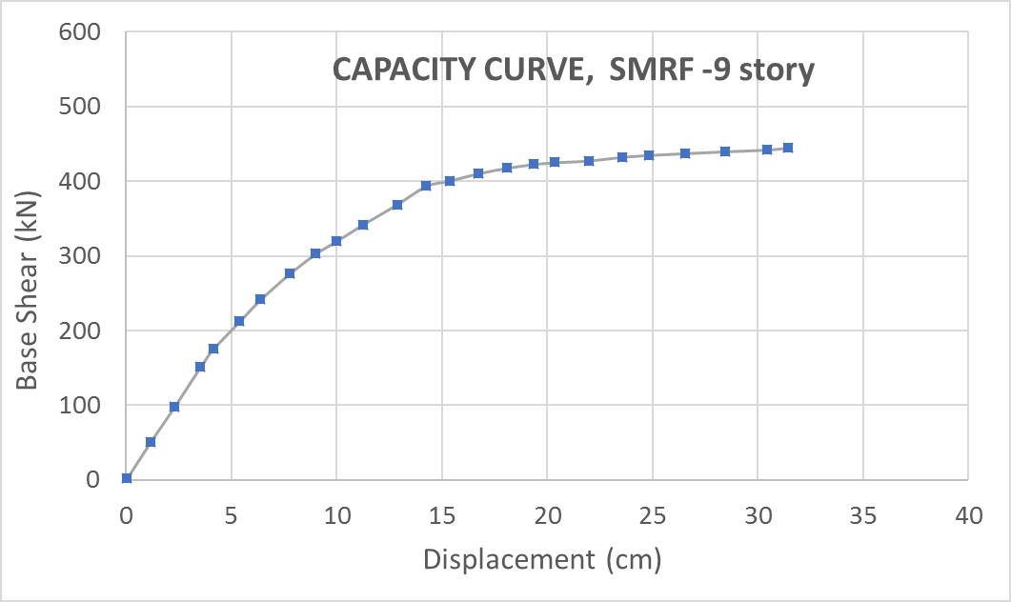
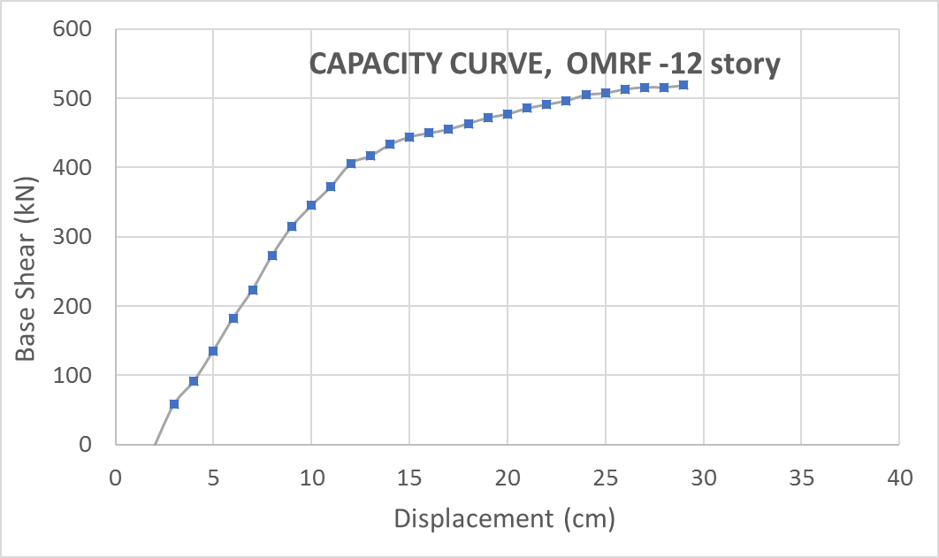 | 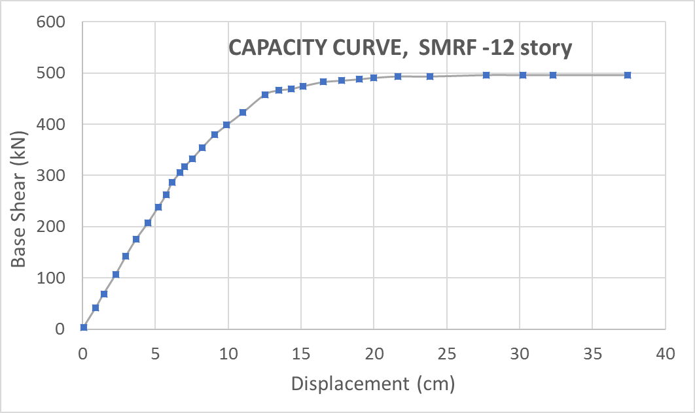
Figure 2. The capacity curve of the Ordinary (OMRF) and Special (SMRF) Moment Resisting Frames.

(5)
(6)
(7)
3. ESTIMATING MAXIMUM LATERAL DISPLACEMENT
The philosophy behind seismic loads in the most design codes rely on the ductility of structures in the nonlinear range of the capacity curve. In other words, they reduce the value of design forces using the inherent capability of structure to dissipate input energy.
For steel and reinforced concrete buildings material ductility, cross-section ductility, member ductility, and structure ductility are widely used [16,17]. While in timber constructions since wood is an inherently brittle material and timber elements exhibit almost no potential for energy dissipation. Thus, in a timber structure the only elements that provide ductility, and consequently exhibit hysteretic dissipation of energy under cyclic loading, are the metal connection systems as documented by many researchers [18-20]. This philosophy is applied to other nonbuilding type structures facing extreme loading condition but are beyond the scope of this work [21,22].
The response modification factor, R, is considered in seismic design to reduce maximum elastic base shear, C_{eu}, due to the nonlinear behavior of the structure. Since the structure enters in the nonlinear range during seismic loads, the actual displacement would be greater than the values calculated based on an elastic analysis. For this purpose, to find the maximum lateral displacement, the deflection amplification factor introduced to increase displacement calculated from an elastic analysis. The relationship between this coefficient and the response modification factor in Load and Resistance Factor Design (LRFD) is as below:
(8)
(9)
Now, by calculating the ductility coefficient, μ, and Ω₀, the deflection amplification factor, C_{ds}, can be determined. By using the New Mark Hall equation for R_{μ} and for the structure with long periods, R_{μ} =μ then:
(10)
It means the real displacement is equal to:
(11)
Based on the code provisions, the nonlinear lateral displacement can be estimated by applying deflection amplification factor, C_{d}, to the displacements calculated from the elastic analysis of the structure under a determined design force. In the seismic design codes, the expected maximum nonlinear displacement is equal to:
(12)
which β is an experimental coefficient.
4. CODE SPECIFICATION FOR DEFLECTION AMPLIFICATION FACTOR, C_{d}
4.1 UBC97 Code
In the UBC97 standard, the nonlinear displacement value is determined as below [2]:
(13)
This equation is similar to the Equation 12, in which β=0.7 and it can be rewritten as:
(14)
4.2 ASCE 7-10
However, theoretically, using Equation 13 is logical to determine the nonlinear displacement of structures, but it is better to consider the effect of other parameters, such as the importance of the structure and the earthquake resisting system, in determining this value. ASCE 7-10 has followed such an approach [23]. In this case, the nonlinear displacement coefficient is determined from the following equation.
(15)
which I is the importance factor of the structure and C_{d} is the deflection amplification factor corresponding to the earthquake resisting system.
5. NONLINEAR PUSHOVER ANALYSIS OF CASE STUDY FRAMES
For extracting the deflection amplification factor, first, the overstrength factor and the ductility ratio of the structure should be determined. For this purpose and comparing the results with values provided by the Code, five different moment resisting frames (MRF) with different stories such as 3, 5, 7, 9 and 12 were modeled and designed using CSI SAP2000 program [24]. Each of these structures was analyzed and designed in accordance with the ordinary moment resisting frame and special moment resisting frame specifications [25], then a nonlinear pushover analysis carried out, and the lateral load pattern corresponding to ASCE 7-10 vertical distribution of seismic forces was increased step by step until the structure collapsed or nonlinear analysis did not get converge. Nonlinear pushover analysis was performed using advanced nonlinear features and analysis of CSI SAP2000 program [24]. The nonlinear pushover analysis can capture the failure modes, defining the location of plastic hinges and plotting the capacity curve. The results of the nonlinear pushover analysis are shown in Figure 2 for OMRF and SMRF. The overstrength factor and ductility ratio were extracted from the above diagrams for each of the ordinary and special moment resisting frames according to Table 1.
Table 1. Overstrength factor and ductility ratio of ordinary and special MRF.
No. of Stories | Overstrength Factor |  |  | Ductility ratio
 | OMRF |  | SMRF | OMRF |  | SMRF
3 | 2.32 | 2.52 |  | 1.05 | 1.99
5 | 2.21 | 2.41 |  | 1.29 | 2.08
7 | 1.95 | 2.35 |  | 1.48 | 2.22
9 | 1.81 | 2.14 |  | 1.68 | 2.57
12 | 1.77 | 2.11 |  | 1.79 | 2.64

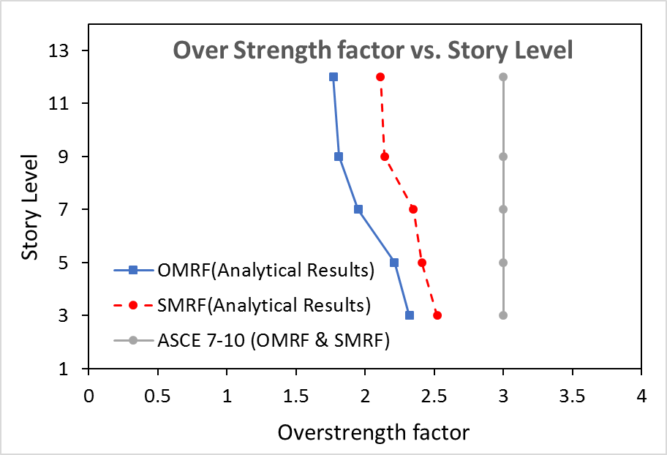
Figure 3. Overstrength factor for different story levels for ordinary and special MRF.
Figure 3 shows the overstrength factor versus story level that indicates ductility decreased by number of story levels or by increasing the period of structure. Figure 4 shows the ductility ratio calculated based on capacity curves. Figure 5 shows the deflection amplification factor for the ordinary and special moment resisting frames resulted from analytical investigation and suggested value by ASCE 7-10.
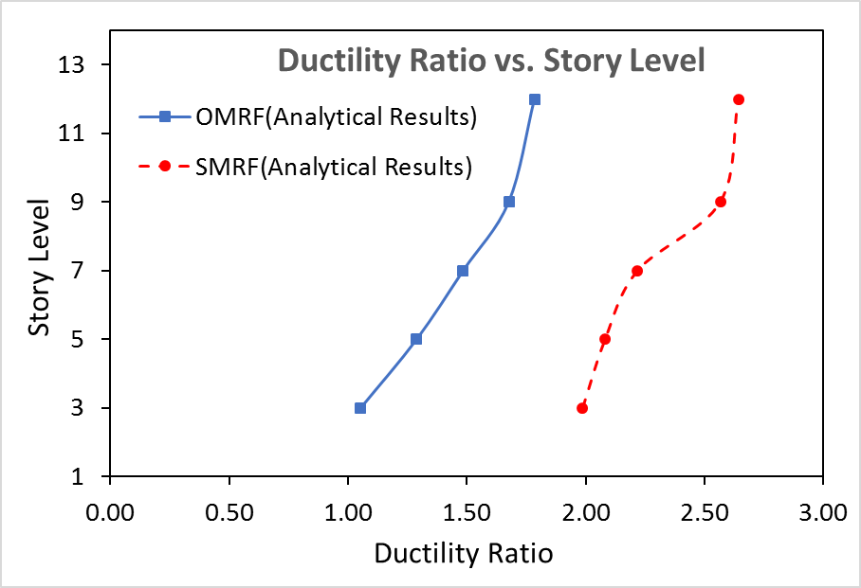
Figure 4. Ductility ratio for different story levels for ordinary and special MRF.
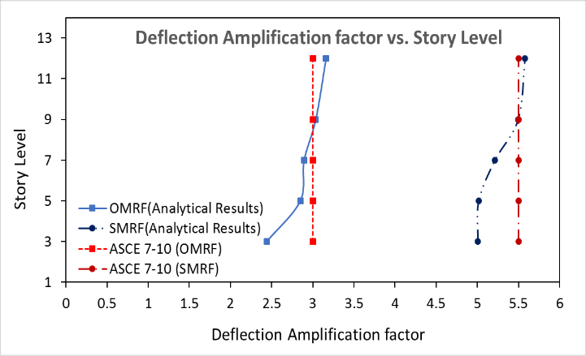
Figure 5. Deflection amplification factor for different story levels in ordinary and special MRF.
6. CONCLUSION
In this research, five-moment resisting frame with three, five, seven, nine, and twelve stories have been subjected to a nonlinear static analysis and their capacity curves has been determined. Then, the overstrength factor and ductility ratio derived using the capacity curves. Finally, the deflection amplification factor was obtained. According to the analysis results, it was observed that the overstrength factor decreases with increasing number of stories. It approximately remains constant for frames with nine to twelve story levels.
The SMRF has higher ductility ratio and overstrength factor than OMRF. For both OMRF and SMRF the overstrength factor in the ASCE 7-10 is higher than the obtained overstrength factor from the analytical results, therefore ASCE 7-10 is slightly conservative. The SMRF have higher C_{d} compared to OMRF according to analytical results, however, values suggested by code is higher.
The deflection amplification factor has a direct relationship with the structural ductility ratio. In this study, the derived deflection amplification factors are less than prescribed values in ASCE 7-10 for frames below 8-story, and with increasing the number of stories, this coefficient becomes closer to the values introduced in the Code. This value almost corresponds to the values introduced in the Code for the SMRF and OMRF in the eight-story frame.
The concept used in calculating the deflection amplification factor is consistent and equal, in both UBC97 and ASCE 7-10. In ASCE 7-10, the importance factor of the building is also included in the calculation of deflection amplification factor, which seems to have more logical meaning for calculating of this coefficient.
NOTATIONS
The following notations are used in this study (Figure 1):
C_{eu} | = | Maximum elastic base shear
C_{s} | = | Design base shear coefficient in LRFD
C_{w} | = | Design base shear coefficient in ASD
C_{y} | = | Base shear at yielding point in idealized bilinear response
R_{u} | = | Response Modification Factor in LRFD
R_{w} | = | Response Modification Factor in ASD
R_{µ} | = | Ductility Reduction Factor
Ω₀ | = | Overstrength factor
Y | = | C_{s} / C_{w}
μ | = | Ductility ratio, Δ_{m} / Δ_{y}
Δ_{s} | = | Drift corresponding to design base shear coefficient in LRFD
Δ_{w} | = | Drift corresponding to design base shear coefficient in ASD
Δ_{y} | = | Drift corresponding to base shear at yielding point in idealized bilinear response
Δ_{e} | = | Drift corresponding to maximum elastic base shear
Δ_{m} | = | maximum Drift in the plastic range
C_{ds} | = | Δ_{m} / Δ_{s}
C_{dw} | = | Δ_{m} / Δ_{w}
I | = | Importance factor

REFERENCES
[1] American Institute of Steel Construction (AISC), Load and Resistance Coefficient Design Specification for Structural Steel Buildings, AISC, Chicago, IL, 1993.
[2] UBC 1997, Uniform Building Code, Volume 2, Structure Engineering Design Provision, International Code Council, Inc. Falls Church, Virginia.
[3] Ramin Taghinezhadbilondy,2016, Extending Use of Simple for Dead Load and Continuous for Live Load (SDCL) Steel Bridge System to Seismic Areas, Ph.D. dissertation.
[4] Ramin Taghinezhad, JH Gull, H Pham, LD Olson, A Azizinamini, 2017, Vibration Monitoring During the Deconstruction of a Post-Tensioned Segmental Brid.
[5] Atorod Azizinamini, Aaron Yakel, Ardalan Sherafati, Ramin Taghinezhad, Jawad H Gull,2016, Flexible Pile Head in Jointless Bridges: Design Provisions for H-Piles in Cohesive Soils, Journal of Bridge Engineering
[6] Huy Pham, Ramin Taghinezhad, Atorod Azizinamini, 2017, Experimental Investigation of Redundancy of Twin Steel Box-Girder Bridges Under Concentrated Load, Transportation Research Board 96th Annual MeetingTransportation Research Board
[7] A Mohammadi, JH Gull, R Taghinezhad, A Azizinamin, 2014, Assessment and Evaluation of Timber Piles Used in Nebraska for Retrofit and Rating, Department of Civil and Environmental Engineering Florida International University Miami, Florida, NDOR Research Project.
[8] Soltangharaei, V., Razi, M. and Vahdani, R., 2016. Seismic fragility of lateral force resisting systems under near and far-fault ground motions. International Journal of Structural Engineering, 7(3), pp.291-303.
[9] Soltangharaei, V., Razi, M. and Gerami, M., 2015. Behaviour factor of buckling restrained braced structures for near and far fault ground motions. International Journal of Structural Engineering, 6(2), pp.158-171.
[10] Soltangharaei, V., Razi, M. and Gerami, M., 2016. Comparative Evaluation of Behavior Factor of SMRF Structures for Near and Far Fault Ground Motions. Periodica Polytechnica. Civil Engineering, 60(1), p.75.
[11] Uang, C.-M. Establishing R (or Rw) and Cd Factors for Building Seismic Provisions, J. Struct. Engrg., Vol. 117, No. 1, pp. 19-28, ASCE, 1991.
[12] Krawinkler,H. And Nassar,A. A., "Seismic Design Based on Ductility and Cumulative Damage Demands and Capacities, "Nonlinear Seismic Analysis and Design of Reinforced Concrete Building, Edited by Fajfar and Krawinkler, Elsevier Applied Science, New YORK,1992.
[13]- Miranda, E. and Bertero, V. V., "Evaluation of Strength Reduction Factor for Earthquake – Resistant Design," Earthquake Spectra,Vol. 10,NO.2,357-379,1994.
[14] Nassar,A .A. and Krawinkler,H., Seismic Demands for SDOF and MDOF Systems, John A. Blume Earthquake Engineering Center, Report No. 95,Stanford University, Stanford California,1991.
[15] Newmark, N. M. and Hall, W. j., "Earthquake Spectra and Design," Earthquake Engineering Research Institute, Berkley, California,1982
[16] Oskouei, V.A. and Mahdavifar, V., 2013. Modeling of Two-Cell Concrete Cores for Investigation of Reliabality of Equivalent Column Method,
[17] Gioncu, V. (2000). Framed structures. Ductility and seismic response: General Report. Journal of Constructional Steel Research, 55 (1): 125-154.
[18] Mahdavifar, V., Barbosa, A., Sinha, A., Muszynski, L. and Gupta, R., 2017. Hysteretic behaviour of metal connectors for hybrid (high-and low-grade mixed species) cross laminated timber, World Conference on Timber Engineering, Vienna, Austria.
[19] Mahdavifar, V., Barbosa, A.R. and Sinha, A., 2016. Nonlinear Layered Modelling Approach for Cross Laminated Timber Panels Subjected to Out-of-Plane Loading., 41st IAHS World Congress on Housing, Albufeira, Portugal.
[20] Mahdavifar, V., 2017. Cyclic performance of connections used in hybrid cross-laminated timber (Doctoral dissertation).
[21] Hamedi, A., Mahdavifar, V., Sajjadi, S. and Fesharaki, M., 2017. Sensitivity Analysis of Earthquake Acceleration and Drainage Efficiency on the Stability of Weighted Concrete Dams.
[22] Hamedi, A., Mansoori, A., Shamsai, A., & Amirahmadian, S. 2014. The Effect of End Sill and Stepped Slope on Stepped Spillway Energy Dissipation. Journal of Water Sciences Research, 6 :1-15.
[23] ASCE Standard ASCE/SEI 7-10, Minimum Design Loads for Buildings and Other Structures, American Society of Civil Engineers, 2010
[24] Computers and Structures Inc. (CSI), SAP2000 Three Dimensional Static and Dynamic Finite Element Analysis and Design of Structures V 8.4.5, Berkeley, California.
[25] American Institute of Steel Construction (AISI), Seismic Provisions for Structural Steel Buildings, July 12, 2016, Pittsburgh, PA
Ramin Taghinezhad Ph.D. received his B.Sc. degree in Civil Engineering and M.Sc. degree in Structural Engineering. He obtained his doctorate degree from Florida International University. He has great experience in nonlinear static and time history analysis and performance-based design. He has over eight years of experience in the seismic design and rehabilitation of commercial, residential, and industrial steel and concrete structures. He is currently working on the seismic retrofit of building structures in the city of Los Angeles.
Arash Taghinezhad is a Ph.D. Graduate Research Assistant in the Department of Construction Management at Louisiana State University. He has a M.Sc. in Engineering Science from Louisiana State University in 2017, and a M.Sc. in Construction Management from University Technology Malaysia in 2013. He has extensive experience in green buildings, natural disaster management, and construction cost analysis.
Vahid Mahdavifar Ph.D. is a Post-Doctoral Research Associate in the Department of Environmental Conservation at the University of Massachusetts Amherst, which he joined after completing a dual-major Ph.D. program in Structural Engineering and Wood Science in 2017. His expertise lies in the multidisciplinary areas of seismic design, structural dynamics, advanced finite element analysis, timber design, wood science, life-cycle assessment, and renewable building materials.
Vafa Soltangharaei is a Graduate Research Assistant in Civil and Environmental Engineering Department at University of South Carolina. His expertise is in earthquake engineering of steel and concrete framed structures, health monitoring system such as acoustic emission method, and data analyzing of signals.

