Predictive Control Scheme for SSSC to Regulate
The Power in Transmission Line

Ritesh C Ujawane | Parag G. Shewane | Shivpal Verma | Nitin Choudhary
Assistant Professor | Assistant Professor | Assistant Professor | Assistant Professor
Department of Electrical Engineering, | Department of Electrical Engineering, | Department of Electrical Engineering, | Department of Electrical Engineering,
D.B.A.C.E.R., Nagpur, India | D.B.A.C.E.R., Nagpur, India | D.B.A.C.E.R., Nagpur, India | JIT, Nagpur
ritesh_ujawane@rediffmail.com | pshewane.dbacer@gmail.com | verma.shivpal@gmail.com | nitz87choudhary@gmail.com

Abstract—Out of the most of the power electronics devices, multilevel inverters are most compatible for high voltage and high power applications. This paper implements a static synchronous series compensator (SSSC) by using five-level FCMLI is mentioned. The results are simulated in MATLAB and the explained system is made to run in two modes of operations and the outcomes affirms the execution of the proposed control scheme and is implemented in a bulk transmission supply where the reactive power has to be controlled to increase the transmission line capacity to transfer more power in the same transmission line.

Index terms—FCMLI; SSSC; FACTS; Multilevel inverters.

I. INTRODUCTION
The transmission system has seen a large growth in recent years due to advancement in power electronics and the study of the electronic circuits in order to control the flow of energy in the electrical systems which lead to the development of new controllers which consist of flexible AC transmission (FACTS) devices. The technology behind the switching of the power supplies, power converters, power inverters and various motors drives and starters has a wide use of Power electronics and switching devices.
Present day control framework is configured to work productively to supply power on request to different loads with high dependability. The energy producing stations are regularly situated at separate locations for economic, ecological and security reasons. In this manner the network of interconnection of transmission system operating at high or extra high voltages is required to transfer power from the producing station to the demand centers.
Certain new innovation in the FACTS technology has been acquainted in order to enhance the power system framework to reduce its existing problems. In FACTS new enhanced devices
are used to control the power exchange in transmission network. It is also used to improve the quality of power in transmission line network. It helps to maintain the voltage, transient stability, power-factor etc. within the specified limit.
“A power electronic based system and other static equipment that provides control of one or more AC transmission system parameters” is called as FACTS controller.
Conventionally, FACTS devices can be distributed into the following categories:

(i) Series Controllers. (ii) Shunt Controllers.
(iii) Combined Series-Series Controllers. (iv) Combined Series-Shunt Controllers.
The advantages of FACTS over the existing system are as follows:-

(i) Power flow control can be possible using FACTS
technology.

(ii) Controlling reactive power flow this way permitting lines to convey more active power at the demand network.

(iii) Damping of oscillations that can damage system vital devices and secure power continuity

(iv). Provide control over transmission line parameters.
Provide more chances of adaptability in locating a new substation.

This paper describes an SSSC using a 5 level flying capacitor inverter. The basic operation of the inverter is also described. A close loop control is also explained in the paper with appropriate labeling as per standard. Simulation results using MATLAB are given to validate the design.

II. STATIC SYNCHRONOUS SERIES COMPENSATOR (SSSC)
Adjusted by Thyristor Switches (TCPST), and Thyristor
Controlled Phase Angle Regulator (TCPAR)”.

E. Static Synchronous Series Compensator(SSSC)
This is a type of series FACTS controller which is used to control power flow and damp power oscillation on power grid. The SSSC works as series compensation device in
transmission lines by means of injected voltage 𝑉q into
connected transmission line, Fig.1.

A. Series Controllers
Series controllers work in two modes of operation. They control real power when injected voltage is in quadrature with feeder current, otherwise they can control real and reactive power [1].For example “Static Synchronous Series Compensator (SSSC), Thyristor-Switched Series Capacitor (TSSC), and Thyristor-Controlled Series Reactor (TCSR)” are series controllers. They are successfully utilized to control power flow and to damp system oscillations after disturbances. SSSC is the most popular device in this family due to multipurpose capability.

B. Shunt Controllers
Shunt controllers work in the same manner as series controllers. The only difference is that they inject current into system instead of voltage at point of common coupling. The current control strategy is achieved by varying shunt impedance causing variable injecting current into the system. Shunt Controllers control active & reactive power by means of injecting current in line. Hence they are utilized as voltage regulators [1]. For example Shunt controllers include “STATCOM, Thyristor Controlled Inductor (TCR), Thyristor- Switched Inductor (TSR), Thyristor-Switched Capacitor (TSC), and Thyristor-Switched Resistor (TCBR)”.

C. Series – Series Contollers
Combined series-series controllers comprise of two separate controllers; series controllers operate in multiline transmission network, and another provide independent reactive power control for each line of same multiline transmission system [1]. For example “The Interline Power Flow Controller (IPFC)” is an great example of this type controllers which balance both real and reactive power flows on transmission lines.

D. Series – Shunt Controllers
Combined series-shunt controllers consist of two separate controllers; one is series and another one is shunt controllers. Series controllers provide series voltage while Shunt controllers inject current into the transmission line network. Therefore, when shunt and series controllers are combined, real power can be exchanged between them thru power links. For example the series shunt controllers include combination of “STATCOM & SSSC (UPFC), Phase-Shifting Transformer

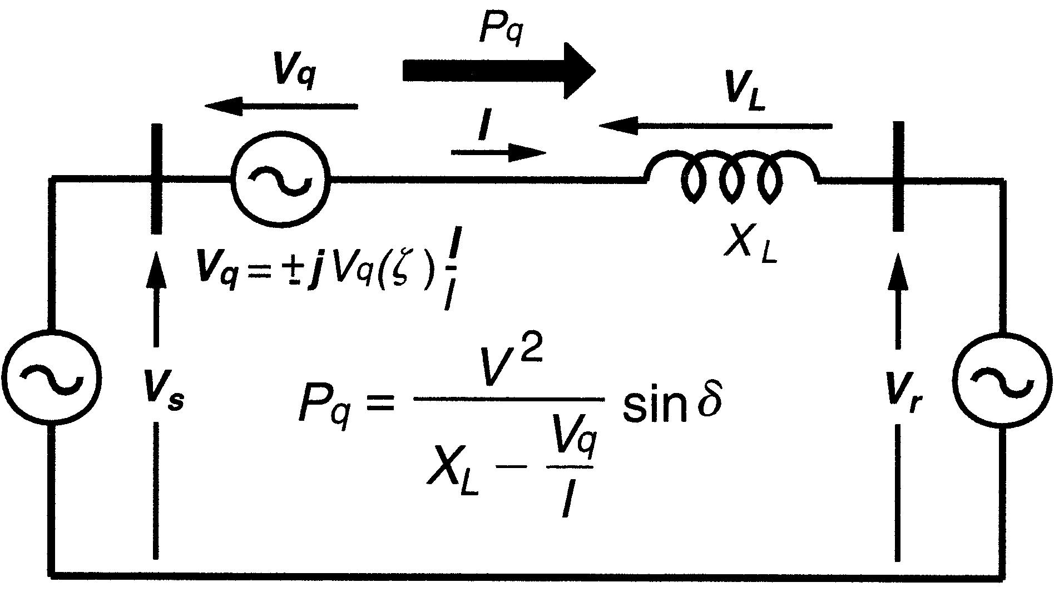Fig.1 Basic Circuit Model of SSSC The real power transfer to the transmission line is
expressed by following formula [1]:
𝑉 𝑉
𝑉
SSSC injects compensation voltage in quadrature with
feeder current. The voltage magnitude can be either positive or negative. Therefore, SSSC rating can be expressed in VA as follows:
√ 𝑉 𝑉
That is, maximum line current multiplied by maximum
injected voltage SSSC is capable of. For instant, SSSC with 1 pu injected voltage has rating of 2 pu VA due to positive/negative characteristics of SSSC.

III. FCMLI BASED SSSC
“An SSSC injects the voltage in series with the transmission line network of controllable magnitude and phase, and therefore controlling the active and reactive power flow in the transmission line”[1]. The heart of SSSC is a voltage source converter.
A five-level FCMLI is used for series compensation of transmission line system. The system constitute of two three- phase sources that are interconnected by the transmission line. The SSSC is connected at the midpoint in the transmission
network. The specifications are given in the Table I. The schematic diagram of the compensated system is shown in fig below.
The inverter is to be connected to the transmission network by through the use of three single-phase transformers. The transformers inverter to line ratio is 2:1 it is selected such that the inverter current should be half that of the line side. The transmission line model of distributed parameters with 100 km has been used
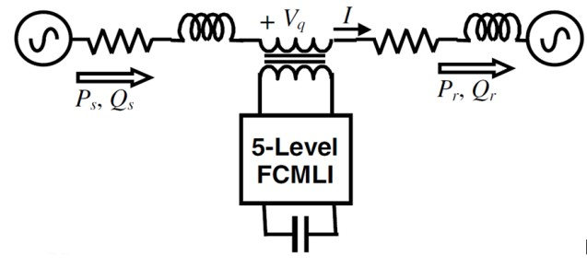

Fig.2 Block Diagram of FCMLI based SSSC

The base MVA is chosen to be 160MVA and the base KV is 154 KV. The phase difference between the two sources is kept at .
output of the five-level flying capacitor multilevel inverter is given in results.
Table I

Base MVA (3-phase) | 160 MVA
Base Voltage (L-L, rms) | 154 kV
Base frequency | 50 Hz
Voltage magnitude (L-L, rms) | 154 kV
Frequency | 50 Hz
Angle difference between the source

It is determined that FCMLI hold forth most of the limitations by traditional two-level inverter, multistep inverters and others multilevel inverters like DCMLI. FCMLI gives better control strategy and redundancy in switching combinations.
Fig.3 shows a five-level flying capacitor multilevel inverter.
The switching states are shown in Table II. For example to have Vdc/2 across the output, switches S1 to S4 should conduct at the same time. For each voltage level four switches should definitely conduct. As it can be seen in Table the maximum output voltage in the output is half of the DC source. It is a drawback of the flying capacitor multilevel inverter. This problem can be solved by using a two times voltage source.
The output voltage of a 5-level diode clamped multilevel inverter is shown in Fig.3. As can be seen in Fig3 all of the voltage level should have the same voltage value. The switching angles should be calculated in such a way that the THD of the output voltage becomes as low as possible. The switching or triggering of the flying capacitor multilevel
inverter is done by using PODPWM which is explained further
in the paper.

Table II

S1 | S2 | S3 | S4 | S’1 | S’2 | S’3 | S’4 | O/P
ON | ON | ON | ON | OFF | OFF | OFF | OFF | Vdc/2
OFF | ON | ON | ON | ON | OFF | OFF | OFF | Vdc/4
OFF | OFF | ON | ON | ON | ON | OFF | OFF | 0
OFF | OFF | OFF | ON | ON | ON | ON | OFF | -Vdc/2
OFF | OFF | OFF | OFF | ON | ON | ON | ON | -Vdc/4

As the number of level increases the output of the flying capacitor multilevel inverter goes near being sinusoidal. The
Fig.3 Single Phase Leg of five-level FCMLI IV. SSSC AND ITS CONTROL SCHEME
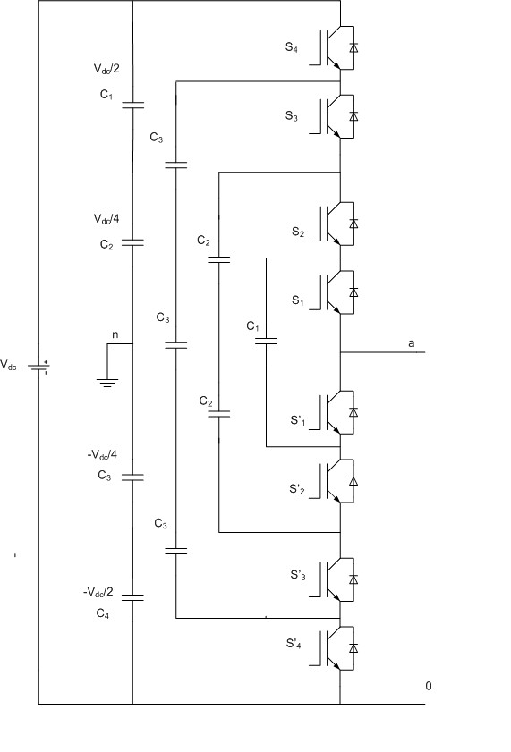The SSSC control system block diagram is given in the Fig.4. There are two control loops, containing two internal PI controllers. The dc capacitor voltage Vdc is kept around the chosen reference value. This reference value is kept fixed and is chosen considering the rating of SSSC. With the help of the phase-locked loop (PLL), the line input current I is converted into angle and is generated. For the reactive power compensation by the SSSC, the voltage injected in the transmission line must be in phase quadrature with the transmission input line current. Thus the phase shift of is introduced with the angle . For pure reactive power exchange between the compensator and the line, the dc link voltage should remain constant and hence SSSC inject the voltage can remain in quadrature with the transmission line current. The PI
controller-1 with an input of error between the 𝑉 and 𝑉
and output of facilitates this power exchange.
Another control loop i.e PI controller-2 generates the modulation index ( ). The input to this PI controller is the difference of the reference value of injected ems voltage
(𝑉 ) and the actual rms value of the injected voltage ( ).
The reference value is calculated from the power equation by
using the system parameters [1]. Thus the control system shown in the below Fig.4, one loop give the angle of the injected voltage and the other gives the modulation index to generate the required rms signal to help trigger the inverter as per the power demand.
The Fig.4 is been simulated in MATLAB. The PI controllers-1 gains are given in the table below along with that of the controller-2.

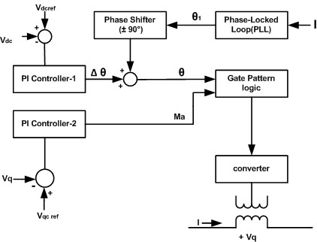
Fig.4 Control Scheme of SSSC

These gains are selected by using trial and error method. The base frequency of switching is also chosen so that it gives required output. The system is made to run for couple of seconds and the results are obtained as discussed below.
The base quantities are taken as given in the below table:

Table III

Nominal Source Voltage | 154 Kv
Fundamental System Frequency | 50 Hz
Main Inductive Load | 1 H
Main Flying Capacitors | 4000 µf
Switching Frequencies of Converter | 2 KHz
Proportional gain and Integral gain of PI  controller-1 | Kp=0.001 and  Ki=0.0001
Proportional gain and Integral gain of PI  controller-2 | Kp=0.8 and Ki=5.0

V. RESULTS

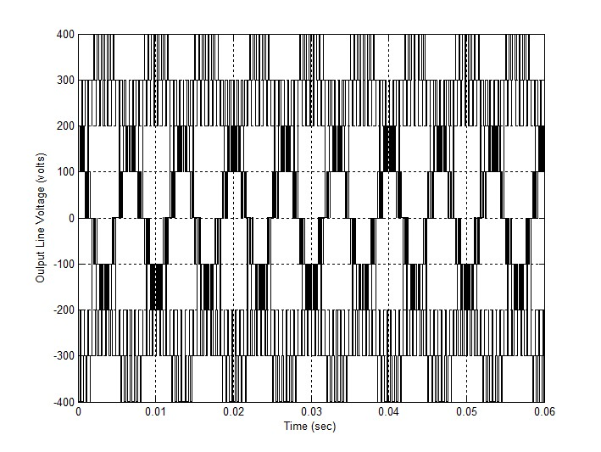Fig.5 Output Line Voltage of five-level FCMLI

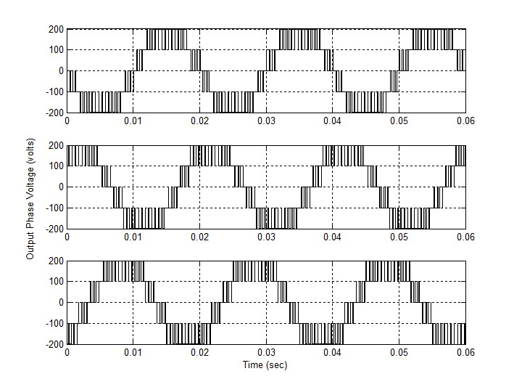Fig.6 Output Phase Voltage of five-level FCMLI
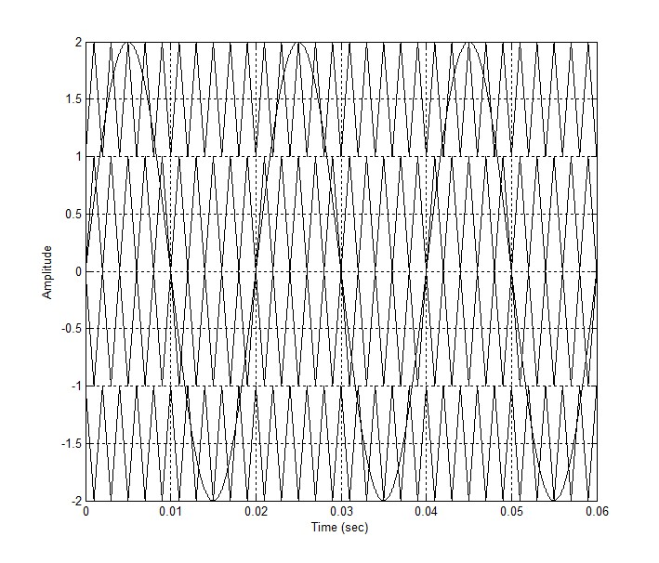
Fig.7 Output of the Triggering Scheme (PODPWM)
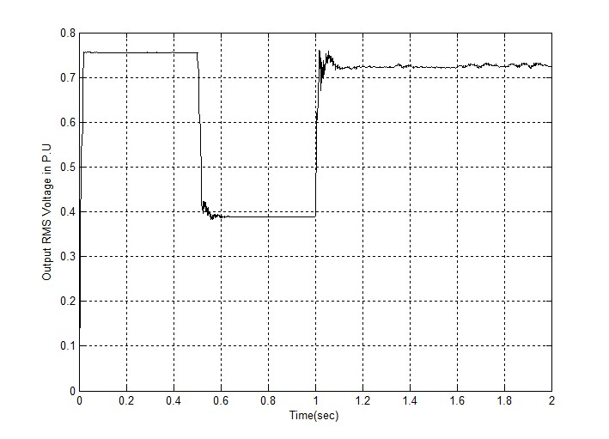
Fig.8 Output RMS Voltage of SSSC (open-loop)

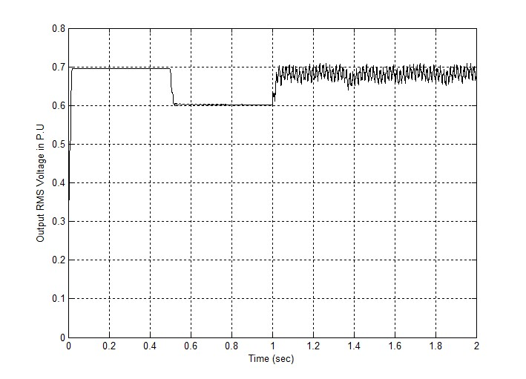Fig.9 Output RMS voltage of SSSC (close-loop) VI. CONCLUSION
From the modulation analysis and the studies presented above, following conclusion can be made:

Multilevel inverter can be more qualified for high voltage and high power application without the necessities of higher rating apparatus and voltage issues.
It is found that FCMLI endeavors to address the vast majority of constraints forced by the ordinary two-level inverter, multi-step inverters and the other multilevel inverters.
A FCMLI based SSSC can be used to control the direct power exchange over the lines.
A better control scheme and the redundancy of switching combinations in FCMLI structure allow to have better output voltages.

VII. REFERENCES
1. N. G. Hingorani and L. Gyugyi, Understanding FACTS: Concepts and technology of Flexible AC Transmssion Systems, IEEE Press, New York, 2000.

2. Anshuman Shukla, A Static Synchronous Series Compensator Based on flying capacitor multilevel Inverter, M.Tech. Thesis, IIT Kanpur, India, 2003.

3. A.C. Rufer, “An aid in the teaching of multilevel inverters for high power applications”, Proc. IEEE Power Electronics Specialists Conference,PSEC’95, Vol 1, pp 347-352, 1995

4. L. Gyugyi, C.D.Schauder and K.K Sen, “Static Synchronous Series Compensator: a solid-state approach to the series compensation of transmission line, IEEE Trans. Power Delivery, Vol. 12, No. 1, pp.
406-417, 1997.
5. L. Sunil Kumar and A. Ghosh, “Modeling and control design of a Static Synchronous series compensator,” IEEE Trans. Power Delivery, Vol.
14,No. 4, pp. 1448-1453, 1999.

6. J. S. Lai and F. Z. Peng, "Multilevel Converters-A new breed of Power Converters", IEEE Transactions of Industry Applications, Vol. 32, No. 3, pp. 509-
517, 1996.

7. A.Ghosh and G. Ledwich, Power Quality Enhancement using Custom Power Devices, Kluwer Academic Publishers, Boston, 2002.

8. X. Yuan and I. Barbi, "Fundamentals of a new Diode Clamping Multilevel Inverter", IEEE Trans. Power Electronics, Vol. 15, No. 4, pp. 711-718, 2000.

9. B. Han, S. Back, H. Kim and G. Karady, “Dynamic characteristic analysis of SSSC based on Multibridge Inverter”, IEEE Trans. Power Delivery, vol. 17, No.
2, pp. 623-629, 2002.

10. F. Z. Peng, “A Generalized Multilevel Inverter Topology with Self Voltage Balancing”, IEEE Trans. Industry Applications, Vol. 37, No. 2,pp. 611-
618,2001.

11. L. Xu and V. G. Agelidis, “Flying capacitor multilevel PWM converter based UPFC,” Proc. IEEE Proceeding − Electrical Power Applications, Vol.149, No. 4, pp. 304-310, 2002.

12. G.Carrara, S. Gardella and M. Marchesoni, "A new multilevel PWM method:A theoretical analysis", IEEE Trans. Power Electronics, Vol. 7,No. 3, pp.
497-505, 1992.

13. M. H. Rashid, Power Electronics Handbook, Academic Press, London, 2001.

14. Giuseppe Carrara, Simone Gardella, Mario Marchesoni, Raffaele Salutari, and Giuseppe Sciutto, “A New Multilevel PWM Method: A Theoretical Analysis”, Member, IEEE.

15. Mohammadreza Derakhshanfar “Analysis of different topologies of multilevel inverters” Department of Energy and Environment Division of Electric Power Engineering Chalmers University of Technology Göteborg, Sweden, 2010.

