Developing platform independent Application using proposed (AP)2 Algorithm

***MohemmedAadil Dalal1, Sumit Chaudhary2, Tejas Kadiya3***

Student, Computer Department, Indrashil Institute of Science & Technology, Ahmedabad, India 1

Head of Department, Computer Department, Indrashil Institute of Science & Technology, Ahmedabad, India 2

Assistant professor, Computer Department, Indrashil Institute of Science & Technology, Ahmedabad, India 3

Abstract*: In today’s world many different platforms such as iOS, Android, windows with different programming language are exist so, for the programmer it being difficult to programme an application for all these different platform, for solving this problem the platform independent application have to develop.*

*A Method and a system for developing the platform independent application, the proposed algorithm is (AP)2 algorithm. In this algorithm first it takes the common JavaScript &HTML5 files, After that Developer writing the codes according to the application requirement then system merge both these files using Cordova*2.X, 3.X. Now framework further comprises programming code and the system optimize the UI according to the platform. The reproduction tab is actually a web application that execute inside a node web kit and inside the inner HTML frame any application can run.*

Keywords*: Cross platform, platform independent, Code Once, Deploy Many, Hybrid platform mobile applications,**multi-platform application.*

1. **Introduction**

In computing, cross-platform software (multi-platform or platform independent software) is computer software that is implemented on multiple computing platforms. Cross-platform software may be divided into two types; one requires individual building or compilation for each platform that it supports, and the other one can be directly run on any platform without special preparation, e.g., software written in an interpreted language or pre-compiled portable byte code for which the interpreters or run-time packages are common or standard components of all platforms. [4]

Native applications are developed using the native programming languages of the devices for which it needs to be developed. For example, Languages used to make mobile application: I-phone: objective C/C++, HTML5, Android : Java, C/C++, HTML5, Windows Phone: C/C++, Silver light, HTML5. [2]

Native apps provide with the best usability, features and best overall user experience. Applications have quickly made up for lost time as of late as far back as application stores were made for the cell phones designers have turned out to be increasingly intrigued by making applications for various working framework and stages. However, the issue was that a similar application must be made for various working frameworks which prompted to wastage of assets and time. Thusly, Hybrid stages for coding utilizing Html, CSS and JavaScript were made which prompted to a fresh start of versatile applications. Cross breed stage applications are produced utilizing advances, for example, HTML, CSS and JavaScript. It is then put into a local compartment, for example, Adobe PhoneGap, Cordova. These local holders run the application code and bundle it into an application. In this way it furnishes us with different Mobile Application Development Platforms

That can produce to a great extent local applications from a solitary unique codebase, which can be sent crosswise over different portable stages. [3]

The characteristic that any native application would possess are

1. Multi touch: allows the user to double tap, pinch-spread and other complex UI gestures.

2. Fast graphic API: any native application provides with the fastest graphics depending on the inbuilt characteristics of various devices.

3. Fluid animation: is very essential for providing a good gaming experience on the device. It is also necessary for highly interactive reporting or compound computational algorithms for transforming audio and videos.

4. Built-in components: inbuilt application such as camera, address book, photo gallery, geo-location and other features can provide their services to mobile apps

5. Ease of use: the user interface of native applications is easily understandable by users which enable them to seamlessly interact with the application. [3]

1. **Literature Review**

Platform independent means the execution of the program is not confined by the sort of OS environment provided. Smartphone and tablets are getting to be distinctly general and with them versatile applications. In any case, what does the creation of different devices mean for developer entering the market? Do they target a single platform or build their applications twice for iOS and Android or other platform .There were smart phones before the iPhone and there were mobile apps as well. Windows CE was first released in 1996, but it was Apple’s iPhone (launched in 2007) that really signalled the start of the Smartphone era. Originally, the iPhone didn’t allow third-party native-code apps to be installed; developers wanting to add their own content had to do so using HTMLweb apps running in the phone’s browser. There were a few augmentations to make such applications resemble Apple's applications rather than website pages; however access to the equipment was constrained. [1]

With 2008 came the App Store, and with it the opportunity to develop in native apps in Objective C. This wasn’t without limitations: development required a Mac, Xcode, and only documented parts of the API were available. The subsequent application then must be screened before being distributed. However, the iPhone's strength at this stage implied that mobile developers truly just needed to target one platform, one gadget, and a very small set of OS versions. Android founded in 2003, acquired by Google in 2005, and with the first handset launched in 2008, the Android platform has since seen an explosion of devices since the original G1. Android devices now collectively account for over 50% of worldwide Smartphone sales (Gartner, Q1 2012), but, unlike the iPhone, there’s huge variation in just about everything: screen size, resolution, processor speed, and memory, features, and OS version. [1]

All of a sudden building up a single application that runs at every place or almost wherever turned into an objective that was much harder to accomplish – yet one that remaining parts as attractive as ever. Many traditional software development cases, developers love platform-independent approaches since you think of one bit of code, and convey it on different places. That shoots down the improvement time and vigorously chops down the software maintenance costs. Furthermore, for a similar reason, there has been heaps of buzz about stage free application advancement instruments in current versatile improvement group. What's more, yes, there has been a decent advance, with such idea coming into the scene. But still, why these rising tools haven't possessed the capacity to wind up distinctly the piece of standard procedure in mobile application improvement? The reasons are numerous. [1]

1. **Architecture**

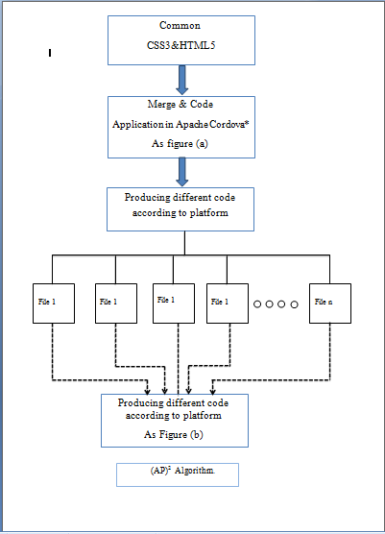

Fig.1. Mechanism of platform independent application

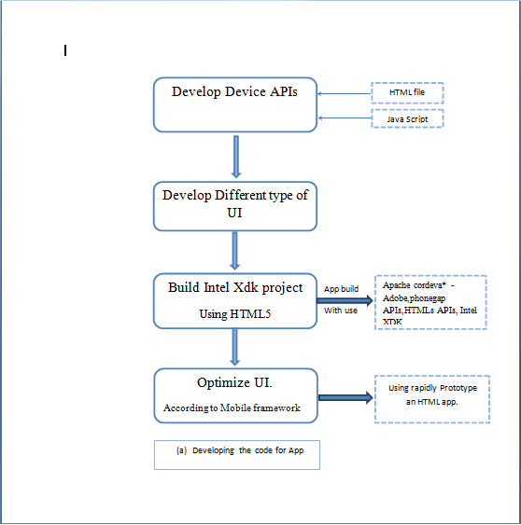

Fig.2. Mechanism of apache cordova

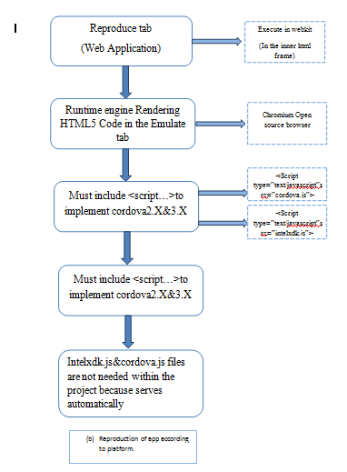

Fig.2. Mechanism of Reproduction Tab

1. **Working**
2. **Working of Apache Cordova**

First of all for developing an app according to device APIs with the help of HTML file and a JavaScript library firstly, we have to develop the HTML5 and JavaScript for the look and view of the application for the attracting view of the application we have to use CSS3, JavaScript and advance HTML tags.

For the attracting view of the application we must have to develop different type of user interface, like as a list view, tab view or side view. For the animation part in the designing we have to use JavaScript .By this user interface, we can easily divide the data into some specific view & by this user interface, the user can gate easily navigation from the application

For building an Intel XDK project by using an existing HTML5 tags,CSS3,javascript,such as an app build with use of Apache cordova* or Adobe, phonegap APIs, HTMLs APIs, Intel XDK device, ApappMobip starter or the appMobi* XDK ,etc. According to the application platform the Framework rapidly prototype an HTML5 on the app, Optimizing UI library.

1. **Reproduction of code**

The reproduction tab is actually a web application that execute inside a node web kit and inside the inner HTML frame, this is running in the up-to-date chromium browser. The HTML5 code in the Reproduce tab is based on the chromium open source browser which is rendered by the runtime engine. The files can be select according to the platform .Mandatory inclusions need these <script...> tags to implement cordova* 2.x and 3.x core APIs in the emulator.

<script type="text/javascript" src="cordova.js"> <script type="text/javascript" src="intelxdk.js">

Intelxdk.js and corvoda.js references are needed to use the Intel Xdk EMALUTE, TEST, and BUILD tabs. However, the intelxdk.js and cordova, js files are not needed within the project because the emulator serves then automatically within the emulator environment.

XDK IDE is that it incorporates every one of the instruments to completely build up an application from begin to distributing. Advancement, Emulation, Testing, Debugging, Profiling and Building are altogether included. There is likewise a unique element for outsider services. The majority of this work process is sorted out into 7 tabs that are in a proper request.

**Pseudo code:**

For (file 1 to file n)

{

If (platform==packet 1)

{

Packet 1 will be installed to the platform;

}

else if (platform==packet 2)

{

Packet 2 will be installed to the platform;

}

else if (platform==packet 3)

{

Packet 3 will be installed to the platform;

}

}

The development tab is the place you will invest the large portion of your hours. You can build up your application utilizing the intuitive instruments (App Designer and App Starter) or the content manager. The word processor depends on Bracket editorial manager which is an open source proofreaders construct utilizing HTML5. Section is kept up by Adobe. For the intuitive prototyping you can pick App Designer or App Starter. App Starter is a simple tool and is aimed for beginners. It only supports the App Framework. App Designer is a more complex tool than App Starter with more features. It bolsters App Framework, Bootstrap 3, JQuery Mobile and TopCoat. When developing with the drag and drop tools and the code editor, you can switch back and forth. You can likewise utilize those two, one next to the other.

The second tab is the Emulate tab. The emulator depends on Apache Ripple. It is a sort of Chrome Browser in addition to some additional APIs; it underpins Cordova and Intel XDK APIs. Testing for various screen sizes and diverse gadgets is truly simple with this device as you can browse a wide assortment of gadgets. Intel incorporated the Chrome Developer Tools for constant investigating and review of your front end. It's much similar to the live review on the create tab however here you can manage an equipment emulator.

The testing highlights makes improvement time significantly quicker as you don't need to construct the application each time you need to test it. Firstly you download the App Preview onto your test machine (telephone, tablet and so on). It is accessible on IOS, Android and the Windows Store. There are two approaches to test. The first is by pulling the venture from the server and executing it in the App Preview. The second is utilizing Wi-Fi; associate the PDA or tablet with a similar Wi-Fi that you interface your portable PC. The second technique is quicker as you don't need to push and draw the information between the servers each time. You can likewise investigate remotely with wiener (not full JavaScript support).

The last tab is the Service tab. In this tab you will see a list of various additional services. Advertising, Data Feeds Notifications and Social. All these services are external to Intel XDK and they can be used under all platforms. Let’s say for example we want push notifications in our application. We can use the AppMobi PushMobi service. Or maybe we want to regular update the application, we can implement Live Update by App Mobi, or we want to use Dropbox API, also easy to do.

1. **Conclusion**

The field of mobile application improvement has grown quickly in the most recent couple of years. Local mobile applications were the main kind of utilizations which were normal before. Local mobile applications without uncertainty give the best client encounter in any case, cross platform stage mobile applications will be favoured when the application is to be made for various stages and time and cost are the essential components. A developer needs to measure the advantages and disadvantages of both hybrid and native applications and pick the correct way to deal with building an application in light of understanding and the application's purpose. For, cross platform application we can develop once, Deploy many.

HTML5 is getting more grounded each day as a reasonable alternative for mobile application improvement. Building cross-platform applications is as of now simple, $(AP)^{2}$ makes more considerably less demanding as it has all requirements for building up a cross-platform application in one place.

This paper concentrated on composing once-running-wherever originates from the cost lessening in having just a single code to compose and keep up, and the time diminishment having the capacity to think of one code and focus on numerous gadgets and platform, making looking into cross-platform mobile applications improvement worth one's exertion and discoveries. Our design is building framework which will comprise of translator on particular platform having a common syntax across platform..Initially, the developers will face difficulties while developing application, but it will reduce prior to the evolving technology.

**ACKNOWLEDGMENT**

This research was partially supported by Indrashil Institute of Science & Technology Cadila group Ahmedabad for inspiring us to do research paper on platform independent application. We thank our colleagues from Computer department from Indrashil institute of Science & Technology, and parents for guiding us on right path.

**References**

[1] **“**PLATFORM INDEPENDENT DESIGN CONCEPTFOR

SMARTPHONE APPS DEVELOPMENT”

Mendapara Vijay R., Ghodasara Yogesh R., Kamani Krunal C,

ISSN (Online): 2320-9801ISSN (Print): 2320-9798

[2]“Platform Independent Mobile Application Development”

Vikram Gupta and Gaurav AggarwalISSN 0974-2239 Volume 4,

[3] “An Introduction to Hybrid Platform Mobile Application

Development”

Anmol Khandeparkar, Rashmi Gupta, B.Sindhya

[4] https://en.wikipedia.org/wiki/

[5] https://www.sitepoint.com/introduction-intel-xdk/

**BIOGRAPHY**

**MohemmedAadil Dalal** is currently pursuing BE in field Computer Science at Indrashil Institute of Science & Technology, Cadila Group, Ahmedabad, Gujarat, India. Currently, he is doing last year project in .Net language & his area of interest is platform independence with research work in platform independent application.



**Tejas Kadia** is working as Assistant professor in CSE at Indrashil Institute of Science & Technology , Cadila Group,Rajpur,Ahmedabad,Gujarat.He obtained his ME(Computer Engineering) with Hons from Gujarat Technological Unversity and also done BE (Computer Engineering) From Saurashtra University.

His many papers are published in various national, international journals and conferences. His area of research includes Algorithm, Wireless Sensor Network (WSN), Network Security, Image Processing, Data mining and MANET (Mobile Ad-Hoc network).



**Sumit Chaudhary** is working as Head of Department in CSE at Indrashil Institute of Science & Technology,Cadila Group, Rajpur,Ahmedabad,Gujarat.He is pursuing Ph.D. from Uttaranchal University, Dehradun,Uttarakhand.He worked with various institutes like Uttaranchal Institute of Technology(UIT),Dehradun,Shri Ram Group of colleges,Muzaffarnagar (U.P.), IIMT Institute of Engineering & Technology,Meerut(U.P.),India. Including all that he has more than 7 year experience in teaching. He obtained his M-Tech (Computer Science & Engineering)with Hons from Shobhit University and B-Tech (Computer Science& Engineering) from SCRIET,Meerut(U.P.).During this short period of time, he has been supervised several dissertation of M.Tech students. He has been member of several academic and administrative bodies.During his teaching he has been coordinated many Technical fests and National Conferences at Institute and University Level. He has attended several seminars, workshops and conferences at various levels. His many papers are published in various national, international journals and conferences. His area of research includes Cloud Computing, Wireless Sensor Network (WSN), Network Security, Neural Network, Artificial Intelligence and MANET (Mobile Ad-Hoc network).