Crowd Analysis and Mask Detection using Raspberry Pi-3

**Pratiksha Sonar1*, Bhushan Rokade2, H.T. Ingale3, Dr. A.J. Patil4**

1PG(M.Tech VLSI & ES) Student, 3Faculty E&TC Engg dept, 4 Professor

*1,3 E&TC Engg dept, GF’S Godavari College of Engineering, Jalgaon*

*4 Samarth Group’s College of Engg. Belhe, Pune*

*\*pratiksha.sonar@gmail.comr*[*1*](mailto:Patilpravin566@gmail.com1)*, hetui@rediffmail.com3*

***Received on****: xxxx,20xx,* ***Revised on****: xxxx,20xx,* ***Published on****: xxxx,20xx*

***Abstract -*** *Now a days all world suffering from a pandemic issue of COVID-19 to control these situation and to maintain the safety of ourselves we all have to take care of the two things like do not make a crowd and wear the mask properly. And to achieve this requirement of safety this paper works with the help of fog node and camera. Managing the crowd requires an intelligent monitoring technology. In this project, we propose a method to manage the crowd by counting multiple humans in the scene by head detection. In our study, we develop a system using Raspberry Pi 3 board that detects the human heads and provide a count of humans in the region using OpenCV-Python. A Haar cascade classifier is trained for human head detection.*

*This work also proposes a fog computing-based face mask detection system for controlling the entry of a person into a facility. The proposed system uses fog nodes to process the video streams captured at various entrances into a facility. Haar-cascade-classifiers are used to detect face portions in the video frames. Each fog node deploys two Mobile Net models, where the first model deals with the dichotomy between mask and no mask case. The second model deals with the dichotomy between proper mask wear and improper mask wear case and is applied only if the first model detects mask in the facial image. This two-level classification allows the entry of people into a facility, only if they wear the mask properly The results of the analysis will be helpful in managing the crowd and mask detection in the area with the help of camera.*

***Key words****- Haar-cascade-classifiers, Adobos algorithm, head detection, mask detection and tracking.*

1. **INTRODUCTION**

This paper introduced the crowd analysis by counting the number of head enter in the areas. Also this paper will helpful to take care from the pandemic issue COVID-19 by detecting the mask wearing person and improper mask wearing person with the help of IOT and Camera which is used in the project. In this project we use Haar cascade amplifier for mask detection and for head detection. This study focuses on training a cascade classifier for human head detection by taking positive samples and negative samples. The trained cascade is then used to process the video frames in which the human heads are detected and the count of the humans in the scene is provided. Haar-cascade-classifiers are used to detect face portions in the video frames. Each fog node deploys two MobileNet models, where the first model deals with the dichotomy between mask and no mask case. The second model deals with the dichotomy between proper mask wear and improper mask wear case and is applied only if the first model detects mask in the facial image. This two-level classification allows the entry of people into a facility, only if they wear the mask properly.

**2. LITERATURE SURVEY**

Detection of objects by using a cascade of simple features was mainly introduced by researchers for face detection [1], [2]. The role of Haar features extracted from an integral image in object detection is elaborated in their work. Some researchers explain a framework that can be trained for object detection [3]. He usage of face mask by the general public to impede the spread of the Corona Virus pandemic is highly essential. Wearing face mask limits the spread of virus through droplets, such as saliva or mucus [4]. Automatic entry and access control systems based on face mask detection are of immense help at several places such as workplaces, railway stations, shopping malls. These systems help in restricting the entry of persons not wearing a mask to a facility without manual intervention. T Fog Computing is a decentralized computing and storage infrastructure that brings processing closer to the data origin [5],[6]. In smart system based counting, peoples are usually avoided in all aspect they are not agreed to share the personal location in the system so that is main challenge for head counting. Most of the system are used the data which are given by peoples in crowd which are give not guarantee to share so that we gives the some inceptive or some offers to the crowd so that they can share the information which are very necessary to head counting (Huang and Chan, 2011; Bahl and Padmanabhan, 2000).[7] A Wi-Fi based where they allow crowd to play a geographical game and based on that they collect the information from the A Wi-Fi based where they allow crowd to play a geographical game and based on that they collect the information from the users. They allow only playing in Wi-Fi enabled area so that crowd may be bound and also it will be a challenge for that (Oka and Lampe, 2010). users. They allow only playing in Wi-Fi enabled area so that crowd may be bound and also it will be a challenge for that (Oka and Lampe, 2010).[8]

**2.1 Problem Statement**

This project totally depends on the camera as well as sensors so if there is no any network range for some duration so at that time we can’t analysis the crowd and movement of the people and the mask wearing people also. Also we use the camera for the analysis but if there is a range problem then we can’t able to access the data. This is the main problem of this system may occurs .Also main problem is with the programming. There is no simultaneously simulation process of head detection and mask detection programme. We have to handelled both the process separately within the project.

**2.2 Proposed Method/System**

This Project consists of various system and technology for the better result. As it’s a analysis of crowd and mask detection. it contains the fog system as well as we use the Rasberry Pie for this system along with the python. Main objective of this system is according to the area or region where it implemented. In this we try to analise and control the crowd in particular area by notifing the movement of the people and by detecting the heads in the crowd. Also we try for the mask detection process, in which two levels are exists like proper mask wearing person and improper mask wearing person.

**2.2.1 For Crowd Analysis:**

The proposed work is to develop a system for multiple head detection and human tracking by estimating the direction movement using Raspberry pi. Initially, a cascade classifier is trained offline for head detection using the samples collected from the scene. Haar features are used to train the cascade classifier through OpenCV. The proposed system uses a camera to record the crowded scene. Raspberry pi 3 uses a quad-core ARMv8 central processing unit which processes the video frame by frame to detect the presence of humans by using the previously trained cascade classifier for head detection. This process gives the count of humans present in the scene. To manage the crowd, the count of the persons is kept in track and if the count goes beyond a threshold, prevention of more people from entering the scene can be done. The detected human heads are then tracked by using the optical flow algorithm and the direction of motion of each human is indicated on the display connected to the processor

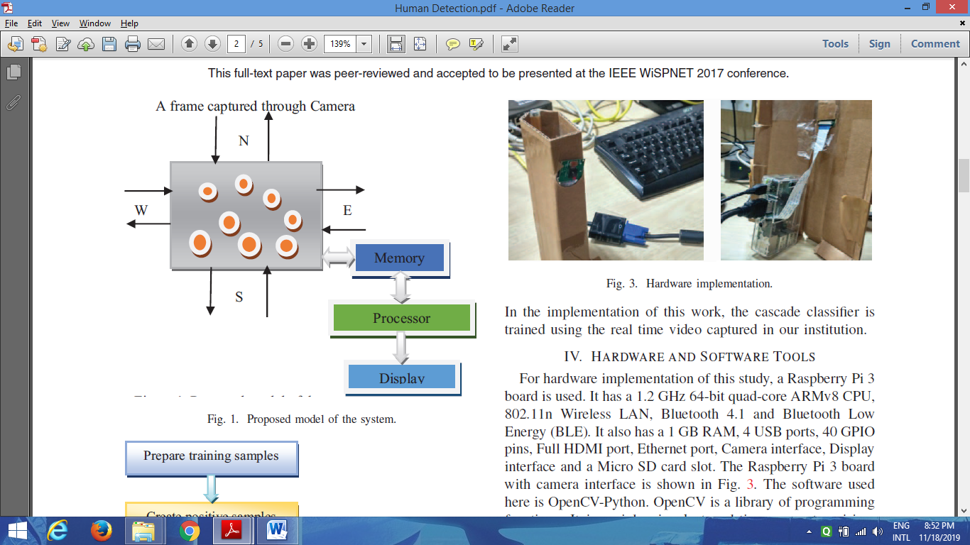 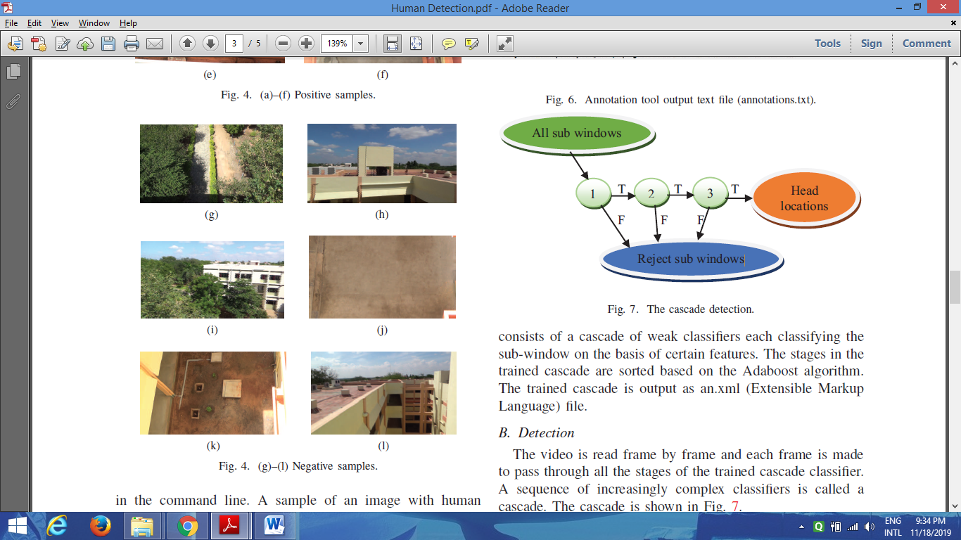

Fig.1: Proposed system for crowd analysis

**2.2.2 for mask detection:**

The proposed system employs a RPi fog node integrated with Raspberry Pi Camera and Relay Sensor at each entrance where entry control is required. The fog nodes are connected to the same Wi-Fi network. The basic architecture of the proposed system is shown in Fig. 2.2.2.1. Face Mask Detection at the Fog Computing Gateway The frames in the video stream captured by Pi Camera are processed by the fog node. Whenever any face(s) is detected in the frame, the face mask detection model tries to identify whether the person(s) is wearing the mask or not. The RPi module sends a control signal to the relay to open the door, if the person wears the mask properly. The decision to open the door or not is taken completely on the fog node, and the event information can be sent to the Cloud optionally for further storage and processing.

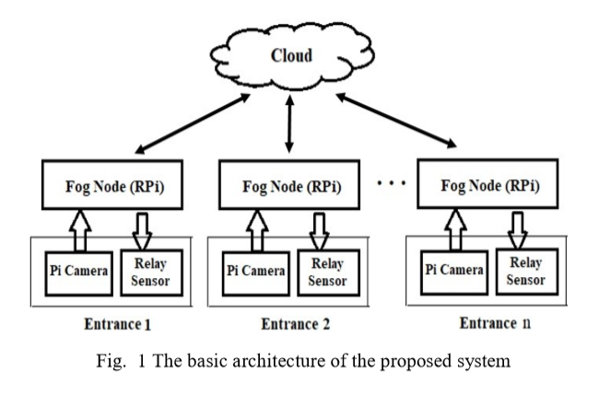

**3. METHODOLOGY**

**3.1 Hardware:**

For hardware implementation of our study, we use Raspberry Pi board. It has a 1.2GHz 64-bit quad-core ARMv8 CPU, 802.11n Wireless LAN, Bluetooth 4.1 and Bluetooth Low Energy (BLE). It also has a 1GB RAM, 4 USB ports, 40 GPIO pins, Full HDMI port, Ethernet port, Camera interface, Display interface and a Micro SD card slot. The Raspberry Pi 3 board with camera interface.

**3.2 Software**:

The software used here is OpenCV-Python. OpenCV is a library of programming functions. It is mainly aimed at realtime computer vision. OpenCV supports a wide variety of programming languages like C++, Python, Java, etc.􀀃OpenCVPython

is the Python API of OpenCV. To support various applications, OpenCV includes a statistical machine learning library.

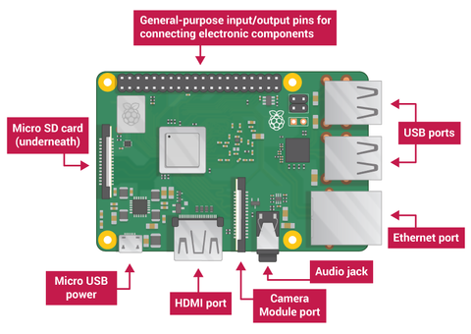Fig. 2: Rasberry Pi-3

**4. RESULT AND DISCUSSION**

In the experimental study, the cascade detector is tested on a real time video recorded in our institution.:

**A. Multiple Human Detection Using Real Time Video:**

Two real time videos are captured in our institution using a 12 mega pixel camera one consisting of humans and the other with no persons in the scene. Surveillance cameras in

crowd are specifically positioned in a particular angle and hence video is recorded for a specified angle and then trained using that video. Each video is then segmented into frames and the frames are saved in separate directories as positive and negative. The positive images are then marked for human heads using annotation tool



Fig. 3: Head Detection and crowd counting Result.

**B. Mask Detection Using the various nodes:**

The face mask detection models (model-1 and model-2) are trained using different learning rates (LR) 0.001 and 0.0001 with two different numbers of epochs 10 and 20. The model-1 and model-2 training tasks have taken 34 minutes and 20 minutes respectively (with LR = 0.001 and #Epochs = 20) on RPi 4. The face detection and inference tasks for the given video frame have taken 0.3 seconds and 3.4 seconds respectively on average. Table I and Table II present the accuracy and loss values during training and validation phases of model-1 and model-2 respectively (with LR = 0.001 and #Epochs = 20). From the results in Table I and Table II, we can observe that training, validation accuracy and loss values are improving during the models’ training. After few number of epochs (epoch #15 for model-1 training, and epoch #10 for model-2 training approximately), we get fluctuations in the accuracy and loss values. The variations in the accuracy and loss values are due to model overfitting with more number of epochs.

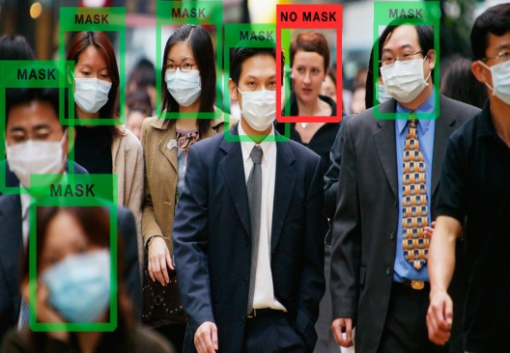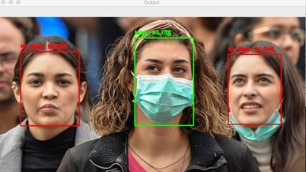

Fig. 4: Mask detection images

**5. CONCLUSION**

This paper presented the analysis of crowd with the mask detection using the fog node and Rpi-3. Due to this we easily conclude the crowd in the specific area using the pi Camera. The estimation of direction of movement of each person aids in human tracking. Using increased number of samples, the results are found to be efficient. The human detection and tracking can generally be used in surveillance tasks. Further improvement in this study can be done by providing re-identification of any person enterin This work also presented a proof-of-concept fog computing based face mask detection system for automatic entry and access control into a facility. The fog gateway processes the video stream captured at the entrance to recognize whether a person is wearing a mask or not.

**REFERENCES**

*[1] Fuentes O., Ramirez G. A., “Multi-Pose face detection with asymmetric Haar features,” in Proceeding of the 15th IEEE workshop on apllications of computer vision, Copper Mountain, 2008, pp. 1–6.*

*[2] Paul Viola and Michael Jones, “Rapid object detection using a boosted cascade of simple features,” Mitsubishi electric research labs, Cambridge, IEEE, 2001.*

*[3] P. Papageorgiou, Micheal Oren, and Tornaso Poggio, “A general framework for object detection,” Center for Biological and Computational Learning Artificial Intelligence Laboratory, Cambridge.*

*[4] J. Howard, A. Huang, Z. Li, Z. Tufekci, V. Zdimal, H. van der Westhuizen et al., "Face Masks Against COVID-19: An Evidence Review",*

*[5]Preprints 2020, 2020040203, http://dx.doi.org/10.20944/ preprints202004.0203.v1 S. Sarkar, R. Wankar, S. Srirama and N.K Suryadevra,*

*[6] “Serverless Management of Sensing Systems for Fog Computing Framework”, IEEE Sensors Journal, ISSN: 1530-437X, 20(3):1564-1572, 2020,.*

*[7] (Huang and Chan, 2011; Bahl and Padmanabhan, 2000).*

*[8] (Oka and Lampe, 2010).*