Comparative analysis of Hardenability of steel using Jominy End Quench Test

Authors Name: Rajat Awadhut, Roshan Khatwar, Rushabh Nehul, Trushal Zodape, Vaibhaw Hemane,
Vijaykumar Mishra.

Department of Mechanical Engineering, G H Raisoni Academy of Engineering & Technology, Nagpur, India.
Corresponding Author: E-mail address: trushalzodape@gmail.com
Guided By: Mr. Prashant Awachat
___________________________________________________________

Abstract
The purpose of this work is to analyze the hardenability of various steels using Jominy End Quench Test. The basic idea is study of martensite generation in different grades of steels, by taking them to their austenization temperature and quenching. A particular hardness for steel is required for many applications. Hence we have tried to analyze the martnesite formation in EN353, 20MnCr5, EN24, EN8, EN19, EN31 and M. S. (Mild Steel).
In this project effort has been taken to analyze for the selection of proper combination of steels for a specific application as per the hardness required.

Introduction
The Jominy end quench test is the simplest and most reliable method of hardenability measurement. It is one of the standard methods for measuring the hardenability of steel. The Jominy end quench test was invented by Walter E. Jominy (1893-1976) and A.L. Boegehold, in Research Laboratories Division of General Motors Corp. in 1937.
Hardenability is that property of steel which determines the depth and distribution of hardness obtained by quenching. It is the ability of material to transform austenite into martensite. Austenite is a solid solution of carbon in iron. It is generally soft and ductile than ferrite. Whereas, martensite formation takes place by transformation of austenite by heating it at austenization temperature and quenching it rapidly.

Construction & Working
The test specimen we have considered is of length 106 mm and 25 mm diameter and cylindrical in cross-section. The specimens were bought from different small scale industries of Nagpur and Pune with length of 110 mm and 30 mm diameter. These bought specimens were first machined and brought into desired dimensions on lathe machines by turning and facing operation.
The specimens were then kept in the muffle furnace (one specimen at a time) for 30 minutes at the austenization temperature i.e., 910°C to transform the microstructure of steel into austenite. After heating the specimen for 30 minutes, it is quickly transferred to our cooling system and the specimen is quenched rapidly with liquid water which is at room temperature with controlled flow from one end. The cooling rate is different along the length of the specimen since it is quenched from one end keeping it in vertical position in the cooling system. Fast quenching transforms austenite into martensite. hence along the length of the specimen the martensite formation will also vary.
The specimens were then ground flat along its length in four different sides opposite to each other with a depth of 0.38 mm. The specimens were ground flat for the removal of decarburized material from their surface using a flat file.
To measure the hardness, 25 points were marked on each flat surface with an interval of 3.33 mm up to 50 mm from the quenched and 5 mm from the center towards the collar end.
Martensite formation results into high hardness in the specimen. Whereas low hardness shows the transformation of austenite into bainite or ferrite. The hardness testing is done using Rockwell Hardness Test machine on “C” scale using a Diamond Indenter.

PROJECT IMAGES

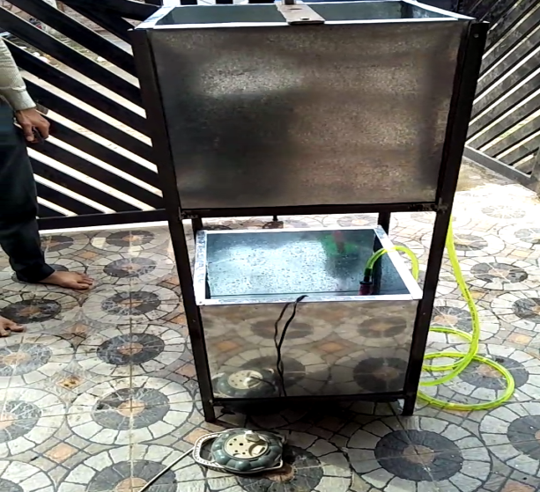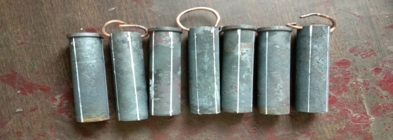
Image: Cooling System Image: Test Specimens

Observation Table

DISTANCE  (mm) | HARDNESS  (HRC)
 | EN24 | EN8 | M.S. | EN31 | EN353 | 20MnCr5 | EN19
3.33 | 58 | 24 | 12 | 63 | 65 | 61 | 54
6.66 | 58 | 24 | 12 | 61.5 | 64 | 61 | 54
9.99 | 57 | 23 | 11 | 61 | 64 | 60.5 | 54
13.32 | 57 | 22 | 12 | 61 | 63 | 60 | 53.5
16.56 | 56 | 21 | 12 | 59 | 62 | 59 | 53
19.98 | 56 | 21 | 12.5 | 58 | 61 | 57 | 53
23.31 | 56 | 20 | 12.5 | 58 | 60 | 54 | 54
26.64 | 53 | 17 | 12 | 56 | 60 | 53.5 | 53
29.97 | 52 | 15 | 11 | 55.5 | 58 | 52 | 52
33.3 | 51 | 15 | 11 | 54 | 54 | 49 | 52
36.63 | 51 | 14 | 11.5 | 54 | 54 | 49.5 | 52
39.96 | 50 | 13 | 11 | 48 | 52 | 48 | 51.5
43.29 | 48 | 12 | 11 | 48 | 50 | 48 | 51.5
46.62 | 48 | 08 | 11 | 45 | 48 | 43 | 50
50 | 45 | 08 | 10 | 42 | 44 | 41 | 50
55 | 42 | 07 | 11 | 42.5 | 42 | 40.5 | 50
60 | 38 | 7.5 | 11 | 39 | 40 | 39 | 50
65 | 38 | 6 | 11.5 | 39 | 39 | 37 | 51
70 | 37 | 6 | 11 | 38 | 33 | 37 | 50
75 | 35.5 | 6.5 | 10.5 | 37.5 | 33 | 36 | 49.5
80 | 35.5 | 6 | 10 | 37.5 | 32 | 36 | 49
85 | 35.5 | 6 | 10 | 35 | 31 | 34 | 49.5
90 | 34 | 5 | 10 | 33 | 29 | 34 | 49
95 | 32 | 5 | 10 | 32 | 28 | 34 | 49
100 | 30 | 5 | 10 | 30 | 28 | 33 | 49

GRAPHS
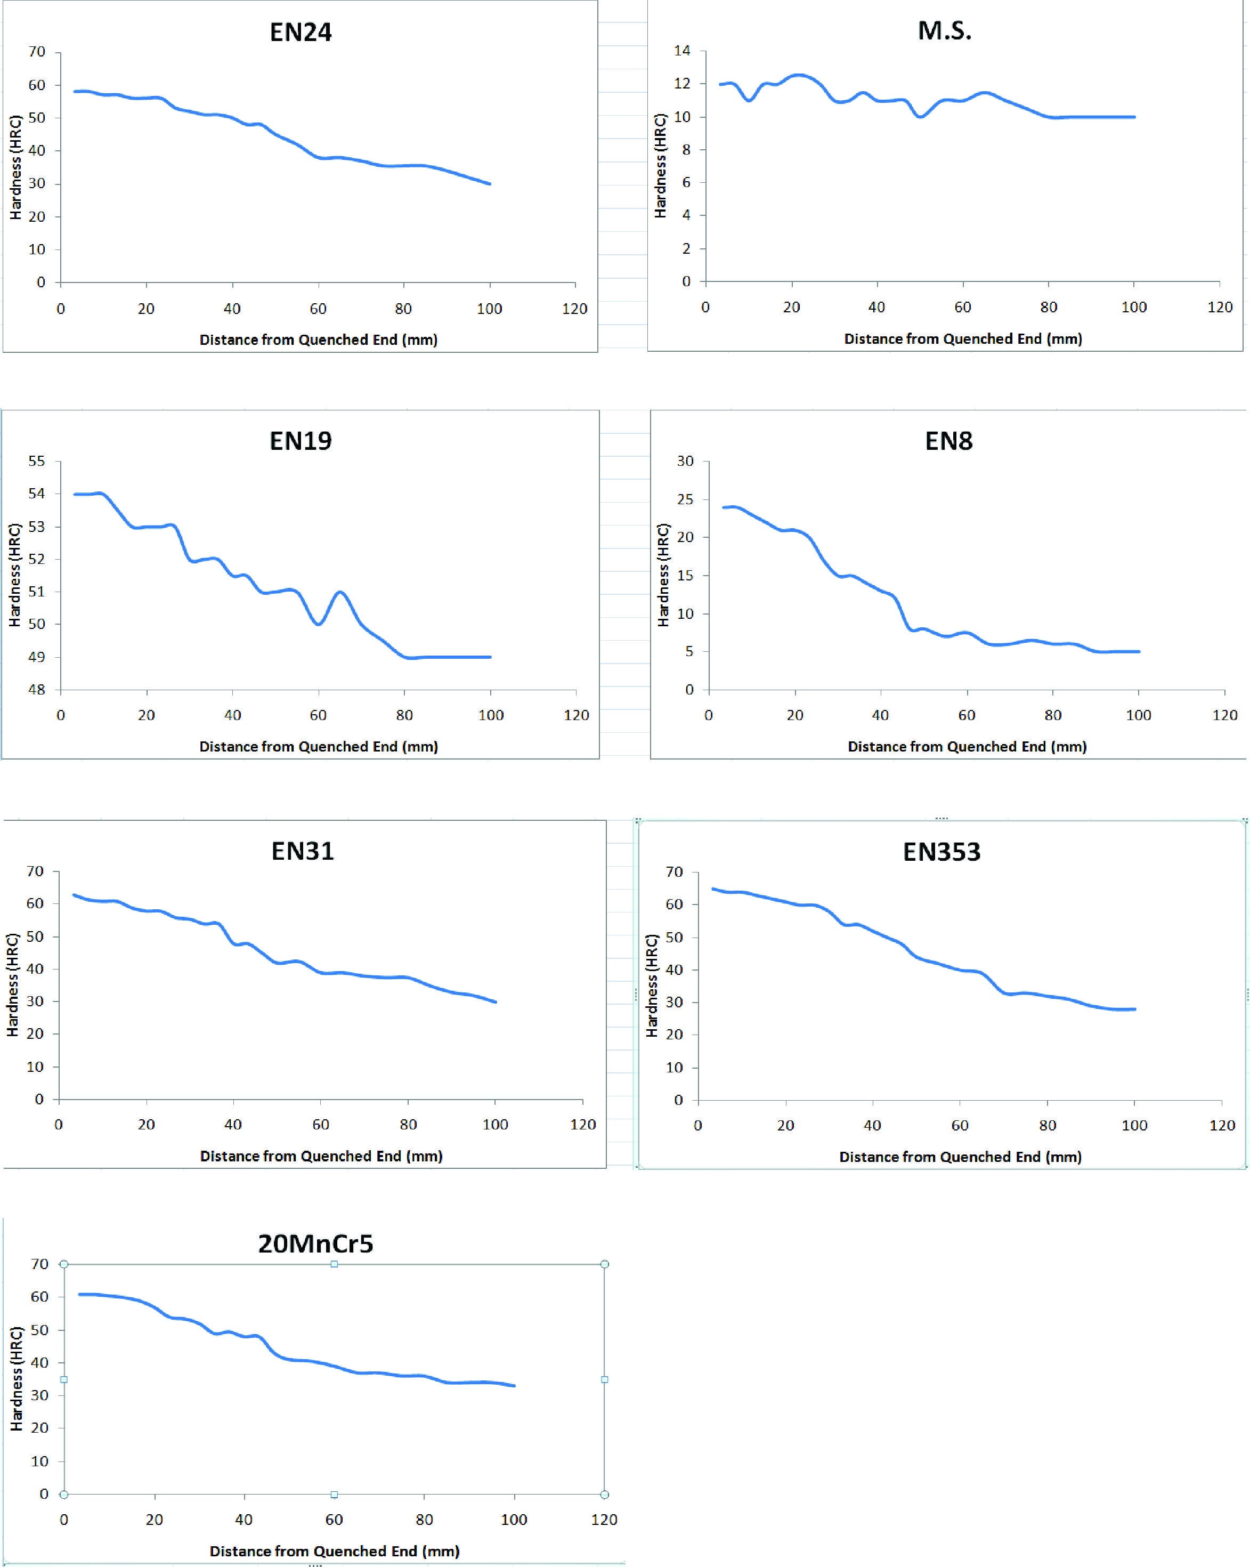

CONCLUSION

From the above results, the following conclusions can be drawn:
1. The designed cooling system worked effectively.
2. The martensite formation is not uniform along the length of the specimen since the hardness value is decreasing from the quench end.
3. We have analyzed that the hardness changes with change of martensite for various grades of steel.
The range of hardness is:
- EN31: 30 – 63 HRC
- 20MnCr5: 32 – 63 HRC
- EN24: 30 – 60 HRC
- EN8: 5 – 24 HRC
- EN19: 45 – 54 HRC
- EN353: 28 – 65 HRC
- MS: 10 – 12 HRC

ACKNOWLEDGMENT
With immense pleasure and great respect we take this opportunity to express our deep sense of gratitude towards our guide, Mr. Prashant Awachat, Asst. Professor, Department of Mechanical Engineering, GHRAET, Nagpur, for invaluable guidance, inspiration, constant encouragement and motivation throughout the session.
We are grateful to Dr. Achal S. Shahare, Professor and Head of Department, Mechanical Engineering, GHRAET, Nagpur. For providing the amicable environment and allowing us to use available faculties in this department during the course of this study.
We are thankful to Dr. Vivek Kapur, Principal, for his encouragement and providing all facilities needed for successful accomplishment of the project work.
We are very thankful to Mr. Mohsin I.A.R. Sheikh, Project coordinator, Mechanical Engineering Dept. GHRAET, Nagpur, who provides amicable environment and guidance to complete the project work.
We are very thankful to all the respected Faculties in the Department of Mechanical Engineering, who helped us to understand basic methodologies of our project.

REFERENCES
1. An analysis of modified Jominy Test.
By: B. Smoljan, D. Iljkic, S. Smokvina Hanza, and F. Traven.
2. Design & Manufacturing Plan of a Jominy Testing Device.
By: James Alison Orivri.
3. Hardenability of Steel: the Jominy Test.
By: Andrew Ruble.
4. Fabrication of Jominy End Quenched Machine: Hardenability Evaluation
By: A. A. Yekinni, J. O. Agunsoye, S. A. Bello, I. O. Awe, S. I. Talabi.
5. A review on Jominy Test and determination of effect of alloying elements on Hardenability of Steel using Jominy End Quench Test.
By: Bhaskar Chandra Kandpal, Agnay Chutani, Amit Gulia, Harsimran, Chandan Sadanna
6. Hardenability of steels for oil industry.
By: M. Gojic, B. Kosec, I. Anzel, L. Kosec, A. Preloscan.
7. Experimental investigations of Jominy End Quench test using CuO nanofluids.
By: M. Baskaran, KCK Vijayakumar, M. Bharathiraja.
8. Heat treatment and mechanical properties of low-carbon steel with dual-phase microstructure.
By: J. Adamczyk, A. Grajcar.
9. Heat Treatment Methods Applied To AISI 431 Martensitic Stainless Steels
By: A. Rajashekhar
10. The effect of heat treatment on the hardness and impact properties of medium carbon steel.
By: Noor Mazni Ismail, Nurul Aida Khatif, Mohamad Aliff Kamil Awang Kecik, Mohd Ali Hanafiah Shaharudin.
11. Material Science and Engineering Book.
By: William D. Callister
12. Wikipedia.

