RECUE WINGS: MOBILE COMPUTING AND EMERGENCY SURVIVAL SERVICES
T. Sravani
PG Scholar
Department of Computer Applications
Madannapalle Institute of Technology & Science, India
Dr.T. Manikumar
Assistant Professor
Department of Computer Applications
Madannapalle Institute of Technology & Science, India
Dr.R. Maruthamuthu
Assistant Professor
Department of Computer Applications
Madannapalle Institute of Technology & Science, India

ABSTRACT: In times of disaster, the provision of quick and focused information and information sharing can be of great benefit to people affected by challenging and difficult situations. This article describes Rescue Wings, a system focused on providing emergency services to victims of disaster and rescue. The system uses mobile services to collect real-time data for users and their environment, and creates service agents (employees) to provide effective services to mobile users. To perform their duties, employees usually use a set of intelligent Rescue Wings services, which can access a variety of government and other public sector services. We identify the most common patterns for Rescue Wings (FRSP) application sequences and build a new bio-inspired algorithm. Requests are well organized to reduce response time. Technology has been put in place for training in many disasters, including the 2013 Ya'an earthquake in Southeast China.

INTRODUCTION: Natural and man-made disasters are posing an increasing threat to us. First responders must acquire as much specific information about population dynamics as possible in order to organize and implement catastrophe rescue operations successfully, special attention to vulnerable groups such as children, the elderly, and the disabled. It is also expected that disaster information and evacuation will be brought to the affected community in a timely and accurate manner, which can save lives and reduce serious damage. Although the correlation of personalized and intelligent services in supporting population in emergencies has long been accepted [1] - [4], the challenges of designing, deploying, managing, and integrating such a system have prevented its emergence and / or widespread acquisition. We've been working on building a
service-oriented system for providing emergency support to both responders and the affected populace in catastrophe rescue operations over the past three years. The Rescue Wings project is based mostly on a hybrid of two developing paradigms: mobile computing and cloud computing. On the one hand, the portability and ease of storing and disseminating information has made mobile devices one of the most viable means of communication with the general public [5], and recent trends in mobile computing have sparked interest in using web services from mobile devices to extend their functionality and access remote data [6].Cloud computing solutions, on the other hand, use virtualization to enable the configuration, scheduling, and coordination of shared resources,communication between a wide range of public andprivateentities[7]..Rescue Wings' client-side applications are installed on end users' mobile devices, allowing them to upload and maintain their profiles on the servers. When entering the emergency mode, a service agent (servant) is created for each Rescue Wings customer, whose behavior is defined by active service programmers [8], [9]. (of as sufferer or a rescuer). The servants are in charge of actively gathering real-time data and monitoring the states of clients on the spot, as well as offering necessary services to aid users in self-defense’s, escape, search and rescue (S&R), and mutual rescue. When anomalous conditions are detected, the servants can also request ad hoc actions from the clients remotely. Rescue Wings has access to a variety of public services for getting rescue information, as well as a suite of intelligent services to assist rescuers at various phases of the rescue operation. The purpose of the paper is threefold in this case:
1) To show the Rescue Wings architectural framework and operating mechanism, which may be used to guide and aid in the development of comparable service-based systems.
2) To propose an efficient heuristic approach for scheduling service requests, which is critical to the system's success and can be applied to a variety of other service scheduling challenges.
3) To present the system's simulation findings and real-world applications, as well as the lessons learnt from them, which will benefit both the system's developers and the general public.
We'll start with a simple case study of a servant's activities in supporting a client during a fire evacuation. On the client device, location-based services (LBS) are enabled by default. The servant obtains the user's location from LBS on a regular basis (every 15seconds by default) and follows his or her moving path.No action is required if the road goes out and the travel speed does not decrease significantly; however, the servant realizes that the path of the road is changing toward a dangerous place. In response, the attendant sends an alert to the client, while simultaneously uploading the client's surround map, marking the dangerous location and location of the user, and recommending an escape route to the user. The process continues until the user returns to the correct path or stops receiving personal information. During the process, the server also requests access to other parts of the Rescue Wings server (servers), such as State Analyzer and Router, which can access external web services via the Internet.
Eventually, the user succeeds in escaping, and the slave process ends when he realizes this or receives a confirmation message. Sequence diagram for the case study is shown in Figure 1. We participated in several rescue trials and tested the effectiveness of the Rescue Wings in support of rescue since mid-2012. Ya'an Earthquake in Sichuan Province, China, in 2013 it was the first real-world application of Rescue Wings. During the rescue operation, more than 400 mobile devices were connected to Rescue Wings servers, an estimated 32,000 service requests were terminated, and at least 58,000 messages were sent. Created, transmitted, and used to help victims and support respondents. Rescue Wings' services contributed effectively to the operation's performance and success, according to on-the-spot research and post-hoc analysis. Rescue Wings' client-side applications have been deployed to over 18,000 end customers thus far. The following is how
the whole paper is organized: The second section discusses the same work. Section 3 introduces the Rescue Wings framework with customers, staff, and support services
that it provides. Section 4 provides a bio-inspired program that saves time to process applications for Rescue Wings service.
Phase 5 introduces the Rescue Wings test in two tests, Phase 6 deals with the rescue operation of the Ya'an Earthquake, and Section 7 wraps things up.
RELATED WORK
Individual challenges in relief operations, such as emergency facility location, vehicle routing, and evacuation planning, were the subject of early disaster management studies, The advancement of information technology, such as the Internet and database system intelligence, allows decision-support systems to integrate and coordinate a variety of operational duties (DSS). Wallace and Balogh established a three-level paradigm for categorizing catastrophe decision-making: performance management, management control, and strategic planning and policy. They emphasized that the activities and structures should be the ones that will be the first choice for computer assistance, which allows for “possible” situations. Although DSS can be used to help judge in response to possible or unlikely events, its importance in training and preparation does not diminish. The DSS for disaster management must deal with unpredictability and change. Mendonca et al has developed a framework to assist emergency managers in responding to real-time events in situations that require the modification or improvement of practical courses, which were evaluated by a project in Port of Rotterdam, Netherlands. Bryson et al. has proposed a mathematical planning approach to help the decision-maker choose between alternatives when modeling a disaster recovery plan. Rolland and colleagues. Utilizing hybrid meta-heuristics and a step-by-step approach to address project planning with multiple resources for disaster response and recovery in DSS, recognizing that ground-to-top planning by responsive local staff is often more helpful than a ground-based plan. developed by managers removed from the scene. Provides categories of DSS models for disaster risk for interested students. Geographic information systems (GIS), global positioning systems (GPS), and wireless communication technology have all been widely used to improve DSS disaster response times over the past decade. Chang et al. demonstrated the use of GIS in the management of chemical emergencies in an urban area, emphasizing the importance of integrating relevant local data with multi-scale model models. under the guise of an easy-to-use visual interface With the goal of facilitating a rapid response to a terrorist attack such as September 11, 2011, Kwan and Lee proposed an emergency management plan that included 3D GIS operations to represent the 3D architecture of small local areas. e.g. , emergency personnel who do not have access to the 3D GIS website and the decision-making function of multiple channels through wireless communication technology and mobile phones. Northwest DSS region of Indiana using computer grid and visual processing tools
Camera. The system network and hardware components are wireless portable objects that can be delivered to the disaster area and used to collect poor data, allowing for reliable emergency communication between the poor and the local emergency management organization. The use of GIS, GPS, and mobile technology to respond to emergencies and disasters has also been described. Traditional DSS, on the other hand, is slow and prone to errors, because the different semantics of data sources create barriers to collaboration, which is especially problematic in emergencies. Web services technology, which facilitates high-level interaction between different network services, allows for more flexible ways of interacting and communicating business operations that are widespread across many businesses. Hashmi et al. define DSS which combines robust and uncontrolled data collection of sensory networks with flexibility and interoperability of web service architectures to meet the needs of an emergency medical response in [5].
Tanasescu et al. [6] has used semantic web services to create DSS that uses content such as usage conditions, user roles, and locations to improve decision-making. They also show the snow storm app. On the M11 highway in 2003, Weiser and Zipf [1] tested the feasibility of web service orchestration technology in disaster risk management. Jones and Thiebaut [7] have proposed a plan to manage visits to hazardous phases of the environment-based processing plants and the near-real-time performance of web services to connect external data, detect suspicious activity, and make decision-making. Demonstrated how to use free GIS platform data applications to support the standard exit mode when the device is detected. Smirnov et al. [2] provides an emergency DSS that uses web resources to collect data from different sources and compile it. distributed system components to all facilities, including mobile phones to receive assignments. Based on an integrated geospatial structure and web services, Li et al. [2] created a Web-GIS emergency management system. The service-oriented design allows for the widespread distribution of the various levels of events. According to the sections of our Rescue Wings program the smart DSS to help disaster recovery at the operational level.

Its front end focuses on mobile device access, while its rear uses web-based web-based design [1] to integrate data from a variety of sources, including GIS, SMS, and other social services.

3.THE RESCUE WINGS FRAMEWORK:
Rescue Wings is made up of two very independent programs from each other. The first is a standard web application with many web pages containing documents and other things that customers can view using their mobile browsers. Customer users can also upload and store their personal information, access personal information, and participate in forum discussions after registered members.





Client
Client
Wechat
SMS
ASP.NET

Page
Page
Servant
Servant
UserDB
Ă
MapDB
ISS
Admin
Ă
PSM
Ă
EMO
Wrapper
Wrapper
Wrapper
Wrapper
PSRCache
Dyn
map
ISRCache
ge
Pa

Figure 1. Framework Rescue Wings (ISS: intelligent support services; ISR: intelligent service applications; PSR: public service applications; PSM: public service manager; EMO: Emergency management organization)
An emergency server application, which is an integral part of Rescue Wings, is a second application. It can be further divided into the following three categories:
• The Human Resources Manager manages a large number of employees. Each employee is responsible for communicating and assisting the client user.
• Intelligent support services (ISS), which includes a collection of intelligent personnel services and an ISR database for unsolicited applications.
• Public Service Manager (PSM), which includes a set of government service contact sheets, a public service application (PSR) application, a broadcaster who sends important messages from emergency management organizations (EMOs) directly to employees. , and a Victim Caregiver who stores victim information in an EMO perspective.
The basic structure of the Rescue Wings is shown in Figure 2.
Typically, Rescue Wings uses an emergency application model on a primary server and provides emergency assistance with a limited number of applications. Rescue Wings often creates a new application model on one or more servers in the event of a major emergency, and program components can be accessed from a variety of portable or virtual servers. Standard and emergency routes are available to Rescue Wings customers. In normal mode, the user can use the client browser to access the standard Rescue Wings website. There are three options for placing a client in an emergency: 1) The client starts the Rescue Wings emergency server (RFH) request. This is a one-button mobile device function. 2) Rescue Wings identifies the client in the disaster area, that is, sees the client user as a (possible) victim of the disaster. 3) The client expresses a desire to be a rescuer in an emergency. The main client application interface in emergency mode is shown in Figure 3, which follows the principles for designing an emergency user interface interface [1] - [3]. Important notifications from the Rescue Wings server are scrolled to the list box at the top of the screen. The icon buttons below will quickly turn on / off voice information, call most commonly used phone numbers, search for important directions (e.g., imminent exit, shelter, victims, etc.), open common tools, and change basic app settings. . The center pivot control is made up of three parts:
. The Escape Map page displays a regional map of the disaster that highlights and updates important items such as victims, rescuers, escape routes, exits, dangerous areas, and more. User location is usually set as central.
• Live Video Website, which shows real-time video of the area around the most important disaster objectives.
• A Professional Support Website, which allows you to contact professionals who can assist you with text, graphics, or audio communication.
PROPOSED SYSTEM:
- Existing System:
In the existing system, the users to admin interaction was very less and there is no immediate response from the administrator. It is a time taking process and users face many problems.
- For older systems, it was a manual process.
- It takes longer to complete all processes.
- More resources are required.
- It's a chance for us to perish.
- Proposed System:
In this proposed system, the user to administrator interaction was quite easy and after sending the problem the administrator can provide immediate response to the user and assign immediate task force like NDBF. This app helps the users easily interact with user and helps the user’s problems immediately.
❖ The question will be sent as soon as possible.
❖ After checking the administrator of this post solution solution for details of escape again.
❖ User can register his account and submit his query during a disaster.
❖ The public can post their inquiries and look for a solution to register without registration and login.
3.1 Applications for Mobile Clients:
Normal and emergency modes are available to Rescue Wings clients. In normal mode, the user can utilize the client browser to access Rescue Wings' regular website. There are three options for putting the client in emergency mode:
1) The client initiates a Rescue Wings emergency server request for help (RFH). The mobile device has only one button for this action.
2) Rescue Wings identifies the client in the disaster area, that is, sees the client user as a (possible) victim of the disaster.
3) The customer expresses a desire to be a rescuer in an emergency.
Figure 3 shows the main client application interface in emergency mode, which adheres to the user's emergency program design principles. ([1–3]). Important notifications from the Rescue Wings server are scrolled to the list box at the top of the screen. The icon buttons below will quickly turn on / off voice information, call most commonly used phone numbers, important payment search (e.g., near exit, refuge, victims, etc.), open normal tools, and change basic app settings... The center pivot control is made up of three parts (pages): • The Escape Map page, which shows a map of the catastrophe region with dynamically marked and updated significant objects including victims, rescuers, escape lines, exits, dangerous zones, and so on. The user's location is usually set as the middle.
• The Live Video website, which shows real-time video of the environment around critical disaster targets.
• The Professional Support website, which allows you to communicate with professionals who can assist you via text, graphics, or audio communications.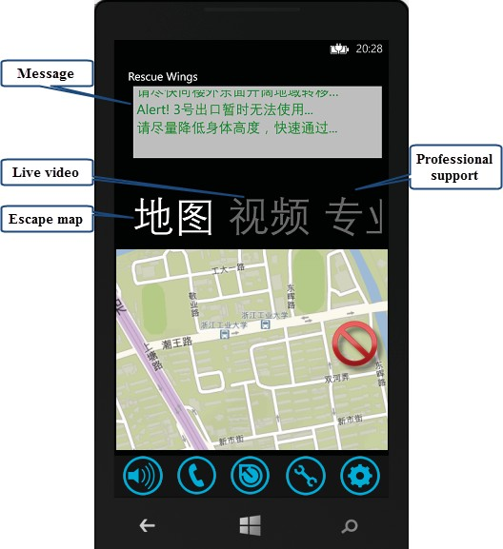
Fig.2 basic Rescue wing

4.SERVICE REQUESTS SCHEDULING
4.1 The Scheduling Schema in Its Most Basic Form:
During emergencies, the level of incoming requests can increase, leading to overload and, ultimately, the result of a crash [4]. There have been a variety of proposed planning methods In Rescue Wings, any Request for Directed Update (targeted review) is prioritized in the available Dyn map service, and all other ISS applications are processed using a pre-programmed system [6] including a method based on -request-sequence-pattern (FRSP). That is, applications are classified by UserID staff. Each application that needs to be handled is listed in the ISR archive and is prioritized based on the RIA value of the user, as shown in Table 2.
If the total number of applications cached falls below the limit (usually 200 in the ISS), applications are sent to accessible resources in diminished p (t + t0), where p is the most important request, t current application wait. time (in seconds), and t0 is a fixed object usually set to 5. If application A with the most important pA has been waiting for tA seconds and request B with pB value has been waiting for tB seconds, A will be considered before B under this program if:
tA > pB/pA (tB + t0) − t0
Otherwise, the heuristic method described in the next chapter selects and schedules requests belonging to the FRSP, while other requests remain in the ISR Cache and are processed in decreasing order of p(t + t0). There is no obvious FRSP in PSM, so requests in the PSR cache are scheduled using the priority-based mechanism described above.

6. Results:
During emergencies, the level of incoming requests can increase, leading to overload and, ultimately, the effect of a crash [4]. There have been a variety of proposed editing methods In Rescue Wings, any Requested Directed Request (targeted review) is prioritized for the available Dyn map service, and all other ISS applications are processed using a pre-programmed system [6] including method. based on request-sequence-pattern (FRSP). That is, applications are classified by UserID staff. Each application that needs to be hosted is listed in the ISR archive and is prioritized based on the RIA value of the user, as shown in Table 2.
If the total number of applications cached falls below the limit (usually 200 in the ISS), applications are sent to accessible resources at a reduced p (t + t0), where p is the most important request, waiting for the current request. time (in seconds), and t0 is the constant value set at 5. If application A with the most important pA was waiting for tA seconds and request B with pB value was waiting for tB seconds, A would be considered before B. under this scheme if: respectively, during the first 72 hours of the rescue operation. All the results shown in the figures.

We also run a simulation to examine the scheduling performance of the other three approaches in Section 5, and the results are shown in Fig. 7(d), which demonstrates that PBBO-LS always achieves the smallest NCR in the event. Rescue Wings' key duties in the rescue operation are threefold:
- For those who were stranded by the earthquake or aftershocks right away, Rescue Wings clients submitted location information to the command center and maintained in touch with rescuers, greatly easing the rescue procedure.
- 2) For sufferers who have escaped on their own, Rescue Wings clients receive essential communications (such as risk warnings and route guidance) from the center server, which can be life-saving for the escapees.
- 3) Rescue Wings assisted rescuers in searching for and locating victims, collecting real-time information about them, and communicating with them as necessary, considerably improving the efficiency of the rescue.

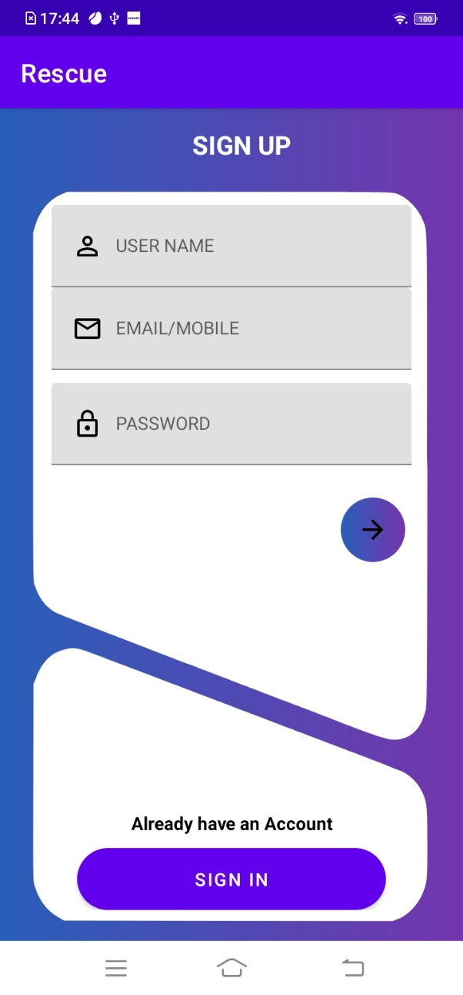
Fig.6.1. Home page

Fig.6.2. User login page
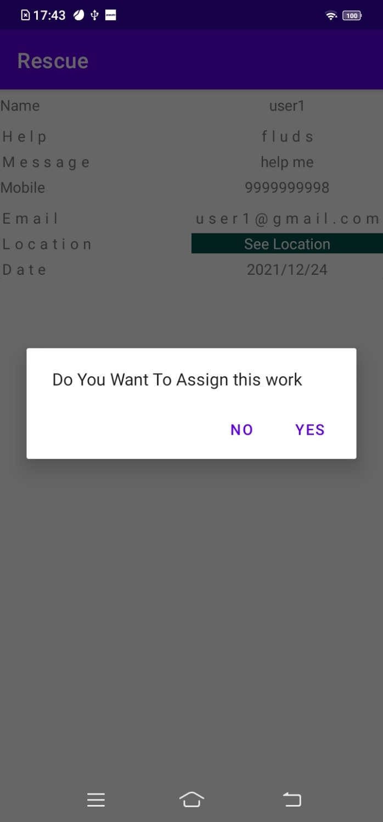 Fig.6.3 Assign the work

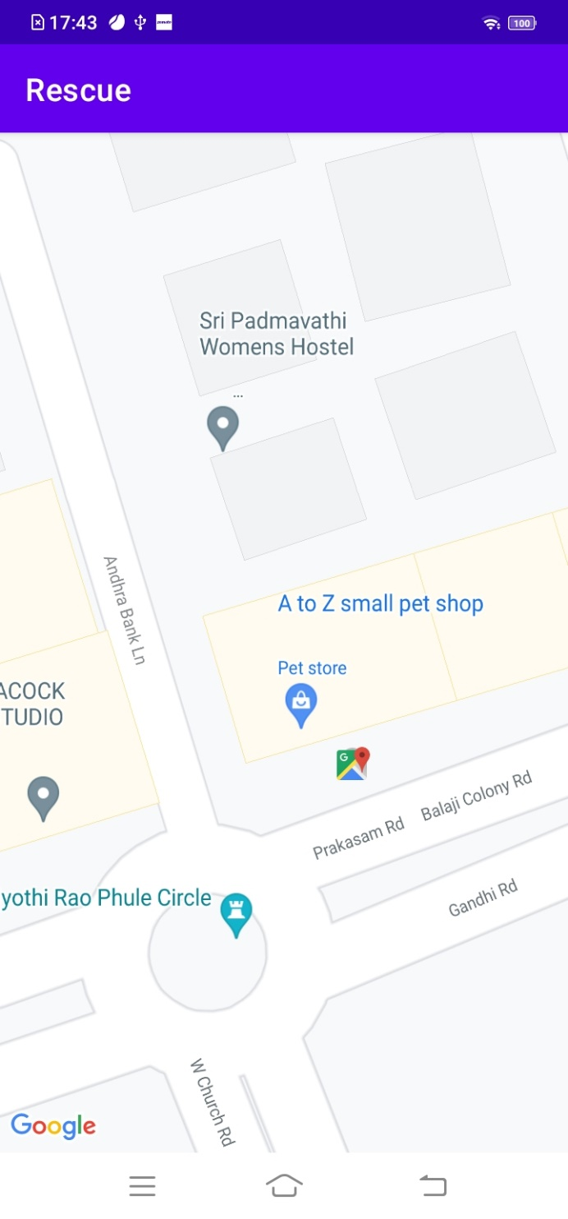
Fig.6.4 Check the location

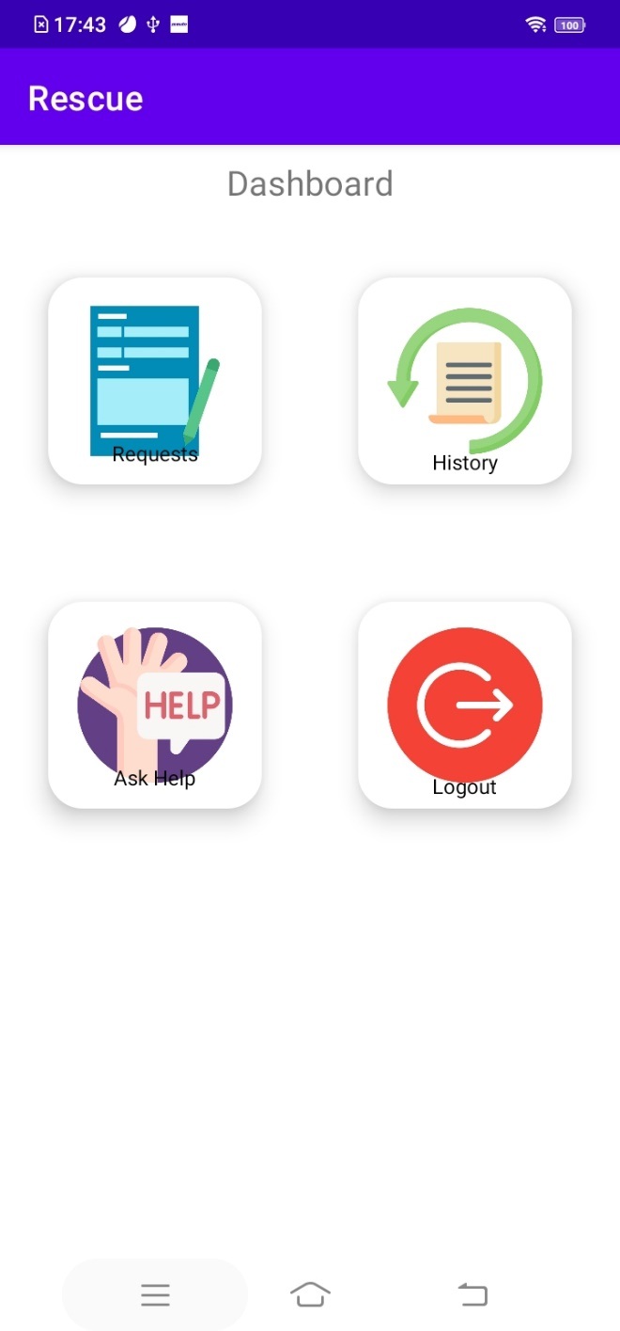
Fig.6.6 Dashboard

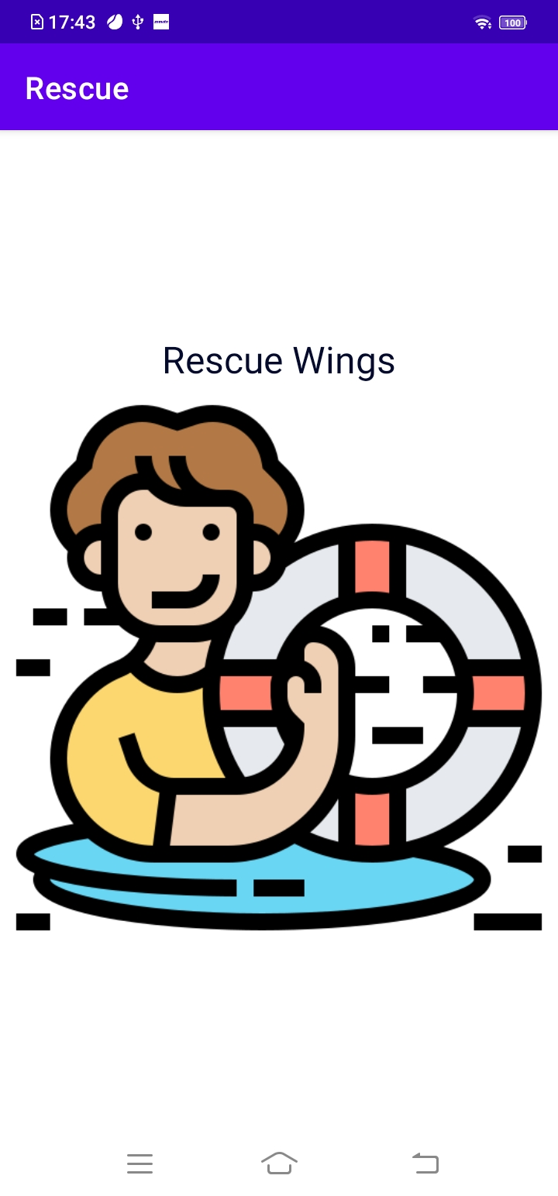

Fig 6.6 Recue wings

7. Conclusion:
Rescue Wings, a service-based program that supports victims and rescuers in disaster relief operations, is presented in this paper. There are many workers in this city. a set of internal protocols for customer communication.
There are plenty of papers to access social services, as well as intelligent support services. We are developing a new heuristic approach based on the BBO and a local search engine optimization for Rescue Wings service applications, which outperforms some of the advanced planning algorithms. The Rescue Wings was put to its test in two rescue trials before being used in the 2013 Ya'an earthquake. The findings suggest that Rescue Wings technology is attracting a growing number of users, forcing us to focus more on strengthening the robustness and diversity of disaster recovery support services. We work hard to add additional custom and personalized features to the Rescue Wings client applications, as well as to develop existing service planning rules and algorithms to support multiple applications simultaneously without compromising response times. We also aim to expand Rescue Wings services by integrating / utilizing Internet of Things Devices [4], [5] [7]. Rescue Wings, we believe, will be widely used and will play a significant role in future disaster relief efforts. It plays a major role in helping users and improving the efficiency of rescue.
8. References:
[1] A. Weiser and A. Zipf, "Web service orchestration of OGC web services for disaster management," in J. Li, S. Zlatanova, and A. Fabbri, Eds., Springer Berlin Heidelberg, pp.
[2] M. Gloria, V. Lersi, G. Minei, D. Pasquariello, C. Monti, and A. Saitto, "A semantic Web services platform to support disaster and emergency management," International Environmental Modelling and Software Society, 4th Biennial Meeting, pp.
[3] "Resilience metrics for service-oriented networks: A service allocation approach," IEEE Transactions on Services Computing, vol. 2, no. 3, pp. 183–196, 2009. D. Rosenkrantz, S. Goel, S. Ravi, and J. Gangolly, "Resilience metrics for service-oriented networks: A service allocation approach," IEEE Transactions on Services Computing.
[4] "The Chinese national emergency medical rescue team response to the Sichuan Lushan earthquake," Nat. Hazards,. 2013.
[5] J. Yang, J. Chen, H. Liu, K. Zhang, W. Ren, and J. Zheng, "The Chinese national emergency medical rescue team response to the Sichuan Lushan earthquake," Nat. Hazards, vol. 69, no. 3, pp. 2263–2268
[6] D. Guinard, V. Trifa, S. Karnouskos, P. Spiess, and D. Savio, "Interacting with the SOA-based internet of things: Discovery, query, selection, and on-demand web service provisioning," IEEE Transactions on Services Computing, vol. 3, no. 3, pp. 223–235.
[7] J.-S. Leu, C.-F. Chen, and K.-C. Hsu, IEEE Transactions on Services Computing, vol. PrePrints, 2021, "Improving heterogeneous SOA-based IoT message stability via shortest processing time scheduling."

.

