Transparent Concrete: An Evolution Towards Better India
Shweta R. Kamble¹, Prof. Sagar R. Raut², Prof. Hitshkumar D. Mishra³
¹B.E Appearing Student Jagadambha College of engineering and technology, Yavatmal, India, 445001

²Assistant Professor Jagadambha College of engineering and technology, Yavatmal, India, 445001

Abstract –Transparent concrete is a concrete based building material with light transmissive property due to embedded light optical elements usually optical fibers. There are many varieties of concrete, depending on what people want to achieve. By changing its chemical composition, technological process and adding various other materials, we receive various types of concrete. We use them to create durable supporting structures, a variety of concrete which is resistant to constant moisture or different chemical types. Additionally, some aspects of aesthetics in architecture are made with the help of concrete.
Light is conducted through this fiber from one end to another end. Therefore the fibers have to go through the whole object. Transparent concrete is also known as translucent concrete or light transmitting concrete because of its properties. The main purpose is to use sunlight as a light source to reduce the power consumption. This concrete is used in architectural purpose for good aesthetical view of building.
Keywords- : Transparent concrete, optical fibers, light transmissive property.

INTRODUCTION
The Concrete has been used since Roman times for the development of infrastructure and housing but is basic components have remained the same.
In 2001, the concept of transparent concrete was first put forward by Hungarian architect at the Technical University of Budapest.

Hungarian architect, Aron Losonczi, first introduced the idea of light transmitting concrete in 2001 and then successfully produced the first transparent concrete block in 2003, named LiTraCon.
By research and innovation, newly developed concrete has been created which is more resistant, lighter, white or colored. The first transparent concrete block was successfully produced by mixing large amount of glass fiber into concrete in 2003, named as LiTraCon.

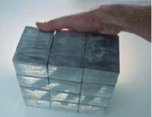
Figure 1: Picture of LiTraCon light transmitting concrete

INGREDIENT
- Cement: It is a binder, a substance that sets and hardens as the cement dries and also reacts with carbon-di-oxide and can bind other materials together. As the optical fiber is only responsible for transmission of light, there is no special cement required. So, ordinary Portland cement is used for transparent concrete.

- Fine aggregate: it is a chemically inactive material, most of which passes through a 4.75 mm IS sieve. The fine aggregate serve the purpose of filling all the open spaces in between the particles. Thus, it reduces the porosity of the final mass and considerably increases its strength. Usually natural sand is used as a fine aggregate. However, where natural sand is not available economically, finely crushed stones may be used as a fine aggregate. The specific gravity is 2.70 and fineness modulus is 2.80. The loose and compacted bulk density values of sand are 1600 and 1688kg/m³ respectively. The water absorption is 1.1%.
- Coarse aggregate: Crush granite aggregate available from local sources has been used. The coarse aggregate with maximum size of 10 mm having the specific gravity is 2.6. The fineness modulus of 5.60 was used as a coarse aggregate. The loose and compacted bulk density values of coarse aggregate are 1437 and 1556kg /m³ respectively. The water absorption is 0.4%.

- Optical fiber elements:
These are further divided into three as follows:
1) Core
2) Cladding
3) Buffer coating

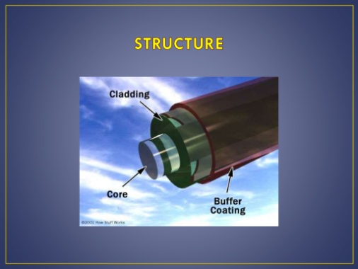

1) Core: The thin glass center of the fiber where the light travels is called “Core”. This central tube is made up of optically transparent dielectric medium and carries the light from transmitter to receiver.

2) Cladding: The outer optical material surrounding the core that reflects the light back into the core. To confine the reflection in the core, the refractive index of the core must be greater than that of the cladding.

3) Buffer Coating: This is the plastic coating that protects the fiber from damage and moisture.

3. OPTICAL FIBERS
- Optical fiber is a wave guide made of transparent dielectric (glass or plastic) in cylindrical form through which light is transmitted by total internal reflection.
- Based on the refractive index profile and the number of modes, optical fibers are classified into three types:
1) Step index single mode fiber
2) Step index multimode fiber
3) Graded index multimode fiber
1) Step index single mode fiber:
A step index single mode fiber may have very small core diameter (i.e. 5-10um). Due to its small core diameter, only a single mode of light ray transmission is possible. About 80% of the fibers that are manufactured in the world today are of this type.
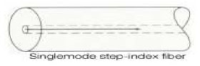
2) Step index multimode fiber:
A step index multimode fiber has a core diameter of 50-200um and an external diameter of cladding 125-300um. Since the core material is of uniform refractive index and the cladding material of lesser refractive index than that of the core, there is a sudden increase in the value of refractive index from cladding to core.
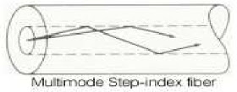
3) Graded index multimode fiber:
In a graded index multimode fiber, the refractive index of the core is maximum at the axis of the fiber and it gradually decreases towards the cladding. Since there is the gradual decrease in the refractive index of the core, the modal dispersion can be minimized.
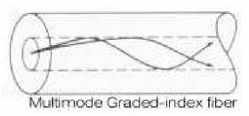
4. PRINCIPLE
Transparent Concrete or Translucent Concrete is work based on “Nano-Optics”. Optical Fibers passes as much light when tiny slits are placed directly on top of each other as when they are staggered. Principle can carry because optical fibers in the concrete act like the slits and carry the light across throughout the concrete.
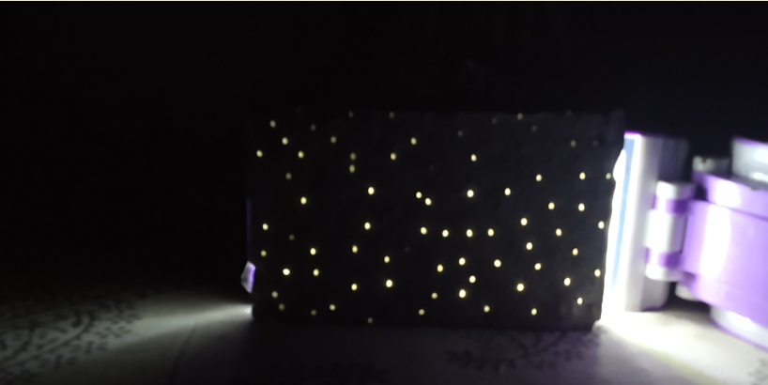
Figure: View of Transparent Concrete a

5. MANUFACTURING PROCESS OF TRANSPARENT CONCRETE
The manufacturing process of transparent
concrete is almost same as regular concrete. Only optical fibers are spread throughout the aggregate and cement mix Small layers of the concrete are poured on top of each other and infused with the fibers and are then connected. Thousand of strands of optical fibers are caste into concrete to transmit light either natural or artificial.
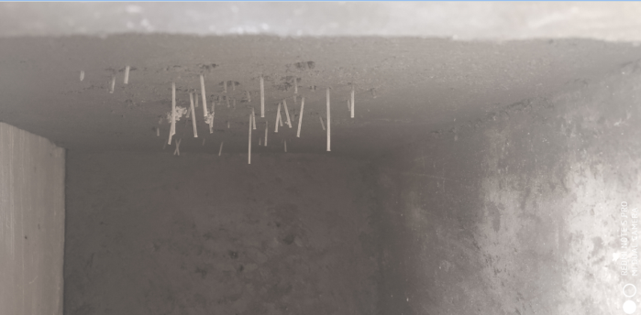

Fig: Inserting the optical fibers

Light Transmitting Concrete is produced by adding 4% to 5% optical fibers into the concrete mixture. The concrete mixture is made from fine materials only. Thickness of the optical fibers can be varied between to macro meter to 2 mm depending upon the requirements of the light transmission.
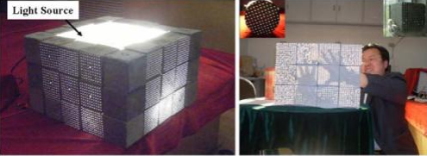
Fig. 1 Manufacturing process of transparent concrete.

6. PROPERTIES OF TRANSPARENT CONCRETE:
- PRODUCT- LiTraCon- Light Transmitting Concrete
- Form- Prefabricated block
- Ingredients - 96% concrete and 4% optical fiber
- Density - 2100-2400kg/m²
- Block size- 600mm*300mm
- Thickness- 25-500mm
- Color- White, Grey or Black
- Fiber distribution- Organic
- Finished- Polished
- Compressive strength- 50 N/mm².
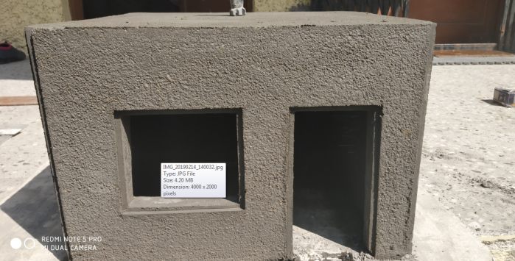
7. Applications
The main advantage of transparent concrete is that it can transmit light. There, it can be used to make green buildings. Since it can transmit light from natural as well as artificial sources, the building can have fewer lights to meet its demand for lighting. Thus saving huge energy cost. Transparent concrete uses sunlight as source of light instead of electrical energy and reduces power consumption. This concrete can also be used cold countries to transmit heat with sunlight. Translucent concrete is not currently widely produced. There are only a select few companies, and the process is somewhat low-tech and slow. It can only be produced as pre-cast or prefabricated blocks and panels; it cannot be poured on site like traditional concrete. The blocks come in a range of sizes, the maximum for glass fibre being 1200 x 400 mm (47.2 x 15.7 inches), and the thickness can range from 25-500mm (1-20 inches). This allows translucent concrete to be used for a variety of purposes, from a thin veneer to a structural system. According to one German company, it can be used “for ventilated facade systems as well as for interior cladding”. So far translucent concrete has been used to make light installations, signs, and fixed-in-place furniture such as benches, desks, and counters. In its early days, it was used mostly in art installations and material demonstrations such as the Liquid Stone exhibit at the National Building Museum, and a sidewalk in Stockholm that looked “like an ordinary sidewalk by day but illuminated at night by lights under it”. It is presently used mostly in interiors as decoration, but is making its foray into exterior structural walls.
7.1 Walls
Transparent Concrete can be used as building material for interior and exterior walls. If sunshine illuminates the wall structure, then eastern or western placement is recommended; the rays of the rising or setting sun will hit the optical glass fibres in a lower angle and the intensity of the light will be bigger. Besides the traditional applications of a wall, the light transmitting concrete can also be used as wall covering illuminated from the back. Also in some cases roof can be designed in creative way by using translucent concrete.
Fig. 7.1: Translucent Roof
7.2 Pavement
This concrete can be used as flooring a passable surface illuminated from below. During the day it looks like typical concrete pavement but at sunset the paving blocks begin to shine and in different colours.
7.3 Creative Design
The building units are versatile and can be used in many areas of design. Two successful designs using the light transmitting concrete were a jewel and a concrete bench. You can also create a logo with colourful figures, inscriptions, and pictures and can used for beautification purpose. Fig 7.3 shows one of the creative designs of translucent concrete. Fig. 7.3: Translucent Wall
7.4 Desk
If you really want to create a look that stands out, you should opt for this artsy and vogue reception desk where light up in the front and the sides.
7.5 A Lighting Fixture and Conversational Piece
The transparent concrete cube is, without a doubt, a great conversation piece. The new cube line consists of four identical pieces of concrete and, due to its special geometry; the pieces form a stable structure without fixing them together.
8. ADVANTAGES:
- Energy saving can be done by utilization of transparent concrete in building.
- The places at where the light is not able to come properly, at that places transparent concrete may be used.
- It has very good architectural properties for giving good aesthetical view to the building.
- It is totally environmental friendly because of its light transmitting characteristics, so energy consumption can be reduced.
- This concrete uses sunlight as source of light instead of electrical energy and reduces the power consumption.
- This concrete can also be used in cold countries to transmit heat with sunlight.
9. DISADVANTAGES
- The main disadvantage is this concrete is very costly because of the optical fibers.
- Casting of transparent concrete block is difficult for the labour so special skilled person is required.
10. CONCLUSION
An innovative material called transparent concrete can be established by introducing optical fiber or large diameter glass fiber in the concrete mix. Addition of waste glass in transparent concrete can even make the concrete sustainable and can reduce the overall cost of the project to some extent. The transparent concrete has good light guiding property and the ratio of optical fiber volume to concrete is proportional to transmission. The strength parameter of transparent concrete is observed to be same as the conventional concrete and it is also important for aesthetical point of view. Transparent concrete can be used in temples, furniture, walls, ceiling, and panels for the best architectural appearance of the building. It can also be used in a field, where the sunlight cannot reach with suitable intensity.
• It is concluded that, on usage of 4% of optical fibres the compressive strength increased. The compressive strength of concrete cube depends on diameter of the holes in the mould and the diameter of the optical fibre and it is directly proportion to its compressive strength.
• The compressive strength of Light Transmitting Concrete was found to be ranging between 20 – 23 N/mm2 with optical fibre specimen and with glass rods specimen the compressive strength was found to be ranging between 24-26 N/mm2, which indicates that the concrete satisfies the compressive strength requirement for M20 grade concrete. The study concludes that the transparency of light is possible in concrete without affecting its compressive strength, as the optical fibres and glass rods act as fibre reinforcement thereby enhancing the strength and also enhances appearance.
• The amount of POFs has seriously influenced the compressive strength of the corresponding concrete. The much number the POFs are, the smaller the compressive strength is. So the transmissions cannot endless increase by way of endless increasing the number of POFs in concrete. Furthermore, the POFs have also reduced the anti-permeability of the concrete. Using the epoxy resin to seal the boundary of POFs and concrete, the smart transparent concrete’s anti-permeability can be greatly improved.

11. REFERENCE
- Soumyajit Paul and Avik Dutta “Translucent Concrete” IJSRP, vol.3, Issue 10, October 2013
- P. S. Mane Deshmukh and R. Y. Mane Deshmukh “Comparative study of waste glass powder utilized in concrete”, IJSR, Volume 3, Issue 12, December 2014.
- Satish kumar V and Suresh T “Study of Behavior of Light Transmitting Concrete using Optical Fiber” IJETS Volume 2 Issue
- Y. Li, J. Li, Y. Wan, Z. Xu, "Experimental study of light transmitting cement-based material (LTCM)", Construction and Building Materials 96, pp. 319–325, 2015
- Neha R. Nagdive & Shekhar D. Bhole, TO EVALUATE PROPERTIES OF TRANSLUCENT CONCRETE /MORTAR & THEIR PANELS, International Journal of Research in Engineering & Technology (IMPACT: IJRET) ISSN(E): 2321-8843; ISSN(P): 2347-4599 Vol. 1, Issue 7, Dec 2013, 23-30
- Bhavin K. Kashiyani, Varsha Raina, Jayeshkumar Pitroda, Shah Bhavnaben K., 2013. A Study on Transparent Concrete: A Novel Architectural Material to Explore Construction Sector, International Journal of Engineering and Innovative Technology (IJEIT) Volume 2, Issue 8.
- P. M. Shanmugavadivu, V. Scinduja, T. Sarathivelan, C.V Shudesamithronn, an Experimental Study on Light Transmitting Concrete, International Journal of Research in Engineering and Technology eISSN: 2319-1163 | pISSN: 2321-7308
- Shakir Ahmed Salih, Hasan Hamodi Joni, Safaa AdnanMohamed "Effect of Plastic Optical Fibre on Some Properties of Translucent Concrete", Eng. &Tech.Journal, Vol. 32,Part (A), No.12,2014, pp. 2846-2861.
- Anurag Shukla, Trushik Poriya, Jigar Zala "An Experimental Work On Light Transmitting Concrete", International Journal of Advance Engineering and Research Development (IJAERD) Volume 1,Issue 5, 2014
- A. Momin, R. Kadiranaikar, Vakeel Jagirdar, Arshad Inamdar "Study on Light Transmittance of Concrete Using Optical Fibres and Glass Rods", International Conference on Advances in Engineering & Technology (ICAET-2014),2014,pp.67-72

Details of all Authors:-

Sr.No | Photo | Details
1 |  | Shweta R. Kamble (final year student) jagadambha college of engineering and technology, Yavatmal, India , 450001.
2 |  | Prof. Sagar R. Raut is working as assistant professor, civil engineering department jagadambha college of engineering and technology, Yavatmal, India , 450001.
3 |  | Prof. Hitshkumar D. Mishra is working as assistant professor, civil engineering department jagadambha college of engineering and technology, Yavatmal, India , 450001.

