**Different Micromachining Processes of Fabrication For Micro-Electromechanical Systems**

**Mr. Yogesh M.Motey** **Ms. Purnashti A. Bhosale**

(Electronics & Tele.Dept.) (Electronics Dept.)

GHRIET,Nagpur PIGCE,Nagpur

[yogesh.motey@gmail.com](mailto:yogesh.motey@gmail.com)bhosalepurnashti@gmail.com

*Abstract—Microelectromechanical systems or MEMS are integrated micro devices or systems combining electrical/ electro and mechanical components. The fast development of MEMS technology has brought many great ideas and development of physical, chemical and biological sensors. . If semiconductor microfabrication was contemplated to be the first micro-manufacturing revolution, MEMS is the second revolution. The paper reflects the results of a study about the state of the art of this technology. In this paper review of processes like Surfacemicromachining, Bulk micromachining, LIGA micromachining and laser micromachining is done for showing features and comparison of each.*

***Keywords—Microelectromechanical, Surface micromachining, High-aspect-ratio micromachining, LIGA, Bulk micromachining, Laser micromachining.***

1. INTRODUCTION

The interdisciplinary nature of MEMS utilizes design, engineering and manufacturing expertise from a wide and diverse range of technical areas including integrated circuit fabrication technology, mechanical engineering, materials science, electrical engineering, communication engineering, chemistry and chemical engineering, as well as fluid engineering, optics, instrumentation and packaging.The ultimate goals for MEMS have been and will continue to be continuous miniaturization, expanded functionalities, lower cost, and improved performance and reliability. The purpose of MEMS demands direct integration of mechanical structures with electronics that are normally fabricated by micromachining technologies.

Typical MEMS consist of components with a size of 1 to 100 μm – the whole MEMS device generally ranges in size from 20 μm to 1 mm. structure (Jaeger, R.C 1988). It usually consists of a central unit that processes data, themicroprocessor and several components that interact with the outside such as e.g. pressure sensors, accelerometers or gyroscopes. Many opportunities in technology derive from the ability to fabricate new types of microstructures or to reconstitute existing structures in down-sized versions. The most obvious examples are in microelectronics. Microstructures should also provide the opportunity to study basic scientific phenomena that occur at small dimensions: oneexample is quantum confinement observed in nanostructures. Although micro fabrication has its basis inmicroelectronics and most research in micro fabrication has been focused on microelectronic devices,applications in other areas are rapidly emerging. These include systems for microanalysis, micro-volumereactors, combinatorial synthesis, microelectromechanical systems (MEMS), and optical components.

Surface micromachining is based upon the process steps used repetitively to produce integrated circuits. It is therefore grounded in the use of photolithography to define patterns that are subsequently selectively subjected to chemical processing steps that either modify the properties of the silicon substrate or else define the geometries of overlying thin films deposited on the substrate[].This study presents a bulk micromachining fabrication platform on the (100) single crystal silicon substrate. The fabrication platform has employed the concept of vertical corner compensation structure and protecting structure in to integrate the wet anisotropic etching and DRIE[5]. Based on the characteristics of wet anisotropic etching and DRIE, various MEMS components are demonstrated using the bulk micromachining platform. For instance, the free suspended thin film structures and inclined structures formed by the {111} crystal planes are contributed by the wet etching. On the other hand, the mesas and cavities with arbitrary shapes and the structures with different level heights (or depths) are realized by the characteristics of DRIE.LIGA is a micro fabrication technique used to fabricate micro structures with high aspect ratio, from a variety of materials (plastics, metals, and ceramics). LIGA is the German acronym for Lithographie, Galvanoformung (electro deposition), Abformung (molding). It was developed in the early 1980s at the institute for Nuclear Process Engineering at the Karlsruhe Nuclear Research Center. LIGA process is one of the few processes that offer lateral precision below one micrometer. LIGA finds application in the MEMS industry due its capability of forming molds from various materials with complex shapes and with high aspect ratio and reasonably good absolute tolerances, which is essential for the realization of high aspect ratio MEMS devices. The advantage of LIGA over other microfabrication techniques such as bulk and surface micromachining is its capability of forming structures with comparable dimensions not just in the lateral direction but also in the z-direction defining the thickness of the device.Laser micromachining techniques such as metal micromachining, ultra short pulses and femtosecond pulses are used in micro fabrication. Metal micromachining includes micro drilling and micro milling. Ultra short pulses are used in machining glass and in fabrication of waveguides in silicon. Ultra short pulses provide high intensified beams which produce minimal thermal deprivation [4].

1. MATERIALS USED IN MEMS FABRICATION

*2.1 Silicon*

Silicon is the material used to create most integrated circuits used in consumer electronics in the modernworld. It is also an attractive material for the production of MEMS, as it displays many advantageous mechanical and chemical properties: Single crystalline silicon is an almost perfect Hookean material. Thismeans that when silicon is bent there is virtually no hysteresis and hence almost no energy loss. This property makes it to the ideal material, where many small motions and high reliability are demanded, as silicon displays very little fatigue and can achieve service lifetimes in the range of billions to trillions of cycles (Petersen, K.E. 1982).

*2.2 Polymers*

Even though the electronics industry provides an economy of scale for the silicon industry, crystalline silicon is still a complex and relatively expensive material to be produced. Polymers on the other hand canbe produced in huge volumes, with a great variety of material characteristics. MEMS devices can be made from polymers by processes such as injection moulding, embossing orstereolithography and are especially well suited to micro fluidic applications such as disposable blood testing cartridges.

*2.3 Metals*

Metals can also be used to create MEMS elements. While metals do not have some of the advantages displayed by silicon in terms of mechanical properties, when used within their limitations, metals canexhibit very high degrees of reliability. Metals can be deposited by electroplating, evaporation, andsputtering processes. Commonly used metals include gold, nickel, aluminum, copper, chromium, titanium, tungsten, platinum, and silver.

*2.4Ceramics*

The nitrides of silicon, aluminum and titanium as well as silicon carbide and other ceramics areincreasingly applied in MEMS fabrication due to advantageous combinations of material properties.

*2.5 Other materials*

Besides silicon also some metals and polymers can be used to form MEMS elements or functional layers. The common fabrication processes for metals such as gold, nickel, copper, titanium, silver and several more are electroplating, evaporation and sputter deposition. Polymeric MEMS can be produced by using injection moulding, embossing or stereo lithography. These MEMS devices are especially well suited to micro fluidic applications such as disposable blood testing cartridge.

1. FABRICATION TECHNOLOGIES

**A. Substrates**

Silicon is still by far the most commonly used substrate in microelectronics and microtechnology, particularly by the semiconductor industry. For microcantilever the most popular substrate is silicon for the following reasons:

**1)** Silicon is abundant, inexpensive, and can be processed to unparalleled purity.

**2)** Silicon’s ability to be deposited in thin films is very amenable to MEMS.

**3)** High definition and reproduction of silicon device shapes Using photolithography are perfectly suited to achieve high Levels of precision and repeatability.

**4)** It allows fabrication with high quality and high volumes inefficient semiconductor facilities.

The sensitivity of the sensor depends on Young’s modulus of the structural material, thickness of the cantilever as well as on the gauge factor of the piezoresistor. UV patternable polymers

Such as SU-8 have a very low Young’s modulus compared to the silicon-based materials. Polymer microfabrication methods are becoming increasingly important as low-cost alternatives to the silicon or glass-based MEMS technologies. Polymer hot embossing and injection molding are replication methods applicable to micro replication of a diversity of materials and microstructures. Due to its ease of fabrication, low cost and great variety of functionalities, polymer has become an important material in micro fabrication. MEMS devices with polymer as the structure material have found applications in various fields, especially in Bio MEMS and optical MEMS.

**B. Planar technologies**

The planar technologies are mostly based on semiconductor technologies like photolithography, sputtering, evaporating, Low Pressure Chemical Vapour Deposition (LPCVD), Plasma Enhanced Chemical Vapour Deposition (PECVD), wet and dry etching, and chemical mechanical planarisation. To those technologies some specific MEMS technologies are added like bulk and surface machining; wafer bonding; backside alignment, Deep Reactive Ion Etching (DRIE) etc.

**5) Photolithography**

Photolithography is the photographic technique to transfer copies of a master pattern, usually a circuit layout in IC applications, onto the surface of a substrate of some material (usually a silicon wafer).For example, the substrate is covered with a thin film of some material, usually silicon dioxide (SiO2), in the case of silicon wafers, on which a pattern of holes will be formed. A thin layer of an organic polymer, which is sensitive to ultraviolet radiation, is then deposited on the oxide layer; this is called a photoresist. A photomask, consisting of a glass plate (transparent) coated with a chromium pattern (opaque), is then placed in contact with the photoresist coated surface. The wafer is exposed to the ultraviolet radiation transferring the pattern on the mask to the photoresist which is then developed in a way very similar to the process used for developing photographic films. The radiation causes a chemical reaction in the exposed areas of the photoresist of which there are two types; positive and negative (see figure 1).

**6) Etching**

In bulk and surface micromachining silicon etching is an important step. Not only for creating the base structures like trenches and cavities, but also for the final release of the membranes, cantilevers or free hanging masses in surface micromachining. This final release etching or sacrificial etching involves the undercutting by etching of a structure. Wet Etching types HF etching, Electrochemical etching**.** Dry Etching TypesVapor etching, Xenon difluoride, Reactive ion etching (RIE), Plasma etching.

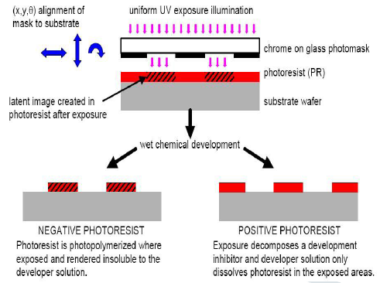

Figure 1 : Negative and Positive Photoresist

**a) Wet etching**

Wet etching describes the removal of material through the immersion of a material (typically a silicon wafer) in a liquid bath of a chemical etchant. These etchants can be isotropic or anisotropic. Isotropic etchants etch the material at the same rate in all directions, and consequently remove material under the etch masks at the same rate as they etch through the material; this is known as undercutting (Figure 2 a and b). Etch rates can slow down and in some cases (for example, in deep and narrow channels) they can stop due to diffusion limiting factors. However, this effect can be minimized by agitation of the etchant, resulting in structures with near perfect and rounded surfaces (Figure 2 b).

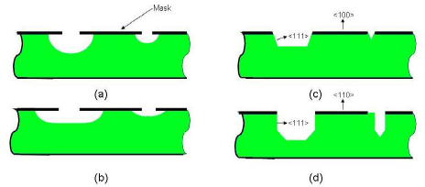

Figure 2 : Isotropic Etching (a and b), Anisotropic Etching (c and d)

Dopant levels within the substrate can affect the etch rate by KOH, and if levels are high enough, can effectively stop it. Boron is one such dopant and is implanted into the silicon by a diffusion process. This can be used to selectively etch regions in the silicon leaving doped areas unaffected, for instance to control the thickness of a silicon membrane.

**b) Dry itching**

Dry etching relies on vapour phase or plasma-based methods of etching using suitably reactive gases or vapours usually at high temperatures. The typical etch rates are 1 to 3 μm/min and it is commonly used for release etch. The other is Reactive Ion Etching (RIE) which utilizes additional energy in the form of radio frequency (RF) power to drive the chemical reaction. Energetic ions are accelerated towards the material to be etched supplying the additional energy needed for the reaction; as a result the etching can occur at much lower temperatures (sometimes room temperature or even lower). The MEMS process Deep Reactive Ion Etching (DRIE) is a much higher-aspect-ratio etching method. It involves an alternating process of high-density plasma etching (as in RIE) and protective polymer deposition to achieve greater aspect ratios.

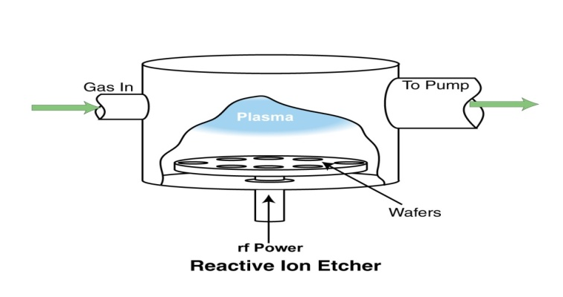

Figure 3 (a) : RIE Dry Etching

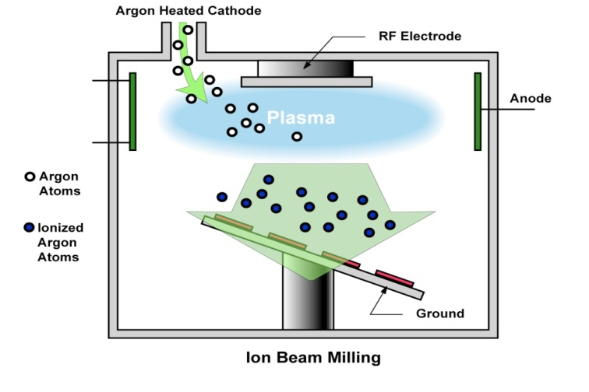

Figure 3 (b) : Plasma Dry Etching

1. MICROMACHINIG TECHNIQUES

**A). Surface Micromachinig**

Surface micromachining involves processing above or in the top layers of the substrate, the substrate only using as a carrier on which to build. Material is added to the substrate in the form of layers of thin films. The process usually involves films of two different materials: a structural material out of which the free standing structure is made (generally polycrystalline silicon or polysilicon, silicon nitride or aluminum) and a sacrificial material, deposited wherever either an open area or a free standing mechanical structure is required (usually an oxide, but also resist or metals are used).

* Step 1: Deposition of sacrificial layer



* Step 2: patterning of the sacrificial layer



* Step 3: deposit structural layer (conformal deposition)



* Step 4: liquid phase removal of sacrificial layer



* Step 5: removal of liquid - drying.



In the above example shown , a sacrificial layer of oxide is deposited on the silicon substrate surface using a pattern and photolithography. A polysilicon layer is then deposited and patterned using RIE processes to form a cantilever beam with an anchor pad. The wafer is then wet etched to remove the oxide (sacrificial) layer releasing the beam. More complex MEMS structures can be made using several structural polysilicon and sacrificial silicon dioxide layers, including sliding structures, actuators and free moving mechanical gears.

**B). Bulk micromachining**

Bulk micromachining starts with the deposition of a masking layer on both sides of the wafer, mostly LPVCD low stress silicon nitride. In the most simple process, this mask is then structured and the wafer is subsequently etched in KOH etch. Depending on the mask pattern cantilevers of free hanging silicon nitride layers, cavities, membranes and wafer through holes are formed (see Figure 4).

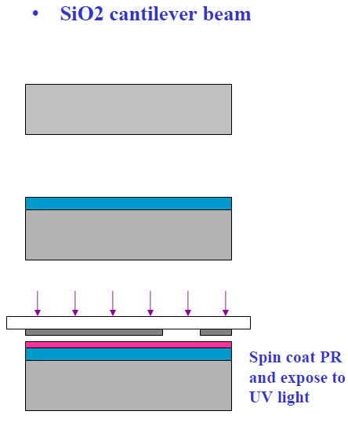

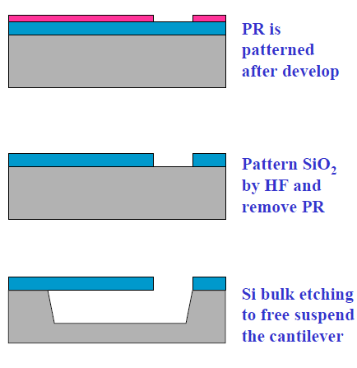

Figure 4 : Bulk Micromachining Steps

**C) LIGA Process**

LIGA is an important tooling and replication method for high-aspect-ratio microstructures. The technique employs X-ray synchrotron radiation to expose thick acrylic resist of PMMA under a lithographic mask. The exposed areas are chemically dissolved and, in areas where the resist is removed, metal is electroformed, thereby defining the final product or the tool insert for the succeeding moulding step. LIGA is capable of creating very finely defined microstructures up to 1000 μm high. LIGA provides a radically new way to produce small precise micromachined parts at relatively low cost.

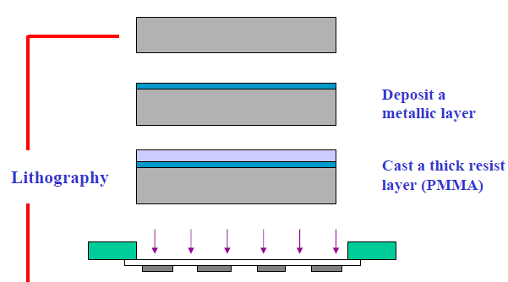

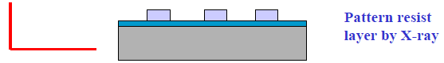

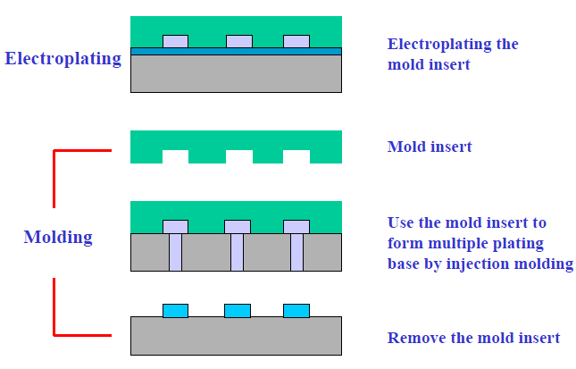



Figure 5 : LIGA Micromachining Steps

**D) Laser Micromachining**

Most laser micromachining processes are serial and hence insufficiently fast for cost effective MEMS fabrication. Nonetheless, such techniques have their use in specialty micromachining or in fabricating moulds. Excimer laser micromachining is, particularly, used for the micromachining of organic materials (plastics, polymers etc.). Applications include machining lubrication or air channels in bearings, machining variable shape nozzles for ink jet devices, machining channels, reservoirs and elements for micro-fluidic, bio-medical and photonic devices.

1. CONCLUSION

The variety and diversity of MEMS products is huge. Each of these product groups relies on its own, often unique, technology. Contrary to the semiconductor industry, the MEMS industry does not show such a generic technology platform that can be shared. Still, when studied in detail, some general trends become clearer and it is possible to define, at least in general terms, the principle technology developments that underpin microcantilever fabrication. MEMS fabrication uses high volume IC style batch processing that involves the addition or subtraction of two dimensional layers on a substrate (usually silicon) based on photolithography and chemical etching. As a result, the 3-D aspect of MEMS devices is due to patterning and interaction of the 2-D layers. Additional layers can be added using a variety of thin-film deposition and bonding techniques as well as by etching through sacrificial “spacer layers”. “Real” 3-D technologies include high-aspect-ratio micromachining (HARM), such as LIGA (a German acronym from LithographieGalvanoformung, Abformung translated as lithography, electroforming and moulding,; but also conventional macro scale manufacturing techniques such as injection moulding, are all good for producing three dimensional shapes and objects, but limited to low complexity products.

REFERENCES

1. *Neha Mishra, 2Bharatbhushan Kale, 3Prachi Khond* ***,”****REVIEW: MICROCANTILEVER FABRICATION TECHNOLOGY****”*** *JETIR (ISSN-2349-5162),2016.*
2. *R. Berger, E. Delamarche, H.P. Lang, C. Gerber, J.K. Gimzewski, E. Meyer, H.-J. Güntherodt, Surface stress in the self-assembly of alkanethiols on gold, Science 276 (1997) 2012.*
3. *AnjaBoisen, SørenDohn, Stephan Sylvest Keller, SilvanSchmid and Maria Tenje, “Cantilever-like micromechanical sensors” Rep. Prog. Phys. 74(2011) .*
4. *Yuxian Li1, Yifu Du2, Bin Liu2, Haibin Li3, Qiang Zhang3, Yaqian Li3“Image Segmentation Method Based on Improved Graph Cut Algorith”IEEE 2012.*
5. *Pradeep Kumar Agrawal, “Laser Micromachining: Technology and Applications”, International Journal of Engineering Research and Applications (IJERA) ISSN: 2248-9622 National Conference on Advances in Engineering and Technology. http://www.ijera.com/special_issue/AET_Mar_2014/ECE/Ver sion%20%202/B0709.pdf*
6. *Venkata Ramesh Mamillaa* , Kommuri.Sai Chakradhar, “Micro Machining For Micro Electro Mechanical Systems” 3rd International Conference on Materials Processing and Characterisation (ICMPC 2014).*
7. *Agostinho, C., Y. Ducq, G. Zacharewicz, J. Sarraipa, F. Lampathaki, R. Poler, and R. Goncalves.* *2016**. “Towards a Sustainable Interoperability in Networked Enterprise Information Systems: Trends of Knowledge and Model-Driven Technology.” Computers in Industry 79: 64–76. doi:*[*10.1016/j.compind.2015.07.001*](http://dx.doi.org/10.1016/j.compind.2015.07.001)*.*
8. *Angulo, P., C. C. Guzmán, G. Jiménez, and D. Romero.* *2016**. “A Service-Oriented Architecture and its ICT-Infrastructureto support Eco-efficiency Performance Monitoring in Manufacturing Enterprises.” International Journal of Computer Integrated Manufacturing. Advance online pub-lication. doi:*[*10.1080/0951192X.2016.1145810*](http://dx.doi.org/10.1080/0951192X.2016.1145810)*.*
9. *BCG.* *2015**. “Industry 4.0: The Future of Productivity and Growth in Manufacturing Industries.” Boston Consulting Group Perspective on Industrial Products & Processes, Technology & Digital.* [*https://www.bcgperspectives.com/content/articles/engineered_products_project_business_industry_40_future_.*](https://www.bcgperspectives.com/content/articles/engineered_products_project_business_industry_40_future_productivity_growth_manufacturing_industries/)