DESIGN OF FOUNDATION OF STEEL STRUCTURE FOR FRACTIONATION PLANT
Saurabh Dewarde¹ , Shubham Kanade² , Ankit Karde³ , Rohan Mane⁴
¹ Mr. Manjunath M
St. John College of Engineering and Management, Maharashtra, India

Abstract – In Oil & Gas, Refinery & Power Plants different types of Equipments plays a major role for process requirements. Majority of Equipments are categorized into Horizontal Vessels, Vertical vessels, Exchangers, Storage tanks. These are further divided into Static Equipments and Dynamic Equipments based on rotations and vibration. Equipment Foundations design is major challenge for Structural Engineers to withstand process loads and Environmental loads for different load combination in terms of safety and economy. Most of the Vertical Equipments Foundation are Octagonal in shape for Constructability point of view and economy point of view. In the present project Equipment Foundation has been analyzed by using Staad Software and designed by using International codes as per American code of institute.
Keywords - Horizontal Vessels, Vertical vessels, Foundation.
1.INTRODUCTION
1.1 GENERAL: Foundations are substructures that are constructed below the ground level which support the superstructures above the ground level. The main function of the footing or foundation is to
- Transmit the load safely and effectively coming on to it to the underlying soil without exceeding the “Safe bearing capacity of the soil”.
- Ensuring that the settlements of the structure are within the permissible limits.
- In addition to that, the foundation should provide adequate safety against possible instability due to overturning, sliding and uplift.
- The design is carefully done so that foundation has to provide adequate steel to resist tensile forces and at the same time it should be verified that more steel than required should not be placed as it gives brittle failure.

1.2 TYPES OF EQUIPMENT FOUNDATIONS:
- Vertical Vessel Foundation
- Horizontal Vessel Foundation

1.2.1 VERTICAL VESSEL FOUNDATION:
Vertical vessels are process equipment placed vertically on either foundation at grade either in a concrete or steel structure. Vertical vessels are cylindrical in shape with each end capped by a domed cover called a head. The length to diameter ratio of a vertical vessel is typically 3:1. Vertical vessels are usually supported by legs, lugs and skirts. They can be Short and stubby or tall and slim.

1.2.2 HORIZONTAL VESSEL FOUNDATION:
Horizontal vessels are relatively large diameter cylindrical pressure vessel used for variety of pressure functions. The height above grade is usually determined by NPSH requirements of pumps in the liquid outlet line or gravity flow requirement to other equipment. Foudation type is similar to both of them. Horizontal vessels are usually supported on fixed end saddle and sliding end saddle.

2.METHOLOGY
2.1 VERTICAL VESSEL:

2.1.1 VESSEL 1:

Table 1 | Operating | Empty
Live load | 1 kN/m² | 1 kN/m²
Dead load | 10488.834 kN | 6307.464 kN
Shear | 324.739 kN | 119.884 kN
Moment | 10827.890 kNm | 6511.38 kNm

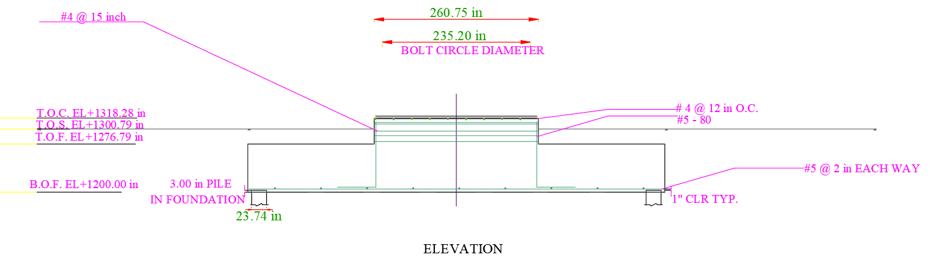
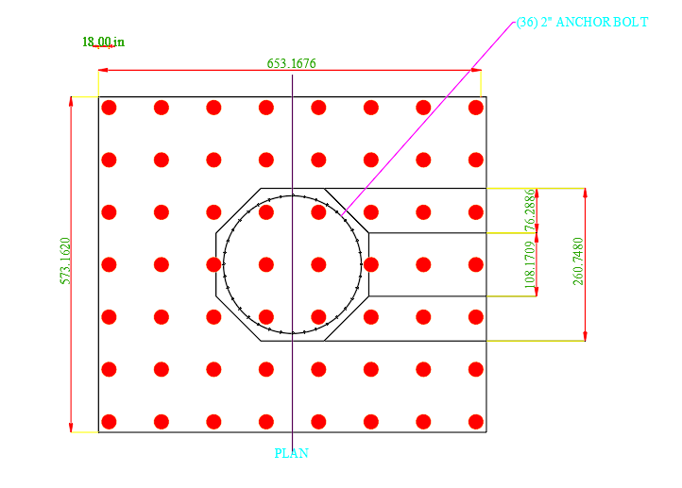Fig. 1, 2 - fig shows the STAAD Foundation output

Table 2: Anchor Bolt
Grade | F1554  Grade 36
Tensile strength | 399895.5 kN/m²
Yield strength | 248211 kN/m²
Diameter | 0.069 m
Table 3: Pedestal:
Geometry | Octagonal
Length of each side | 2.747 m
Height of pedestal | 1.053 m
Area | 36.188 m²
2.1.2 VESSEL 2:
Table 4 | Operating | Empty
Live load | 1 kN/m² | 1 kN/m²
Dead load | 10562.98 kN | 5744.472 kN
Shear | 328.129 kN | 40.085 kN
Moment | 15612.58 kNm | 8483.188 kNm
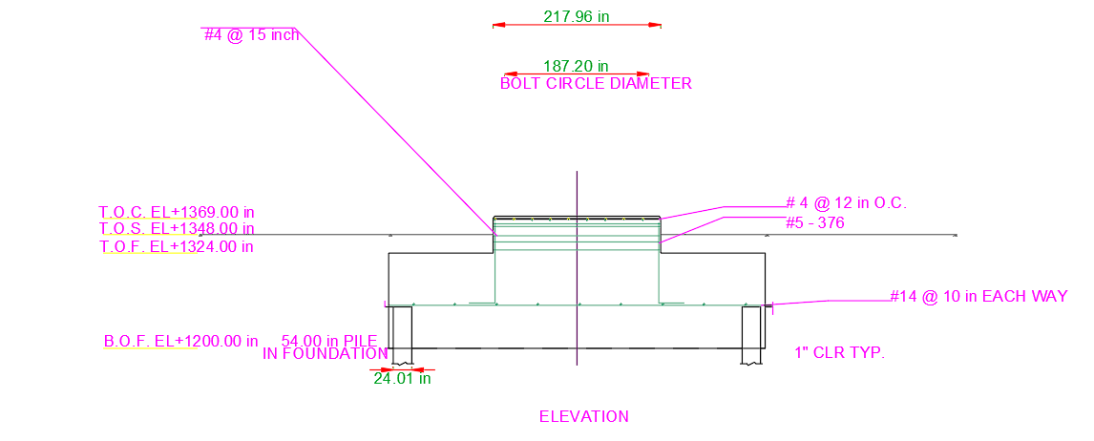
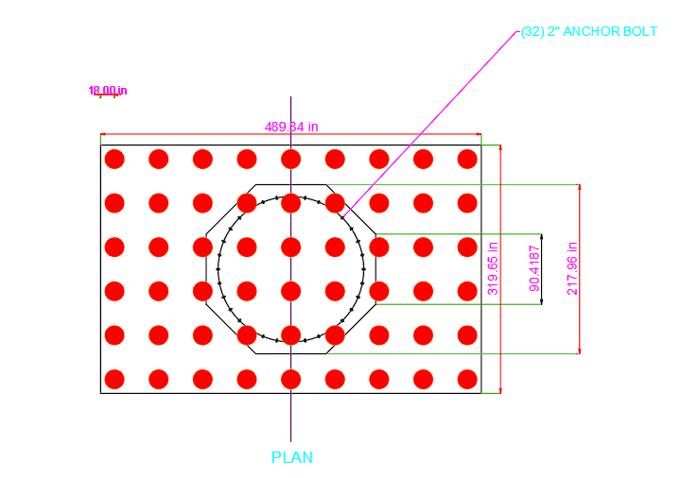Fig. 3, 4: fig shows the STAAD Foundation output

Table5: Anchor Bolt
Grade | F1554  Grade 36
Tensile strength | 399895.5 kN/m²
Yield strength | 248211 kN/m²
Diameter | 0.074 m
Table 6: Pedestal
Geometry | Octagonal
Length of each side | 2.514 m
Height of pedestal | 1.143 m
Area | 30.53 m²
2.1.3 VESSEL 3:

Table 7 | Operating | Empty
Live load | 1 kN/m² | 1 kN/m²
Dead load | 6848.7 kN | 2759.016 kN
Shear | 212.694 kN | 85.681 kN
Moment | 11787.795 kNm | 4748.594 kNm

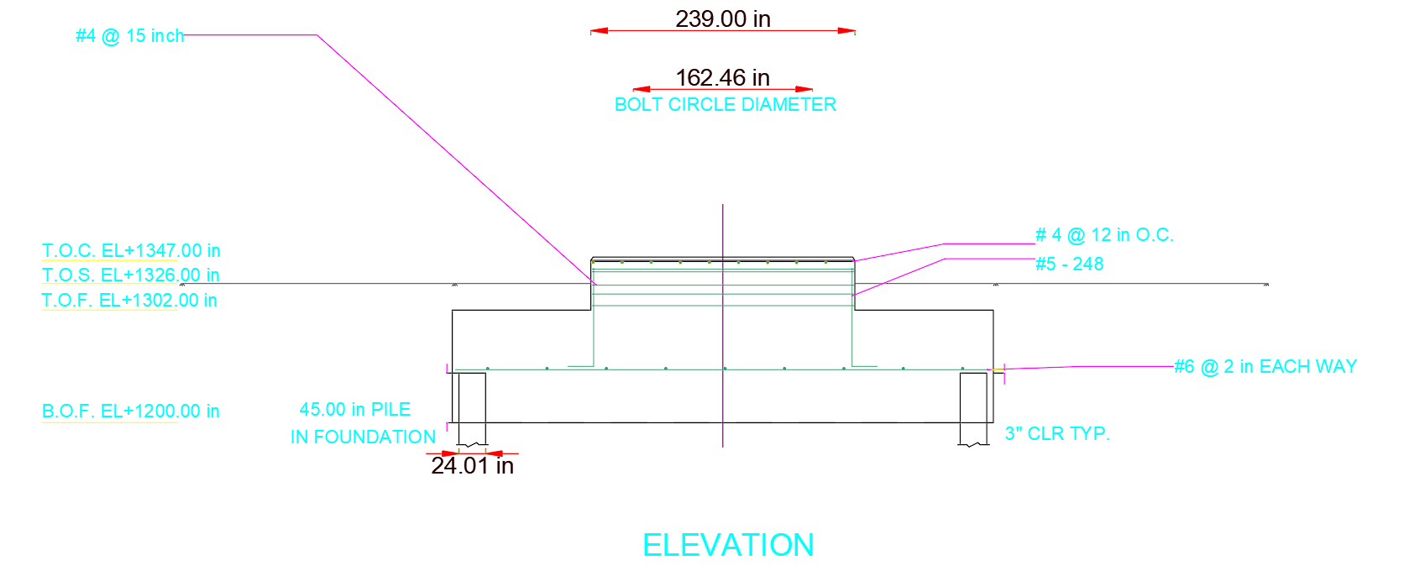
Table 11 | Operating | Empty
Shear | 24.241 kN | 15.247 kN
Vertical load | 9.924 kN.m | 6.242 kN.m
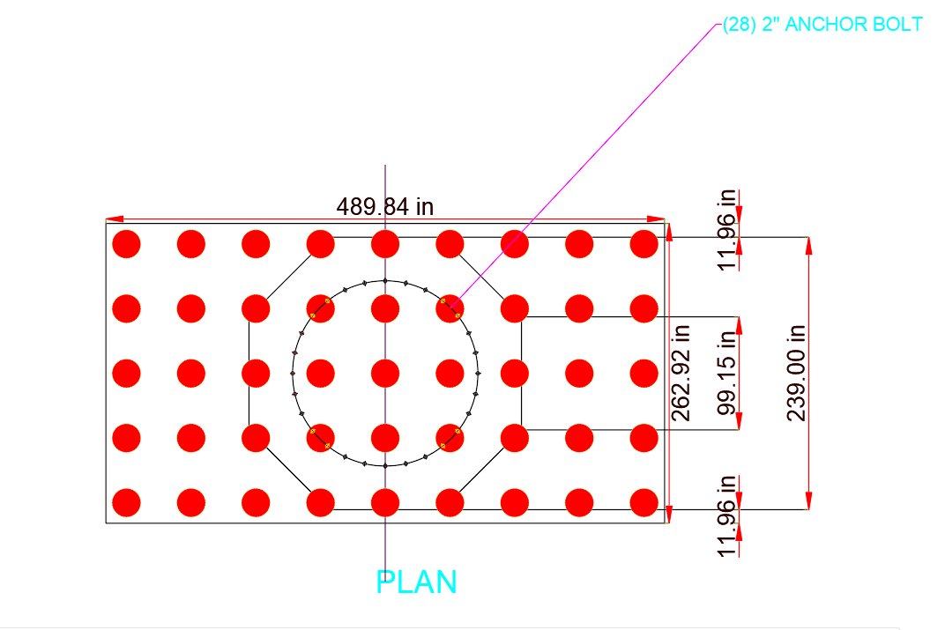Fig. 5, 6: fig shows the STAAD Foundation output

Table 8: Anchor Bolt
Grade | F1554  Grade 36
Tensile strength | 399895.5 kN/m²
Yield strength | 248211 kN/m²
Diameter | 0.069 m
Table 9: Pedestal
Geometry | Octagonal
Length of each side | 2.514 m
Height of pedestal | 1.143 m
Area | 30.53 m²
2.2 HORIZONTAL VESSEL:
2.2.1 VESSEL 1:
Seismic in transverse direction (for sliding):
Seismic in longitudinal direction (for sliding):
Table 10 | Operating | Empty
Shear | 32.6 kN | 20.514 kN
Moment | 146.453 kN.m | 90.201 kN.m

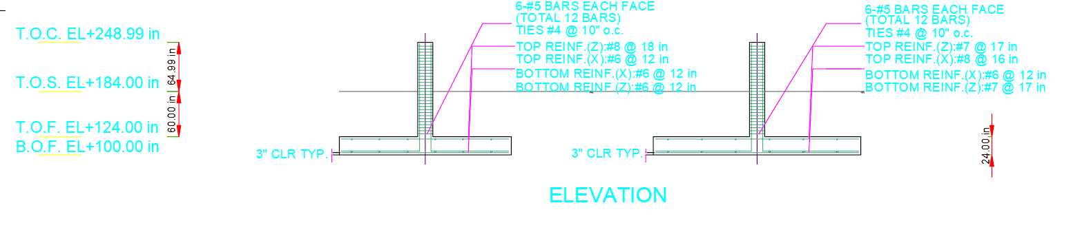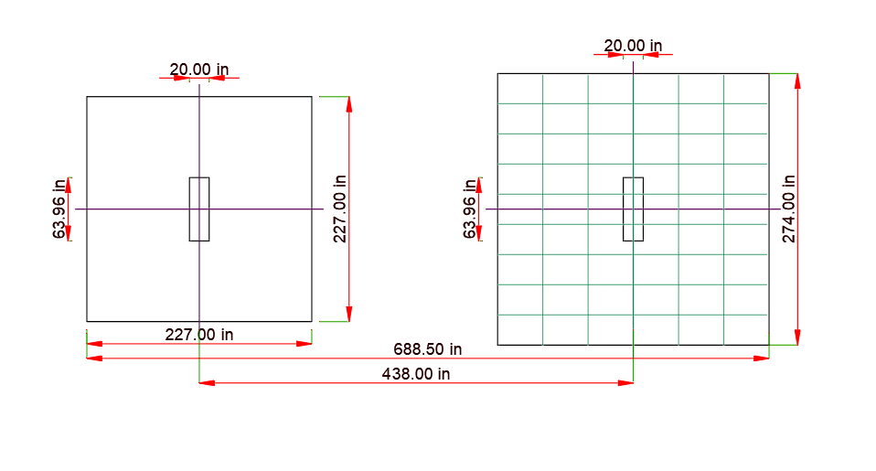fig shows the STAAD Foundation output

Seismic in transverse direction (for fixed):
Table 12 | Operating | Empty
Shear | 48.127 kN | 30.304 kN
Moment | 216.399 kN.m | 136.141 kN.m
Seismic in longitudinal direction (for fixed):
Table 13 | Operating | Empty
Shear | 56.574 kN | 35.539 kN
Vertical load | 9.924 kN.m | 6.242 kN.

2.2.2 VESSEL 2:
Seismic in transverse direction (for sliding):
Table 14: | Operating | Empty
Shear | 27.755 kN | 13.415 kN
Moment | 136.352 kN.m | 65.891 kN.m

Seismic in transverse direction (for fixed):
Table 15 | Operating | Empty
Shear | 38.564 kN | 18.628 kN
Moment | 189.635 kN.m | 91.504 kN.m

Seismic in longitudinal direction (for sliding):
Table 16 | Operating | Empty
Shear | 19.922 kN | 9.612 kN
Vertical load | 8.46 kN.m | 4.083 kN.m
Seismic in longitudinal direction (for fixed):
Table 17 | Operating | Empty
Shear | 46.486 kN | 22.435 kN
Vertical load | 8.46 kN.m | 4.083 kN.m
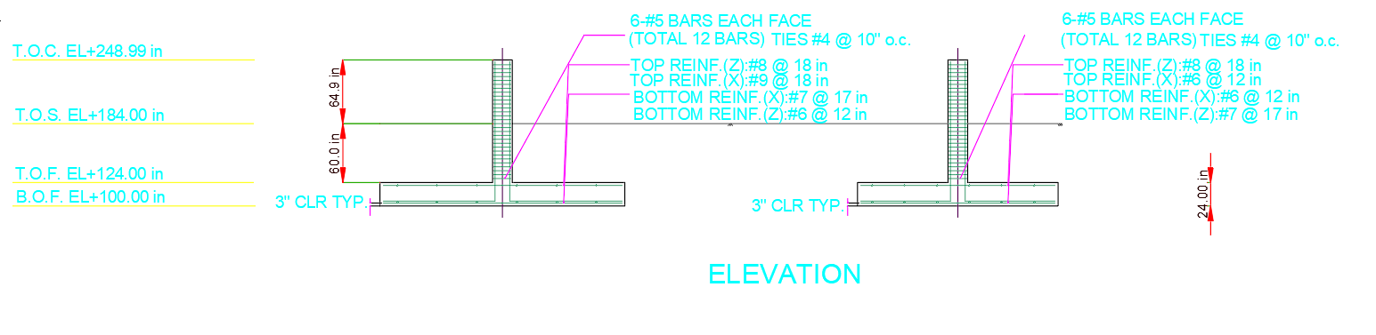
Fig. 9: fig shows the STAAD Foundation output

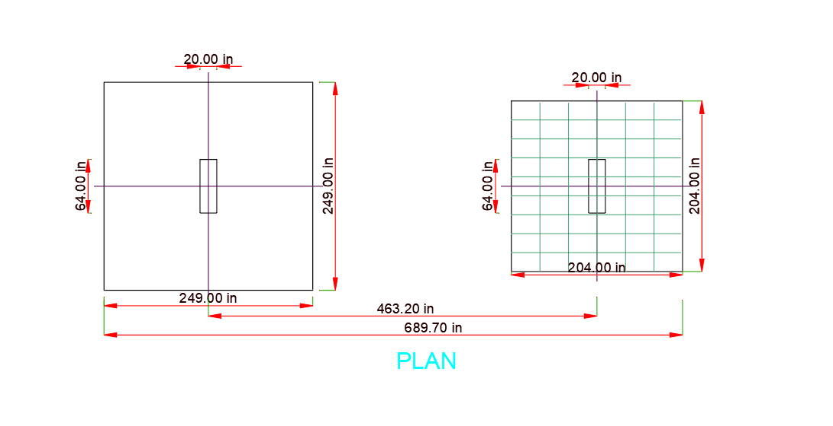
Fig. 10: fig shows the STAAD Foundation output
CONCLUSIONS:
The conclusion as per the result obtain from the STAAD foundation:
We came into conclusion that:
- For vertical vessel 1: the value calculated for the overturning moment is slightly increased. The manually calculated value was 18612.956 kip-ft while STAAD calculated the value was 164002.586 kip-ft. due to which there is change in no. of dowels. Through manual calculation it was 50 Nos. and the STAAD result was 80 Nos. also STAAD foundation has calculated checks for one way shear which found out to be safe.
- For vertical vessel 2: the value calculated for the overturning moment is slightly increased. The manually calculated value was 32040.971 kip-ft while STAAD calculated the value was 442375.553 kip-ft. due to which there is change in no. of dowels. Through manual calculation it was 50 Nos. and the STAAD result was 376 Nos. also STAAD foundation has calculated checks for one way shear which found out to be safe.
- For vertical vessel 3 : the value calculated for the overturning moment is slightly increased. The manually calculated value was 18353.735kip-ft while STAAD calculated the value was 290123.983 kip-ft. due to which there is change in no. of dowels. Through manual calculation it was 50 Nos. and the STAAD result was 248 Nos. The tensile force also changes. while STAAD value was 16.706 kip-ft. also STAAD foundation has calculated checks for one way shear which found out to be safe.
- For horizontal vessel 1: the footing geometry provided for fixed and sliding saddle was identical. The minimum length provided was 15 ft and maximum was 25 ft. but the final length and width of vessel adopted was 18.91 ft. with depth same as provided 2ft.if we provide load combination in STAAD Foundation as per PIP we can see that the Foundation is failing in bearing check as well as the footing size is inadequate so to avoid such errors we will provide the load combination as per ASCE 7-05.
- For horizontal vessel 2: the footing geometry provided for fixed and sliding saddle was identical. The minimum length provided was 15 ft and maximum was 25 ft. but the final length and width of vessel adopted was 20.75 ft. with depth same as provided 2ft.if we provide load combination in STAAD Foundation as per PIP we can see that the Foundation is failing in bearing check as well as the footing size is inadequate so to avoid such errors we will provide the load combination as per ASCE 7-05.

REFERENCES
- Finite Element Analysis Software – STAAD Foundation, STAAD Pro, AutoCAD Naviswork.
- ACI (American concrete institute )-Concrete code – ACI – 318-11
- ASCE (American society of civil engineer )-Loading code- ASCE-SEI-7-10
- PIP (Process industry practices)-Structural code-STE05121-STE03360
- Structural magazine - Burns & McDonnell performed an Engineer, Procure, Construct contract for a new NGL Fractionation Plant for ONEOK Hydrocarbon, L.P. located in Mont Belvieu, TX.
- Tutorial links
https://www.youtube.com./watch?v=G2elijkignZ8&t=226s – Horizontal Vessel Foundation Isolated design
https://www.youtube.com./watch?v=hZ_5G6qdzMU&t=1550s – For loading criteria

