Dynamic Seismic Analysis of RCC Building as per IS 1893:2002 by Using STAAD-Pro Software
Hiteshkumar D. Mishra¹, Prof. D.L.Budhlani²
¹M.Tech-Student Appearing (Structural Engineering)
Guru Nanak Institute Of Technology, Dahegaon, Nagpur, India, 441501
²Assistant Professor,
Guru Nanak Institute Of Technology, Dahegaon, Nagpur, India, 441501

Abstract – In this paper seismic response of (G+7)R.C. framed building is analyses for seismic load case by using STAAD-Pro software as per IS1893:2002 part-1.This paper consider different seismic parameter like seismic zone(IV), response reduction factor(R), importance factor(I)& other parameters like rock/soil type, structure type, damping ratio etc. This paper provides complete guidelines for STAAD-Pro software analysis & STAAD –Pro gives the results after run analysis in the STAAD output viewer which shows joint displacements, support reactions, member forces, base shear and lateral load.
Keywords- dynamic analysis, IS 1893:2002, reinforced structure, Earthquake, STAAD-Pro, Seismic loads, multistory building, RCC building.
INTRODUCTION
In general, for design of multistory buildings seismic loads need to be considered. According to IS 1893(Part -1):2002 height of the structure, seismic zone, vertical and horizontal irregularities, soft and weak storey necessitates dynamic analysis for seismic load. Structural engineer’s role becomes challenging when the building is located in a seismic zone. So, it is to design the structure to resist an earthquake. Seismic design stated, as the structure should be able to ensure the minor and frequent shaking intensity without any damage. In Response Spectrum Method, the Time Periods, Natural Frequencies and Mode Shape Coefficients are calculated by STAAD-Pro Software and remaining process will be done by manually. The modal combination rule for Response Spectrum Analysis is SRSS (Square Root Sum of Squares). The main parameters considered in this

Study are seismic zone IV, response reduction factor(R), importance factor (I) and medium soil type.
METHODOLOGY
Consider (G+7) storey building located in new Delhi zone IV, the soil conditions is medium stiff soil, entire building is supported on raft foundation, RC frame infill with brick masonry, lumped weight due to dead load is 12kN/m² on floors and 10kN/m² on roof, floors carry live load of 4kN/m² on floors and 1.5kN/m² on roof, span of building 5m in X and Z direction, Floor to floor height is 3.1m, bottom floor height is 4.2m, size of beam is assume to be as 0.35X0.45m And size of column as 0.35X0.5m, material assume to be concrete. All the supports are assigning as fixed supports,
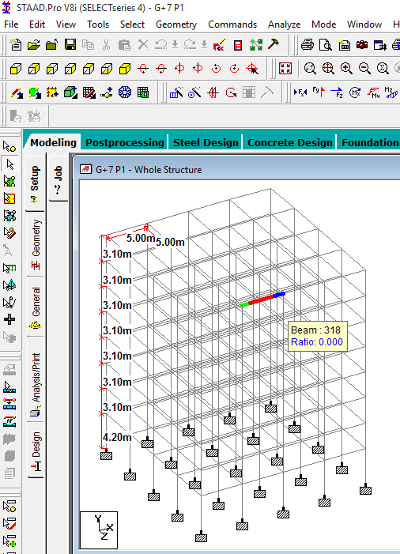
Fig. 1- fig shows the Structural model of building in STAAD-Pro software.
Calculation of design seismic force by (dynamic) Response spectrum analysis method by using STAAD-PRO software:-
The design lateral shear force is at each floor in each mode is computed by STAAD equation in accordance with equation (7.8.4.5c and7.8.4.5d) from IS 1893-2002.
$Q_{ik}=A_{k} x ɸ_{ik} x P_{k }$ $x$ $W_{i }$

Where $A_{k} ,W_{i }$ are user inputs

STAAD utilizes the following procedure to generate the lateral seismic load.
- User provides the value for $\frac{Z}{2} x \frac{I}{R}$ as factors for input spectrum.
- Program calculate time periods for first six modes or as specified by the user.
- Program calculates $\frac{Sa}{g}$ for each mode utilizing time period and damping ratio for each mode.
- The program calculates design horizontal acceleration spectrum $A_{k}$ for different modes.
- The program then calculates mode participation factor for different modes.
- The peak lateral seismic force at each floor in each mode is calculated.
- All response quantities for each mode are calculated.
- The peak response quantities are then combined as per method (CQC or SRSS or ABS or TEN or CSM) as defined by the user to get the final results.
In order to calculate Base shear value$V_{b}$: -
Vb = Ah x W
Seismic parameter:-
- Seismic zone IV, zone factor Z is 0.24
………… (Table no. 2 of IS1893:2002 Part-1)
- Response reduction factor, R is 5
………… (Table no. 7 of IS1893:2002 Part-1)
- Importance factor, I is 1.0
.………... (Table no. 6 of IS1893:2002 Part-1)
Building is made of moment resisting frame with brick in fill panels; we should use empirical expression the fundamental natural period is as follows:
T=0.09h/sqrt (d)……… (Clause 7.6.2 of IS 1893:2002)
Hence approximate fundamental natural period in both X and Z direction is as follows:
T = 0.09(25.9) / sqrt (20)
T = 0.5212 sec… (Since X and Z direction value D = 20)
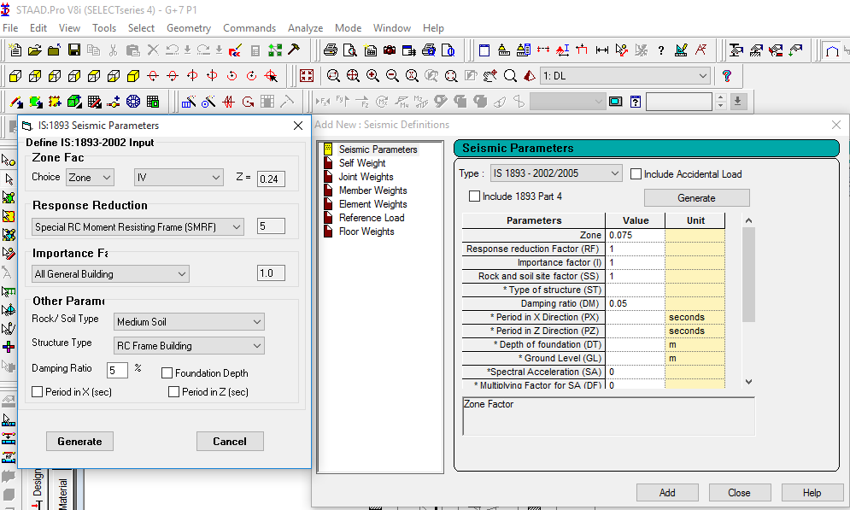Fig. 1- fig shows the seismic parameter
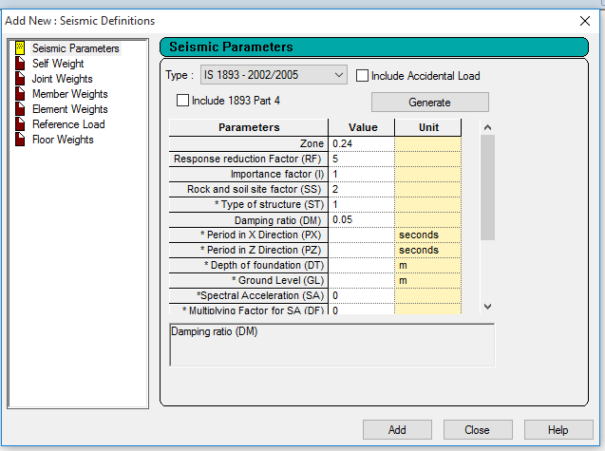
Fig. 2- fig shows the seismic load definition
Floor Loads in Seismic definition
Dead loads and Live loads
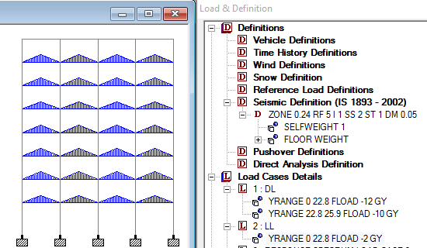
Fig. 3- fig shows the D.L. and L.L.
Defining Response Spectrum load Case:-
First Add Response spectrum load case to load cases. We will have to specify values attach to be considered to calculate the value of Wi.
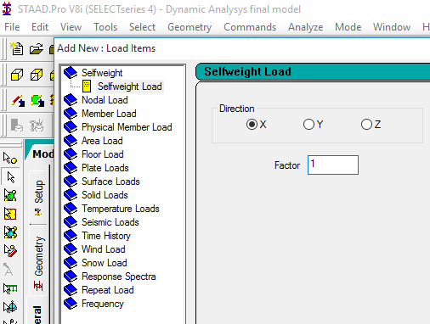
Fig. 4- fig shows self weight load in X, Y AND Z-direction
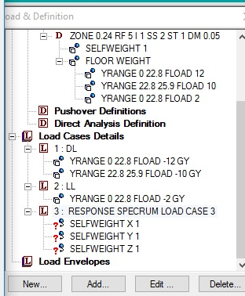
Fig. 5- fig shows response spectrum load case
Same way for add self weight load in Y and Z direction
In Response Spectrum analysis we will have to add floor load (Dead load) in all three direction
Floor load in X-direction:-
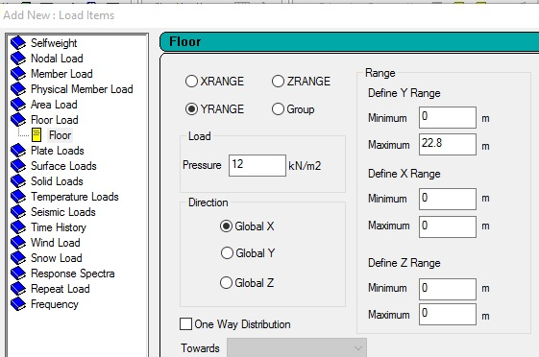Fig. 6- fig shows floor load in X-direction
Floor load in Y-Direction:-
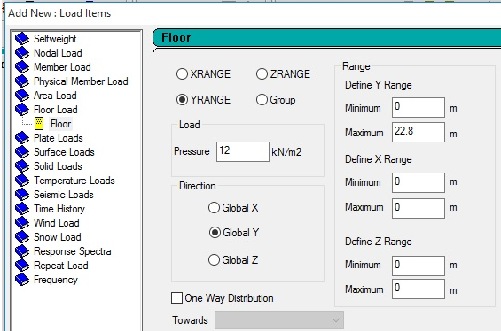 Fig. 7- fig shows floor load in Y-direction
Floor load in Z- direction:-
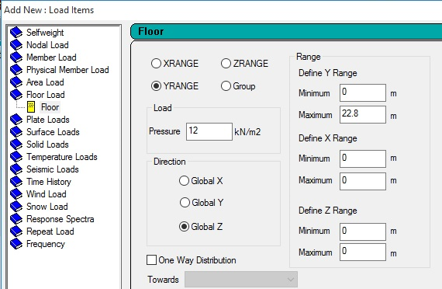
Fig. 8- fig shows floor load in Z-direction
Roof load in X- direction:-
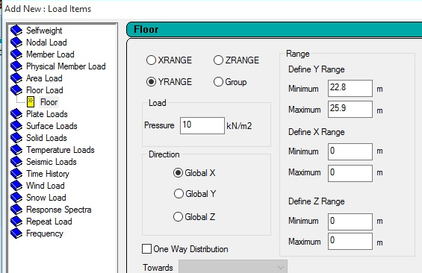Fig. 9- fig shows roof load in X-direction
Roof load in Y- direction:-
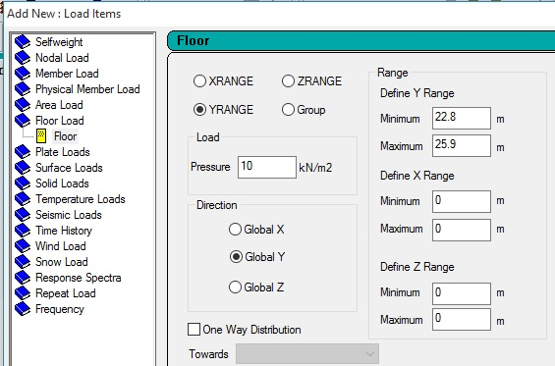Fig. 10- fig shows roof load in Y-direction
Roof load in Z- direction:-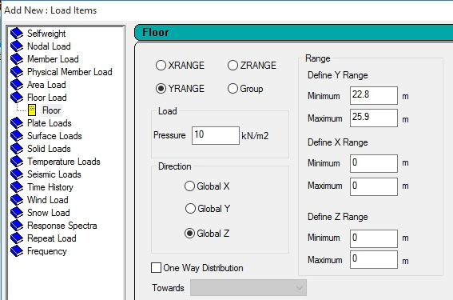Fig. 11- fig shows roof load in Z-direction

Adding Live loads in all directions
X- Direction:-
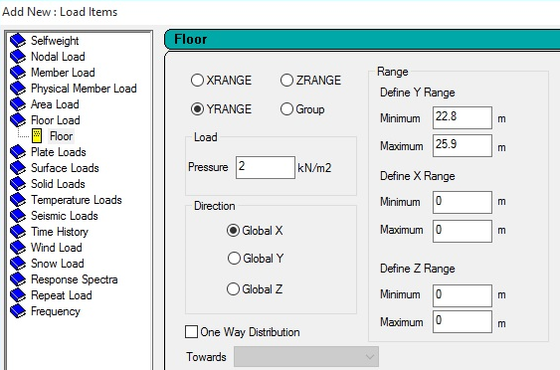Fig. 12- fig shows L.L. in X-direction
Y- Direction-
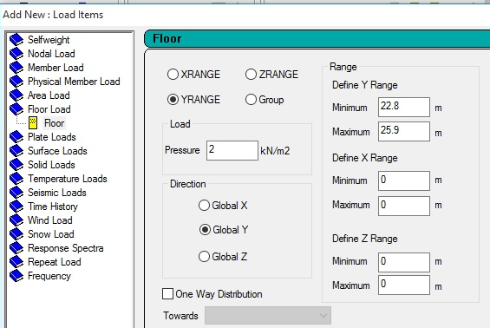Fig. 13- fig shows L.L. in Y-direction
Z- Direction-
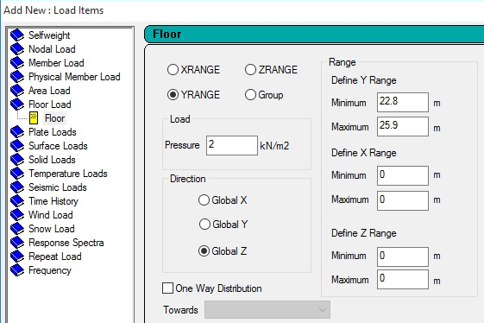
Fig. 14- fig shows L.L. in Z-direction
All this plates will be considered for calculating Wi so to calculate Floor Shear

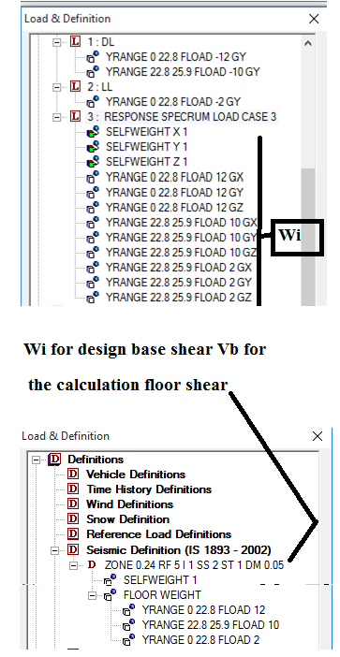
Fig. 15- fig shows the load and definition
Apply Self weight in X, Y and Z to structure
- Response Spectrum Command
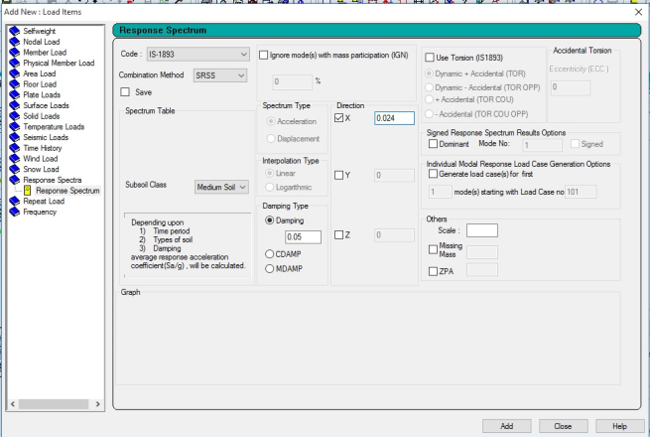
Fig. 16- fig shows the response spectrum

$\frac{Z}{2} x \frac{I}{R}$ = $\frac{0.24}{2} x \frac{1}{5}$= 0.024

- Analysis / Print--Mode Shapes

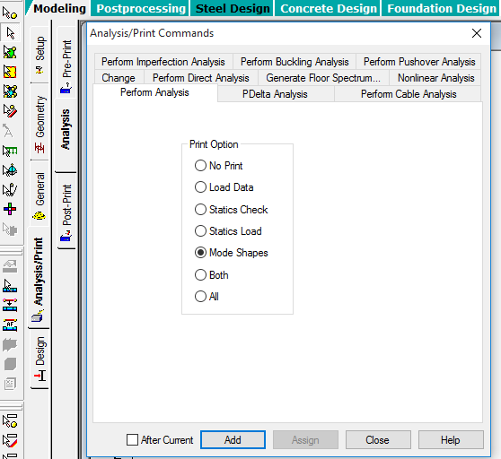
Fig. 17- fig shows the analyses the mode shapes

- Click Post Print Command
- Define Commands
- Add-Print Analysis Results
- Add-Storey drift
Analyze the Structure

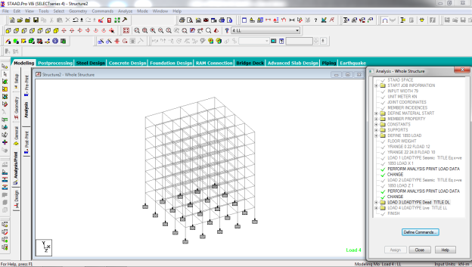
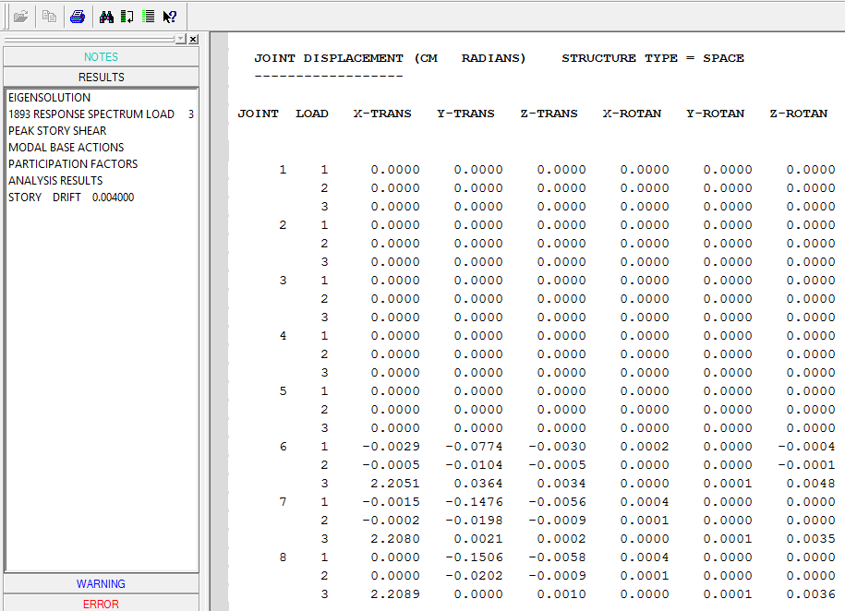
Fig. 18- fig shows the Joint displacement
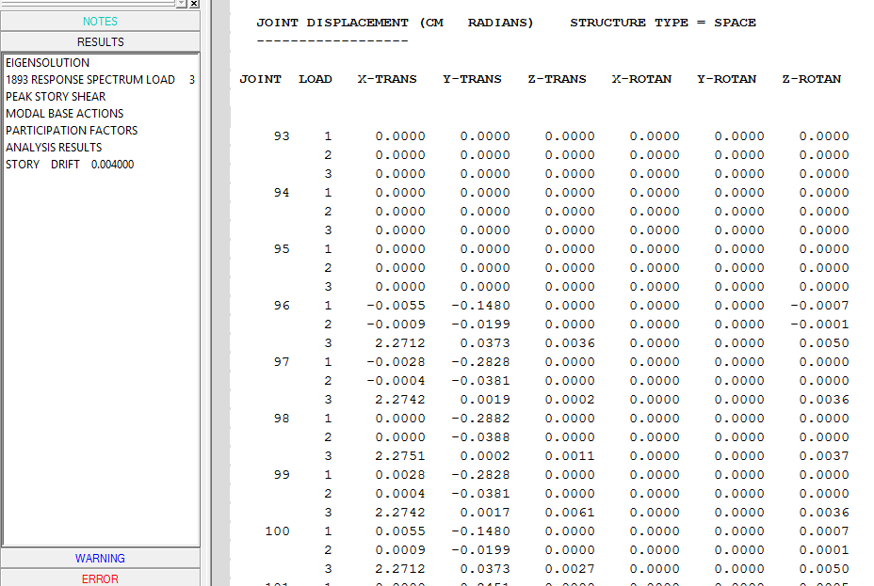
Fig. 19- fig shows the Joint displacement
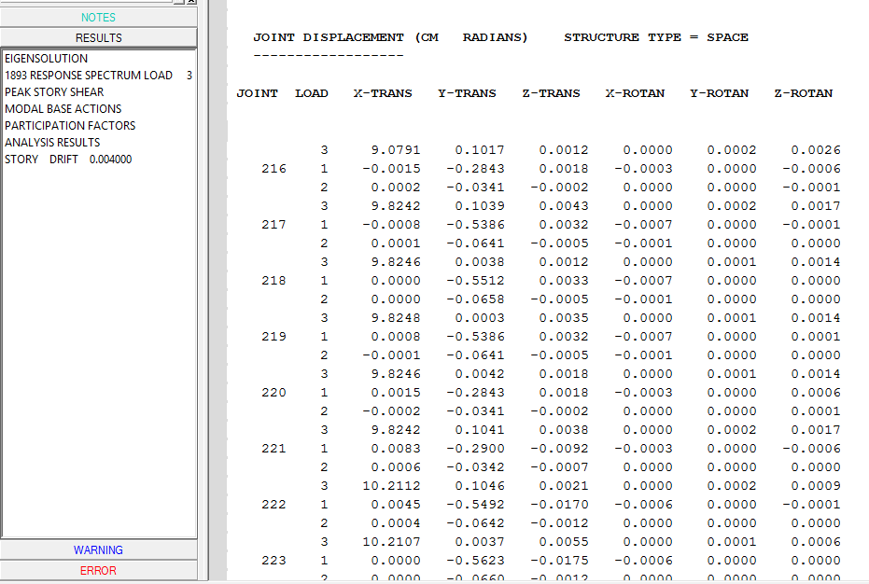
Fig. 20- fig shows the Joint displacement
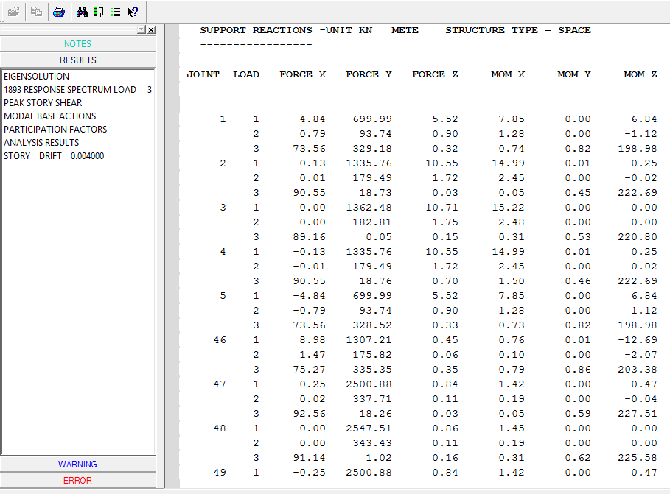
Fig. 21 fig shows the support reaction
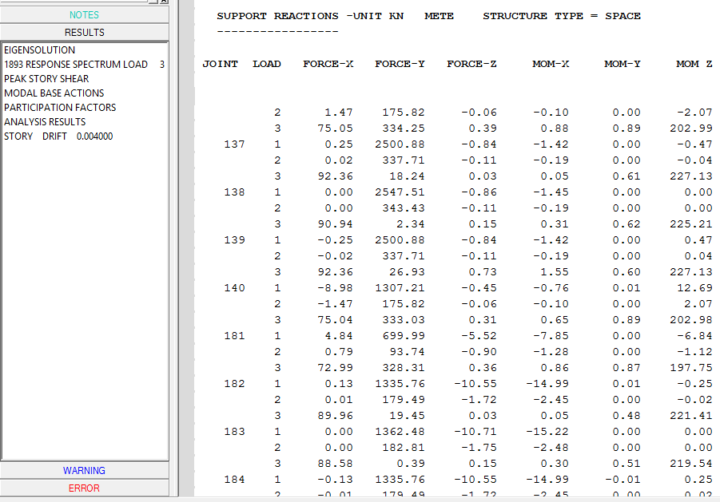Fig. 22- fig shows the support reaction
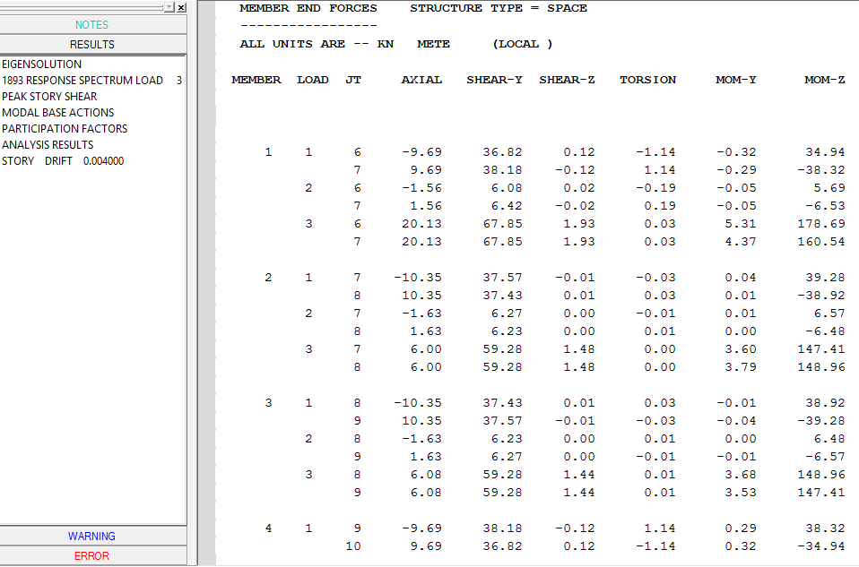
Fig. 23- fig shows the member forces
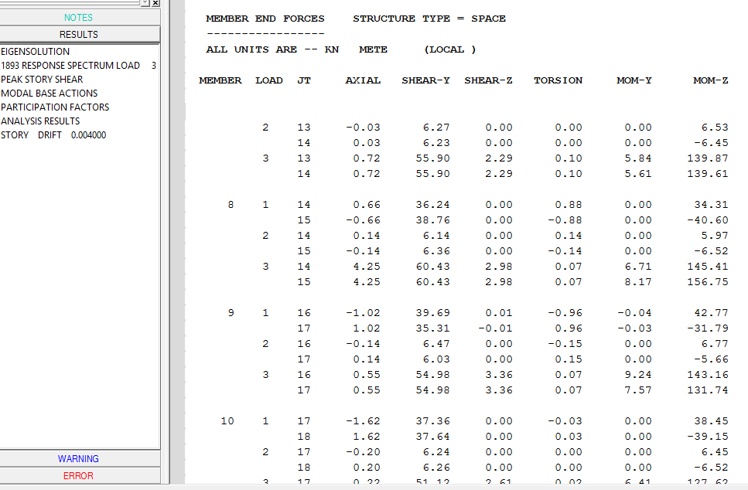
Fig. 24- fig shows the member forces
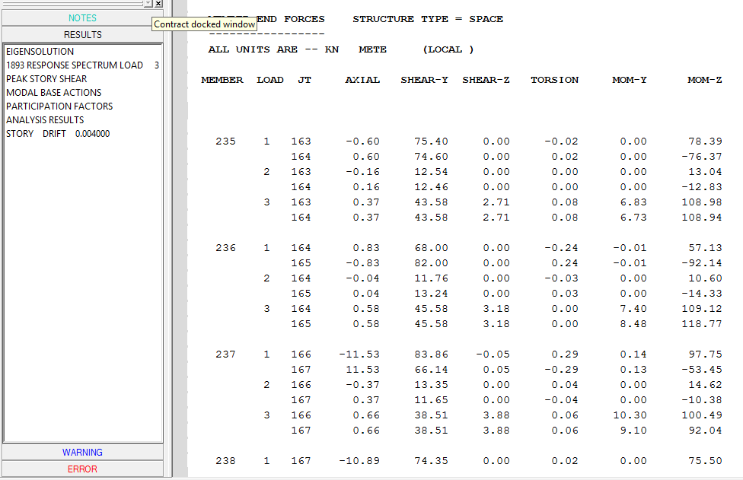
Fig. 25- fig shows the member forces
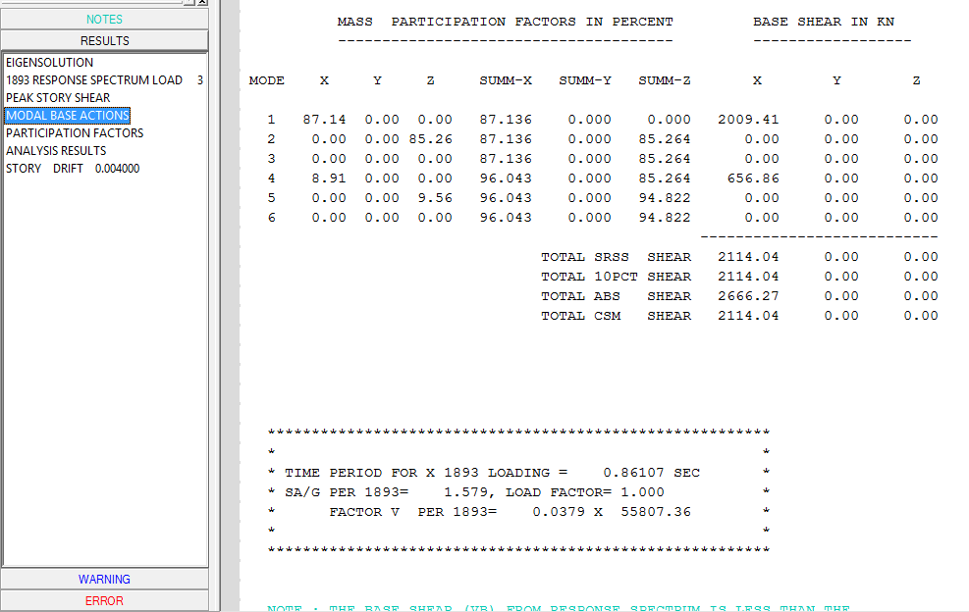
Fig. 25- fig shows the base shear

CONCLUSION
The response of (G+7) storey RC building under seismic load as per IS1893:2002 (Part-1) by using software STAAD -Pro has been studied. This analysis provides complete guidelines for STAAD-Pro software analysis of dynamic method. STAAD-Pro gives result very quickly as compared to manual calculation. Also Base shear, Lateral load, Joint displacement, support reaction and member forces for all the joints of a building has been calculated in STAAD output viewer.

REFERENCES
- Bureau of Indian standards: IS 875(Part 1):1987,dead load on 7 structures, new Delhi, india
- Paulay T and Priestley M. J. N, Seismic Design of Reinforced Concrete and Masonry Buildings, Willy Interscience, Canada, 1992
- Li Qiusheng, Cao Hong and Li Guiqing, “Static and Dynamic Analysis of Straight Bars with Variable Cross – Section”, Computers & Structures, Volume: 59, No: 6. Page: 1185 - l 191, 1996.
- Bureau of Indian standards: IS 1893(Part 1):2002indian standard criteria for earthquake resistant design of structure part 1 general provisions of building (fifth revisions), new Delhi india
- Bungale S. T, Wind & Earthquake Resistant Buildings Structural Analysis and Design, Monticello, New York 12701, U.S.A, 2005.
- Agarwal Pankaj, Shrikhande Manish, “Earthquake resistant design of structures”, PHI learning private limited, New Delhi, 2009.
- BahadornBagheri, Ehsan SaliminFiroozabad, and MohammadrezaYahyaei, “Comparative Study of the Static and Dynamic Analysis of Multi-Storey Irregular Building”, International Journal of Civil, Environmental, and Structural, Construction and Architectural Engineering, Volume: 6, No: 11, 2012.
- A.K Chopra "Dynamic of structures theory and Earthquake Engineering" fourth edition,Prentice Hall, 2012
- P.p.Tapkire, S.J.(2013) Comparative study of highrise building using Indian standards and EURO standards under seismic forces. International journal of science and research(IJSR),1-4.
- B. Srikanth, V.Ramesh, “Comparative study of seismic response for seismic coefficient and response spectrum methods” al Int. Journal of Engineering Research and Applications ISSN: 2248-9622, Vol. 3, Issue 5, Sep-Oct2013, pp.1919-1924G.
- E. Pavan Kumar1, A. Naresh2, M. Nagajyothi3, M. Rajasekhar, “Earthquake Analysis of Multi Storied Residential Building - A Case Study”, 2014.
- A.K.Chopra , V.S.(2014).Design as per Indian standards and also to determine the effect of providing shear wall to building Mr. Gururaj B. Katti, Dr. Basavraj Balapgol “Seismic Analysis of Multistoried RCC Buildings Due to Mass Irregularity By Time History”, IJERT, Vol: 3(7), pg 2278-0181, 2014
- Mr. S.Mahesh, M. D. (NOV-DEC 2014). Comparison of analysis and design of regular and irregular configuration of multi Story building in various seismic zones and various types of soils using ETABS and STAAD. IOSR Journal of Mechanical and Civil Engineering (IOSR-JMCE), 1-8.
- AnirudhGottala, Kintali Sai Nanda Kishore and Dr. Shaik Yajdhani “Comparative Study of Static and Dynamic Seismic Analysis of a Multistoried Building” International Journal of Science Technology & Engineering, Volume 2, Issue 01, July 2015
- Vinit Dhanvijay , P>D.(2015). Comparative study of different codes in seismic assessment. International research journal of engineering and technology (IRJET),1-13.
- Mahesh N. Patil, Yogesh N. Sonawane, “Seismic Analysis of Multistoried Building”, International Journal of Engineering and Innovative Technology (IJEIT) Volume 4, Issue 9, March 2015.
- Chetan Raj, Vivek Verma, Bhupinder Singh, Abhishek ,“Seismic Analysis of Building with Mass and Vertical Geometric Irregularity by Response Spectrum and Seismic Coefficient Method in Zone V and II”, International Journal of Recent Research Aspects ISSN:2349-7688, Vol. 2,Issue 2, June 2015, pp. 204-211.
- Jun Chen, G.l.(2016). Accelaration response spectrum for predicting f;oor vibration due to occupants jumping.
- Kumar C.S. (n.d.). Comparision of seismic vulnerability of building designed for Higher force versus Higher ductility.1-13
- “Comparative Study of the Static and Dynamic Analysis of Multi-Storey Irregular Building” Bahador Bagheri, Ehsan Salimi Firoozabad, and Mohammadreza Yahyaei
- Document No. :: IITK-GSDMA-EQ21-V2.0 Final Report :: A - Earthquake Codes IITK-GSDMA Project on Building Codes.
- Staad. Pro Help Menu & Bentley Student Server.

AUTHOR PROFILE
Sr.No | Photo | Details
1 |  | Hiteshkumar D. Mishra received the B. E. (Civil Engineering) in the year 2015 from MGM’S College of Engineering (SRTMNU Nanded University), Maharashtra State, India. Now he is M.tech. – Student appearing (Structural Engineering) from Gurunanak Institute of Management and Technology, kalmeshwar road, Dahegaon, Nagpur (RTM Nagpur University), Maharashtra State, India.
2 |  | Prof.D.L.Budhlani is working as Assistant Professor, department of civil engineering, Guru Nanak institute of Technology, Dahegaon, Nagpur, Maharashtra, India

