Design Approach of WSN Model for Traffic Monitoring
Dhanashree Tajne¹, Dr. Gajendra Asutkar², Dr. Kiran Tajne³
¹Research Scholar,
Priyadarshini Institute of Engineering and Technology, Nagpur, India, 441110
²Vice Principal
Priyadarshini Institute of Engineering and Technology, Nagpur, India, 441110 ³Assistant Professor
Government College of Engineering, Nagpur, India, Pin

Abstract – Wireless sensor network (WSN) consists of sensor nodes with different abilities, such as different computing power, sensing range etc. With the increase in the number of nodes in the network, it becomes important to measure the traffic efficiently. If these techniques, measure traffic efficiently then it would be helpful for the nodes to find out the best possible route. In this paper, several traffic measurements have been divulged. Comparing these techniques a design approach has been suggested in this paper. This approach is advancement in the already developed algorithm. This improvisation aims 100% accuracy in traffic flow measurement.

Keywords- WSN, node deploymemt, dashboard camera, traffic flow measurement
INTRODUCTION
Wireless sensor network (WSN) refers to a group of spatially dispersed and dedicated sensors for monitoring, analyzing and recording the physical conditions of the environment and collecting this data at a central location. These networks can measure various environmental conditions like temperature, sound, humidity, pollution etc. The WSN is made up of "nodes". The network may consist of a few to several hundreds or even thousands. In such networks, each node is connected to one or more sensors. Each such sensor network node has typically divided in several parts consisting of a radio transceiver with an internal antenna or connection to an external antenna. It may also be extended with a microcontroller which will be interfaced with the sensors and a battery which generally used as a power source. A sensor node might vary in size from that of a shoebox down to the size of a grain of dust. The topology of the WSNs can vary from a simple star network to a mesh network.
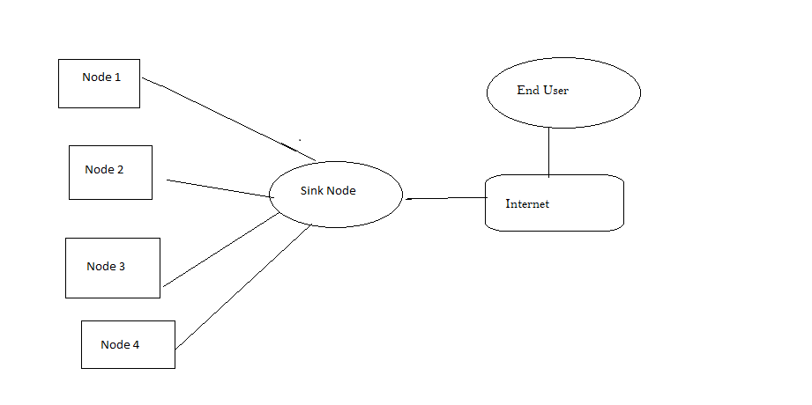
With the increase in the load, nodes need to be tracked. There are several techniques to track the traffic. One of such techniques works by analyzing the GPS-determined locations transmitted by a large number of cell phone users. Thus by calculating the speed of users along a length of road, a live traffic map is generated.
Due to the increasing of the traffic densities nowadays, a demand for advanced systems that provides the essential traffic information for the drivers to improve the traffic quality and travel optimization is growing. The complete and detailed traffic information is the important aspect in order to govern the roadway network and to provide the navigation service for the road users. The density value measurement is one of the important aspects of transportation management. Intelligent Transportation System is an important developing technology that combines components of information management systems to create better system. Currently, demands on such transportation systems are growing rapidly with an estimated travel demand increase of 30% over the next ten years [1]. The efficient of transportation system can be an alternative to increase the roadway capacity in order to prevent the traffic congestion at current levels from getting worse.
THEORETICAL BACKGROUND
There are several methods that are used for the measurement of traffic of the nodes. Some of these techniques are as mentioned.
- Using dashboard camera
Kohai et al proposed a method for traffic measurement using the approach of collecting data from camera device that is mounted on the car’s dashboard. The image which is captured by digital camera photo then that image was analyzed to get an estimated value of roadway traffic flow. A traffic measurement using digital camera device installed can be a practical approach and it is low cost solution as compared to the conventional traffic measurement methods.
In moving observer method, there are two common approaches [6]. The first method is the floating car data (FCD). In this method, speed is recorded and travel time is measured as a function of time. The motive of given method is the floating car behaves as an average vehicle within the traffic stream. However, this method does not provide the accurate average speed data. For producing qualitative information about roadway conditions and operations, this is the most effective one. There are several approaches of this method, one form uses a person in the floating car to record speeds and travel times and second form uses a modified recording speedometer which are regularly used in long-distance trucks or buses. While the drawback of this is that it means there are less speed observations than volume observations.
- Using Wi-Fi signals
Sensors or techniques that can identify individual vehicles such as automatic number-plate recognition (ANPR) or electronic tags allow to measure travel times. Amongst several approaches stated, the vehicle tracking via radio signal emissions is considered a cost-efficient method. Road tolling systems that require the user to carry a transponder in the vehicle are able to deliver travel times at certain measurement points. But also other devices than dedicated transponders emit signals that can be used for road traffic estimation. Most people carry mobile phones, and these help in delivering mobility data via the cellular network [8]. Mobile phones and the hands-free car kits emit Bluetooth signals. These emitted signals are then received by roadside equipment for travel time measurements.

EXPERIMENTATION

The design of a system is an approach having different stages. Each stage has its own technique. In first stage, a WSN model needs to be developed by deploying several heterogeneous nodes. The next stage deals with finding out the best route. This entire system is built with the help of Internet of Things. A local app needs to b developed which would show the accurate traffic load and the best route to travel.

CONCLUSION
This paper focuses on several traffic monitoring techniques. A new approach to traffic monitoring technique is stated in this paper. This is possible with the help of Internet of Things. As stated in previous techniques like camera on dash board, traffic monitoring is not accurate. This technique aims at providing the accurate traffic measurement.
REFERENCES
- Mishra D. P., Dorale S.S., Asutkar G. M., An Application of Wireless Sensor Network in Intelligent Transportation System, DOI 10.1109/ICETET.2013.22
- Chun-Hsien Wu, Yeh-Ching Chung, Heterogeneous Wireless Sensor Network Deployment and Topology Control Based on Irregular Sensor Model, IEEE Internet Computing 10(2) (2006) 18-25
- Internet of Things: Wireless Sensor Networks, International Electrotechnical Commission
- Kapileswar Nellore, Gerhard P. Hancke, A Survey on Urban Traffic Management System Using Wireless Sensor Networks, Sensors 2016, 16, 157; doi:10.3390/s16020157
- Nooralahiyan A. Y., Kirbaya H. R., McKeown D., Vehicle Classification by Acoustic Signature. Math.Comput.Model1999.27, P.P.205-214.
- Kohei Arai, Steven Ray Sentinuwo, Method for Traffic Flow Estimation using On dashboard Camera Image, (IJACSA) International Journal of Advanced Computer Science and Applications, Vol. 3, No. 2, 2014
- P. Prasad, “Recent trend in wireless sensor network and its applications: A survey,” Sens. Rev., vol. 35, no. 2, pp. 229–236, 2015.
- B. N. Araghi, L. T. Christensen, R. Krishnan, and H. Lahrmann, “Application of bluetooth technology for mode- specific travel time estimation on arterial roads: Potentials and challenges,” in Annual Transport Conference at Aalborg University, ser. ISSN 1603-9696,
- “IEEE Std 802.11-2012. part 11: Wireless lan medium access control (mac) and physical layer (phy) specifications,” Mar. 2012.
- Z. Zhu, G. Xu, B. Yang, D. Shi, and X. Lin, “VISATRAM: A real-time vision system for automatic traffic monitoring,” Image Vis. Comput., 2000.
- K. Arai and S. R. Sentinuwo, “Effect of Driver Scope Awareness in the Lane Changing Maneuvers Using Cellular Automaton Model,” Int. J. Adv. Res. Artif. Intell., vol. 2, no. 7, pp. 6–12, 2013.

