**A** **Review on investigation of casting defects with simulation**

**Akash A. Gaware¹, Dr. A. K. Mahalle²**

*¹Student, M. Tech CAD/CAM, GHRCE Nagpur, India,*

*²Professor, Department of Mechanical Engineering, GHRCE Nagpur, India,*

*E-mail: aksgaware@gmail.com*

***Abstract:*** *Aim of this paper is to investigate casting defects, provide remedies and simulation of casting process by using casting simulation software. Casting defect occurs where mistake happens in the process of casting. Most defects occur due to improper feeding system. Simulation is helpful in minimizing the casting defects. Various simulation softwares like AutoCAST-X, ProCast & SOLIDCast can be used.*

***Keywords:*** *Casting, casting defects, remedies, simulation*

**Introduction**

Sand Casting:

Casting is a process of making solid objects by pouring molten metal into a cavity of required shape and allowing it to solidify. The solidified product is called casting.

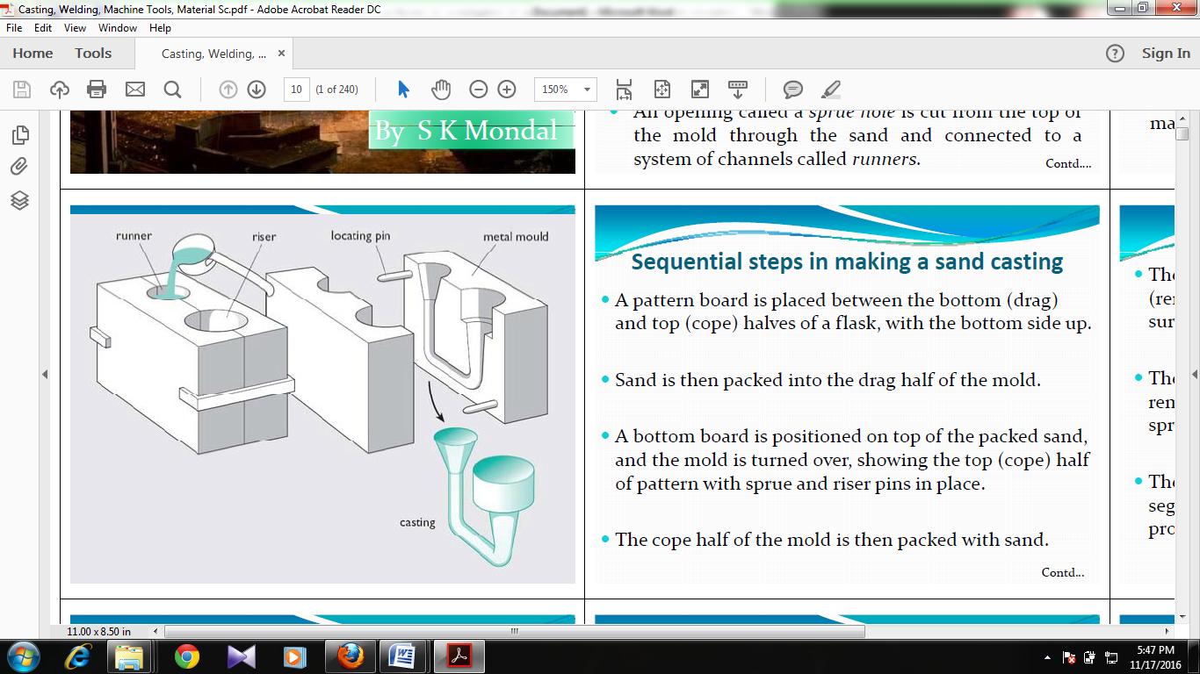

Fig 1: Casting

Casting involves following steps:

* Melting the raw metal.
* Filling molten metal into molding box
* Allowing molten metal to solidify.
* Removalof solidified object from the mold and carry on further treatment.

**Casting terms**

* Flask: A flask holds the molten iron intact.
* Cope: Upper flask.
* Drag: Subordinate flask.
* Pattern: It is the alterego of desired product.
* Allowance: To compensate various defects, extra dimension is provided as allowance.
* Cheek: Middle flask.
* Core: Unoccupied spacing produced in casting if required.
* Pouring Basin: Small semicircular hole at top for filling molten metal
* Sprue: Pathway for molten metal to reach cavity from pouring basin

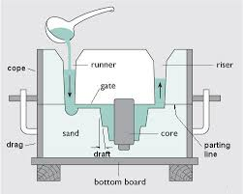

Fig 2: Schematic illustration of sand molding

* Runner: Molten iron is filled in runner to reach cavity.
* Gate: Door of cavity
* Chaplet: Used for backing cores and to overcome metallostic forces.
* Chill: Metallic chills used for desired cooling rate.
* Riser: It is filled when cavity is completely full of liquid metal. It also helps to flow metal backwards.

Probability of accomplishing defect free manufacturing practice is very less. Most of the metallic parts are manufactured by casting process. Casting defects occurs due to some errors in casting process. Defects reduces the superiorityof product, eventually it becomes unacceptable. It is essential to investigate the casting defects for improvement; also finding causes of defects is significant. Casting inspection approaches are basically classified as destructive and non-destructive tests (NDT). Casting may be damaged in destructive test during strength test. NDT test does not damage the part. Some tests are visual test, dimensional test, pressure test, sound test, radioscopic inspection, magnetic particle test, liquid penetrant test, impact test, etc.

Well-designed feeding system reduces the casting defects drastically. Quality of product relies on the quantity of risers and location of runners and risers. Making changes in the feeding system and relocating the positions of risers manually is time taking hence simulation can become an important gizmo to improve the feeding system which will help to develop quality product.

**Casting defects**

1. Shrinkage defect:

This defect occurs due to lack of design and insufficient feed metal. Shrinkage can be a void in the casting.



Fig 3: Shrinkage defect

Causes:

* Non uniform solidification
* Pouring temperature
* Extreme release of gas

Remedies:

* Location of riser should be proper
* Proper position and using chills for better solidification
* Providing good venting.

1. Blowhole defect:

It is fairly large, rounded cavity formed due to gases inside the molten metal.

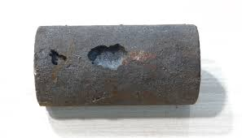

Fig 4: Blowhole defect

Causes:

* Entrapment of gases
* Low permeability
* Moisture absorbed by cores
* Rusted chills, chaplets

Remedies:

* Use of dry chills
* Provide adequate venting
* Alteration in gating arrangement

1. Misrun:

Unfilled portion of the cavity is known as misrun. It arises when molten metal doesn’t fill the cavity completely.

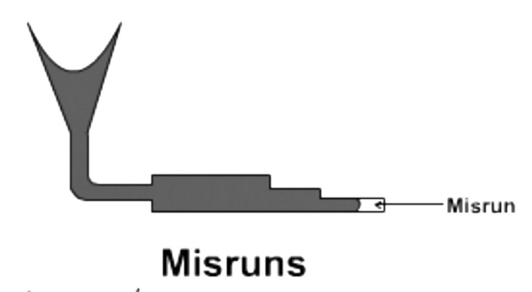

Fig 5: Misrun

Causes:

* Poor flow ability
* Poor feeding and gating system

Remedies:

* Proper speed of filling process
* Modification of design

1. Cold shut:

A cold shut is a crossing point within a casting which is produced when two metal streams do not fused together. Void having round edges is also a sign of cold shut.

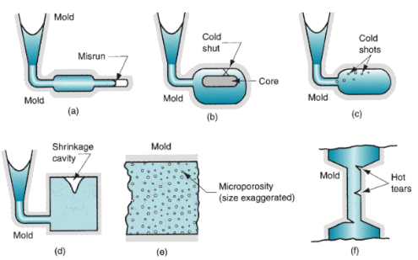

Fig 6: Cold shut

Causes:

* Too cold molten metal
* Thin casting sections
* Poor fluidity of molten metal

Remedies:

* Modify design and feeding system
* Proper temperature needed.

1. Mismatch defect:

It occurs because of fluctuation of molding flashes. It causes dislocation of parting line.

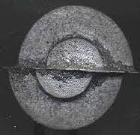

Fig 7: Mismatch defect

Causes:

* Improper position of cope and drag
* Carelessness during the placing of upper and lower boxes

Remedies:

* Rectification of correct dowels
* Using proper molding and pins

1. Cracks:

This defect occurs due to number of reasons. Some cracks visible by naked eye and too small cracks need to magnify for observation.

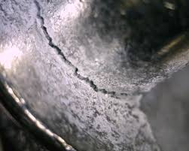

Fig 8: Crack

Causes:

* Thermal disparity in the die
* Internal stresses
* Damage in cavities

Remedies:

* Avoid superheating
* Use of chills
* Proper composition

1. Sand inclusion:

It is also known as sand hole. It is the sand remained in the casting after solidification.

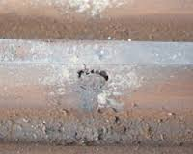

Fig 9: Sand inclusion

Causes:

* Irregular compaction of mold
* Low compact ability
* Too high pouring rate

Remedies:

* Strength of core should be increased
* Dodge core mismatching

**Simulation**

Casting simulation enables envision of whole casting process. Simulation helps to see the differences made to the product and helps to take decision which will lead to technically sound product.

Simulation finds the defected area like shrinkage, blowhole, cracks etc. It is used for improving the existing casting and also for manufacturing newly design casting within very less time. Simulation primarily helps to improve the superiority of product and its faster growth. Simulation requires very less input data and gives reliable results which have impact on quality and yield. Separate design software is necessary to make CAD model as an input to simulation software. Simulation softwares accessible in India like ProCast, SolidCast, AutoCAST-X and MAGMA.

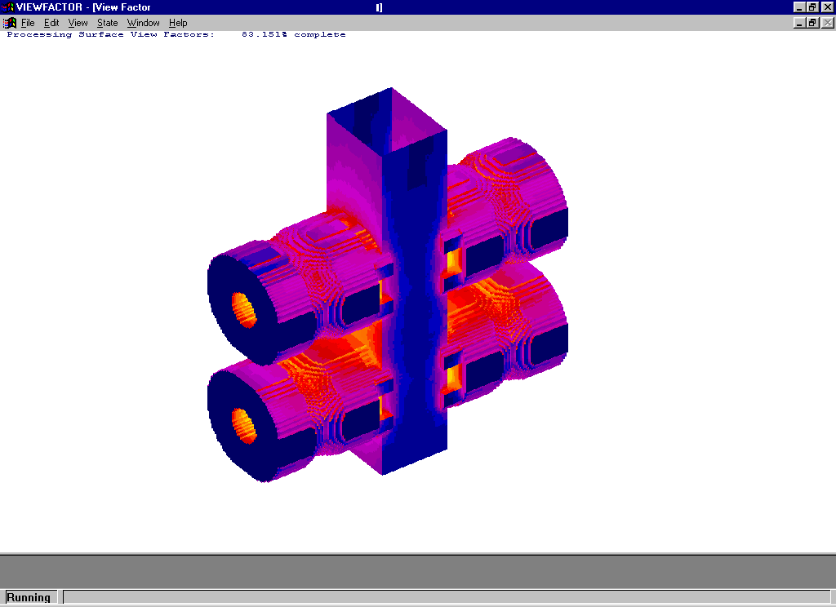

Fig 10: Simulation

It includes following steps:

* Data gathering
* Part modeling
* Gating system design
* Simulation
* Optimization
* Report generation

**Literature review**

This includes brief information about the work done by various authors in reducing the casting defects and enhancing the quality of product. Author has worked on examination of irregularity in casting and remedies are provided to get zero defect casting. Study reveals that rejected casting include sand drop, blowhole, and mismatch defects. These defects were frequently occurring in the casting. Analysis provides remedies to overcome casting defects. Validation of trials reduces most of the defects. [1] In this review several casting defects and their occurrence cause were identified. Study is helpful in examining the defects and application of remedies. Casting defects should be less to avoid rejection. One can continuously control rejections by taking in to consideration different parameters at every stage of production. Thus it is indispensable for a foundry expert to have awareness on the identification of type of defect and to identify the exact root cause, and their remedies. Hence this systematic work will be fruitful for quality casting manufacturing. [2] Author has worked on finding defects in casting process.The full picture for existence of contraction defects is provided and solution is provided. By appropriate casting method developing feeding system, appropriate position of ingates and feeders will lessens the contraction defect. Softcast software is recommended for simulation of casting. [3] Author provides an intense knowledge of critical defects and their root cause analysis. This paper emphasizes on technically viable solutions for decreasing several defects and enhancing the superiority of castings which will be guidelines for foundry engineers. [4] Surface analysis of discontinuities produced in castings is effective for evaluation of castings irregularities and implementing preventive measures. [5] Agenda of work is to probe the probable sources of gases like nitrogen, hydrogen and oxygen, concentrating on making practice that is in contact with the liquid steel. Disadvantages of chemical and gas content are examined. Also gas removing capability of casting should be increase. [6] Study of influencing factors for blowholes in die casting is essential. Aluminum Parts of compressor are studied. Various factors like pressure, pouring speed, starting position and void pressure are examined. Paper focus is on blowhole reduction by considering venting system also. [7]

Special systems are used for processes that are influenced by multiple events to take decisions. Special systems are innovated on fuzzy method to detect the incidence of foremost casting defects. Study concentrates on sand casting of gray iron. Developed systems help the foundry engineers to take decisions regarding sand casting to avoid irregularities. Remedies are provided helpful for less defect casting. [8] Most work is done on irregularity diminution in casting. Author has explained various methods for defect analysis which are FEM, modulus method, solidification simulation using FEM and dedicated software for simulation such as Procast, AutoCast-X.



Fig 11: Solidification simulation of cover plate

Author has done simulation on manhole cover plate in Autocast software to remove warpage defects. [9] Author has provided guidelines for proficient implementation of simulation tool. Also paper has explained points to be followed for making new section for simulation of casting and precautions to be considered while casting are provided for implementation. [10] Author has worked on casting of a plate for removing shrinkage and gas porosity defects. Simulation is done in AutoCast application. Simulation enables the visualization of solidification. Changing feeder location, 15% improvement in yield is obtained.[11] In this review, work is done on a wear plate. Existing feeding system is studied and imitation of new feeding system is done by using AutoCast software. During casting gates and riser were placed symmetrically and flow was uniform, gases were easily escaped to the atmosphere. By using this method superiority of casting has been improved. [12]

**Conclusion**

Defects like shrinkage, blowhole, pinhole, sand inclusion and sand burning can be identified and simulated. Separate design software is needed to design the product which needs to be simulated. Simulation helps to manufacture defect free casting without consuming too much time. In India, casting simulation technology is increasing rapidly. Besides improving the existing casting, this technology can also be used for rapid development of new products.

**References**

1. *Dr. D.N. Shivappa, Mr. Rohit, Mr. Abhijit Bhattacharya, “Analysis of Casting Defects and Identification of Remedial Measures-A diagnostic study”, International Journal of Engineering Inventions ISSN: 2278-7461, www.ijeijournal.com, Volume 1, Issue 6 (October2012) PP: 01-05*
2. *Mr. Bhushan Shankar Kamble, “Analysis of Different sand Casting Defects in Medium Scale Foundry Industry - A Review”, International Journal of Innovative Research in Science, Engineering and Technology Vol. 5, Issue 2, February 2016*
3. *Mahipalsinh G. Jadeja Manoj kumar V. Sheladiya Mayursinh Gohil, “A Review on Casting Defect Minimization Through Simulation”, International Journal for Scientific Research & Development| Vol. 3, Issue 11, 2016 | ISSN (online): 2321-0613*
4. *Avinash Juriani, “Casting Defects Analysis in Foundry and Their Remedial Measures with Industrial Case Studies”, IOSR Journal of Mechanical and Civil Engineering, Nov-Dec 2015*
5. *H. Kambayashi, Y. Kurokawa, “Observation of Defects in Cast Iron Castings by Surface Analysis”, Tsuchiyoshi Industry Corporation, Hiroshima, Japan, 2005.*
6. *CHIH-YUAN CHEN and KUAN-JU LIN, “Forming factors of blowhole defect in continuously-cast beam blank at Dragon steel”, Iron and Steel Research & Development Department China Steel Corporation, 2011.*
7. *Praevadee Kaewkongkha, Somkiat Tangjitsitcharoen, “Investigation of factors affecting the blowhole in Die casting”, IOSR Journal of Engineering (IOSRJEN), 2015.*
8. *A. Rai, S. K. Ganguly, “WEB-BASED EXPERT SYSTEM FOR SOME DEFECT IN SAND CASTINGS”, International Journal of Advanced Engineering Research and Studies, 2015*
9. *Prachi K. Tawele, Laukik Raut, “Warpage in Casting: A Review” International Journal of Advance Research in Engineering, Science & Technology (IJAREST), ISSN(O):2393-9877, ISSN(P): 2394-2444,Volume 2, Issue 4, April- 2015*
10. *Dr. B. Ravi, “Casting Simulation – Best Practices”, Transaction of 58th IFC Ahmedabad 2010.*
11. *C. M. Chaudhari, B. E. Narkhede, S. K. Mahajan, “Casting design and simulation of cover plate using AutoCAST-X software for defect minimization with experimental validation”, 3rd International Conference on Materials Processing and Characterizations (ICMPC 2014)*
12. *Sachin L. Nimbulkar Rajendra, Dr. S. Dalu, “Design and optimization of gating and feeding system through simulation technique for sand casting of wear plate”, Perspectives in Science (2016).*