**Impact of Media: Spreading Web Information**

**Neha Pramod Bhadade**

*Department of Master of Computer Application*

*G.H. Raiasoni Institute of Engineering Technology, Nagpur, Maharashtra*

***nehabhadade08@gmail.com***

***Received on****: 11 June ,2022* ***Revised on****: 07 August ,2022,* ***Published on****: 09 August,2022*

***Abstract****: -False information can be created and spread easily through the web and social media platforms, resulting in widespread real-world impact. Characterizing how false information proliferates on social platforms and why it succeeds in deceiving readers are critical to develop efficient detection algorithms and tools for early detection. A recent surge of research in this area has aimed to address the key issues using methods based on feature engineering, graph mining, and information modelling. Majority of the research has primarily focused on two broad categories of false information: opinion-based (e.g., fake reviews), and fact-based (e.g., false news and hoaxes).This research article attempts to understand the current situation of fake news on social media in India. The study focused on four characteristics of fake news based on four research questions: subject matter, presentation elements of fake news, debunking tool(s) or technique(s) used, and the social media site on which the fake news story was shared. A systematic sampling method was used to select a sample of 90 debunked fake news stories from two Indian fact-checking websites, All News and Fact, from December 2019 to February 2020. A content analysis of the four characteristics of fake news stories was carefully analysed, classified, coded, and presented. The results show that most of the fake news stories were related to politics in India. The majority of the fake news was shared via a video with text in which narrative was changed to mislead users. For the largest number of debunked fake news stories, information from official or primary sources, such as reports, data, statements, announcements, or updates were used to debunk false claims.*

***Keywords****-Fake news, debunking tools.*

**I -INTRODUCTION**

**I**n this work, we present a comprehensive survey spanning diverse aspects of false information, namely

* The actors involved in spreading false information,
* Rationale behind successfully deceiving readers,
* Quantifying the impact of false information,
* Measuring its characteristics across different dimensions, and finally,
* Algorithms developed to detect false information. In doing so, we create a unified framework to describe these recent methods and
* highlight a number of important directions for future research.

**Disinformation Campaigns**

Fake news is defined as stories purporting to be news that are intentionally and verifiably false and has the capacity to misinform and mislead readers. In academic typology, fake news is classified into several forms along the axes of degree of facticity, motivation , fake news is classified into several forms along the axes of degree of facticity, motivation of deception and form of presentation; it includes satire and parody that have a basis in facts but can mislead when de-contextualised, it includes fabrications and manipulation of information which were created with the intent to deceive or mislead and also includes covert advertising and political propaganda which are aimed to deceive in an organized attempt to influence wider public opinion. The UNESCO Handbook for Journalism Education and Training provides an additional distinction of two forms of fake news, one that is deliberately created with the intention of targeting and causing harm to a social group, an organization, a person or a country, described as disinformation and the other being simple misinformation that wasn't created for the purpose of causing harm. In India, fake news is predominantly disseminated by homegrown political disinformation campaign Coronavirus

Misinformation related to coronavirus COVID-19 pandemic is in the form of social media messages related to home remedies that have not been verified, fake advisories and conspiracy theories. At least two people have been arrested for spreading fake news about the coronavirus pandemic. To counteract this, over 400 Indian Scientists are working together to debunk false information about the virus, as of 14 April 2020.

➢ Citizenship (Amendment) Act 2019

The CAA Protests led to a flooding of fake news and manipulated content on social media targeting the protesters and Delhi police alike. Members of the ruling BJP were seen to be sharing videos, falsely insinuating that the students of Aligarh Muslim University were raising anti-Hindu slogans.[16] The Supreme Court of India asked the central government of India to consider "a plea for publicising aims, objectives and the benefits of the Citizenship Amendment Act (CAA) to weed out fake news that was being circulated on the issue. "BJP leaders rolled out a phone number, asking people to give a missed call to show support for the act. The number was widely shared on twitter, with fake claims luring people with companionship with lonely women and free subscriptions to streaming platforms like Netflix.

Indian security and intelligence agencies reportedly identified around 5000 social media handles from Pakistan which were "spreading fake and false propaganda" on CAA, some using "deep fake videos" in the process. Social media platforms had mediators on look-out to curb fake, incendiary and communal news.[21]

Old pictures and videos were shared on social media, even by prominent personalities, giving a communal spin to the protests. Old images were also used to insinuate that the protests involved violence in many sites. Similarly, some old clips involving police brutality were reposted and falsely purported to be linked with crackdown on CAA protesters. BJP's IT Cell Head Amit Malviya shared distorted videos misrepresenting anti-CAA protesters to be chanting "Pakistan Zindabad" and disturbing slogans against the Hindu community.

➢ Elections

Fake news was very prevalent during the 2019 Indian general election. Misinformation was prevalent at all levels of society during the build-up to the election. The elections were called by some as "India's first WhatsApp elections", with WhatsApp being used by many as a tool of propaganda.] As VICE and AltNews write, "parties have weaponized the platforms" and "misinformation was weaponized" respectively.

India has 22 scheduled languages, and vetting information in all of them becomes difficult for multinationals like Facebook, which has only gathered the resources to vet 10 of them, leaving languages like Sindhi, Odia and Kannada completely unvented, as of May 2019. Nevertheless, Facebook went on to remove nearly one million accounts a day, including ones spreading misinformation and fake news before the elections.

➢ Fake news against Pakistan

A study by the EU DisinfoLab in 2019 found that at least "265 fake local news websites in more than 65 countries are managed by Indian influence networks with the aim of influencing international institutions along with elected representatives and swaying the public perception of Pakistan." By 2020, the number of such pro-India fake news websites was revealed to have grown to 750 across 116 countries in an investigation titled the Indian Chronicles. Prominent examples of fake news-spreading websites and online resources include OpIndia and Postcard News.

According to the BBC News, many of the fake news websites were being run by an Indian company called the Srivastava Group, which was responsible for anti-Pakistan lobbying efforts in Europe and was persistently linked to the dissemination of fake news and propaganda. The websites, which are known to copy syndicated news content from other media outlets in order to appear as real news websites, plant opinion pieces and stories critical of Pakistan from individuals who belong to NGOs linked to their network. The network attempts to influence decision-making organisations such as the UN Human Rights Council and European Parliament, where its primary aim is to "discredit Pakistan" In October 2019, the network sponsored a controversial trip of a group of far-right European Parliament MPs to Indian- administered Kashmir, during which they also met prime minister Narendra Modi. Domains operated by the group included the "Manchester Times", "Times of Los Angeles", "Times of Geneva" and "New Delhi Times" among others. A common theme of their coverage tends to be on issues such as secessionist groups, minorities, human rights cases and terrorism in Pakistan. The EU Chronicle, a Srivasta Group was found to have op-ed articles "falsely attributed to their authors, some of them European lawmakers", journalists who seemed to not exist, text plagiarised from other sources, and content mostly focused on Pakistan.[44] EPToday, another news website which highlighted anti-Pakistan material, was forced to shut down after it was similarly exposed according to Politico Europe.[44] As part of its efforts to project Indian lobbying interests, the network had resurrected fake personas of dead human rights activists and journalists, impersonated regular media agencies such as The Economist and Voice of America, used European Parliament letterheads, listed fake phone numbers and addresses including that of the UN on its websites, created obscure book publishing companies and public personalities, registered hundreds of fake NGOs, think tanks, informal groups and imam organisations, as well as website which claimed to deliver news from the European Union, conducted cybersquatting on Pakistani domains Most of the websites had a presence on social media such as Twitter. It was also noted that following EU DisinfoLab's first report in 2019, some domains had closed only to be resurrected under different name slater. Researchers state that the main target of the fake websites' content is not readers in Europe, but rather mainstream Indian news outlets such as ANI and Yahoo News India who routinely reuse and republish their material and act as their conduit to hundreds of millions in India.

➢ Kashmir

Misinformation and disinformation related to Kashmir is widely prevalent. There have been multiple instances of pictures from the Syrian and the Iraqi civil wars being passed off as from the Kashmir conflict with the intention of fuelling unrest and backing insurgencies.

In August 2019, following the Indian revocation of Jammu and Kashmir's Article 370, disinformation related to whether people were suffering or not, lack of supplies and other administration issues followed. The official Twitter accounts of the CRPF and Kashmir Police apart from other government handles called out misinformation and disinformation in the region. The Ministry of Electronics and Information Technology assisted by getting Twitter to suspend accounts spreading fake inciteful news. The Indian Army and media houses such as India Today denied various claims such as the Indian Army burning down houses, the deaths of six personnel in cross border firing, and a series of "torture" allegations made by activist Shehla Rashid via Twitter . On the other hand, The New York Times claimed officials in New Delhi were portraying a sense of normality in the region, whereas "security personnel in Kashmir said large protests kept erupting". The newspaper quoted a soldier Ravi Kant saying "mobs of a dozen, two dozen, even more, sometimes with a lot of women, come out, pelt stones at us and run away."] The Supreme Court of India was told by the Solicitor General Tushar Mehta that "not a single bullet has been fired by security forces after August 5", however BBC reported otherwise. The Supreme Court went onto say that the centre should make "every endeavor to restore the normalcy as early as possible."

➢ Mumbai:

• A team of doctors, health workers and revenue officials who had gone to identify the family members of a 65-year-old man who died of COVID-19 were attacked in Indore, Madhya Pradesh, on April 2, after fake videos claimed that healthy Muslims were being taken away and injected with the virus, reiterating the dangers and physical manifestations of misinformation.

➢ Other examples

• Imposters posing as army personnel on the social media have been called out by the Indian Army as false news and disinformation.

• As part of the 2016 Indian banknote demonetisation, India introduced a new 2,000-rupee currency note. Following this, multiple fake news reports about "spying technology" added in the banknotes went viral on WhatsApp and had to be dismissed by the government.

• The NaMo app, an app dedicated to Narendra Modi, the Prime Minister of India, was reported to have promoted and spread fake news.

Modes of distribution

Social media

The damage caused due to fake news on social media has increased due to the growth of the internet penetration in India, which has risen from 137 million internet users in 2012 to over 600 million in 2019. Fake news is also spread through Facebook and Twitter.

Impact

Socio-political

Fake news is frequently used to target minorities and has become a significant cause of localised violence as well as large scale riots. Engineered mass violence was instigated during the 2013 Muzaffarnagar riots, through a disinformation campaign propagating the love jihad conspiracy theory and circulating a fake news video.

Institutional

Internet shutdowns are used by the government as a way to control social media rumours from spreading. Ideas such as linking Aadhaar to social media accounts has been suggested to the Supreme Court of India by the Attorney General. In November 2019, the Indian ministry of information and broadcasting planned to set up a FACT checking module to counter the circulation of fake news by continuous monitoring of online news sources and publicly visible social media posts. The module will work on the four principles of "Find, Assess, Create and Target" (FACT). The module will initially will be run by information service officers. Near the end of 2019, the Press Information Bureau (which comes under the Ministry of Information and Broadcasting) set up a fact-checking unit which would focus on verifying news related to the government.

Journalists in Kashmir have been subjected to repeated criminal proceedings which led to three UN OHCHR Special Rapporteurs expressing concerns over a "pattern of silencing independent reporting on the situation in Jammu & Kashmir through the threat of criminal sanction", specifically mentioning journalists Gowhar Geelani, Masrat Zahra, Naseer Ganai and Peerzada Ashiq and reiterating the position affirmed at the 2017 Joint Declaration on Fake News, Disinformation and Propaganda that "general prohibitions on the dissemination of information based on vague and ambiguous ideas, including "false news" or "non objective information" are incompatible with international standards for restrictions on freedom of expression."

The J&K administration released a new Media Policy-2020 on 15 May 2020 which read that "any individual or group indulging in fake news, unethical or anti national activities or in plagiarism shall be de-empanelled besides being proceeded against under law".[81] Writing for EPW, Geeta wrote that the policy would serve to "make citizens passive recipients of the information" disseminated by the government. The Indian Express published an editorial stating that "at a time when democratic political voices remain missing" in the Union Territory, the policy is an "affront, intended to keep control of the narrative of J&K." The Press Council of India stated that the provisions regarding fake news affect the free functioning of the press.

Countermeasures

Fact checking organisations

Fact-checking in India has become a business, spurning the creation of fact-checking websites such as BOOM, Alt News, Factly and SMHoaxSlayer. Media houses also have their own fact-checking departments now such as the India Today Group, Times Internet has TOI Factcheck and The Quint has WebQoof. India Today Group, Vishvas.news, Factly, Newsmobile, and Fact Crescendo (all International Fact-Checking Network certified) are Facebook partners in fact-checking.

Grassroot measures

In some parts of India like Kannur in Kerala, the government conducted fake news classes in government schools. Some say the government should conduct more public-education initiatives to make the population more aware of fake news.

In 2018, Google News launched a program to train 8000 journalists in seven official Indian languages including English. The program, Google's largest training initiative in the world, would spread awareness of fake news and anti-misinformation practices such as fact-checking.

Countermeasures by social media companies

In India, Facebook has partnered with fact-checking websites such as BOOM and Webqoof by The Quint. Following over 30 killings linked to rumours spread over WhatsApp, WhatsApp introduced various measures to curb the spread of misinformation, which included limiting the number of people a message could be forwarded to as well as introducing a tip-line among other measures such as suspending accounts and sending cease-and-desist letters. WhatsApp also added a small tag, forwarded, to relevant messages. They also started a course for digital literacy and came out with full page advertisements in newspapers in multiple languages. Twitter has also taken action to curb the spread of fake news such as deleting accounts.

Law enforcement

In 2022, the Tamil Nadu Government announced formation of a special Social Media Monitoring Centre, under Tamil Nadu Police "to monitor and curb the spread of fake news and misinformation online".

Manipulative Fake News On The Rise In India Under Lockdown:-

A study on misinformation in India by scholars from the University of Michigan, released on April 18, 2020, has shown a rise in the number of debunked stories, particularly after the announcement of janata curfew by Prime Minister Narendra Modi on March 22, 2020, and the countrywide lockdown two days later, to contain the spread of COVID-19.

From just two in the third week of January 2020, the instances of debunked misinformation rose to 60 by the first week of April 2020, according to the study. Though fake stories around a cure for COVID-19 lessened in this period, false claims that affected people emotionally increased, the study found.

The study used 243 unique instances of misinformation from an archive maintained by Tattle Civic Technology (a Delhi-based news project that aims to make accurate information more accessible to mobile-first users). The archive represents all the stories that have been debunked by six fact-checkers--AltNews, BOOMlive, Factly, IndiaToday Fact Check, Quint Webqoof, and NewsMobile Fact Checker--cezrtified by International Fact-Checkers Network (IFCN) between January 23 and April 12, 2020.



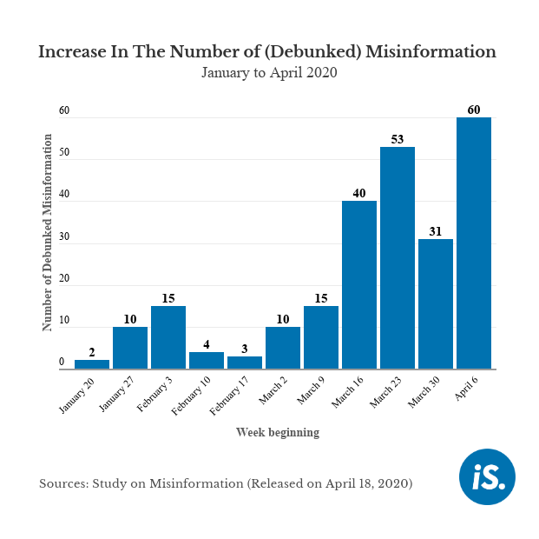

The momentum of misinformation was already building up before PM Modi’s announcement of the janata curfew, but there was a consistent rise in the number of debunked fake news, following the third week of March 2020, the study found.

The misinformation that was circulating on various social-media apps, as found by the study, was classified into seven categories--culture, government, doctored statistics, etc. About 62 fake stories were related to culture, defined as messages targeting a particular socio-religious, ethnic group, followed by 54 instances of fake news around government announcements and advisories, according to the study.

**Results and Discussion**

The following are the results for the different categories and subcategories. In case of percentages, the results were rounded to nearest figures. Also, the percentage total of all the sub-categories under a major category was more than 100% because some news stories belonged to more than one sub-category.

Source: Study on Misinformation (released on April 18, 2020)

**RQ1. Subject Matter of Debunked News**

The first major category involved the identification of the subject matter of a fake news story that one of the fact-checking websites debunked. It was divided into 11 sub-categories having alphabetic codes from A to K. The time period of the present study saw protests against the ruling government due to the CAB, CAA, NPR, and NRC across India. Fake news related to these issues was widely shared on social media. In the study, 35 fake news stories i.e., 39% of the 90 sample stories were related to these topics in some way. It was further observed that these protests were used as a backdrop to spread fake news in almost all sub-categories.

The results showed that the majority i.e., more than half, of the debunked fake news stories (71%) were related to politics (B). This hinted that in India, politics could be a major root cause of fake news. It was observed that most of these fake news stories revolved around different political parties or their leaders, and in many cases, leaders from one political party disseminated fake news about other parties. The main intention was to demean a particular leader or its party among the public through fake news. It was observed that when party leaders shared fake news, most of the users having the same political ideology believed it. This audience liked, commented, and further circulated the misleading news on social media, thereby proliferating fake news. This is consistent with the findings of Van Bavel and Pereira (2018) who have proposed a belief model in their study to understand the effect of partisanship on cognitive processes and explained it as the reason behind people being blindly loyal to a political party to the extent of even disregarding truth. This was observed ahead of Assembly Elections in Delhi (the capital of India) in February 2020 (“Delhi Assembly Election 2020: Important Dates, Full Schedule and Voting Timings, a Quick Guide to 8 February Polls,” 2020) when prominent politicians circulated several fake news stories about different parties on social media. Some fake news stories revolved around US President Donald Trump’s visit to India in the same month (Lakshman, 2020). These observations clarified that media as well as political literacy is very important to educate the public about fake news. After politics, the next most common subject matter of the fake news (22%) was communal issues (issues related to conflicts between ethnic or religious communities) (A). One reason for such a high number of communal fake news could be the aforementioned protests. Many communal fake news stories were observed to be related to the protests. Fake news related to the Jafrabad communal riots in Delhi during the end of February 2020 (“13 Dead, over 250 Injured in Delhi’s Worst Communal Riot in Three Decades,” 2020) also added to this category. It was observed that such fake news was shared to falsely pit one community against another and create disturbances. Some fake news stories were observed to be circulated with the intention of disrupting the harmony between Muslims and Hindus. Ten of the 64 political fake news stories, i.e., 15.6% of the political stories, were directly related to communal issues. This hinted to the fact that communal issues were often used to spread fake news for a political leader’s or party’s benefit. The next subject matter with the highest number of fake news stories was internationally linked to India (I) with 16.7% of fake news stories. Among them, 11 stories i.e., 73% of the international stories were related to politics. In such stories, images and videos from other countries were used to falsely narrate incidents that happened in India.

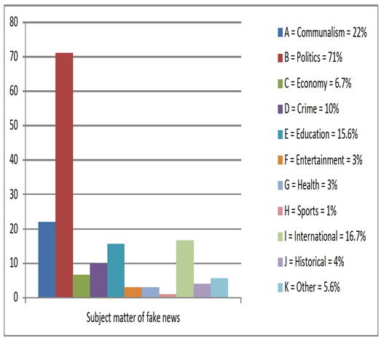

Figure 1: Subject Matter of Fake News

Educational (E) fake news stories were the third most common. All these stories revolved around two Indian universities – Jawaharlal Nehru University (JNU) and Jamia Millia Islamia, both situated in Delhi. Of the 14 stories, 15.6% of educational fake news stories, about 57% i.e., 8 stories, were related to JNU, about 28.6% i.e., 4, to Jamia, and only 7% i.e., 1, was linked to Aligarh Muslim University in Uttar Pradesh state (AMU) and IIT each. Fake news related to JNU protests against a hostel fee hike, CAA, and campus violence at the time of university admission at the beginning of January 2020 were widely shared on social media (Prasad, 2020). In Jamia and AMU, students started protests against CAA and NRC in December 2019 (Ravi, 2019). Jamia students also witnessed the brutality of police when police thrashed unarmed students in the university’s reading room (The Wire Staff, 2019). Fake news related to all these student protests and police violence became rampant on social media. The main intention behind such educational fake news was observed to be to discredit the students’ protests or to further agitate them by falsely blaming the student protesters.

Crime (D) fake news stories were the next most extensively circulated online to mislead users. Out of total

10% of crime stories, 8 stories i.e., about 88.9%, were related to rape or sexual harassment and 5 stories i.e., about 5.6%, had some link to politics. Most of this fake news was spread against the backdrop of the November 2019 Hyderabad rape and murder case of a veterinary doctor (“Hyderabad Veterinarian Rape and Murder: Killers Burnt Body at Underpass,” 2019). The main intention behind such fake news was observed to be to provoke the public’s anger against such crimes and criminals. Subjects with fewer less fake news stories were: economy-related (C, 6.7%), historical (J, 4%), entertainment (F, 3%), health (G, 3%), and sports (H, 1%). In some fake news, historical events like Mahatma Gandhi’s assassination were used with false narratives to mislead users. All 3 health-related fake news stories were related to coronavirus. Such a low number of coronavirus stories could be because it had not yet spread to India. The coronavirus stories were from February. The months after February observed a rise in fake news related to coronavirus in India. Further research in this field is recommended. In addition, research related to fake news in a particular subject matter is also recommended to have a better understanding of the subject area with respect to that particular field. A total of 5.6% of stories belonged to the Other (K) subcategory as they didn’t fall into any of the other mentioned subcategories.

RQ2. Presentation Elements of Debunked Fake News

We identified the presentation element of fake news stories that the fact-checking websites had debunked. This category was divided into 6 sub-categories with alphabetic codes from A to F.

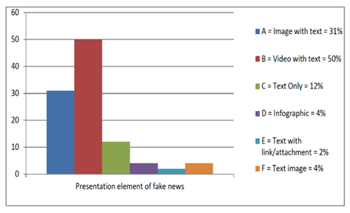

Figure 2: Presentation Elements of Fake News

In all of the sampled stories except four, only one presentation element was used. Here, “image” means still images such as photographs and art. In the case of the sub-categories “image(s) with text” and “video with text,” text refers to the content which was written (like a caption) in the social media post as an explanation of the image or video. Half of the sample of fake news stories (50%) used a video with text (B). In most cases, the context of the video was changed in the shared post using a false narrative to mislead users. Some fake news stories used clipped or manipulated videos to distort facts. This hinted that users more often believed and spread fake news having a video. The next widely used presentation element was image with text (A, 31%). Many fake news stories used one or more photographs to spread misinformation. The photograph was accompanied by a false narrative to change its context. In some cases, photographs were photo shopped or digitally manipulated. In most of the fake news stories, old and unrelated images and videos were used with false claims to spread misinformation. A smaller number of fake news stories (12%) used only text (C). A new presentation element, which was observed in the study of fake news stories, was the infographic (D, 4%). In such stories, an image showing information through a combination of text, data graphs, symbols, and other graphics were used (Merriam Webster, n.d.). This presentation element was given a separate sub-category because social media posts that used an infographic did not need a caption or narrative (text) as the infographic gave all the information

itself. In 4% of news stories, text images (F) were used. Here, “text image” refers to screenshot of a fake post from one social media platform that was posted on another platform to spread misinformation. These posts used two elements, one kind of presentation element (only text) in one social media site and another element (the screenshot image of the text) of another social media site. A negligible number of fake news stories (2%) used text with a link or an attachment (E) to spread misinformation. Such posts had text (usually a little caption) accompanied by a link or attachment which users can click to get more information about what was being said in the social media post. RQ3. What are the prominent debunking tool(s) and technique(s) used by fact-checkers?

The third major category identified the tool(s) or technique(s) used by the fact-checking website to debunk a fake news story. Here, tools refers to the software used for debunking, like Google Reverse Image Search, InVid, etc., while technique refers to the manual analysis done by the fact-checkers, like contacting someone to get information or careful examination of images and videos, etc. It was observed that rarely was only one tool or technique used for debunking. In most of the cases, a combination of tools and techniques were used. This category had the largest number of subcategories. It was divided into 15 sub-categories having alphabetic codes from A to O.

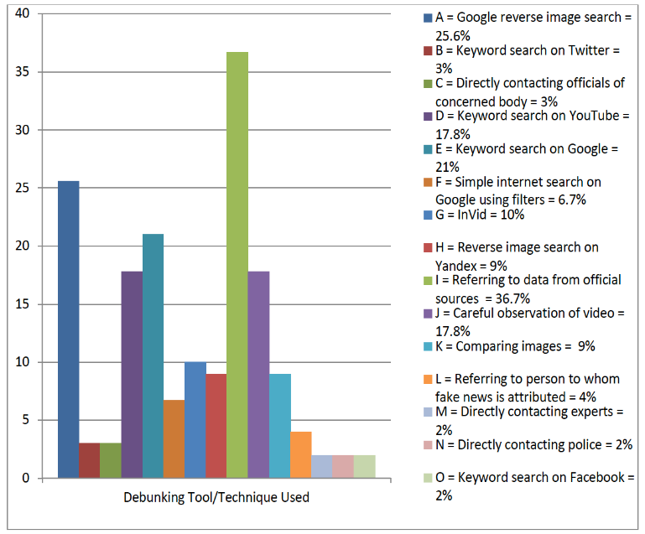

Figure 3: Debunking Tool(s)/Technique(s)

Information from official or primary sources (I) was used most frequently to debunk fake news stories (36.7%). In this technique, reports, data, statements, announcements, or any updates from official or primary sources were used to debunk false claims. Official social accounts, websites, or media reports were sought to obtain information from primary sources to uncover facts. The next most commonly used tool was Google reverse image search (A), which was used in 25.6% of the debunked stories. This tool was used primarily for images and for videos, after making screenshots (Roozenbeek & Van Der Linden, 2019). It helped in finding the origin of an image or a video. The original context of the shared image or video was revealed through this tool once the original was found. It also helped in identifying if the shared image or video was manipulated in any way to mislead users. At this step, the original and shared images were carefully compared (K, 9%) to know the truth. In the case of some fake news storieusing video, this tool was used after using InVid. Fact-checkers used InVid to split a video into multiple keyframes (InVid Verification Application, n.d.). One of the keyframes was then subjected to Google reverse image search to identify the origin of the video. InVid (G) was used in 10% of the stories. Alt News used InVid more than Factly. InVid was used for just one news story checked by Factly. A screenshot or screengrab of the shared video was subjected to Google reverse image search in Factly.

Keyword searches on Google (E, 21%), YouTube (D, 17.8%), Twitter (B, 3%) and Facebook (O, 2%) were also used to debunk fake news stories. Shared videos were also carefully observed or examined (J, 17.8%) to identify any discrepancies. For fake news stories that had some international link, photographs, keyframes, or screenshots of videos were subjected to a reverse image search on a Russian search engine,

Yandex (H, 9%). In some cases, a simple Internet search on Google with search filters (F, 6.7%) was used to identify about the exact origin of a claim. The person to whom the claim was attributed in the social media post was also directly contacted (L, 4%) by the fact-checking website to know about the authenticity of the claims. In a few cases, officials from an organization or body related to a fake news story (C, 3%), reputed experts on the subject matter (M, 2%), and police (N, 2%) were directly contacted to debunk shared social media claims. Both the fact-checking websites mostly used a combination of the aforementioned tools and techniques to thoroughly analyze a fake news story and debunk it with all the pieces of evidence found during the analysis.RQ4. Fake News Platforms

The fourth and last major category identified the social media site where a fake news story was widely circulated and received many likes, shares, and comments. This category was divided into only 4 subcategories using alphabetic codes from A to D.

Most often, a particular fake news story was found to have been circulated on more than one social media platform. Facebook (A) was the site on which the highest number of fake news stories, more than half (81%), were found. This could be due to the fact that Facebook has the highest number of active users in the world (Clement, 2020b). It could be a reason for the proliferation of fake news on Facebook. The site with the next highest number of fake

news stories was Twitter (B), with 49% of the total fake stories. This micro-blogging platform is becoming very popular among social media users. This could be a reason for the high number of fake news stories found on Twitter (Smith, 2020). Very few fake news stories were found to be shared on WhatsApp (C, 9%) or YouTube (D, 4%). Despite the present findings, WhatsApp groups have also emerged as a creator and propagator of fake news stories in India (Farooq, 2018) as well as other countries, like Brazil (Resende et al., 2019) and Nigeria (Apuke & Omar, 2020). In their study, Resende et al. (2019) have analyzed the flow of mis/information within publicly accessible WhatsApp groups in Brazil. They have further designed a web-based system called WhatsApp Monitor which helps fact-checkers and journalists to know about the most popular content being shared in the groups. Many misleading videos are also uploaded and shared on YouTube (Hussain et al., 2018). Apart from these four social media sites, fake news is also disseminated on other social networking sites. Further studies can be conducted on fake news spread and developing strategies to combat fake news on these less frequently used social media platforms. Apart from the above results, it was observed during the analysis that five misleading news stories i.e., about 5.6%, were found to be spread through national media platforms. This hinted that even mainstream media could become a victim of fake news. Thus, it is very important for media professionals to carefully observe a news story to check its authenticity and truthfulness before publishing or broadcasting it. Media professionals also need to be made more aware and educated about fake news. Organizing more workshops and training programs on identifying fake news for media professionals can help. Further research on misleading news reported by media is recommended in future.

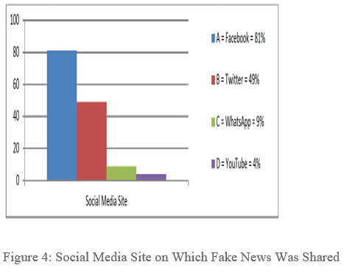

**CONCLUSION AND RECOMMENDATIONS**

Political fake news stories were the most commonly found

online. Of these political stories, majority were international or had a communal angle. This finding implies that in India, most of the fake news originates from the political field or has some link to it. There as on could be propaganda or conspiracy theories used by political parties to target the people who share their political ideologies, which often lead to polarization in a society. Unverified and false political, communal, or xenophobic content may lead to communal clashes, lynching, hate crimes, and proved an gerous for democracy.

The present study recommends that people should cross Verify any claim before believing it. Most of the fake news stories were circulated using video with a false narrative to Mislead users. Users and fact-checkers need to be more Alert when viewing social media posts with videos. The Most used debunking tool/technique was referring to information from official or primary sources. Fact checkers used a combination of debunking tools and techniques. These can also be used by social media users who must apply critical thinking and use tools like In Vid data viewer, You Tube data viewer, and Google reverse image search to check the claims. After the evaluation of this data, source verification or consulting the officials could be another option to debunk false claims in as hared story. Facebook and Twitter are two of the most popular, social networking sites and highest number off a ke news stories. Users need to be more alert when coming across on tent on the set wo social media outlets. Fact-checkers should more often check the content of these two social media sites. In almost all the stories, it was found that most of the social media users believed the false claims blindly. This shows that there is an urgent need of media and information literacy, which should be taught o students beginning in elementary school. Users, as well as media professionals, must be educated on how not to believe every thing that is on social media. Social media users need to think analytically while coming across fake news stories(Pennycook & Rand, 2019). In their study, Penny cook and Rand (2019) found that lazy thinking is the reason behind people falling prey to political fake news. They further suggest that analytic thinking can play a major role in self-inoculating people against such disinformation. Social media platforms can warn users by highlighting a particular story that needs a fact-check. That would simply help people to believe the claim only after its verification. Fact-checking initiatives should be increased. Non-Government Organizations (NGOs)and other institutions should also promote the initiatives along with media literacy. Transparency in the working of governments and other organizations is necessary. Data should be made available freely and transparently to help counter act fake information. Technology is not the only solution to curb fake news. Active and collaborative participation of social media platforms, users, governments, and media professionals can help to fight fake news not just in India but also a round the world. Factly mostly analyzed fake news from Facebook. Fake news from other social media sites were not analyzed much. This could be a limitation of the present study, and future studies can focus more on other social media sites, too. Although the present study has selected technocrat operate fact-checking websites as they tend to not have much bias towards certain ideologies and advertisers, t hey are not immune to bias. Thus, future studies can be conducted on the performance of technocrat-operated vs. media-operated fact-checking agencies. The time period selected for the study was only three months; future studies can be done for longer time periods to get a better understanding of fake news trends and the current situation in India.

**ACKNOWLEDGMENT**

According to my Study Fake News effect to the people bad way and Political, students, commoners on, etc In almost all the stories, it was found that most of the social media users believed the false claims blindly. This shows that there is an urgent need of media and information literacy, which should be taught to students beginning in elementary school.

**REFERENCE**

[1] *Neha bhadade (2022) Impact of media: spreading web information, Tekdi Wadi Near Mokashdham, Wadi, Nagpur440023*

[2] *13dead, over 250 injured in Delhi’s worst communal riot in three decades. (2020, February 26).HindustanTimes.https://www.hindustantimes.com*

[3] *Akers, J., Bansal,G., Cadamuro, G.,Chen,C.,Chen,Q.,Lin, L., Mulcaire, P., Nandakumar, R., Rockett, M., Simko, L., Toman, J., Wu, T. , Zeng, E., Zorn, B.,& Roesner, F.(2018). Technology enabled disinformation: Summary, lessons, and recommendations. ar Xiv Preprint.https://arxiv.org/abs/1812.09383*

[4] *Allcott ,H., & Gentzkow, M.(2017). Social media and fake news in the 2016 election. Journal of Economic Perspectives,31(2), 211–236. https://doi.org/10.1257/jep.31.2.21*

[5] *Apuke, O. D., & Omar ,B.(2020).Fake news proliferation in Nigeria: Consequences, motivations, and prevention through awareness strategies. Humanities & Social Sciences Reviews,8(2), 318–327.https://doi.org/10.18510/hssr.2020.823*