“Seismic Analysis of Building Using Staad-Pro”
Prof. Komal S. Meshram¹, Samiksha Kumbhare²,Sagar Thakur³,Diksha Mate⁴,
Amit Moundekar⁵, Raksha Waghmare⁶.
¹ Asst. Professors, Dept. of Civil Engineering, M.I.E.T. SHAHAPUR, BHANDARA, INDIA 441906
^{2,3,4,5,6,}B.E. Department of Civil Engineering, M.I.E.T. Shahapur, Bhandara, India.

Abstract-The earthquake is a nature phenomenon which can generate the most destructive forces on structure. Therefore, building should be safe for lives by proper design and detailing of structural members in order to have a ductile form a failure, so structure in wellbeing against seismic power of multistoried working. There is need of seismic examination study and planning to earthquake protection structure. The goal of seismic resistance construction is to erect structures that fare better during seismic activity than their conventional counterparts. The project report comprises of seismic analysis and design of G+7 RCC building. A G+7 storied structure for the seismic investigation and it is situated in zone-II district in India. The present project deals with seismic analysis of multistoried residential building G+7. The dead load and live load applied and design for beam, column, slab and footing are obtained. Total structure was analyzed by computer by using STAAD-PRO software. Various software now-a-day are available & STAAD-PRO is most common used for analysis and designing of a building by considering the earthquake forces and to review & study the behavior of multistoried building by Equivalent Static Lateral Force Method.

Key-Words: STAAD-Pro, base Shear Equivalent, load, assign, property, definition, seismic analysis, design, earthquake behavior, modeling, seismic resistance
- INTRODUCTION
Day-by-day increase in population growth in cities of India for several acceptable reasons and deficiency of land area so that there is a requirement of design and seismic analysis of multistoried building before construction work starts.
Multistoried buildings are designed for the basic need of people. These buildings are the shelter for all the human beings and help grown up the infrastructure to the city. So, we need a residential building to serve the people. The main object of the project is to modify the general design of multi storied building with seismic effect. Seismology is the study of vibration of earth mainly caused by earthquakes and seismic waves that move through and around the earth. A seismic wave causesthe sudden breaking of rock within the earth or an explosion. They are the energy in the form of waves that travels through the beneath of earth and is recorded on seismographs. The study of these waves by various techniques, understanding there nature and various physical processes that generate there from the major part of the seismology. A seismic design of high-rise building has assumed considerable important in recent times. In traditional method adopted based on fundamental mode of the structure and distribution of earthquake forces as static forces at various stories may be adequate for structure of small height subjected to earthquake of very low intensity but as the number of the stories increases the seismic design demand more rigorous.
  - Stages in Structural Design
Each components of building follows their own specific path from its initiation to ultimate design as follows:
- Structural Planning of building
- Applied load calculations
- Structural analysis of building
- As per analysis design of building
- Detailing and drawing of structural members
- Preparation of schedule

  - Introduction to STAAD-Pro
Our paper involves analysis and design of multistoried (7-story) using a worldwide most common used designing software STAAD-Pro.
- Advantages of STAAD-Pro:
- Confirmation with Indian standard Codes,
- Versatile nature of solving any type of problem,
- Easy to use interface,
- Accuracy of the solution.

- Features:
- STAAD-Pro features a user interface, visualization tools, powerful analysis and design appliance with advanced limited element and dynamic analysis efficiency.
- From model generation, analysis and design to output visualization and result verification, STAAD-Pro is the specialist’s best choice forconcrete, steel, aluminum, timber and cold-formed steel design of low and high-raised multistoried buildings, culverts, petrochemical plants, tunnels, bridge, piles and much more.

  - Getting Started
In this paper, methodology of structural analysis and design on STAAD-Pro and step by step procedure of has been explained with the help of diagrams. Further, load calculations have been explained in depth/thickness and manual seismic load calculations have also been included in this paper.
- OBJECTIVES

- The main objective is to estimate and check seismic response of building and analyze & design it on that basis using STAAD-Pro software.
- Design and seismic analysis of multistoried building before construction work using STAAD-Pro Software using.
- Modeling of 7-storey building and application of different loadsonSTAAD-Pro, load calculations due to different loading combinations, analysis and design of structure on STAAD-Pro.
- Study of reactions, shear forces, bending moment, seismic forces and node displacement during assigning process and restrained them by applyingsuitable property and material and again assigning.

- METHODOLOGY
Step-1: Modeling:
With respect to the consideration of type of structure modeling has been done using Geometry and Structural Wizard tool.
Step-2: Generation of Nodal Point:
As per the planning with respect to the positioning of column in building, their respective nodal point has been created on that model.
Step-3: Property Definition:
Using General-Property command define the property as per size requirement to the respective building on STAAD-Pro. So, beam and columns have been generated after assigning to selected beam and columns.
Step-4: Create and Assign Support & Member Property:
After column definition at supports have been provided as fixed below each column by selecting columns using Node Curser and its cross-section assigning based on load calculations and property definition.
Step-5:3-DRendering:
After assigning the member property to structure the 3-D view of the structure can be shown using #-D Rendering command.
Step-6: Load Assignment:
- Dead load
The dead load contains of the weight of walls, partitions floor finishes, false ceilings, floors and the other permanent standing construction in the buildings. The dead load loads are estimated from the dimensions of various members of building and their unit weights. The unit weights of plain concrete and reinforced concrete taken as 25kN/m³.The unit weight of masonry taken as 19kN/m³. As per IS:1893 (Part 1)-2016, the dead load have been assigned on the basis of member load, floor load, self-weight of the beams definition.
- Live Load
As per IS:875 (part 2)-1987, live load 2kN/m has been assigned to the members.
- Seismic Load
After defining the seismic load as per requirement of IS: 1893 (Part 1): 2016, the seismic load has been assigned with respect to +X, -X, +Z, and –Z directions with their respective appropriate seismic factor.
- Load combination
Required load combinations cases for seismic analysis have been assigned to the model based on specified loading combinations provided in the Indian standard CODES that are also available in STADD-Pro.
Step-7:Structural analysis on STADD-Pro.
After adding Analysis/Print, using Run Analysis Command, the structure is analyzed and detailed study of forces and bending moment is undertaken through the Post processing mode to recognize their shear forces, bending moment diagrams to it check is safe or not.
Step-11: Design of Structure on STADD-Pro
The design is undertaken as per IS 456:2000 for RCC. M25 concrete and Fe415 is used as design parameters. Percentage steel of 3% has been specified as per IS Code standards and the design parameters have been assigned to respective every beam and column to get the final design.
Step-12:Output Generation.
After that output file is generated which containing the structural design of each individual beam and column member of structure.
- MANUAL SEISMIC ANALYSIS OF G+7 BUILDING (AS PER IS 1893 (PART 1) : 2016
Equivalent Static Lateral Force Method of analysis is chosen for the following structure. This approach defines a series of forces acting on the building to exhibit the effect of earthquake vibrations, defined by a seismic design response spectrum. It is considering that the building vibrates in its fundamental mode. For this to be true, the building must be low-rise and must not twist meaningfully when the ground moves. There is four seismic zone divided in India are given below categorizing every zone as zone I, II, III and IV. For this seismic analysis we are considering zone II.
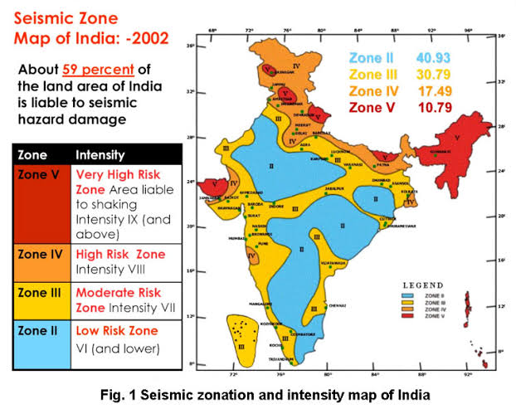

4.1 EQUIVALENT STATIC LATERAL FORCE METHOD
Step 1: Seismic Weight of Building (Manual Calculations)
Load Calculation:
Dead load, Live load, Seismic load and Wind load are calculated and applied into STADD-Pro model as give below:

Deal Load-

- Dead load due to self wt. of slab :
Reinforced concrete unit weight =25kN/m³ Slab Thickness =165mm
Deal load due to Slab = 25xBxD
= 25 x 20 x 0.165x25
= 2062.5kN

- Dead Load due to wall :
Unit weight of brick masonry = 19KN/m3 Thickness of wall = 230 mm
Height of wall = 3m
Dead load of wall = (3x5x.23 x 30 x 19) + (3x4x0.23x30x19)
= 3540kN
Wall load on top floor = 1770kN

- Dead Load due to Beam :
Reinforced concrete unit weight = 25KN/m3
Depth of the beam = 350mm
Width of the beam =300mm
Slab depth = 165mm
Dead Load of Beam= 6 x (25x0.35x0.3x20) +
6 x (25x0.35x0.3x25)
= 708.75KN/m

- Dead Load due to Column :
Size of Columns :
Column Group 1 : 750 X 750 mm
Column Group 2 : 600 X 600 mm
Column Group 3 : 700 X 650 mm
Dead Load due to column = 3x(0.75x0.75x25)x16 +3x(0.6x0.6x25)x 4 + 3x(0.7x0.65x25)x16
= 1329kN

Imposed Load (Live Load)-
Live Load = 25% of (7xBxD)
= 0.25x(7x20x25)
= 875kN

Total Dead Load on each story:
Total DL on 1 to 6 story =2062.5+3540+708.75+1329+875
= 8515.25kN

Total DL on Roof
= 2062.5+3540+708.75+664.5+1770
=5205.75kN

Seismicweight of building (W)
=Sum of DL of each story
=5205.75+8515.25+8515.25+8515.25+8515.25+8515.25+8515.25
=56297.25kN

Step 2: Time Period
The fundamental natural period of a vibration (Ta), in seconds, of a moment resisting frame building without bricks infill panels may be estimated by the empirical expression.
Ta= $\frac{0.09h}{√d}$
= $0.09*\frac{21}{√20}$ = 0.422 sec.

Where h is the height of the building, in meters.
Step 3: Determination of Design Base Shear
Design seismic base shear, V_{B} =A_{h} W
$$Ah =\frac{\left(\frac{Z}{2}\right)\left(\frac{Sa}{g}\right)}{\begin{aligned}\frac{R}{I} \\ \end{aligned}}=\frac{\frac{0.1}{2}*2.5}{\begin{aligned}\frac{3}{1} \\ \end{aligned}}=0.041$$
For T_{a=}0.422 ,$\frac{Sa}{ g}=2.5$, as per Clause-6.4; IS 1893(Part 1):2016
Where,
A_{h=} Design horizontal seismic coefficient
Z=0.1; seismic zone factor given in Table-3 for zone II
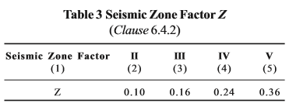
I=1; Importance factor given in IS 1893 (part1-5) for the corresponding structures; when not specified, the minimum value of I shall be,
- 1.5 for critical and lifeline structure,
- 1.2 for business continuity structures,
- 1.0 for the rest.
R=3; response reduction factor given in IS 1893 (Table-9) for the corresponding structures.
$\frac{Sa}{g}$= The design acceleration coefficient considered as per Indian Standards for design, as per IS 1893 (Part 1): 2016.
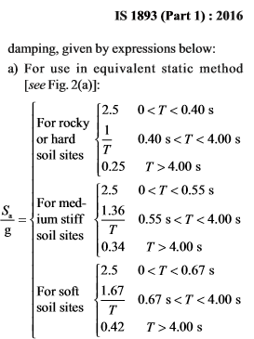

Design seismic base shear,
V_{B} =0.0416x56297.25
= 2345.71kN
Step 4: Vertical Distribution of Base Shear
The design base shear (V_{B}) computed shall be distributed along the height of the building as per the expression,
Q_{i}= V_{B} $\frac{{Wihi}^{2}}{\sum_{i=1}^{n}{{Wihi}^{2}}}$
Where,
Q_{i}= Design lateral forces at floor i,
W_{i} = Seismic weights of the floor i,
h_{i} = height of the floor, measured from base, and
n = Number of stories.

Floor | W_{i}  (in kN) | h_{i}  (in m) | W_{i} h_{i}² | Q_{i} | Shear Force (in kN)
7 | 5205.75 | 21 | 2295.73 | 580.93 | 580.93
6 | 8515.25 | 18 | 2758.94 | 698.15 | 1279.08
5 | 8515.25 | 15 | 1915.93 | 484.82 | 1763.9
4 | 8515.25 | 12 | 1226.19 | 310.28 | 2074.18
3 | 8515.25 | 9 | 689.73 | 174.53 | 2248.71
2 | 8515.25 | 6 | 306.55 | 77.57 | 2326.28
1 | 8515.25 | 3 | 76.637 | 19.39 | 2345.67
∑= |  |  | 9269.7

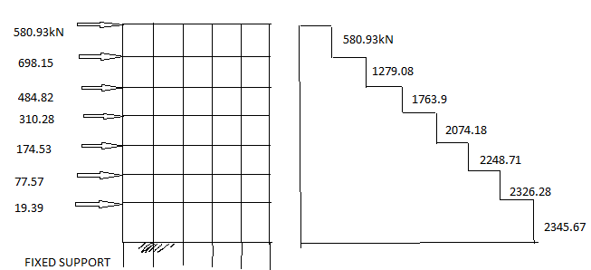
Fig: Shear Force Diagram
4.2 Project Statement
The building is designed for the following parameters:
- Seismic Zone – II
- Type of the soil: Medium soil.
- Response Reduction factor(R) = 3 for OMRC.
- Floor Height = 3m
- No. Of storey = 7 nos.
- External thickness of wall = 230mm
- Internal thickness of wall = 230mm
- Beam Size: 350x300 mm
- Column Size:
Group-1= 750x750mm; (Total Nos. = 16)
Group-2= 600x600 mm; (Total Nos. = 4)
Group-3= 700x650 mm; (Total Nos. = 16)

- Slab Thickness: 165mm

- Live Load: 2KN/m2

- Earthquake Load = IS: 1893-2016

- Grade of Concrete: M25

- Grade of Steel: FE415

The STADD-Pro plan and model for the considered G+7 building is shown below.
- The building plan is of size 20m x 25m.
- Height of the building (h) = 21 m Width of the building (dx) = 25 m
- Width of the building (dz) = 20 m

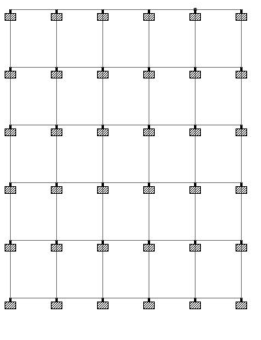
Fig: STADD Plan
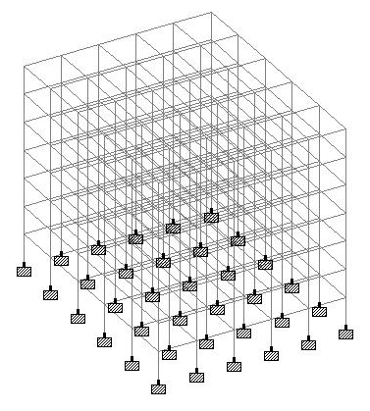
Fig: STAAD Model

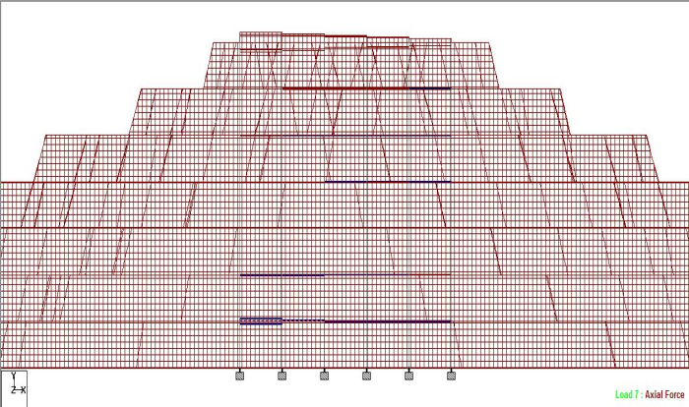

Fig: Axial Force

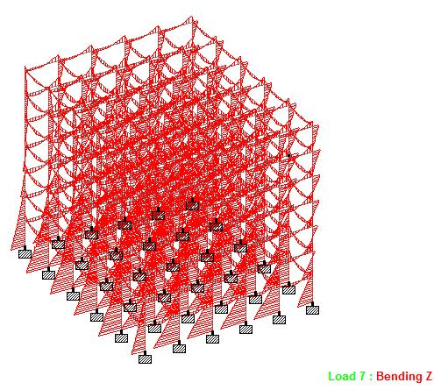
Fig: Bending

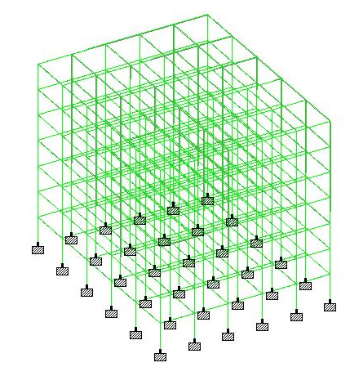
Fig: Displacement

4.4 STAAD-Pro SEISMIC ANALYSIS

T_{a} = 0.73574 sec.,
$\frac{Sa}{g}=1.848$.
Load Factor =1,
A_{h}=0.0308,
Total Weight=53052.25kN,
V_{B}= 1634.43kN

STAAD-Pro model Load to make the structure seismic force resistant, the fundamental period of the building while vibration should be calculated and procure as input to STADD-Pro for seismic analysis. The considered building is in zone II.
These values are derived as input to the seismic definition in STADD-Pro and seismic forces are calculated. The earthquake force acting on the structure is represented below.
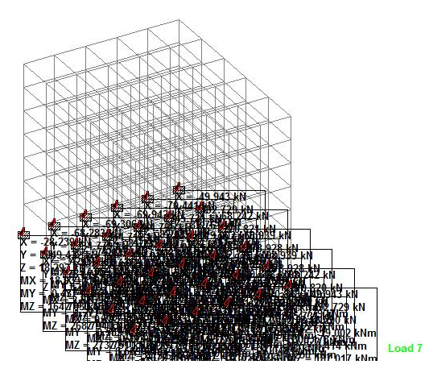

Fig: Reactions
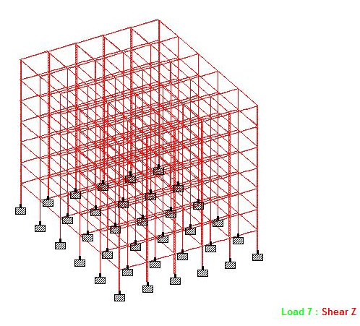
Fig: Shear-Z

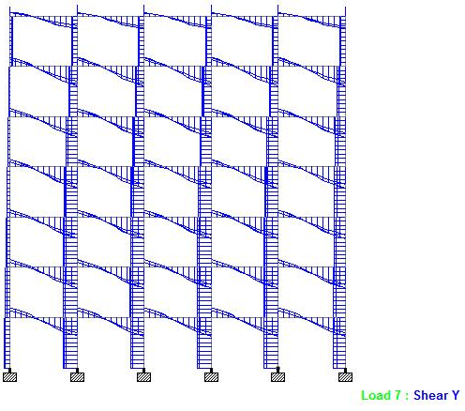
Fig: Shear-Y

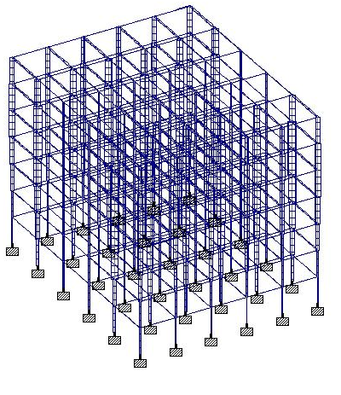
F

Fig: Torsion

- CONCLUSION

- Design Base Shear (Manually)
= 2345.71 KN
- Design Base Shear (STAAD Pro)
= 1634.43 KN
- The G+7 residential building has been analyzed and deigned using STADD. Pro.
- Seismic forces have been considered and the structure is designed as an earthquake resistant structure.
- To conclude, STADD. Pro is versatile software having the ability to determine the reinforcement required for any concrete section based on its loading and determine the nodal deflections against lateral forces.
- It experiences static as well as dynamic analysis of the structure and gives accurate results which are required. The following points have been obtained at the end of the design.

REFERENCES

- IS-875(PART-1) : 1987 Indian Std. Code Of Practice For Design Loads
- IS-1893(Part 1): “Earthquake Resisting Design of Structures”.
- IS: 875 (Part 2): 1987 “Imposed Loads”.
- STAADPRO manual.
- Pankaj Agrawal, “Earthquake Resistant Design of Structures” by, Eastern Economy Edition.
- D.R. Deshmukh, Yadav, A.K., Supekar, S.N., Thakur, A.B., Sonawane, H.P., Jain, I.M., (2016). “Analysis and Design of G+19 Storey Building Using Staad-Pro”. Int. journal of engineering research and application (IJERA), ISSN: 22489622, Vol 6, Issue 7.
- Akshay R. Kohli, Prof. N. G. Gore , MGM’s College of Engineering & Technology, Navi Mumbai, Maharashtra, India, “Analysis and Design of an Earthquake Resistant Structure using STADD. Pro”, Int. journal of engineering research and application (IRJET), e-ISSN: 2395-0056 Volume:04, Issue:12Dec-2017 www.irjet.net, p-ISSN: 2395-0072
- Dr. V. L. Shah and Dr. S. R. Karve, (2010). “Illustrated design of Reinforced Concrete Buildings”. 4th ed.
- Murthy C.V.R, Learning earthquake design.

