Secure Social Media
Bhagyashri Bawankule¹, Harsha Uikey², Sneha Bhoyar³,
Suraj Wardhaiyya⁴ , Sanjay Khobragade⁵
¹Assistant Professor, C.R Pote , ²Assistant Professor, Pooja Dhawane

Priyadarshani College Of Engineering, Hingna Nagpur, 440019

Abstract:
Social networking websites such as Facebook, Twitter, Google+, and LinkedIn are the popular social sites. Privacy and security are the main concern of any social media network sites such as Facebook, Twitter, and LinkedIn etc. The primary purpose of these sites is to allow people to share interests, activities, real-life connections. Facebook is most popular social networking site. Social sites are most common platform to communicate with their other friends, family and share thoughts, photos, videos and lots of information. Social networking websites have become platforms for cybercriminals for cybercrime; cybercriminals exploit sensitive and personal information through social engineering and reverse social engineering. It is usual for the users of social websites to share information; however they lose privacy, while sharing information with strangers, they can fall in honey trap made by them. Privacy has become an important concern in online social networking sites. Users are unaware of the privacy risks involved when they share their sensitive information on the social network sites. The default settings share everything, users have to change their default privacy setting options to make their accounts and personal information more secure. Security attacks continue to be a major concern of all users. How to keep social networking sites more secure and more private are the challenges that have been concern for every user. It is difficult for social networking sites and users to make and adjust privacy setting to protect privacy without practical and effective way to identify measure and evaluate privacy. Maximum numbers of users are not aware of the security risk associated whenever they shared sensitive data on the social sites, so that privacy concern will be raised among those online communications if their personal data has been shared to other users. The users should be aware of their privacy quotient and should know where they stand in the privacy measuring scale. Unfortunately many users are not aware of this and become victim of privacy and identity breach. So we conducted a survey to find users viewregarding security and privacy of social networking sites and regarding.
Keywords : Social network privacy issues, social media, security, confidentiality, securityissues, privacy awareness, social networking sites.
INTRODUCTION

Cyber is a common term used for the computers interconnected in a network and we can say a cyber is related to a computer network. As the number of users in the network is increased which give rise to our concern about the security which we called as “cyber security”. Cyber security is defined as the security of data on cloud from theft, damage or unauthorized access. Now the questions arise from where the maximum security breaches occurs in the network? The more ambiguous is the users, the more there curiosity of accessing the information some may do knowingly and some unknowingly, from all this facts obviously our mind will drift towards the social networking sites. “Social networking sites” is an online medium that allows users from different background to create a profile and interact with the other users on the same websites. Social networking sites such as Facebook, twitter, etc. have become so popular among the people that they have started to share every single moment of their lives on these sites. Social networking sites are one of the easiest forms of communication these days and have become an unavoidable thing for youth. Every sectors of The system which already exists in the environment is there is no mechanism to stop peoples from creating fake ID’s.
- Users can share posts which may cause violence.
- Users can share vulgar posts, morph images.
- User can comment on anyone’s post.
- User can send abusive message.
METHOLOGY
Guest User
Guest user able to register in the secure social media. But having very limited privilege. He/ She just able to view the secure social media system not able to post text, image and video. Like, comment, tag and send friend request will be disable.
Authenticated user
Authenticated user will register by the personal detail ,adhar card number and adhar card image. If admin will approve that registered user then he/she able to login into the system. User will able to set privileges for friends. Authenticated user will able to post text, image and video.
Text: Not able to post text which consist offensive , vulgar and abusive words then it will not post on wall.
Image: User not able to post morph and nude image.
Video: first video will send to admin. if admin enable then video will appear on wall otherwise not.
Tag: If user tags to friend any post then notification send to friend if fiend allow to tag then it will tag otherwise not.
DESIGN
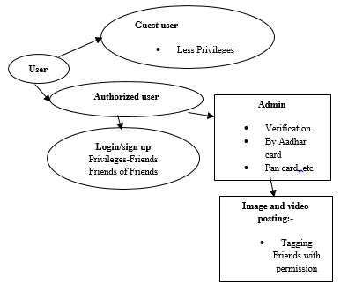
Fig:- General Architecture of Secure Social Media

Admin
Admin will monitor the activity of users. Able to view authenticate user and approve them to login into the system after verifying Adhar card number and Adhar card. User uploaded video enable or disable.

CONCLUSION
In the end, the only solution to social network privacy and security issues is to have some knowledge of the ways in which one can get fooled. Don't post anything you would want to hide from a stranger. Be careful who you add as a "friend" since there's simply no way of verifying a user's actual identity online. We have proposed a architecture for secure communication between the users and a secure request-response architecture for exchange of information between the users. Keep your system clean and updated. Keep your senses open while using the internet and never jump to conclusions. Analyze the content thoroughly before doing anything.
1) The people will find it secure by this application.
2) We provide Secure Media which will do not allow people for making fake Id’s.
3) User can create login Id after providing Aadhar proof.
4) This Id will be verifying by Admin after that user can access the application.
4) User can post video only after permission of Admin.
5) Only Authenticated User can use entire application.
6) Guest user does not have permission to access the features. He only able to see the application.
7) Here Restrictions are provided to all user that - user cannot post abusive Message, morph and vulgar images.
REFERENCES
- International Journal of Computer Applications (0975 – 8887) Volume 144 – No.3, June 2016.
- Gunatilaka D. A Survey Of Privacy And Security IssuesInSocialNetwork.http://www.cse.wustl.edu/~jain/c se571-11/ftp/social/index.html.
- Gangopadhyay S and Dhar M. D. social networking sites and privacy issues concerning youths. Article – 2 Global Media Journal-Indian Edition Sponsored by the University of Calcutta/www.caluniv.ac.in ISSN 2249 – 5835 Summer Issue/June 2014/Vol. 5/No. 1.
- Verma, Kshirsagar D. and Khan S. 2013. Privacy and Security: Online Social Networking, Association of Computer Communication Education for National Triumph (ACCENT), vol. 3, no. 8, pp. 310-315, 2013.
- (IJACSA) International Journal of Advanced Computer Science and Applications, Vol. 7, No. 2, 2016.
- International Journal of Scientific and Research Publications, Volume 3, Issue 4, April 2013 1 ISSN 2250-3153

DETAILS OF ALL AUTHORS

PHOTO | DETAIL
Name :- Bhagyashri D. Bawankule
Email-Id :- bhagyashri.bawankule@gmail.com
Contact No :- 7887448795

Name :- Harsha L. Uikey
Email-Id :- harshauikey6@gmail.com
Contact No :- 7030631942
Name :- Sneha P. Bhoyar
Email-Id:-sneha16.20@gmail.com
Contact No :- 7020468074
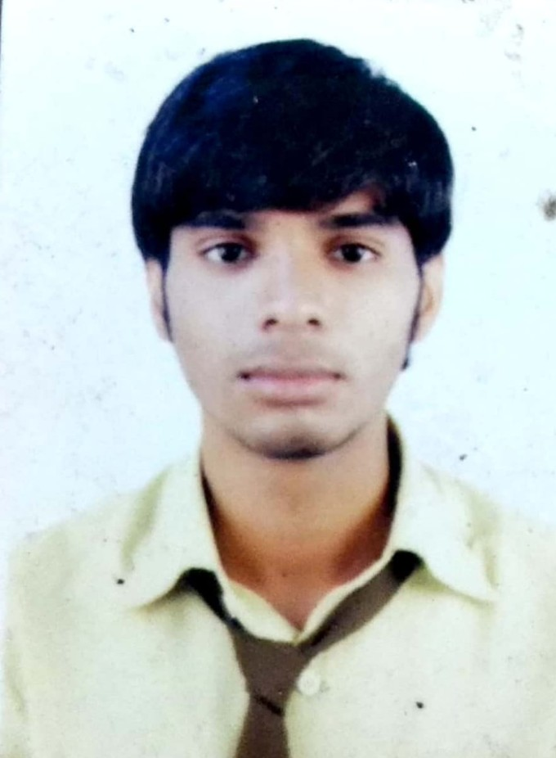 | Name:- Sanjay Khobragade  Email Id:-  Contact No.:-  8208077480
Name:- Suraj Wardhaiyya
Email.Id:-
Contact No.:- 9370508849
Guide
Name:- Prof.C.R.Pote
Email Id:- scrpote@gmail.com
Contact No.:- 7719966016
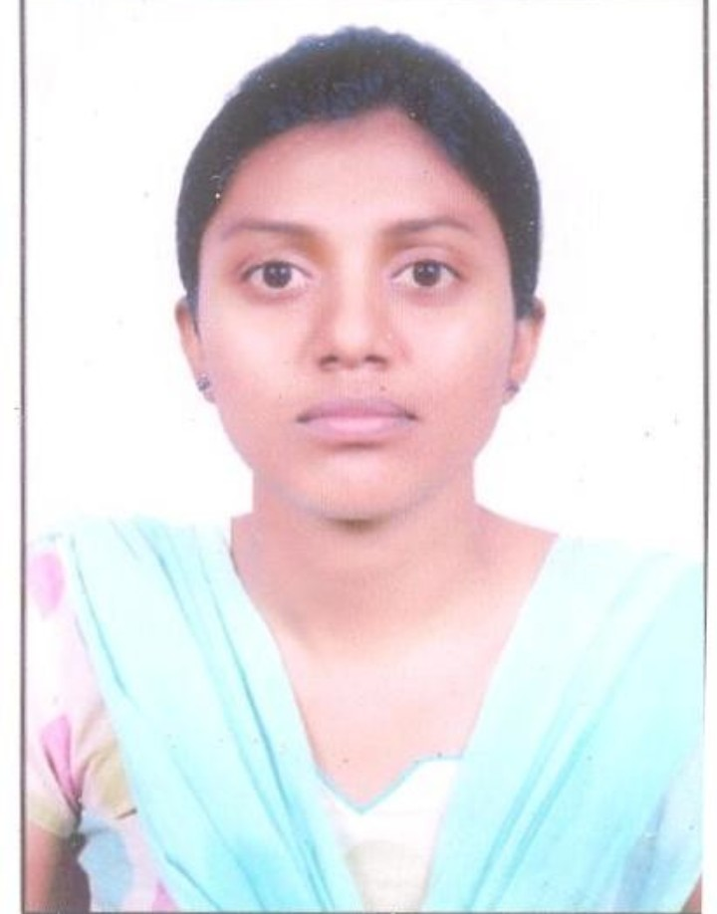 | Co-Guide  Name:- Prof.Pooja Dhawane  Email Id:-poojadhawane  @gmail.com  Contact No.:- 9370354436

