Impact Factor Value 4.046 e-ISSN:2456-3463

National Conference on “Emerging Trends in Engineering & Technology”

Organized by Manoharbhai Patel Institute of Engineering & technology Shahapur , Bhandara International

Journal of Innovation in Engineering and Science Vol.4, No.5, 2019 www.ijies.net

Online Student Feedback System

Ankita Malkhandale¹, Archana Nashine², Komal Deulkar³, Shraddha Raut⁴, Yogita Gaidhane⁵ Prof. Nitesh Hatwar⁶
Assistant Professor, Students

Dept. of Computer Engineering, MIET BHANDARA (MH)

Abstract- The Online student feedback system is the feedback system which help to take feedback from online. Also it provide a way to allow the Lecturers gradation .

The feedback was done manually with the use of pen and papers. This has many drawbacks and evaluating this hand written forms is a difficult process.

Student needs to logging into the website and giving his/her feedback and can perform modifications too. But the restrictions here is once the student submits the report then he can not modified latter. Within this the student can successfully submit feedback on lecturers teaching and it vary efficient manner.

Keyword –login, Authentication, Feedback, Report, Online, Analysis

I. INTRODUCTION .

This type of Student Feedback System reduces, the Strenuous work of physically examining the feedback pages of each and every student .

The system also reduces the burden of efforts and burden of keeping and maintaining the records on a manual base, it requires a lot of space and safety to keep up such records.

Another important features of Student Feedback System is that physical presence of neither the admin nor the student is required for the either giving the feedback nor for assessing the feedback.

By online Feedback system report generation is consumes very less time. In online feedback system students gives feedback for

teacher of particular subject for particular period of time. Feedback is send to HOD to particular department as well as all department feedback to principle.

HOD has rights to whether feedback he online student feedback shows to respected teacher or not. After analyzing report HOD or principle conducts the meeting for staff by contact to them.

Impact Factor Value 4.046 e-ISSN:2456-3463

National Conference on “Emerging Trends in Engineering & Technology”

Organized by Manoharbhai Patel Institute of Engineering & technology Shahapur , Bhandara International

Journal of Innovation in Engineering and Science Vol.4,No.xx 2019

www.ijies.net

  - .LITERATURE SURVEY

- Mobile Virtual Online Feedback System. We take this paper as refrence

paper no[2]In these system some

security issues Are occurred.

b. Feedback Management System For

Evaluating and Generating Monthly Report. We also take reference from these paper no [3]but in these system no User-friendly environment and It is not time bound.

- The Online Feedback System which is used to extraction of knowledge we have taken reference from the paper no [6] given in references.

result by using pie chart .

In sematic web rebuilt the existing web content by adding layer that will enable us in doing advanced automatic processing web content then data can be distributed and proceed by both human being and software.

IV. PROPOSED METHOD

Here we aimed to design the online web application for giving the feedback about the lecturer’s, particular subject ,etc.by student to teachers.

The Online Student Feedback System is management information system for education establishments to manage student data. Student Feedback System provide capabilities for selecting particular subject for feedback and generate the report automatically.

III . EXISTING SYSTEM

Feedback is done by manually by using pen and paper. After giving these feedback this papers are collected and calculate the overall grade for each subject and each lecturer.

The another is Correlation of grade Prediction Performance with Characteristic of Lesson these system also designed to show overall feedbacks related to the subject.

A Online Student Feedback System is an feedback generation system which provides the proper feedback to the teachers which categories like always, poor, good. also it maintained the college report and all work ,it also show the percentage of feedback taken from

the students side for one lecturer. Two is completed online so paper work are not required.

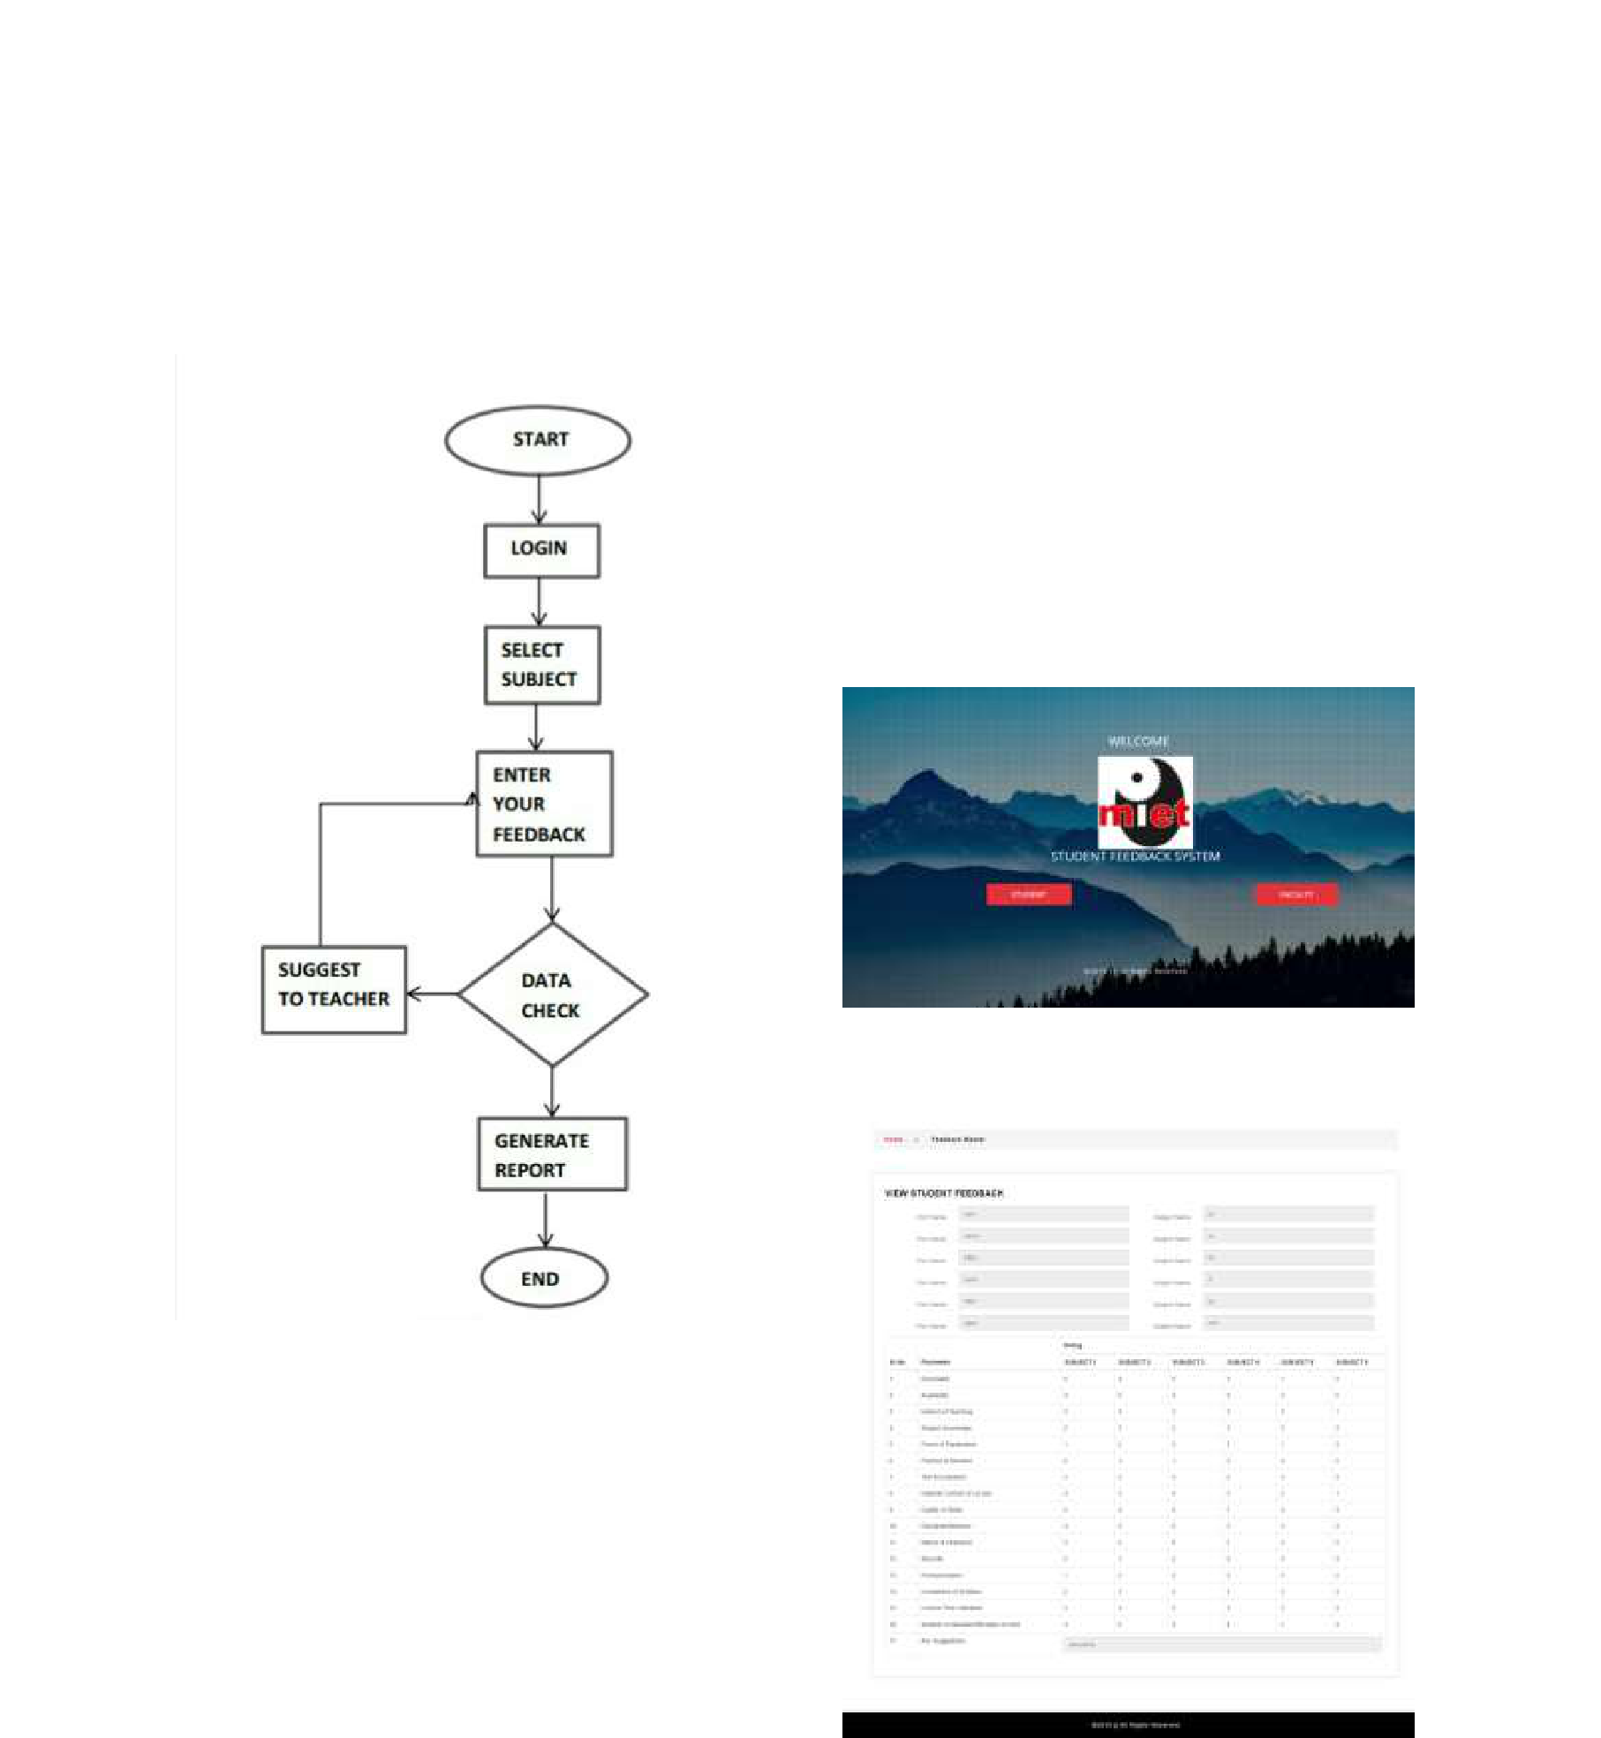
Impact Factor Value 4.046 e-ISSN:2456-3463

National Conference on “Emerging Trends in Engineering & Technology”

Organized by Manoharbhai Patel Institute of Engineering & technology Shahapur , Bhandara International

Journal of Innovation in Engineering and Science Vol.4,No.xx 2019

www.ijies.net

calculated the overall grade for each subject and each lecturer. The study presented in the system mainly focuses on the lecturers perceptive also System aim to improve teaching and course content quality from lecturers view on factors that obtained the student feedback rating.

Fig2.RegistrationForm

Fig 1 Flowchart

moderate ,excellent , extremely poor. By this process student can give feedback in online system without waste of time in writing. The system is designed to be simple to use, and

Fig3. Feedback Form

Impact Factor Value 4.046 e-ISSN:2456-3463

National Conference on “Emerging Trends in Engineering & Technology”

Organized by Manoharbhai Patel Institute of Engineering & technology Shahapur , Bhandara International

Journal of Innovation in Engineering and Science Vol.4,No.xx 2019

www.ijies.net
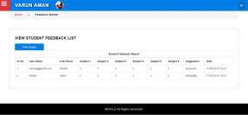

Fig.4 Student Feedback list
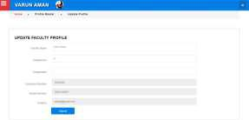

Fig4.Faculty Profile

V. CONCLUSION

The project is designed to reduced the burdens to maintained the record by college . whenever the student give feedback to any lecturer then they can generate the report easily. As per existing system these system is easy to manage everything related to feedback .

VI. REFRENCES

- J .hatie, H.Timperly, “The power of feedback” J. review of Eaducational

Research 87(1).app.81-112,2017

- Vasileva E., Puronnem S., Pechenizkiy

M., Rasanem P.,”Virtual Feedback

Management System ”, Special Issue of Int.J.ofcontinuingengineering

Eaducation and Life long learning.17(4-5),pp.337-357,2007.

- M.Tharane, M.Manawani,” Feedback

Management System for Evaluating

Generating Monthly Report.” 2015

- Shute, V. J.:”Focus on Formative Feedback”,Research Report Retrived

January15, 2007

- ShyamaaE.Sorour,JingyiLuo,

KazumasaGodaandTsunenori

Mine,”CorrelationofGrade

PredectionPerformancewith

CharacteristicofLesson

Subject”2015IEEE 15th international conference on Advanced Learning Technologies.

- Sana Seikh, Prashant Sonwane

,RajeshPatilRohit

Neerj,”Knowledge Extraction From

Online Feedback System Using

Ontology”,2015International

Conference on Technologies for Suistanable Devlopment (ICTSD-

2015),Feb.04-06,2015 Mumbai, India.

