WEBTECH: A Online Learning Platform for Web Developers

Mr. Hitesh Giri¹, Mr. Ashwin Kukade², Mr. Rajkumar Galbale³, Mr. Anshul Charde⁴, Mr. Akshay Raut⁵, Mr. Rakesh Neware⁶, Prof. Piyoosh Awthare⁷

¹⁻²⁻³⁻⁴⁻⁵⁻⁶Students,Dept. of Information Technology, MIET Bhandara, Bhandara -441904
⁷AssitantProfessor,Dept. of Information Technology, MIET Bhandara, Bhandara -441904

Abstract-E-learning system can all forms of electronically supported learning and teaching devices. e-Learning began decades ago with the introduction of televisions and over-head projectors in classrooms and has advanced to include interactive computer programmers, 3D simulations, video and telephone conferencing. 'e-Learning' is considered by many as the only viable solution to the problem of delivering the knowledge required to facilitate lifelong learning. E-learning is essentially the computer and network-enabled transfer of skills and knowledge based on relevant technology. E-learning web based applications include Web-based learning, computer-based learning, virtual educational opportunities and digital collaboration. Courses/knowledge is delivered via the Internet, intranet, audio or video tape, satellite TV, and CD-ROM. It can be self-paced and includes media in the form of text, image, animation, streaming video and audio. This web application can provide the theoretical based learning, video lecture and online code execution.

Keywords—Learning, Internet, Video Tutorial, Online Text Editor, Online courses, Literature.
I. INTRODUCTION
E-learning systems uses electronic technologies to access educational resources and knowledge outside of classrooms. In most cases, it refers to an online course, program or degree/certificate delivered completely online. e-Learning began decades ago with the introduction of televisions and over-head projectors in classrooms and has advanced to include interactive computer programmers, 3D simulations, video and telephone conferencing and real-time online discussion groups comprised of students and other peoples from all over the world. As technology advances, so does online learning, making the possibilities endless. Since the Internet was adopted and further developed as a means of communication by educational institutions in the 1970s, academics have been aware of its massive potential as a learning tool. In recent years, governments of both developed and under-developed nations have become increasingly excited about the possibilities of online learning to deliver cost effective, easily accessible and ever-current education to all ages, social backgrounds, regardless of time and geography.
'E-learning' is seen as key to the continued success of modern society. 'e-Learning' is considered by many as the only usable solution to the problem of delivering the resources and knowledge required to facilitate lifelong learning.

A. Objectives

(a) Learners may have the option to select online courses and tutorials that meets their level of knowledge and interest.
(b) Learners can study wherever they have access to a computing devices and internet.
(c) Self-paced learning module allow learners to work at their own pace.
(d) This website provides easy content for learning.

III. EXISTING SYSTEM

E-learning systems uses electronic technologies to access educational resources and knowledge outside of classrooms. existing system provide better education and resources but the many of e-learning system cannot provide whole as in one the systems only can introduce with theoretical part or video lectures. and many of them can delivered or share theresources with theory and online text editor to execute the part of web programing. Sometimes it seems difficult to understand the theoretical part. The video tutorial is easy to understand but sometimes the we do not understand the language of lecturers if it does not contain theory part.

III. PRAPOSED SYSTEM

In proposed system we can add easy to understand content with simple English with theoretical part, video tutorial, and online text editor to execute web program. The online courses are freely available on our website but learners may have to sign up for free to select online courses which the learner want to learn. For the sign in and register/sign up the learner need to click on login/register button. Once the learners successfully log in they have the option to select online courses and tutorials that meets their level of knowledge and interest. This website consists of various courses based on web technology i.e. HTML, CSS, JAVASCRIPT, SQL, PHP, PYTHON learners can take video lectures if they want to deep knowledge about any technology. The learners may have freedom to choose online courses that meet their level of knowledge. The online text editor which is software program that allows user to create or manipulate plain text computer file. Learners can click on demo button to see how the program can generate the output and what kinds of errors can occur in program. Online text editor has preview button to see how the code will display the output and home button to go back on tutorial page.

IV. MODULE

- Home Page
- Login Module

- Register Module
- Course Module

V. MODULE DESCRIPTION

Home Page

Home page of this website provide the great interface to the user the home page navigate user to different module of the website the user can choose the courses, and can view about the website and can login the registered user or the new user can register

Login Module

The user can login to the courses by authenticating him/her self-using E-mail id and password once the Lerner’s log in successfully they can access the online courses.

Register Module

The new user can create an account by registering on to the website this module store the information provided by user into the database and this information is used to authenticate the user

Course Module

This module manages the courses which are provided to the user. The user can take the course which he/she want to learn the course module provide the courses in easy and understandable language in this module the user can also be able to take video lecture related to the course

ADVANTAGES

- Learners may have the option to select online courses and tutorials that meets their level of knowledge and interest.
- Learners can study wherever they have access to a computing devices and internet.
- Different learning methods are addressed and facilitation of learning occurs through varied activities.
- Development of computer systems and Internet skills that are transferable to other facets of learner’s lives.

DISADVANTAGES

- No self-discipline.
- No face to face interaction.
- Lack of input from trainers.

OUTPUT:

Home Page

Home page of this website provide the great interface to the user the home page navigate user to different module of the website the user can choose the courses, and can view about the website and can login the registered user or the new user can register

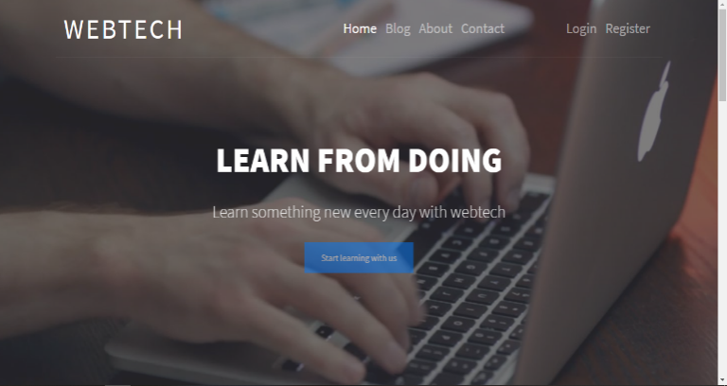
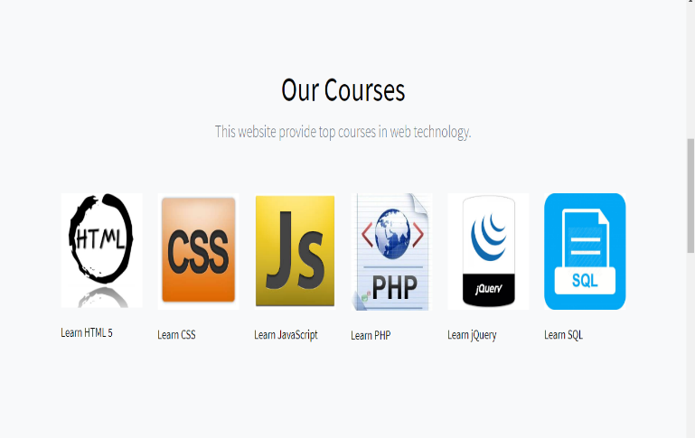

Log In

The user can login to the courses by authenticating him/her self-using E-mail id and password.
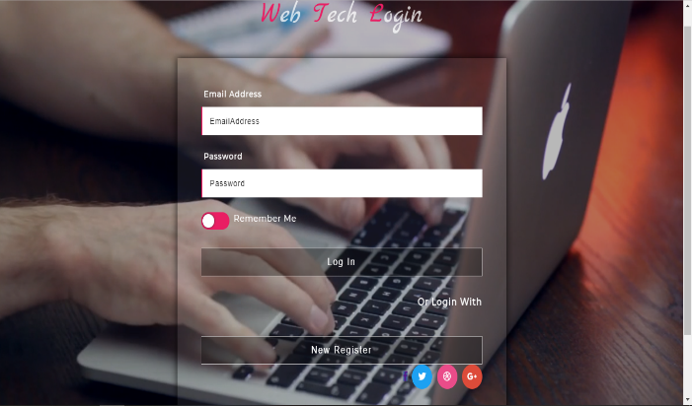

Online Courses

This module manages the courses which are provided to the user. The user can take the course which he/she want to learn the course module provide the courses in easy and understandable language in this module the user can also be able to take video lecture related to the course.
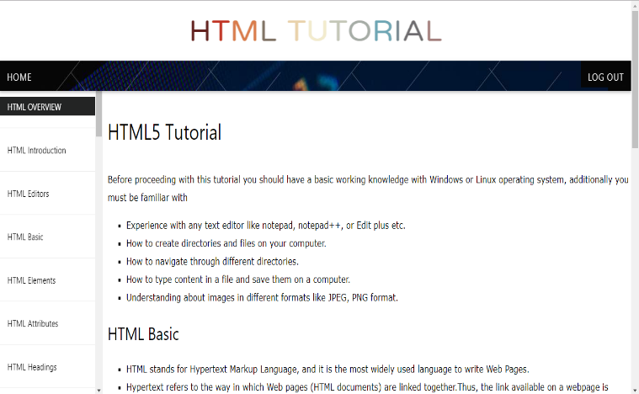

Video tutorial

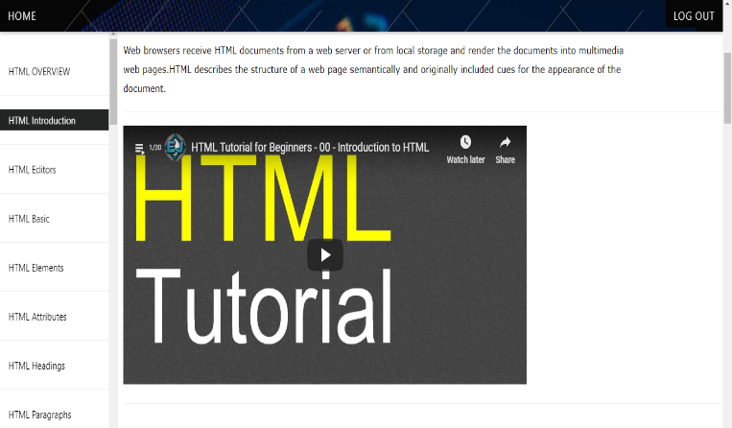

Online Text Editor

An HTML editor is program for editing HTML the mark-up language of a web page. Although the HTML mark-up in a web page can be controlled with any text editor specialized html editor can offer convenience and added functionality. for example, many html editor not only html but also related technologies such as css, xml JavaScript.

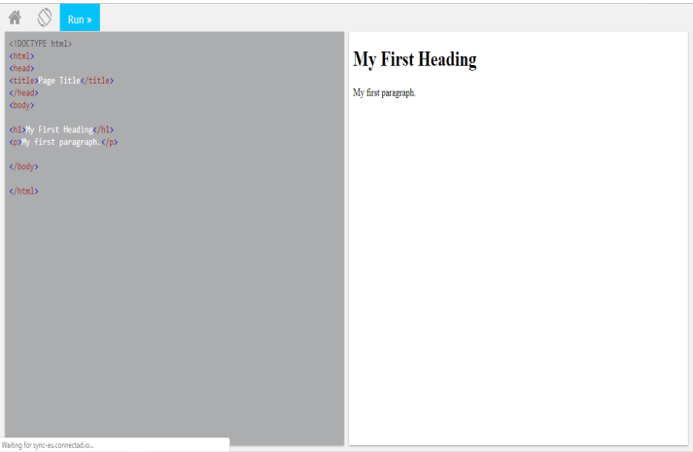

VI. CONCLUSION

Online learning and e-learning are viable forms of education for populations with ready ICT-access, regardless of how remote their physical locations are. The highest potential countries are already well prepared to take full advantage of these new tools. However, in the low to mid potential countries, a host of political and socioeconomic factors stand in the way of implementing e-learning to its fullest potential. In order to increase the effectiveness of education via online delivery, public and private organizations in each of these countries will need to work together to improve infrastructure, rethink education policies, increase funding, and train both users and operators to ensure quality and access for all. Indeed, further research is needed to clarify the link between ICT access and education to pave the way for such improvements.

REFERENCES
[1] Sharples, M., Adams, A., Ferguson, R., Gaved, M.,McAndrew, P., Rienties, B., Weller, M., &Whitelock, D. (2014). Innovating Pedagogy 2014: Open University Innovation Report 3. Milton Keynes: The Open University.

[2] Sharples, M., McAndrew, P., Weller, M., Ferguson, R., FitzGerald, E., Hirst, T., &Gaved, M. (2013). Innovating Pedagogy 2013: Open University Innovation Report 2. Milton Keynes: The Open University.

[3] Freeman, A., Adams Becker, S., Cummins, M., Davis, A., & Hall Giesinger, C. (2017). NMC/CoSN Horizon Report: 2017 K–12 Edition. Austin, Texas: The New Media Consortium

[4] Sharples , M., Adams, A., Ferguson, R., Gaved, M., McAndrew, P., Rienties, B., Weller, M., &Whitelock, D. (2014). Innovating Pedagogy 2014: Open University Innovation Report 3. Milton Keynes: The Open University

[5] A survey paper on e-learning based learning management system by Chirag Patel, Mahesh Gadhavi, DR Atul Patel International Journal of Scientific & Engineering Research, Volume 4, Issue 6, June-2013-171

[6] Area, M. &Adell, J. (2009). eLearning: Enseñaryaprenderenespaciosvirtuales. In J. De PablosTecnologíaEducativa. La formación delprofesorado enslaver de Internet. Aljibe, Málaga, pp. 391- 24

[7] Learning management systems (LMS) and e-learning management: an integrative review and research agenda by Paulo Cristiano de Oliveira, Cristiano Jose Castro de Almeida Cunha Volume 4, Issue 6, June-2 0 13 171

[8] Aggarwal R, GupteN, Kass N, Taylor H, Ali J, Bhan A, Aggarwal A, Sisson SD, Kanchanaraksa S, McKenzie-White J, McGready J, Miotti P, Bollinger RC. 2011. A comparison of online versus onsite training in health research methodology: a randomized study. BMC Med Educ.

