Solar Powered Smart Fencing System for Agriculture
Protection using GSM & Wireless Camera

Yamini V.Tighare1,Pooja D. Sarade²,Hardika S.Wanjari³,Shraddha R. Makde⁴,
Kapil Kokney⁵ ,Tushar Raut⁶

^{1,2,3,4}B.E. student, ⁵Associative Professor,⁶ Assistant Professer
Department Of Electronics and communication Engineering
MIET Shahapur, Bhandara, India

Abstract- India, with immense horticultural grounds has distinctive harvests going from paddy to tomato. Be that as it may, few harvests are pulverized because of creature threat and thus a security is required to spare the yields from creature. Sun powered Fencing Perimeter Protection is the cutting edge need to the developing security danger in denying, distinguishing. In this undertaking, we structure actualize Fencing Perimeter Protection for farming. at the point when any item is detected by PIR or IR sensor, Immediately controller sends the message to the approved individual through the a shot at Solar Energy with reinforcement GSM modem, and it is interfaced with the controller. In the meantime bell and LCD show will on. Additionally we connected remote camera through which we screen ranch from control room. Sunlight based Powered Fence is logical Fence and takes office to run uninterruptedly amid the evenings just as shady days.

Keywords- GSM modem, sensor, fence, agriculture, Wireless Camera, Solar Powered.

- INTRODUCTION
Farming in India is the broadest monetary part and assumes a noteworthy job in the general financial factor of India. The expanding news articles in TV and paper on wild creatures attacking agrarian yields amid collect season demonstrates that these creatures can demolish a rancher's employment. In such regions Electric fencing framework can be utilized in which the creatures experience a high voltage low flow stun for a brief

timeframe. As a result of the little greatness of current there is no danger to the creature's life. As a rule, PIR sensors enable you to detect movement, quite often utilized to detect whether a human has moved in or out of the sensors run. They are regularly alluded to as PIR, "Uninvolved Infrared", "Pyroelectric", or "IR movement" sensors. A photoelectric sensor, or photograph eye, is a gadget used to distinguish the separation, nonattendance, or nearness of an item by utilizing a light transmitter, often infrared, and a photoelectric beneficiary. They are utilized broadly in modern assembling. There are three distinctive practical sorts: restricted (through pillar), retro-intelligent, and nearness detecting (diffused).
The flow extreme stun is given, just when somebody is attempting to enter through fence. Its so litary typical stun so that, nobody can hurt. In such cases, just the stun is given to the fence while human/creature is entered in the land. The sun oriented vitality got is put away to a battery. The battery supply is bolstered voltage controller IC7805 and thusly to a aurdino. sensor which is equipped for creating ON/OFF heartbeats to controller. This is encouraged to a signal, and LCD show and sent to message to approved individual however GSM modem.

II- NEED OF PROJECT

An Electric Fence is a fence which is electrically empowered to repel creatures or gatecrashers by a high voltage stun. It's anything but a physical yet a mental boundary. An electric fence as a rule comprises of a few uninsulated channels bolstered on separators and associated with a fence controller which thusly is associated with the power source and an establishing framework. The live uninsulated wires and the establishing framework structure a beat high voltage open circle circuit with a creature or gatecrasher as the finishing join. A viable electric fence has a high and solid structure, high voltage and the caution, whenever joined, goes OFF when the fence is messed with. A controller is the machine that provisions capacity to the fence wires. The controller is additionally alluded to as the fence energizer, fence charger or fencer.

II- LITERATURE SURVEY

On the off chance that any article cross the passageway and encompassed zone, at that point the comparing sign will be given to the aurdino. In the wake of getting this flag the alert will make a sound to show some interference in the ranch. In the meantime GSM modem is enacted and send message to administrator. The sun based board is utilized to produce the electric supply and store it to battery, battery will provide for supply to fence wires, the additional high edge voltage creates the proportionate stun voltage.
Because of presents of part of creatures the ranches are regularly annihilated by them, so the human needs to ensure and verify their homesteads. However at this point a-days there is no time for the people to take every necessary step. Consequently to keep away from the human interface (security) and furthermore to ensure the ranches, we give a framework called programmed electric homestead assurance framework.
The advancement in science and innovation is a constant procedure. New things and new innovation are being created. As the innovation develops step by step, we can envision about the future in which thing we may involve each spot. The proposed framework dependent on Atmel microcontroller is observed to be progressively reduced, easy to use and less unpredictable, which can promptly be utilized so as to perform. A few dreary and redundant errands. In spite of the fact that it is structured remembering about the requirement for industry, it can reached out for different purposes, for example, business and research applications. Because of the likelihood of high innovation (Atmel microcontroller) utilized this "sun oriented fencing unit and caution for creature section aversion" is completely programming controlled with less equipment circuit. The component makes this framework is the base for future frameworks. The rule of the advancement of science is that "nothing is unthinkable". So we will anticipate a splendid and complex world.
BLOCK DIAGRAM
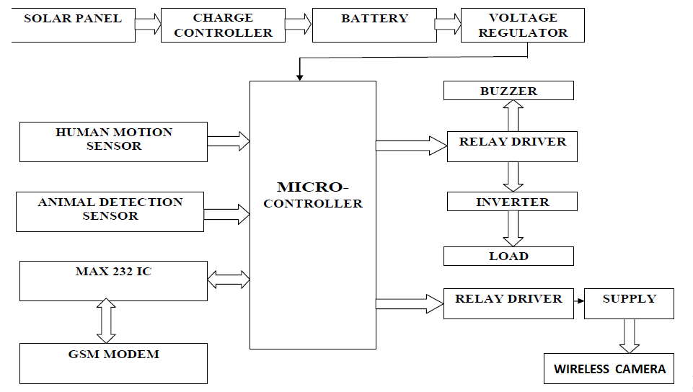
FUTURE SCOPE
• Prohibit the section of creature into the homestead
• To structure a security framework for homestead insurance .
• Use GSM module for alarming use.
Conclusion

We are closed the sunlight based fencing framework was planned and manufactured effectively. The test demonstrates that the proposed framework is basic and productive one. We are spare expense so as to execute this task for security reason just as less time devour.
There is requirement for government endorsement for giving flow stun going back and forth. Influence the people. Rather than electric power supply, utilizing sensor and GSM Modem to diminish control level. Fence chips away at Solar Energy with reinforcement office to run uninterruptedly amid the evenings, just as the shady days. Engine can be constrained by GSM. Favourable position of our proposed framework are Solar vitality is utilized, Easy to control and keep up the fence, Less tedious.

RESULT
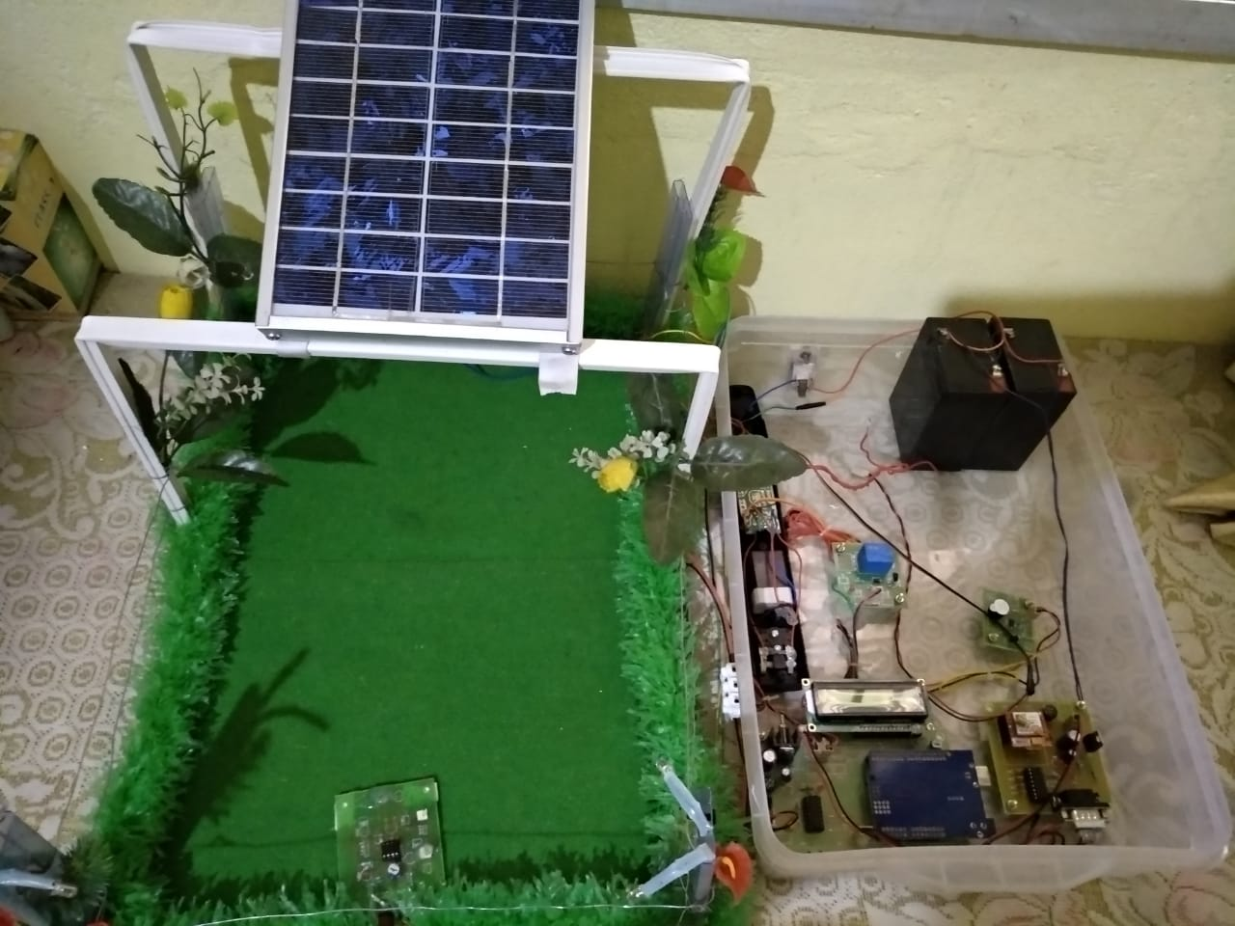
REFRENCES
[1] M. G. B. De Martino, F. S. Dos Reis, and G. A. D . Dias, “An electric fence energizer design method,” in Proc. IEEE Int. Symp. Industrial Electronics ,Conf., 2006.

[2] Luo and Ye,“Positive output cascade boost converters”,IEE Proc.- Electr. Power Appl., Vol. 151, No. 5,2004

[3] F.L.Luo, “Re-Lift Circuit: a new DC-DC step-up (boost) converter” , IEE Electronics Letters, 33(1), 5-7, 1997.

[4] F.L.Luo, “Re-Lift converter: design, test, simulation and stability analysis”, IEE Proceedings on EPA, 45(4), 315-325, 1998.

[5] F.L.Luo, Luo converters , “ New DC-DC step-up converters”, Proceedings of the International Conference ISIC- 97,Singapore, 227-230, 1997.

[6] F.L.Luo, Luo converters, “A series of new DC-DC step-up (boost) conversion circuits”, Proceedings of IEEE International Conference PEDS’97, Singapore, 582-589.

[7] Modeling pulse reflections due to multiple discontinuities on electric fence structures – IEEE Conference Publication", Ieeexplore.ieee.org, 2017. [Online]. Available: http://ieeexplore.ieee.org/stamp/stamp.jsp?arnumber =4608687. [Accessed: 19- Sep- 2017].

