**Smart Helmet**

**Dipak Patle1, Pankaj Selokar2**, **Ketan Katekhaye3**, **Abhishek Rotake4**, **Mohammad Naseer5**, **Ashwini Lade6**

*5AssociativeProfessor,6AssitantProfessor,1-4Students*

*Dept. of Electronics and communication engg. MIET Shahaour, Bhandara 441904*

ABSTRACT - Now a days most of the countries are enforcing their citizen to wear helmet while riding bike and not to ride bike when the person is under the influence of alcohol, sleeping ,but still rules are being violated. In order to overcome this problem “accident detection, alcohol detection, eye blinking, bluetooth connectivity, protection using gsm & gps based smart helmet

Keywords - gps, gsm, alcohol sensor, eye blinker, bluetooth connectivity .

**A. Introduction**

The project aim of the security and safety of the bikers against road accidents. A smart helmet is special idea which make motor cycle driving safer than before, this is implemented using gsm and gps technology.

The other advantage of this project is to measure the alcohol level of drunken people who is riding bike. We are developing an embedded kit or embedded system which will be placed in helmet. Consist of some sensors and electronic circuitry which continuously monitoring and measuring the alcohol level and condition of accelerometer. We measure the alcohol level and show it in the lcd display. Whenever the alcohol level crosses the predefined value the alarm starts and we get notification about the drunken person.

The eye blink sensor measures the eye blinking time continuously . Whenever the eye do not open the eyes then the alarm will start.

The one of the advantage of this helmet is when rider is riding the bike if normally call is coming then the riders get distracted but by using this helmet there is no chances of distracting of rider because the bluetooth connectivity is there for receive the calls.

An accident is an unexpected and unintended event. in today’s world road accidents stand among the leading cause of human death, road safety for driver is an essential requirement of society, as the number of vehicles increase day by day, collision of vehicle also increases simultaneously, in this situation this project fulfills the purpose of saving lives. helmet is best safety equipment for driver. in this system initially we try to avoid accidents by using, the sensor will activate the gps to find the location and further sms will send to ambulance and family members. this will optimize accidents as well as human death ratio by accidents due to providing proper care with in time frame.

**b. Working principle:**

The working principle of the smart helmet is very simple. Helmet hit the ground, this sensors sense and gives to the microcontroller .then controller extract gps data using gps module then alarm will run until the message goes. If the rider continues to sleep the eye blinker sensor play the alarm. Bluetooth receives the call when rider riding the bike.

This project is mainly to detect the alcohol drunken people. Here we are using microcontroller which is interfaces to alcohol sensor. Alcohol sensor is a sensor that measures the amount of alcohol that is present in surrounding environment. If any drunken person came, alcohol sensor sense it and passes it to controller through adc.

c. Block diagram**:**



Fig.1. Block Diagram Of Smart Helmet Using GSM, GPS Based System.

1. Micro-Controller Board: It Is A Low Power, High-Performance Cmos 8-Bit Microcomputer With 8k Bytes Of Flash Programmable And Erasable Read Only Memory Rom). The Device Is Manufactured Using Atmel’s High-Density Nonvolatile Memory Technology And Is Compatible

With The Mcs-51. Instruction Set And Pin Out. The On Chip Flash Allows The Program Memory To Be Reprogrammed In-System Or By A Conventional Nonvolatile Memory Programmer. By Combining A Versatile 8-Bit Cpu With Flash On A Monolithic Chip, It Provides A Highly Flexible And Cost Effective Solution So Many Embedded Control Applications.

Gsm Modem:

Gsm (Global System For Mobile Communications) Is An Open, Digital Cellular Technology Used For Transmitting Mobile Voice And Data Services. Here We Are Using It Only For Transmitting And Receiving The Messages. Gsm Wireless Data Module Is Used For Remote Wireless Applications, Machine To Machine Or User To Machine And Remote Data Communications In Many Applications. Microcontroller Sends At Commands To Gsm Modem And Accordingly It Operates.

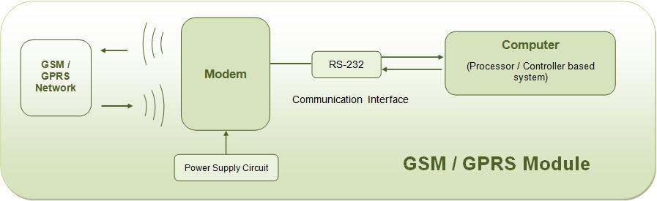

Fig. 2.Gsm And Gprs Module.

2. Adc: A/D Converter Is That It Can Continuously Follow The Input Signal And Give Updated Digital Output Data If The Signal Does Not Change Too Rapidly. In Addition, For Small Input Changes, The Conversion Can Be Quite Fast.

3. Accelerometer/Vibration/Tilt Sensor

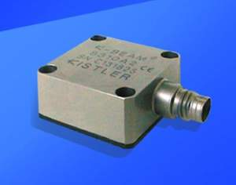

Fig.3. Accelerometer.

Accelerometer Sensor Can Measure Static (Earth Gravity) Or Dynamic Acceleration In All Three Axis. Application Of The Sensor Is In Various Fields And Many Applications Can Be Developed Using This Sensor. Accelerometer Sensor Measures Level Of Acceleration Where It Is Mounted This Enable Us To Measure Acceleration/Deceleration Of Object Like Vehicle Or Robot, Or Tilt Of A Platform With Respected To Earth Axis, Or Vibration Produced By Machines.

4. Power Supply:

Initial Stage Of Every Electronic Circuit Is Power Supply System That Provides Required Power To Drive The Whole System. The Specification Of Power Supply Depends On The Power Requirement And This Requirement Is Determined By Its Rating. For Our Project We Require + 5 Volt.

5.Eye Blink Sensor:

Eye Blink Sensor Is Used For Eye

Blinking Measure Time

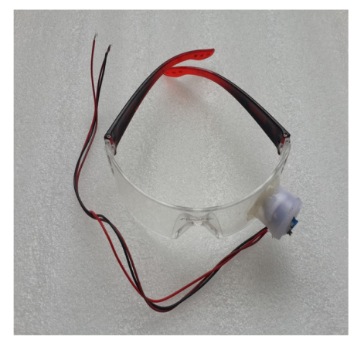

Fig..6-.Eye Blink Sensor

6. **.**GPS Tracking Location:

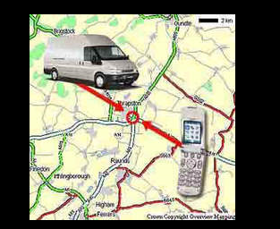

Fig 4.Gps Tracking Location.

The Gps Concept Is Based On Time And The Known Position Of Specialized Satellites. The Satellites Carry Very Stable Atomic Clocks That Are Synchronized With One Another And To Ground Clocks. Any Drift From True Time Maintained On The Ground Is Corrected Daily. Likewise, The Satellite Locations Are Known With Great Precision.

Gps Receivers Have Clocks As Well; However, They Are Usually Not Synchronized With True Time, And Are Less Stable. Gps Satellites Continuously Transmit Their Current Time And Position. A Gps Receiver Monitors Multiple Satellites And Solves Equations To Determine The Precise Position Of The Receiver And Its Deviation From True Time. At A Minimum, Four Satellites Must Be In View Of The Receiver For It To Compute Four Unknown Quantities (Three Position Coordinates And Clock Deviation From Satellite Time)

**7.Bluetooth Connectivity :**

It Is Used For Receiving The Call

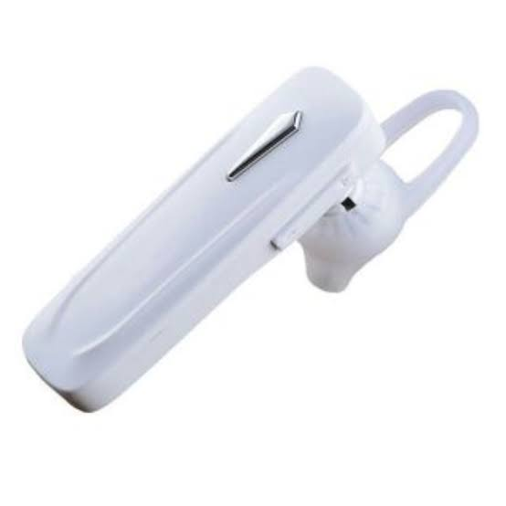

Fig. 7- Bluetooth Connectivity:

**8. Alcohol detector:**

It is used for measure the consumption of alcohol & it is continuously monitoring the rider.



Fig.8.Alcohol Detector:

**D. SOCIETAL BENEFITS:**

The safety helmet system devised aims to reduce the number of deaths caused by not wearing helmets. We want the riders to be safe and adhere to the law. As for a society we would want to see more discipline when it comes to commuting. Pollution statistics keep the citizens informed about the pollution of the locality they live in. As people become aware of the pollution levels they transform into a more concerned and responsible human beings thus making them more disciplined. As this change begins our environment will be more livable, safer, healthier and friendly

E. **CONCLUSION**.

In this project, we developed a smart helmet based system which was successfully able to detect whether the rider as worn the helmet or not. It also sets an alarm if he has consumed alcohol beyond permissible levels. Also sets an alarm if he is asleep. Apart from this, the system also monitors atmospheric pollution levels

**F. REFERENCE**

[1] *Manjesh n, prof. Sudarshan raj,” smart helmet using gsm & gps technology for accident detection and reporting system”, international journal of electrical and electronics research, vol. 2, october - december 2014*

*[2] Abhinavanand “alcohole detection”, department of electronics and telecommunication, ijeetc, vol. 4, april 2015*

*[3] Rasli, mohd, et al. "smart helmet with sensors for accident prevention." electrical, electronics and system engineering (iceese)”, 2013 international conference on.ieee, 2013.*

*[4] Nitinagarwal, anshul kumar singh, pushpendrapratap singh, rajesh sahani “smart helmet” international research journal of engineering and technology, vol:2, issue:2, may 2015*

*[5] Manjesh n “smart helmet using gsm & gps technology for accident detection and reproting system” internal journal for electrical and electronics research, vol:2, issue:4, october 2014 [4] micheal margolis “arduino cookbook” o’reilly media, published 2011.*