Hand Gesture Based Wheelchair Movement Control for Disabled Person Using MEMS.

Akshita K. Bagade¹Bhavina G. Namurte²Puja G.Vaidya³Neha S.Bharatkar⁴
Unnati R. Kamble⁵I.P. Nikose⁶ T.Raut⁷

^{1,2,3,4,5} B.E. student⁶Associative Professor⁷ Assistant Professor
Department Of Electronics and communication Engineering , MIET Shahapur, Bhandara, India

Abstract-This paper is to develop a wheel chair control which is useful to the physically disabled person with his hand movement or his hand gesture recognition using Acceleration technology.Tremendous leaps have been made in the field of wheelchair technology. However, even these significant advances haven‟t been able to help quadriplegics navigate wheelchair unassisted.It is wheelchair which can be controlled by simple hand gestures. It employs a sensor which controls the wheelchair hand gestures made by the user and interprets the motion intended by user and moves accordingly.In Acceleration we have Acceleration sensor. When we change the direction, the sensor registers values are changed and that values are given to microcontroller. Depending on the direction of the Acceleration, microcontroller controls the wheel chair directions like LEFT, RIGHT, FRONT, and BACK. The aim of this paper is to implement wheel chair direction control with hand gesture reorganization.
Keywords- Micro-electromechanical systems (MEMS), wheelchair..

- INTRODUCTION
This paper proposes an integrated approach to real time detection, tracking and direction recognition of hands, which is intended to be used as a human-robot interaction interface for the intelligent wheelchair. This paper is to demonstrate that accelerometers can be used to effectively translate finger and hand gestures into computer interpreted signals. For gesture recognition the accelerometer data is calibrated and filtered. The accelerometers can measure the magnitude and direction of gravity in addition to movement induced acceleration. In order to calibrate the accelerometers, we rotate the device’s sensitive axis with respect to gravity and use the resultant signal as an absolute measurement. Integrating a single chip wireless solution with a MEMS accelerometer would yield an autonomous device small enough to apply to the fingernails, because of their small size and weight. Accelerometers are attached to the fingertips and back of the hand. Arrows on the hand show the location of accelerometers and their sensitive directions, that the sensitive direction of the accelerometer is in the plane of the hand.The gesture based wheelchair is suitable for the elderly and the physically challenged people who are unfortunate to have lost ability in their limbs due to paralysis or by birth or by old age. Elders find it tough to move inside the house for day to day activities without help or external aid. Our proposed system makes use of a wheelchair that can be used by elderly or physically. Challenged to move inside the home without difficulty and without external aid. The elders may also forget the way to the different rooms in house due to the increase in forgetfulness as they become older. The physically challenged, find difficult to move the wheel chair without help from others. By making use of the system, the elderly and the physically challenged can go to different rooms in the house like kitchen, living room, dining room etc by just showing a gesture which is predefined to that particular room. It is also a virtue of the system that even the foot can be substituted in place of the hand for users who might find that more convenient. The aim of this project is to controlling a wheel chair and electrical devices by using MEMS ACCELEROMETER SENSOR (Micro Electro-Mechanical Systems) technology. MEMS ACCELEROMETER SENSOR is a Micro Electromechanically Sensor which is a highly sensitive sensor and capable of detecting the tilt. This sensor finds the tilt and makes use of the accelerometer to change the direction of the wheel chair depending on tilt. For example if the tilt is to the right side then the wheel chair moves in right direction or if the tilt is to the left side then the wheel chair moves in left direction. Wheel chair movement can be controlled in Forward, Reverse, and Left and Right direction along with obstacle detection using ultrasonic sensor. Automation is the most frequently spelled term in the field of electronics. The hunger for automation brought many revolutions in the existing technologies. One among the technologies, which had greater development, is the MEMS ACCELEROMETER SENSOR. These had greater importance than any other technologies due to its user-friendly nature. MEMS ACCELEROMETER SENSOR based devices can be easily reachable to the common man due to its simpler operation.

II. NEED OF PROJECT

This paper to develop a wheel chair control which is useful to the physically disabled person with his hand movement or his hand gesture reorganization. With the help of the wheel chair physically disabled person would able to move himself to the desired location with the help of hand gestures which controls the movement of the chair. This paper aims to provide a feasible solution to those handicapped people who do not have the ability to maneuver the wheelchair by themselves. These include people with serious paralytic condition. Wheelchair automated control systems proved to be versatile tools for many problems in human-computer interface systems. Basically, they are used for providing better usability of a computer or a system for people, including

III. LITERATURE SURVEY
When an unfortunate event affects the motor capacity of a person, it is necessary to use devices like wheelchairs that offer a means of displacement for patients with motors problems of the lower limbs. Tremendous leaps have been made in the field of wheelchair technology. However, even these significant advances haven‟t been able to help quadriplegics navigate wheelchair unassisted. Some patients that cannot manipulate the wheelchair with their arms due to a lack of force or psychomotor problems in the superior members, request electric wheelchairs, frequently manipulated with joysticks; however the joystick manipulation is even not practical and frequently it must be handle with the mouth. The present article presents the partial results in the development of a wheelchair controlled by an intuitive interface, where the instructions are given by hand gesture instructions. The advances are presented in the realization of the control software using a Webcam and some distances and presence sensors controlled by a PIC microcontroller that establishes the communication with a program developed in Lab view. This paper is inspired from an IEEE Research Paper Titled „A Wearable Head- Mounted Sensor-Based Apparatus for Eye Tracking Applications‟ that was presented in the IEEE International Conference on Virtual Environments, Human-Computer Interfaces, and Measurement Systems Istanbul, Turkey, dated 14-16 July 2008. The above paper approach was dealing with wheelchair control using eye ball movement with slight modification to it. Our paper deals with the control of wheelchair motion by hand gesture.
IV.TRANSMITER :
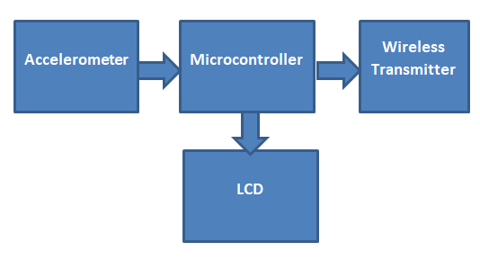
V. RECEIVER END
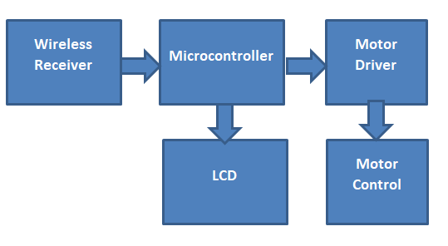
VI. Conclusion and future scope
Our paper is capable to control the wheelchair motion fordisabled people using hand gesture. Improvements can be made by using various body gestures such as eye gaze, legmovement or head movement accordingly.
Voice monitoring helps the disabled person to determine the obstacle by acknowledging with alarm signals with slight modification in power section by monitoring the battery voltage levels to enhance the speed and estimate the delay for action to be taken.to enhance the speed of the wheelchair dc motors can be replaced by servomotors.

RESULT
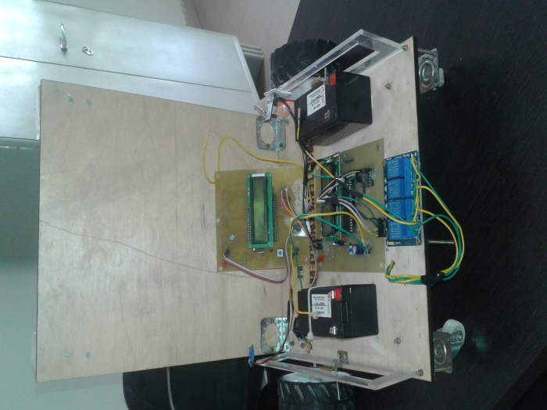

REFERENCE
[1] L.Josefsson and P.Persson, Conformal Array Antenna Theory and Design

[2] R. Ghodssi, P. Lin (2011). MEMS Materials and Processes Handbook. Berlin: Springer

[3] “A Wearable Head- Mounted Sensor-Based Apparatus for Eye Tracking Applications” IEEE International Conference on Virtual Environments, Human-Computer Interfaces, and Measurement Systems Istanbul, Turkey, dated 14-16 July 2008.

[4] A. Murarka, M. Sridharan and B. Kuipers. 2008. “Detecting obstacles and drop-offs using stereo and motion cues for safe local motion”.IEEE/RSJ International Conference on Intelligent Robots and Systems (IROS-08).

[5] ShilpaGulati, Benjamin Kuipers2008. “High Performance Control for Graceful Motion of an Intelligent Wheelchair”.Proceedings of the IEEE International Conference on Robotics and Automation (ICRA).

[6] Marhic, B. “ Robotic assistance: an automatic wheelchair tracking “Intelligent Robots and Systems, 2005. (IROS 2005). 2005 IEEE/RSJ

