Transformer Incipient Fault Monitoring Using DGA

**Atul A. Barhate1, Dr. P. J. Shah2, Dr. Manoj E. Patil3**

*1Research Scholar, SSBT’s College of Engineering Jalgaon, India,*

*2Professor,Shree Balaji Institute of Technology and Management, Betul,*

*3Associate Professor, SSBT’s College of Engineering Jalgaon,*

***atbarhate@gmail.com***

***Received on****: 30 April, 2023* ***Revised on****: 23 May, 2023* ***Published on****: 25 May, 2023*

***Abstract –*** *Dissolved gas analysis (DGA) is most reliable and trustful tool for monitoring the health status of transformer. Using DGA can monitoring the status of concentration level of various combustible gaseous in transformer oil? The concentration of combustible gaseous use as determining the status of transformer oil to diagnose the incipient fault or indicator of undesirable event inside the transformer transformer has may be suffer from incipient fault such as partial discharge, electrical arcing, overheating, hot spot. Here neural network is used to diagnose the status of transformer to reduce human error as well as time. Here DGA data is get from various substation and analyses it and reach to conclusion that which type of fault to be occur in transformer and can save the transformer.*

***Key words****— Dissolved Gas Analysis, Neural Network, Fuzzy logic*

**I -INTRODUCTION**

**P**ower transformer is important equipment in power system, its status of service directly impact on stability and safety of power system. Discover the incipient fault in power transformers timely and accurately is very much important by using any electrical or non-electrical methods. Specially dissolved gas analysis is more accurate and sensitive to find out incipient of hidden faults in oil immersed power transformer. There are many diagnostic methods put forward in the recent decades based on DGA, such as the key gases, the IEC triple-ratio method and that of the Institute of Electric Research of Japan, Practically there is uncertainty always present in existing diagnosis and it cannot remove obsolesce, due to ambiguity in inference so proper judgment can’t receive.

Incipient fault of power transformer can be detect by using d technique. Here artificial neural networks (ANN) applications is used for detection of incipient fault in power transformer. The fault diagnosis is based on dissolved gas-in oil analysis (DGA). Using the historical transformer dissolved gases values and multi-layer Perceptron (MLP) neural network is applied.. The proposed work can overcome the drawbacks of previous methods. This work is simulated and tested.

**II - LITERATURE REVIEW**

**Roger’s ratio**

The Rogers' method uses four ratios, viz. CH4/H2, C2H2/CH4, C2H4/C2H6 and C2H2/C2H4. Using roger’s ratio the various codes developed and this four conditions are detectable, i.e. normal ageing, partial discharge, thermal fault and electrical fault of various degrees of severity. The Roger’s ratio method better than Orenburg’s method since a roger’s method has wide range combination of ratio so there is reduction of 'no-interpretation’. Nevertheless, no consideration is given for dissolved gases below 'normal' concentration values. Therefore, many miss-interpreted cases may be existence due to exact implementation of Rogers' method.

The original Rogers ratio method used Table for diagnosis, where a 1 indicates that the actual value is above 1.0, and a 0 indicates that the actual value is below 1.0. The refined Roger’s method used two tables: one defined the code, and the other defined the diagnosis rule, as shown in Tables. These preliminary methods used four ratios. The ratio ethane/methane (C2H6/CH4) only indicated a limited temperature range of decomposition, but did not assist in further identification of the fault. Therefore, in IEC standard 599, the further development of Rogers’s ratio method, it was deleted.

**Key gas method**

Double laboratories had started study of key gas method and was summarized in 1973 and officially proposed in 1974. In 1978, a comparison between the key gas method and the Rogers ratio method was presented at the Doble annual conference. It was realized that ratio methods were devised for use on conservator-type transformers, but the key gas method was developed mainly from either sealed or gas blanketed transformer. Griffin gave an extensive review on the key gas method, the ratio methods, and related application issues.

The key gas method find out the key gas for each type of fault and it uses the percent of this gas to diagnose the fault. It interprets DGA results based on a simple set of facts.

For example, low intensity PD or corona produces mainly H2 with trace amounts of some hydrocarbon gases, so the key gas for PD or corona is H2, and PD or corona can be detected if the percent amount of H2 is large in an oil sample.

**III - METHOLOGY**

P (1) and P (2) are scalar inputs and are transmitted through a connection that multiples its strength by the scalar input. WP is the only weightage of the transfer function F, which produced the scalar output a. At the right side neuron has scalar bias The neuron on the right has a scalar bias, b. It may view the bias as simply being added to the product us as shown by the summing junction or as shifting the function f to the left by an amount b.

Bias acts as weights, except that it has a constant input of 1. The transfer function net input n, again a scalar, is the sum of the weighted input wp and the bias b. This sum is the argument of the transfer function f. Here F is a transfer function, here step function or a sigmoid function, which takes the argument n and produces the output a. Note that weightage and bias are both adjustable scalar parameters of the neuron. These parameters can be adjusted so that the network exhibits some desired or interesting result.

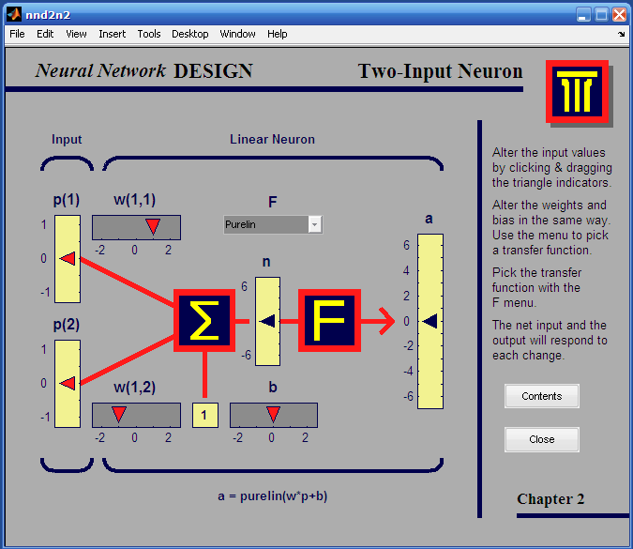

*Fig. 1- Two Input Neuron Model*

Train the neural network by adjusting the weight or bias or sometimes the network itself will adjust these parameters to achieve some desired result. All of the neurons in this toolbox have provision for a bias, and a bias is used in many of our examples and will be assumed in most of this toolbox. However, the constant 1 that drives the bias is an input and must be treated as such when considering the linear dependence of input vectors in Linear Filters.

**IV- SYSTEM DEVELOPMENT**

**ANN development**

Log-sigmoid and tan-sigmoid transfer functions are used in back propogation network. Each neuron output in first layer is given by:



a1 = F1 (w1* p + b1) (1)

And output of the second layer is:

a2 = F2 (w2 * p + b2)

= F2 [w2 * F1 (w1* p + b1) + b2)] (2)

Where p is the input to the first layer; Transfer function of first and second layers are F1 and F2 respectively, the biases of first and second layer are b1 and b2 respectively and The connection weights of the first and second layers w1 and w2 respectively. The network is trained to learn the relationships between the inputs and target outputs. For training, a number of pairs of input patterns p and target patterns t are presented to the ANN and then the ANN is asked to adjust weights in all connecting links and also the biases in the nodes such that the desired output patterns are produced at output nodes. In general, the network output a2 will not be same as the target or desired values, i.e. t for each pattern, the Sum Square of the Error is:

SSE = 1/2 ∑ ║t – a2║ (3)

The main goal of back-propagation (BP) algorithm is to adjust the connection weights w and biases b to minimize error between desired output and actual network output. Generalized delta rule (GDR) is used to achieve the goal. To achieve convergence towards improved values for the weights and biases, the incremental changes in weight and bias can be calculated by using following equations:

∆w1 = η δ 1  p (4)

∆b1 = η δ 1  (5)

∆w2 = η δ 2  a1  (6)

∆b2 = η δ 2  (7)

Where η is the learning rate constant.

δ 2 = (t – a2) F'2 (8)

and

δ 1 = w1(s1) δ 2 F'1 (9)

Back-propagation network is very slow because it requires small learning rate for stable learning. Sejnowski and Rosenberg (1987) described a method for improving the training time of back-propagation algorithm based on exponential smoothing. The method involves adding a term to the weight adjustment that is proportional to the amount of previous weight change.

∆ ω(i+1)=(1- α) η δp+ α∆ ω(i) (10)

where α is the smoothing coefficient in the range of 0.0 to 1.0. α is the learning rate constant. Adaptive learning rate are used to reduce the training time, so that it attempts to keep the learning step size as large as possible while keeping learning process stable. In the current study, the ANN is trained using the Adaptive back-propagation learning algorithm as described above. This algorithm consists of repeatedly passing the training sets through the neural network until its weights and biases minimize the output error the entire set of inputs. The learning rate (α) is updated during training process. First, the initial network output and error are calculated. New weights and biases are calculated using the current learning rate at each epoch. New output and error are then calculated. If the new exceeds the old error by more than a predetermined ratio (1.05), the new weights, biases, output and error are discarded. In addition, the α is decreases (by multiplying it by 0.74), otherwise the new weights etc are kept. If the error is less than the old error, the α is increased (by multiplying it by 1.05).

**Fuzzy Inputs - Gas Ratios**

In fuzzy diagnosis, each crisp value (Code 0, 1 or 2) of gas ratio CH4/H2 is represented by a Gaussian Bell fuzzy-membership function illustrated in figure 2. The same follows for the other 3 gas ratios C2H2/CH4, C2H4/C2H6, and C2H2/C2H4

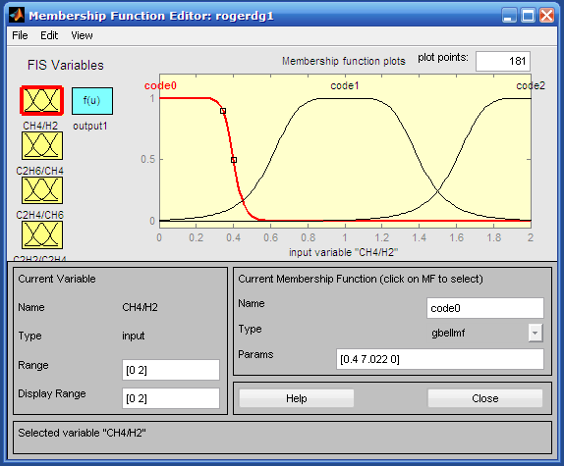

*Fig – 2: Membership Function Editor*

**Rule Editor**

Although the fuzzy rules appear strictly defined, borderline cases with gas ratios on or near the line between code 0, 1 or 2 allows FIS to interpret membership of these rules flexibly, and classify these cases under two different fault types with individual probability of occurrence attached to each type.

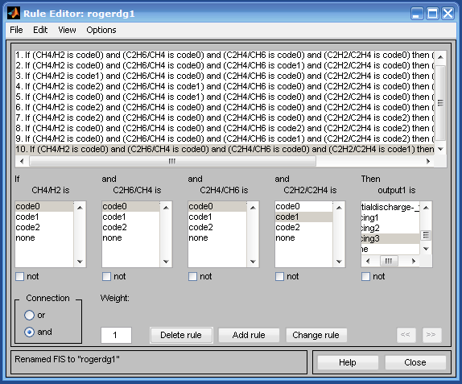

*Fig. 3 – Rule Editor*

FIS involves the operations between input fuzzy sets, as illustrated graphically in figure 3 Known as the Sugeno type; FIS derives output fuzzy sets from “judging” all the fuzzy rules by finding the memberships for the fault types as represented by the 10 fuzzy output rules.

**V- RESULT & DISCUSSION**

Table: 1 Pattern values

|  |  |  |  |  |  |
| --- | --- | --- | --- | --- | --- |
| Pattern Number | H2 | CH4 | C2H6 | C2H4 | C2H2 |
| 1 | 48 | 43 | 3 | 75 | 81 |
| 2 | 318 | 337 | 57 | 583 | 641 |
| 3 | 338 | 32 | 1 | 32 | 50 |
| 4 | 114 | 1417 | 296 | 2096 | 0 |
| 5 | 2 | 4 | 3 | 4 | 0 |
| 6 | 21 | 34 | 5 | 47 | 62 |
| 7 | 37 | 75 | 126 | 5 | 0 |
| 8 | 59 | 339 | 42 | 392 | 1 |
| 9 | 13 | 10 | 4 | 13 | 0 |
| 10 | 800 | 1393 | 304 | 2817 | 3000 |

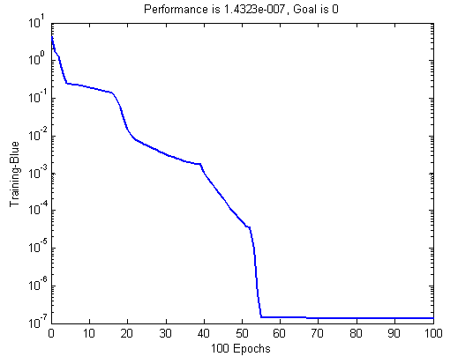

*Fig. 4 Training of Pattern*

*Table 2 – ANN based Fault diagnosis*

|  |  |
| --- | --- |
| Pattern Number | Diagnosis |
| 1 | Arcing |
| 2 | Arcing |
| 3 | Partial Discharge |
| 4 | Overheating |
| 5 | Normal |
| 6 | Arcing |
| 7 | Normal |
| 8 | Overheating |
| 9 | Normal |
| 10 | Arcing |

**Rule View:**

The Rule Viewer displays a roadmap of the whole fuzzy inference process. It’s based on the fuzzy inference diagram. A single figure window with 10 small plots nested in it. The five small plots across the top of the figure represent the antecedent and consequent of the first rule. Each rule is a row of plots, and each column is a variable. The first four columns of plots (the forty yellow plots) show the membership functions referenced by the antecedent, or the if-part of each rule. The fifth column of plots (the ten blue plots) shows the membership functions referenced by the consequent, or the then-part of each rule. If you click once on a rule number, the corresponding rule will be displayed at the bottom of the figure. Notice that under C2H2/C2H4, there is a plot which is blank. This corresponds to the characterization of none for the variable C2H2/C2H4 in the second rule. The eleventh plot in the fifth column of plots represents the aggregate weighted decision for the given inference system. This decision will depend on the input values for the system.

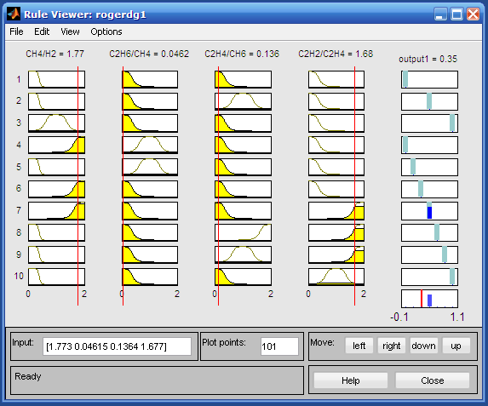

*Fig. 5 – Rule View*

**Rule View**

If we follow rule 1 across the top of the diagram, we can see the consequent has been truncated to exactly the same degree as the (composite) antecedent—this is the implication process in action. The aggregation occurs down the fifth column, and the resultant aggregate plot is shown in the single plot to be found in the lower right corner of the plot field. The defuzzified output value is shown by the thick line passing through the aggregate fuzzy set. The Rule Viewer allows to interpret the entire fuzzy inference process at once. The Rule Viewer also shows how the shape of certain membership functions influences the overall result. Since it plots every part of every rule, it can become unwieldy for particularly large systems, but, for a relatively small number of inputs and outputs, it performs well (depending on how much screen space you devote to it) with up to 30 rules and as many as 6 or 7 variables. The Rule Viewer shows one calculation at a time and in great detail. In this sense, it presents a sort of micro view of the fuzzy inference system. If you want to see the entire output surface of your system, that is, the entire span of the output set based on the entire span of the input set, it need to open up the Surface Viewer.

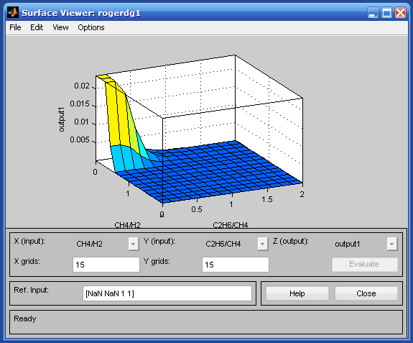

*Fig. 6 – Surface view*

Sugeno FIS represents each output membership function by a single spike rather than a distribution curve. The solution is arrived by taking the weighted average of these spikes (fuzzy output rules). As illustrated in figure 4.3, the blue spikes are the Sugeno outputs from each of the 10 fuzzy rules, denoting probabilities (from 0 to 1) for belonging to the fault type denoted by each fuzzy rule.

Upon opening the Surface Viewer, It presented with a two-dimensional curve that represents the mapping from service quality to tip amount. Since this is a one-input one-output case, we can see the entire mapping in one plot. Two-input one-output systems also work well, as they generate three-dimensional plots that MATLAB can adeptly manage. When we move beyond three dimensions overall, we start to encounter trouble displaying the results. Accordingly, the Surface Viewer is equipped with pop-up menus that let you select any two inputs and any one output for plotting. Just below the pop-up menus are two text input fields that let you determine how many x-axis and y-axis grid lines you want to include. This allows you to keep the calculation time reasonable for complex problems. Pushing the Evaluate button initiates the calculation, and the plot comes up soon after the calculation is complete. To change the x-axis or y-axis grid after the surface is in view, simply change the appropriate text field, and click on either X-grids or Y-grids, according to which text field you changed, to redraw the plot. The Surface Viewer has a special capability that is very helpful in cases with two (or more) inputs and one output: you can actually grab the axes and reposition them to get a different three-dimensional view on the data. The Ref. Input field is used in situations when there are more inputs required by the system than the surface is mapping. We have a four-input one-output system and would like to see the output surface. The Surface Viewer can generate a three-dimensional output surface where any two of the inputs vary, but two of the inputs must be held constant since computer monitors cannot display a five-dimensional shape. This concludes the quick walk-through of each of the main GUI tools. Notice that for the fault problem, the output of the fuzzy system matches our original idea of the shape of the fuzzy mapping from service to fault fairly well.

**VI- CONCLUSION**

The evaluation of selection of the training network training cases indicates that the performance of the neural network significantly affected by the selection of cases used to calculate the weights**.** This logically follows from the fact that the model is based on a self-learning concept.

Back propagation network is identified as the proper choice for transformer incipient fault diagnosis. It has been concluded that for normal, overheating, corona, arcing diagnosis, five gas in-oil concentrations including H2, CH4, C2H2, C2H4 and C2H6 are suitable.

High diagnosis accuracy is obtained through the proposed scheme. This method can provide useful information for future fault trends and do not require any expertise to train the network. The tested data demonstrate the success of proposed scheme.

An important advantage of ANN-based fault diagnosis is that it can learn directly from the training samples, and update its knowledge whenever necessary. The highly non-linear mapping capability of the neurons provides a comparable and often superior performance over fuzzy system solutions. ANN computational complexity is not too high, especially in the testing (diagnosis) process.

It is seen that in fuzzy diagnosis system is insensitive to errors in the oil sampling, storage and testing processes.

Fuzzy Approach having drawback is that it is bonded with conventional DGA methods, and cannot learn directly from data samples.

**REFERENCES**

1. *Abolfazl Salami1, Parvaneh Pahlevani “Neural Network approach for fault diagnosis of transformer” IEEE transaction 978-1-424-1622-6/08.*
2. *Sam J. Ferrito “Comparative study of dissolved gas analysis technique” IEEE Transaction on power delivery , 1990, volume 5, pp. 220-225.*
3. *Y. Zhang, X. Ding, Y. Liu, P.J. Griffin “An artificial neural network approach to transformer fault diagnosis” IEEE Trans. Power Delivery volume11, 1996, pp. 1836-1841*
4. *G. N. Swami & G. Vijay Kumar, “ Neural Networks” Scitech Publication. laf Diegel, Aparna Badave, Glen Bright, Johan Potgieter,*
5. *Sylvester Tlale, (2002) “Improved Mecanum Wheel Design for Omni-directional Robot”, Australasian Conference on Robotics And Automation, Auckland.*
6. *B. Yegnanarayana, “Artificial Neural Networks” Prentice hall India*
7. *N. Yadaiah , Nagireddy Ravi “Fault Detection Technique for Power Transformer” IEEE transaction ,2007, pp. 1291-1299.*
8. *Diagnosis” IEEE Transaction Power Delivery, volume 18, 2003, pp. 164-169*
9. *T. K. Saha, “Review of modern diagnostic techniques for assessing insulation condition in aged transformers” IEEE Trans. Dielectrics Electric Insulation Volume10, 2003, pp. 903–917.*
10. *E. Dornenburg, O.E. Gerber, “Analysis of Dissolved and Free Gases for monitoring Performance of Oil-Filled Transformers” The Brown Boveri Review, 54 (2/3):104- 11, 1967.*