Impact Factor Value 4.046 e-ISSN: 2456-3463
National Conference on “Emerging Trends In Engineering & Technology”
Organized by Manoharbhai Patel Institute Of Engineering & Technology Shahpur, Bhandara
International Journal of Innovations in Engineering and Science, Vol. 4, No. 5, 2019

www.ijies.net
Online Bus Pass Generation & Inspection Using Website & Android App
Omkar Harshe1, Sahista Khan2, Aashna Khan3, Jaya Kamale4, Lalita Bhivgade5 Jayant Rajurkar6

6Assitant Professor,1-5Students
Dept. of Computer Engineering, MIET Bhandara , (MH)

Abstract— This is real time project provides an effective solution for managing bus pass information. It is useful for students who are facing problems with the current manual work of bus pass registration and renewal. This system has three logins for user, admin and conductor. This system provides web application as well as android application for people to get their Bus passes online. This system is useful for users to get their bus pass online instead of standing in long queues to obtain their bus passes. User can refill their account and extend the validity of card when the pass is going to expire. The conductor in bus would be able to verify the pass by checking the ID provided by the user. And the attendance of the user will get updated in the student app everyday.

Keywords- Login, Authentication, Generation, Inspection, Notification.

- INTRODUCTION

In present era we are using passes or tickets to travel by a bus. There are various types of passes such as student passes, private passes, etc. To issue passes from the bus depot, we have to go to the bus depot and submit the documents, fill up the pass application, verify documents and pay the fees to the issuer and then we get a pass. This task takes too much time as we have to stand in the long queues present there. Sometimes we have to return back as there is no availability of the pass issuer. Such type of pass creation is not only time consuming but also not reliable always. After getting pass there is need to renew the pass every month and it is again not reliable always. Our project is created to provide time saving, comfortable and safe services for students. Due to the drawbacks that are present in the existing system, we got the idea of doing this project of generating the bus pass through online which can help students in a better way. In the existing system student had to do each and every process manually, but our project
helps student to make their work faster and easy. Students can collect the bus pass through the intent. This system is also used the to save the students time. Project comprises of website and android app to check a pass digitally to make process faster and reliable.

- RELATED WORK
- “Development of an Effective Online Bus Pass Generation System” was published by Parashuram Baraki, Sandhya Kulkarni in 2015 in Karnataka. This project is mainly aims to provide an effective facility of online bus passes. This system was intended to develop an application to perform functions like accessing information for authentication and provide pass to particular person. So, users don’t need to stand in queue for long time. This system is helpful for people to get a pass.

- “A Survey on Online Bus Pass Generation System Using Aztec Code” published by Akshaya k Abhishek Chowdhury, et al in 2016.This system is intended to perform functionalities like accessing basic information for authentication and provide authenticity of the pass by scanning the Aztec code.

- “Online Bus Pass Renewal System Using Web Application” published by S.Famtha ,M.Vasanthi, et al in 2016 in Tamilnadu in which verification can be done by sending OTP to users mail The administrator will verify the student details and if they are satisfied they will approve bus pass. The pass will be generated and send to student’s mail. The student can login with their college id no and password and then renewal can be performed.

Impact Factor Value 4.046 e-ISSN: 2456-3463
National Conference on “Emerging Trends In Engineering & Technology”
Organized by Manoharbhai Patel Institute Of Engineering & Technology Shahpur, Bhandara International Journal of Innovations in Engineering and Science, Vol. 4, No. 5, 2019

www.ijies.net

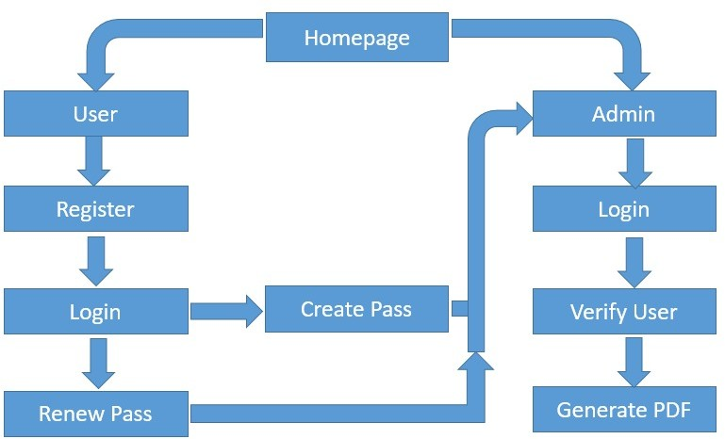
- “Digital Bus Pass Using QR Code” published by Snehal Banale, Prajakta Dudhade in 2017. This project provides an eﬀective solution for managing bus pass information using a database. system has three logins for user, admin and conductor. This system provides web application as well as android application for people together. Bus passes online. This system provides security option for user. The conductor in bus would be able to verify the pass by scanning QR code provided on the pass with a recommended device. The notification generated by the system would be send to the user in form of message such as when where and what time the card was use. This system also provides online payment facility.

- PROPOSED METHOD

The proposed system is invented to overcome the drawback of the currently existing manual system. This system is web based and android based application for user to get bus pass online as well as pass checking by conductor. In this project, we maintain two portals, one for administrator and another for conductor & users to maintain transparency in the system. This project replaces the concept of QR code with unique ID as scanning of QR code is a time consuming process. The proposed system provides additional functionalities by conveying bus delay message from the admin to the users.

Fig 1. Architecture of web application for pass generation.

The web application mainly consists of 3 modules :

Registration & Login module :

In registration module user can register himself by filling online pass generation form along with user id proof. After successful registration, user can login by entering required credentials such as username, email id and password.

Pass Generation module:

In this module admin check the information filled by the user in pass generation form. If the information provided by the user is valid and correct. Then admin send the notification to the user so that user can verify the documents from the admin at the depot and pay the amount for pass. The pass is sending by the admin to the user by means of user email address in the form of PDF. User need not have to go to the depot for verification of documents. The verification process is only at initial first time. User can renew

Impact Factor Value 4.046 e-ISSN: 2456-3463
National Conference on “Emerging Trends In Engineering & Technology”
Organized by Manoharbhai Patel Institute Of Engineering & Technology Shahpur, Bhandara
International Journal of Innovations in Engineering and Science, Vol. 4, No. 5, 2019

www.ijies.net

their passes simply by sending request to the admin then user only have to pay the fees for the pass, not at all.

Pass Checking Module:

Pass checking is done by a bus conductor by entering bus number to an android application just by entering a unique id of the user. As conductor enter user’s unique id, the pass is displayed to the conductor with user’s id card. Then conductor can easily mark the user as present on the pass. Conductor can also convey message to the depot if the bus is failed for some reason so that admin can generate a late certificate for the users travel by that bus including bus number and date along with time.

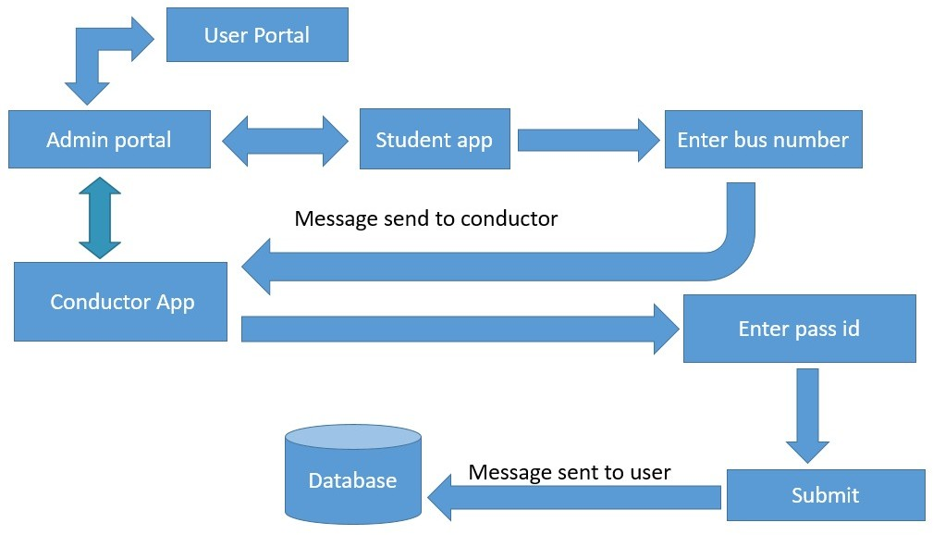

Fig. 2. Architecture of android application for checking of

of pass by sending notifications to the user. Bus conductor also get benefited as he can check passes from his own place just by asking unique id of the user. The user also can present the bus fail report to the organization obtain by the admin when bus get failed accidently. In future, we can implement E- Payment also.

REFERENCES :
  - Certified Organization) Vol. 4, Issue 2, February 2016
  - Donghyuk Park, Hyunsung Kim, Secure Urban Bus Information System based on Smart Devices”, International Journal of Security and Its
Applications Vol.9, No.1 (2015), pp.205-220.s

  - Asad, A.A., Ayad, M.J. and Hayder, N.K. (2012). Design and Developing Online Iraqi Bus Reservation System Using Unified Modeling Language. International Journal of Scientific
Knowledge Available Accessed 13th December 2014.
  - S. Chandurkar, S. Mugade, S. Sinha, M. Misal and P.Borekar, “Implementation of Real Time Bus Monitoringand Passenger Information System”, International Journalof Scientific and Research
Publications, vol. 3, no. 5, (2013), pp. 1-5.

pass.

h ttp://www.ijsk.org/uploads/3/1/1/311
7 743/v3i103_ information_technolog .pdf

V. CONCLUSION

Bus pass generation and inspection by using website and android is a real time application system which is useful for students and passengers who want to generate the pass online to reduce problems of current manual bus pass generation and renewal. It also frequently warns to the user before expiration
  - Lee, K. Hong, H. Lee, J. Lim and S. Kim, “Bus information system based on smart-phone Apps”, in Proc of KSCI Winter Conference (2012), pp. 219- 222.

