Revelation of Fraud Apps using Sentiment Analysis App Reviews

Ashwini Tichkule¹, Nidhi Nikhar², Dewanand Kapgate³, Prof. Omkar Dudhbure⁴

¹⁻³Students,⁴AssistantProfessor,
Dept. of Computer Engineering, Manoharbhai Patel Institute of Engineering & Technology Shahapur, Bhandara, India

Abstract-The amount of versatile Apps has created at an astounding rate over the span of late years. For occurrences, the development of applications was expanded by 1.6 million at Apple's App store and Google Play. To increment the advancement of portable Apps, numerous App stores propelled day by day App leaderboards, which show the graph rankings of most famous Apps. In reality, the App leaderboard is a standout amongst the most vital ways for advancing versatile Apps. A higher position on the leaderboard more often than not prompts an immense number of downloads and million dollars in income. Along these lines, App designers will in general investigate different ways, for example, publicizing efforts to advance their Apps so as to have their Apps positioned as high as conceivable in such App leaderboards. To avoid this fraud, we tend to area unit creating application in which we tend to area unit planning to list the applications. In this research paper, we offer a quick view of ranking fraud and propose fraud detection system by using sentimental analysis for mobile Apps.
Keywords—Mobile Apps, Fraud Detection, Classification, Sentiment Analysis, Ranking, classification, Applications, Tokenization, and Feature.
- INTRODUCTION
The Mobile App may be a highly regarded and accepted conception thanks to the fast advancement within the mobile technology, thanks to the massive range of mobile Apps, ranking fraud is that the key challenge before of the mobile App market. There are ample apps are offered in marketplace for the applying of mobile users [1]. However, all the mobile users initial like high hierarchical apps once downloading it. To transfer application sensible phone user must visit play store like Google Play Store, Apples store etc. once user visit play store then he's able to see the varied application lists. This list is constructed on the premise of promotion or promotion [2]. User doesn’t have data concerning the applying (i.e. that applications are helpful or useless). Therefore user appearance at the list and downloads the applications. However typically it happens that the downloaded application won’t work or not helpful. This means its fraud in mobile application list. To avoid this fraud, we tend to are creating application during which we tend to are attending to list the applications. During this paper, we offer a quick read of ranking fraud and propose a ranking fraud detection system for mobile Apps. Specifically, we tend to initial propose to accurately find the ranking fraud by mining the active periods by mistreatment mining leading session algorithmic program. What is more, we tend to investigate 3 forms of evidences, i.e., ranking primarily based evidences, rating primarily based evidences and review based evidences,[3] by learning historical records. We tend to use a best aggregation methodology to integrate all the evidences for fraud detection. Finally, we tend to value the projected system with real-world App information collected from the Google App Store for an extended period. Inside the tests, we will in general approve the adequacy of the anticipated framework, and demonstrate the quantifiability of the recognition algorithmic program in like manner as some consistency of positioning misrepresentation exercises [4].
- RELATED WORKS
There are some connected works, for instance, we tend to positioning spam recognition, on-line survey spam identification and transportable App suggestion, and however the difficulty of distinctive positioning falsehood for mobile Apps is until under-investigated[5]. The matter of sleuthing ranking fraud for mobile Apps continues to be underexplored. To overcome these necessities, during this paper, we tend to build a system for positioning falsehood discovery framework for transportable apps that's the model for sleuthing ranking fraud in mobile apps. For this, we've to spot many necessary challenges [6].
First, fraud is happen any time throughout the complete life cycle of app, that the identification of the precise time of fraud is required. Second, because of the massive range of mobile Apps, it's troublesome to manually label ranking fraud for every App, thus it's necessary to mechanically notice fraud while not victimisation any basic info. Mobile Apps don't seem to be forever hierarchal high within the leaderboard, however solely in some leading events ranking that's fraud typically happens in leading sessions[7].
Therefore, main target is to notice ranking fraud of mobile Apps at intervals leading sessions. Initial propose an efficient rule to spot the leading sessions of every App supported its historical ranking records[5]. Then, with the analysis of Apps’ ranking behaviors, determine the dishonorable Apps typically have totally different ranking patterns in every leading session compared with traditional Apps. Thus, some fraud evidences are characterized from Apps’ historical ranking records. Then 3 functions are developed to extract such ranking based mostly fraud evidences. Subsequently, extra 2 types of misrepresentation confirmations are anticipated upheld Apps' appraising and audit history that reflect some irregularity designs from Apps' authentic rating and survey records. Also, to incorporate these 3 types of confirmations, partner degree unsupervised proof collection procedure is built up that is utilized for assessing the validity of driving sessions from versatile Apps[8].
- PROPOSE SYSTEM
With the expansion in the quantity of web Apps, to distinguish the misrepresentation Apps, this undertaking proposes a straightforward and successful framework. Fig.1 demonstrates the Framework of Fraud positioning disclosure in portable application.
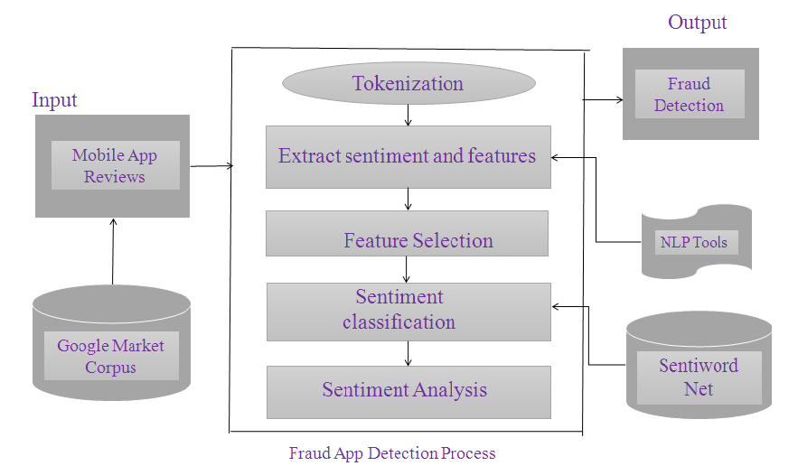

The main aim is to develop such system that notice ranking, rating and review behaviors for work review based evidences, rating based evidences and ranking based evidences therefore aggregation supported optimization to mix all the evidences for detection of fraud [9]. So we are proposing associate humanoid applications which can method the knowledge, comments and 3 reviews of the appliance with linguistic communication processing to present results. Thus it'll be easier to determine fraud application. The main objectives are, We propose a system that provides a many-to-many mapping from reviews to topics of interest, and a list of reviews for each topic that are representative of user sentiment towards that topic. As a developer, it is essential to “stay on top of your game”, i.e., keep your app updated with the most requested features and bug-fixes. However, most app stores provide only an average rating (out of 5) for each app. Consequently, it is difficult to identify why people like or dislike a particular. We aim to solve this problem.

Modules
This system consists of seven modules described as follows:
- App Reviews
- Tokenization
- Feature and Sentiment Identification
- Feature Selection
- Sentiment Classification
- Sentiment Analysis App Reviews
- Fraud App Detection
First of all we are taking reviews of apps on store after that transforming a stream of print into a stream of dispensation units known as tokens. Tokenization is that the method of breaking a stream of text into words, phrases, symbols or significant parts known as tokens[9].

The list of tokens becomes input for any process. After pre-processing of reviews system determine the emotions of the reviews. It’ll classify the review as positive or negative. The system can realize sentiment of the review which might be positive or negative. Positive review ads and one to positive score, if negative it'll add one to negative score. During this manner it'll determine score of every of the reviews and confirm whether or not app is fraud or not on the premise of review based mostly evidences.

Sentiment analysis algorithm
Sociologists have studied human sentiment for half century. Among the pattern of interaction between people, which suggests of vocabularies has the central role to indicate people’s reaction to each different and together works and different actions meant to evoke a sentimental response from between vocabularies [10].
The expansion of online life like websites and informal communities has powered enthusiasm for assessment investigation. So on comprehend the new chances and to deal with the notorieties, specialists normally peruse the surveys/appraisals/suggestions and varying sorts of on-line assessment. this permits to not exclusively see the words that unit characteristic of opinion anyway also to chase out the connections between words therefore as that each word that changes the supposition and what the slant is with reference to are taking care of be precisely recognizable [11]. Scaling system is employed to work out the sentiment for the words having a positive, negative and neutral sentiment. It together analyzes the next concepts to know the words and additionally the means that they relate to the conception.
There unit many sentiment analysis algorithms out there for developers. Implementing sentiment analysis in your apps could be easy job. There do not appear to be any servers to line up, or settings to place along. Sentiment Analysis analyzes the text of reports articles, social media posts like Tweets, Facebook, and more. Social Sentiment Analysis is degree algorithm that's tuned to analysis the sentiment of social media content, like tweets and standing updates. The algorithm takes a string, and returns the sentiment rating for the “positive,” “negative,” and “neutral.” additionally, this algorithm provides a compound result that is degree overall sentiment of the string.
For this purpose we have a tendency to tend to tend to use Classifiers is Sentiment Analysis is to look at the subjective worth of a text-document, i.e. however positive or negative is that the content of a text document.
- SYSTEM ANALYSIS

Existing system
In the writing, while there square measure some associated work, similar to net positioning spam recognition, on-line survey spam discovery and portable App proposal, the matter of recognition positioning misrepresentation for versatile Apps is still under-investigated. Typically, the associated works of this investigation will be arranged into 3 classes. The essential class is concerning net positioning spam discovery. The below average is focused on recognition on-line survey spam. At long last, the second rate class incorporates the examinations on portable App Suggestion.

Disadvantages
- Although a number of the prevailing approaches will be used for anomaly detection from historical rating and review records, they're ineffective to extract fraud evidences for a given period of time (i.e., leading session).
- Cannot able to find ranking fraud happened in Apps’ historical leading sessions
- There is not any existing benchmark to determine that leading sessions or Apps really contain ranking fraud.

Proposed system
In today’s era, because of speedy development at intervals the mobile technology and mobile devices, the applications i.e. mobile apps area unit being really fascinating and stylish conception. As there is sizable quantity of mobile Apps, ranking fraud is the troublesome consider front of the mobile App market. Ranking fraud is the term used for relating dishonest or suspicious activities having the intention of boosting up the Apps at intervals the standard list. In fact, App developer’s area unit exploitation troublesome means oft for increasing their Apps sales. The main aim is to develop such system that understand ranking, rating and review behaviors for investigation review based totally evidences, rating based totally evidences and ranking based totally evidences then aggregation supported improvement to combine all the evidences for detection of fraud.
- CONCLUSION
A positioning misrepresentation recognition framework for versatile Apps has been created in this undertaking. In particular, it starting demonstrated that positioning extortion occurred in driving sessions and gave an approach to digging driving sessions for each Application from its verifiable positioning records. Then, it known ranking based mostly evidences, rating primarily based mostly evidences and review based evidences for police work ranking fraud. Moreover, it arranged partner degree improvement based for the most part total strategy to incorporate every one of the confirmations for assessing the authenticity of driving sessions from portable Apps. A novel perspective of this approach is that everyone the evidences are often sculptured by applied math hypothesis tests, so it's straightforward to be extended with alternative evidences from domain data to notice ranking fraud. Finally, it validates the planned system with intensive experiments on real world App knowledge collected from the Apple’s App store. Experimental results showed the effectiveness of the planned approach.

- FUTURE WORK
In the future, it's planned to review more practical fraud evidences and analyze the latent relationship among rating, review and rankings. Moreover, it will be extended to ranking fraud detection approach with alternative mobile Apprelated services, like mobile Apps recommendation, for enhancing userexperience.

REFERENCES
[1] C. Sangani, “Sentiment Analysis of App Store Reviews.”
[2] T. Shingare, M. Sancheti, S. Shaikh, J. Ugale, and P. J. N. Kale, “Fraud Application Detection Using Data Mining Techniques,” no. 2, pp. 3447–3450, 2017.
[3] B. C. and D. H. C. Mahmudur Rahman, Mizanur Rahman, “FairPlay: Fraud and Malware Detection in Google Play.”
[4] H. Zhu, H. Xiong, S. Member, and Y. Ge, “Discovery of Ranking Fraud for Mobile Apps,” no. March, 2015.
[5] M. M. Mhatre, M. S. Mhatre, M. D. Dhemre, and P. S. T. V, “Detection of Ranking Fraud in Mobile Applications,” pp. 2187–2191, 2018.
[6] and Z. T. B. Zhou, J. Pei, “A spamicity approach to web spam detection,” Proc. 2008 SIAM Int. Conf. Data Mining, SDM’08, pages 277–288, 2008.
[7] and P. S. Y. S. Xie, G. Wang, S. Lin, “Review spam detection via temporal pattern discovery,” in In Proceedings of the 18th ACM SIGKDD international conference on Knowledge discovery and data mining, KDD ’12, pages 823–831, 2012.
[8] P. Rohini, K. Pallavi, J. Pournima, K. Kucheta, and P. P. Agarkar, “MobSafe : Forensic Analysis For Android Applications And Detection Of Fraud Apps Using CloudStack And Data Mining,” vol. 4, no. 10, pp. 3779–3782, 2015.
[9] A.meshram, c. pillai, A.madankar,O. dudhbure, “Discovery of Fraud Apps utilizing Sentiment Analysis,” IRJET, vol. 0 6, no. 2.
[10] E.-P. Lim, V.-A. Nguyen, N. Jindal, B. Liu, and H. W. Lauw. Detecting product review spammers using rating behaviors. In Proceedings of the 19th ACM 68 international conference on Information and knowledge management, CIKM ’10, pages 939–948, 2010.
[11] N. Spirin and J. Han. Survey on web spam detection: principles and algorithms. SIGKDD Explor. Newsl., 13(2):50–64, May 2012.

