**Design and Fabrication of Manual Operated Aonla Seed Removal Machine**

**1Prof. Chandrakant Choudhary**

**2Mr. Roshan Sathawane, 3Mr. Fanindrasingh Hirapure, 4Mr. Chetan Barai.**

**5Mr. Ishwar Maske , 6Mr. Sachin Ghasle**

***1Assistant Professor, 2-6Students***

*Department Of Mechanical Enginnering, Manoharbhai Patel Institute Of Engineering And Technology, Shahapur, Bhandara, MAHARASHTRA-441906*

***Abstract:*** *A manual-operated machine for the removal of seed as well as shred from the fresh aonla fruit was designed and fabricated. Aonla is a popular and medicinal fruit in India. Aonla seed stone needs to remove before the preparation of the value-added product like pickle, murabba etc. The machine consisted of fruit seat, fruit punching rod, handle and frame to hold all the parts. In which all most part were made of stainless steel and only nut and bolt made were of mild steel. The aonla fruit after removal of seed and shred by the machine was used for the production of intermediate moisture food by osmotic dehydration which had a good consumer acceptance.*

***Keywords:* - *Plunger, penetration rod, cutting blade.***

**I. INTRODUCTION**

**T**he Aonla belongs to EUPHORBIACEOUS family. Aonla is known as Indian gooseberry. It is an important fruit crop of the tropic and subtropic region in India. It contains about 600 mg of vitamin C in 100 g of aonla pulp along with 0.88 g protein, 0.54 g pactin, 0.55 g thamin (Goyal2008). Aonla is also rich in mineral, fiber and other vitamins (Tripathi 1988). That is why it is used in traditional system of medicines like ayurvedic and unani due to its therapeutic value. The Aonla fruit is used in

medicines to treat the common cold, gastric troubles, headache, constipation, enlarged lever etc.

Aonla (Emblica Officinalis) an edible fruit indigenous to tropical India and South East Asia, is a rich source of vitamin C, Pectins and tannins apart from pharmaceutical properties. Because of its unique nutritive and therapeutic qualities aonla is considered as “Wonder fruit for health”, and it has extensive adoptability to grow in diverse climatic and soil conditions.

**II. OBJECTIVE**

1. To develop a machine to remove seeds from aonla.

2. To maintain the original properties of aonla.

3. To increase the productivity.

4. To maintain the quality of product and reduce the operation time.

5. To develop a multipurpose machine to remove only seed or remove seed as well as slice the pulp.

**III. LITERATURE REVIEW**

**1.N. P. Awate (2012) CIGR** -Investigated to overcome the problem arising with the manual punching of aonla for deseeding while manufacturing Murabba and developed a machine that was both economical and also yielded good health to the operator. Also the ergonomics (health) of the operator was a big issue as it caused harm to the workers wrist and hand. A Pro E model of the machine was prepared so as to modify it as per the need of process. The model increased the productivity and reduced labour work. Production rate was improved and fatigue to the worker reduced.

**2.E. Nambi (2012) CIGR-** Developed a pneumatic assisted electronically controlled continuous aonla seed removing machine. The machine was evaluated with three different plunger’s viz., sharp edge, hallow cutting edge and star edge in different orientation of fruit with three verities of aonla (Kanchan, Chakaiya and NA-7).



Fig.1: Continuous seed removing machine

**3.A. Ganachari (2008) Agricultural mechanization in asia** Investigated the design and development of a hand operated tool for aonla seed removal. The performance data revealed that the capacity of hand operated machine was 16.66 kg/h or 530 fruits/h. The waste that included the pulp and juice recorded to be 10 %. The cost of the tool was Rs.650/-, in which the fruit platform and the punching rod were made of stainless steel and all other parts were of mild steel, which was electro plated.

**IV. WORKING PRINCIPLE**

Aonla seed removal machine works on punching principle. Punching designateda slitting process in which sheet is severed in one stroke, similarly punching rod punches aonla in such a manner that it penetrates pulp and removes seed along with it.

**V. MATERIALS AND METHODS**

The developed hand operated seed removing machine consisted of a fruit-punching rod, fruit resting seat, handle with extension and the frame to hold all the important movable parts. The parts of the machine coming in contact with fruit were made of stainless steel (food grade). The whole machine was to avoid rusting of parts when it comes in contact with ascorbic acid present in the fruit. The hand operated shred and seed removing machine for aonla is given in Fig. The fruit to be destined is kept on the fruit seat on the platform, which has a hole at the centre of the seat. The blade connected to solid penetrating rod and solid rod connected to the handle punches the fruit with a shock load, which makes the seed portion of the fruit move down through the hole provided at the center of the seat. After each punching, the seed will be removed and the fruit will have shredded.

The fruit platform holds the fruit for punching. It is made with stainless steel plate, which is bent at different places to get the required shape.

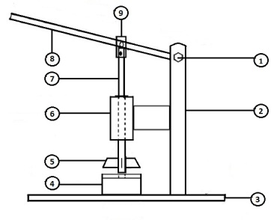

Fig.2: Schematic diagram of Aonla seed removing machine.

|  |  |  |  |
| --- | --- | --- | --- |
| Sr. No. | Part | Sr. No. | Part |
| 1. | Nut and bolt | 6. | Guider |
| 2. | Supporting rod | 7. | Fruit punching rod |
| 3. | Frame | 8. | Handle |
| 4. | Platform | 9. | Clip |
| 5. | Blade |  |  |

A hole is made at the center of the platform which is surrounded with depression, which helps the fruit rest comfortably without any movement during punching.

**AONLA PLATFORM AND SEAT**

The dimensions are designed based on the physical properties of the aonla fruit. The platform is made with a stainless steel plate of 3 mm thick, 70 mm width and 75 mm length. This plate is bent every 75 mm along the length to have the designed dimensions and welding arrangements as shown in Fig. 1. Maximum width of the fruit 50 mm Allowance on all sides: 20 to 25 mm Size of the platform: 70 × 75 mm. The diameter of the hole is based on the maximum size of the aonla seed.

Maximum diameter of aonla seed: 18 mm Diameter of the hole provided: 19 mm For self-alignment of the fruit over the platform, a semicircular depression called the fruit seat is provided around the hole. The platform is provided at certain height above the base plate so for collection of fruit core with seed. Height of the fruit core: 40 mm Clearance above and below the core: 30 mm Height of the platform above base plate: 70 mm

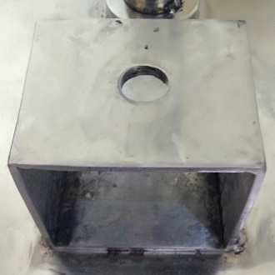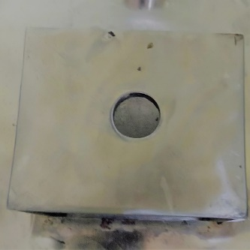

Fig. 3: Aonla platform and seat

**PUNCHING PLUNGER**

Fruit punching plunger is a solid rod made of stainless steel hinged with the handle, which penetrates the fruit through a guider and removes the fruit core with seed when the handle is moved down. The diameter was selected as 9 mm. The length was designed based on the length of stroke and link arrangements as Stroke length of plunger: 67 mm Length of the guider: 113 mm Extension below guide: 10 mm Distance between plunger hinge point and guide: 70 mm Total length of plunger = 67+113+10+70 = 260 mm.

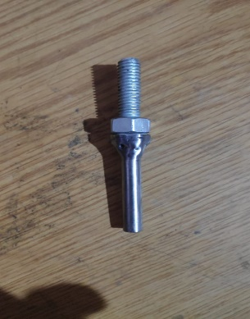

Fig. 4: Plunger

**CUTTING BLADE**

Cutting blade made stainless steel and its connected to the punching plunger solid rod, the push down the blade plunger move down and blade cut aonla in shredded. The length depend upon the aonla diameter, the maximum diameter of aonla 50 mm with allowances 60 mm length of cutting blades, thickness 2 mm, width 12 mm.

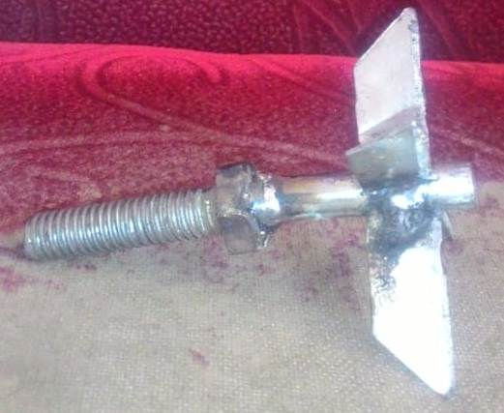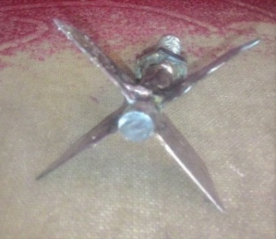

Fig. 5: Cutting blade

**HANDLE**

The handle is an important component of the machine which works on the principle of lever mechanism and is used for transmitting the force required for punching the fruit. Calculated force required for cutting the fruit, The movement of the handle will be an arc due to hinging at one end. And free to another end. Length of handle is 500 mm.

2. Effectiveness of machine =

**FRAME**

The frame consists of base plate and vertical pipe, to which a handle, plunger and fruit seater. The vertical pipe is welded to the base plate. The frame consists of Base plate: 450×250 mm Height of frame: 450 mm.

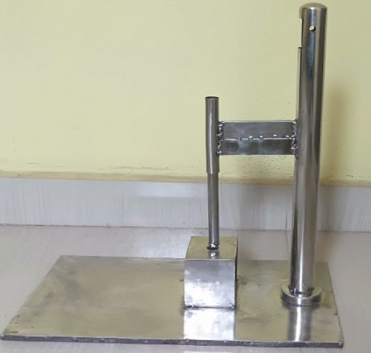

Fig. 6: Frame

**Table1.** Design specifications of Aonla seed removing equipment the developed

|  |  |
| --- | --- |
| **Part** | **Dimension in mm** |
| Platform size | 70×75 |
| Seater hole | 19 |
| Punching plunger diameter | 9 |
| Length of handle | 500 |
| Frame plate | 450×250 |
| Height of the frame | 450 |
| Blade length | 60mm |
| Blade thickness | 2 |

**VI. FORMULAE USED**

1. Force =mass (m) × acceleration due to gravity (g)

×100

3. Percentage of fruit pulp wastage

= $\frac{Amount of pulp along with seed}{Total amount of pulp present in fruit}$ ×100

Large fruit is almost the same.The economics of the developed machine was estimated by considering the cost of the raw materials, overhead charges and labor charges. The cost of operation was calculated by estimating the fixed cost and variable cost.

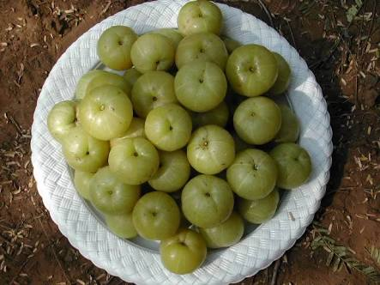

Fig. 7: Fresh Aonla fruit

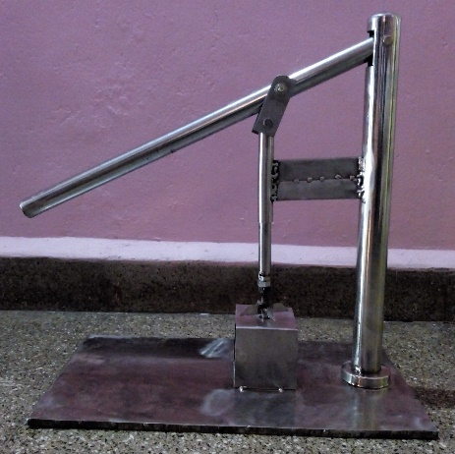

Fig. 8: Aonla seed removal machine

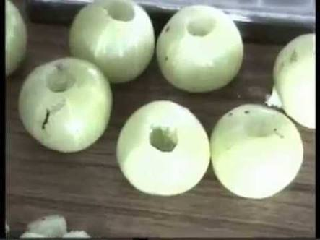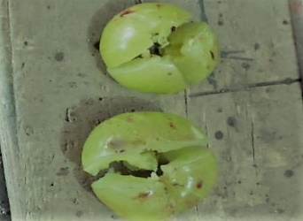

Fig. 9: Aonla fruit after seed removal and shred.

**VII. COST ECONOMICS**

The cost of the newly developed machine was Rs.3000.

**VIII. RESULTS AND DISCUSSION**

The specifications of the fabrication of manual operated seed removing machine is given in the Table 1.

The capacity of the machine was found to be 20 kg/h and 720 fruits/ h. The capacity of the machine was also determined on per day basis, which was 130 kg/day and 4,240fruits/day, which a single labour can operate. Manual removal of seed is very laborious because of the hardy nature of the fruit; hence, the fruit needs prior blanching to remove the seed, which causes the loss of valuable nutrients. The developed machine would be useful to remove the seeds from the fresh fruits and the deseeded fruits could be used for juice extraction without any loss of nutrients. The fresh fruit after the removal of seed could also be used for the preparation of value added products and intermediate moisture foods.

The some percentage loss was due to adherence of hard fibers along draining of juice during the punching operation. It was found that 2.1 percent of juice was going as waste along with seed. The loss of might be due to structural arrangement of the seed present almost at the center of the fruit, which was also removed while punching with a solid rod and the loss of juice might be due to shock load application.

**IX. CONCLUSIONS**

A manual operated machine for the removal of the seed from Aonla fruit as well as shredded was designed and fabricated. The developed machine had a capacity of 20kg/h and 720 fruits/h. The waste that included the pulp and juice during seed removal was 10 percent. The efficiency of pulping was 90.65 percent. The cost of the machine was Rs.3000, in which the fruit platform and the punching rod and all other part were made of stainless steel and only nut bolt were of mild steel, The fabricate the machine could be used to remove seed and shredded from the fresh aonla fruit and the decided aonla fruit could be used in full shape for further value addition.

**X. REFERENCES**

1. *Barthakur, N. N. and N. P. Arnold. 1991. Chemical analysis of the emblic (Phyllanthus Emblica L.) and its potential as a food source. Scientia Horticulturae, 47: 99-105.*
2. *Giri, A. K. and T. S. Banerjee. 1986. Antagonistic activity of herbal drug (Phyllanthus Emblica) on cytological effects of environmental chemicals in mammalian cells. Cytologica, 15: 375-380.*
3. *Rao, M. R. R. and H. H. Siddique. 1964. Pharmacological studies on Emblica Officinalis Gaertn. Indian J. Exp. Biol., 2: 29-31.*
4. *Singh, H. P. 2003. Augmentation of production and utilization of aonla. National seminar on production and utilization of aonla, 8-10 August, Salem, India.*