Design of Multi-Terrain Rover Mechanism

Ashish Sharnagat
Professor, Mechanical Department
Ankit Sakharwade¹, Prinkesh Ghadle², Mukund Bhiogade³, Shubham Karemore⁴,
Sharad Dadave⁵
Scholars, B.E. (Mechanical Engineering)
Manoharbhai Patel Institute of Engineering and Technology, Bhandara, India
(R. T. M. Nagpur University, Nagpur, Department of Mechanical Engineering)

Abstract: Rover-Bogie Mechanism is the mechanism developed to completely replace the conventional suspension system and nullify the disadvantages caused by it. Rover bogie mechanism provides features of independent suspension without using any spring, damper or stub axle. All these help in lowering the overall weight. As rough terrain suspensions contain very heavy springs and dampers, they increase the height of centre of gravity making the system unstable. This Mechanism is designed with highly stable suspension system capable of operating in multi terrain surfaces while keeping all the wheels in contact with the ground. It can climb vertical heights equal to twice of its wheel diameter. This mechanism can sustain tilt up to 50 degree. A series of mobility experiments in the agriculture land, rough roads, inclined, stairs and obstacles surfaces concluded that with this type of rover bogie mechanism, smooth mobility can be achieved in any type of terrain. This can be used easily in traverse terrains like desserts, snow and swamp etc, because of higher tractive force obtained due to presence of 6 wheels.
Keywords: Wheel type robot, Stair climbing, Rover.
- INTRODUCTION

The rover is designed to replace the conventional suspension system, which restrict us to achieve the smooth movement on terrain. The term “rocker” describes the rocking aspect of the larger links present each side of the suspension system and balance the vehicle as these rovers are connected to each other and the vehicle chassis through a selectively modified differential. To avoid the misbalancing due to the complex design of rover, it is design in such a way that, when one rover moves up-word, the other goes down. This motion helps rover to stay connected with the ground, which helps rover to stay balanced. These designs are initially used in the mechanical robots which were sent on mars. This system is designed in such a way that it can easily climb the disturbed land without leaving connection with ground; also it can climb up to 2X of its wheel diameter. It may be useful in future for delivery services and it can also be used for various other works such as inspection purposes, transport purposes etc.
In this report a dynamic mechanism with a six wheels capable of traversing rough terrain using an efficient high degree of mobility suspension system is proposed. The primary mechanical feature of the rover bogie design is its drive train simplicity, which is accomplished by using six different motors for mobility. Six wheels (Four in front and two in rear) are used because there are few obstacles on natural terrain that require both front and rear wheels of the rover to climb simultaneously. When the frame of one side is climbing a higher obstacle the frame of other side is pressed downwards. Hence the normal reaction on wheels which are climbing never becomes zero. And none of its wheels are ever lifted above ground. This helps in maintaining equal reaction on all wheels. The rover mechanism is designed in such a way that it can easily traverse terrains by its individual movements of all the four front wheels which climb the different obstacles simultaneously.
- LITERATURE REVIEW
The modern day design of rocker arm mechanism is proposed for the betterment of the current suspension system. The conventional suspension system being heavyweight and complex in mechanism cause many disadvantages which makes a room for the betterment of the system. The rocker arm mechanism initially used in the “curiosity” was developed by NASA. The research paper deals with the designing and modeling of stair climbing robot based on the well-known rocker bogie mechanism. The rocker-bogie suspension system passively keeps all six wheels on the robot in contact with the ground even on uneven surfaces. It also can be used for other purposes to operate in rough roads and to climb the steps. It was having lots of advantages but one of the major disadvantages is the rotation of the mechanism when and where is required. The motive the research initiation was to understand mechanical design and its advantages of Rocker- bogie suspension system in order to find suitability to implement it in conventional loading vehicles to enhance their efficiency and also to cut down the maintenance related expenses of conventional suspension systems. Also the main objective behind evolution of rocker bogie suspension system is to develop a system which minimizes the energy consumption, the vertical displacement of the rover’s centre of mass and its pitch angle. In this research, our endeavor is to transfer these major advantages embedded with the rocker bogie system into conventional vehicles in order to remove discomfort and complexities present in conventional suspension system in general and suspension system of heavy vehicles in particular.
- DESIGN OF TERRAIN ROVER
The main consideration while designing terrain rover is to carefully choose the dimensions of the rocker arm and its links. Also we need to calculate the angle of inclination so that it can cross over (climb) the hindrance. We designed the rover specifically keeping in mind the stairs climbing. It can climb stairs of 180 mm height. It should climb over any obstacle of an angle of 45 degree. Height of the rover can be change as per the requirements. Angle can also be modified accordingly. We can find the dimensions of linkages using the Pythagoras theorem since the angle between them is 90 degree.
- DESIGN CALCULATIONS
We are testing it on stairs of dimensions having height of 180mm and length of 410 mm. The dimensions of rocker arm and linkages of terrain rover should be adjusted according to the dimensions of the stairs we want our rover to climb through. To stop terrain rover from loosing balance and maintaining proper stability while climbing stairs it is necessary that at every moment of time while it is climbing it maintains its balance and it is stable throughout the climbing operation. For that it is necessary that only one pair of wheels must be in rearing position. The distance between first and second pair of wheel must be equal to the height of the stairs in order to climb then. We know the height of the stairs is 180mm so using Pythagoras theorem in triangle ABC we can calculate the length of arm AB and BC.
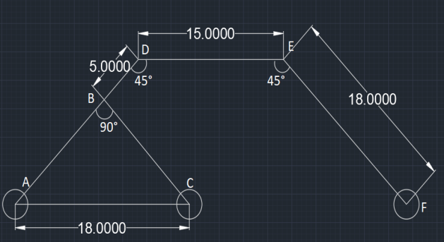
Fig.1. Dimensional Sketch
By using Pythagoras theorem in triangle ΔABC we can find the lengths of the rocker arms. Assume the length of AB and BC is x,
AC² = AB² + BC²
180² = x² + x²
180² = 2x²
x = 130
Hence, AB = BC =130 mm

The angle taken at point D and E is 45° since it provide maximum stability to rover. The length of link EF must be equal to the length of link AD in order for rover to maintain the proper balance at plane surface.
AD=EF
AD=180 mm hence, (from cad software)
EF=180 mm

- DRAWING
After calculating all the dimensions required the 2D drawing is prepared using AutoCAD software which are shown below in figure.
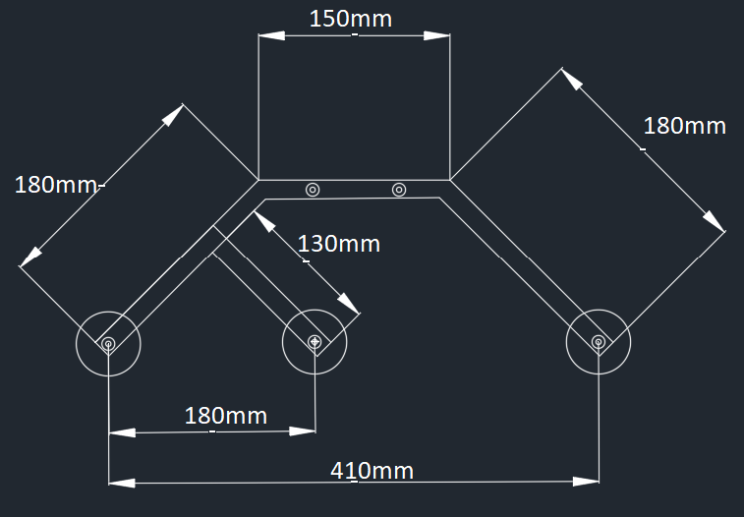
Fig.2. SIDE VIEW
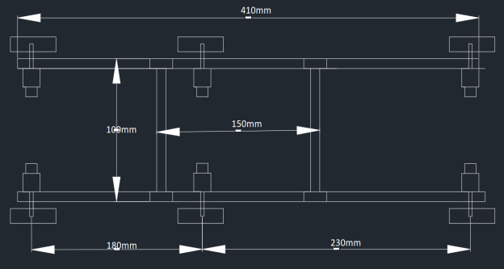
Fig.3. TOP VIEW
- METHODOLOGY
As per the research it is find that the rover system reduces the motion by half compared to other suspension systems because each of the rover’s six wheels has an independent mechanism for motion and in which all the motors fixed in them have the torque generating power which enhance the rover’s performance. Every wheel in the rover is compelled with extra griped system which provides grip for climbing in soft sand and scrambling over rocks with ease. In order to overcome vertical obstacle faces, the front wheels are forced against the obstacle by the centre and rear wheels which generate maximum required torque. The rotation of the front wheel then lifts the front of the vehicle up and over the obstacle and obstacle overtaken. Those wheels which remain in the middle, is then pressed against the obstacle by the rear wheels and pulled against the obstacle by the front till the time it is lifted up and over. At last, the rear wheel is pulled over the obstacle by the front two wheels due to applying pull force. During each wheel's traversal of the obstacle, forward progress of the vehicle is slowed or completely halted which finally maintain vehicles centre of gravity. The above said methodology is being practically proved by implementing it on six wheel drive rover system in order to gain maximum advantage.
- OBSERVATION
The main reason behind the current suspension system is their slow speed of motion and complex design which makes it difficult for the vehicle to absorb the shock and react according to it. In this type of suspension system in order to pass over obstacles, when the left side of the mechanism is boarding the obstacle the right side should take the normal force and stick to the ground which helps the vehicle to enhance the torque. Also while driving from uneven terrain the conventional suspension system may have chances to break down due its overall shock absorbing time which is why the heavy vehicles are used to run slow in uneven terrain. But for this mechanism the software based testing of rover bogie suspension system describes the momentum and efficiency related utilities in cumulative manner.
- RESULT & DISCUSSION
After various tests and experiments it is been brought to our sight that this system has a full ability to replace the conventional system and can minimize the disadvantages caused due to it. Also in various tests the dynamic nature of this mechanism is come to our knowledge. The torque generated due to these motors is much greater than the conventional one. The test track used for these experiments is platform with one cylindrical bumper.
CONCLUSION
The proposed paper produces a suitable design to replace the conventional suspension system which is currently being used in various machineries. The suspension system we are currently using for heavy vehicles are good enough for now but for future this mechanism is necessary due to the complexities and drawbacks of current system.
REFERENCES
[1] S Avinash, A Srivastava, A Purohit, SV Shah, and K M Krishna. A compliant multi-module robot for climbing big step-like obstacles. In ICRA, pages 3397–3402. IEEE, 2014.
[2] S.H. Turlapati, M Shah, P Singamaneni, A Siravuru, S.V. Shah, and K. M. Krishna. Stair climbing using a compliant modular robot. IROS, 2015.
[3] D Choi, J Oh, and J Kim. Analysis method of climbing stairs with the rocker-bogie mechanism. Journal of Mechanical Science and Technology, 27(9):2783–2788, 2013.
[4] M Lauria, Y Piguet, and R Siegwart. Octopus: an autonomous wheeled climbing robot. In CLAWAR, pages 315–322, 2002.
[5]P.E.Sandin, Robot Mechanisms and Mechanical Devices Illustrated (McGraw Hill-New York-2003) [4]Roving over Mars, Mechanical Engineering Journal, April 1988.
[6]Jump up – David P. Miller, Tze-Liang Lee: ”High-speed traversal of rough terrain using a rocker-bogie mobility system ”.
[7] Dongkyu Choi, Jongkyun Oh and Jongwon Kim: Analysis method of climbing stairs with the rocker-bogie mechanism Journal of Mechanical Science and Technology 27 (9) (2013) 2783~2788
[8] Chottiner,J. E., 1992, “Simulation of a Six-Wheeled Martain Rover Called the Rocker-Bogie”, M.S. Thesis, The Ohio State University, Columbus, Ohio
[9] Hayati, S., et. al., “The Rocky 7 Rover: A Mars Sciencecraft Prototype”, Proceedings of the 1997 IEEE International Conference on Robotics and Automation, pp. 2458-64, 1997.

