Design and Fabrication of Electric Bicycle
Prabhu Randhir¹, Pratik Gaurshettiwar²,Shubham Waghmare ³, Kunal Mogre⁴, Prof.C.K.Tembhurkar⁵
UG Student, Mechanical, PCE, Nagpur, India¹, UG Student, Mechanical, PCE,Nagpur, India² UG Student, Mechanical, PCE, Nagpur, India³ , UG Student, Mechanical, PCE, Nagpur, India⁴,Assistant Professor, Department of Mechanical Engineering, PCE, Nagpur⁵

Abstract:
Now-a-days there are so many vehicles on road, which consumes more fuel and also hazards our environment. It is our responsibility to reduce the consumption of fuel and its hazardous emission products. Taking this into consideration it is our small step towards reducing the use of more fuel consuming vehicles and attract the eye of people towards its alternatives i.e. Electric bicycle. So we intend to design a cycle which would run on an alternative source and also reducing human efforts called as Battery Operated Cycle. In this paper we design an alternative mode of transport for betterment of social and environment.

Keywords: Direct Current Motor (DC Motor), Reaction on Front Wheel (R_{fw}), & Reaction on Rear Wheel(R_{rw}).

I. INTRODUCTION
The electric bicycle is an electrical-assisted device that is designed to deliver the electromagnetic momentums to a present bicycle therefore relieving the user of producing the energy essential to run the bicycle. It contains a strong motor and enough battery power that just needs charging to help in hill climbing, generate greater motoring speeds and provide completely free electric transportation. Electric vehicles price more and perform poorer than their gasoline counterparts. The aim is that mainly because gasoline cars have promoted from a century of intensive development; electric cars have been virtually overlooked for several years. Even today, gasoline cars profit from billions of dollars of research every year while electric vehicles receive a small fraction of that quantity of money. The primary principle for the Universities‟ support of the electric-powered over the petrol powered has been towards improving air quality, though air quality alone is not a satisfactory justification to mandate electric bicycles. The single biggest advantage of electric bicycle is that it is cost operative as it mainly only entails building cost as running cost would only require the charging of the battery. An Electric bicycle would, however offer other solid benefits that are overlooked by the marketplace. These include the intense reduction in oil consumption that its widespread use would bring about. Much less oil would be needed because only a tiny proportion of electricity is generated from oil. The further major non-market benefit would be lower greenhouse gas emissions.

II. DC MOTOR
A DC motor is one of a class of rotary electrical machines that converts direct current electrical power into mechanical power. The most mutual types rely on the forces created by magnetic fields. Nearly all types of DC motors have specific internal mechanism, either electromechanical or electronic, to periodically change the direction of current flow in portion of the motor.
DC motors were the first type commonly used, since they could be powered from present direct-current lighting power distribution systems. A DC motor's speed can be controlled over a extensive range, using either a variable supply voltage or by changing the strength of current in its field windings. Tiny DC motors are used in tools, toys, and appliances. The universal motor can operate on direct current but is a lightweight motor used for convenient power tools and appliances. Bigger DC motors are used in propulsion of electric vehicles, elevator and hoists, or in drives for steel rolling mills. The arrival of power electronics has made replacement of DC motors with AC motors possible in many applications.
Working Principle: - A motor is an electrical machine which translates electrical energy into mechanical energy. The principle of working of a DC motor is that "whenever a current carrying conductor is placed in a magnetic field, it practices a mechanical force".
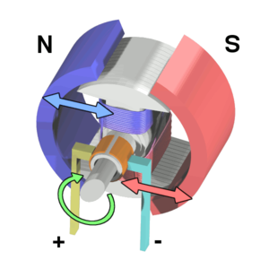
Fig.1 Working of Brushed Electric DC Motor.

III. CONTROLLER

A) Speed Control Basics:-

The speed controller of an electric bike is an electronic circuit that not only controls the speed of an electric motor but also serves as a dynamic brake. This controller unit uses power from the battery box and drives it to the motor. Different forms of controllers are used for brushed and brushless motors. For adaptive e-bikes, a conversion kit is used and the controller is the core component of that kit.

B) Function:-
The electric bike speed controller sends signals to the bike's motor in many voltages. These signals detect the direction of a rotor relative to the starter coil. The suitable function of a speed control depends on the employment of various mechanisms. In a purpose-built electric bike, Hall effect sensors help detects the location of the rotor. If your speed controller does not include such sensors and the speed controller on an adaptive bike may not the electromotive force of the un-driven coil is calculated to get the rotor orientation.
The mechanism of an electric speed controller differs depending on whether you own an adaptive or purpose-build electric bike. An adaptive bike includes an electric drive system installed on an normal bicycle. A purpose-built bike, more expensive than an adaptive bike, provides easier acceleration and affords extra features.

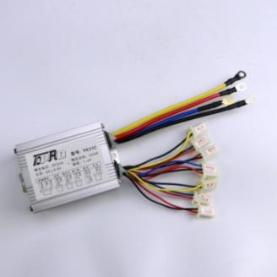

Fig.2 Controller Device

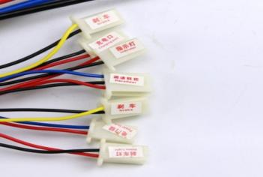

Fig.3 Functions of Pins

C) Plug:-
1.Red & Black (large cable) : Battery connections
2.Yellow & Blue : Motor connections
3.Red & Blue : Key Switch(power lock)
(If there is no power door locks, red connection to blue)
4.Yellow & black : brake
5.Red & Yellow: Brake light
6.Red&Black(small cable) : indicator light
7.Red, Black & Blue: Speed Regulator 1-4 V Throttle (Red : +5v, Black : - , Blue :Signal Wire)
8.Red & Black (small cable): Charger

IV. WORKING
The working of our project basically explain by using the five blocks as follows
a) Battery.
b) Motor Controller Circuitry.
c) Electric motor.
d) Chain and Sprocket.
e) Bicycle speed Rotation.

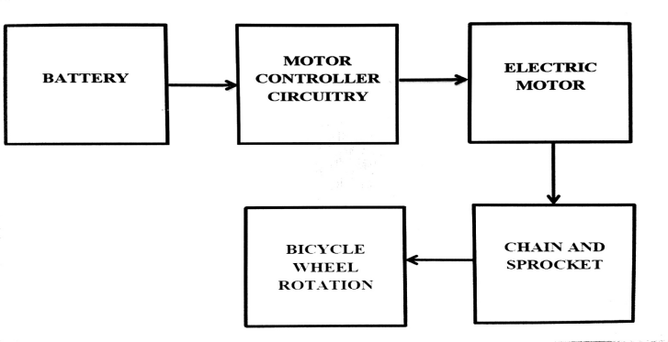Fig 4 Block diagram of the Electric bicycle construction process

A) Battery:-
Two lead acid rechargeable batteries of 12v, 9 amp are used which are connected in parallel position. It basically stores the electrical energy generated and utilise it to run the motor. A battery has a positive terminal called cathode and negative terminal called

anode. The terminal marked positive is at higher electric potential energy and the terminal marked negative is source of electrons when connected to external circuit will flow and deliver energy to external device Rechargeable batteries are recharged multiple times.

B) Motor Controller Circuitry:-
It used to control all the working of cycle.

C) Electric Motor:-
Use the specific motor having suitable power and torque according to design.

D) Chain and Sprocket:-
Take the suitable material & no. of teeth according to center distance.

E) Bicycle Wheel Rotation:-
Provide the torque and speed to the wheel through out sprocket.

V. NO LOAD SPEED CALCULATION

Step 1 :-
Number of teeth on smaller sprocket ( motor) (t₁) = 9
Number of teeth on larger sprocket ( bicycle) (t₂) = 18
Speed on smaller sprocket (motor) (N₁) = 3300 rpm
By using reduction ratio (9.78), speed will be reduced to 338 rpm
Speed on larger sprocket (bicycle) ( N₂) = ?

Step 2 :-
Using speed ratio formulae,
N₁t₁ = N₂t₂
N₂ = 169 rpm

Step 3:-
Diameter of wheel =650mm
Circumference of wheel =
=3.14*650
=2041mm
Step 4:-
Speed of vehicle = speed of wheel X circumference of wheel
=169 X 2041
=344418075 mm/min
=344.41 m/min
=20665 m/hr
_{=20.66 Km/hr}

VI. REQUIRED POWER TO DRIVE BICYCLE
Step (1)
Total load act on bicycle is as follow
Normal weight of person =60 kg
=60*9.81
=588.6 N
Weight of bicycle = 4.5 kg
=4.5*9.81
=44 N
Other Miscellaneous load =5 Kg
= 5*9.81
=49.05 N
The total load = (588.6+44+49.04)
= 681.64 N
Step (2)
To find reaction on each wheel, The above total load which is divided equally on both wheel
Force (F_{fw}) =Force(F_{rw})
=681/2
=340.5N
Where reaction on rear and front wheel are as follows
R_{fw}=R_{rw}
=0.2*340.5
=68.1 N
Step (3)
To find torque on each wheel
Total torque=T_{fw}+T_{rw}
To find Torque on Front Wheel
T1 = R_{fw}*(D÷2)
=68.1*[(65*10⁻²)/2]
=22.1325Nm
T1=T2=22.1325Nm
Total torque on wheel=44.265 Nm
Step(4)
To find power on motor =
=
=391.69 watt
VII. CONCLUSION

This project is designed to improve the normal bicycle and make it extra efficient. The electric bicycle is a hybrid and so it can run electrically and can also be pedaled thereby still retaining the exercise people drive from riding bicycle.
The calculated No load speed of bicycle is = 20.66Km/hr
The Required power is =391.69 watt
- References
[1] Chetan Mahadik, Sumit Mahindraka, Prof. Jayashree Deka , “An Improved & Efficient Electric Bicycle system with the Power of Real-time Information Sharing” ,2014.
[2] D. M. Sousa, P. J. Costa Branco, J. A. Dente, Electric bicycle using batteries and Supercapacitors, 2007.
[3] Arun Eldho Alias1, Geo Mathew2, Manu G3, Melvin Thomas4,Praveen V Paul5, Energy Efficient Hybrid Electric Bike with Multi -Transmission System, 2015.
[4] Ian Vince McLoughlin, I. Komang Narendra, Leong Hai Koh, Quang Huy Nguyen,Bharath Seshadri, Wei Zeng, Chang Yao, Campus Mobility for the Future: The Electric Bicycle, 2011.
[5] Olakunle Alao , The Design and Construction of an Electric Bicycle,2015.
[6] Muhsin Abdur-Rahman, Bo Hu,2007.
[7] Srivatsa Raghunath, Hardware Design Considerations for an Electric Bicycle
[8] Using a BLDC Motor, 2014.
[9] Rony Argueta, The Electric Vehicle, 2010.
[10] FABIAN FOGELBERG, Solar Powered Bike Sharing System with Electric Bikes,2015.
[11] Christopher Cherry, Electric Bike Sharing--System Requirements "! and Operational Concepts,2010.
[12] Kevin Antalek, Electric Motorbike with Regenerative Braking ,2014.
[13] Linus Garrett1,Jack Baker2,Jon Higginbotham, Electric Bicycle and Agricultural Trailer,2013.

