An Investigation Of Performance Improvement In Refrigeration Test Rig By using Phase Change Material (PCM):Research
¹Umesh N Patil , ²Prof. M. P. Thakur , ³Prof. T. A. Koli , ⁴Dr. V. H. Patil
¹(Mechanical Engineering Department GF’S Godavari College of Engineering Jalgaon (MS), India)
²(Assistant Professor Department of Mechanical Engineering GF’S Godavari College Of Engineering Jalgaon,
³(PG Coordinator Department of Mechanical Engineering GF’S Godavari College Of Engineering Jalgaon, India 425003)
⁴(Academic Dean and H.O.D. of Mechanical Department GF’S Godavari College Of Engineering Jalgaon, India 425003)
Email : ¹umeshnpatil.99@gmail.com , ²mayurthakur941@gmail.com , ³kolitushar09@gmail.com
, ⁴vhpatil76@yahoo.co.in

Abstract –The refrigerator and air conditioning (AC) are ordinarily utilized in a large portion of the nations and they are a standout amongst the most vitality demanding apparatuses due to their nonstop utilizing tasks. According this demand a phase-change material (PCM) is a substance with a high heat of combination which, dissolving and cementing at a specific temperature, is equipped for putting away and discharging a lot of vitality. Heat is assimilated or discharged when the material changes from strong to fluid and the other way around. So the PCM is most appropriate for the warm vitality stockpiling utilizing as a wide application in the field of cooling and refrigeration framework. Actually, Expanding vitality effectiveness of local machines will diminish vitality utilization in private framework. Utilizing waste heat emitted while apparatus is working is one method for expanding vitality proficiency. Wellsprings of waste heat and temperature levels show contrasts in various local apparatuses. In this survey paper, expanding vitality proficiency of Evaporator in refrigeration test rig through latent heat stockpiling in phase change materials (PCM) is examined. PCMs are produced for this reason. The evaporator in the refrigerator test rig is verified with another case which has a capacity farthest point and it covers the phase change material. The target of this work is to expand the sustenance preservation time. The vitality store in the PCM is improved to decrease the blower cycle and grant a few hours of steady task without power supply.
Keywords-COP, Evaporator, Compressor, Refrigeration Test Rig, Phase change material (PCM)
- INTRODUCTION
Normally, heat exchange happens from the locale of higher temperature to bring down temperature without requiring any outside gadgets. The invert procedure that is from higher temperature to bring down temperature can't happen without anyone else's input. Its required exceptionally structured gadget called refrigerators. Refrigerator chips away at vapor compression refrigeration cycle. Vapor compression refrigeration framework is a framework which is utilized to exchange heat from low temperature energy supply to the high temperature store by the utilization of working liquid known as a refrigerant. Refrigeration, air conditioning and heat siphon applications speak to the segment which is the biggest shopper of refrigerant synthetic concoctions, and power. The power use by these gadgets in created nations are around 10-20%. The financial impact of refrigeration innovation is substantially more noteworthy than for the most part accepted. Around 300 million tones or merchandise are consistently refrigerated. While the yearly power utilization might be gigantic. Refrigeration frameworks are specifically or in a roundabout way in charge of An unnatural weather change issues which allude to the ascent in temperature of Earth's air and sea. Expanding the energy productivity of refrigeration gadget is hence an imperative issue as far as energy reserve funds. As an enthusiasm on Thermal energy storage (TES) frameworks give elective answers for advantage from sustainable power source and waste heat. Thermal energy storage is acknowledged because of the change in inner energy of a material. Likewise, Refrigeration and Air conditioning frameworks are straightforwardly or in a roundabout way in charge of present energy emergency issue as their utilization in family unit, business and transportation segment are expanding quickly to an ever-increasing extent. Presently a-days control slices are all the time because of accidents, or could be because of execution of demand side management schemes (DSM) to move control utilization to stay away from high loads by the power provider, or by the client to move their power use to off-crest estimating periods (electrical burden moving) and it is critical to keep up ordinary temperatures inside cool storage facilities and cold transport vehicles. Most solidified and chilled nourishments are touchy to temperature changes. The refrigeration framework evacuates this heat load, however in the event that there is a power disappointment, cooling isn't giving to the put away item.
Thermal Energy storage frameworks (TES) will utilize phase change materials for storage of heat and cold at moved time. Thermal Energy Storage through Phase Change material has been utilized for wide applications in the field of air conditioning and refrigeration particularly at mechanical scale. The particular utilization of this Thermal Storage has been for Energy Storage amid low demand and arrival of this Energy amid pinnacle loads with potential to give energy reserve funds because of this. Of late however the use of this kind of Phase Change materials for residential refrigeration application to spare energy or work amid the power blackout has been under active consideration .The utilization of latent heat storage is particularly fit to the storage of energy to drag out the sustenance protection time of household refrigerators crisp nourishment compartment and likewise utilize the inordinate put away energy can to improve the cooler cooling cycle by its discharge at suitable time . The rule of latent heat storage utilizing phase change materials (PCMs) can be consolidated into a thermal storage framework appropriate for use in local refrigerator.
- LITERATURE SURVEY
The use of latent heat storage system using phase change materials (PCM) is a suitable securing heat energy and has the upsides of high storage thickness and the isothermal method for the capacity strategy. It has been appeared, for the improvement of latent heat storage structure, choice of the PCM accept a basic part. Following are the some reviews regarding on PCM materials
Md. Imran Hossein Khan and Hasan M.M. Afroz [1] investigate that the major issue experienced in the close-by refrigerator was of the sustenance quality and weight. The sustenance quality was out and out changed with temp vacillations due to the on-off cycle of the compressor. To discard the above issue Imran Hossein Khan and Hasan M.M Afroz played out the examinations on nearby cooler at different warm prompts diminished the vacillations in evaporator compartment by using two kinds of PCM materials (Water and Eutectic arrangement (90% H2O + Performance Improvement of VCR base Domestic Refrigerator Utilizing Phase change Material: A Survey of 10% NaCl). As demonstrated by Md Imran et-all phase change material (PCM) is an inactive inside latent warmth securing structure which diminishes and sets at specific temperatures. In the midst of the phase change handle, the material is fit for verifying and discharging a significant measure of warm energy and that is the reason it is called as latent heat storage system (LHS). The PCM was put around the five sides of the evaporator compartment in which the evaporator was submerged. The preliminary comes about with PCM announce the quiet diminishment of the difference of the lodge temperature at lower load anyway at higher burden, this impact isn't all that empowering. Between two PCMs, the Eutectic arrangement was better than water. This diminishment of temperature change, finally, upgrades the nourishment preservation quality. By using particular PCM we can expand cooling execution and COP neighborhood cooler.
Aim of this paper
- To complete the experimentation with PCM and without PCM
- To investigate the achievability of PCM in family unit refrigerator to keep up detached cooling inside hotel
- To support Coolpack propagation comes about with preliminary comes about
- To watch temperature easygoing quality in cabin with PCM
Sharma et al.[2], recommended distinctive sorts of latent heat storage materials and focal points of latent heat storage system. This paper is a gathering of more information on various PCMs and latent heat stockpiling framework. Study will find the reasonable PCM for various purposes, proper warmth exchangers with approaches to improve the warmth exchange, and it will likewise give a verity of designs to store warm using PCMs for different applications, that is space warming and cooling, sun situated cooking, nurseries, sun arranged water warming and waste warmth recovery frameworks.
B. Zalba et al. [3], concentrated the execution of a latent heat storage framework with all phase change. This paper additionally gives the information managing thermal energy storage (TES) using phase change materials. This paper fuses a total study of a wide scope of material which have been used as latent heat storage materials, their characterization. Attributes, focal points and weaknesses and the diverse trial methods used to choose the method for these materials in relaxing and cementing. The paper contains recorded more than 154 materials used as a piece of research as PCMs and around 45 financially accessible PCMs.
K.Azzouz et al.[4], concentrated the impact of including a phase change material (PCM) chunk outwardly face of a refrigerator evaporator. A dynamic model of the vapor weight cycle including the closeness of the phase change material and its test approval is shown. The proliferation eventual outcomes of the framework with PCM demonstrates that the extension of heat energy internationally redesigns heat exchange from the evaporator and permits a higher disseminating temperature, which expands the thermal capability of the system. The energy set away in the PCM is regarded the refrigerator cell amid the off cycle and takes into account a couple of long stretches of constant task without power supply. The phase change material considered in this survey is an eutectic liquid arrangement whose phase change temperature might be picked in the range from - 9°c to 0°c. The PCM piece is arranged on the behind of the evaporator, between the assurance and the evaporator, and the surface of the PCM area is around 0.48m
M.Cheralathan et al. [5], investigated the transient direct of a phase change material-based virus heat storage system included a barrel molded capacity tank stacked with epitomized phase change materials (PCMs) in round compartment composed with an ethylene glycol chiller plant. A propagation program was made to evaluate the temperature narratives of the heat exchange liquid and the phase change material at any pivotal territory amid the charging time frame. The results of the model were endorsed by comparison with exploratory delayed consequences of temperature profiles of phase change material. The outcomes demonstrate that in the event that porosity is expanded, at that point heat storage is also expanding.
J.P.Bedecarrats et al.[6], separated an advanced procedure of energy storage usable for air conditioning and cooling or refrigeration. Exploring a test plant which is a tank with a reduced size. Loaded with arbitrarily scattered commercial knobs, put in a refrigeration circle. The knobs are round containers in which phase change materials (PCM) are typified. This test plant allows the learn finally of the conduct of the tank with, specifically, the charge mode considering the under cooling and the release mode. A reproduction program that considers parts of both the encompassing warmth exchange fluid and the stage change material stuffed inside the modules is produced here in the instances of the charge and the release forms.
S. Kalaiselvam et zal [7], examines the conduct of three kinds of paraffin, 60% ntetradecane+40% n-hexadecane, n-tetradecane, and n-pentadecane as latent heat stockpiling materials.
A.C. Marques et al. [8] explored the plan and operation of a thermal stockpiling refrigerator. Right off the bat the investigation of compressor is done which demonstrates greater compressor gives higher productivity yet more start/stop occasions, which diminishes general effectiveness. The high cooling point of confinement yield of greater compressor is put away in a phase change material (PCM), decreasing the quantity of on/off cycles. Numerical displaying and exploratory approval is finished using a model thermal storage icebox with PCM. The outcomes demonstrated that the expansion of a 5 mm PCM section into the ice chest considered 3 to 5 hours of consistent operation without a power supply. The numerical model was observed to be in great concurrence with the test comes about, with the mistake between the recreation and tests underneath 5% for generally explores
Tulapurkar et al [9] clarifies the technique and of a novel, Dual evaporator based residential cooler with Phase Change materials (PCM). The utilization of PCM as a Thermal energy stockpiling will enhance the COP (Coefficient of execution) of new refrigeration cycle by presenting another sub-cooling schedule. This upgrade by subcooling should be possible for both single evaporator refrigeration framework and additionally twofold evaporator framework for cooler/cooler blend. Due to delaying of the compressor off time by using the dormant heat of energy of the PCM we can have better sustenance quality because of lower hysteresis cycles of on/off for a given time of operation
Rezaur Rahman et al [10] researched the execution of residential cooler change with utilization of PCM with the evaporator in a household refrigerator. The investigation of the examination demonstrates the extensive change in COP of a traditional refrigeration framework. Here the PCM used as a part of a load fabricated physically and which encompasses the Evaporator assembly of an ordinary cooler. Majority share of heat exchanges by conduction mode from load given to cooler bureau to evaporator and evaporator to PCM. So warm exchange rate of evaporator refrigerant increments significantly which enhances the COP of the refrigeration framework by about 18-26%.
3. EXPERIMENTAL SET UP AND PROCEDURE
The experimental set up consists of a domestic refrigerator of 165 liters capacity, designed to work with R-134a refrigerant which has the four main components compressor, condenser, capillary tube and evaporator coil. The experimental set up consists of the conventional vapor- compression refrigerating machine with proper instrumentation to measure temperature at evaporator section and to measure energy required by the system.
An energy meter is used to measure the energy input to the compressor motor and temperature indicator is used to measure the temperature inside the evaporator. The schematic diagram of the experimental set up is shown in Fig 1. The PCMs are bonded to the evaporator on the outer surface in order not to reduce storage capacity. The PCM box is made up by galvanized iron (GI) sheet.
Here a measured quantity of 1lit 300ml .solution with proportions of KCl (19.5wt %)+H2O(80.5wt%). The evaporator is covered with another box which has storage capacity or passage through phase change material and in order to prolong the compressor off time and also analyze the energy efficiency of the conventional system. The readings were taken power on and power off condition
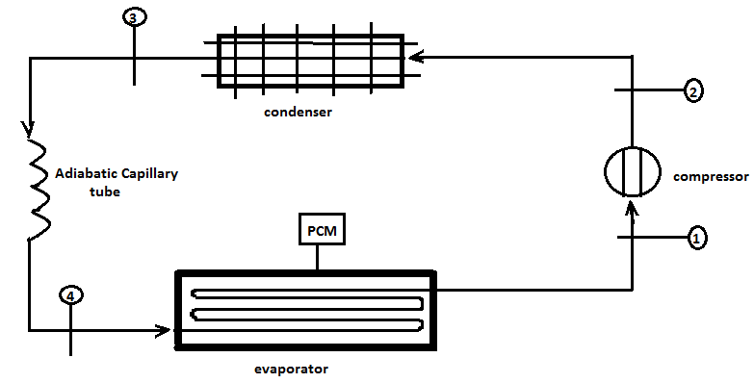
Fig.1 - Line Diagram of Experimental setup
Table 1- PCM Box Specifications
Particulates | Specifications
Length | 35cm
Height | 13cm
Width | 26cm
Thickness | 1.7cm
Freezing point temperature | -15°C
Melting enthalpy | 283kJ/kg

Table 2- Specifications of Refrigeration test ring
Refrigerator model | Refrigerator test ring 165 liters
Ice making time | 2h 30min
Voltage range | 230% V 50Hz AC Supply
Rated energy consumption | 2.00 kWh/24h max
Rated gross volume | 165 Liters
Rated general storage volume | 123 Liters
Fuse rating | 5A
Refrigerant | R-134a

PROCEDURE

- The household refrigerator test ring is chosen which work on vapor compression refrigeration framework
- Pressure and temperature measures are introduced at each entry and exit of the parts.
- Flushing of the framework is finished by pressurized nitrogen gas
- R134a refrigerant is charged in to the vapor compression refrigeration framework.
- Leakage tests are finished by utilizing cleanser arrangement.
- After starting the test unit , pressure and temperatures are recorded at each point.

4. RESULTS AND DISCUSSIONS
By performing this experiment the following results were obtained.
Table 3- Coefficient of performance with and without PCM

Performance parameters | Without PCM | With PCM
Refrigerant effect KJ / kg | 140 | 145
Work of compression KJ/KG | 44 | 40
Coefficient of performance  (Load condition) | 3.29 | 3.5
Coefficient of performance  (No Load condition) | 3.5 | 3.625

Fig.3 - Coefficient of performance with and without PCM at load

Fig.4- Coefficient of performance with and without PCM at load
We can also study this project in ansys for 1 month then we can conclude that pcm can store more heat than water. I design a pcm box of same dimension as above and apply the boundary condition. The pcm box has two temperatures one is at outer layer (20 c) and one is at inner layer (-19c) then following images are obtained
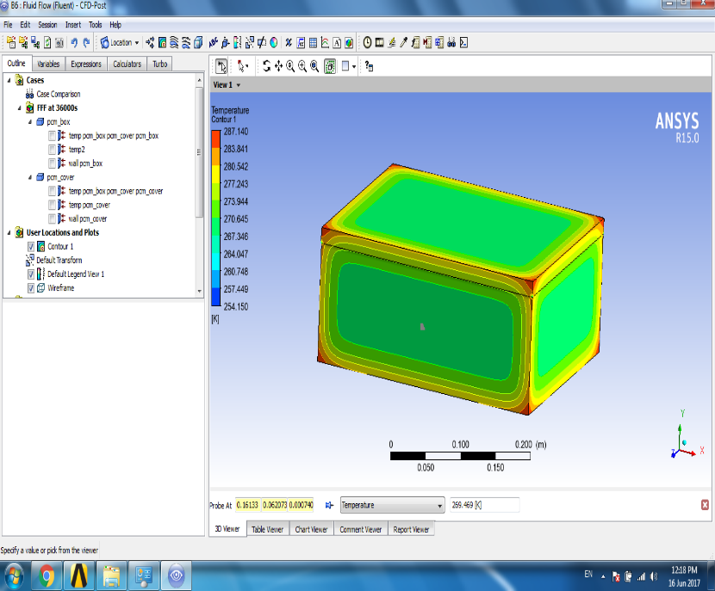
Fig 5 - Cooling effect of pcm in all side
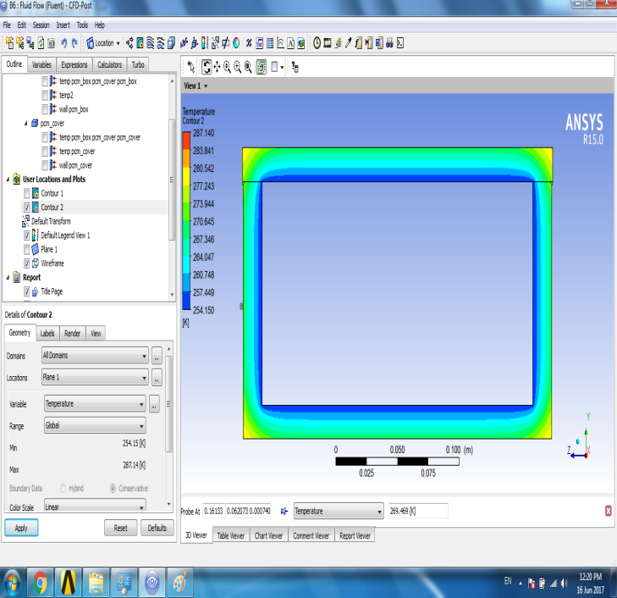
Fig.6- Inner side temperature of pcm box (-19⁰ C)

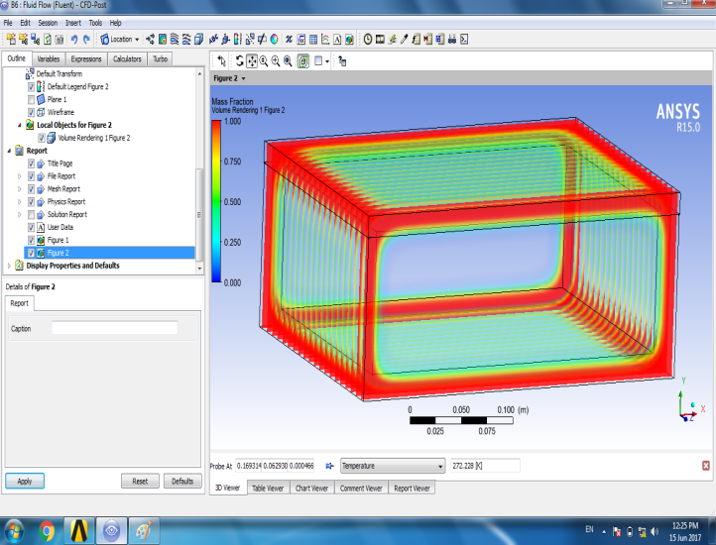
Fig 7-Solidification inside of pcm box
5. CONCLUSIONS
Try tests have been finished to explore the execution change of a nuclear family fridge using stage change material and tried with and without PCM.
- COP Without PCM and with load is 3.29
- COP With PCM and with load is 3.5
- COP Without PCM and without load is 3.5,
- COP With PCM and without load is 3.625

The results demonstrated that cooling impact is kept up inside the chamber without PCM is expanded 5 hours 21 minutes to 7 hours 10 minutes in the midst of the energy of periods and expanded COP from 3.29 to 3.5 at full load. In the wake of changing to the framework an opportunity to achieve the temperature of the evaporator from 32 °c to - 16.9°c is noted 7hours 10 minutes. This is the time required to store the thing without ruining inside the cooler at power off conditions.
REFERENCES
- Md. Imran Hossein Khan and Hasan M.M. Afroz review on effect of phase change material on performance of a household refrigerator,Asian Journal of applied science 6 (2);56-67,2013.
- S.D Sharma, kazunobusagara, latent heat storage materials, and frameworks; A Review, International Journal of Green Energy,2(2002) 1-56.
- Belen Zalba, Jose Ma Maryn, Review on thermal energy storage with phase change materials, heat exchange investigation and applications, Applied Thermal Engineering, 23 (2003) 251-283.
- K. Azzouza, D. Leducqa, D. Gobinb, execution upgrade of a family unit refrigerator by expansion of latent heat storage, worldwide diary of refrigeration 31 (2008) 892-901.
- M. Cheralathan, R.Velraj, S. Renganarayanan, Heat exchange and parametric investigations of an exemplified phase change material based cool thermal energy storage framework, diary of Zhejiang college 7 (2006) 1886-1895.
- J.P. Bedecarrats, F. strub, B. bird of prey, J.P. Dumas, phase-change thermal energy storage utilizing round cases: execution of a test plant, International Journal of Thermal Science 19 (1998)119-152.
- S. Kalaiselvam, M. Veerappan, A.ArulAaronb, S. Iniyan, Experimental and logical examination of hardening and dissolving characteristics of PCM inside barrel shaped embodiment, International diary of Thermal sciences 47 (2008) 858-874.
- A.C. Marques, J.A. Evans, G.F. Davies, G.G. Maidment, I.D. Wood, (2013). Hypothetical demonstratingand exploratory examination of a thermal energy storage refrigerator, Energy, Volume 55, Pages 457– 465.
- P. Subramaniam, C. Tulapurkar, R. Thiyagarajan, G. Thangamani, (2010), Phase Change Materials For Domestic Refrigerators To Improve Food Quality And Prolong Compressor Off Time, International Refrigeration and Air Conditioning Conference at Purdue.
- Rezaur Rahman, Md. Arafat Hossain, Shubhrakanti Das And Adnan Hasan (2013) "Execution Improvement Of A Domestic Refrigerator By Using PCM (Phase Change Material), Global Journal Of Researches In Engineering Mechanical And Mechanics Engineering Volume 13 Issue 10 Version 1.0 ,pp 2249-4596
- M. A. Sattar, R. Saidur, and H. H. Masjuki, Performance Investigation of Domestic Refrigerator Using Pure Hydrocarbons and Blends of Hydrocarbons as Refrigerants, International Journal of Mechanical Systems Science and Engineering Volume 1 Number 1, pp 50-55.
- E. Oro, L. Miro, M. M. Farid , L.F. Cabeza, (2012), Improving thermal execution of coolers utilizing phase change materials, worldwide diary of refrigeration 35, pp 984-991.
- Blond, G., M. Le Meste, (2004) "Standards of solidified storage", In: Hui, Y.E., Cornillon, P., Legaretta, I.G., Lim, M.H., Murrell, K.D., Nip, W. (Eds.), Handbook of Frozen Foods.Marcel Dekker, New York. pp. 25-53.

