DESIGN AND DYNAMIC ANALYSIS OF CABLE-STAYED BRIDGE IN STAAD PRO
Radhika¹, Prahallad Choudhari²
Research Scholar¹, Assistant Professor²
MATS School of Information and Technology, Raipur, India, 492001
radhikat032@gmail.com

ABSTRACT- It takes a long time to span gaps in the ground, so bridges are constructed. Bridges are buildings constructed to provide access across a lake, river, valley, road, or other obstruction. Over the past 20 years, bridges supported by cables have become the most widespread long-span structural system. A long-span bridge could be constructed using strong materials and cutting-edge methods. The dead weight of the structure (the bridge deck's own weight) and the bridge's carrying capacity are balanced by tension cables that are firmly fixed to the tower. The live load is transferred to the bridge deck from the bridge itself. The entire working load is carried by the tower of the bridge. To reduce the depth, creative efforts have been made. This is the final span. A computer is needed to solve this kind of structure, with the exception of very straightforward bridge supported by cables scenarios. It is necessary to use computer programmers to create impact schemes for forces exerted by cables, beam rigidity, bending instances, and scissors, tower, and pier responses. A fairly efficient design should consider the need for programmers to quickly respond to a variety of parametric efforts and loads. The most important issues are probably cable size and layout, as well as the determination of the stiffness section's ideal section.
Keywords - STAAD Pro, structures, cable-stayed bridges, and bridges.

- INTRODUCTION

Due to their capacity to span significant distances, bridges supported by cables have attracted more attention than any other alternative type of bridge in recent years, particularly in third-world nations, the United States, Japan, and Europe. Bridges with cables can span almost a thousand meters. (Amori Bridge in Japan; Millau Viaduct Bridge in France) There are currently a few more cable-stayed bridges being built in India. Like the Akkar Bridge, the Second Yamuna Bridge is the best bridge in India with cables. In Bangalore and Chennai, cable-stayed bridges for road overpasses have been constructed, and cable-stayed bridges for road overpasses are being proposed in a number of smaller emerging cities. The utilization of cable-supported bridges still has room for improvement. A cable-stayed bridge is one that is supported by cables, with one or more girder segments attached to the pylons by cables and additional pylons installed in the middle. Pylons and cable-stayed bridges' shapes, enabling the use of a variety of structural systems. The size of the girder's bending moment, for instance, can be decreased by adjusting the tension of the cable forces. This enables a more economical design. A more aesthetically pleasing bridge design that blends in with the surroundings can also be planned using various cable configurations and pylon shapes.
- TYPES OF BRIDEES
Suspension Bridges.
The main suspension caters nary cables, and the suspension bridge decks are connected by vertical hangers. The main cable travels nonstop between anchorages, crossing saddles at the pylons or towers. The main extremities of a suspension bridge are fixed at earth constraints, making the process for determining the initial configuration under dead load fairly straightforward. The bridge's structural performance in relation to more complicated outside loads, such as seismic and elasticity in the air is therefore frequently determined using optimization techniques. Without fully optimizing the geometry, structural element stiffness, or construction cost, the majority of methodologies, however, are typically focused on determining the best dead load configuration; post-tensioning forces exist.

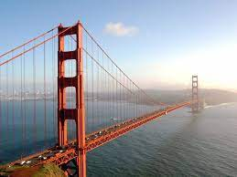
Figure No.1 Bridge with Suspension

Bridge with Cable Stays:
The newest, most exciting, and most promising bridge types are cable-stayed ones. The suspension structure includes the cable-supported bridge under its wing. The towers and deck girder cables support the span of a cable-stayed bridge, just like those of a suspension bridge, but using diagonal cables, the deck's vertical loads are directly transferred to the towers. Because the stay cables on cable-stayed bridges are more flexible than the pillar supports, they act as continuous girders, applying additional compressive forces to the deck. To counteract the majority of vertical loads on the main deck, the prestressed system is guyed as its cleats are tensioned.
.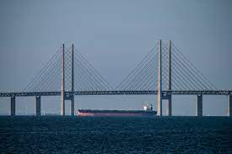
Figure No.2 Bridge with Cable Stays
BENEFITS OF BRIDGES WITH CABLE STAY
The advantages of cable-supported bridges include good stability, efficient structural performance, aesthetics, and optimal use of materials in the structure's construction, and nearly inexpensive design and upkeep costs. As a result, these bridges have become increasingly popular and are often chosen for their length at intersections rather than their sway. Here is the superiority of bridges supported by cables:
- Compared to suspension bridges, cable-stayed bridges have significantly higher rigidity, which lessens deck deformation brought on by live loads.
- They are strong because they are stiffer than suspension designs and can withstand higher stresses on cables. As a result, the deck has better stiffness and less deformation under live loads.
- They are more cost- effective than concrete structures because they use fewer materials and take less time to build.
BRIDGES WITH CABLE STAYED PARTS
Various bridges with cable stayed structural elements include:
- Pylon/Tower
- Girder/Deck
- Cable stay
- Cable Anchorage
- Support system
Seven different configurations for support columns are possible single, double, portal, A, H, inverted Y, and M-shaped. The last three configurations are blend ones that merge two different configurations into a single.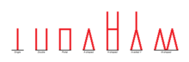
Figure No.3 Support Columns
THE RIGGING ON CABLE-STAYED BRIDGES IS DIVIDED INTO FOUR MAIN CATEGORIES:
- Mono shaped
One receptive cable runs along the axis of the above-ground level-spanning bridges that make up this type of system.
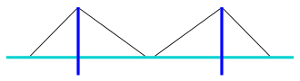
Figure No.4 Mono Type

• Harp-shaped
When using an H-type, the cables are attached to the observation tower at various heights while running aligned to one another. Higher deflation is present in the manner described here.
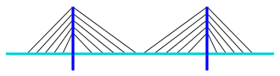
Figure No.5 Harp Type

- Fan design

This design is the most cost-effective cable layout because all of the cables are linked at the same height from the tower.
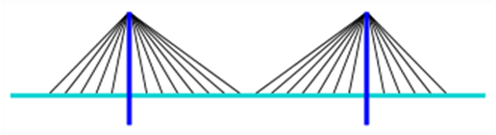
Figure No.6 Fan Type

- Star-shaped
Two opposing locations on the pier are joined by cables in a star configuration.

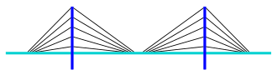
Figure No.7 Star Type
- Mathematical Analysis
Details of the model:
- Bridge's overall length with cable stays = 400cm
- Bridge width = 850cm
- Deck slab height = 200mm
- Wearing coat taken = 70mm
- Carriage way width = 7.5m
- Pylon's height above the deck slab = 30m.
- Pylon height is below the deck slab level =12.5m
- Spacing between cables = 5m
- Number of cables = 80
The size of the components:
1. Pylon’s diameter = 1500cm
2. Girder's longitudinal cross section =
500$×$ 80
3. Cross Section of an overhead girder =
400 $×$ 800
4. Slab thickness for the deck = 20cm
5. Cable diameter = 40cm
Design Calculation
Load estimation
Bridge's entire length = 4000cm
Span’s width = 850 cm
Lateral girder = 500 * 800
Cross girder every 5 meters = 400 * 800
Cable-stay spacing along the bridge's span = 5m
Thickness of deck taken = 20 cm
Wearing coat is taken = 7 cm
Dead load calculation:
Load on a deck = 0.27 * 25 * 8.5 = 57.375×10³N/m
Load on longitudinal girders = 2 x 0.5 * 0.8 * 25 = 20×10³N/m
Load on cross girders = 0.4 * 0.8 * 25* 9 * 8.5/40 = 15.3×10³N/m
UDL for total dead load = 92.675 ×10³N/m
As a result, one girder is loaded = 47×10³N/m
Live load calculation:
Live load response on a girder = 485×10³N/m
Taking impact factor into account as 11% live load on girder = 540 × 10³N/m
UDL can therefore be expressed as =180kN/m

Components of the Bridge's Design:
The components of a bridge supported by cables that will be designed:-
- Cables for the bridge
- Along girders
- Beams
- Deck of bridge
- Tower of bridge
The cables' design:
Four of the eight cables in the bridges supported by cables must endure designed for symmetry or structural reasons. A rope design:-
Total force in OA rope = 932KN
Suppose the tensile strength of the rope is l200N/mm2 and its ultimate strength is l600N/mm2
Consider 7 mm strands
Strength of 7 mm strands = n/4*7* 1200= 46.I5KN so number of wires used =932/46.15=21 no
Ultimate resistance of the OA cable= 21* z/4 * 7 * 7 * 1600=129200N
Thus, no 70 cm wire can be used for the OA 21 cable, and it can support the maximum load of 129200N
Design of Deck slab:
The deck plate design is appropriate for class AA rail vehicles and dead loads. M40 concrete grade and the Fe4l5 steel is consider in design.
Calculation of static load moment:-
Bridge plate self-weight as UDL = 0.270 * 25000N/m³ = 6.750N/m²
Aspect proportion = 7.5 $÷$5 = l.5
Load in one direction shorter using the Rankine-Grashoff formula = 5600 N/m²
Lengthier direction =1150N/m²
Midspan in the short direction, maximum bending moment = 8.75 kNm
Midspan in the long direction has the largest bending moment. = 4.043 kNm
Highest possible negative bending moment at the support in the short direction. = - 17.50 kNm
Highest negative bending moment in the direction of the long support = - 8.085kNm
Applying Pigeaud's approach
u= 1, v = 4.713, k= 0 .670, u/b = 0.2, v/l= 0 .6280
Interpolation obtain the value of M₁ = 0.1341 and M₂ = 0.0515
Lateral Momentary =350 * (0.1341 + 0.l5 * 0.0515) = 49.6kNm
Momentary longitudinal = 350 * (0.0515 + 0.15 * 0.1341) = 25.10kNm
If the central span and the support moment are greater than 80% and allow a 10% impact, then the moment of lateral support = 43.6kNm
Longitudinal Support Moment = 22.088kN
Transverse Support Design Moment = 61.1kNm Midspan Design Moment = 52.35kNm
Longitudinal Support = 30.94kNm
Longitudinal Midspan - 26.124kNm
Efficacious depth = l7.5cm
To support in a transverse direction, so Ast = 130.2cm²
Longitudinal depth that is effective = l 75-12-163mm
So longitudinal steel area = 1116.2mm2
Supply Fe 415 steel bars spacing = 0 .9cm
So provide 12mm diameter bars longitudinally and transversely at 80mm spacing
Deck details are given below with stringer details.
Longitudinal girder design:
The highest moment in the beam obtained from the analyze = 345kNm9 (-)
The highest moment obtained from the analyzed in the span = (540*1250 - 315) = 674 kNm (+)
Therefore, the efficient depth reached = 60.2cm
The depth attained is therefore acceptable 440mm is taken; 0.5 cm clear cover is taken.
Therefore steel used as positive and negative bars = 1760mm²
Therefore 10 bars of 16mm diameter are supplied as positive and negative bars for all of the silt.
Check shear in spars:-
Max. In spars 730.97 KN, Vu = 1.826, % steel = 0.876,
So Vus = 526.0 KN
Therefore, 80 cm stirrup range = 300 cm in critical section.
The cross girder's design:
Taken Dead load for UDL = 2700 *25 *150 *50 = 10.12kN/m
Taken Dead load for moment = 10l200 * 5 * 5/8 = 31.6kNm
Taken Live load for moment = 350 * 12500= 43750 kNm
Taken Total moment = 469. 2 kNm
Efficient depth = 70.2cm Steel area = 240.5 cm²
So allow 20mm No or diameter 80mrn upper and lower layers of reinforcement act as upper and lower reinforcement.
Check the shear:-
Max Shear = Max Reaction = 460kN
So Stirrup Spacing = 8.5cm
So foresee a stirrup spacing of 0.8cm, Diameter 0.8cm.
Tower construction design:
Axial force calculation inside the tower P = 2430kN
Time calculation = 9565.140kNm
119 kg/m of pressure of wind
Bidirectional b/d= 140, so suppose b= 200cm and d= 140cm, wind force udl = l.66kNm
Hence, the wind moment = 9.960 kNm
Taking both the axial forces and the moments in both directions into account
Mu /f_{ck}bd² = 20
Pu /f_{ck}bd= 650
As a result, we learn from the interaction diagram P/f k= 700, therefore P = 290
Thus, a need for Ast. = 808281mm ²
Therefore provide 100 bars with a diameter of 32 mm in equilateral bars.
- Experimental Validation
Introduction to Analysis with STAAD Pro
The following are important factors to take into account when utilizing STAAD-PRO (the software used for structural analysis and design), or similar programs. STAAD is a computer program, so you shouldn't place all your faith in it or any other engineering software. Thus, you analyze and create structures by running parallel computations on crucial structures before you have at least a year's worth of expertise using STAAD consistently.
Modeling of Cable Stayed Bridge
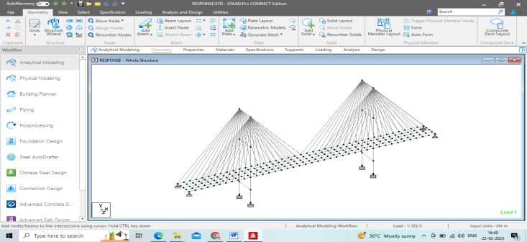
Fig no.8 three dimensional modeling of cable stayed bridge
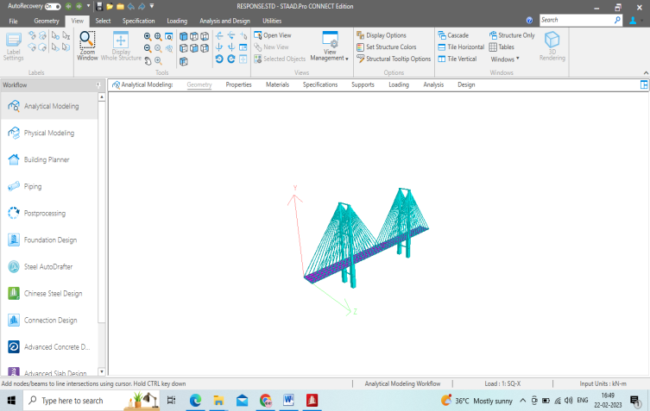
Figure No.9 Displaying a cable- bridge in 3D rendered form.
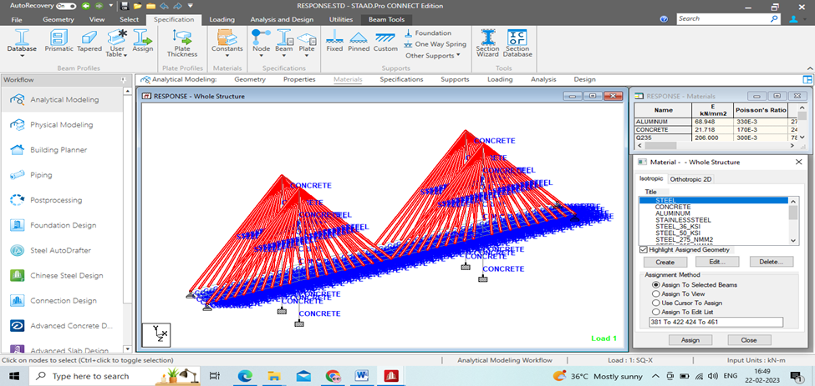
Figure No.10 Assigning Properties of Bridge with Cable Stays
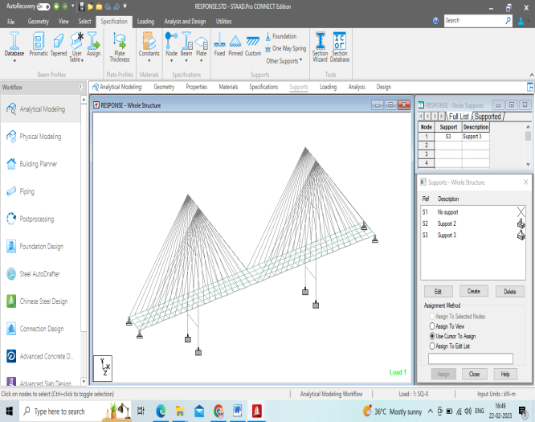
Figure No.11 Assigning Supports of Bridge with Cable Stays
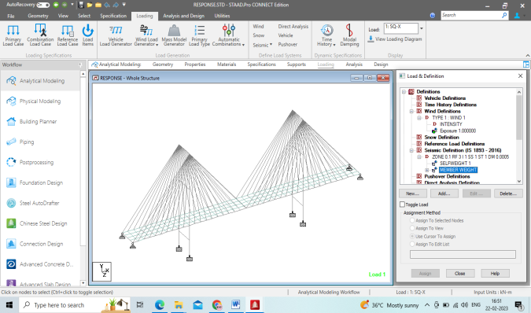
Figure No.12 Load Assigning and Cable Bridge Definitions
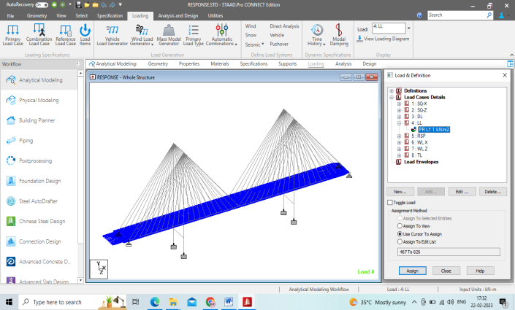
Figure No.13 Bridge with cable stays under live load
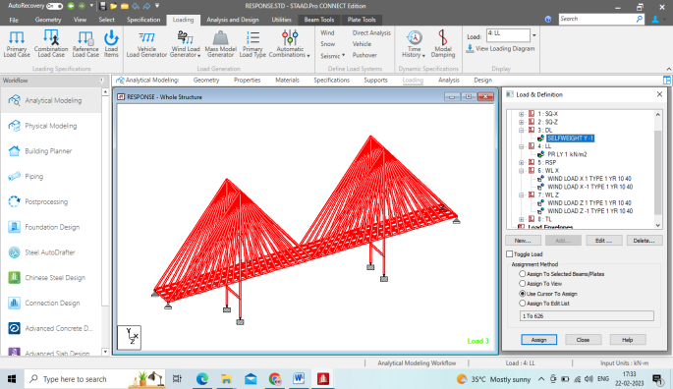
Figure No.14 Bridge with cable stays under dead load
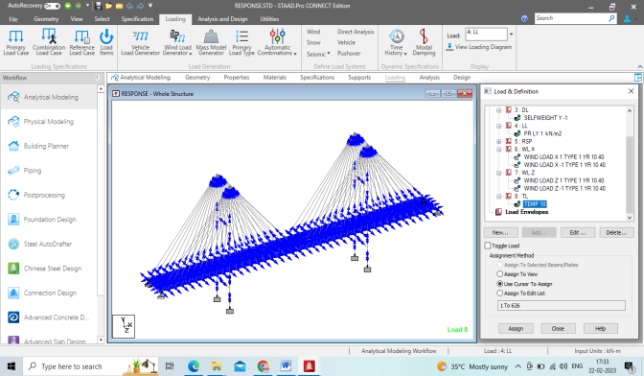
Figure No.15 Bridge with cable stays under temperature load
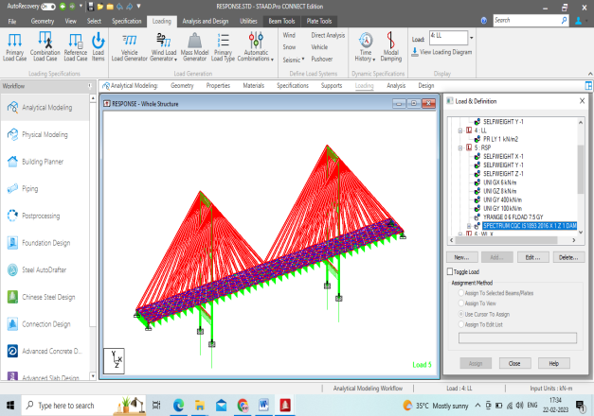
Figure No.16 Bridge with Cable Stays: Response spectrum
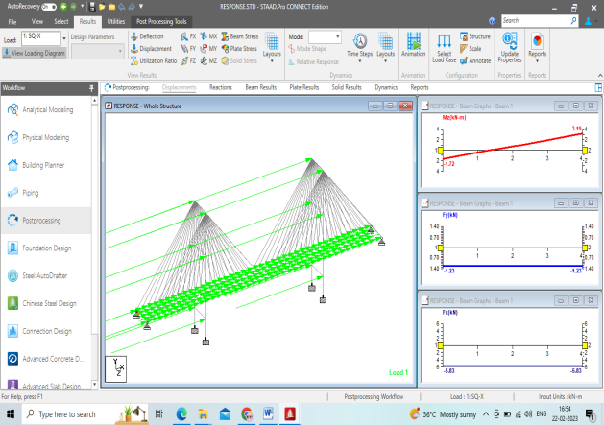
Figure No.17 Bridge with cable stays under seismic strain
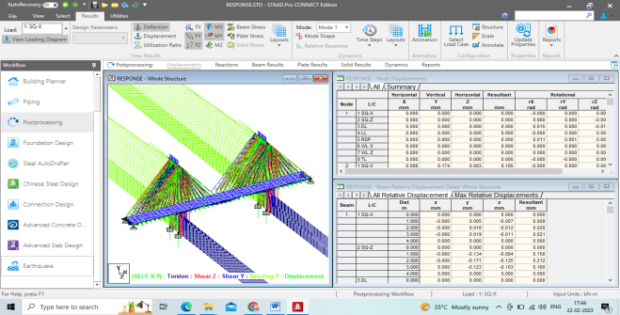
Figure No.18 Bridge with Cable Stays: Dynamic Analysis
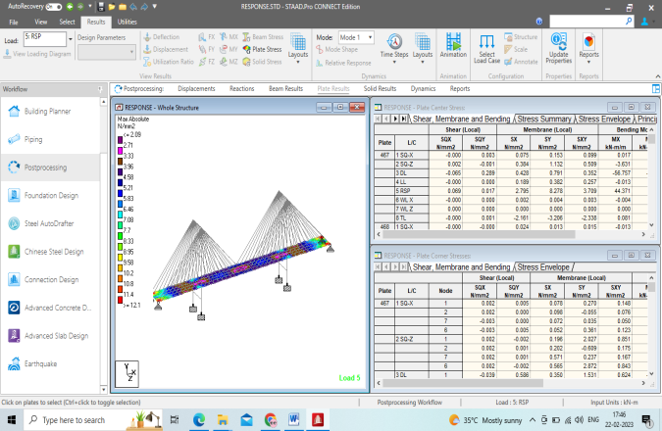
Figure No.19 Bridge with Cable Stays: Plate Stresses
- Results
The cable-stayed bridge project has been completed and various inspections of allowable and maximum deflections have been completed. Shear force, bending moment, shear stress, reactions and shear stress are applied and determined to be satisfactory, and bridge analysis is performed using computer software. The results obtained as a result of computer calculations confirm the design.
Beam | L/C |  | Distance  (m) | Moment  (z) | Distance  (m) | Moment  (y)
3 | 1 SQ-X | Maximum +ve | 0.000 | 0.613 | 0.000 | 0.904
 |  | Maximum -ve | 4.000 | -0.085 | N/A | N/A
 | 2 SQ-Z | Maximum +ve | 4.000 | 24.755 | 4.000 | 2.790
 |  | Maximum -ve | N/A | N/A | 0.000 | -5.956
 | 3 DL | Maximum +ve | N/A | N/A | 4.000 | 3.579
 |  | Maximum -ve | 0.000 | -530.283 | N/A | N/A
 | 4 LL | Maximum +ve | 0.000 | 0.025 | 0.000 | 2.462
 |  | Maximum -ve | 4.000 | -0.074 | N/A | N/A
 | 5 RSP | Maximum +ve | 4.000 | 253.235 | 0.000 | 55.143
 |  | Maximum -ve | N/A | N/A | N/A | N/A
 | 6 WLX | Maximum +ve | N/A | N/A | 0.000 | 0.027
 |  | Maximum -ve | 4.000 | -0.028 | N/A | N/A
 | 7 WLZ | Maximum +ve | 0.000 | 0.000 | 0.000 | 0.000
 |  | Maximum -ve | 0.000 | 0.000 | 0.000 | 0.000
 | 8 TL | Maximum +ve | 0.000 | 0.625 | 4.000 | 4.425
 |  | Maximum-ve | N/A | N/A | 0.000 | -16.481

Table No. 1 Ultimate Bending Moment
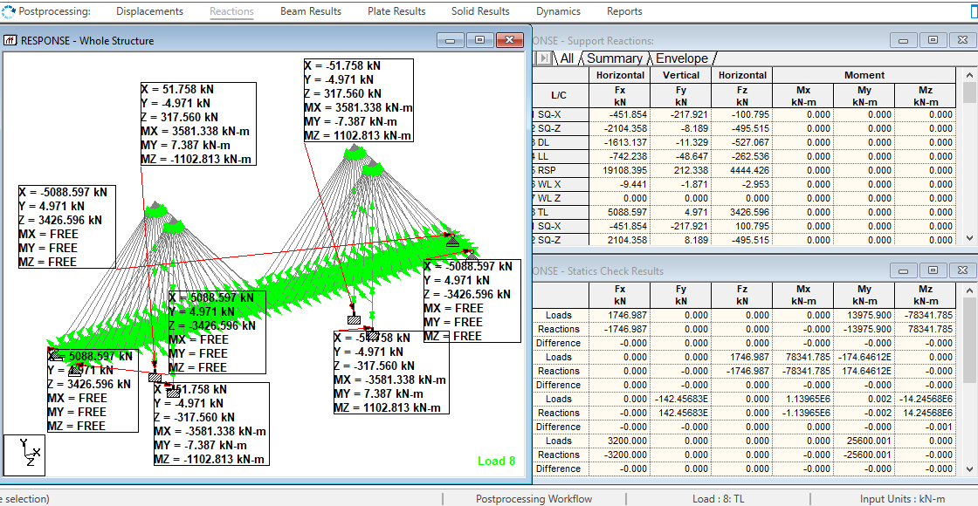
Figure No.20 Bridge Stabilized by Seismic Load on Cable
- Conclusions
1. The rigidity of the self-anchored suspension bridge is much higher than that of the pedestrian bridge, and the deck of the bridge has only little distortion.
2. Staircase bridge is a statically very uncertain structure.
3. The cable-stayed bridge is analyzed, and an exact solution is found for this very uncertain system.
4. The loads are transferred sequentially to the foundation
• To the deck
• To the cable
• To the pylon
• Finally to the foundation.
- Reference
[1] Agarwal T.P., “Cable stayed bridges-Parametric study,” Journal of bridge engineering, (May 1977), pp.61-67.
[2] Animesh Das, Anjan Dutta , Sudip Talukdar “ Efficient dynamic analysis of cable stayed bridges under vehicular movement” Finite Element Analysis and Design (6 January 2003) pp. 407-424.
[3] Artur Tukendorf Selection of erection technologies for cable stayed bridges in the aspect of further behavior during exploitation.
[4] Bhavi Katti Structure analysis Vikash Publishing House Fourth Edition (2004).
[5] D.W .Chena, F.T.K, Aub,L.G. Thamb , P.K.K.Lee. Determination of initial cable forces in prestressed concrete cable stayed bridges for given design deck profiles using force equilibrium method, computer and structure (18 November 1998), pp1- 9.
[6] En.wikipedia.org internet source.
[7] Engineering ASCE, May (1971), pp. 1789-1802.
[8] Gimsing N., “Cable supported bridges: Concept and Design” John Wiley & Sons, (1983).
[9] Ian N .Robertson “prediction of vertical deflection in cable stayed bridge” Engineering Structures (1 July 2005)
[10] H.G. Kwak, J.K.Son Determination of design moment in bridges construction by balance cantilever method Engineering Structures (2004) pp. 639-648.
[11]https://www.midasbridge.com/en/solutions/cable-styaed-bridge.
[12] Krishna Raju Design of bridges Oxford and IBH Publishing, Third Edition (2006).
[13] M.S. Troitsky Cable stayed bridges theory and design Granada Publishing Limited (1977).
[14] Pao- Hsii Wang, Tzu-Yang, Hou-Nong Zheng Analysis of cable stayed bridges during construction by cantilever method Computer ad Structure (2004) pp. 329- 346.
[15] P. H.Wang,5 T.C.Tseng and C.G.Yang Initial shape of cable stayed bridges, department of Chung-Yuan Christian University.
[16] R.K. Rajput Strength of material S. Chand (2004).
[17] Shodhbhagirathi.iitr.c.in.8081,Internet source.
[18] Structural Behavior of Cable-stayed Bridges by Elizabeth Davalos.
[19] Tang M.,”Design of cable stayed girder bridges Journal of Structural engineering”, ASCE, (May 1971), pp.1481-1496.
[20] Tang M., “Analysis of cable stayed girder bridges” Journal of the Structural.
[21] Wang P. And Yang C “Parametric studies of cable stayed bridges”, J.Computer &Structures, Volume 60, No-2 pp. 243-260, (1996).
[22] W.Podoliny and J.B. Scalzi, “construction and design of cable stayed bridges”, John Wiley & Sons, New York, (1986).

